HW5

9/28/2021

Question 8.1 Describe a situation or problem from your job, everyday life, current events, etc., for which a linear regression model would be appropriate. List some (up to 5) predictors that you might use.

I would love to predict the price of steal. The reason behind this is that I find the current hikes in price to be fascinating in the real-estate market. Some predictors that I would use would be, diplomatic tensions with China, supply chain health, Covid related business shutdowns, market demand for construction material, and commercial construction-to-permanent loan numbers.

Question 8.2 Using crime data, uscrime.txt, use regression (a useful R function is lm or glm) to predict the observed crime rate in a city with the following data:

M = 14.0 So = 0 Ed = 10.0 Po1 = 12.0 Po2 = 15.5 LF = 0.640 M.F = 94.0 Pop = 150 NW = 1.1 U1 = 0.120 U2 = 3.6 Wealth = 3200 Ineq = 20.1 Prob = 0.04 Time = 39.0

Lets first load in some required packages.

library(caret)

## Loading required package: lattice

## Loading required package: ggplot2

library(corrplot)

## corrplot 0.90 loaded

Let’s clear out the current work seasons data and pull in us crime data.

rm(list = ls())  
uscrime <- read.table("uscrime.txt", stringsAsFactors = FALSE, header = TRUE)  
uscrime

## M So Ed Po1 Po2 LF M.F Pop NW U1 U2 Wealth Ineq Prob  
## 1 15.1 1 9.1 5.8 5.6 0.510 95.0 33 30.1 0.108 4.1 3940 26.1 0.084602  
## 2 14.3 0 11.3 10.3 9.5 0.583 101.2 13 10.2 0.096 3.6 5570 19.4 0.029599  
## 3 14.2 1 8.9 4.5 4.4 0.533 96.9 18 21.9 0.094 3.3 3180 25.0 0.083401  
## 4 13.6 0 12.1 14.9 14.1 0.577 99.4 157 8.0 0.102 3.9 6730 16.7 0.015801  
## 5 14.1 0 12.1 10.9 10.1 0.591 98.5 18 3.0 0.091 2.0 5780 17.4 0.041399  
## 6 12.1 0 11.0 11.8 11.5 0.547 96.4 25 4.4 0.084 2.9 6890 12.6 0.034201  
## 7 12.7 1 11.1 8.2 7.9 0.519 98.2 4 13.9 0.097 3.8 6200 16.8 0.042100  
## 8 13.1 1 10.9 11.5 10.9 0.542 96.9 50 17.9 0.079 3.5 4720 20.6 0.040099  
## 9 15.7 1 9.0 6.5 6.2 0.553 95.5 39 28.6 0.081 2.8 4210 23.9 0.071697  
## 10 14.0 0 11.8 7.1 6.8 0.632 102.9 7 1.5 0.100 2.4 5260 17.4 0.044498  
## 11 12.4 0 10.5 12.1 11.6 0.580 96.6 101 10.6 0.077 3.5 6570 17.0 0.016201  
## 12 13.4 0 10.8 7.5 7.1 0.595 97.2 47 5.9 0.083 3.1 5800 17.2 0.031201  
## 13 12.8 0 11.3 6.7 6.0 0.624 97.2 28 1.0 0.077 2.5 5070 20.6 0.045302  
## 14 13.5 0 11.7 6.2 6.1 0.595 98.6 22 4.6 0.077 2.7 5290 19.0 0.053200  
## 15 15.2 1 8.7 5.7 5.3 0.530 98.6 30 7.2 0.092 4.3 4050 26.4 0.069100  
## 16 14.2 1 8.8 8.1 7.7 0.497 95.6 33 32.1 0.116 4.7 4270 24.7 0.052099  
## 17 14.3 0 11.0 6.6 6.3 0.537 97.7 10 0.6 0.114 3.5 4870 16.6 0.076299  
## 18 13.5 1 10.4 12.3 11.5 0.537 97.8 31 17.0 0.089 3.4 6310 16.5 0.119804  
## 19 13.0 0 11.6 12.8 12.8 0.536 93.4 51 2.4 0.078 3.4 6270 13.5 0.019099  
## 20 12.5 0 10.8 11.3 10.5 0.567 98.5 78 9.4 0.130 5.8 6260 16.6 0.034801  
## 21 12.6 0 10.8 7.4 6.7 0.602 98.4 34 1.2 0.102 3.3 5570 19.5 0.022800  
## 22 15.7 1 8.9 4.7 4.4 0.512 96.2 22 42.3 0.097 3.4 2880 27.6 0.089502  
## 23 13.2 0 9.6 8.7 8.3 0.564 95.3 43 9.2 0.083 3.2 5130 22.7 0.030700  
## 24 13.1 0 11.6 7.8 7.3 0.574 103.8 7 3.6 0.142 4.2 5400 17.6 0.041598  
## 25 13.0 0 11.6 6.3 5.7 0.641 98.4 14 2.6 0.070 2.1 4860 19.6 0.069197  
## 26 13.1 0 12.1 16.0 14.3 0.631 107.1 3 7.7 0.102 4.1 6740 15.2 0.041698  
## 27 13.5 0 10.9 6.9 7.1 0.540 96.5 6 0.4 0.080 2.2 5640 13.9 0.036099  
## 28 15.2 0 11.2 8.2 7.6 0.571 101.8 10 7.9 0.103 2.8 5370 21.5 0.038201  
## 29 11.9 0 10.7 16.6 15.7 0.521 93.8 168 8.9 0.092 3.6 6370 15.4 0.023400  
## 30 16.6 1 8.9 5.8 5.4 0.521 97.3 46 25.4 0.072 2.6 3960 23.7 0.075298  
## 31 14.0 0 9.3 5.5 5.4 0.535 104.5 6 2.0 0.135 4.0 4530 20.0 0.041999  
## 32 12.5 0 10.9 9.0 8.1 0.586 96.4 97 8.2 0.105 4.3 6170 16.3 0.042698  
## 33 14.7 1 10.4 6.3 6.4 0.560 97.2 23 9.5 0.076 2.4 4620 23.3 0.049499  
## 34 12.6 0 11.8 9.7 9.7 0.542 99.0 18 2.1 0.102 3.5 5890 16.6 0.040799  
## 35 12.3 0 10.2 9.7 8.7 0.526 94.8 113 7.6 0.124 5.0 5720 15.8 0.020700  
## 36 15.0 0 10.0 10.9 9.8 0.531 96.4 9 2.4 0.087 3.8 5590 15.3 0.006900  
## 37 17.7 1 8.7 5.8 5.6 0.638 97.4 24 34.9 0.076 2.8 3820 25.4 0.045198  
## 38 13.3 0 10.4 5.1 4.7 0.599 102.4 7 4.0 0.099 2.7 4250 22.5 0.053998  
## 39 14.9 1 8.8 6.1 5.4 0.515 95.3 36 16.5 0.086 3.5 3950 25.1 0.047099  
## 40 14.5 1 10.4 8.2 7.4 0.560 98.1 96 12.6 0.088 3.1 4880 22.8 0.038801  
## 41 14.8 0 12.2 7.2 6.6 0.601 99.8 9 1.9 0.084 2.0 5900 14.4 0.025100  
## 42 14.1 0 10.9 5.6 5.4 0.523 96.8 4 0.2 0.107 3.7 4890 17.0 0.088904  
## 43 16.2 1 9.9 7.5 7.0 0.522 99.6 40 20.8 0.073 2.7 4960 22.4 0.054902  
## 44 13.6 0 12.1 9.5 9.6 0.574 101.2 29 3.6 0.111 3.7 6220 16.2 0.028100  
## 45 13.9 1 8.8 4.6 4.1 0.480 96.8 19 4.9 0.135 5.3 4570 24.9 0.056202  
## 46 12.6 0 10.4 10.6 9.7 0.599 98.9 40 2.4 0.078 2.5 5930 17.1 0.046598  
## 47 13.0 0 12.1 9.0 9.1 0.623 104.9 3 2.2 0.113 4.0 5880 16.0 0.052802  
## Time Crime  
## 1 26.2011 791  
## 2 25.2999 1635  
## 3 24.3006 578  
## 4 29.9012 1969  
## 5 21.2998 1234  
## 6 20.9995 682  
## 7 20.6993 963  
## 8 24.5988 1555  
## 9 29.4001 856  
## 10 19.5994 705  
## 11 41.6000 1674  
## 12 34.2984 849  
## 13 36.2993 511  
## 14 21.5010 664  
## 15 22.7008 798  
## 16 26.0991 946  
## 17 19.1002 539  
## 18 18.1996 929  
## 19 24.9008 750  
## 20 26.4010 1225  
## 21 37.5998 742  
## 22 37.0994 439  
## 23 25.1989 1216  
## 24 17.6000 968  
## 25 21.9003 523  
## 26 22.1005 1993  
## 27 28.4999 342  
## 28 25.8006 1216  
## 29 36.7009 1043  
## 30 28.3011 696  
## 31 21.7998 373  
## 32 30.9014 754  
## 33 25.5005 1072  
## 34 21.6997 923  
## 35 37.4011 653  
## 36 44.0004 1272  
## 37 31.6995 831  
## 38 16.6999 566  
## 39 27.3004 826  
## 40 29.3004 1151  
## 41 30.0001 880  
## 42 12.1996 542  
## 43 31.9989 823  
## 44 30.0001 1030  
## 45 32.5996 455  
## 46 16.6999 508  
## 47 16.0997 849

I’d like to know what these column headers stand for, so let’s take a look at: <http://www.statsci.org/data/general/uscrime.html>

Variable Description M percentage of males aged 14–24 in total state population So indicator variable for a southern state Ed mean years of schooling of the population aged 25 years or over Po1 per capita expenditure on police protection in 1960 Po2 per capita expenditure on police protection in 1959 LF labour force participation rate of civilian urban males in the age-group 14-24 M.F number of males per 100 females Pop state population in 1960 in hundred thousands NW percentage of nonwhites in the population U1 unemployment rate of urban males 14–24 U2 unemployment rate of urban males 35–39 Wealth wealth: median value of transferable assets or family income Ineq income inequality: percentage of families earning below half the median income Prob probability of imprisonment: ratio of number of commitments to number of offenses Time average time in months served by offenders in state prisons before their first release Crime crime rate: number of offenses per 100,000 population in 1960

Let’s get a general plot of Crime from the us crime data set.

plot(uscrime$Crime)

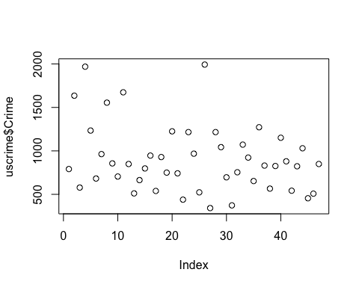

Let’s see if there are any outliers for getting a better feel for the data set. These are not set in stone, and will not be excluded.

boxplot(uscrime$Crime)$out

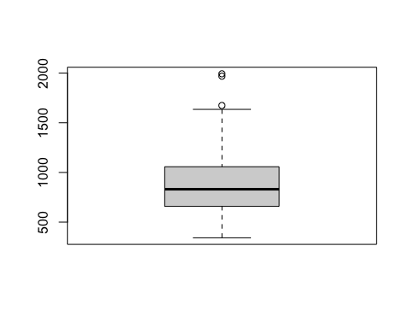

## [1] 1969 1674 1993

Let’s take a look at the overall range of the actual crimes commited.

range(uscrime$Crime)

## [1] 342 1993

The qqnorm plot will give us an outlook on the data’s general distribution. Two values on either end being outside the second standard deviation.

qqnorm(uscrime$Crime)

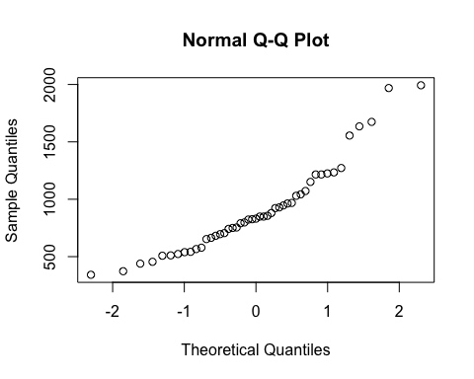

The U1 and the U2 clearly have a high positive correlation. One might consider omitting one of these to not have the prediction skewed, because both values are conveying a similar message. Something to look at potentially is at what age is one more likely to commit a crime and keep that range/ U predictor. U1 unemployment rate of urban males 14–24 U2 unemployment rate of urban males 35–39

It is also interesting to note that Wealth and Ineq have a high negative correlation. The reasoning is quite obvious, but im not sure I would exclude either. Wealth wealth: median value of transferable assets or family income Ineq income inequality: percentage of families earning below half the median income

These two predictors have a correlation of one i would condider excluding one of these predictors. Po1 per capita expenditure on police protection in 1960 Po2 per capita expenditure on police protection in 1959

corrplot(cor(uscrime))

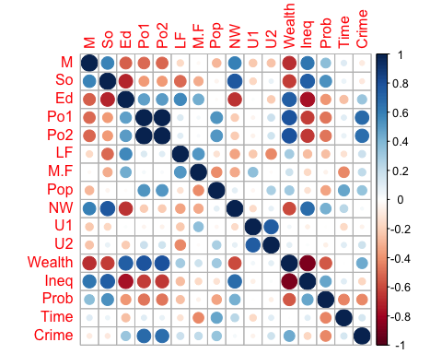

Here is the most simple of the models using lm and all predictors.

set.seed(0)  
Md1_lm_crime <- lm(Crime~., data = uscrime)  
Md1_lm_crime

##   
## Call:  
## lm(formula = Crime ~ ., data = uscrime)  
##   
## Coefficients:  
## (Intercept) M So Ed Po1 Po2   
## -5.984e+03 8.783e+01 -3.803e+00 1.883e+02 1.928e+02 -1.094e+02   
## LF M.F Pop NW U1 U2   
## -6.638e+02 1.741e+01 -7.330e-01 4.204e+00 -5.827e+03 1.678e+02   
## Wealth Ineq Prob Time   
## 9.617e-02 7.067e+01 -4.855e+03 -3.479e+00

summary(Md1_lm_crime)

##   
## Call:  
## lm(formula = Crime ~ ., data = uscrime)  
##   
## Residuals:  
## Min 1Q Median 3Q Max   
## -395.74 -98.09 -6.69 112.99 512.67   
##   
## Coefficients:  
## Estimate Std. Error t value Pr(>|t|)   
## (Intercept) -5.984e+03 1.628e+03 -3.675 0.000893 ***  
## M 8.783e+01 4.171e+01 2.106 0.043443 *   
## So -3.803e+00 1.488e+02 -0.026 0.979765   
## Ed 1.883e+02 6.209e+01 3.033 0.004861 **   
## Po1 1.928e+02 1.061e+02 1.817 0.078892 .   
## Po2 -1.094e+02 1.175e+02 -0.931 0.358830   
## LF -6.638e+02 1.470e+03 -0.452 0.654654   
## M.F 1.741e+01 2.035e+01 0.855 0.398995   
## Pop -7.330e-01 1.290e+00 -0.568 0.573845   
## NW 4.204e+00 6.481e+00 0.649 0.521279   
## U1 -5.827e+03 4.210e+03 -1.384 0.176238   
## U2 1.678e+02 8.234e+01 2.038 0.050161 .   
## Wealth 9.617e-02 1.037e-01 0.928 0.360754   
## Ineq 7.067e+01 2.272e+01 3.111 0.003983 **   
## Prob -4.855e+03 2.272e+03 -2.137 0.040627 *   
## Time -3.479e+00 7.165e+00 -0.486 0.630708   
## ---  
## Signif. codes: 0 '***' 0.001 '**' 0.01 '*' 0.05 '.' 0.1 ' ' 1  
##   
## Residual standard error: 209.1 on 31 degrees of freedom  
## Multiple R-squared: 0.8031, Adjusted R-squared: 0.7078   
## F-statistic: 8.429 on 15 and 31 DF, p-value: 3.539e-07

According to what we witnessed via p-value above from the first lm model and the general assessment of the correlation chart above we will ommit a few or the predoctors for testing purposes.

set.seed(0)  
lm_crime_6 <- lm(Crime~M+Ed+Po1+U2+Ineq+Prob, data = uscrime)  
lm_crime_6

##   
## Call:  
## lm(formula = Crime ~ M + Ed + Po1 + U2 + Ineq + Prob, data = uscrime)  
##   
## Coefficients:  
## (Intercept) M Ed Po1 U2 Ineq   
## -5040.50 105.02 196.47 115.02 89.37 67.65   
## Prob   
## -3801.84

summary(lm_crime_6)

##   
## Call:  
## lm(formula = Crime ~ M + Ed + Po1 + U2 + Ineq + Prob, data = uscrime)  
##   
## Residuals:  
## Min 1Q Median 3Q Max   
## -470.68 -78.41 -19.68 133.12 556.23   
##   
## Coefficients:  
## Estimate Std. Error t value Pr(>|t|)   
## (Intercept) -5040.50 899.84 -5.602 1.72e-06 ***  
## M 105.02 33.30 3.154 0.00305 **   
## Ed 196.47 44.75 4.390 8.07e-05 ***  
## Po1 115.02 13.75 8.363 2.56e-10 ***  
## U2 89.37 40.91 2.185 0.03483 *   
## Ineq 67.65 13.94 4.855 1.88e-05 ***  
## Prob -3801.84 1528.10 -2.488 0.01711 *   
## ---  
## Signif. codes: 0 '***' 0.001 '**' 0.01 '*' 0.05 '.' 0.1 ' ' 1  
##   
## Residual standard error: 200.7 on 40 degrees of freedom  
## Multiple R-squared: 0.7659, Adjusted R-squared: 0.7307   
## F-statistic: 21.81 on 6 and 40 DF, p-value: 3.418e-11

It is clear that the second model, lm_crime_6, with M + Ed + Po1 + U2 + Ineq + Prob as the predictors performs a better then the Md1_lm_crime model. Scoring a slightly higher Adjusted R-squared of 0.7307 and haveing a lower Residual standard error of 200.7.

Using Cross-Validated (10 fold) with the same lm method.

set.seed(0)  
  
ctrl<- trainControl(method = "cv", number = 10)  
  
lmCVCrime<-train(Crime ~ ., data = uscrime, method = "lm", trControl = ctrl, metric= "Rsquared")  
  
lmCVCrime

## Linear Regression   
##   
## 47 samples  
## 15 predictors  
##   
## No pre-processing  
## Resampling: Cross-Validated (10 fold)   
## Summary of sample sizes: 42, 41, 43, 42, 42, 42, ...   
## Resampling results:  
##   
## RMSE Rsquared MAE   
## 243.7301 0.512716 189.8613  
##   
## Tuning parameter 'intercept' was held constant at a value of TRUE

summary(lmCVCrime)

##   
## Call:  
## lm(formula = .outcome ~ ., data = dat)  
##   
## Residuals:  
## Min 1Q Median 3Q Max   
## -395.74 -98.09 -6.69 112.99 512.67   
##   
## Coefficients:  
## Estimate Std. Error t value Pr(>|t|)   
## (Intercept) -5.984e+03 1.628e+03 -3.675 0.000893 ***  
## M 8.783e+01 4.171e+01 2.106 0.043443 *   
## So -3.803e+00 1.488e+02 -0.026 0.979765   
## Ed 1.883e+02 6.209e+01 3.033 0.004861 **   
## Po1 1.928e+02 1.061e+02 1.817 0.078892 .   
## Po2 -1.094e+02 1.175e+02 -0.931 0.358830   
## LF -6.638e+02 1.470e+03 -0.452 0.654654   
## M.F 1.741e+01 2.035e+01 0.855 0.398995   
## Pop -7.330e-01 1.290e+00 -0.568 0.573845   
## NW 4.204e+00 6.481e+00 0.649 0.521279   
## U1 -5.827e+03 4.210e+03 -1.384 0.176238   
## U2 1.678e+02 8.234e+01 2.038 0.050161 .   
## Wealth 9.617e-02 1.037e-01 0.928 0.360754   
## Ineq 7.067e+01 2.272e+01 3.111 0.003983 **   
## Prob -4.855e+03 2.272e+03 -2.137 0.040627 *   
## Time -3.479e+00 7.165e+00 -0.486 0.630708   
## ---  
## Signif. codes: 0 '***' 0.001 '**' 0.01 '*' 0.05 '.' 0.1 ' ' 1  
##   
## Residual standard error: 209.1 on 31 degrees of freedom  
## Multiple R-squared: 0.8031, Adjusted R-squared: 0.7078   
## F-statistic: 8.429 on 15 and 31 DF, p-value: 3.539e-07

Now lets predict the observed crime rate in a city with the following data.

crime_rate_preditors <- data.frame(M = 14.0, So = 0, Ed = 10.0, Po1 = 12.0, Po2 = 15.5  
 , LF = 0.640, M.F = 94.0, Pop = 150, NW = 1.1, U1 = 0.120  
 , U2 = 3.6, Wealth = 3200, Ineq = 20.1, Prob = 0.04, Time = 39.0)  
# make predictions  
predictions<- predict(lmCVCrime,crime_rate_preditors)  
predictions

## 1   
## 155.4349

Looking at the above prediction with is a very low prediction. Definitely being outside of the second standard deviation on the low end.

summary(uscrime)

## M So Ed Po1   
## Min. :11.90 Min. :0.0000 Min. : 8.70 Min. : 4.50   
## 1st Qu.:13.00 1st Qu.:0.0000 1st Qu.: 9.75 1st Qu.: 6.25   
## Median :13.60 Median :0.0000 Median :10.80 Median : 7.80   
## Mean :13.86 Mean :0.3404 Mean :10.56 Mean : 8.50   
## 3rd Qu.:14.60 3rd Qu.:1.0000 3rd Qu.:11.45 3rd Qu.:10.45   
## Max. :17.70 Max. :1.0000 Max. :12.20 Max. :16.60   
## Po2 LF M.F Pop   
## Min. : 4.100 Min. :0.4800 Min. : 93.40 Min. : 3.00   
## 1st Qu.: 5.850 1st Qu.:0.5305 1st Qu.: 96.45 1st Qu.: 10.00   
## Median : 7.300 Median :0.5600 Median : 97.70 Median : 25.00   
## Mean : 8.023 Mean :0.5612 Mean : 98.30 Mean : 36.62   
## 3rd Qu.: 9.700 3rd Qu.:0.5930 3rd Qu.: 99.20 3rd Qu.: 41.50   
## Max. :15.700 Max. :0.6410 Max. :107.10 Max. :168.00   
## NW U1 U2 Wealth   
## Min. : 0.20 Min. :0.07000 Min. :2.000 Min. :2880   
## 1st Qu.: 2.40 1st Qu.:0.08050 1st Qu.:2.750 1st Qu.:4595   
## Median : 7.60 Median :0.09200 Median :3.400 Median :5370   
## Mean :10.11 Mean :0.09547 Mean :3.398 Mean :5254   
## 3rd Qu.:13.25 3rd Qu.:0.10400 3rd Qu.:3.850 3rd Qu.:5915   
## Max. :42.30 Max. :0.14200 Max. :5.800 Max. :6890   
## Ineq Prob Time Crime   
## Min. :12.60 Min. :0.00690 Min. :12.20 Min. : 342.0   
## 1st Qu.:16.55 1st Qu.:0.03270 1st Qu.:21.60 1st Qu.: 658.5   
## Median :17.60 Median :0.04210 Median :25.80 Median : 831.0   
## Mean :19.40 Mean :0.04709 Mean :26.60 Mean : 905.1   
## 3rd Qu.:22.75 3rd Qu.:0.05445 3rd Qu.:30.45 3rd Qu.:1057.5   
## Max. :27.60 Max. :0.11980 Max. :44.00 Max. :1993.0