Create an EC2 machine for windows and created a new VPC and respective subnet

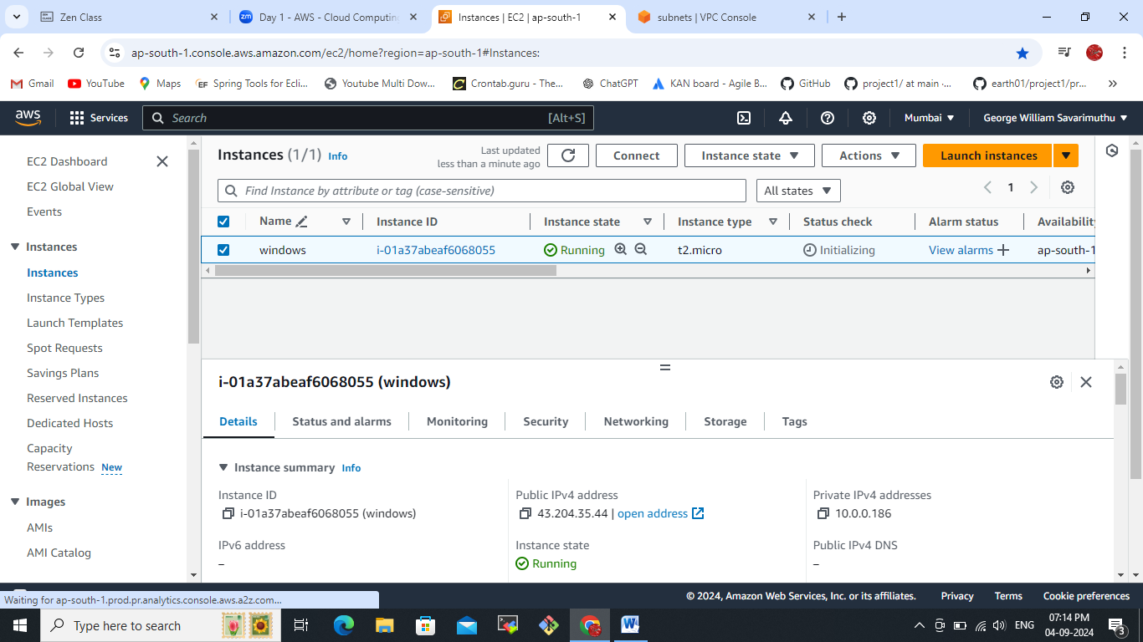  
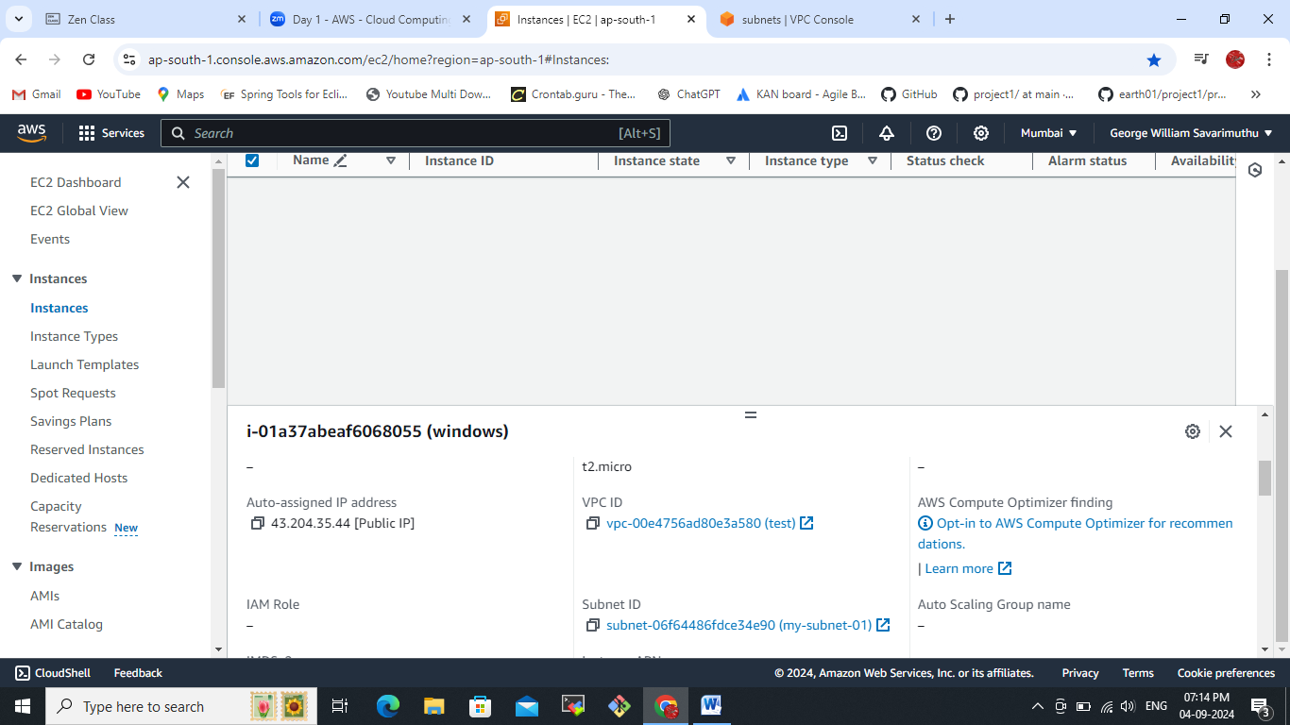

Upload private key for remote access  
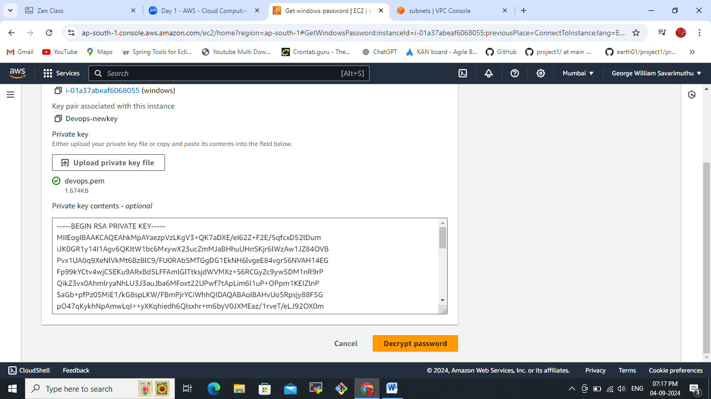

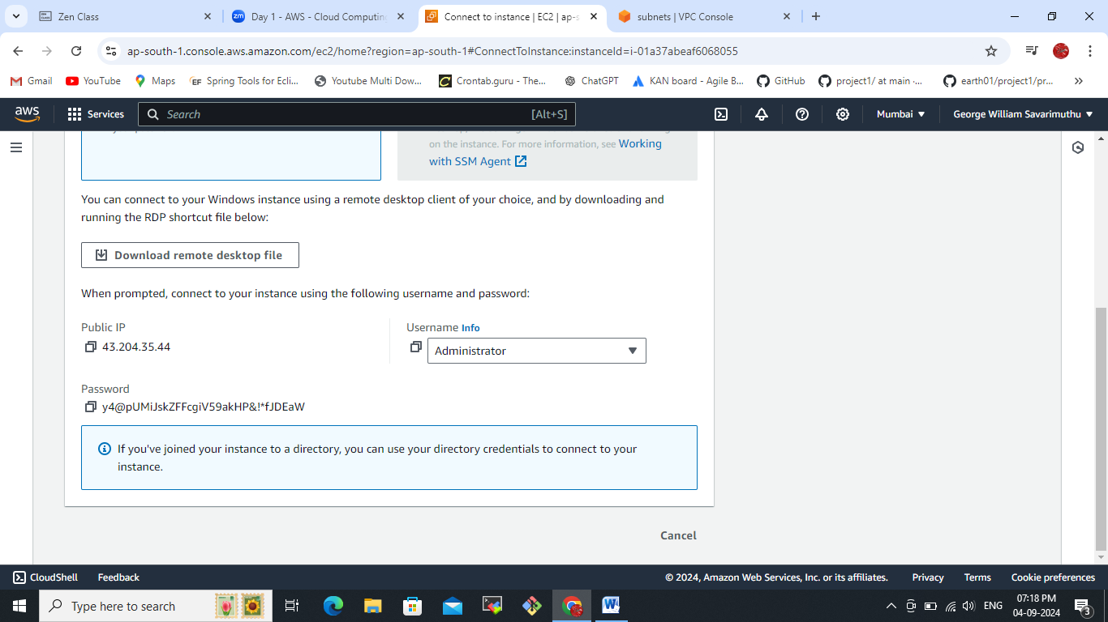

Taking remote by using RDP:  
  
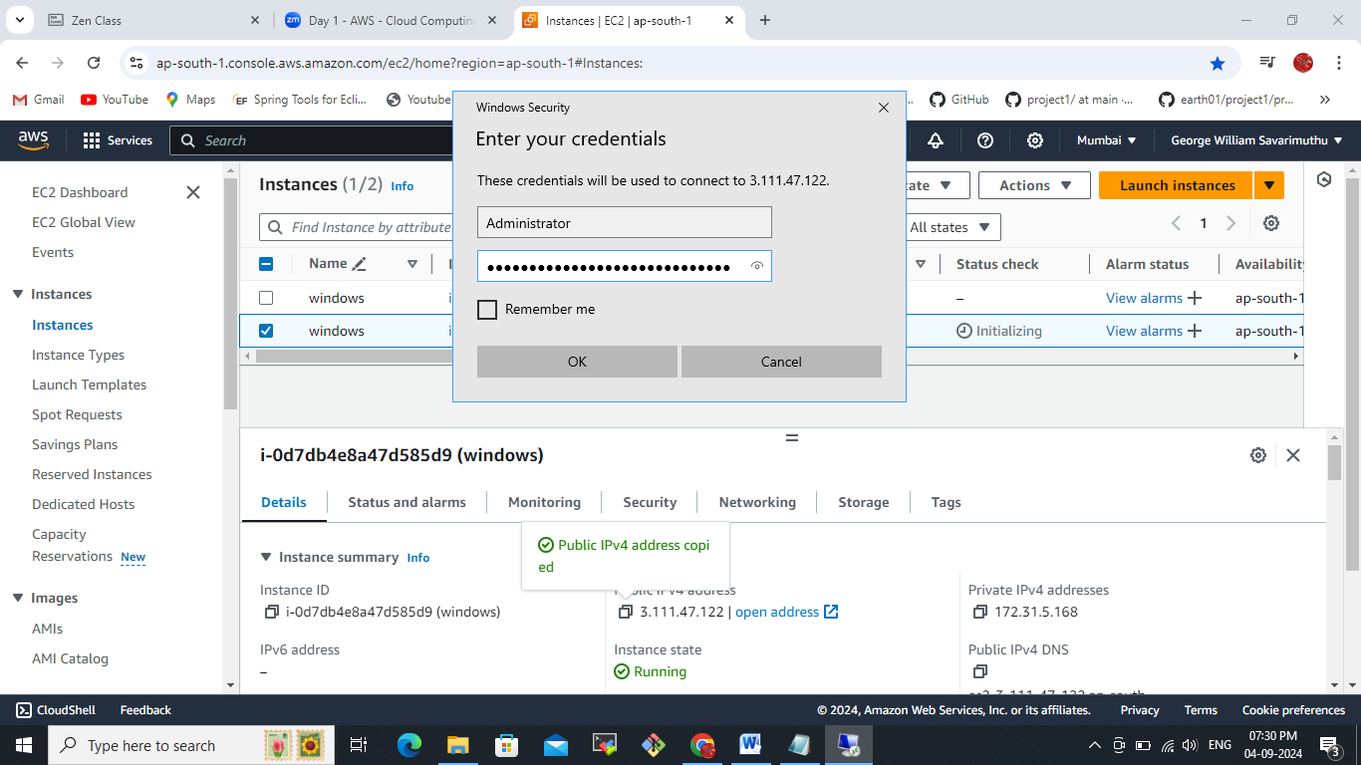  
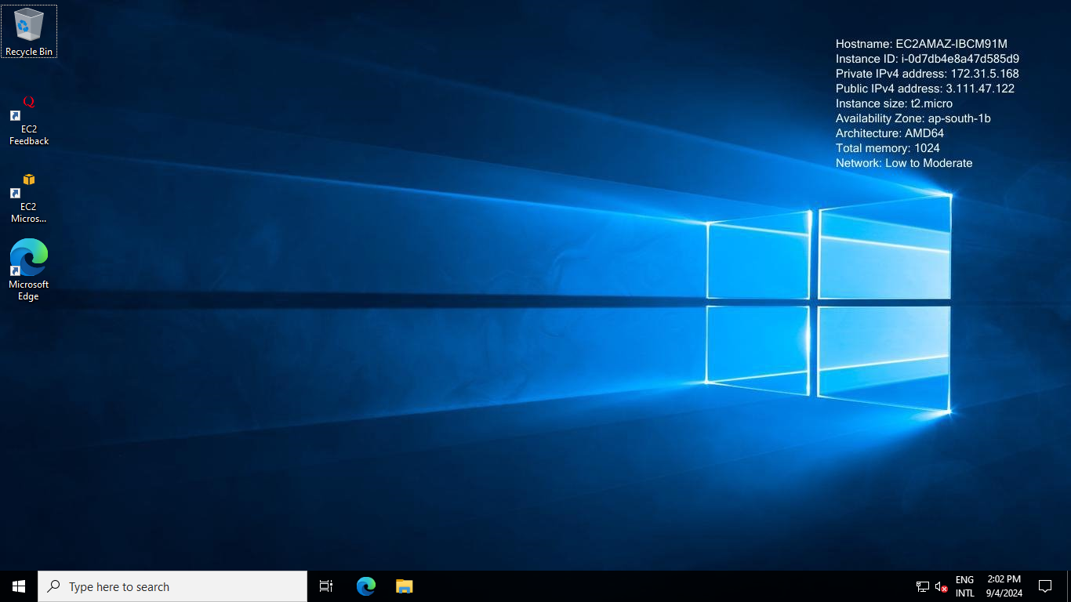

Configuring Http server in the windows remote machine.  
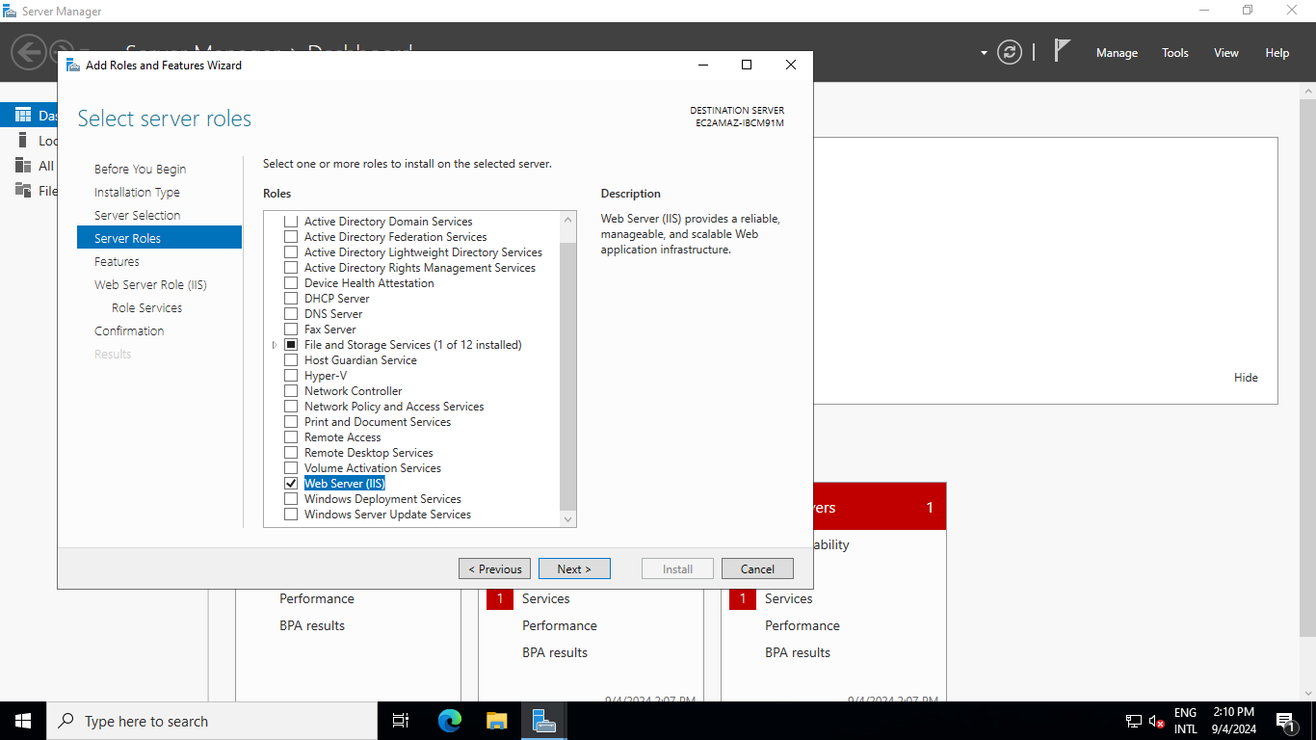  
since we can able to see my IP outside(expose to the internet) anywhere by using http protocol since the purpose we are installing web server if you want install more services you can install by using IIS server console.  
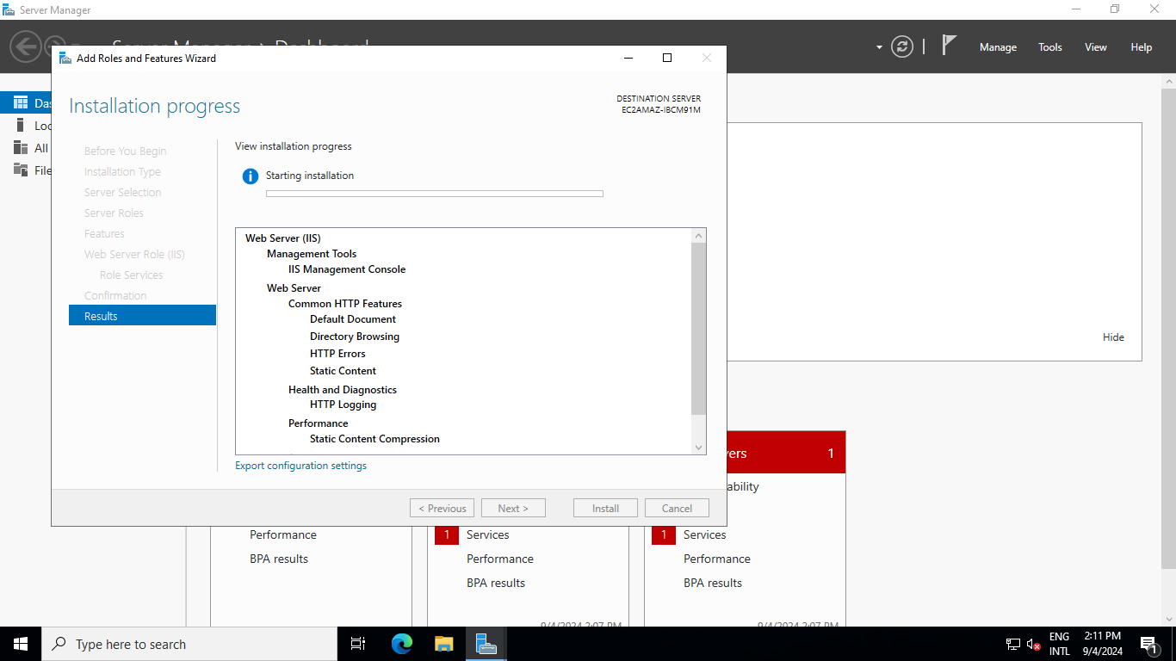  
Enable http and https and respective ports in the EC2 instance security groups  
  
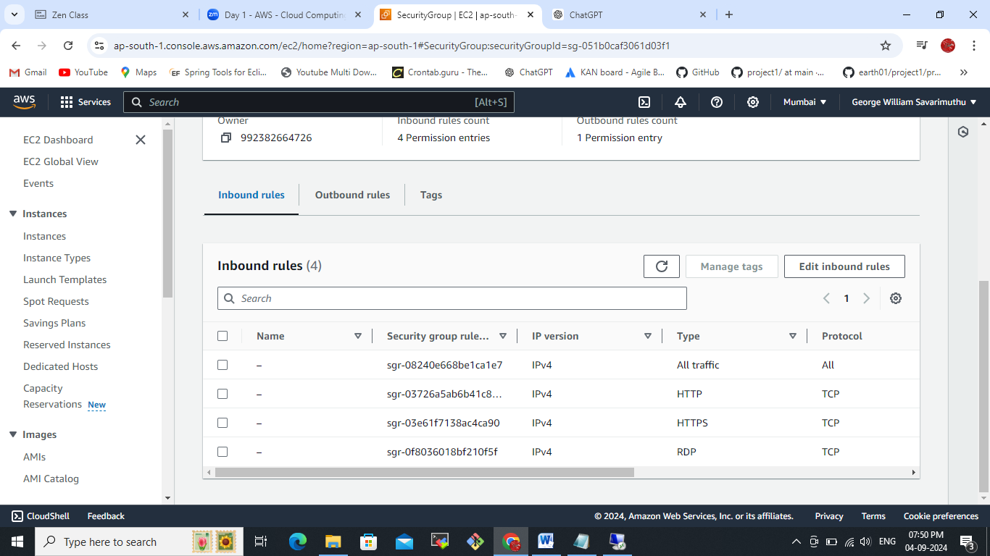

Can able to access the default page from the windows remote server. 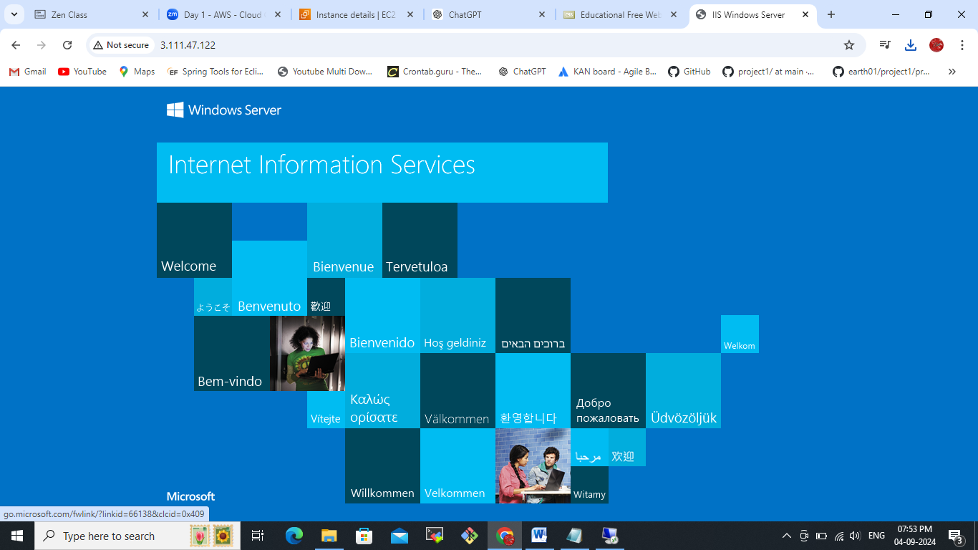  
Base location:  
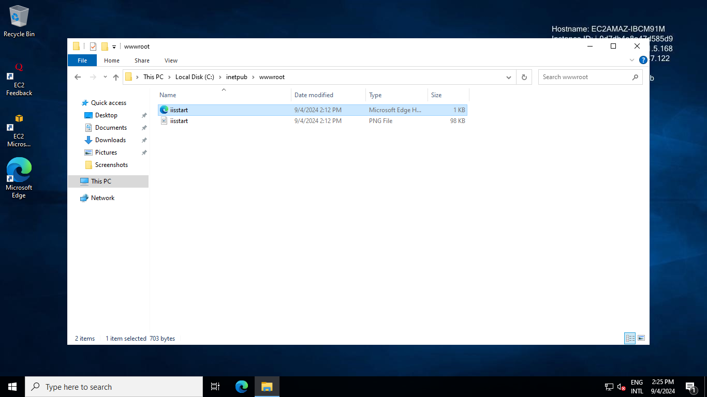  
We have try to access some custom web sites by replacing here the root base location of IIS server.  
download and paste the base location  
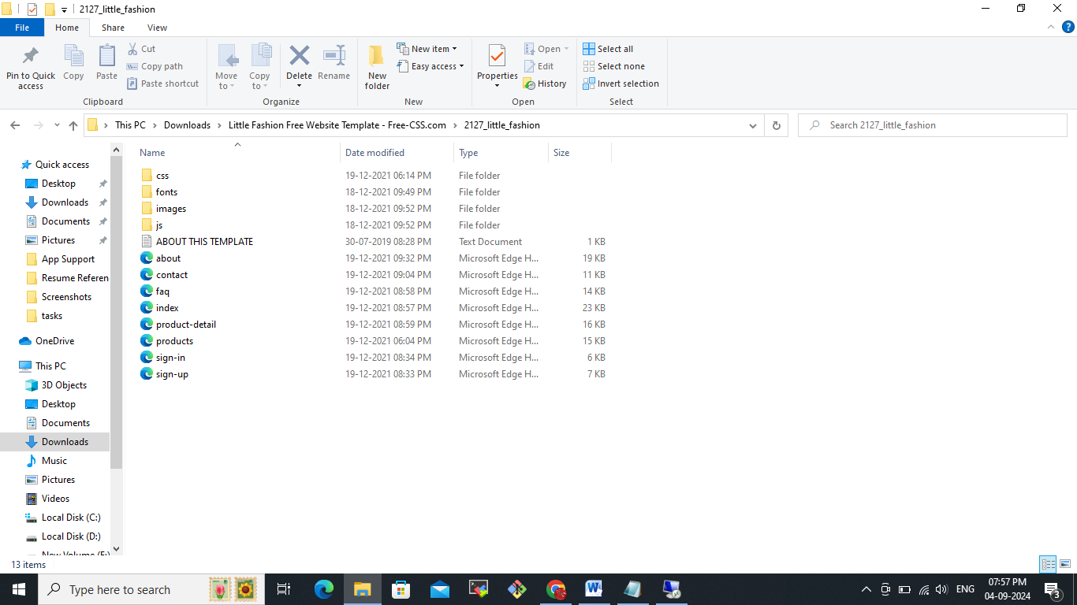  
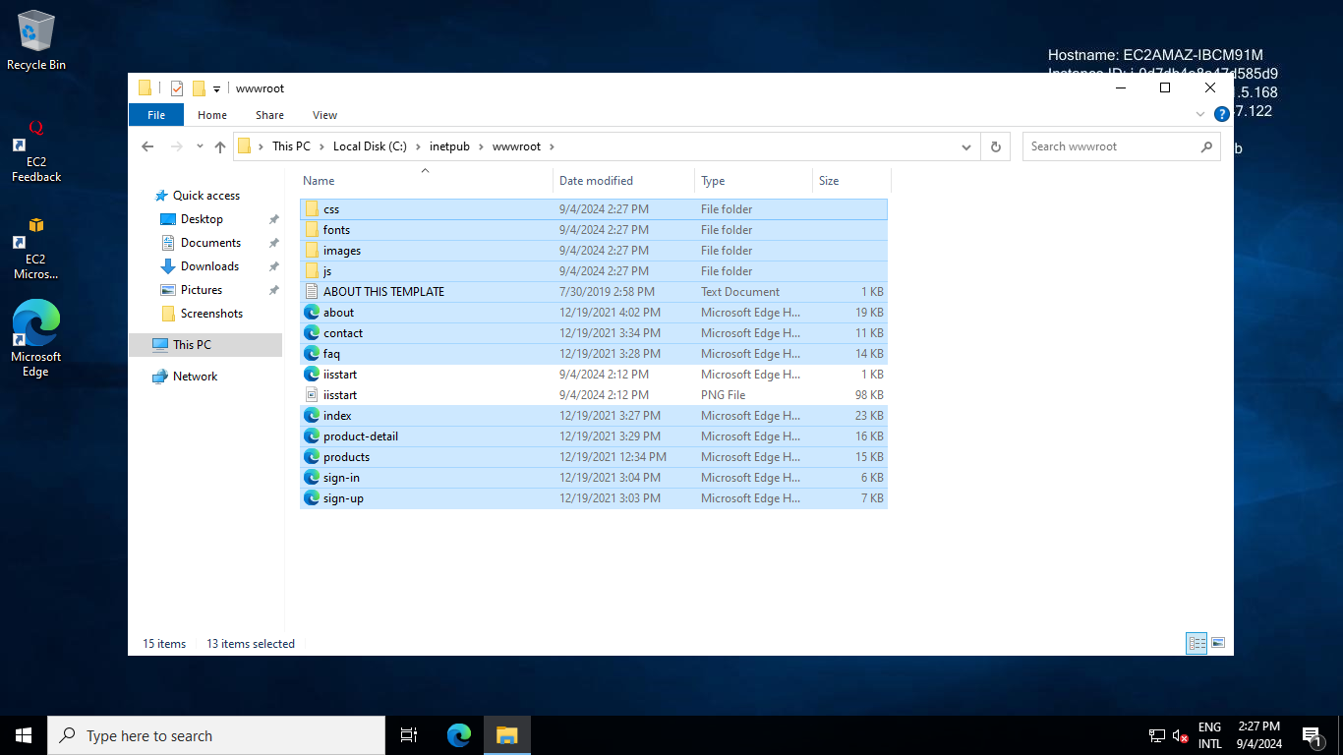  
Now refresh the screen you can able to see the new webpage  
  
now we will get the system information for your remote server:  
  
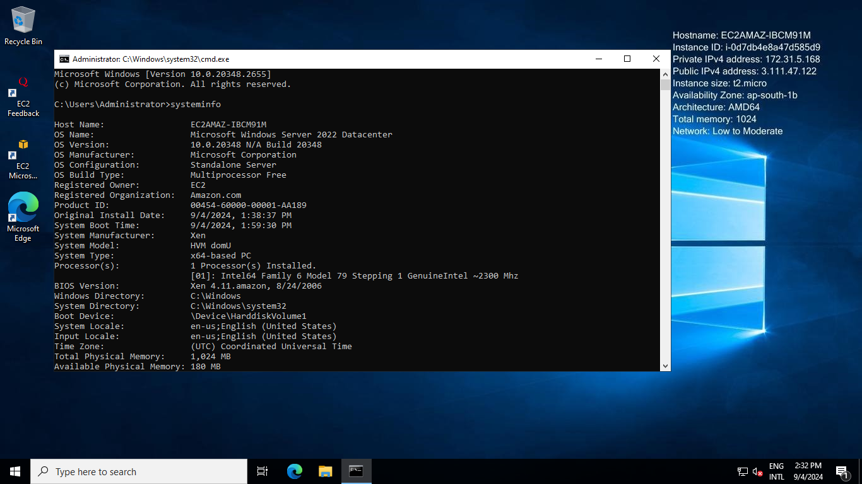  
Attached here as a text format  
