Setup minikube at your local and explore creating namespaces (Go through official documentation)  
install cholatey first and follow these steps.  
  
Refer link : https://minikube.sigs.k8s.io/docs/start/?arch=%2Fwindows%2Fx86-64%2Fstable%2Fchocolatey  
  
Run the docker container first and if you have any problem were installed mini kube just removed the existing minikube installed and try again.  
  
minikube delete –all  
  
Note: if you are using ec2 machine you need run this command to install kubectl  
sudo apt-get install -y kubectl

Then you can start the minikube and dashboard   
  
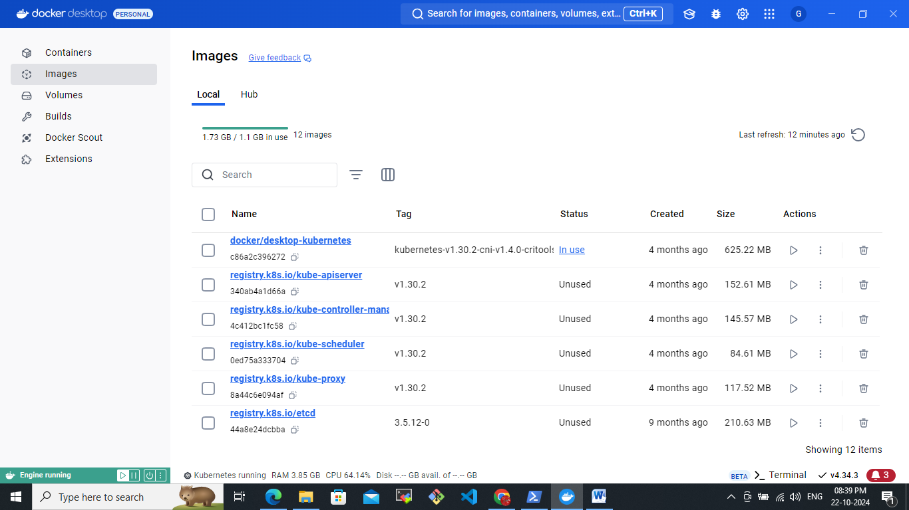

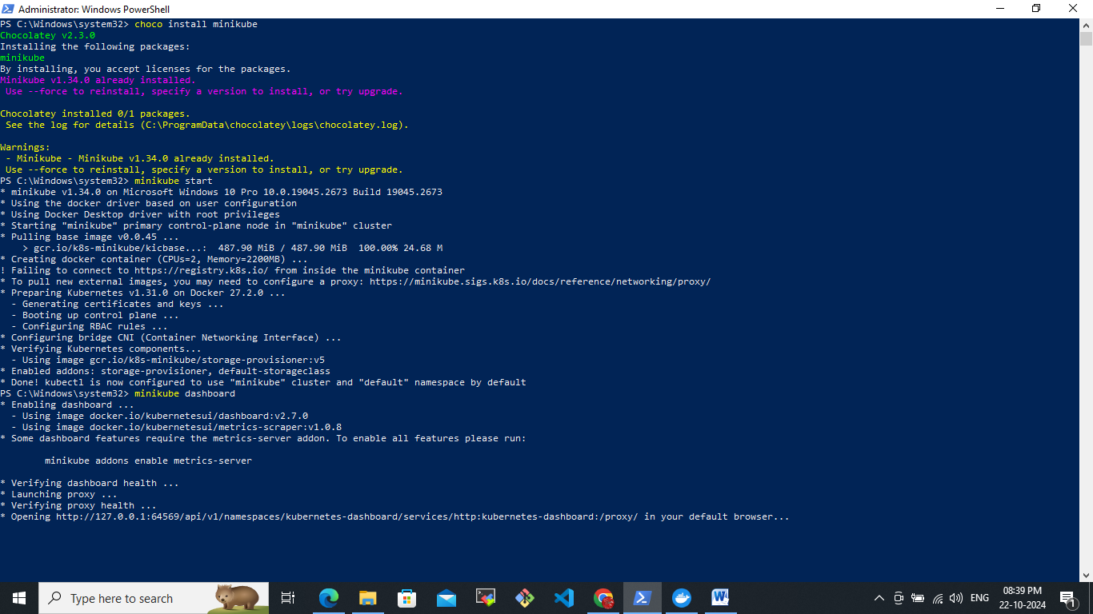

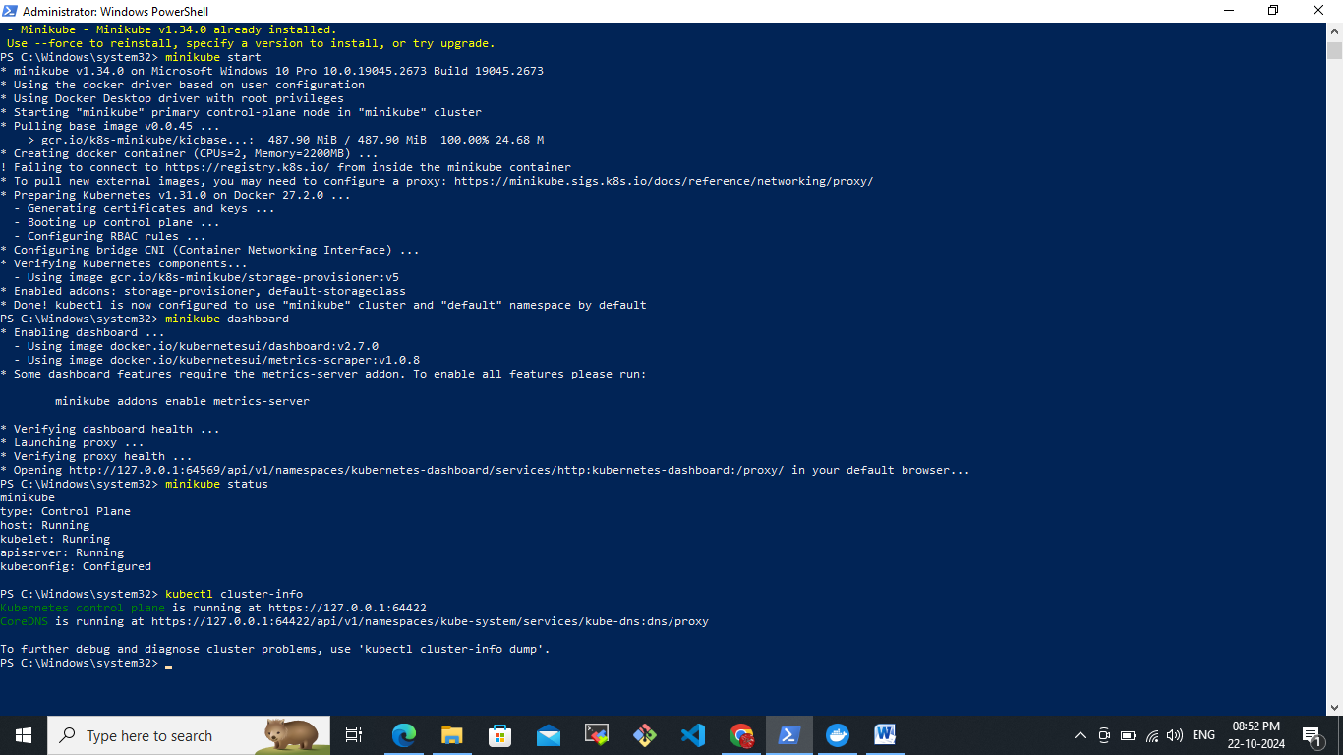

Create a new namespace by using this command  
kubectl create namespace my-namespace  
  
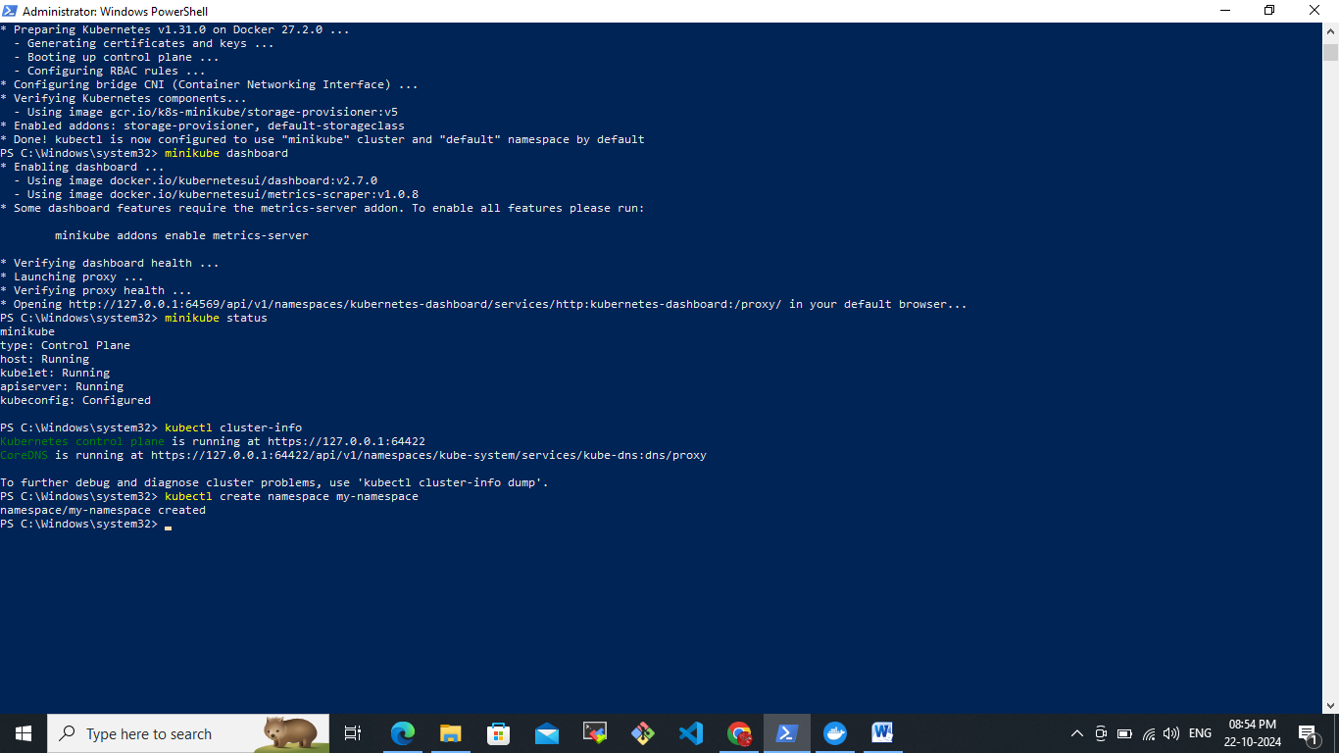  
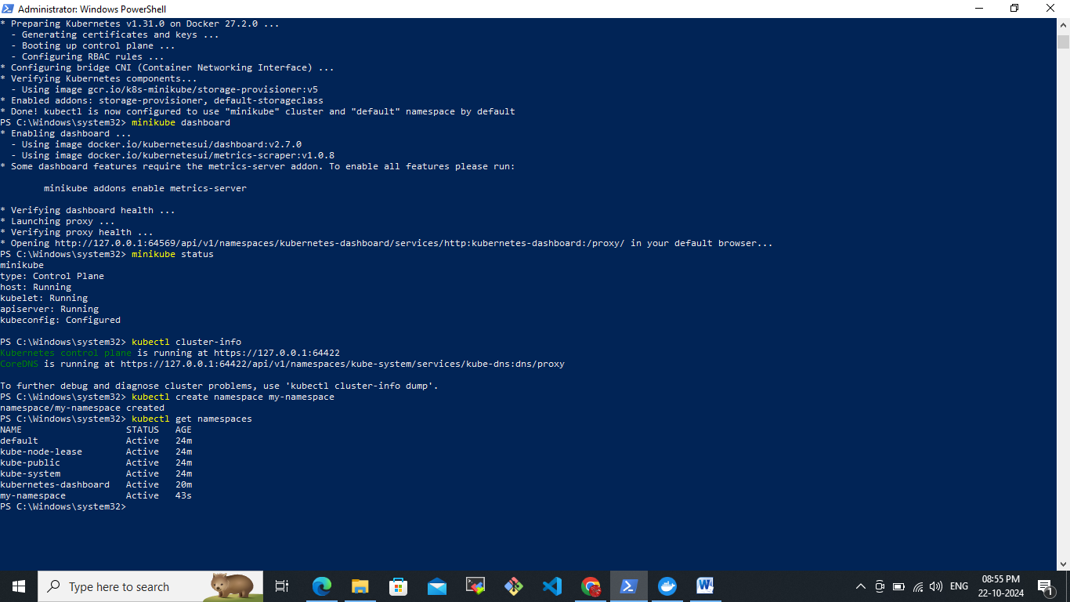  
here my created namespace is my-namespace  
  
**Create a resource (Pod) in a specific namespace**  
  
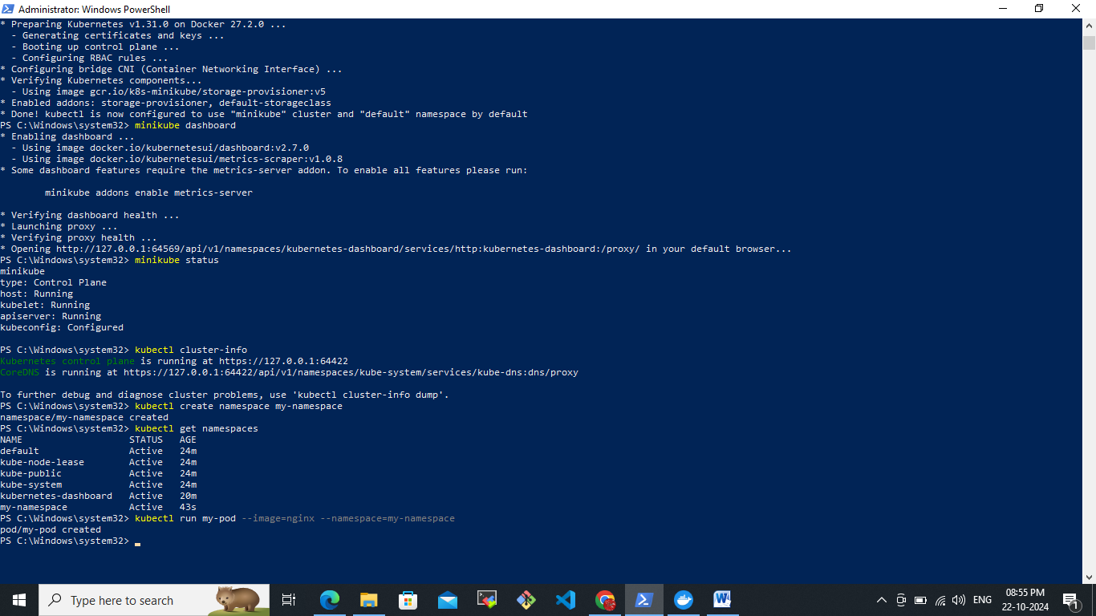  
  
Switch to a Namespace  
  
kubectl config set-context --current --namespace=my-namespace  
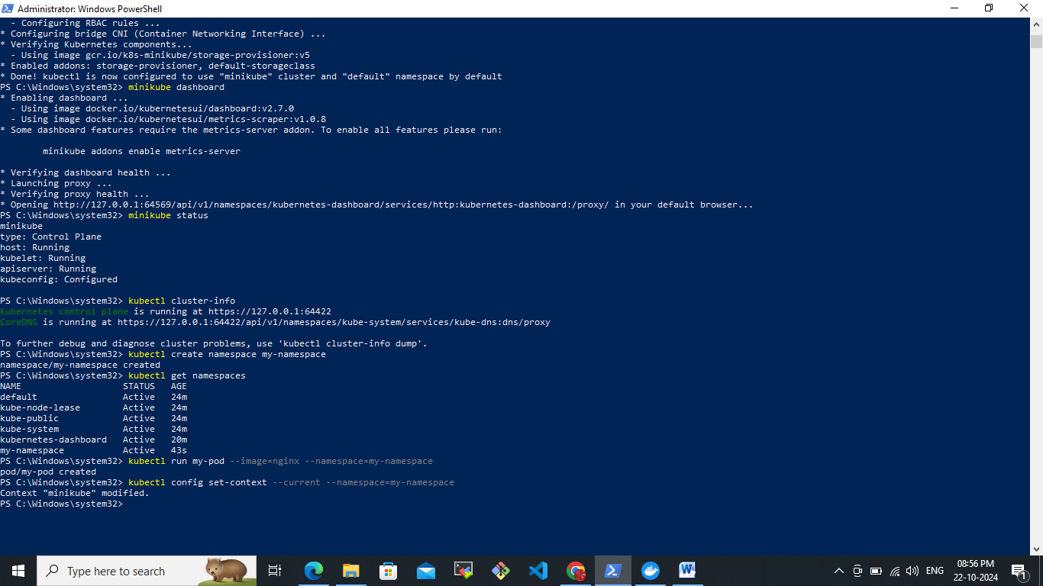

To see the created pod  
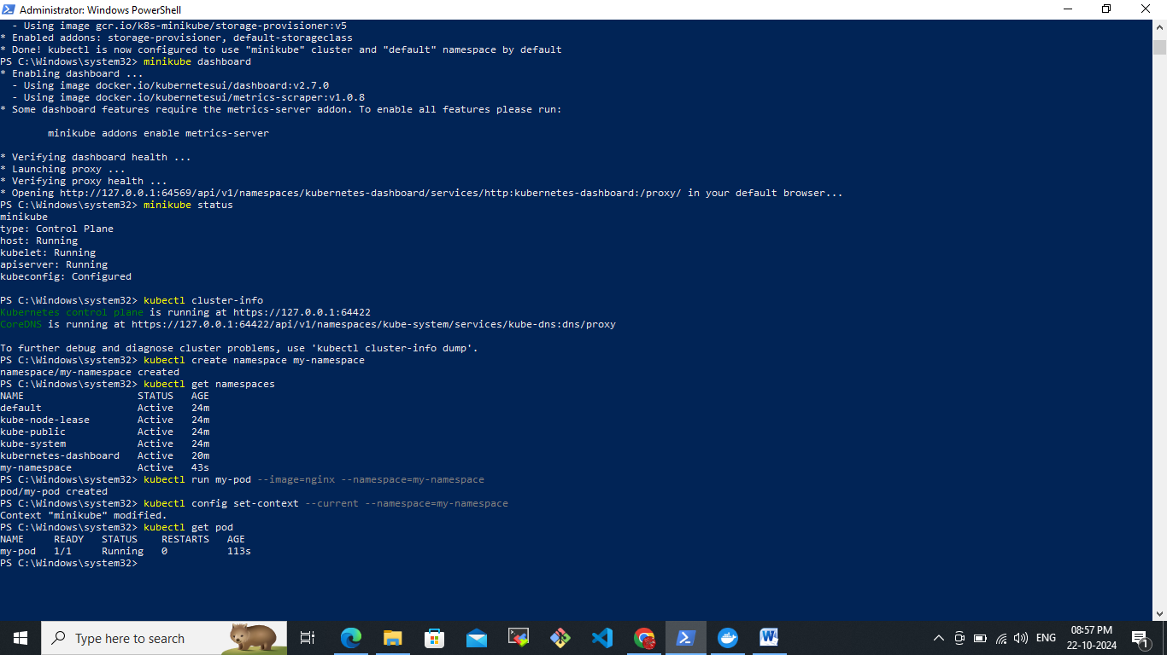  
Delete the created namespace(my-namespace).  
