Physical Consequence, Not Localization, Governs Terrain-Induced Target Re-observability
First Author¹*
¹ Laboratory, Department, Organization, City, State, Country
* Correspondence: First Author, email@example.edu
Keywords: target re-observability, terrain-induced occlusion, physical consequence prediction, partial observability, active perception, legged locomotion, benchmark, failure analysis
Abstract
Terrain-induced target re-observability is the problem a robot faces when a target it has already observed disappears behind terrain and must be made visible again by physical motion. This paper asks what information and what action reasoning that requires, and answers by elimination. We construct paired worlds that share terrain, pose, heading and a pixel-identical current observation yet require opposite re-observation actions, and in eight of eight pairs the successful action sets are disjoint, so no memoryless rule can solve both; a second family additionally shares the target memory and still requires different optimal actions. Over 240 (state, action) pairs, 43.1% of the actions a geometric visibility oracle endorses fail when executed, while the same oracle placed at the pose the robot actually reaches agrees with the physical outcome 97.9% of the time, so the missing quantity is the physical consequence of an action rather than its visibility. Testing that conclusion positively, on 2240 physically executed (state, action) pairs adding the candidate action to observation-plus-memory raises re-observation AUC from 0.854 to 0.934 whereas adding the current observation to the memory buys 0.002, and a planner built on the resulting action-conditioned consequence model raises RSR@10 from 0.250 to 0.792 and RSR@1 from 0.167 to 0.708 without privileged information. Three negative results bound how such a model may be used, and all three concern the prediction-to-decision step: perfectly localized anchor recovery still fails physically; a safety consequence head that is accurate and made better calibrated at the decision boundary yields exactly zero planning gain; and lookahead of two, three and five steps is not significantly better than one step on any budget while costing 1.8 to 2.1 times the motion. All results are in simulation with a vendored third-party locomotion policy; we claim the formulation, the benchmark, the failure analysis and the identification of the missing quantity, not a world model.
Word count: 6238. Figures: 6. Tables: 9.

Introduction
Robots that operate in natural terrain rarely enjoy a clear view of what they care
about. A legged platform descending into a crater, a rover traversing a ridge line, or
a manipulator reaching behind a boulder all face the same structural problem: the
terrain itself determines what can be seen from where, and the robot's own motion is
what changes it. Partial observability in these settings is not sensor noise. It is a
deterministic consequence of geometry, and it is therefore predictable in principle —
but only if the robot reasons about how its next action will change what it can see.
This paper studies a specific and, we argue, under-analysed instance of that problem.
The robot has already observed a target. At some later time the target is no longer
visible — not because it moved or because the sensor failed, but because the robot's
own position and the intervening terrain now block the line of sight. The robot must
choose an action that makes the target visible again. We call this target
re-observability, and it differs from the classical search problem in one decisive
way: the robot has information about where the target is, and that information is
still not enough.
The natural intuition is that moving toward a target makes it more likely to be seen.
Terrain breaks that intuition. Consider a robot walking a straight line toward a target
placed beyond a ridge. Measured along the traverse, the visibility sequence is not a
single step from visible to hidden; it alternates:
stairs_up V X V X waves X V X V X
trench V X V X perlin X V X V X
pit V X V X basin X V X
barrier V X V X perlin_rough X V X V X
where V marks a position from which the target is visible and X one
from which it is blocked. The number of transitions ranges from two to four on a single
traverse. Two consequences follow. First, a policy that assumes monotonicity —
``get closer'' — is not merely imprecise; it is aimed at the wrong objective. Second,
the moment of loss is not the moment of failure: a robot may lose the target and then
re-acquire it purely as a side effect of continuing forward.
Existing lines of work each supply a necessary component but address a different
question. Lost-target search (Radmard and Croft, 2016; Radmard et al., 2018) maintains a
belief over where the target went and selects search actions to reduce it; the
mechanism is a belief and a search policy. Occlusion-aware active perception and
next-best-view (OA-NBV authors, 2026; LEAP-NBV authors, 2026) select viewpoints by predicting visibility or
information gain from a candidate pose, typically using geometry rather than execution.
Object permanence filters (Peng et al., 2024) maintain a belief through periods of
non-observation and act on the filtered estimate. Embodied visual tracking and
target-loss recovery is an established research direction with its own benchmarks and
systems (Wang et al., 2025; EVT-Bench authors, 2025); work in this line already combines action-conditioned
world models with model-predictive control for recovering a lost target
(CST-WM authors, 2026), and recent work explicitly couples visibility with
reachability/feasibility in perception-aware design (authors, 2026).
World-model planning more broadly (Yin et al., 2025; Wu et al., 2023; Robotic World Model authors, 2025)
learns to predict the consequences of actions and plans with them.
None of this is unstudied, and we do not claim otherwise. What the literature lacks is
a unified analysis: these lines are evaluated in their own settings, with their
own observation and action interfaces and their own budgets, so the boundaries between
them are never visible. In particular, no existing benchmark isolates the case in which
the target is known and the failure is purely a matter of which physical action
makes it visible again under terrain-induced occlusion. We place the same set of
decision rules on a single task — terrain fixed, target static, action set identical,
only the decision rule differing — and ask where and why each one breaks.
We do that here, and the answer is uncomfortable for all of them. We construct
paired worlds: two scenes that share terrain, robot pose, heading and — we
verify this by rendering the injected camera on the actual robot model — a
pixel-identical current observation, but in which the target was last seen from opposite
sides. Across eight such pairs, the optimal re-observation action is opposite in the two
worlds, and there is no action that succeeds in both. Since any function of the current
observation is identical in the two worlds, no memoryless policy can solve both.
Knowing where the target is, however, is also not sufficient. A second family of paired
worlds shares the current observation and the reconstructed target memory, and
still requires different optimal actions. A rule that aims at the remembered target
drives straight into the occluder; a heading-preservation rule holds a heading that was
correct when the target was lost but is wrong after any lateral displacement. On 16
paired worlds, every classical decision rule scores 0/16 under a multi-step budget with
a shared observation and action interface, while a privileged counterfactual oracle
scores 13/16.
A third assumption also fails, and it is the one most likely to be silently wrong in
practice. Next-best-view style methods predict the benefit of an action from a
geometric re-projection of the believed target into a hypothetical camera pose.
We implement that baseline with the strongest reasonable map — the exact height field
— and measure over 240 (state, action) pairs that 43.1% of the actions geometry
endorses fail physically. Crucially, the fault is not in the visibility model: placing
the same oracle at the pose the robot actually reaches agrees with the physical outcome
97.9% of the time. What fails is the step before it — predicting where an action
takes the robot. Because the discrepancy is a property of the closed loop rather than of
the sensor, better perception cannot remove it.
Taken together, the three failures identify what a method for this problem must
actually predict: the action-conditioned, physically-executed future observability
P(V_t+H=1 | O_t, M_t, a_t:t+H), where V is measured after the action has
been carried out.
We then test that conclusion positively rather than leaving it as a deduction. On 2240
physically executed (state, action) pairs, adding the candidate action to
observation-plus-memory raises the re-observation AUC from 0.854 to 0.934, while adding
the current observation to the memory buys 0.002. The information is in the
action, not in seeing more. A planner built on the resulting consequence model —
prediction of the executed pose followed by the already-validated visibility oracle —
raises RSR@10 from 0.250 to 0.792 and RSR@1 from 0.167 to 0.708 with no privileged
information, and is the only method we evaluate that chooses different actions in the
two members of every paired world.
We also report where it still fails, and two negative results that constrain how any
such model may be used. Its remaining errors are no longer action-selection errors but
physical-termination errors (leaving the terrain, losing stability). And both an
attempt to add safety to the decision rule and an attempt to plan over longer horizons
fail in the same characteristic way: the prediction carries information, and the
decision rule does not convert it.
This paper contributes:
A formulation of terrain-induced target re-observability as an
action-selection problem, with the non-monotonicity of V along a traverse as its
defining property, and an evaluation metric (RSR@K) whose implementation is audited
against its own definition rather than assumed to match it (Section 2).
A procedurally generated benchmark of eight terrain-induced occlusion
mechanisms, organised by physical mechanism and real-world analogue rather than as a
difficulty ladder, built as exact box geometry so that the analytic visibility oracle
and the MuJoCo collision surface are the same object; together with (i) paired worlds
that differ in history and are provably identical in the current observation, (ii) a
second set additionally identical in target memory, and (iii) a mechanism-support audit
that proves which mechanisms can express such an ambiguity and which structurally
cannot.
A frozen observation/action interface under which every decision rule is
evaluated on the same terrain, with the same budget, the same termination set and a
policy-agnostic terrain contract, with all comparisons reported as paired bootstrap
intervals rather than point estimates.
A failure analysis that separates the three assumptions, quantifies each,
shows they are separable rather than three names for one failure, and identifies a
failure class that the first version of our own taxonomy got wrong.
A measured answer to what the missing quantity is, and two negative
results — in safety integration and in lookahead depth — showing that prediction
quality is not the same thing as decision usefulness.
We are explicit about scope. All results are in simulation with a vendored third-party
locomotion policy, on one controller; the oracle is an upper bound and not a deployable
method; the learned consequence model is evaluated with terrain held out, which is
generalisation within a mechanism family and not across mechanisms; and our target
memory is a structured location memory rather than an open-vocabulary semantic one.

Materials and Methods

Problem formulation
Let O_t be the observation available at time t (pose, proprioception, a short action
history and, where available, the camera), M_t the target memory — where and when the
target was last seen — and a_t:t+H a sequence of physical actions. Write
V_t+h in 0,1 for target visibility after executing that sequence. The task is
equation
a^*_t:t+H \;=\; _a_t:t+H \; P\!(V_t+H=1 O_t, M_t, a_t:t+H).

equation
The target is lost when V_t=0 after having been observed, and
re-observed when there exists h <= H : V_t+h=1. Safety is deliberately
not part of this definition: the experiments below show that physical safety is
a dimension of the consequence model rather than part of the task statement, and mixing
it into Eq. 1 would confound the two.

The evaluation metric
The benchmark reports a difficulty curve rather than a single success flag, because the
quantity of interest is how many physical actions are needed to regain sight of the
target. For episode i and budget K,
equation
r_i(K) = 1\![\, h K : V_i,t+h = 1],

RSR@K = 1N_i=1^N r_i(K).

equation
Four policies may all eventually succeed while facing very different problems: one
action, or three, or more than the budget allows. Note what the definition deliberately
does not require: visibility to be held. Visibility under these mechanisms is
non-monotonic, and the task is to regain sight within a budget, not to keep it.
The implementation is audited against this definition rather than assumed to match it.
rsr_at evaluates Eq. 2 directly on the recorded per-step visibility
trace, while an episode also terminates at its first re-observation, so
success and steps_used <= K gives a second reading. A contract test asserts
the two agree for three terrains at every K = 1 6; if the termination semantics
ever change, the test fails instead of silently redefining the headline number.
Two companion metrics are reported alongside, and no single scalar combines them. The
re-observation time T_reobs is the elapsed time from loss to the
first re-observation, which separates ``wandered and then found'' from ``found
immediately''. The action cost C_action is cumulative base-path length; it
is averaged over every episode rather than only the successful ones, so that
exhausting the budget does not look cheap, with the success-only figure reported
alongside.

Benchmark: eight terrain-induced occlusion mechanisms
The suite is not ``eight kinds of terrain'' and it is not a set of obstacles built to
break a baseline. Each entry is a terrain-induced target occlusion scenario: a situation
in which a robot that has already seen a target loses sight of it and must regain sight
by moving. Table 1 lists them, organised by physical mechanism
rather than by surface name.
The mechanisms span five roughly orthogonal axes: occlusion direction, elevation
dependence, spatial scale, visibility transition frequency, and terrain spatial
complexity. Two points of framing are enforced mechanically rather than left to
intent. First, the taxonomy is checked for the wording ``challenging / hard / difficult
/ adversarial terrain'' and refuses to render if it appears, because the difficulty is
in the target's visibility, not in the driving. Second, perlin and
perlin_rough are not claimed to be real surfaces: Perlin/fBm noise is
used as a procedural representation of spatially correlated natural elevation variation,
and the table gives the situation it stands in for.
All terrain is built as explicit box slabs rather than as a height field, so that the
analytic visibility oracle and the MuJoCo collision surface are the same object. This
matters: a height-field collider measurably stalls the locomotion policy, which would
make the oracle and the physics disagree for reasons unrelated to the question.

Mechanism support validation
Observation-equivalent pairs with opposite optimal actions require the mechanism to be
able to produce a one-sided winning set — every action that reveals the target
moves the robot the same way laterally. We therefore test, per mechanism, the property
that the construction requires, and report which mechanisms structurally cannot carry
it. Table 2 gives the result; a high one-sided rate is necessary but not
sufficient, and only window_wall has been searched end to end.

Frozen interface and baselines
Comparing decision rules across published work is normally confounded by each being
evaluated with its own observation, its own action set and its own budget. We remove
that confound by fixing one interface and expressing every baseline through it:
Environment (owns physics and camera, policy-agnostic) ->
Observation -> ReObservationPolicy.act(observation)
-> Environment.rollout(action) for privileged scoring only.
Three properties make the comparison meaningful. No privileged information appears in
Observation: ground-truth visibility and the target's world position live in a
separate PrivilegedState that only the evaluator and the oracle may read, and a
contract test asserts this rather than trusting convention. The terrain is
policy-agnostic: terrain modules must not import the API or any policy, enforced both by
an AST scan of the terrain modules' imports and by a subprocess that imports each
terrain module alone and fails if the policy stack comes with it. And counterfactuals do
not perturb the episode: rollout saves and restores the integration state and
resets the controller; without this the oracle's own probing would move the robot it is
deciding for, a defect the contract test caught in the first implementation.
Every baseline implements the core decision mechanism of a line of work, not a
full reproduction. Reactive always drives forward. HeadingLock holds
the heading recorded at the loss moment from IMU only. HistoryOnly aims the
heading at the remembered target and drives. LostTargetSearch faces the belief
and then closes on it. ObjectPermanence runs a constant-velocity belief filter
and acts on the filtered estimate — kept as a filter rather than defined as equivalent
to HistoryOnly, because on a static target the extrapolation term vanishes and
the collapse is then a measured result rather than a stipulated one. NBV
re-projects the believed target from a kinematic hypothetical pose and is deliberately
given the exact height field, since an active-perception method is allowed a map and a
failure should not be attributable to a weak one. Oracle physically rolls out
every candidate and takes the fastest success; it is a privileged upper bound, never
presented as a deployable method.
Fairness invariants, asserted by contract tests: every primitive costs the same
simulated time, so one step is one unit of budget; the budget is actually granted,
verified by forcing the visibility read to report ``hidden'' and checking that a failing
episode consumes all N steps; one N, one termination set and one observation stream
length for every policy; an action identifier outside the frozen set is an error and
never a silent fallback; and RSR@N is monotone in N.
Statistics. Every proportion carries a Wilson score interval, not a normal
approximation, because several results sit at or near 0 % or 100 % where the
normal interval produces out-of-range bounds. Every comparison is paired: all policies
run on the same terrains, so a difference in RSR is tested by resampling
terrains with replacement and examining the distribution of the paired
difference. Two degenerate cases are labelled rather than dressed up as statistics.
Where two policies make outcome-identical choices on every terrain there is no variance
to bootstrap and no p-value is reported, because reporting p=1 would present
``identical'' as ``not significant''. Where a difference distribution contains no
non-positive resamples the p-value is bounded as <5x10^-5 rather than printed
as an exact zero.

Action-conditioned consequence model
The failures above identify the quantity to predict as Eq. 1. Rather
than learning visibility end to end, we exploit the third result: since the visibility
oracle is accurate at whatever pose the robot reaches, the model predicts the
executed body-frame pose delta and the already-validated oracle is applied to the
predicted pose. This keeps the validated part validated and localises the remaining
error.
Training data is 24 terrains x 10 states x 10 actions = 2240 physically
executed (state, action) pairs, positive rate 0.143. Features are the pose, the
projected gravity vector, a short pose history, the target memory in body coordinates
with an explicit presence flag, and the action. The memory block is body-relative and
its age is carried, both of which must be maintained during any chained rollout. The
targets are the executed pose delta and whether the target was re-observed. Splits are
by terrain and never random, so a terrain family cannot appear on both sides.
The planner scores every candidate action with the model, takes the argmax, and
replans after each executed step.

Results

H1: the current observation does not determine the action
We construct paired worlds that share terrain, robot pose, heading and a
pixel-identical current observation, but in which the target was last seen from opposite
sides. Across eight pairs: the rendered camera images are identical (mean and maximum
absolute pixel difference both zero), the optimal re-observation action is opposite in
the two worlds in 8/8, and the successful action sets are disjoint in 8/8.
Because any function of the current observation takes the same value in both worlds, no
memoryless policy can solve both. On 16 paired-history worlds the five classical rules
score 0/16 within a ten-step budget.
This is not a statement that a particular baseline is weak. It is a statement that the
task is structurally partially observable.

H2: a correct target memory is also not sufficient
A natural reply to H1 is to remember where the target is. We therefore construct a
second family of pairs sharing the current observation and the reconstructed
target memory, differing only in terrain hidden inside the shadow of a visible occluder
— terrain that is invisible from the decision point and was never traversed.
Over six such pairs, the rendered observations are pixel-identical in 6/6, the target
memory is identical in 6/6, and the optimal action differs in 4/6. Two properties must
be reported precisely, because they bound the claim. First, the successful action sets
overlap (0/6 disjoint), so H2 does not show that no fixed rule can
succeed: what it shows is that a correct memory does not determine the optimal action.
Second, on these pairs all six classical policies choose the same action (toward)
and fail in both worlds, so H2 separates the baselines not at all — it is an
information-level result, and presenting it as ``existing methods fail here'' would be
wrong.
Transferring the failure to the main suite is nevertheless unambiguous: on the 16
paired-history worlds, every classical rule scores 0/16, and a heading-preservation rule
that holds the correct inertial heading fares exactly as well as a purely reactive one
— paired difference 0.000 with interval [0,0], i.e.\ outcome-identical on every
terrain.

H3: geometric visibility is not physical re-observability
For every candidate action at every decision state we compute two quantities. G(s,a)
asks whether the target would be visible if the robot reached the ideal pose the action
nominally produces, using a kinematic displacement and the line-of-sight oracle —
what an active-perception method assumes it can evaluate. P(s,a) asks whether the
target is actually re-observed when the primitive is executed.
Over 24 terrains x 10 actions = 240 pairs, the confusion matrix is
G=0,P=0=171, G=0,P=1=11, G=1,P=0=25,
G=1,P=1=33. 43.1% of the actions geometry endorses fail
physically. The disagreement is not one-sided — geometry also under-predicts in 4.6%
of cases.
The mechanism is identified by the same experiment. Placing the same oracle at
the pose the robot actually reaches makes it agree with the physical outcome in
97.9% of pairs. The pose prediction error is larger on the failing cell than
on the agreeing cells by a paired bootstrap difference of +0.28 m with 95% interval
[+0.11, +0.45] and p = 0.0005; decomposed, the error is 0.52 m forward, 0.34 m
lateral, 0.40 m in height and 5.5 degrees of yaw.
The comparison of the point estimate is large, but the practical reading is what
matters: no active-perception method is mis-implemented here. Candidate viewpoints scored
by kinematic re-projection are simply a different quantity from where the robot ends up.

E4-1: the action carries the information that the observation does not
We ablate the input to the re-observation predictor with terrain held out
(Table 3).
Adding the candidate action raises AUC by +0.080. Adding the current
observation to the memory raises it by 0.002. The information is in the action,
not in seeing more.
On the 16 paired-world decision states the O+M+a model reaches 0.8125 accuracy and
switches its chosen action in 8 of 8 pairs — the thing a memoryless rule
provably cannot do.

E4-2: a learned consequence model beats the analytic one, but not everywhere
The correct statement is that the learned model wins on the components that decide
success, not that learning is better in all dimensions.

E4-3: consequence prediction converts into task performance
RSR@10 rises from 0.250 to 0.792 and RSR@1 from 0.167 to 0.708, with no privileged
information. The paired comparison against HistoryOnly is +0.708 with a 95%
interval of [+0.542, +0.875].
By contrast, no classical baseline significantly outperforms any other. Relative to
HistoryOnly, Reactive, HeadingLock, LostTargetSearch
and ObjectPermanence each differ by 0.000 with interval [0,0] — they
succeed and fail on exactly the same terrain set. NBV differs by +0.042 with
interval [0.00, 0.125] and p=0.356, so it cannot be claimed to be better. Only the
privileged references separate.

E4-4: short history helps motion, not visibility
Visibility AUC is flat across every horizon, while pose error improves from 0.177 to
0.147 and saturates at four recent observations. History helps predict where the robot
will end up, not whether the target will be visible — which is consistent with the
localisation of the missing quantity in H3.

E4-5 and E4c: the safety paradox
Adding safety as a consequence head raises Oracle-S to 0.4107 against Oracle-V at
0.3884, so the safety term is worth having. The learned head is accurate, with ROC-AUC
0.900 and PR-AUC 0.606 on a positive rate of 0.083. Yet the planner gets worse at every
penalty weight: 0.3661 without safety, 0.3125 with a hard veto, and 0.3438–0.3571
across soft penalties.
E4c separates the prediction from the rule. The head's overall calibration is healthy
(ECE 0.042) while its calibration in the band |p-0.5| <= 0.15 — the only region
where a threshold changes anything — is 0.197, a factor of 4.7. Temperature scaling
halves the decision-band ECE to 0.099. The planning improvement is zero. Across
raw, temperature-scaled and isotonic variants, no operating point at any threshold or
coverage beats not using safety at all, and every variant's optimum falls at coverage
0.
This is the more informative branch of the diagnostic: it rules out ``calibrate it
better'' as the next step and locates the limit in the joint visibility–safety decision
boundary rather than in the accuracy of the probability.

E4d: the horizon paradox
Against H=1, the paired success differences are -0.208 with interval
[-0.458, +0.042], 0.000 with [-0.208, +0.208], and -0.125 with
[-0.333, +0.083]. No horizon is significantly better on any budget, and every
horizon costs 1.78–2.09 times the motion.
The per-terrain breakdown is what makes this informative rather than merely negative.
The privileged reference genuinely requires multiple steps on six terrains. Lookahead
does rescue two of them reliably — stairs_up and pit, solved by
H >= 2 and not by H=1 — which confirms that re-observation is intrinsically
sequential. But it breaks eight terrains that one step solves.
Model-error accumulation is not the explanation. The measured one-step pose error is
lowest at H=2 (0.301 m) and yet H=2 performs worst. The mechanism is instead that
the chained score _k p_k is monotonically optimistic in H: a longer horizon
offers more opportunities to find a sequence that the model confidently believes
will glimpse the target, and those are exactly the confidently wrong predictions. The
one-step pose error (0.30–0.76 m) is of the same order as an action's displacement
(0.5–1.8 m), so by the second or third chained step the predicted state is nearly
uninformative.

E4e: a joint decision over one event does not rescue it either
E4c and E4d failed in the same shape, which suggests the fault is not in either head
but in how they are combined. Both were serial compositions of quantities
predicted independently: a visibility ranking with a safety term that vetoes it, and a
per-step visibility score with a maximum taken over chained steps. A veto is the wrong
shape — the planner does not want to know whether an action is unsafe, it wants to
know whether the action achieves the goal, where the goal is re-observed and
still on its feet. That is a single event.
We therefore predict that single event directly. A joint head is trained on
P(V and safe | O,M,a) — the conjunction, not a product of two
marginals, since multiplying marginals would reintroduce the independence assumption
under test. Alongside it we test a conformal filter whose threshold is the out-of-fold
quantile of the safe class's unsafe-score, which by construction bounds how often
a genuinely safe action is discarded; this is the targeted fix for the measured failure
that a fixed threshold on the safety score removes good and bad actions at similar
rates.
Neither works. Against a baseline of 0.3661 one-step success, the joint head reaches
0.3527 (a gain of -0.013, intervening at 18.3% of states), and the best conformal
filter reaches 0.3616 (-0.005). Combining them is worse still (0.3348–0.3571). The
positive rates are 0.143 for visibility, 0.119 for visibility-and-safe and 0.083 for
unsafe, so the conjunction is rarer than either component — and the privileged
Oracle-S, which has ground truth, still improves on Oracle-V (0.4107 against 0.3884).
Three successive principled fixes — hard and soft penalties, temperature and isotonic
calibration, a joint head, and a conformal filter with a distributional guarantee —
all fail to convert the safety information into planning improvement, while the same
information with ground-truth labels improves it. We report this as the paper's open
problem rather than as a solution: the gap is not in the accuracy of the predicted
quantities, and it is not closed by predicting the right quantity instead.

E-Odom: the task is not localisation recovery
The most damaging reading of this benchmark is that it reduces to state recovery: save
the pose at which the target was last seen and use odometry to return to it. We
implement three such baselines — steering back to the last-visible pose, dead-reckoned
backtracking along the recorded walk-in, and returning to that pose before advancing
again along the original sight ray — and evaluate them under three odometry
conditions: perfect, moderate drift (2% range, 1^ per step heading) and
realistic drift (5% range, 3^ per step).
Two results settle the objection. First, perfect odometry does not solve the
task: the best anchor-recovery baseline reaches RSR@10 = 0.250, the same as the
classical rules and far below the consequence planner's 0.792. Second, and more
pointedly, six of its 24 failures under perfect localisation are physical
terminations — the robot falls or leaves the terrain while returning to a pose it
knows exactly. A perfect localization memory cannot guarantee physical re-observability.
The drift conditions then make the point sharper rather than weaker. Perfect and
moderate drift produce identical results, and realistic drift changes RSR@10 by
0.000, raising cost by 0.13 m and moving one failure from B to F. The failure is
therefore not an odometry-accuracy problem: it is the physical-consequence gap of H3,
reached from a completely independent direction.

Failure taxonomy
Classical policies predominantly fail because they select ineffective actions, whereas
the learned consequence planner substantially reduces action-selection failures and
instead exposes physical-termination failures. The failure type changes with the
capability of the planner, which is itself evidence that the modelled quantity is the
right one and that the remaining gap is coverage of the consequence model rather than
candidate diversity.
Two limitations of the taxonomy are stated rather than smoothed over. The classes C
and D have one example each, which is enough to establish that the class occurs and
not enough to report a rate. And the classification of F was a correction: our first
version recorded falls and boundary exits as action-selection failures, which is an
attribution error, since the action was chosen on a defensible prediction and the
prediction of stability was what failed.

Discussion

Why the classical baselines are indistinguishable
Not because they are poor algorithms. On 24 terrains, five of the six produce
outcome-identical success patterns, differing by 0.000 with interval [0,0]. They are
not merely similar; they make the same decision.
The reason is structural. All five mechanisms operate on the same quantity —
``which way should I face or move'' — that is, O_t, M_t -> a heading or a
direction. None of them explicitly models the map
O_t, M_t, a -> S_future. Since what is missing is the same thing in
all of them, no amount of care in writing the heading rule changes the decision. This
also explains why NBV is the only baseline that differs at all on the main
suite: it is the only one that happens to use an action-consequence proxy, and as H3
shows, that proxy is not good enough.

Why next-best-view does not significantly beat history-only
Because geometric visibility and physical consequence differ systematically, and NBV
only has access to the former. 43.1% of the actions geometry endorses fail physically.
The paired difference against HistoryOnly is +0.042 with an interval of
[0.00, 0.125] and p = 0.356 — not significant. On the paired-history worlds NBV
scores 0/16, exactly like the other classical rules.
This is not an implementation issue. Placing the oracle at the executed pose recovers
97.9% agreement with physics. What fails is the prediction of where the action takes
the robot.

The safety and horizon paradoxes are the same paradox
Both negative results have the same shape. A prediction carries real information —
Oracle-S beats Oracle-V, and the horizon ablation shows that some terrains genuinely
require multiple steps — and the decision rule fails to convert it. In the safety case
this survives a targeted fix: halving the decision-band calibration error changes
planning performance by exactly nothing. In the horizon case it survives increasing the
depth: the chained score is optimistic in H, so more lookahead offers more ways to be
wrong.
The common lesson is that prediction quality and decision usefulness are different
properties. A head can rank well and still be unusable as a decision term; a model can
be accurate one step ahead and still be unusable for multi-step ranking. Neither is
fixed by more data, better calibration, or a longer horizon; both point at how
consequences are combined into a decision.

Limitations
All results are from simulation, with a vendored third-party locomotion policy, on a
single controller; no sim-to-real claim is made and the pose-consequence numbers should
not be transferred across controllers. The oracle is a privileged upper bound and the
search reference is incomplete: an earlier version of this work judged four terrains
unsolvable, and beam search subsequently solved all four with two- to three-step
sequences. That error — mistaking a planner's defect for a property of the benchmark
— nearly put a spurious ceiling into the results, and the corrected solvability is
24/24 with an upper bound of 1.00 rather than 0.88.
The learned consequence model is evaluated with terrain held out, which is
generalisation within a mechanism family; cross-mechanism generalisation is not
established here and an earlier single-step predictor scored below a naive baseline out
of distribution. The target memory is a structured location representation reconstructed
without noise, so belief-estimation failure is excluded by construction and claims about
memory hold only for this representation. The action set is ten fixed primitives, and
whether discretisation affects the H1 and H2 conclusions has not been tested. A binary
fall label proved unusable — zero falls in 720 single-action rollouts — so safety is
represented by boundary exit and a continuous stability margin instead, which means the
learned safety head does not cover the event it is named after. Finally, the paired-world
construction is available only in mechanisms that can express a directional aperture;
Table 2 shows five mechanisms where this is structurally impossible, and
the correct statement is that the construction is evaluated on the mechanisms that can
carry it.

Conclusion
We asked what information and what action reasoning a robot needs in order to regain
sight of a target that terrain has occluded. The answer arrived by elimination.
The current observation is not sufficient: there exist worlds with pixel-identical
observations whose optimal re-observation actions are opposite, and whose successful
action sets are disjoint. A correct target memory is not sufficient either: there exist
worlds identical in observation and in memory that still require different
actions. Geometric visibility is not sufficient: 43.1% of the actions it endorses fail
physically, while the same oracle at the executed pose agrees with physics 97.9% of the
time.
What is missing is the action-conditioned physical consequence. Adding the candidate
action to observation-plus-memory raises predictive AUC by 0.080, while adding the
observation to the memory raises it by 0.002; a planner built on the resulting model
raises RSR@10 from 0.250 to 0.792 with no privileged information.
Two negative results bound how such a model may be used, and both are about the
prediction-to-decision step rather than about prediction quality. A safety head that is
accurate (AUC 0.900) and whose decision-band calibration can be halved by temperature
scaling produces exactly zero planning gain, with no operating point beating simply not
using it. A receding-horizon planner over the same model finds that deeper lookahead is
not significantly better on any budget, costs nearly twice the motion, rescues two
genuinely sequential terrains and breaks eight that one step solves.
The compact statement of the paper is therefore
O_t + M_t does not imply a^*, and the reason is the step in between:
a -> S_future -> V_future must be modelled
explicitly, must be action-conditioned, and must then be turned into a decision rather
than a threshold.

Author Contributions
TO BE COMPLETED BY THE AUTHORS.

Funding
TO BE COMPLETED BY THE AUTHORS.

Data Availability Statement
The benchmark, baselines, consequence dataset and all result artefacts are generated by the code in the accompanying repository. Every figure and table in this manuscript is produced by a script from recorded JSON artefacts, so the numbers cannot drift from the figures.

Abbreviations
Non-standard abbreviations used in this manuscript, defined here as permitted immediately before the acknowledgments: AUC, area under the receiver operating characteristic curve; CI, confidence interval; ECE, expected calibration error; MAE, mean absolute error; MPC, model predictive control; NBV, next-best-view; OR, odds ratio; PR-AUC, area under the precision-recall curve; RSR, re-observation success rate.

Acknowledgments
TO BE COMPLETED BY THE AUTHORS. If generative artificial intelligence was used in preparing this manuscript, its name, version, model and source must be declared here and in the Methods.

Conflict of Interest
The authors declare that the research was conducted in the absence of any commercial or financial relationships that could be construed as a potential conflict of interest.

References
Ammirato, P. and others (2018). Active Vision Dataset Benchmark. CVPR Workshops. Available at: https://openaccess.thecvf.com/content_cvpr_2018_workshops/w40/html/Ammirato_Active_Vision_Dataset_CVPR_2018_paper.html (accessed 2026).
authors (2024). Predicting Consequences and Reinforcing Navigation Policies with Latent World Models. European Conference on Computer Vision (ECCV). Available at: https://eccv2024.ecva.net/virtual/2026/poster/4904 (accessed 2026).
authors (2026). Visible-Reachable Workspace for Perception-Aware Humanoid Design. arXiv preprint. Available at: https://arxiv.org/abs/2609.08905 (accessed 2026).
CST-WM authors (2026). CST-WM. arXiv preprint. Available at: https://arxiv.org/abs/2609.06302 (accessed 2026).
EVT-Bench authors (2025). EVT-Bench. arXiv preprint. Available at: https://arxiv.org/abs/2506.01600 (accessed 2026).
LEAP-NBV authors (2026). LEAP-NBV. arXiv preprint. Available at: https://arxiv.org/pdf/2609.23974 (accessed 2026).
OA-NBV authors (2026). OA-NBV. arXiv preprint. Available at: https://arxiv.org/abs/2603.11072 (accessed 2026).
Peng, Y. and Wang, Y. and others (2024). Object Permanence Filter for Robust Tracking with Interactive Robots. IEEE International Conference on Robotics and Automation (ICRA). Available at: https://ieeexplore.ieee.org/abstract/document/10611528/ (accessed 2026).
Radmard, S. and Croft, E. A. (2016). Active target search for high dimensional robotic systems. Autonomous Robots. Available at: https://dl.acm.org/doi/10.1007/s10514-015-9539-8 (accessed 2026).
Radmard, S. and Meger, D. and Law, E. and Croft, E. A. (2018). Resolving Occlusion in Active Visual Target Search of High-Dimensional Robotic Systems. IEEE Transactions on Robotics. Available at: https://dl.acm.org/doi/10.1109/TRO.2018.2796577 (accessed 2026).
Robotic World Model authors (2025). Robotic World Model: A Neural Network Simulator for Robust Policy Optimization in Robotics. arXiv preprint. Available at: https://arxiv.org/pdf/2501.10100 (accessed 2026).
Wang, S. and others (2025). TrackVLA. Proceedings of Machine Learning Research. Available at: https://proceedings.mlr.press/v305/wang25f.html (accessed 2026).
Wu, W. and others (2023). Dreamwalker: Mental Planning for Continuous Vision-Language Navigation. arXiv preprint. Available at: https://arxiv.org/abs/2308.07498 (accessed 2026).
Yin, Y. and others (2025). WoMAP. Conference on Robot Learning (CoRL). Available at: https://mlanthology.org/corl/2025/yin2025corl-womap/ (accessed 2026).
Table 1. Terrain-induced occlusion mechanisms. A mechanism is a point on an axis, not a
member of a category: pit and basin are both spatial scale, at
opposite ends of it.
Mechanism | Axis | Real-world analogue | Visibility effect
barrier | occlusion direction | walls, boulders, shelving | lateral occlusion
trench | elevation | ditches, trenches, ravines | edge occlusion
stairs_up | elevation | staircases, platforms | height-dependent
pit | spatial scale | potholes, craters | local depression
basin | spatial scale | valleys, broad depressions | large-scale occlusion
waves | visibility dynamics | dunes, rolling ground | repeated flips
perlin | terrain complexity | natural off-road ground | distributed occlusion
perlin_rough | terrain complexity | rubble, rock fields | irregular occlusion

Table 2. Mechanism support. A y-symmetric height field cannot express a directional
aperture, so no amount of pair search will find a one-sided world in it.
Mechanism | |h(x,y)-h(x,-y)| | One-sided rate | Can carry the pair
stairs_up | 0.0000 m | 0.00 | no (structurally)
trench | 0.0000 m | 0.00 | no (structurally)
pit | 0.0000 m | 0.00 | no (structurally)
waves | 0.0000 m | 0.00 | no (structurally)
basin | 0.0000 m | 0.00 | no (structurally)
barrier | 0.0000 m | 0.095 | yes
perlin | 0.2000 m | 0.00 | asymmetric, insufficient
perlin_rough | 0.3000 m | 0.00 | asymmetric, insufficient

Table 3. Information ablation, leave-one-terrain-out, 2240 samples. The informative
comparison is O+M against O+M+a.
Inputs | ROC-AUC | PR-AUC | Brier | ECE | Pose MAE
O | 0.759 | 0.360 | 0.117 | 0.076 | 0.436
M | 0.852 | 0.639 | 0.077 | 0.039 | 0.461
O+M | 0.854 | 0.600 | 0.084 | 0.056 | 0.425
O+M+a | 0.934 | 0.748 | 0.062 | 0.022 | 0.148

Table 4. Pose-consequence error. The learned model wins on the components that decide
success and loses on height, where the analytic model predicts no change and changes are
small.
Component | Analytic (nominal) | Learned | Ratio
forward | 0.829 | 0.152 | 5.5x
lateral | 0.418 | 0.145 | 2.9x
height | 0.090 | 0.149 | analytic wins
yaw | 0.538 | 0.147 | 3.7x
mean | 0.469 | 0.148 | 3.2x

Table 5. Multi-step episode protocol, 24 terrains, identical budget and termination set
for every method.
Method | RSR@1 | RSR@3 | RSR@5 | RSR@10
six classical baselines | 0.167 | 0.250 | 0.250 | 0.250
LearnedConsequence | 0.708 | 0.708 | 0.792 | 0.792
Oracle (privileged) | 0.833 | 0.875 | 0.875 | 0.875
OracleSearch (privileged) | 0.750 | 1.000 | 1.000 | 1.000

Table 6. History ablation. Visibility prediction is flat, pose prediction improves and
saturates.
H | AUC | Brier | Pose MAE
H0 | 0.930 | 0.063 | 0.177
H1 | 0.929 | 0.061 | 0.165
H2 | 0.926 | 0.063 | 0.157
H4 | 0.934 | 0.063 | 0.147
H8 | 0.934 | 0.062 | 0.148

Table 7. Action-horizon ablation. Intermediate states come from the learned model, never
from ground-truth stepping; only the first action of each plan is executed.
H | RSR@1 | RSR@3 | RSR@5 | RSR@10 | Cost (m)
1 | 0.708 | 0.708 | 0.833 | 0.833 | 2.56
2 | 0.292 | 0.542 | 0.625 | 0.625 | 5.35
3 | 0.542 | 0.667 | 0.708 | 0.833 | 4.56
5 | 0.500 | 0.667 | 0.667 | 0.708 | 4.79

Table 8. Anchor-recovery baselines. Perfect localisation does not solve the task, and
drift barely changes the outcome; the failures are physical, not positional. F denotes
physical termination (fallen or out of bounds).
Drift | Mode | RSR@1 | RSR@3 | RSR@10 | Failures
perfect | last-visible pose | 0.125 | 0.125 | 0.167 | B 14, F 6
perfect | backtrack | 0.167 | 0.250 | 0.250 | B 18
perfect | original ray | 0.125 | 0.125 | 0.167 | B 14, F 6
moderate | last-visible pose | 0.125 | 0.125 | 0.167 | B 14, F 6
moderate | backtrack | 0.167 | 0.250 | 0.250 | B 18
realistic | last-visible pose | 0.125 | 0.125 | 0.167 | B 13, F 7
realistic | backtrack | 0.167 | 0.250 | 0.250 | B 18

Table 9. Failure classification under protocol B, 24 terrains. B: a belief was present
and a good action existed but was not chosen. F: the action was selected for a
defensible reason and the physical outcome was not anticipated.
Planner | B action | F physical termination | other
HeadingLock/HistoryOnly/LostTargetSearch/ObjectPermanence | 18 | 0 | —
Reactive | 17 | 1 | —
NBV | 16 | 1 | C 1, D 1
LearnedConsequence | 1 | 4 | —
Oracle | 3 | 0 | —

Figure 1. Re-observation performance and where the discrimination comes from. (A) Re-observation success rate against action budget for every method, with Wilson 95% intervals; the five rule-based baselines coincide at every budget. (B) Success at the full budget, split by terrain group. Every classical method sits at 0.75 on the multi-terrain scenes and at 0.0 on the paired-history worlds; only the learned consequence planner and the privileged oracles leave zero.
Figure 2. Evidence established by the paired-world constructions. H1 pairs share a pixel-identical observation and opposite optimal actions with disjoint winning sets; H2 pairs additionally share the target memory and differ only in the optimal action.
Figure 3. Geometric visibility against physical re-observation. (A) Confusion matrix over 240 (state, action) pairs; the outlined cell is geometry endorsing an action that fails physically. (B) Pose prediction error grouped by outcome, with the bootstrap contrast between the failing and agreeing cells.
Figure 4. History ablation. (A) Decision quality against history horizon, flat throughout. (B) Out-of-fold AUC, which saturates; the visibility prediction gains nothing from history while the pose prediction does.
Figure 5. Calibration against decision usefulness. (A) Overall expected calibration error compared with the error inside the decision band. (B) Success against the fraction of states at which the consequence term changed the action; no operating point beats not using it.
Figure 6. Action-horizon ablation. (A) Success by lookahead depth. (B) Mean action cost, which rises with depth. (C) The one-step pose error actually measured, which does not explain the ordering.

Figures
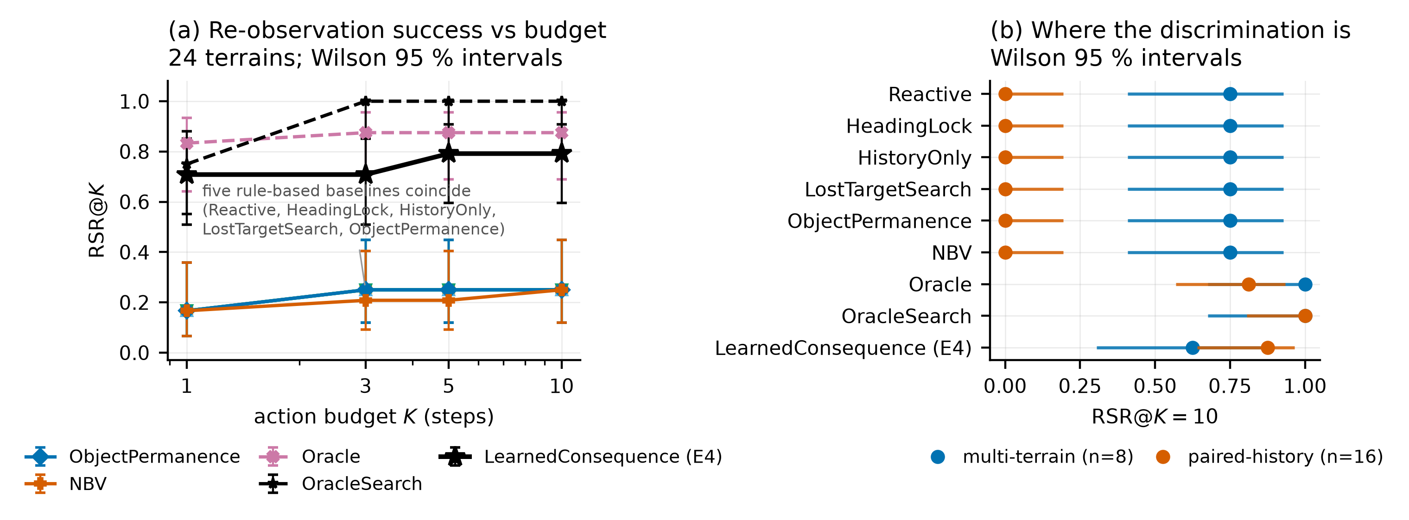

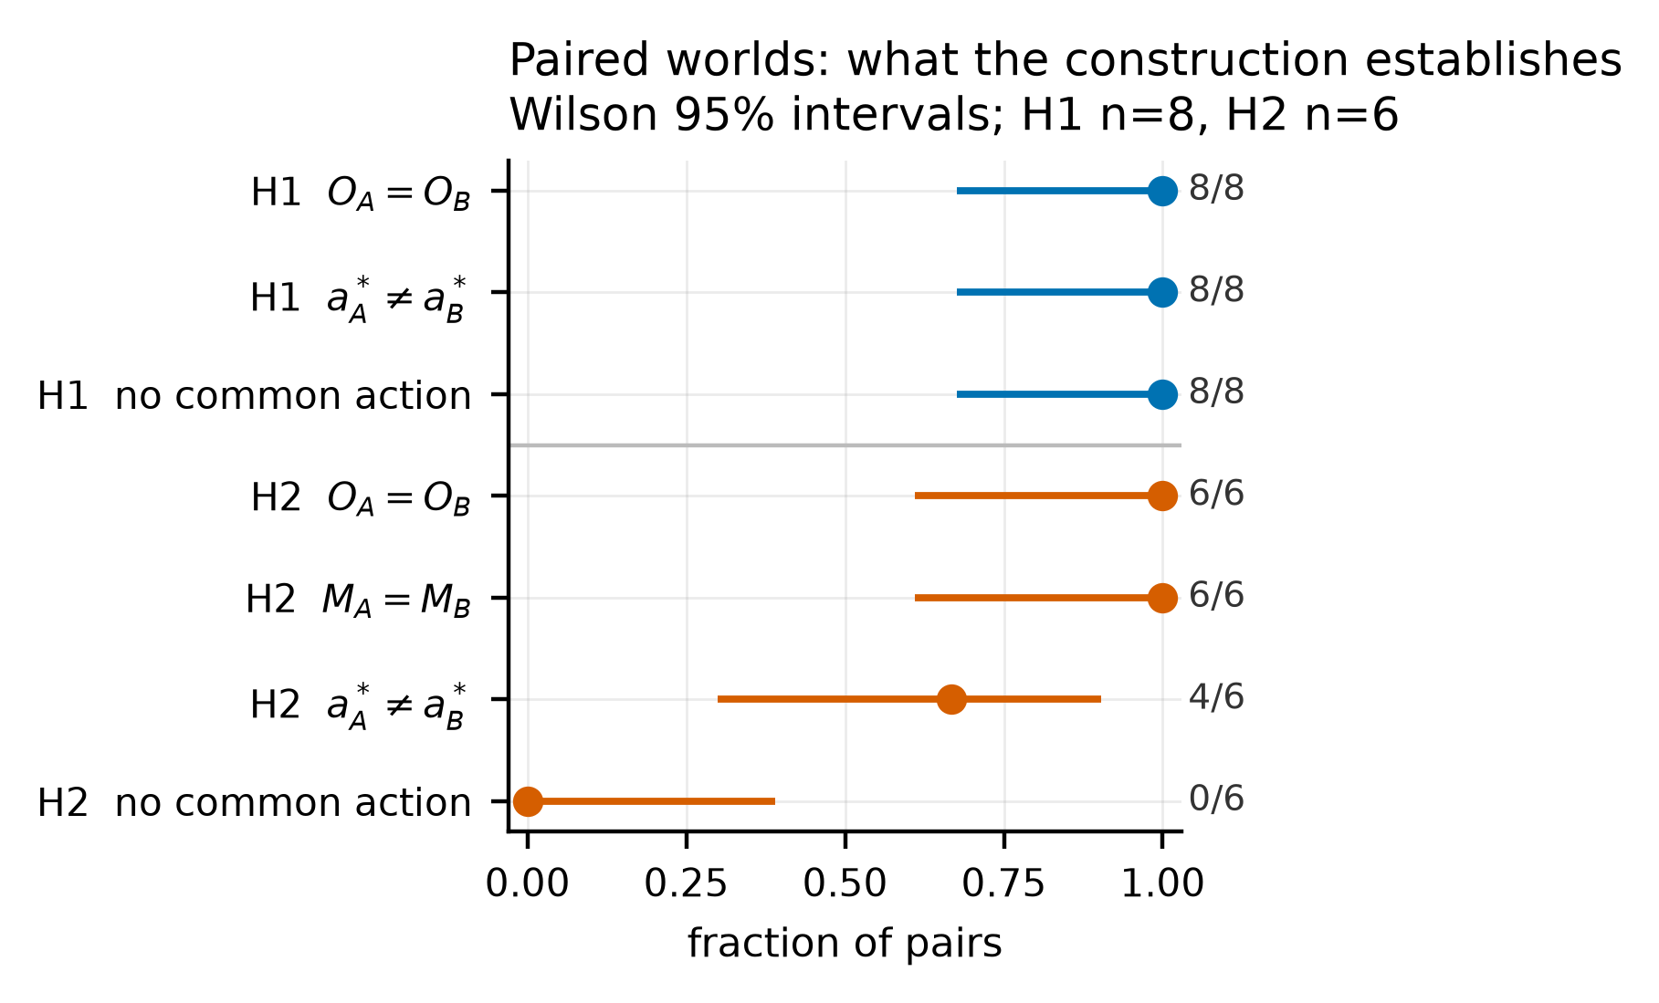

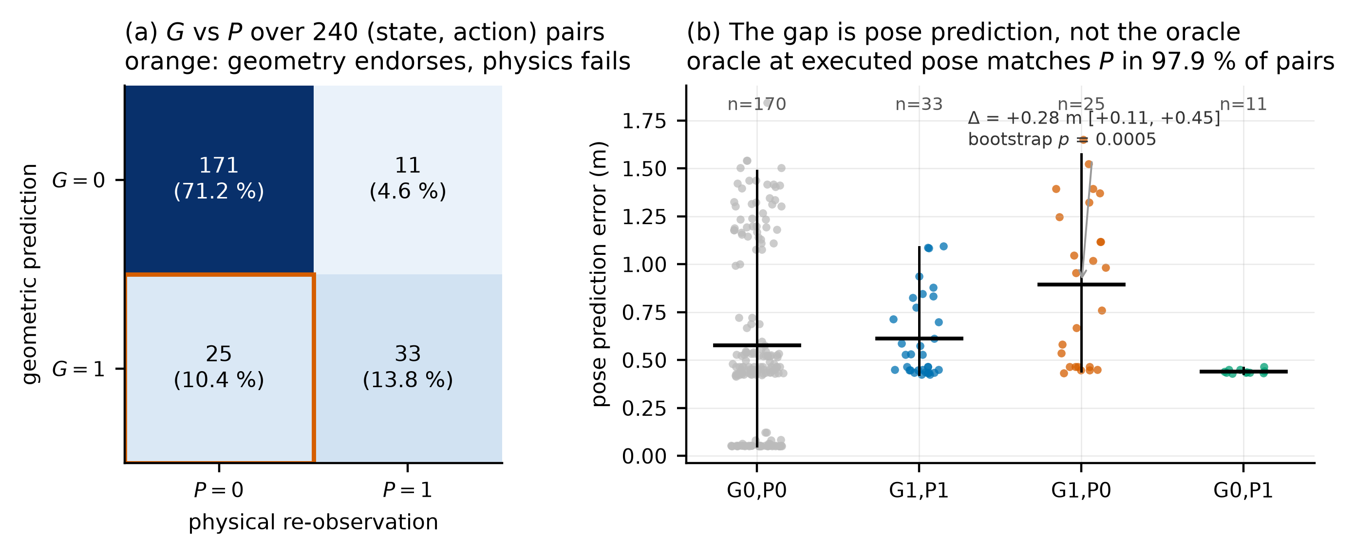

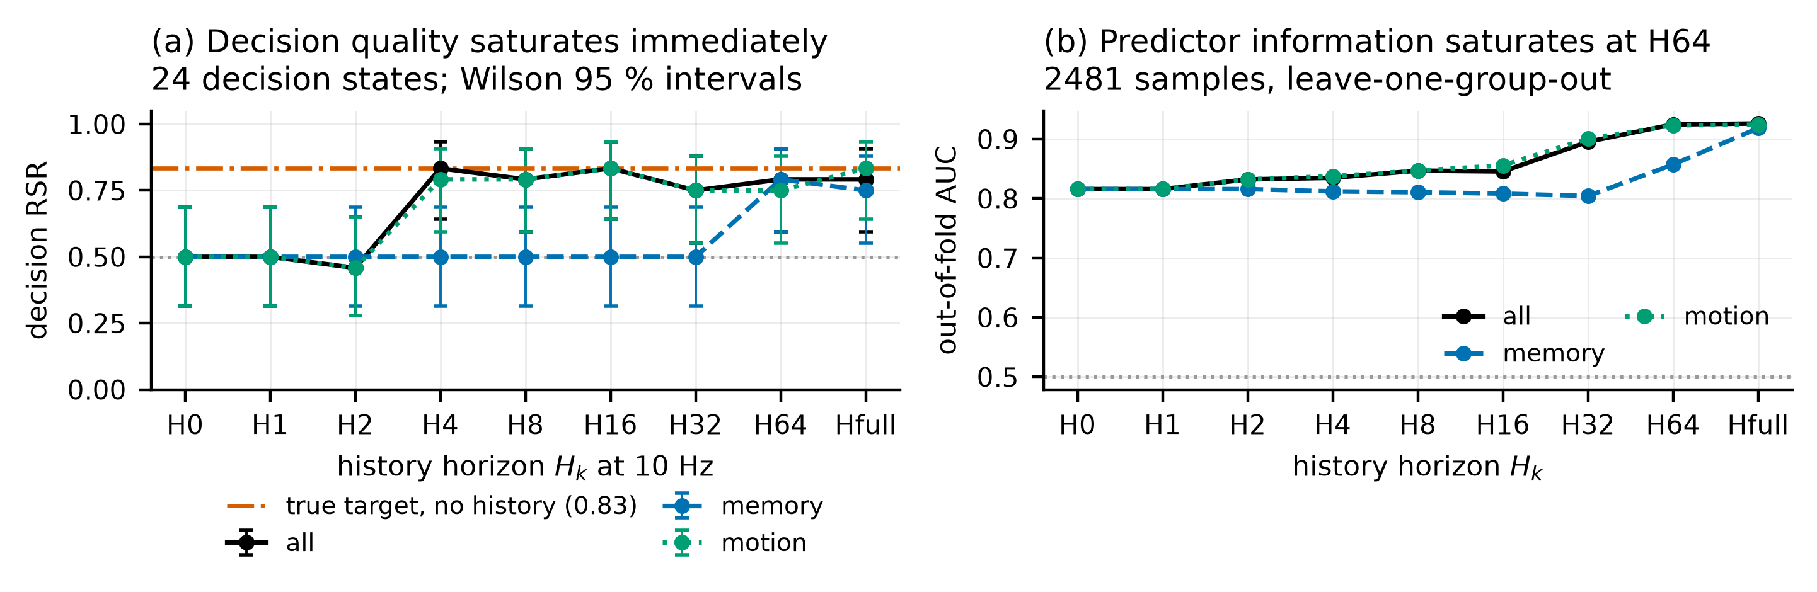

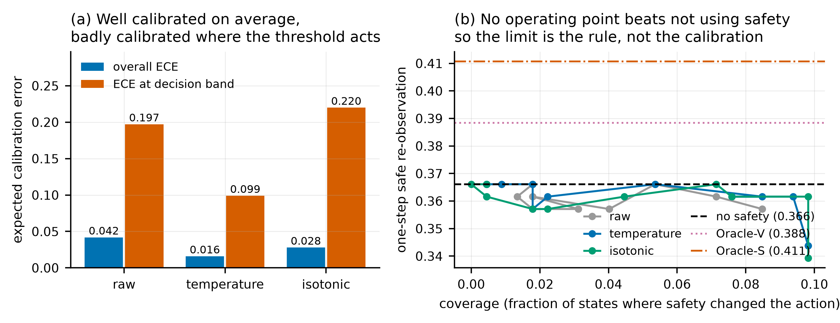

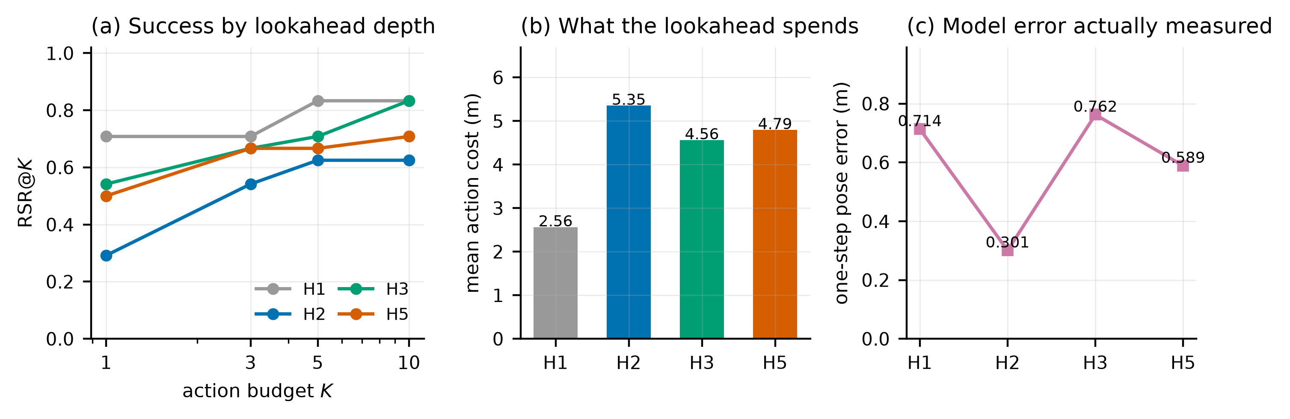

For Original Research articles, please note that the Material and Methods section can be placed in any of the following ways: before Results, before Discussion or after Discussion.

