George Mavroeidis

To be corrected by Daniel Rinaldi

COMP 476-N

Kaustubha Mendhurwa

Q1A)

Declaration of variables

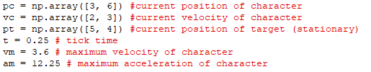

Steps explained through code

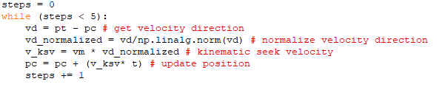

Results of next five updates:

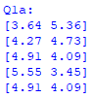

Q1B)

Steps explained through code

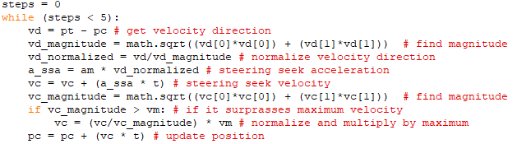

Results of next five updates:

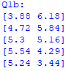

Q1C)

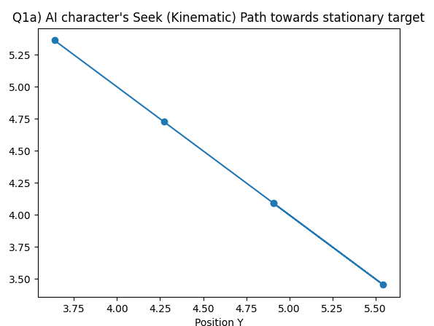

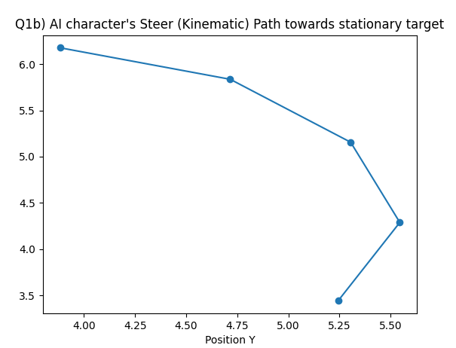

Q1D)

Declaration of variables

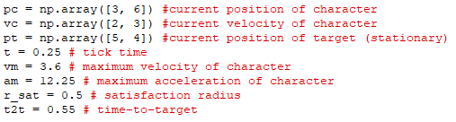

Steps explained through code

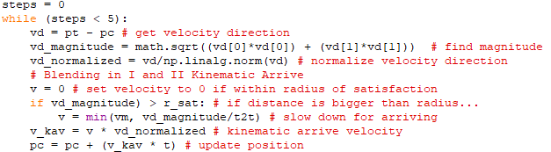

Results of next five updates:

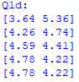

Q1E)

Declaration of variables

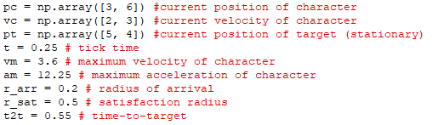

Steps explained through code

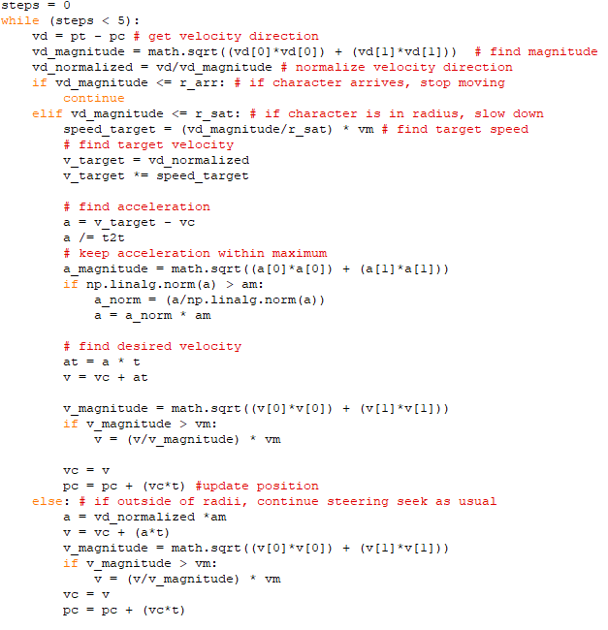

Results of next five updates:

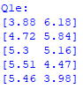

Q1F)

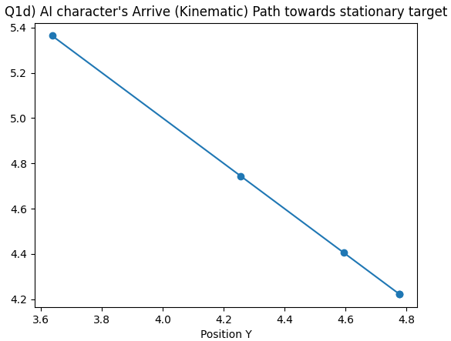

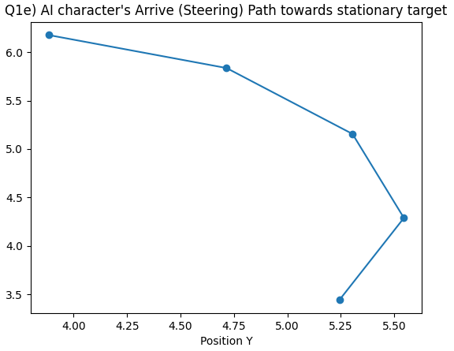

Q2A)

Declaration of variables:

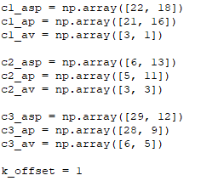

Steps explained through code



Results:



Q2B)

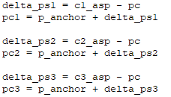

Results:

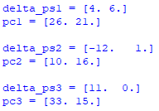

Q2C)



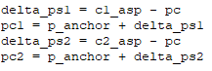

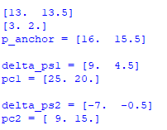

When C3 is killed, the anchor and the slot positions of C1 and C2 will change only if C3 was killed prior to any of these calculations. If p_anchor was calculated, but then C3 dies, nothing changes.