“Unfortunately, no one can be told what the Matrix is. You have to see it for yourself.” -Morpheus

By George Mavroeidis 1559858 Due date: Thursday 11 May 2017 201-HTK-05 Linear Algebra II (section 00001)

Professor: Geeta Johal

*BEHIND THE ANIMATION AND MOVEMENT OF AN OBJECT*

TABLE OF CONTENTS

1. **ABSTRACT** . . . . . . . . . . . . . . . . . . . . . . . . . . . . . . . . . . . . . . . . . . . . . . . . . . . . . . . . . . . . . . . . .2
2. **INTODUCTION** . . . . . . . . . . . . . . . . . . . . . . . . . . . . . . . . . . . . . . . . . . . . . . . . . . . . . . . . . . . 2-4
3. **MATERIALS AND METHODS OF ANALYSIS**  . . . . . . . . . . . . . . . . . . . . . . . . . . . . . . . . . . .4-27
4. *Materials . . . . . . . . . . . . . . . . . . .* . . . . . . . . . . . . . . . . . . . . . . . . . . . . . . . . . . . . . . 4-5
5. *Theory . . . . . . . . . .* . . . . . . . . . . . . . . . . . . . . . . . . . . . . . . . . . . . . . . . . . . . . . . . . .5-11
6. Fundamentals of Linear Transformation . . . . . . . . . . . . . . . . . . . . . . . . . . . . 5-7
7. Kernel of a Linear Transformation . . . . . . . . . . . . . . . . . . . . . . . . . . . . . . . . . . . .8
8. Rank and Nullity of a Linear Transformation . . . . . . . . . . . . . . . . . . . . . . . . . . . 8
9. Standard Matrix . . . . . . . . . . . . . . . . . . . . . . . . . . . . . . . . . . . . . . . . . . . . . . . . . . .9
10. Transformation of a matrix for a non-standard basis . . . . . . . . . . . . . . . . . .9-10
11. Similar Matrices . . . . . . . . . . . . . . . . . . . . . . . . . . . . . . . . . . . . . . . . . . . . . . .10-11
12. *Applications of Linear Transformation . . . . . . .* . . . . . . . . . . . . . . . . . . . . . . . . .11-17
13. *Model Exercise . . .* . . . . . . . . . . . . . . . . . . . . . . . . . . . . . . . . . . . . . . . . . . . . . . . .18-26
14. **RESULTS** . . . . . . . . . . . . . . . . . . . . . . . . . . . . . . . . . . . . . . . . . . . . . . . . . . . . . . . . . . . . . . 27-28
15. **DISCUSSION**  . . . . . . . . . . . . . . . . . . . . . . . . . . . . . . . . . . . . . . . . . . . . . . . . . . . . . . . . . . .29-30
16. **CONCLUSION**  . . . . . . . . . . . . . . . . . . . . . . . . . . . . . . . . . . . . . . . . . . . . . . . . . . . . . . . . . . . . .30
17. **REFERENCES** . . . . . . . . . . . . . . . . . . . . . . . . . . . . . . . . . . . . . . . . . . . . . . . . . . . . . . . . . . . . . .31
18. ***ABSTRACT:***

In this comprehensive assessment, the applications of Linear Transformation were studied and used to analyze an object’s movement in space. This was done by understanding the fundamental theorems of the topic and analyzing the essence of linear algebra in real-life examples. The model of this question was solved using properties of transformation matrices and was displayed using visual representations of each transformation. The calculations were verified using the software Matlab and visuals were represented using the software Geogebra. The outcome of this model was to display and find the final position of the object after being transformed six times. Also, the results validated the applications of the theorems of linear transformation. Overall, the model resulted in a fully successful solution and understanding of the essence of linear algebra on interpreting the movement of an object in space.

1. ***INTRODUCTION:***

Digital motion in computer graphics and animation has struck by storm the past two decades. The animation and game development industries flourish and are the leading contributors to the evolution of digital motion. Today, the use of digital motion in computers is more frequent in our everyday lives. This fundamental study is the basis for animating objects in softwares for fields such as gaming development and film animation industry. Another, but often forgotten, example is the animation in computer interfaces. The hover of the computer mouse over the start icon produces a coded animation. Computer graphics consist of many sectors such as rendering of an object, shading, ray tracing and animation. In this comprehensive assessment, the animation and transformation of an object will be analyzed.

Animation is the creation of digital images, which with processing produce the illusion of motion of a virtual structure or entity. It is the process of “puppeteering” something, to create a simulation out of the object. These digital movements are created by coding the tools and inputs. If a point is needed to be scaled twice its original size, the input is be the initial size and the output is the new, double sized of the point. This process of going from one space to another is called linear transformation. The movement of a point or object can be interpreted in an algebraic structure. This algebraic structure is placed on an axis plane and encoded in a form of a matrix (a rectangular array), where the components are sorted in rows and columns.

Linear algebra is a field of mathematics that focuses in the study of vectors, lines and spaces. Linear transformation is the mapping of an algebraic structure from one space to another. Basically, the movement and mapping of an object is the main subject of animating a body in space. Using additive and multiplicative properties of linear transformation, the object’s new coordinates can be mapped in the new, transformed space. Properties such as scaling, rotating, shearing are multiplicative properties, where when multiplied with an input, they produce the resulting transformation of the input, the output.

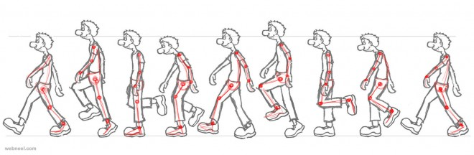

* A walk cycle of a puppet. Contains rotation, translation and shearing of joints.

Another great, but advanced use of linear transformation is the formation of fractals. Fractals is the infinitely self- repeated patterns at different scales. When a pattern contains many copies of itself within it, it is called “Self-Similarity”, where if we were to zoom in or out of it, we would discover the same pattern over and over again. Mathematician Benoit Mandelbrot describes fractals as “chaotic” due to their complex and mind-blowing properties. Fractals are found everywhere, most commonly in nature and the universe. Trees have self-repeating patterns of their branches. Other natural phenomena such as hurricanes and lightning bolts contain smaller copies of themselves. In a mathematical and geometric perspective, fractals are used to calculate an equation infinitely by just computing the calculation once.

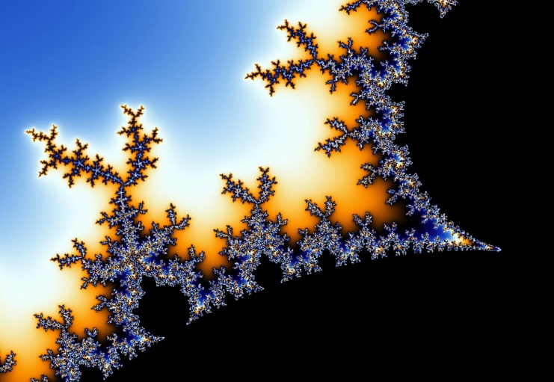

* Fractal in nature: Tree with many branches that have the same shape of itself, but in different scales.
* Fractals in Nature: Mandelbrot Set is a function repeated infinitely times with infinitely scales.

In this comprehensive assessment, the goal is to rotate a three dimensional cube’s four vertices and display various views of it in. The task is to rotate, scale, translate and reflect the vertices multiple times and display the final position of the cube.

1. ***MATERIALS AND METHOD OF ANALYSIS***

*3.1) Materials:*

The procedure done for solving the exercise involved multiple steps of calculating transformations and using softwares to analyze and confirm the results both numerically and visually. In the beginning, the theory of linear transformation was studied in order to obtain all the necessary information for solving the mathematical model. Any relevant theorems, concepts and basic formulas have to be studied first before trying to solve the given task. Once that is done, the problem can be solved.

During the solving process, each step has to be clearly written, where every step is orderly showcased and able to be understood. For every transformation done, a visual representation must be shown so the reader will be able to observe every step in a simplified and easily perceived way. In general, every calculation must be shown with a visual representation next to it. Once the final answer is calculated, both the final and initial states of the object are represented to compare the two states.

A great way to confirm the results is to use various softwares, which are the most accurate means of giving the best outcomes of a problem-solving task. *MATLAB R2017a* was the software used to obtain confirmations for any numerical values calculated for the model. By plugging in each transformation in order, the program was able to provide each step with an answer. This was the way the results can be confirmed right or wrong, so if an error is found, it can be corrected.

For the visual representations of each transformation, the software *Geogebra* was used. It is an interactive program made for the graph plotting of various functions and shapes. In Linear Algebra, this software is useful for demonstrating any geometrical notions in a graph. For this comprehensive assessment, the software is used to provide a visual outcome for each transformation calculated. If the object is rotated 30 degrees, the software will give an output of the cube being rotated 30 degrees from its original or previous state.

*3.2) THEORY*

3.2.1) Fundamentals:

A linear transformation is the process of transforming an input vector to a new output vector. For a transformation to be linear is when the vector space keeps its lines straight, equal and parallel and when the origin is fixed. When the lines become all curvy and the origin is moved, it is no longer called a linear transformation.



* Distinction between a linear transformation and a non-linear transformation of space.

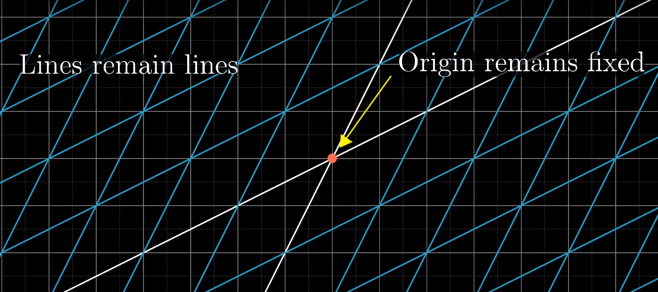

* Examples of Linear Transformations in a Cartesian plane( taken from: https://www.youtube.com/watch?v=kYB8IZa5AuE)

In algebraic terms, it is the transformation of T: V→W of a vector space V into a vector space W. Let be the input vector and be the new transformed vector. The input is part of the vector space V, where V is the domain and the output is part of the vector space W, where W is the codomain. The vector is also the image of and is the pre-image of . The transformation T: V→W can be written as T()= where T is the transformation between the two vectors. T: V→W can only be a transformation if it follows the two axioms of addition and scalar multiplication.

* where is the addition in V and is the addition in W.
* where is the scalar multiplication in V and is the scalar multiplication in W.

Linear transformation has properties that allow to retrieve results from taking shortcuts. The properties are:

* If then

So far we’ve looked transformation as a function that creates an image of a vector in a vector space. Linear transformation can be given by a matrix. This makes it due to the simplification of doing one calculation for all points or vectors, instead of calculating the process individually for each one. Let A be a square nxnmatrix for the transformation T:Rn→Rm. The transformation can be written as where A is the transformation matrix for V. This is a linear transformation if and only if it satisfies the two axioms of addition and scalar multiplication of the vector spaces.

Earlier we saw the property of the zero vector giving a transformation of no matter what the transformation matrix is. When a vector is transformed and becomes is called the Kernel of a Linear Transformation. It is the set of all vectors in vector space V that satisfy the transformation. This is called the Kernel of T or is written as Ker(T). The Kernel of a linear transformation T: V→W is a subspace of V, which satisfies the axioms of being a subspace.

3.2.2) Kernel of a Linear Transformation:

The Kernel can also be described as the nullspace of a linear transformation. Nullspace is the solution space of , where its dimension equals the amount of free arbitrary variables of the solution. Therefore, we can conclude in a transformation that the Ker(T)=Nullspace(A). Since the dimension of the nullspace is called the nullity (which is the amount of free variables), the dimension of the kernel of the transformation is equal to the nullity of the transformation. Therefore: dim(Ker(T))=nullity(T). If the Kernel of a transformation or its dimension is equal to zero, which means there are no free variables, it is called a one-to-one transformation.

A basis for the kernel can be found by solving the transformation matrix. By row reduction, a spanning linearly independent set can be obtained, indicating what the vectors of the nullspace are.

3.2.3) Rank and Nullity of a Linear Transformation:

Since the nullity is the amount of the free arbitrary variables, the rank represents the amount of the leading ones (the number of variables in a row echelon form of matrix A). Like mentioned earlier, the image of the transformation on T: V→W is the input vector. The dimension of the image represents the amount of variables of the transformation. Thus, it is the same thing for the definition of a rank, giving the relation: dim(Im(T) =rank(T).

In a T: V→W transformation, the codomain is the vector space of the image of the transformation. The dimension of W is the dimension of the codomain. If the dimension of the image of the transformation (or rank) equals to the dimension of the codomain, it is said that T is onto. A linear transformation T: V→W is isomorphic if it is both one-to-one and onto (bijective).

3.2.4) Standard Matrix:

Knowing what T is, we can define how a transformation is actually done. The transformation contains A, being the standard matrix for the transformation. The standard matrix contains columns that are images of the transformation of the standard basis. The standard basis is the n columns of Rn consisting of en vectors, where e1=(1, 0,…,0), e2=(0, 1,…,0) and so on. It is the set of unit column vectors of the subspace. When it is asked to find the standard matrix, of A given the transformation, the solution is to transform the standard basis and combine them to form column vectors of the standard matrix.

3.2.5 Transformation of a matrix for a non-standard basis:

So far we’ve looked at standard bases and matrixes, but in the transformation, a basis can be different than just a standard basis. Therefore, in a T: V→W transformation, the finite dimensional vector spaces have the bases B and B’ respectively, where B={v1, v2,…,vn} if T is a linear transformation such that:

,,…,

Then the mxn matrix forms the new non-standard basis transformation:

With this transformation, the matrix representation relative to B or B’ can be found. Such transformations from one basis to another can be obtained using a linear map. The matrix A is the transformation matrix for T relative to B, so for B’ the matrix A’ is the transformation matrix for T relative to B’. It is also possible to transition from one basis to another. The transition matrix P is obtained by the transformation column vectors from B’ to B. If is diagonalizable, P is invertible, therefore P-1 is the transition matrix from B to B’. In order to visualize these transformations and transitions, the linear map aids in finding what is needed:

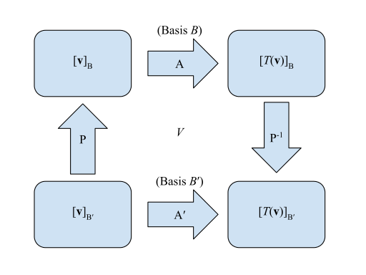

* Linear map of linear transformation

Now we can get from one place to another, for example, from to :

Plugging in the needed transition matrices:

We get the final transformation equation: ***A’=P-1AP***

3.2.6) Similar Matrices:

Knowing how to navigate ourselves with the linear map from one basis to another, a relation between the square matrices of order n A and A’ is denoted. A’ is similar to A when the transition matrix P exists in order to confirm that the linear map A’=P-1AP is true. The properties of similar matrices can be derived:

1. A is similar to itself when , where In is the identity matrix and is invertible.
2. If A and B are similar, this means A’=P-1BP. Removing P-1 by multiplying by P on both sides, we get PA’=BP. To remove P, its inverse P-1 is multiplied. And it turns out, that if A is similar to B then B is similar to A by deriving B=PAP-1
3. Now if A is similar to B and B is similar to C, the equations can be set: A’=P-1BP and B=Q-1CQ. B can be substituted by its relation: A=P-1BP= P-1(Q-1CQ)P=(QP-1)C(QP) therefore making both A and C similar, if A is similar to B and B is similar to C.

*3.3) Applications*

So far the fundamentals of linear transformations describe how a vector is transformed from one space to another using a transformation matrix or function to create an image of itself. To visualize and understand better these transformations, linear algebra is able to use the same method of the transformation in a more detailed and sophisticated application. With this concept, the geometry of linear transformation can be interpreted.

In general, a linear transformation T: V→W transforms points from V to W. This can happen many ways with different types of multiplicative operations such as reflection, rotation, expansion, shear and scaling. In R2 a two dimension movement is projected and the elementary matrices of each operation and is represented by a 2x2 matrix, meaning the operations appear in X and Y axes. In R3 a three dimension movement is projected and the elementary matrices of each operation and is represented by a 3x3 matrix, meaning the operations appear in X, Y and Z axes.

The noted operations are:

* **Reflection** is the mirroring of a vector with respect to an axis or line. Basically reflection can be obtained by reversing the number of the opposite axis asked to reflect on: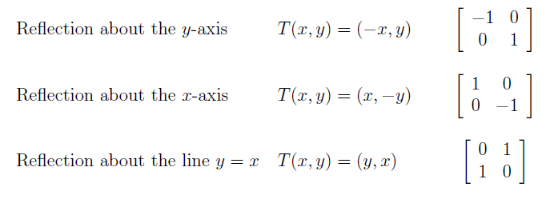

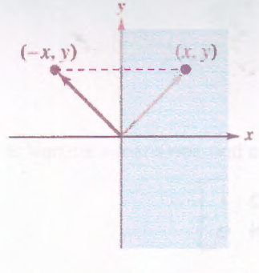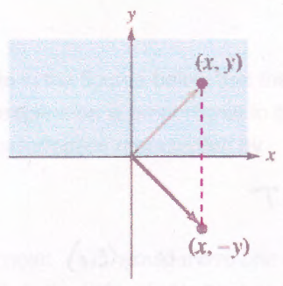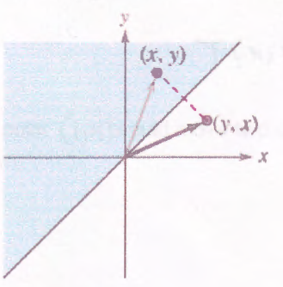

Reflections of point (x,y) about the x-axis, y-axis and y=x line

For example, if the reflection is about the y-axis, the negative sign is noted on the x-axis, since it is the axis that gets reflected.Now reflections can be about not just an axis or line, but for a plane in R3 as well:

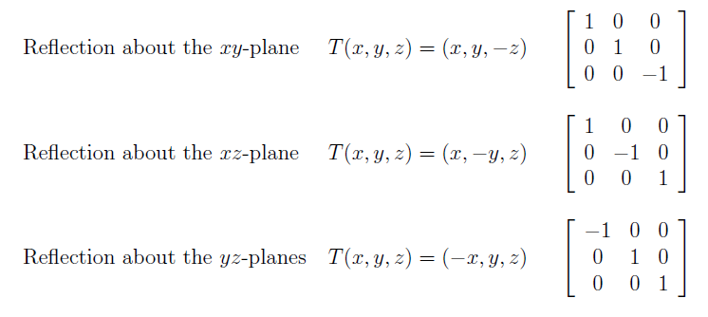

* **Projection** provides the orthogonal projection of the axis. In R2, the projection of an (x,y) point onto the x-axis would be:

This means the point is projected just in the specified axis. For y-axis it would be:

For R3, an example of a projection of the point (x, y, z) onto the xy-plane would be:

* **Expansion and contraction** is the stretching or shrinking of a vector, depending on the factor k without changing the direction. If k ≥ 1, it is called an expansion, and if 0 ≤ k ≤ 1 then it is called a contraction. In R2, the operations consist of the two cases:

Horizontal expansion or contraction:

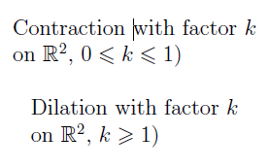

Vertical expansion or contraction:



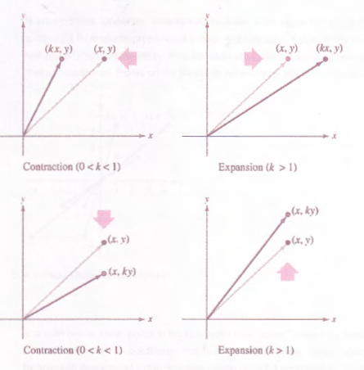

In R3, it is similar but this time, the third axis is added, where it causes no major differences in calculations, just visually.

* **Horizontal and vertical shear** is the stretching distortion that stretched the object in both ends. Basically, it is the addition of expansion of the opposite corresponding axis.

For example, if the shear is horizontal, the expansion of the vertical axis is added to the x-axis, resulting in a shear about the x axis (horizontal):

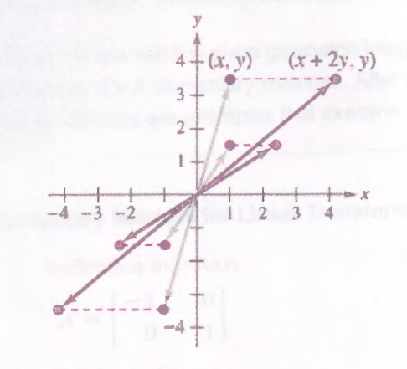

* Examples of horizontal shear

Similar to the vertical shear, but this time the expansion of the horizontal axis is added to the y-axis:

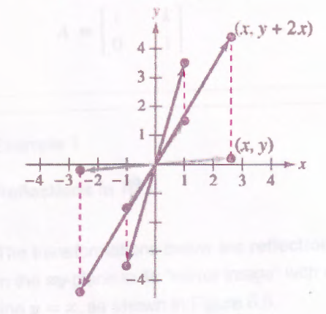

* Examples of vertical shear
* **Scaling** is the enlargement or shrinking of an object by a factor of k. If k ≥ 1, then the object is being enlarged. If 0 ≤ k ≤ 1, then the object is becoming smaller. To scale a vector, all axes must be multiplied by the factor, since every part of it is being scaled by the same amount:
* **Rotation** is the most complex operation that rotates an object around space in a certain number of degrees θ. This is the operation that uses more than one concept such as trigonometry.

If the point (x, y, z) is rotated by angle θ in R3, there are three ways it can be rotated. It can be rotated about the x-axis or y-axis or z-axis. Visually, the rotation about each axis can be represented by the right-hand rule.

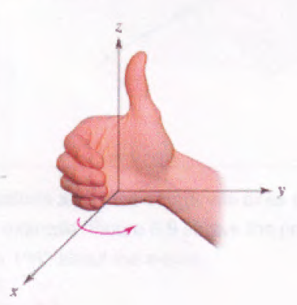

* Representation of the thumb rule around the z axis. The thumb is pointing at the axis of rotation and the rest of the fingers indicate the direction of rotation (clockwise or counter-clockwise)

Therefore the rotations are different for each axis, resulting in different operators:

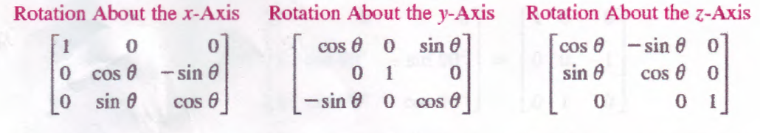

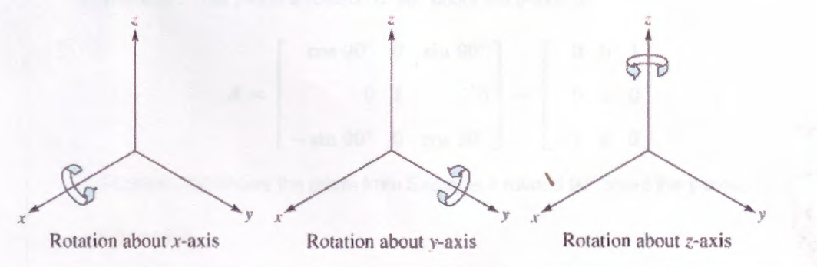

It is noted that **translation** is not considered a linear transformation because it is not a multiplicative property that satisfies the transformation. When asked to translate an object, the addition of the given numbers is added to the points of each axis.

*3.4) Model exercise*

In this comprehensive assessment, various views of a three-dimensional object are to be visualized. The four vertices of the cube (0, 0, 0), (1, 0, 0), (1, 1, 0) and (0, 1, 0) are selected to be transformed in 7 different steps. Each step will include a visual of the outcome view. The specific transformation steps are:

1. Scale the view along the x,y and z directions by factors of 2,3,5.
2. Translate the object to a new position on screen by 1,1,2:
3. Rotate the object around the x-axis by 30°
4. Rotate the object around the y-axis by -70°
5. Rotate the object around the z-axis by -27°
6. Reflect the object about the xz-plane.

The final position of the object must be shown.

The original and initial position of the object is the following:

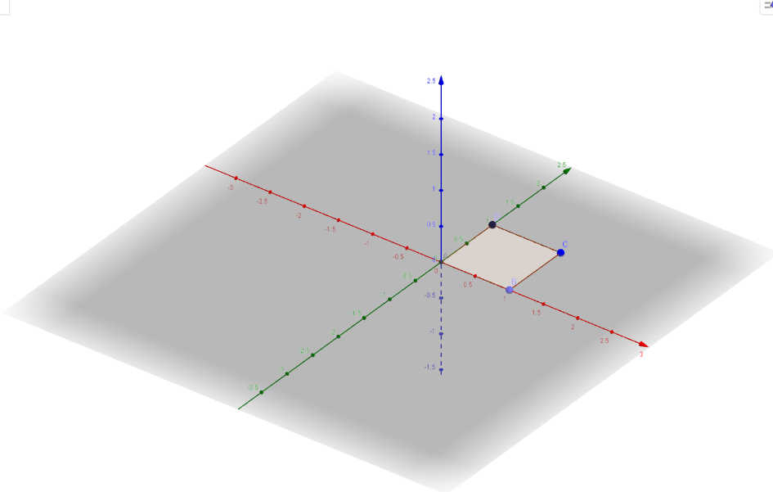

* Red line is the x-axis, green line is the y-axis and blue line is the z-axis
* V1= (0,0,0), v2=(1,0,0), v3=(1,1,0) and v4=(0,1,0)
* The following illustrations throughout the exercise are generated by *Geogebra*.

1. The object must be scaled along the x, y and z directions by factors of 2, 3 and 5. Now the transformations of each vertex can be written, but the transformation matrix must be found first. The transformation matrix A is represented as:

Now the transformations for the vertices are:

Note that v1 becomes the zero matrix, resulting in the Kernel of the transformation. Now the resulting transformation displays as:

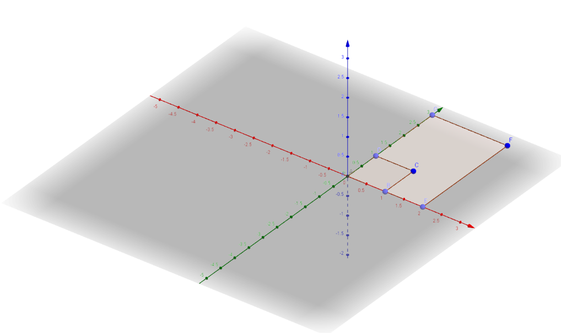

* An original copy of the previous position is shown for comparison. It is also noted that no vertex is part of the z-axis therefore the transformation matrix still results to 0.
* ABCD is the shape of the previous step and AEFG is the shape of the new step

1. The object is now translated to a new position by (1, 1, 2). Like mentioned earlier, translation is not a linear transformation, thus just adding the points to the vertices gives a new translated position of the object. Translation is written as:

* Note: the vertex used is the transformed vertex from the previous step.

This results to a linear movement of the object. The object no longer lies on the origin or any of the axes. The result looks like:

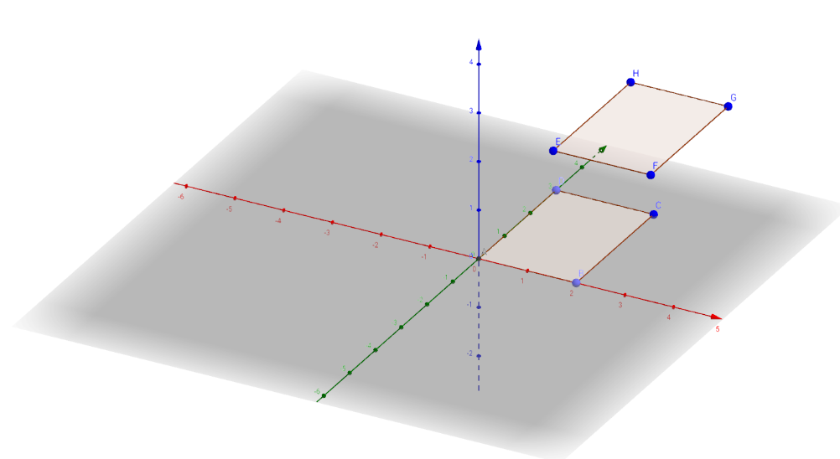

* ABCD is the shape of the previous step and EFGH is the shape of the new step
* Note: the translated object rises in the z-axis, making it “float” in the graph

1. The object will be rotated about the x-axis by 30°. Since the angle is positive, it will be rotated by the clockwise direction. The transformation matrix A will be:

The rotations of the object’s vertices will be expressed as the following transformations:

* Since calculations become more and more complicated, the answers were confirmed using *MATLAB R2017a*.
* Four decimals will be written throughout the decimal results for a better accuracy when plugging the values in *Geogebra*.

The rotation is shown below in visual form:

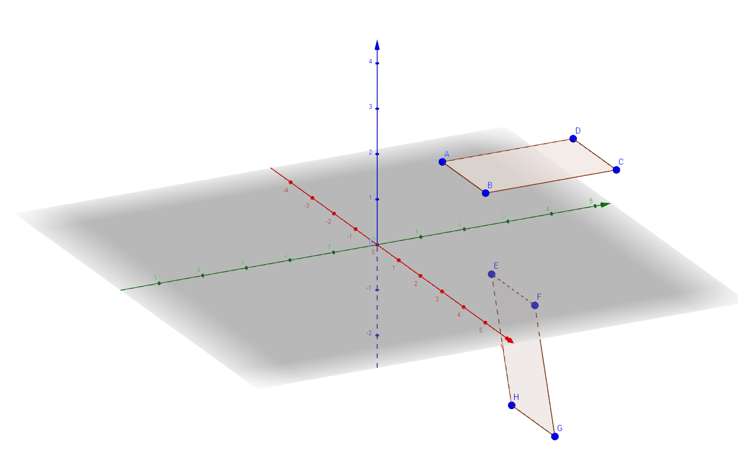

* As seen, the object is rotated about the x-axis
* Note: the reason why the polygon looks displaced is because the whole three dimensional object is not shown, or else we would have 8 vertices and the rotation would look something like this:

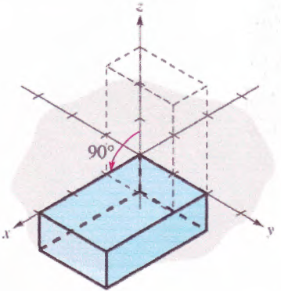

* The lower surface is not fixed in its position and it’s the same side of the cube analyzed in the model exercise.

1. Now the object is rotated for the second time, but this time by -70° about the y-axis. Since there is a negative sign, it is indicated that the rotation is clockwise, so it is expected to rotate on the other side this time, but about the y-axis. The transformation matrix changes, but still looks similar to the previous one:

The rotations of the object’s vertices will be expressed as the following transformations:

The rotation is shown below in visual form:

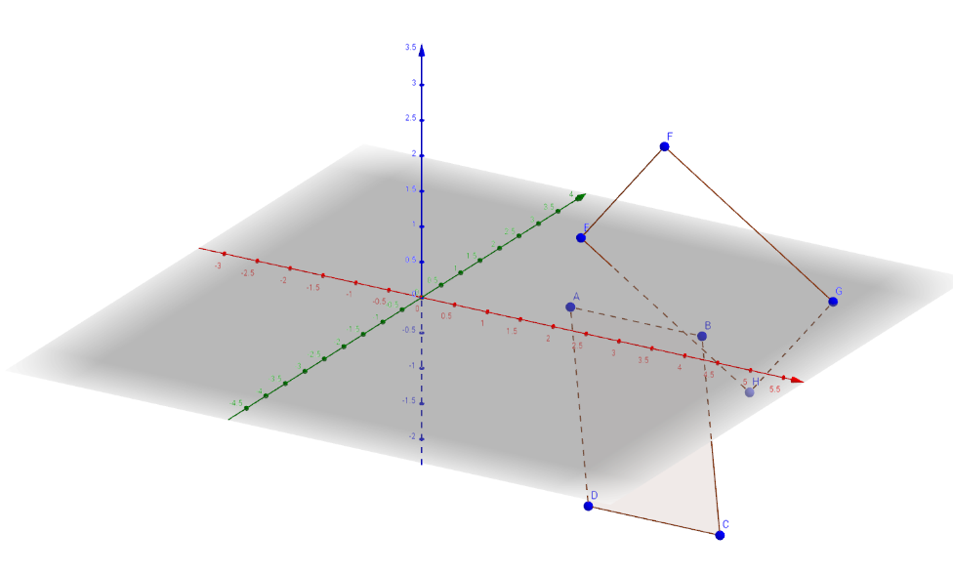

* Reminder: ABCD is the shape of the previous step and EFGH is the shape of the new step
* Note: the surface moved as well due to the same reason mentioned in the previous rotation.

1. The object is rotated for the third and last time about the z-axis by -27°, meaning it will rotate clockwise again. The same procedure follows here as the previous rotation, but the transformation matrix A is different again:

The rotations of the object’s vertices will be expressed as the following transformations:

The rotation is shown below in visual form:

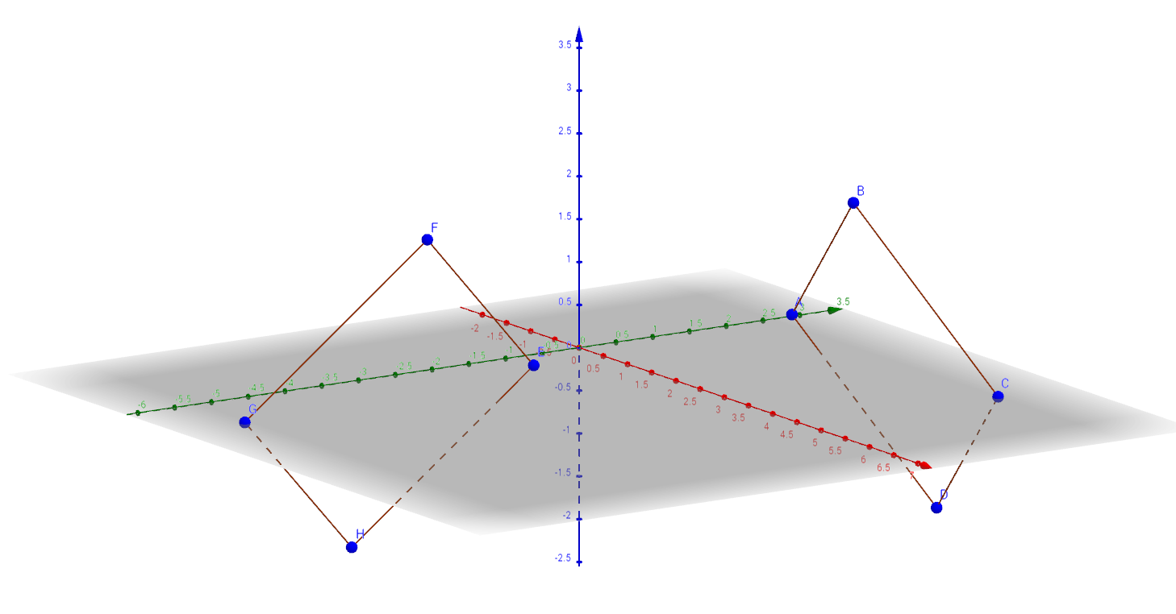

* Although hard to distinguish, the surface is rotating clockwise about the z-axis.
* Note: the angle about the x-axis and y-axis remain the same for both surfaces.

1. Last and hardest transformation to visualize is the reflection of the object about the xz-plane. As mentioned earlier, reflection is the mirroring of an object relative to a given axis, line or plane. In this case, it is a plane, therefore it is expected to be reflected on the other side of the coordinate system. The transformation matrix is as follows:

The calculated transformations are:

* The difference is that the y coordinate is reflected on the xz-plane.

Now mapping out the transformation in the grid:

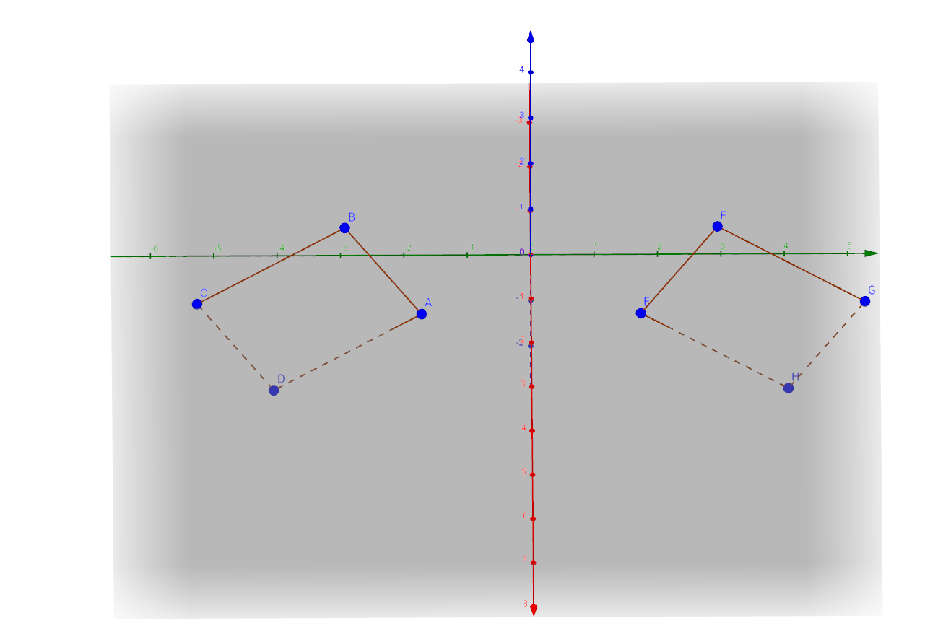

* Reminder: red line is the x-axis, green line is the y-axis and blue line is the vertical z-axis.
* The object is reflected on the plane, making the y coordinates of each vertex to change its sign.

1. ***RESULTS:***

Since every transformation has been completed, an initial and final comparison of the object can be displayed. Here are two distinct views of the comparison.

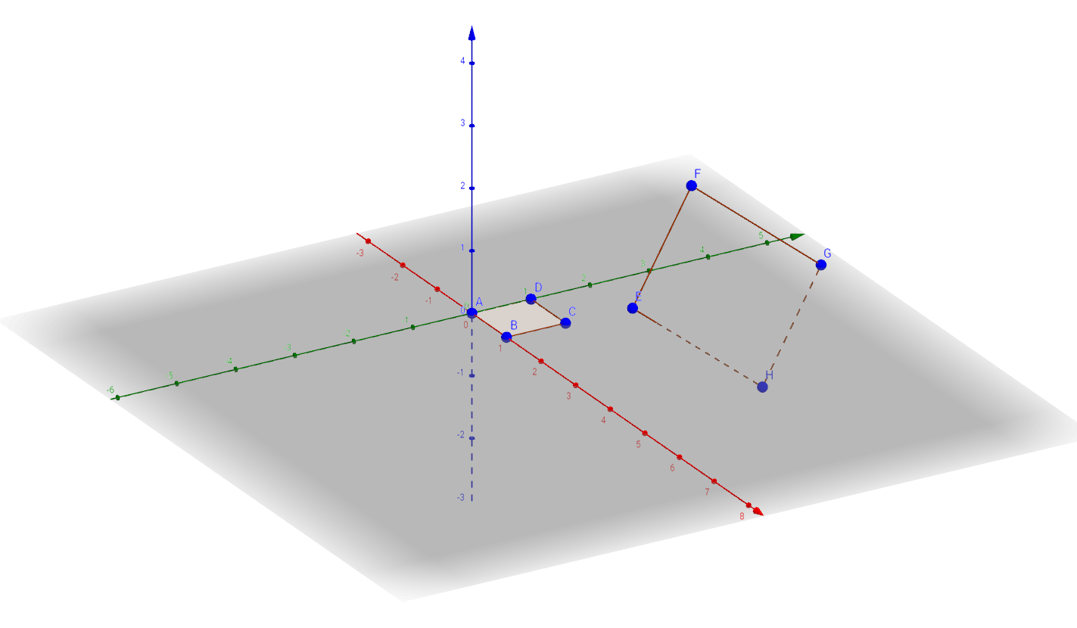

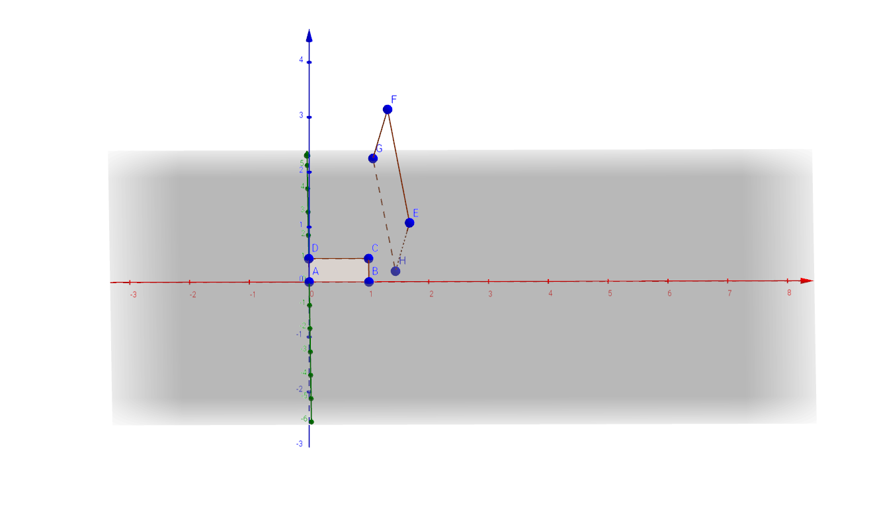

* Reminder: ABCD is the original polygon and EFGH is the new final transformed polygon.

A table is constructed to better interpret and organize the results of each transformation:

***Results and Information for each transformation of the model exercise:***

|  |  |  |
| --- | --- | --- |
| ***Operation*** | ***Transformation matrix A*** | ***Resulting positions of transformed vertices*** |
| ***Scaling x, y, z by factors 2, 3, 5*** |  |  |
| ***Translation by (1,1,2)*** | No transformation matrix for translation |  |
| ***Rotation about the x-axis by 30°*** |  |  |
| ***Rotation about the y-axis by -70°*** |  | ,, |
| ***Rotation about the z-axis by -27°*** |  |  |
| ***Reflection about the xz-plane*** |  |  |
| ***FINAL POSITION*** | - |  |

* Both preliminary and final results are tabulated.

The initial position of the object was v1=(0,0,0), v2=(1,0,0), v3=(1,1,0), v4=(0,0,1) and its final transformed position is T(v1)=(1.69,1.73,0.34), T(v2)=(1.33,2.94,1.89), T(v3)=(1.11,5.27,0.01), T(v3)=(1.47,4.06,-1.53). Hardly seen on the visuals, only the H vertex is in the negative side of the coordinate system, therefore it is the only vertex under one of the axes.

1. ***Discussion:***

In general, the outcome of the model was expected and is validated by the theories of Linear Transformation. Since the transformation T:R3→R3 is in the third dimension, the dimension dim(R3)=3 and A is a 3x2 matrix, M33. Since dim(domain)=dim(codomain)=dim(R3)=3, isomorphism occurs in T. Each transformation is one-to-one because there are no free variables after each solution, indicating that nullity(T)=dim(Ker)T))=0. Each transformation can be row reduced with rank(T)=3, which is the same as dim(codomain)=dim(R3)=3. Thus, the transformations are onto as well, meaning they are bijective.

The first transformations or steps were easy to calculate and visualize. Scaling and translation weren’t too complex and the results were pretty straight forward. When demonstrating rotations, it gets more complicated. At first, the object was expected to rotate relative to itself, but once confirming results on a graph, the object rotated relative to the given axis, meaning the object’s origin did not remain fixed and it changed position in the three dimensional space. When scaling, it was noted that the square surface transformed into a rectangle. This occurred due to the absence of a vertex in the z-axis, meaning each vertex had a z value of 0. Since value was 0, any transformations on it do not change the value, except translation, which is not an actual transformation.

There is not really another way to define the results, since they are pretty straight forward transformations. An input is given and using a matrix transformation, an output is being displayed. The order of the steps done does not matter. If rotation was done first and the rest at the end, the final position would not change. But when calculating the transformation the transformation matrix A must be placed in front of the vector or else multiplication is impossible. The inner matrix dimensions must agree. If A is a M33 matrix and v is a 3x1 vector, the multiplication must occur in such a way where the inner dimensions 3 (from A) and 3(from v) must cancel out to produce a 3x1 T(v) transformation. If v was placed first, inner dimension 1 will not cancel out with inner dimension 3 and matrix multiplication is impossible.

Finally, *Matlab* and *Geogebra* confirm the model question’s results with the greatest accuracy possible. Calculation errors were made when the model was being solved in paper and transformations were not properly drawn.

1. ***Conclusion:***

In conclusion, the purpose of this comprehensive assessment is to utilize the applications of linear transformation on a three-dimensional object in space and prove the real life use and study of this branch of mathematics. This was done by displaying and calculating various positions of the object in different position, size, angle and more. The final position of the object indicates that it has been scaled, translated, rotated by all three axes (x, y and z) and reflected. All vertices fall in the positive quadrant of the coordinate system, except one of them, which it found in the negative side of the y-axis. The transformations are one-to-one and onto due to the T:R3→R3 indication and the dimensions of the domain and codomain being equal, meaning both vector spaces are equal. It turns out that the results for the model question were validated correct, thus, the overall goal of the comprehensive assessment, fully succeeded.

Without a doubt, linear transformation is one of the most important topics in Linear Algebra. Usually, it goes unlearned when it is first taught, but when it is understood well, the learner is able to move on to more advanced topics and start to realize how this branch of mathematics really is useful for understanding the true power of the matrix.

1. ***REFERENCES***

Beal, V. (n.d.). Animation. Retrieved May 11, 2017, from http://www.webopedia.com/TERM/A/animation.html

Gashkov, S. B. (2012). Arithmetic complexity of certain linear transformations. Mathematical Notes, 97(3/4), 531-555. doi:10.1134/S0001434615030256

Jiménez-Munguía, R. R., Galan, V. J., Giménez, F. M., & Peris, A. (2016). Chaos for linear fractional transformations of shifts (S. Romaguera, M. Sanchis, & A. Tamariz-Mascarua, Eds.). The Iberoamerican Conference on Topology and its Applications 2014, 203, 84-90. Retrieved May 5, 2017.

Khan, S. (2009). A more formal understanding of functions. Khan Academy, Retrieved May 2, 2017

Mandelbrot, B. (2010). Fractals and the art of roughness. Retrieved May 5, 2017, from https://www.ted.com/talks/benoit_mandelbrot_fractals_the_art_of_roughness#t-417869

Nykamp DQ, “Linear transformations.” From Math Insight. http://mathinsight.org/linear_transformation_definition_euclidean

What are Fractals? (n.d.). Retrieved May 2, 2017, from http://fractalfoundation.org/resources/what-are-fractals/