This is a Big Data project which deals with taxi dataset to collect and process large volumes of taxi trip data, including pickup/dropoff locations, times, fares, and other attributes, and to analyze and gain insights into taxi operations, passenger demand, and traffic patterns in a city.

We used S3 to store the data and emr to create cluster of machines(EC2) to perform big data operations
we used Spark for implementing queries that have been performed on the data.
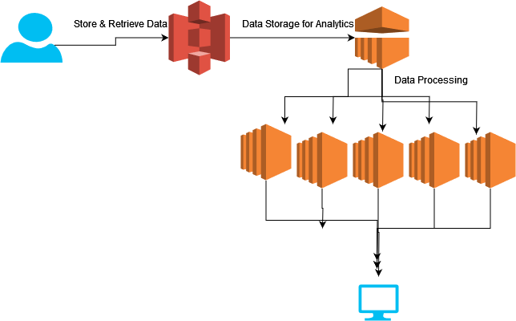
Examples of code:
Query: to create or replace a temporary name taxi for the DataFrame df
df.createOrReplaceTempView("taxi")

Query:
spark.sql("select count(*) from taxi").show()
Result:
+--------+
|count(1)|
+--------+
|13452892|
+--------+

Query: This query calculates the average fare amount for a taxi ride
spark.sql("select avg(fare_amount) from taxi").show()
Result
+-----------------+
| avg(fare_amount)|
+-----------------+
|12.69916888050212|
+-----------------+

