Asset Report

# Assets Breakdown

This section provides a comprehensive summary of your organization’s assets, breakding down the total number of assets in the system, their active and retired statuses, and the overall value of these assets.

## Summary Table

|  | Asset Type | Total Assets | Active Assets | Retired Assets | Total Asset Value |
| --- | --- | --- | --- | --- | --- |
|  | Mobile | 2 | 2 | 0 | 610 |
|  | Tablet | 2 | 2 | 0 | 1220 |
|  | Laptop | 2 | 1 | 1 | 1830 |
| TOTAL |  | 6 | 5 | 1 | 3660 |

## Asset Visualization

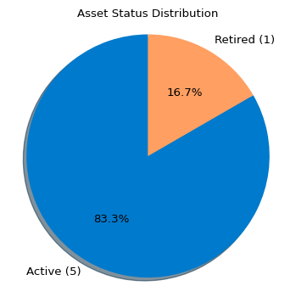

## Analysis Guide

This guide provides a framework to analyze the summary table and glean meaningful insights:

1. **Asset Utilization**:
   * Compare the number of active and retired assets across different categories to evaluate how well resources are being utilized.
   * Identify categories with a higher proportion of retired assets to assess potential inefficiencies or aging equipment.
2. **Category Insights**:
   * Review the asset types with the highest counts to determine which are most critical to operations.
   * Evaluate the distribution of assets to ensure alignment with organizational needs and priorities.
3. **Asset Value Assessment**:
   * Analyze the total asset value across categories to understand the scale of investment.
   * Use this metric to evaluate return on investment (ROI) and prioritize future resource allocation.

### Key Recommendations:

* Evaluate the retired assets for potential recycling, resale, or repurposing opportunities to maximize their value.
* Highlight high-value asset categories and explore strategies to maintain or improve their productivity.
* Monitor trends over time by comparing successive reports to identify changes in utilization or asset lifecycle patterns.

Report generated: 04-12-2024 04:44:42 PM