РУСЕНСКИ УНИВЕРСИТЕТ “АНГЕЛ КЪНЧЕВ”
Факултет: Електротехника, електроника и автоматика
Катедра: Компютърни системи и технологии

ДИПЛОМЕН ПРОЕКТ

Дипломант:
Георги Живков Чапъров
Фак. No 223025

РУСЕ
2026 г.
РУСЕНСКИ УНИВЕРСИТЕТ “АНГЕЛ КЪНЧЕВ”
Факултет: Електротехника, електроника и автоматика
Катедра: Компютърни системи и технологии

ДОПУСКАМ ДО ЗАЩИТА
Ръководител на катедра КСТ:

/ проф. д-р Цветозар Георгиев /

ОБЯСНИТЕЛНА ЗАПИСКА
НА
ДИПЛОМЕН ПРОЕКТ

ТЕМА:
Класификация на фазите на ръчен монтаж чрез мултимодални сигнали от проследяване на движенията на очите и главата

Дипломант:
/ Георги Чапъров /

ОДОБРЯВАМ:
Ръководител:
/ Marco Porta /
Консултант:
/ /

РУСЕ
2026 г.
РУСЕНСКИ УНИВЕРСИТЕТ “АНГЕЛ КЪНЧЕВ”
Факултет: Електротехника, електроника и автоматика
Катедра: Компютърни системи и технологии

РЕГИСТРИРАЛ: УТВЪРЖДАВАМ:
Орг.фак.к-я: Ръководител на катедра КСТ:
/ М. Дечева / / проф. д-р Цв. Георгиев /

З А Д А Н И Е
ЗА
ДИПЛОМЕН ПРОЕКТ

На студента: Георги Живков Чапъров, Фак. No: 223025
Специалност: Компютърни системи и технологии

- Тема:
„Класификация на фазите на ръчен монтаж чрез мултимодални сигнали от проследяване на движенията на очите и главата“
- Изходни данни:
Модел за машнно обучение за класифициране на фазите за производство на поточна линия.
- Съдържание на обяснителната записка:
- Анотация
- Увод
- Обзор на съществуващите решения. Изводи. Цел и задачи.
- Проектиране на софтуер за класифициране на данни.
- Проектиране на модел за машинно обучение.
- Основни резултати. Изводи и препоръки.
- Използвана литература
- Приложения
- Съдържание на графичната част:
- UML диаграми.
- Екранни снимки.

Дата на задаване: 22.02.2026 Срок за предаване: 31.08.2026

Дипломант: Ръководител:
/ Георги Чапъров / / Marco Porta /

Консултант:
/ /
Table of contents
1. Abstract 9
2. Introduction 10
2.1. Basic concepts in artificial intelligence, machine learning, and deep learning 10
2.2. The characteristics of the gaze 11
2.3. Gaze tracking 11
2.4. Classification of assembly line phases 12
2.5. Project objective 12
3. Overview of existing solutions 14
3.1. Video analysis-based approaches 14
3.2. Approaches based on eye tracking 14
3.3. Approaches using a combination of multiple sensors 15
3.4. Classification models used 15
3.5. Analysis of the solutions considered 16
3.6. Conclusions 16
4. Description of experiment and data collection hardware 18
4.1. Structure and method of conducting the experiment 18
4.2. NEON from Pupil Labs 18
5. Data classification software 20
5.1. Requirements, architecture and data organization 20
5.2. Choosing a programming language and environment 22
5.3. Implementation of the software system 22
5.3.1. Description of the program modules 22
5.3.2. Structure and organization of the programming interface 26
5.4. Input and output data format 28
6. Development environment and remote access 29
6.1. Creating a Docker image 29
6.2. Creating a compose.yml file 31
7. Creating and training the model 34
7.1. Input data 34
7.2. Data pre-processing 35
7.3. Choosing a machine learning model 35
7.4. Training methodology 35
8. Main results 36
8.1. Сравнение на 36
9. Conclusions and recommendations 37
10. References 38
11. Applications 40

Списък на използваните фигури

Списък на използваните таблици

Използвани съкращения
2.1.
AI, ML, DL
3.1.
CNN, LSTM
3.1.
IMU, EMG
3.4
SVM, k-NN, GRU

- Abstract
The subject of the thesis is the modeling and training of a model that can classify the individual actions of a person working on an assembly line, using only data from glasses that track eye and head movement.
A LEGO set was used to simulate an assembly line. Participants in the experiment wore glasses to track their eyes and head movements. During the experiment, participants followed the steps in the LEGO set's guide book while there actions were recorded. In addition to various types of movements, the glasses recorded the workspace on which the participant assembled the LEGO set. The total number of participants was twenty-seven, but due to technical problems, two of the recordings were unusable.
Software has been developed to classify the obtained data. When launching the software, the user can select a folder with the data of a given participant. The software can play the recording on the work area, overlaying the point at which the participant was looking at the given moment, on the played recording.
The VS Code text editor with multiple modules and the Python programming language were used to develop the classification software. The PyQt6 library was used for the graphical user interface. The Numpy library was used for interpolation between two points of the gaze data of the participant in the experiment, as well as the pandas library for loading and saving the classified data in a file with the csv extension.
For data processing, model creation and training, the Python programming language was used, as well as a self-hosted instance of JupyterLab, running in a Docker container based on the image "nvidia/cuda:12.1.1-runtime-ubuntu22.04". The instance is located on a home computer and is accessible via the local network. The local network was accessed remotely via a locally located virtual private network. As a backup option in case of a problem with the virtual private network, a connection was established via AnyDesk, as well as a self-hosted instance of Sunshine and Moonlight.
Използван модел, кои модели съм сравнявал, как съм оптимизирал параметрите на моделите, резултати .......
- Introduction
Manual assembly on an assembly line is still widespread, despite the high level of automation in various industries. The prolonged performance of the same type of repetitive operations can lead to fatigue, reduced concentration and an increased likelihood of making errors due to inattention.
The classification of the phases that workers go through on an assembly line allows analyzing the duration of individual operations, the time spent searching for parts and tools, as well as the way the work process is performed.
By analyzing this information, the company can optimize the layout of the workspace, improve the sequence of operations, or, if necessary, change individual stages of the production process. Such optimizations can lead to a reduction in the risk of human error, improved ergonomics of the workplace, and limiting defects in the final product.
One approach to analyzing worker actions is the use of eye-tracking technologies that provide information about the visual attention of the worker during the execution of assembly operations.
Before presenting the proposed approach for classifying the phases that workers go through on an assembly line, it is necessary to consider several basic concepts on which this study is based.
  - Basic concepts in artificial intelligence, machine learning, and deep learning
Artificial Intelligence (AI) is a field of computer science that aims to create systems capable of performing tasks that normally require human intelligence. Such tasks include object recognition, information analysis, decision-making, and discovering patterns in large amounts of data.
Machine Learning (ML) is a subset of artificial intelligence that allows computer systems to learn from data without being explicitly programmed for each individual task. Instead of being taught rules, machine learning models detect patterns and relationships in given examples and then use what they have learned to make predictions or classifications on new data.
Deep Learning (DL) is a specialized approach to machine learning that uses artificial neural networks with multiple successive layers. These models are capable of automatically extracting complex features from large amounts of data, making them suitable for tasks such as image processing, object recognition, behavior analysis, and time series processing.
  - The characteristics of the gaze
In this thesis, gaze is one of the main sources of information for training the model. It can be considered as a source of information about the intentions of a person.
Gaze movements are usually divided into three main types, which are characterized by the speed of eye movement and the duration of fixation.
Fixations - Fixations are periods in which the gaze is relatively stable and directed at a specific point for a certain interval of time. During fixation, the main part of visual information processing takes place. [1]
Saccades - Saccades are rapid, ballistic eye movements between two fixations. During a saccade, visual information is limited, and their main function is to move the gaze between different objects or areas. [1]
Smooth pursuits - Smooth pursuit is an eye movement in which the gaze follows a continuously moving object. This type of movement is used when observing dynamic scenes. [1]
  - Gaze tracking
It is important to define what eye tracking technology is and how it works. This is because it is key to the development of the thesis.
An eye tracking device is any device that tracks various signals from the eyes such as movements, pupil size, blinks, and others. [1]
They are divided into two main types, namely invasive, which use sensors attached directly to the eye, and non-invasive, which use sensors placed around the eye or so that it is in direct view. Non-invasive is further divided into electro-oculography, which uses electrodes placed in close proximity to the eye, and video-oculography, which uses cameras that capture the eye. [1]
Eye tracking using video capture can be further divided into two types. [1]
Remote eye capture - cameras are most often placed behind or at the level of the work area. They are mainly used to capture the gaze in front of a computer screen and generally in most cases where the participant is sitting largely still. [1]
Eye tracking with attached camera - Cameras are worn, most often through glasses, allowing for a more dynamic work environment. Very often, they also include a camera that captures the participant's work area. [1]
Eye tracking devices typically measure several key metrics, including:
- Gaze direction – this is a fundamental parameter used to identify and classify eye movements, such as fixations, saccades, and smooth pursuit. Gaze direction analysis can provide additional information about cognitive, emotional, physiological, and neurological processes.
- Pupil size and reactivity – through the method of pupillometry (measuring pupil parameters), these indicators can be used to study various cognitive functions, including emotional responses, language processing, perception, and memory. [2][3]
- Blink rate – the number of blinks over a period of time can serve as a reliable indicator of cognitive activity related to learning processes and goal-directed behavior. [4]
- Eye state (open or closed) – tracking whether the eyes are open or closed allows for the assessment of physiological states such as alertness, fatigue, or sleepiness. [5]
  - Classification of assembly line phases
The classification of the phases that a worker goes through when performing assembly operations is a process of dividing the work cycle into separate stages with a clearly defined purpose. Each stage can be associated with a specific action, such as picking up a component, using a tool, performing an assembly operation, or checking the work performed.
Traditionally, the analysis of work processes in an industrial environment is carried out by observing the worker and using video recordings of the workplace. Through subsequent analysis of the video materials, the moments of start and completion of individual operations can be determined, as well as the time required for their execution. This approach provides detailed information about the worker's behavior, but requires a significant amount of video data and human intervention in the analysis.
  - Project objective
This thesis examines an approach to classifying the phases of an assembly line, in which data related to the movement of the eyes and head of the worker are used instead of full video recordings. The main goal of this approach is to reduce the amount of information required for processing, which can lead to faster analysis and lower requirements for computational resources.
The use of data from the gaze and head movements provides an opportunity to extract information about the visual attention and intentions of the worker, while preserving the main characteristics of the work process. This allows the development of more effective automatic analysis systems that can be used to optimize production processes, improve ergonomics and reduce the likelihood of human errors.
- Overview of existing solutions
  - Video analysis-based approaches
Much of the existing research on assembly process analysis uses workplace video footage as the primary source of information. In this approach, one or more cameras monitor the worker and their workspace, and computer vision methods are used to determine which operation is being performed at any given time.
Modern systems use deep neural networks to automatically extract spatial and temporal features from the video. Combinations of convolutional neural networks (CNN) and Long Short-Term Memory (LSTM) are often used, as well as Transformer-based architectures that allow modeling the sequence of actions over time. Such models achieve high accuracy in recognizing individual stages of assembly and allow tracking the sequence of performed operations. https://www.sciencedirect.com/science/article/pii/S0952197625000764
The main advantage of video analysis is the availability of rich visual information. In addition to the worker's movements, the tools used, individual components and their location can be recognized. This allows the construction of systems that not only classify the phases of assembly, but also detect missed or incorrectly performed operations. https://www.sciencedirect.com/science/article/abs/pii/S073658452400139X
A disadvantage of this approach is the need to process a large volume of video data. This increases the computational requirements and creates difficulties for real-time use. In addition, video recordings raise issues related to the protection of personal data and the privacy of workers.
  - Approaches based on eye tracking
In recent years, there has been a growing interest in the use of eye tracking technologies in the analysis of assembly operations. The basic idea is that the direction of gaze provides information about the visual attention and intentions of the worker even before the corresponding action is performed.
In such systems, data from the eye tracking device is used to determine the object to which the operator’s attention is directed, as well as to analyze the sequence of observed elements. This allows for predicting the next actions, assessing cognitive load, and detecting deviations from the standard workflow. https://arxiv.org/abs/2405.07570
Some modern solutions combine eye tracking with worker assistance systems that display instructions or mark the necessary components in real time. This reduces the likelihood of errors and speeds up the assembly process. https://www.sciencedirect.com/science/article/pii/S0952197625000764
Despite its advantages, the use of visual data alone is not always sufficient to unambiguously determine the operation being performed. Different assembly actions may be accompanied by similar patterns of visual attention, which is why additional sensors are often used.
  - Approaches using a combination of multiple sensors
In order to increase reliability, multimodal systems are increasingly being used that combine information from several different types of sensors. In addition to visual data, inertial measurement units (IMU), RGB or RGB-D cameras, force sensors, electromyography (EMG) and other sources of information can be used.
Combining data allows compensating for the limitations of individual sensors. For example, IMU provides accurate information about head or limb movements, while eye tracking provides information about the visual attention of the worker. https://arxiv.org/abs/2405.07570
A number of publications use precisely the combination of gaze and video, which allows for simultaneous recognition of assembly operations and tracking of the operator's attention. The results obtained show higher accuracy compared to systems using only one type of data. https://www.sciencedirect.com/science/article/pii/S0952197625000764
A disadvantage of multimodal solutions is the greater complexity of the system. Data synchronization between different devices is required, as well as significantly more complex processing during model training.
  - Classification models used
The choice of machine learning model has a significant impact on the accuracy of assembly phase recognition.
In earlier studies, classical machine learning algorithms such as Support Vector Machines (SVM), Random Forest and k-Nearest Neighbors (k-NN) were widely used, in which manually defined features are extracted from the signals in advance.
With the development of deep learning, neural networks are increasingly used, which automatically extract the necessary features. Convolutional neural networks (CNN) are suitable for extracting local patterns in signals, while Long Short-Term Memory (LSTM) and Gated Recurrent Unit (GRU) model dependencies in time sequences. In recent years, Transformer architectures have been increasingly widely used, which allow for efficient modeling of long-term dependencies and often achieve better results when analyzing sequential data. https://www.sciencedirect.com/science/article/pii/S0952197625000764
  - Analysis of the solutions considered
The approaches considered show that currently the most common systems for the analysis of assembly activities use video data as the main source of information. These solutions achieve high accuracy due to the rich visual information, but require significant computational resources and processing of large volumes of data.
Systems using eye tracking offer the possibility of analyzing the visual attention and intentions of the worker with a significantly smaller volume of information. However, eye data alone are not always sufficient to reliably distinguish between individual assembly operations.
The highest results are usually achieved by combining several types of sensors. However, most existing solutions use video recordings as a mandatory component of the system, which increases the complexity and required computational resources.
A comparison between the considered approaches is presented in Table 3.1.
Подход | Предимства | Недостатъци
Видео | Богата информация, висока точност | Голям обем данни, високи изчислителни изисквания
Проследяване на погледа | Малък обем данни, информация за вниманието | Не винаги е достатъчно за еднозначна класификация
Поглед + IMU | Допълваща информация за внимание и движение | Необходима е синхронизация между сензорите
Видео + поглед | Много висока точност | Най-сложна система и най-големи изчислителни изисквания

  - Conclusions
The review shows that existing solutions increasingly use deep learning methods to automatically recognize individual stages of the assembly process. The most common systems rely mainly on video data, and in many cases they are combined with information from eye tracking devices and other sensors.
Despite the high accuracy of these solutions, the need to process video recordings leads to an increase in computational complexity, the volume of stored data and the emergence of issues related to the protection of personal data.
Therefore, there is interest in developing systems that use less information, while maintaining high accuracy in classifying assembly phases. The present thesis follows this direction, exploring the possibility of classifying the phases of the assembly process using only eye tracking and IMU data, without the need to analyze full video recordings.
- Description of experiment and data collection hardware
  - Structure and method of conducting the experiment
Due to the impossibility of collecting data in a real assembly line environment, the decision was made to use a LEGO set to be assembled by the participants in the experiment. The set used is from the LEGO 3-in-1 series, and its name is “Space Shuttle”. [1] The set provides the opportunity for three different buildings, the one used here being a spaceship with a total number of parts – seventy-two.
Before the start of the experiment, each participant together with the organizer of the experiment must sign a contract identical to Appendix A. The contract is prepared and signed in two identical copies – one for each party.
Each participant begins the experiment with all the necessary parts, as well as the guide book gathered in front of them. The experiment ends when the participant has finished building, or when the participant no longer wishes to continue the experiment. If the participant refused to complete the experiment and the recording was less than ten minutes long, the recording was discarded.
The total number of participants was twenty-seven. Several participants expressed a desire to end the experiment prematurely, but in each of these cases, the recordings were longer than ten minutes. Due to technical problems with the glasses, two of the recordings were lost, and the only information from these participants was the raw data about their gaze. The loss of the recording prevented the classification of this data.
The total number of recordings used to train the model was twenty-five.
To record the participants' actions, NEON eye-tracking glasses from Pupil Labs were used. [2] The creators of the glasses say that they do not require pre-calibration. Therefore, no such calibration is provided before the start of each experiment.
The choice of eye-tracking glasses, rather than a stationary remote tracking system, is due to their ability to register both gaze movement and head position. This makes them more suitable for application in assembly line conditions, where the orientation of the worker's head and body changes dynamically, and the use of multiple external sensors around the workspace would significantly increase the required resources and system complexity.
  - NEON from Pupil Labs
Pupil Labs was founded in Berlin, Germany in 2014 and is engaged in the development of software and hardware for eye tracking. Pupil Labs' latest product is the NEON eye tracking glasses. [6]
NEON is a frame of glasses with a built-in module between the two lenses.
The glasses have a camera that looks forward and records what the person wearing them sees. The resolution of this camera is 1600px by 1200px and operates at a frequency of 30Hz. The horizontal viewing angle is 103°, the vertical 77°, and the horizontal 128°. [3]
The glasses have two infrared sensors, each of which tracks one eye. The resolution of one of them is 192px by 192px, and the operating frequency is 200Hz. [3]
Another important feature is the inertial measurement module. It has an accelerometer, magnetometer and gyroscope. Thanks to it, head movements are recorded at a frequency of 110Hz. [3]
Another thing that the glasses have is two stereo microphones, but they were not used during data collection. [3]
NeoNet is the name of the machine learning model that is fed data from the infrared cameras. It is he who returns information about gaze, blinks, pupil diameter, orientation and position of the eyes and eyelid opening. [4]
The glasses have a USB-C 2.0 port for charging and transmitting data in real time to the mobile application – Neon Companion [3]
Neon Companion is a mobile application that allows you to watch a recording while it is being recorded. In addition, you can also see the position of the eyes, as well as the recordings from the cameras that capture them. After the recording is finished, the application allows it to be uploaded to Pupil Cloud. [5]
Pupil Cloud allows for the storage of recordings in one place, as well as their further processing and visualization. [5]
- Data classification software
After collecting the data, it needs to be categorized. Part of the data is expected to be categorized by hand, and after collecting a sufficiently large number of categorized data, a machine learning model is to be created that, with sufficient accuracy, manages to categorize the data from a single record, and the user only has to correct the errors. For this purpose, an application is needed that allows not only the easy addition of events, but also their editing.
When searching for existing solutions, no one was found that would allow easy modification of the data in the required format. Most of the existing solutions offer only paid versions, many of which are cloud-based services. In order to reduce the risk associated with uploading sensitive information (such as the voice and eye data of the experiment participants) to external cloud storages, as well as in order to reduce costs, a decision was made to develop a specialized application for data classification.
The developed application is entirely for personal use and is not expected to be used outside the scope of the current thesis. It will not be maintained or updated. For this reason, the application will not be reviewed in the depth in which a similar application for public use would be reviewed.
  - Requirements, architecture and data organization
Since the purpose of the application being developed is clear and precise, and it is not the main goal of this project, the functional requirements are few and short.
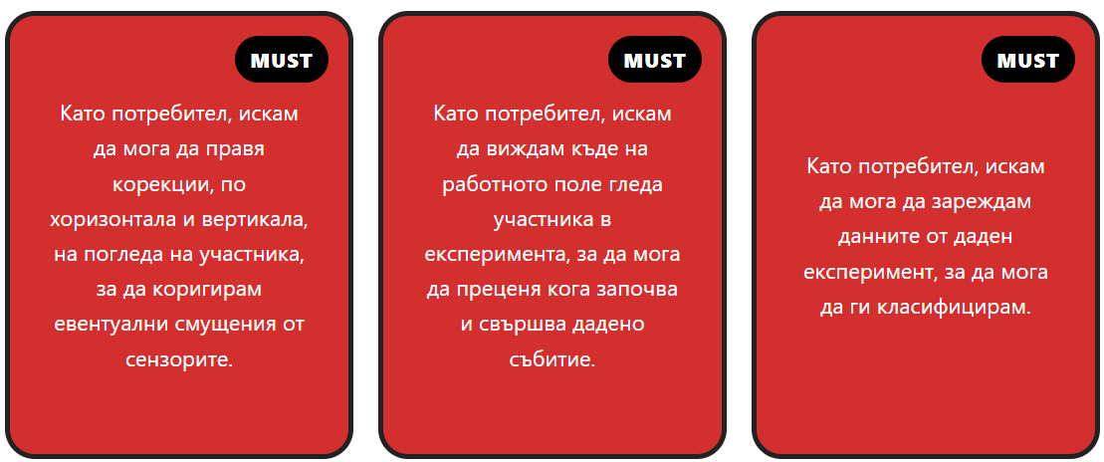
Фигура 1.1. Функционални изисквания

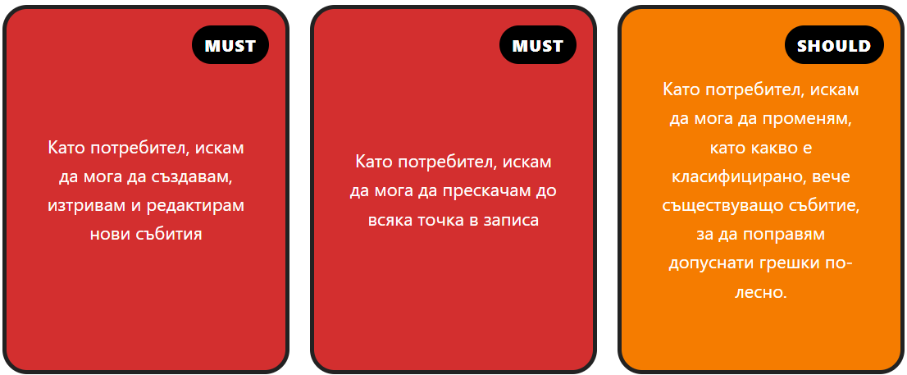
Фигура 1.2. Функционални изисквания

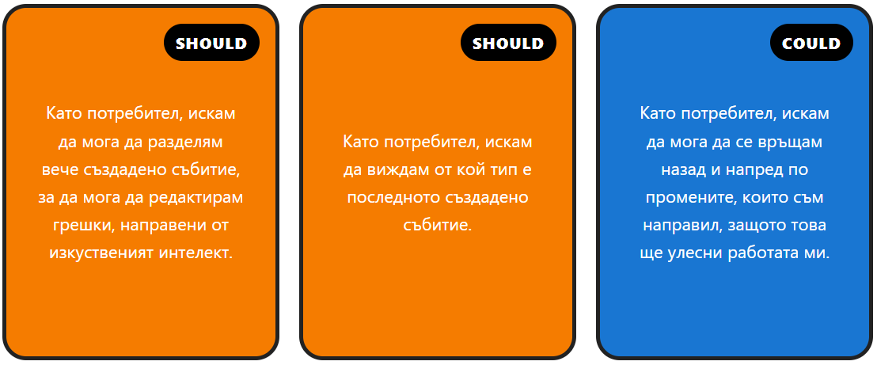
Фигура 1.3. Функционални изисквания

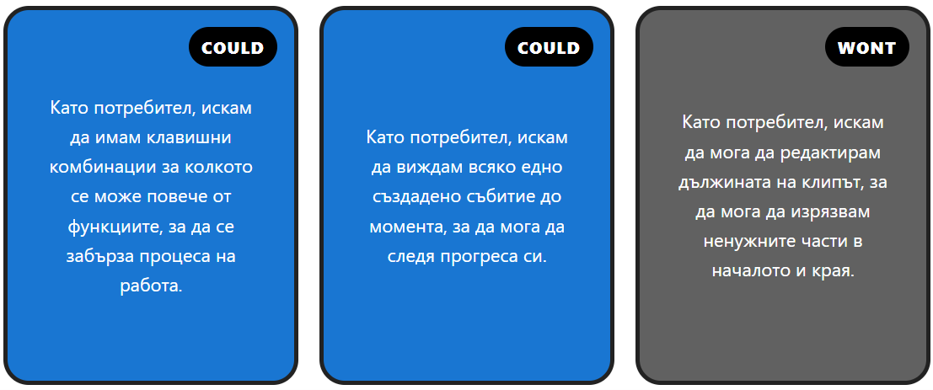
Фигура 1.4. Функционални изисквания

  - Choosing a programming language and environment
The Python programming language was chosen because of the availability of numerous graphical user interface libraries that allow rapid prototyping and development.
The Visual Studio Code text editor was chosen as the programming environment. This is because the support of multiple modules allows for enormous flexibility in the size and functionality of Visual Studio Code, and this in turn guarantees the availability of a given functionality of the text editor at the moment it is needed.
  - Implementation of the software system
    - Description of the program modules
Module: Main coordinating module (LabelingApp)
Purpose: It manages the application lifecycle. It initializes all the main components, establishes connections between them using Qt's signal-slot mechanism, and coordinates data exchange between the user interface, video player, timeline, and event handler.
Dependencies:
- User interface management module;
- Video playback module;
- Event management module;
- Timeline module;
- Action history module;
- Data reading and writing module;
- A file containing constants;
- A file containing information about the current video;
- The PyQt6 library;
- The numpy library;

Interface:
Class LabelingApp in file /classes/LabelingApp.py

__init__() – Initializes the application, loads the data, creates all the main components, and establishes the connections between them.
init_shortcuts() – Registers all keyboard shortcuts.
update_overlay() – Updates the position of the visualized gaze point.
update_timeline_text() – Updates the current time and timeline.
fit_video() – Scales the video to fit the window size.
handle_add_event() – Handles adding a new event.
undo_event() / redo_event() – Manages the recovery of previous actions.
split_event() – Splits the current event.
change_event_start_time() / change_event_end_time() – They change the boundaries of the current event.
on_current_event_changed() – Synchronizes the selected event with the user interface.
on_events_change_requested() – Updates the timeline after changes to events. Saves the action in the action history module.

Module: User interface management
Purpose: Builds the application's graphical user interface. Creates and arranges all visual components, including the video window, timeline, controls, labeling buttons, and settings panel. Associates graphical elements with appropriate event handlers.вързва графичните елементи със съответните обработчици на събития.
Dependencies:
- Main coordinating module;
- The timeline module;
- The PyQt6 library;

Interface:
Class MainWindowUI in file /classes/MainWindowUI.py

setup_ui(parent) – It builds the entire graphical interface, creates all the visual components, and establishes the connections between them and the event handlers.
make_slider() – Creates and configures a slider for setting parameters.

Module: Timeline visualization
Purpose: Implements a graphical visualization of the video timeline. Displays the current playback position and all defined labeled events through colored intervals. Allows the user to change the current position of the video by selecting a desired position on the timeline.
Dependencies:
- The Event model
- A file containing constants;
- The PyQt6 library;

Interface:
Class TimelineWidget in file /classes/TimelineWidget.py

set_duration(duration) – Sets the total duration of the video and updates the preview.
set_position(pos) – Sets the current playback position and updates the indicator on the timeline.
set_events(events) – Sets the list of events to visualize and updates the timeline.
seek_requested(int) – A signal generated when a position is selected on the timeline. Used to change the current position of the video.

Module: Manage action history
Purpose: Provides the ability to restore previous and reapply undone changes to the event list. Implements Undo/Redo functionality.
Dependencies:
- Data presentation module;
- The Event and CurrentEvent models;
- The standard library copy;

Interface:
Class Snapshot and Class TimeMachine in file /classes/TimeMachine.py

Snapshot(events, last_event) – Creates a snapshot of the current state, containing the event list and the currently selected event.
TimeMachine(events, last_event, max_snapshots=10) – Initializes the change history.
take_snapshot(events, current_event) – Writes a new state to history and removes all future states after the current one when a new change occurs.
undo() – Restores the previous state of the event list and the currently selected event.
redo() – Restores the next state from history.

Module: Video playback control
Purpose: Provides control over video playback. It implements the basic operations of starting, stopping, moving to a specific point, and moving relative in time. It also creates and manages the graphic element used to visualize the gaze point on the video.
Dependencies:
- The PyQt6 library;

Interface:
Class VideoPlayer in file /classes/VideoPlayer.py

toggle_play() – switches between play and pause.
jump_to_time(time) – moves playback to a specified point.
seek(time) – moves the current position by a relative offset.
    - Structure and organization of the programming interface
When developing the user interface, the main goal is the quick and easy classification of data. For this reason, a large part of the system's functions are accessible only through keyboard shortcuts.
Only those functions that allow the user to configure the system, correct errors, navigate through the record, or those that remind him of the last action performed are depicted as graphic elements.
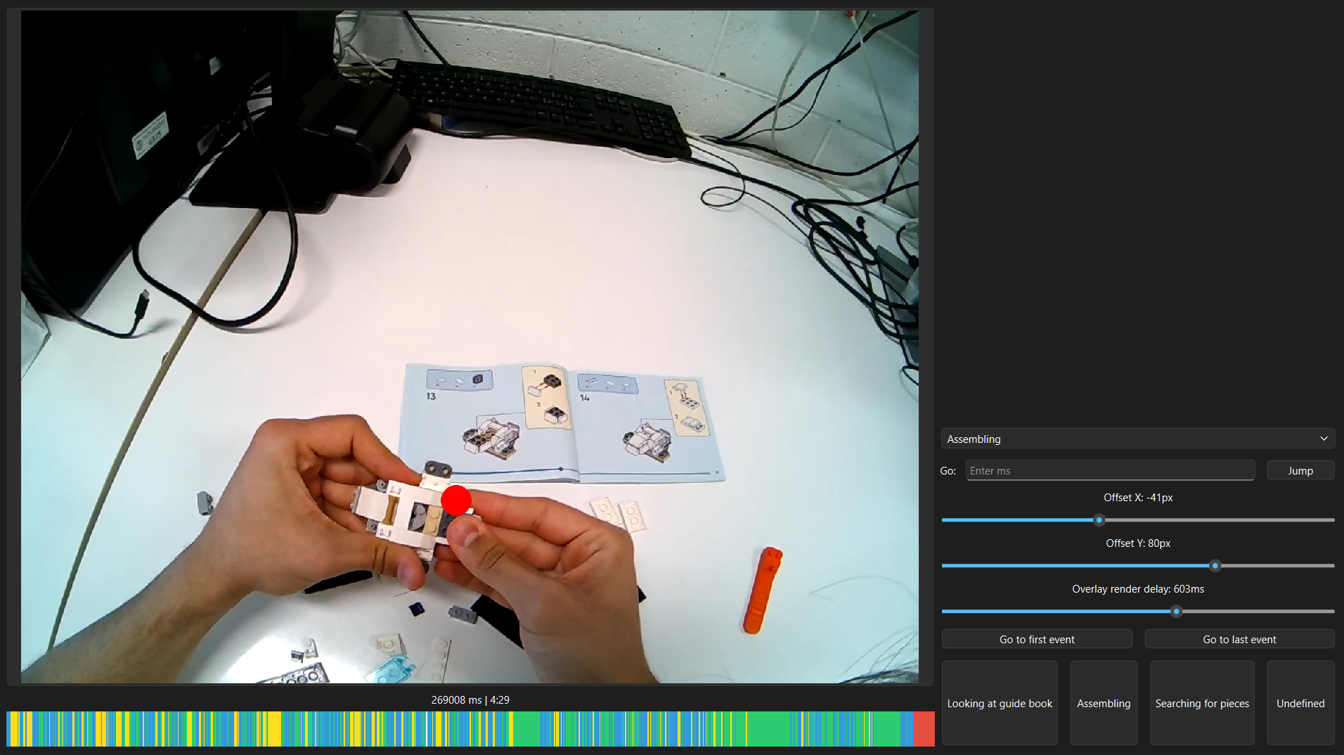
The main graphic element is the video recording being played. It has an aspect ratio that takes up the maximum part of the application in order to make it as easy as possible to notice the details. A red dot is superimposed on the recording, which shows where the participant in the experiment is looking in the given frame.
Below it is the elapsed time, from the beginning of the recording, in milliseconds and minutes. The decision to display it in milliseconds was made for the purpose of easier comparison of the current frame with the already existing data. This is because the majority of time data is measured in milliseconds.
Immediately after the elapsed time is the timeline. Its purpose is to depict where in time the current frame is located, as well as what the time segment in which it is located is categorized as. This is achieved by depicting the current frame with a horizontal white line, and the time segment with a rectangle of a different color, relative to the given category. The left side of the rectangle is located at the beginning of the given event, and the right side is located at the end.
All other elements are located to the right of the playing track.
The first of these is a drop-down menu. It allows you to see what the current time segment is categorized as and change it if necessary.
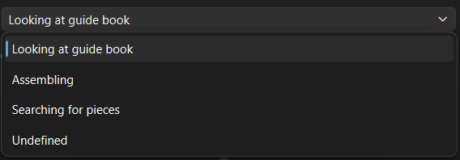
Below the drop-down menu, there is a section that allows the user to jump directly to a frame located at a given millisecond from the beginning of the recording. This is done through a text field in which the given millisecond is written, and a button that, when pressed, jumps the recording to the given millisecond. This section has been added to make it easier to check a specific time fragment taken from the csv file in which the time fragments are written.
The next section allows the user to adjust the red dot that indicates where the participant is looking in a given frame. The user can add horizontal and vertical offset, as well as offset the dot in time. This is done using three sliders.
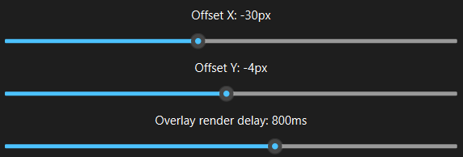
The last two sections allow event-related control, with the first of them allowing the selection of the first or last created time segment. Thanks to this, it is easier to temporarily stop and resume the classification of the recording.
The last section consists of four buttons, each labeled with one of the four categories. When one of them is pressed, the current time segment is categorized with the corresponding category, and the button changes color. This way, the user always knows what the last selected category was.
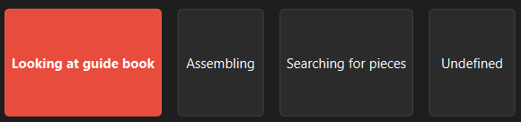
  - Input and output data format

- Development environment and remote access
JupyterLab was chosen as the development environment because it is one of the most common solutions for developing and experimenting with machine learning models. The platform supports notebooks, which allow the combination of code, visualizations, and documentation in a single document.
The choice to install a local instance of JupyterLab was made in order to avoid dependency on a foreign platform, as well as to allow the entire experiment to be as reproducible as possible.
To achieve this goal, Docker was used. Docker is a containerization platform that allows the development and execution of applications in isolated environments called containers. [1]
Containerization in this case is achieved through a Docker container. A Docker container is a standardized unit for distributing and executing software that contains the application and all the dependencies necessary for its operation. This allows the application to function in the same way in different execution environments. [1]
  - Creating a Docker image
A Docker image is created to create the container. A Docker image is an immutable template that contains the necessary instructions and files to create a Docker container. [1]
The created Docker image contains the following directives:
FROM nvidia/cuda:12.1.1-runtime-ubuntu22.04
WORKDIR /workspace
RUN apt-get update && apt-get install -y python3-pip git && rm -rf /var/lib/apt/lists/*
RUN pip install --no-cache-dir fastai jupyter matplotlib pandas scikit-learn polars
EXPOSE 8888
CMD ["jupyter", "lab", "--ip=0.0.0.0", "--port=8888", "--no-browser", "--allow-root"]
The FROM directive indicates which other image this image is based on. [2] In this case, it is based on the image “nvidia/cuda:12.1.1-runtime-ubuntu22.04”
The WORKDIR directive specifies the working directory, and if it does not exist, it will be created. The working directory indicates where subsequent directives that have something to do with the file system will be executed. [2] In this case, the working directory is “/workspace”
The RUN directive specifies a command to be executed during the image creation [2]. Here, we specify the command apt-get update && apt-get install -y python3-pip git && rm -rf /var/lib/apt/lists/*
This command is actually a combination of 3 commands, namely apt-get update, apt-get install -y python3-pip git, and rm -rf /var/lib/apt/lists/*. These commands are separated by &&. These two characters represent the logical AND operator, used to execute commands sequentially in Unix-like operating systems. The next command is executed only if the previous one completed successfully with an exit code of 0. [3]
The first two commands start with apt-get. This is a console-based package manager.
The apt-get update command updates the local package index by retrieving up-to-date information from the configured software repositories (/etc/apt/sources.list). This way, the system receives information about the available versions of the packages before installing or updating them. [4]
The apt-get install command installs or updates all the libraries listed after it. [4] In this case, we are installing the python3-pip and git libraries. The -y flag is added to ensure that all requests are automatically confirmed during the installation. This is necessary when building Docker images, since the process is performed automatically and does not allow interactive user input.
The rm command removes all found files or directories that match the following parameter. [5] In this case, everything in the /var/lib/apt/lists/ directory is removed in order to reduce the size of the image. Two flags are used, the first of which is -r. This flag allows the command to recursively remove everything in a given directory [5]. The -f flag tells the command not to display any messages and not to throw errors if the given directory does not exist. [5]
The next command that we put before the RUN directive is pip install --no-cache-dir fastai jupyter matplotlib pandas scikit-learn polars
pip is the most common and frequently used package manager for Python. It allows you to find, download, and install packages from the Python Package Index (PyPI), as well as other packages. [6]
The install command tells pip that the following libraries should be installed. [7] The –no-cache-dir option tells pip that no cache should be stored when installing the given libraries. [8] Here again, the goal is to keep the image size as small as possible.
The EXPOSE 8888 directive specifies that the application in the container listens on port 8888. It is informative and does not automatically publish the port to the host system. [2]
The CMD directive defines the default command that is executed when the container starts. [2] In this case, a JupyterLab server is started, connecting to all network interfaces in the container (0.0.0.0) and using port 8888. The --no-browser option prevents the automatic opening of a browser [9], and --allow-root allows execution with root privileges. [9]
  - Creating a compose.yml file
Compose files are files that allow the user to configure and orchestrate multiple containers at once. [10] In this case, compose.yml is used to ensure the reproducibility of the runtime environment. This is because otherwise all additional commands, except for the name of the image we want to use, would have to be written separately each time the container is created.
As you can see from the file extension, this file is a YAML file. YAML is a human-readable data serialization language used to represent structured data. [11]
In this case, compose.yml looks like this:
services:
fastai_and_jupyter:
image: fastai-jupyter-lab
container_name: fastai-jupyter-lab
ports:
- "8888:8888"
volumes:
- ../notebooks:/workspace/notebooks # Notebooks
- ../data:/workspace/data # Used for datasets
deploy:
resources:
reservations:
devices:
- capabilities: [gpu]
stdin_open: true
tty: true
The services element is a set of container service configurations, with each service defining a way to create one or more containers. [12] This is a required element, without which we cannot describe the rest of the file.
The fastai_and_jupyter element is created by the user, it is the name of the service.
The image element specifies which image will be used to create the service. [12] In this case, fastai-jupyter-lab is used, as this is the name of the image that was created previously
The container_name element specifies the name of the container. [12] Here, the container is the same as the image – fastai-jupyter-lab.
The ports element is used to define the relationship between the machine ports and the container ports. [12] First, the host machine port is specified, and then which port on the container it should correspond to. In this case, port 8888 on the machine will correspond to port 8888 on the container.
The volumes element is used to mount directories from the host system to the container file system, allowing data to be shared and saved between them. [12] In this case, we can see that two directories are being mapped – the ../notebooks directory on the host machine to the /workspace/notebooks directory on the container, and the ../data directory on the host machine to the /workspace/data directory on the container.
The deploy element specifies additional information about how the containers will be executed. [13]
The resources element specifies the physical resource constraints. [13]
The reservations element tells the system that the following defined resources must be made available to the container; if this is not possible, the container will not be created. [13]
The devices element reserves a specific hardware device. [13]
The capabilities element specifies which device to reserve. [13]
The stdin_open and tty elements together serve to create a terminal for the purpose of an interactive session. [14]
  - Remote access
Since the development environment needs to be accessed remotely,
- Creating and training the model
  - Input data
After classifying the data using the application developed for this purpose, the following useful files are available for each participant in the experiment: "3d_eye_states.csv", "blinks.csv", "fixations.csv", "gaze.csv", "imu.csv", "labels.csv" and "saccades.csv".
These are files in the .csv format. This format is used to store plain text data that represents a worksheet. This is done by treating each new line in the file as a separate row in the table, and the values ​​in that row are separated by a comma. Each value defines a separate column in the table. The values ​​in the first row of the file are treated as the headers of the corresponding column. [1]
Each of the files contains the column “recording id”, which serves to identify the given recording, and its value is unique for all records. The column is used repeatedly in organizing and pre-processing the data, as described in the next subsection.
The files “3d_eye_states.csv”, “gaze.csv” and “imu.csv” share the same column, namely “timestamp [ns]”. This column shows in which nanosecond the given measurement was made.
The files “fixations.csv”, “saccades.csv” and “blinks.csv” share three identical columns, namely “start timestamp [ns]”, “end timestamp [ns]” and “duration [ms]”. The first two show in which nanosecond the beginning and end of the given event occurred, and the third – how many milliseconds the given event lasted. Each of these files also has a column that shows the identification number of the given event. The name of this column is a suffix of the given file name, and the word “id” separated by a space.
The file “labels.csv” also has two columns indicating the start and end of the event, but the unit of measurement is milliseconds. Their names are “start timestamp [ms]” and “end timestamp [ms]” respectively.
All other columns, in separate files, are:
3d_eye_states.csv – Contains the physical parameters of the eye, which indicate its current state such as: pupil diameter left/right [mm], eyeball center left/right x/y/z [mm], optical axis left/right x/y/z, eyelid angle top/bottom left/right [rad], and eyelid aperture left/right [mm]. This information is largely used by the Pupil Labs model to extract additional data, which is stored in the files below.
blinks.csv – Contains no additional columns other than those listed above.
fixations.csv – Contains information about each fixation such as the position of the work area in pixels (fixation x/y [px]), as well as the horizontal (azimuth [deg]) and vertical (elevation [deg]) angle relative to the center of gaze measured in degrees.
saccade.csv – Contains the distance between the start and end points of the saccade in pixels (amplitude [px]) and in degrees (amplitude [deg]). It also stores the maximum and average saccade velocity as pixels per second (peak velocity [px/s], mean velocity [px/s])
gaze.csv – Stores information about the gaze as a whole. The position of the gaze on the work area in pixels (gaze x/y [px]), as well as the horizontal (azimuth [deg]) and vertical (elevation [deg]) angle relative to the center of gaze measured in degrees. The blinks id and fixation id columns indicate the sequential number of the fixation or blink, if any. Additionally, it contains information about whether the glasses were worn at a given time (worn).
imu.csv - Contains data from the inertial measurement module (IMU) of the glasses. The columns "gyro x/y/z [deg/s]" represent the angular velocity around the three axes, measured in degrees per second, and "acceleration x/y/z [g]" - the linear acceleration along the three axes, measured in units of the acceleration of gravity (g). The columns "roll [deg]", "pitch [deg]" and "yaw [deg]" describe the orientation of the glasses using the three Euler angles, measured in degrees. The columns "quaternion w/x/y/z" represent the same orientation in the form of a quaternion.
label.csv - Additionally, it contains the column "label", which indicates how the given time range is identified.
  - Data pre-processing

  - Choosing a machine learning model
  - Training methodology

- Main results
  - Сравнение на

- Conclusions and recommendations

- References
2. Introduction
2.2 The characteristics of the gaze
[1] http://www.scholarpedia.org/article/Eye_movements

2.3 Gaze tracking
[1] https://pupil-labs.com/blog/what-is-eye-tracking
[2] https://wires.onlinelibrary.wiley.com/doi/abs/10.1002/wcs.1323?casa_token=A_yvrpreDXQAAAAA%3AUGndcySO1wi56WqXFlTgPqBkR9FlLVP8RxMSj6QIPMhuDNNPp5NIemmPYsQR3wbfLLM8oX2ciWalFbs
[3] https://pp.bme.hu/eecs/article/view/10736
[4] https://www.sciencedirect.com/science/article/pii/S1878929316300846
[5] https://ieeexplore.ieee.org/abstract/document/4743785

4. Description of experiment and data collection hardware
[1] https://lego.bravostore.bg/products/lego-creator-31134
[2] https://pupil-labs.com/products/neon
[3] https://pupil-labs.com/products/neon/specs
[4] https://pupil-labs.com/products/neon/neonnet
[5] https://pupil-labs.com/products/neon/software
[6] https://pupil-labs.com/about

6. Development environment and remote access
[1] https://docs.docker.com/get-started/docker-overview/
[2] https://docs.docker.com/reference/dockerfile/
[3] https://www.gnu.org/software/bash/manual/html_node/Lists.html
[4] https://people.debian.org/~jak/apt-doc/man/apt-get.8.html
[5] https://www.ibm.com/docs/en/aix/7.1.0?topic=r-rm-command
[6] https://packaging.python.org/en/latest/key_projects/#pip
[7] https://pip.pypa.io/en/stable/cli/pip_install/#pip-install
[8] https://pip.pypa.io/en/stable/topics/caching/
[9] https://jupyter-server.readthedocs.io/en/latest/other/full-config.html#options
[10] https://docs.docker.com/compose/
[11] https://yaml.org/spec/1.2.2/#chapter-1-introduction-to-yaml
[12] https://docs.docker.com/reference/compose-file/services/
[13] https://docs.docker.com/reference/compose-file/deploy/
[14] https://docs.docker.com/reference/cli/docker/container/run/#interactive

7. Creating and training the model
7.1 Input data
[1] https://en.wikipedia.org/wiki/Comma-separated_values
- Applications
APPLICATION А
Declaration of informed consent
