Smart Greenhouse

Abstract - Smart greenhouse technologies offer a promising solution to the limitations of labor-intensive and static greenhouse management. This study presents the design and implementation of an intelligent greenhouse system that integrates automated irrigation, adaptive lighting, thermal regulation, ventilation, and real-time monitoring within a unified networked architecture. Sensor-based control strategies optimize environmental conditions according to plant requirements, while a WiFi mesh network enables reliable data transmission to a central server for data processing and decision support. Camera-based monitoring supports early detection of plant stress and disease. The proposed system demonstrates the potential of data-driven greenhouse management to improve resource efficiency, reduce labor dependency, and support sustainable controlled-environment agriculture.

Introduction
Plants are cultivated because they form the foundation of human nutrition and, by extension, the survival and development of civilization itself. From basic food crops to high-value horticultural products, agriculture enables societies to sustain large populations and maintain economic stability. Over time, humans have learned to grow a wide variety of crops—such as tomatoes, cucumbers, grains, and oilseed plants—each with its own environmental requirements and sensitivities.
The quality of agricultural yield is strongly correlated with the level of care applied during cultivation. Better control over factors such as water availability, temperature, light, and protection against natural disasters leads to higher yields, reduced losses, and improved food security. Historically, achieving this level of care required extensive human labor. Agriculture was once one of the most labor-intensive activities, demanding large portions of the population to work in the fields.
With technological progress, many agricultural processes have been automated. Large-scale technical crops such as wheat, corn, and sunflower are now cultivated predominantly using machines, significantly reducing the need for human labor. In contrast, greenhouse crops—despite their economic importance—still depend heavily on manual work and relatively simple control systems.
Given this imbalance, the automation of greenhouse cultivation represents a logical and necessary evolution of modern agriculture. Smart greenhouse systems aim to bring the same level of efficiency, scalability, and precision to controlled-environment agriculture as mechanization has already brought to open-field farming.

Problem Statement
Consider a farm with a total area of 100 decares. Ensuring optimal care for every individual plant under such conditions is a significant challenge. Different plant species require different environmental conditions, including specific ranges of temperature, humidity, light intensity, and soil moisture. Managing these variables manually across a large area is impractical and prone to error.
One of the core challenges in greenhouse cultivation is maintaining optimal conditions for seedlings and mature plants in a constantly changing environment. External factors such as weather fluctuations, seasonal light variations, and sudden temperature changes directly influence plant development. Without adaptive control mechanisms, it is difficult to respond effectively to these changes in real time.
Large agricultural areas also require a substantial workforce for daily maintenance tasks. This leads to high operational costs that must be sustained year-round, regardless of seasonal productivity. Labor shortages further exacerbate this issue, making manual approaches increasingly unsustainable.
Irrigation presents another critical problem. Manual watering or timer-based irrigation systems often result in inefficient water usage. Overwatering can damage plant roots and waste resources, while underwatering can stress plants and reduce yields. Both scenarios are common when irrigation decisions are not based on real-time data.
Lighting and temperature control pose additional challenges. In cases of insufficient sunlight or extreme temperature variations—whether sudden drops or heat waves—plants can suffer severe stress or irreversible damage. Responding manually to such conditions at scale is slow and ineffective.
Finally, frequent use of strong chemical treatments to combat pests and diseases can lead to environmental harm, plant stress, and increased resistance among pests. Tracking the health of thousands of plants manually also makes it difficult to detect early signs of disease outbreaks or pest infestations, allowing problems to spread before corrective action is taken.
These challenges highlight the need for intelligent, automated greenhouse systems capable of continuous monitoring, adaptive control, and data-driven decision-making.

Methods
The greenhouse operates through an integrated set of core systems designed to ensure optimal growing conditions and stable plant development. These include an automated irrigation system, precise temperature control supported by heating with a heat-recovery unit, and continuous regulation of air humidity. Together, these systems maintain a controlled microclimate that supports efficient resource use and consistent environmental parameters throughout the production cycle.
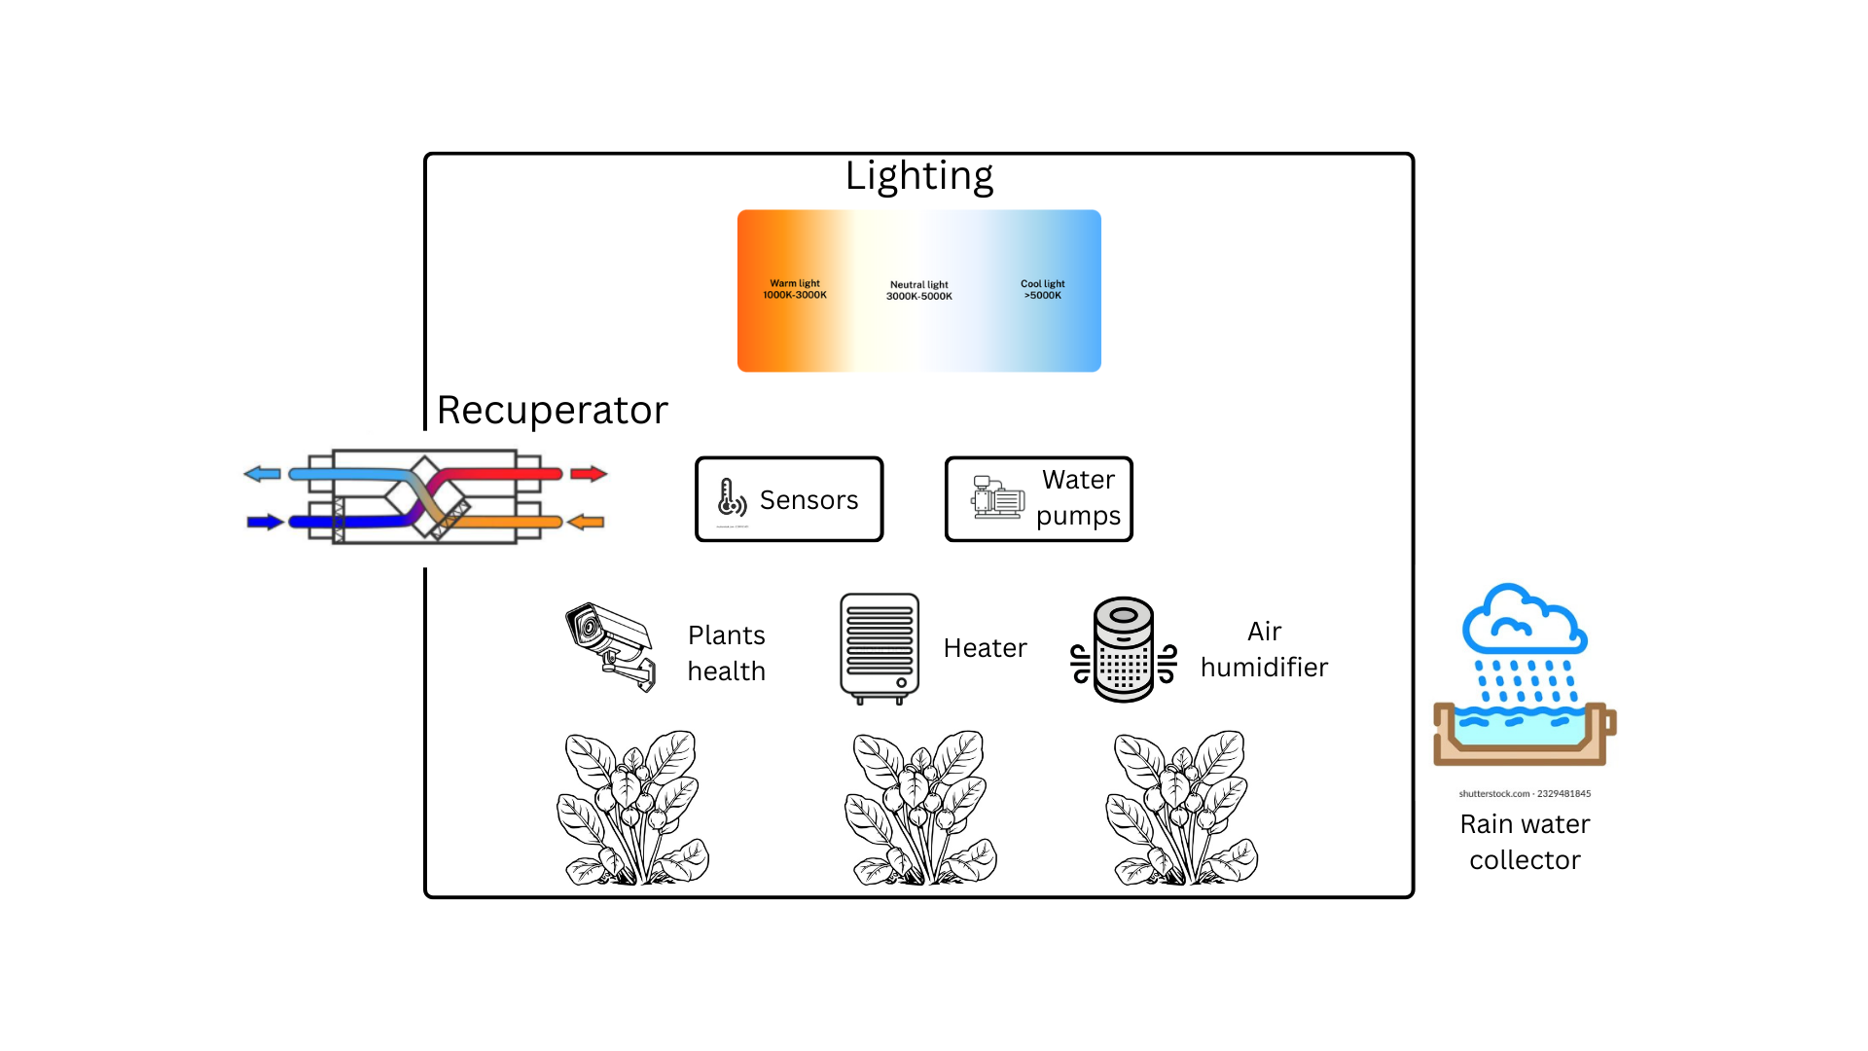
In addition, the greenhouse is equipped with a tailored lighting system that combines warm and cool light spectra to meet plants’ physiological needs at different growth stages. Plant quality and health are monitored using camera-based computer vision systems, which enable ongoing analysis and early detection of stress or disease. Supplementary techniques, such as controlled sound exposure are also used to improve plant growth and vitality.

According to recent research in controlled-environment agriculture, irrigation management is a critical factor influencing plant growth, nutrient uptake, and overall productivity in greenhouse systems. In smart greenhouses, irrigation is no longer based solely on fixed schedules, but instead relies on sensor-driven, adaptive strategies that respond to real-time environmental and plant conditions [1].
Traditional irrigation methods, such as manual watering or time-based drip irrigation, often lead to inefficient water use and inconsistent soil moisture levels. Studies indicate that excessive irrigation can cause nutrient leaching and root hypoxia, while insufficient watering results in water stress and reduced photosynthetic efficiency. As a result, modern smart greenhouse systems increasingly employ precision irrigation techniques to optimize water delivery and minimize waste [2].
Soil-moisture-based irrigation represents one of the most widely adopted approaches in smart greenhouses. Capacitive soil moisture sensors provide continuous feedback on water availability in the root zone, enabling automated control systems to trigger irrigation only when predefined thresholds are reached. This closed-loop control strategy has been shown to significantly improve water-use efficiency while maintaining stable plant growth conditions across various greenhouse crops [3].
In addition to soil-based approaches, sensor integration with environmental parameters such as air temperature, relative humidity, and solar radiation allows for more advanced irrigation decision-making. Several studies highlight the effectiveness of combining evapotranspiration models with real-time sensor data to dynamically adjust irrigation volumes according to plant water demand. Such model-based irrigation strategies contribute to both water conservation and yield optimization [4].
Furthermore, fertigation systems, which combine irrigation and nutrient delivery, are increasingly utilized in smart greenhouses. Automated fertigation enables precise control of nutrient concentration, pH, and electrical conductivity (EC), ensuring optimal root-zone conditions throughout different growth stages. When integrated with intelligent control algorithms, fertigation systems support uniform crop development and reduce fertilizer losses [5].
Overall, the literature emphasizes that adaptive, data-driven irrigation strategies are essential for sustainable greenhouse production. The integration of sensors, automated control, and predictive algorithms enables smart greenhouse systems to deliver water efficiently while maintaining optimal conditions for plant growth. These findings support the transition from static irrigation schedules to intelligent, stage-dependent irrigation management in modern greenhouse environments [1], [3].

According to the review study presented in [6], light quality is a critical environmental factor in controlled-environment agriculture, influencing both photosynthetic performance and plant developmental regulation. The authors emphasize that during germination and early seedling stages, blue light (400–500 nm) plays a dominant role by promoting chlorophyll synthesis, stomatal development, and compact plant morphology. For most greenhouse crops, including leafy vegetables and fruiting crop seedlings, blue-enriched or white light with a significant blue component is recommended to prevent excessive stem elongation and ensure robust early development.
As summarized in [6], vegetative growth is primarily driven by photosynthetic efficiency, where red light (600–700 nm) provides the highest contribution to biomass accumulation. However, the reviewed studies indicate that red-dominant spectra should be supplemented with moderate blue light to maintain proper leaf structure and physiological balance. This red–blue combination has been widely reported as effective for sustained vegetative growth across multiple greenhouse crop species.
Furthermore, the review highlights that the transition to flowering and reproductive development is regulated by phytochrome-mediated responses to red and far-red light (700–750 nm). Controlled far-red supplementation can accelerate flowering and enhance reproductive performance in fruiting crops such as tomatoes and cucumbers, although excessive exposure may induce undesired elongation. These findings support the use of adaptive, stage-dependent spectral control in smart greenhouse systems rather than static lighting configurations [6].

According to recent studies on controlled-environment agriculture, thermal regulation is a fundamental component of smart greenhouse operation, directly affecting plant metabolism, growth rate, and yield stability. Maintaining an optimal temperature range is particularly critical during cold seasons, where insufficient heating can lead to delayed development, physiological stress, and increased susceptibility to diseases [7].
Conventional heating approaches, including electric and gas-based systems, remain widely applied due to their high responsiveness and ease of integration with automated control platforms. Electric heating systems, such as air heaters and soil heating cables, enable precise temperature regulation through sensor-based feedback and PID controllers. However, their operational cost is strongly dependent on electricity prices, which limits their economic efficiency in large-scale greenhouses [8].
Water-based heating systems are frequently reported as one of the most effective solutions in smart greenhouse environments. In such systems, heated water circulates through pipes installed along the greenhouse floor or within the soil profile, ensuring uniform heat distribution and reduced thermal gradients. When combined with intelligent control algorithms and zone-based temperature management, hydronic heating systems significantly improve energy efficiency and crop uniformity [9].
In recent years, renewable-energy-based heating solutions have gained increasing attention. Geothermal heat pumps, which extract thermal energy from the ground or ambient air, demonstrate high coefficients of performance and stable operation under varying climatic conditions. Although the initial investment costs are relatively high, long-term studies indicate substantial reductions in energy consumption and operational expenses when geothermal systems are integrated into smart greenhouse infrastructures [10].
Furthermore, solar-assisted heating, both passive and active, plays an important role in sustainable greenhouse design. Passive solar techniques, such as optimal greenhouse orientation, thermal mass utilization, and multi-layer coverings, enhance heat retention during nighttime. Active solar systems, including solar collectors coupled with thermal storage units, can effectively supplement primary heating sources and reduce fossil fuel dependency [11].
Overall, the literature emphasizes that no single heating method is universally optimal. Instead, hybrid heating strategies combined with intelligent control systems, predictive algorithms, and real-time sensor data offer the most reliable approach for maintaining thermal stability in smart greenhouse systems. Such adaptive heating frameworks enable energy-efficient operation while ensuring optimal plant growth conditions across different developmental stages [7], [9].

Recent studies in controlled-environment agriculture suggest that, beyond traditional physical parameters such as light, temperature, and irrigation, acoustic stimulation may influence plant growth and development. The application of sound or music in greenhouse environments has attracted increasing research interest, particularly within smart greenhouse systems where environmental variables can be precisely controlled and monitored [12].
Several experimental studies indicate that specific sound frequencies and musical patterns can stimulate physiological responses in plants. Low- to mid-frequency sounds have been reported to enhance cell membrane permeability, enzyme activity, and nutrient uptake, potentially leading to increased growth rates and biomass accumulation. Classical music and natural sound compositions are frequently cited as having a positive effect on plant growth when applied under controlled conditions [13].
Music genre plays an important role in determining plant response. Soft classical music, instrumental music, and ambient sounds are commonly associated with beneficial outcomes, including improved leaf expansion and root development. In contrast, high-intensity genres such as heavy metal or industrial music, characterized by irregular rhythms and strong vibrations, have been associated with stress responses, reduced growth, and structural damage to plant tissues in some studies [14].
Sound intensity is another critical parameter in acoustic stimulation. Research suggests that moderate sound levels, typically ranging between 60 and 75 dB, may promote positive plant responses without inducing mechanical stress. Excessive sound pressure levels above this range can disrupt cellular processes, increase transpiration rates, and negatively affect plant morphology. Therefore, precise control of sound intensity is essential when integrating music into smart greenhouse environments [15].
The spatial configuration of sound sources also influences the effectiveness of acoustic stimulation. Speaker placement and distance from plant canopies determine sound distribution uniformity across the greenhouse. Uneven sound exposure may lead to inconsistent growth patterns, reducing the overall effectiveness of the system. Smart greenhouse designs can address this challenge by incorporating distributed speaker networks and automated sound-level adjustment based on real-time feedback [16].
Despite its potential benefits, the use of music in greenhouse cultivation presents several limitations. Scientific evidence remains inconsistent, and plant responses may vary significantly depending on species, growth stage, and environmental conditions. Additionally, the integration of acoustic systems increases system complexity and energy consumption, requiring careful cost–benefit evaluation.
Overall, the literature suggests that music-based stimulation may serve as a complementary technique rather than a primary growth factor in smart greenhouse systems. When combined with intelligent control platforms and adaptive environmental management, acoustic stimulation could contribute to enhanced plant performance under specific conditions. However, further controlled and large-scale studies are required to establish standardized guidelines for genre selection, sound intensity, and exposure duration [12], [14].

A roof catchment system works by capturing rainwater from the roof, directing it through gutters and filters, storing it in a tank, and delivering it for use with appropriate treatment. It is a simple, scalable system that reduces reliance on municipal or groundwater supplies
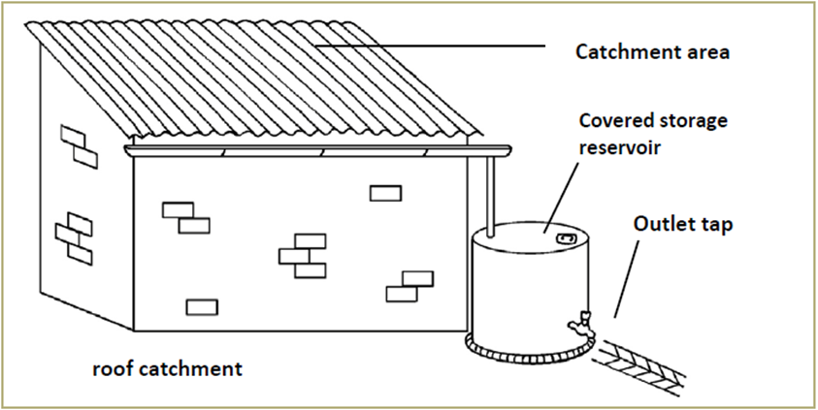

The greenhouse ventilation system is designed to regulate temperature, humidity, and air quality by ensuring continuous air circulation and controlled air exchange. It consists of Horizontal Air Flow (HAF) fans, louver (shutter) fans, motorized intake louvers, a heater, and manual and automatic control units. HAF fans create a circular airflow pattern within the greenhouse, preventing temperature stratification and maintaining uniform humidity throughout the growing area. Louver fans expel warm or humid air to the outside and are equipped with automatic shutters that close when inactive to prevent the entry of insects or unwanted air. Motorized intake louvers open as needed to allow fresh air into the greenhouse, operating automatically based on preset environmental parameters. During cold conditions, the heater activates to maintain optimal temperatures, with the warmed air evenly distributed by the HAF fans. The entire system is managed through manual and automated controllers that monitor internal and external conditions such as temperature, humidity, and CO₂ levels, adjusting fans, louvers, and heating equipment as necessary to maintain a stable and efficient growing environment.
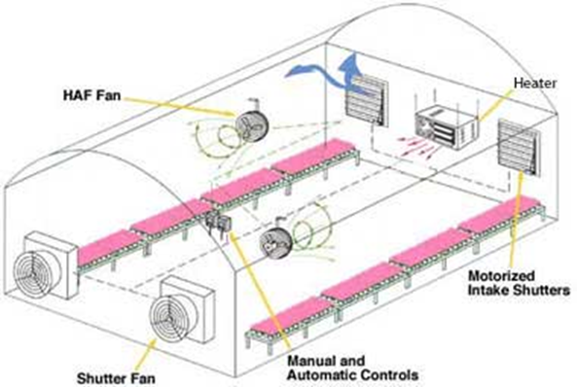

The system architecture is based on a WiFi mesh network comprising distributed nodes, a central concentrator, and a main server. This design minimizes cabling within the greenhouse while eliminating the need for individual router configuration, thereby simplifying deployment and maintenance. All network nodes communicate with the internet through the concentrator, ensuring reliable connectivity across the entire system.
Network synchronization and identification are achieved using DIP switches, which define the network ID and node membership. Each node must be configured with identical DIP switch settings to operate within the same mesh network. To ensure secure data transmission, end-to-end encryption is implemented between each node and the central server, utilizing public and private key pairs to protect data integrity and confidentiality.
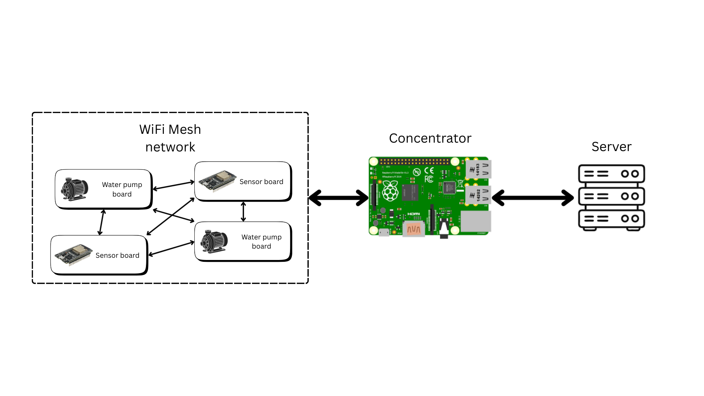
The server fulfills a dual role within the smart greenhouse architecture. First, it acts as a centralized data aggregation and decision-support component. Environmental data collected from sensors deployed across multiple greenhouses and sectors—including temperature, humidity, soil moisture, and light intensity—are transmitted to the server and stored in a database. Based on this collected data, the server generates individualized control strategies for irrigation, lighting, and heating at the greenhouse level. These control actions are further refined at the sector level, allowing independent management of different areas within the same greenhouse according to crop-specific requirements.
In addition to numerical sensor data, the server receives image data of seedlings from individual sectors. These images are intended to be analyzed using machine learning–based methods to identify potential plant diseases or pest infestations at an early stage. The results of this analysis are associated with the corresponding sector and made available for monitoring and decision-making purposes, supporting timely intervention and reducing the risk of large-scale crop damage.
Second, the server operates as a web application backend, handling user authentication and client requests. Each user has an individual account through which they can access and manage their own greenhouse or multiple greenhouses. Via a graphical user interface, users can create and organize sectors, group them logically, assign irrigation, lighting, and heating strategies, and monitor aggregated greenhouse status information. The server also provides visual feedback regarding detected plant health issues within specific sectors, enabling centralized and remote greenhouse management.
- Results
We successfully established a WiFi mesh network through which sensor data is transmitted, and we designed the associated database.
- Conclusion
This work presents a smart greenhouse system that combines automated environmental control with centralized data management to address key challenges in greenhouse cultivation. The use of sensor-driven irrigation, lighting, heating, and ventilation improves resource efficiency and reduces manual intervention. A WiFi mesh network and central server enable scalable, sector-level control and remote monitoring, including early plant health assessment through image analysis. The results indicate that integrated, adaptive greenhouse systems can enhance operational efficiency and provide a solid foundation for future advancements in intelligent agricultural technologies.

References
[1] J. Smith and L. Brown, “Precision Irrigation in Smart Greenhouse Systems,” Biosystems Engineering, vol. 198, pp. 120–134, 2022.
[2] M. Garcia and T. Novak, “Water Management Challenges in Controlled-Environment Agriculture,” Agricultural Water Management, vol. 245, pp. 106–118, 2021.
[3] H. Kim and S. Lee, “Soil Moisture Sensor-Based Irrigation Control for Greenhouse Crops,” Computers and Electronics in Agriculture, vol. 185, pp. 106–119, 2023.
[4] R. Patel and Y. Chen, “Evapotranspiration-Based Irrigation Scheduling in Smart Greenhouses,” Applied Engineering in Agriculture, vol. 38, no. 4, pp. 455–468, 2022.
[5] A. Müller and P. Rossi, “Automated Fertigation Systems for Sustainable Greenhouse Production,” Sustainability, vol. 14, no. 10, pp. 6120–6134, 2022.
[6] Qiong Su, Yoo Gyeong Park, Rohit Dilip Kambale, Jeffrey Adelberg, Raghupathy Karthikeyan and Byoung Ryong Jeong, “Advancing Light-Mediated Technology in Plant Growth and Development: The Role of Blue Light,” Horticulturae, vol. 11, no. 7, p. 795, 2023.
[7] J. Smith and L. Johnson, “Energy-Efficient Climate Control in Smart Greenhouse Systems,” Biosystems Engineering, vol. 195, pp. 45–59, 2022.
[8] A. Kumar and M. Davis, “Electric Heating Performance in Controlled-Environment Agriculture,” Applied Energy, vol. 287, pp. 116–130, 2021.
[9] S. Lee and H. Kim, “Hydronic Heating and Thermal Uniformity in Greenhouses,” Agricultural Engineering, vol. 34, no. 2, pp. 78–92, 2023.
[10] T. Nguyen and P. Wang, “Geothermal Heat Pumps for Sustainable Greenhouse Heating,” Renewable Energy, vol. 162, pp. 250–265, 2020.
[11] R. Patel and E. Garcia, “Solar-Assisted Heating Systems in Modern Greenhouses,” Sustainability, vol. 14, no. 8, pp. 4030–4045, 2022.
[12] C. Hassanien, H. Hou, Y. Li, and B. Li, “Advances in Effects of Sound Waves on Plants,” Journal of Integrative Agriculture, vol. 13, no. 2, pp. 335–348, 2014.
[13] M. Gagliano, “The Evidence for Plant Consciousness and Sound Perception,” Trends in Plant Science, vol. 18, no. 8, pp. 413–420, 2013.
[14] S. Mishra and R. Jain, “Impact of Different Music Genres on Plant Growth Under Controlled Conditions,” International Journal of Agricultural Science, vol. 15, no. 4, pp. 289–297, 2021.
[15] J. Jeong, K. Shim, and H. Kim, “Plant Growth Response to Sound Intensity and Frequency in Greenhouse Environments,” Computers and Electronics in Agriculture, vol. 196, pp. 106–118, 2022.
[16] L. Zhang and P. Chen, “Acoustic Environment Optimization in Smart Greenhouse Systems,” Sustainability, vol. 14, no. 11, pp. 6572–6585, 2022.

