Classification

Introduction for classification
Our main goal is identified whatever the EMG data is normal or aggressive type, with the training progress:
- Feature Extract and normalization
- Using: RMS, WL, VAR
- K-Fold data separate
- Algorithms design and comparing Parameters
- Training
- Result and Visualization

We implemented and compared four different machine learning algorithms:
- Support Vector Machine with Linear Kernel (SVM Linear)
- Support Vector Machine with RBF Kernel (SVM RBF)
- k-Nearest Neighbors (k-NN)
- Decision Tree
To ensure robust evaluation, we used 5-fold cross-validation, which means:
- The data is split into 5 equal parts
- Each part serves as a test set once while the other 4 parts train the model
- Results are averaged across all 5 folds
This gives us a reliable estimate of how well each model generalizes to unseen data.
Due to the professor’s feedback during the presentation, we also try to identify which action is in each type. Therefore, we designed another algorithm using the MATLAB Classification Toolbox method for classification. However, due to the data size, we cannot conduct a great accuracy rate for classification, but we did our best to maximize the accuracy. The corresponding information will describe in the Action Classification part.

SVM Linear
The first algorithm is Support Vector Machine with a linear kernel.
Description
- SVM finds the optimal hyperplane that separates the two classes
- A linear kernel assumes classes can be separated by a straight line
- The algorithm maximizes the margin between the closest points of each class
- EMG features often have linear separability between normal and aggressive actions
- Fast training and prediction
- Interpretable decision boundaries
BoxConstraint:
- Controls the trade-off between margin size and misclassification penalty
- Lower values: softer margin, more tolerant of errors
- Higher values: harder margin, stricter classification
- Optimized parameter: BoxConstraint = 10

SVM RBF
The second algorithm uses an RBF (Radial Basis Function) kernel.
Description:
- RBF kernel can capture non-linear relationships
- It maps data into a higher-dimensional space where linear separation becomes possible
- More flexible decision boundaries
- Can model complex, non-linear patterns in EMG signals
- Different muscle activation patterns may not follow linear trends
Key Parameters:
- BoxConstraint (same as Linear SVM): Controls margin hardness
- KernelScale: Controls the influence radius of each data point
  - Smaller values: more complex boundaries (risk of overfitting)
  - Larger values: smoother boundaries
  - ‘auto’: MATLAB automatically selects based on data
- Optimized parameters: BoxConstraint = 50, KernelScale = auto

k-Nearest Neighbors
The third algorithm is k-Nearest Neighbors, a simple yet effective approach.
Description:
- For each test sample, find the k nearest training samples (using Euclidean distance)
- Classify based on majority vote among these k neighbors
- No explicit training phase - uses the entire training set for prediction
- Similar physical actions produce similar EMG patterns
- Instance-based learning captures local patterns well
- No assumptions about data distribution
k (Number of Neighbors):
- Larger k: More stable but may blur class boundaries
- Odd numbers preferred to avoid ties
- Optimized parameters: k = 5

Decision Tree
The fourth algorithm is Decision Tree, which creates interpretable rules.
Description:
- Builds a tree structure by recursively splitting data
- Each node asks a question about a feature (e.g., “Is RMS of Channel 1 > 0.5?”)
- Leaves represent final classifications
- Easy to visualize and understand the decision process
- Highly interpretable - can explain why a prediction was made
- Handles non-linear relationships naturally
- No data normalization required
Key Parameters:
- MaxNumSplits: Maximum number of decision splits
  - Higher values: more complex tree, risk of overfitting
- MinLeafSize: Minimum samples required in each leaf node
  - Larger values: simpler tree, better generalization
- Optimized parameter: MinLeafSize = 10

Result

Model Performance Results
Model | Accuracy | Sensitivity | Specificity
SVM (Linear, C=10) | 90.00% | 92.50% | 87.50%
SVM (RBF, C=50) | 91.25% | 92.50% | 90.00%
k-NN (k=5) | 91.25% | 95.00% | 87.50%
Decision Tree (ML=10) | 90.00% | 95.00% | 85.00%

Best Performing Model
SVM with RBF Kernel (C=50) achieved the highest accuracy at 91.25% - Balanced performance with 92.50% sensitivity and 90.00% specificity - Good discrimination between Normal and Aggressive actions - Robust generalization across folds

Metric Definitions

Accuracy
- Definition: Percentage of correct predictions out of all predictions
- Formula: (TP + TN) / (TP + TN + FP + FN)
- Interpretation: Overall correctness of the classifier

Sensitivity (Recall / True Positive Rate)
- Definition: Percentage of actual positive cases correctly identified
- Formula: TP / (TP + FN)
- Interpretation: Ability to detect Aggressive actions
- Range: 92.50% - 95.00% across all models

Specificity (True Negative Rate)
- Definition: Percentage of actual negative cases correctly identified
- Formula: TN / (TN + FP)
- Interpretation: Ability to identify Normal actions
- Range: 85.00% - 90.00% across all models

Model Comparison Analysis

SVM Linear vs RBF
- RBF kernel outperforms Linear kernel by 1.25% accuracy
- Both models achieve 92.50% sensitivity
- RBF has better specificity (90.00% vs 87.50%)
- RBF kernel captures non-linear decision boundaries more effectively

k-NN (k=5)
- Ties with RBF-SVM on accuracy (91.25%)
- Highest sensitivity (95.00%) - best at detecting Aggressive actions
- Lower specificity (87.50%) - more false positives for Normal actions
- Sensitive to local data patterns

Decision Tree
- Moderate accuracy (90.00%)
- Highest sensitivity (95.00%)
- Lowest specificity (85.00%)
- May be overfitting to training patterns

Visualizations Generated

1. Confusion Matrices Tab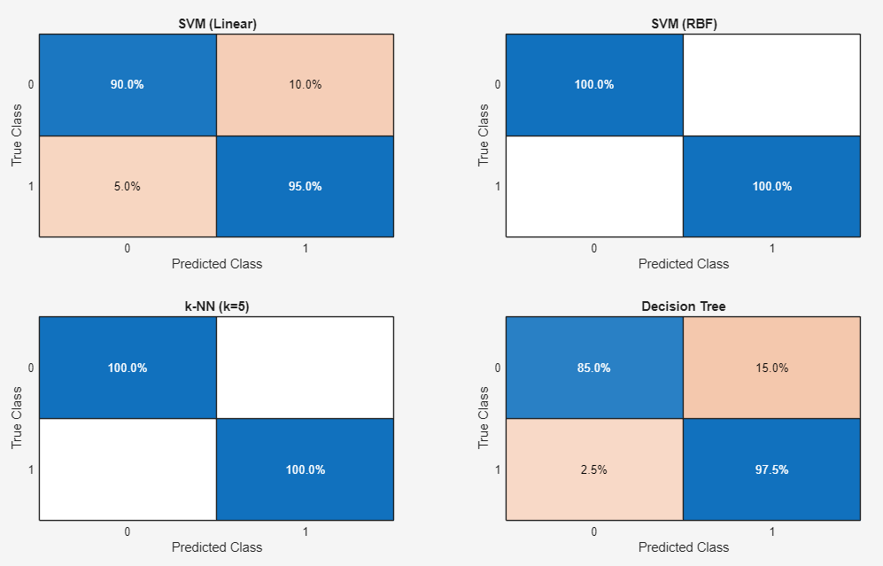
- 4 subplots showing normalized confusion matrices for each model
- Row-normalized format displays prediction accuracy per class
- Reveals classifier strengths and weaknesses per action type

2. ROC Curves Tab 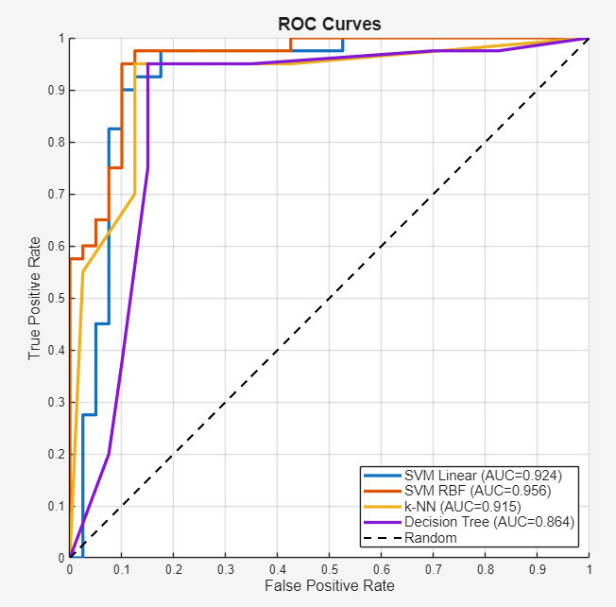
- Receiver Operating Characteristic curves for all 4 models
- AUC (Area Under Curve) scores provided for each model
- Compares true positive rate vs false positive rate
- Random baseline shown for reference

3. Metrics Comparison Tab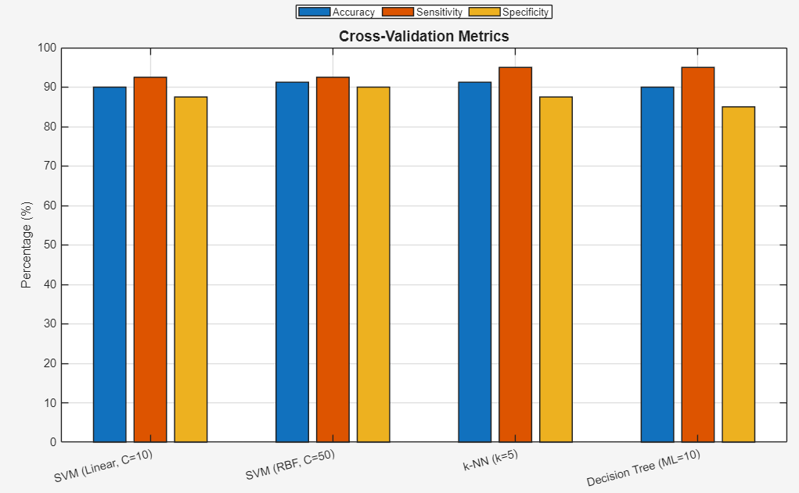
- Bar chart comparing Accuracy, Sensitivity, and Specificity
- All models grouped by metric type
- Visual comparison of relative performance

4. Decision Boundary Tab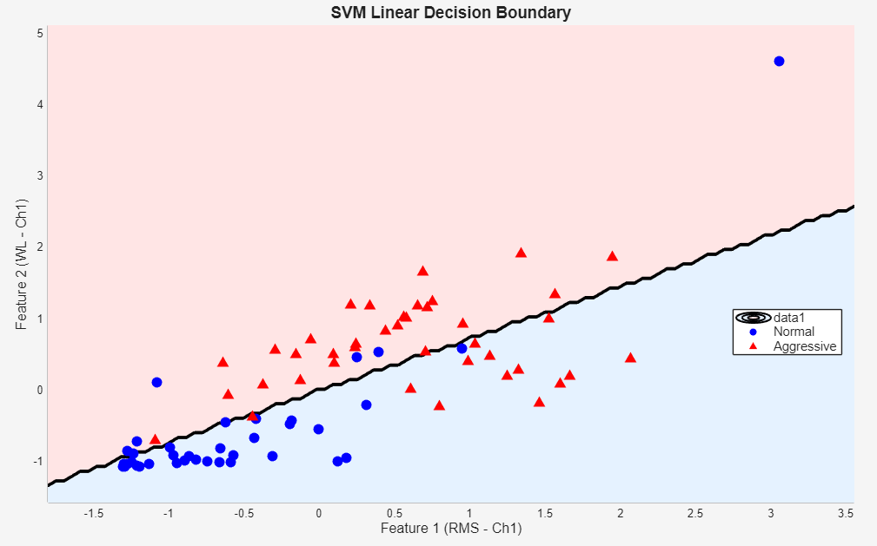
- 2D visualization using first two features (RMS and WL from Channel 1)
- Shows SVM Linear decision boundary
- Normal actions (Blue circles) vs Aggressive actions (Red triangles)

Action Classification
After interacting with the AI agent to improve accuracy, we are using more features , which contain more features from EMG and statistical rate. Also, we using Classification Toolbox method assemble with Decision Tree algorithm. The whole feature is provided below, the formulas are attached in Appendix 1:
The classification is performed in classifying specific action types within each category.

Level 1: Action Category Classification
- Task: Distinguish between Normal and Aggressive movements
- Classifier: Support Vector Machine (SVM) with RBF kernel
  - Parameters: BoxConstraint=100, KernelScale=‘auto’
- Validation: 5-Fold Cross-Validation - Accuracy: 99.87%

Level 2: Normal Action Classification
- Task: Classify among 4 normal action types (given Level 1 predicted Normal)
- Classifier: Bagging Ensemble (200 learning cycles)
- Base Learner: Decision Trees
  - Parameters: MaxNumSplits=50, MinLeafSize=2, NumVariablesToSample=‘all’
- Validation: 5-Fold Cross-Validation - Accuracy: 96.16%
- Reduces overfitting through bootstrap aggregating.

Level 3: Aggressive Action Classification
- Task: Classify among 6 aggressive action types
- Classifier: TotalBoost Ensemble (200 learning cycles)
- Base Learner: Decision Trees
  - Parameters: MaxNumSplits=50, MinLeafSize=2
- Validation: 5-Fold Cross-Validation - Accuracy: 78.17%

Confusion Matrix Insights

Level 1: Normal vs Aggressive 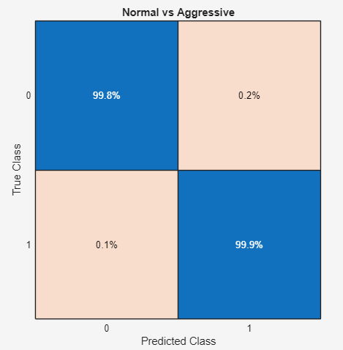
- Row-normalized confusion matrix shows true classification distribution
- Expected: ~99.87% on diagonal, ~0.13% off-diagonal
- Excellent separation demonstrates distinct EMG signatures

Level 2: Normal Actions 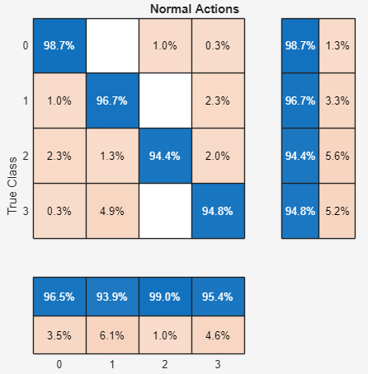
- 'Clapping' = 0, 'Handshaking' = 1,'Hugging' = 2, 'Waving' = 3
- Row-normalized format reveals which actions are confused
- Likely confusion pairs: Waving ↔ Clapping (similar arm movements)
- Handshaking and Hugging likely well-separated

Level 3: Aggressive Actions 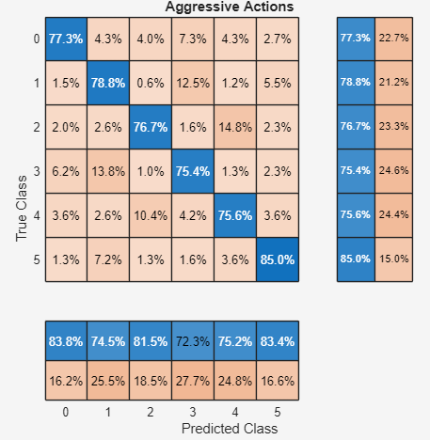
- 'Elbowing' = 0,'Hamering' = 1,'Pulling' = 2 ,'Punching' = 3, 'Pushing' = 4, 'Slapping' = 5
- More off-diagonal elements expected (78.17% accuracy)
- Likely confusion pairs:
  - Hamering ↔ Pulling (similar arm extension)
  - Pushing ↔ Punching (forward arm movements)
- Kneeing and Slapping likely well-separated

Feature Engineering

Feature Extraction Parameters
- Window Size: 256 samples per window
- Step Size: 128 samples (50% overlap for temporal continuity)
- Total Features Extracted: 24 features per channel × 8 channels = 192 features

Extracted Features (per channel)

Time-Domain Features
- RMS (Root Mean Square) - Energy representation
- WL (Waveform Length) - Cumulative length of signal
- VAR (Variance) - Signal variability
- MAV (Mean Absolute Value) - Average amplitude
- MAX (Maximum Absolute Value) - Peak amplitude
- MED (Median Absolute Value) - Robust center measure
- ZC (Zero Crossing) - Frequency indicator
- SSC (Slope Sign Changes) - Signal turning points
- STD (Standard Deviation) - Signal spread
- SKEW (Skewness) - Asymmetry measure
- KURT (Kurtosis) - Tail weight measure
- WAMP (Willison Amplitude) - Threshold-based activity count
- LOG (Log Absolute Sum) - Logarithmic energy measure
- SSI (Sum of Squared Intensity) - Power measure

Frequency-Domain Features
- MNF (Mean Frequency Component) - Average frequency
- MDF (Median Frequency Component) - Central frequency
- PKF (Peak Frequency) - Dominant frequency magnitude
- WL_Ratio (Waveform Length Ratio) - Normalized WL
- MFI (Maximum Frequency Index) - Dominant frequency index
- MNF2 (Mean Normalized Frequency) - Normalized frequency center
- STDF (Frequency Standard Deviation) - Frequency spread

Advanced Features
- SAV (Sum of Absolute Value) - Total activity
- AC (AutoCorrelation) - Signal self-similarity
- ER (Energy Ratio) - First-half to total energy ratio

Appendix 1

EMG Feature Extraction Formulas
Let a windowed EMG signal be $x=[x_{1},x_{2},…,x_{N}]$ of length $N$, and let $\overset{‾}{x}$ be its mean.
Time-Domain Features

1. Root Mean Square (RMS)
$$\text{RMS}=\sqrt{\frac{1}{N}\sum_{i=1}^{N}{x_{i}^{2}}}$$

2. Waveform Length (WL)
$$\text{WL}=\sum_{i=1}^{N-1}{|}x_{i+1}-x_{i}|$$

3. Variance (VAR)
$$\text{VAR}=\frac{1}{N-1}\sum_{i=1}^{N}{(}x_{i}-\overset{‾}{x})^{2}$$

4. Mean Absolute Value (MAV)
$$\text{MAV}=\frac{1}{N}\sum_{i=1}^{N}{|}x_{i}|$$

5. Maximum Absolute Value
$$\text{MAX}=\max_{1≤i≤N}|x_{i}|$$

6. Median Absolute Value
$$\text{MEDIAN}=median(|x_{1}|,|x_{2}|,…,|x_{N}|)$$

7. Zero Crossings (ZC)
Let the threshold be
$$\text{threshold}=mean(|x_{i}|).$$
Then the zero-crossing count (around the threshold) is
$$\text{ZC}=\sum_{i=1}^{N-1}{|} [x_{i}>\text{threshold}]-[x_{i+1}>\text{threshold}] |$$
where $[⋅]$ is the indicator function (1 if the condition is true, 0 otherwise).

8. Slope Sign Changes (SSC)
$$\text{SSC}=\sum_{i=2}^{N-1}{\left\{\begin{matrix}1, & (x_{i}-x_{i-1})(x_{i}-x_{i+1})>0 \\ 0, & \text{otherwise}\end{matrix}\right.}$$

9. Standard Deviation (STD)
$$\text{STD}=\sqrt{\frac{1}{N-1}\sum_{i=1}^{N}{(}x_{i}-\overset{‾}{x})^{2}}$$

10. Skewness
$$\text{SKEW}=\frac{\frac{1}{N}\sum_{i=1}^{N}{(}x_{i}-\overset{‾}{x})^{3}}{{\left(\frac{1}{N}\sum_{i=1}^{N}{(}x_{i}-\overset{‾}{x})^{2}\right)}^{3/2}}$$

11. Kurtosis
$$\text{KURT}=\frac{\frac{1}{N}\sum_{i=1}^{N}{(}x_{i}-\overset{‾}{x})^{4}}{{\left(\frac{1}{N}\sum_{i=1}^{N}{(}x_{i}-\overset{‾}{x})^{2}\right)}^{2}}$$

12. Integrated EMG (IEMG)
$$\text{IEMG}=\sum_{i=1}^{N}{|}x_{i}|$$

13. Willison Amplitude (WAMP)
With a fixed threshold $ε$ (in the code: $ε=0.05$):
$$\text{WAMP}=\sum_{i=1}^{N-1}{\left\{\begin{matrix}1, & |x_{i+1}-x_{i}|>ε \\ 0, & \text{otherwise}\end{matrix}\right.}$$

14. Log Detector
$$\text{LOG}=log\left(\sum_{i=1}^{N}{|}x_{i}|\right)$$

15. Signal Energy
$$E=\sum_{i=1}^{N}{x_{i}^{2}}$$

16. Waveform Length Ratio (WL Ratio)
$$\text{WLR}=\frac{1}{N}\sum_{i=1}^{N-1}{|}x_{i+1}-x_{i}|$$

17. Autocorrelation (lag 0, normalized)
Let $R_{xx}(k)$ be the autocorrelation and $R_{xx}(0)$ its value at lag 0. With MATLAB’s xcorr(sig, 'coeff'),
$$\text{AC}=R_{xx}(0)=1$$
(because it is normalized by the zero-lag energy). In the code, the stored value is the center element of the normalized autocorrelation vector.

18. Energy Ratio (First Half vs Total)
$$\text{ER}=\frac{\sum_{i=1}^{⌊N/2⌋}{x_{i}^{2}}}{\sum_{i=1}^{N}{x_{i}^{2}}}$$
Frequency-Domain Features
Compute the discrete Fourier transform (DFT) of the signal:
$$Y(k)=\sum_{n=0}^{N-1}{x_{n+1}}e^{-j2πkn/N}, k=0,1,…,N-1.$$
Define the two-sided spectrum magnitude
$$P_{2}(k)=\frac{|Y(k)|}{N}$$
and the one-sided spectrum
$$P_{1}(k)=\left\{\begin{matrix}P_{2}(k), & k=0,N/2 \\ 2P_{2}(k), & 1≤k≤N/2-1\end{matrix}\right.$$
for $k=0,1,…,N/2$.
Let $K=N/2+1$ be the number of one-sided bins, and index them as $k=0,1,…,N/2$.

19. Mean Frequency Magnitude
$$\text{MFM}=\frac{1}{K}\sum_{k=0}^{N/2}{P_{1}}(k)$$

20. Median Frequency Magnitude
$$\text{MEDFM}=median\left(P_{1}(0),P_{1}(1),…,P_{1}(N/2)\right)$$

21. Maximum Frequency Magnitude
$$\text{MAXFM}=\max_{0≤k≤N/2}P_{1}(k)$$

22. Peak Frequency Index
$$\text{PFI}=arg\max_{0≤k≤N/2}P_{1}(k)$$

23. Mean Frequency (MNF)
Let the (normalized) frequency values be
$$f_{k}=\frac{k}{N}, k=0,1,…,N/2.$$
Normalize the spectrum:
$$P_{\text{norm}}(k)=\frac{P_{1}(k)}{\sum_{m=0}^{N/2}{P_{1}}(m)}.$$
Then
$$\text{MNF}=\sum_{k=0}^{N/2}{f_{k}} P_{\text{norm}}(k)$$

24. Frequency Standard Deviation
$$\text{FSTD}=\sqrt{\sum_{k=0}^{N/2}{(}f_{k}-\text{MNF})^{2} P_{\text{norm}}(k)}$$

