Deploying a Java Spring Boot Application to Azure App Service Using Docker, Azure VM, Git, DockerHub, and Azure Container Registry

1. Project Overview
This project demonstrates the complete end-to-end process of deploying a Java Spring Boot application into Azure App Service by:
- Creating a Linux Azure VM
- Building a Spring Boot app using Maven
- Dockerizing the application
- Pushing the Docker image to:
  - DockerHub
  - Azure Container Registry (ACR)
- Deploying the container to Azure App Service
The application used in this project is the Spring PetClinic sample project.
Repository Source:
👉 Spring PetClinic GitHub Repository
https://github.com/spring-projects/spring-petclinic

2. Architecture Diagram (Conceptual Flow)
GitHub Repo → Azure Linux VM → Maven Build → Docker Image
↓
Push to DockerHub & Azure ACR
↓
Azure App Service (Linux)
↓
Live Web Application
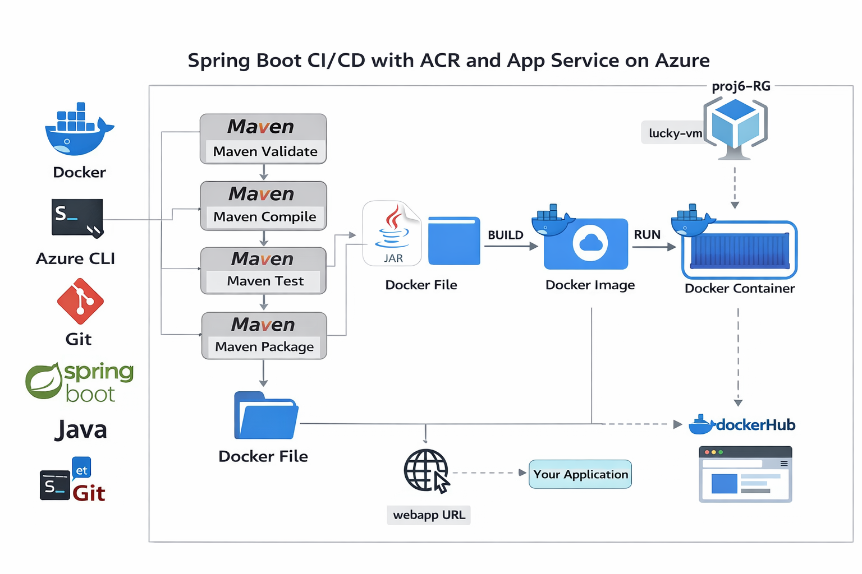

3. Prerequisites
- Azure Subscription
- SSH Client (PuTTY / Terminal)
- DockerHub Account
- Basic Linux Knowledge
Tools Used:
- Microsoft Azure
- Docker
- GitHub
- Apache Maven
- OpenJDK

4. Step 1: Create Azure Ubuntu Virtual Machine
Requirements:
- OS: Ubuntu Linux
- Size: Minimum 2 vCPUs
- Ports Open:
  - SSH (22)
  - Application Port (8080)
Steps:
- Go to Azure Portal → Virtual Machines → Create VM
- Configure:
  - Image: Ubuntu Server
  - Size: Standard B2s (or equivalent)
  - Authentication: SSH Key / Password
- Add inbound rules:
  - Port 22 (SSH)
  - Port 8080 (Application)
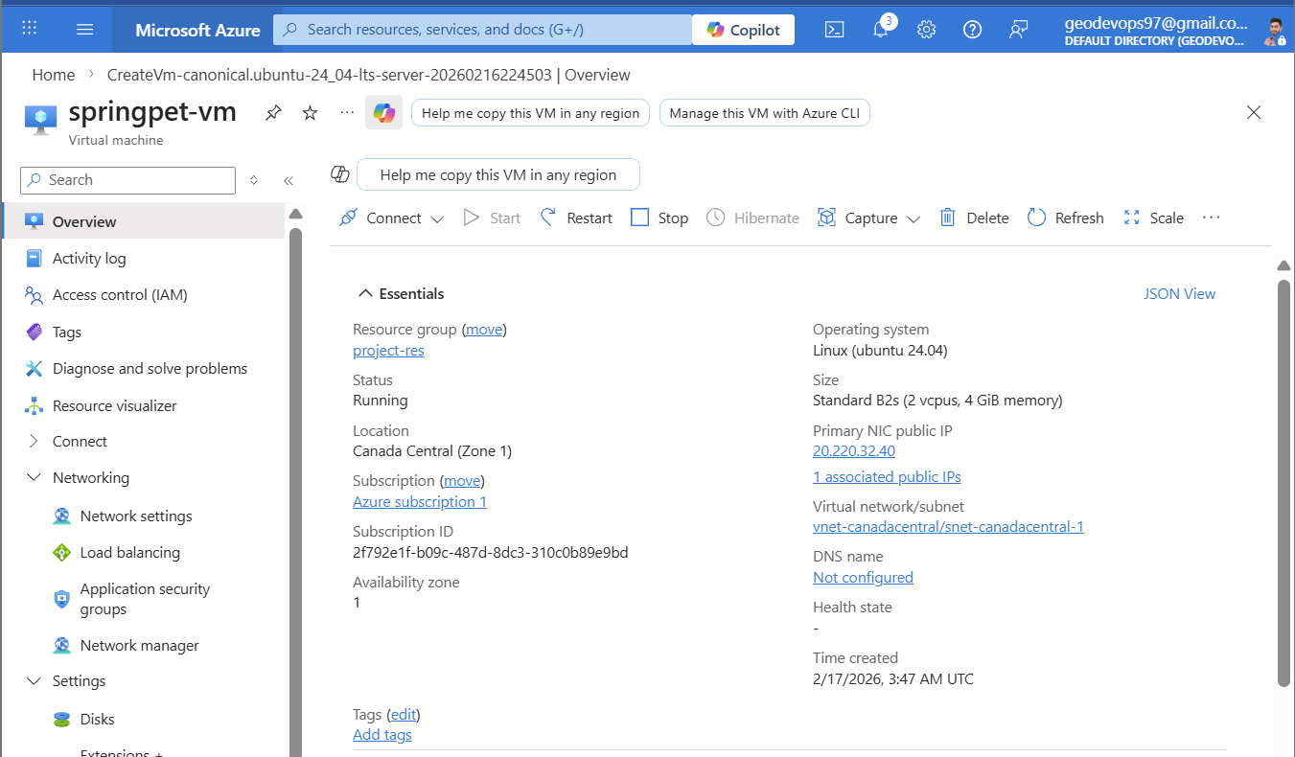

5. Step 2: Login to VM and Install Required Software
SSH into VM:
ssh azureuser@<VM_PUBLIC_IP>

Install Git
sudo apt update
sudo apt install git -y
git --version

Install Docker
sudo apt install docker.io -y
sudo systemctl enable docker
sudo systemctl start docker
docker --version

Install Azure CLI
curl -sL https://aka.ms/InstallAzureCLIDeb | sudo bash
az version

Install Java
sudo apt install openjdk-17-jdk -y
java -version

Install Maven
sudo apt update
wget https://dlcdn.apache.org/maven/maven-3/3.9.12/binaries/apache-maven-3.9.12-bin.tar.gz
tar -xzvf apache-maven-3.9.12-bin.tar.gz
mv apache-maven-3.9.12 maven
Set Path:
vi .bashrc
Add:
export MAVEN_HOME=/home/<VM_USERNAME>/maven
export PATH=$MAVEN_HOME/bin:$PATH
Reload:
source .bashrc
mvn -version

6. Step 3: Verify Installations
Check versions:
git --version
docker --version
java -version
mvn -version
az version
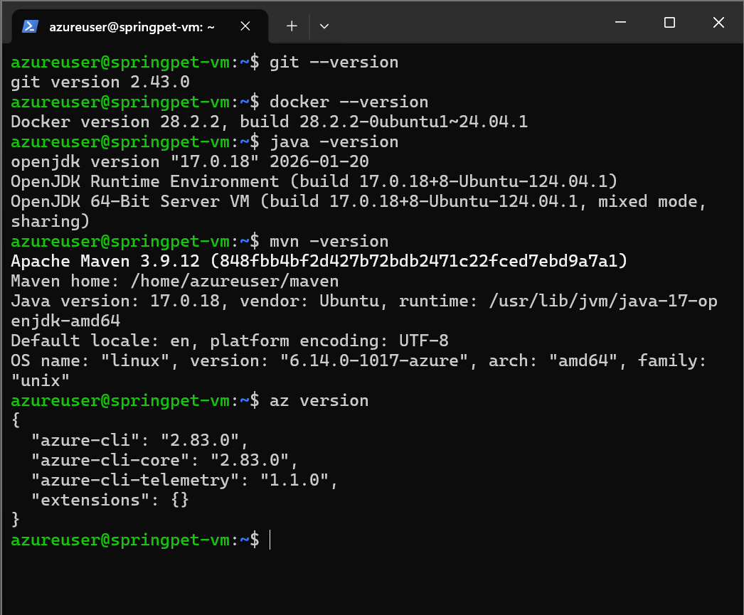

7. Step 4: Login to Azure from VM
az login
Follow browser authentication.
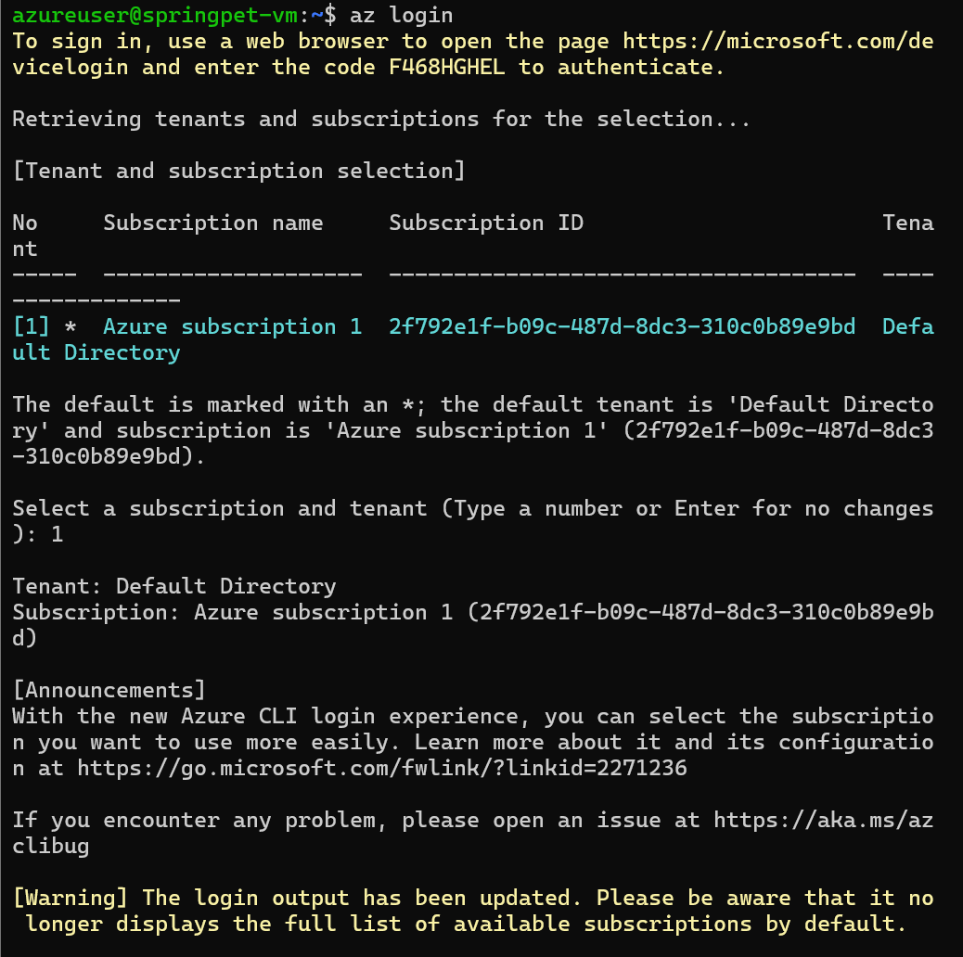

8. Step 5: Clone Spring Boot Application
git clone https://github.com/spring-projects/spring-petclinic
cd spring-petclinic
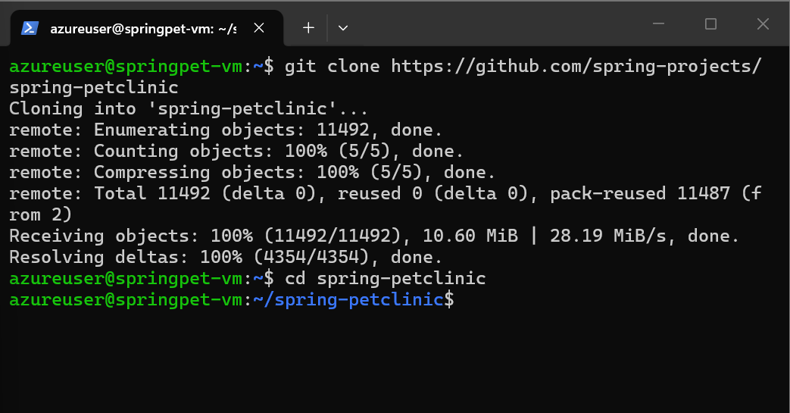

9. Step 6: Build Application Using Maven Lifecycle
Validate
mvn validate
Compile
mvn compile
Test
mvn test
Package
mvn package
Output file:
target/spring-petclinic-3.5.0-SNAPSHOT.jar

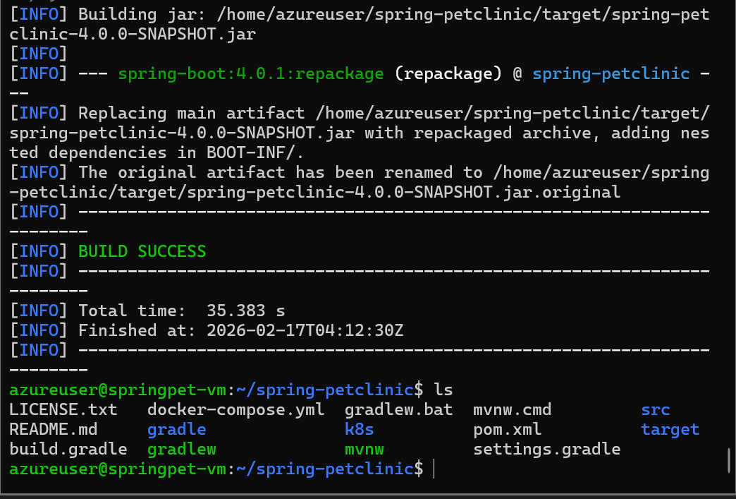

10. Step 7: Dockerizing the Application
Create Dockerfile:
vi Dockerfile
Paste:
FROM eclipse-temurin:17-jdk-jammy

RUN groupadd -r appgroup && useradd -r -g appgroup appuser

WORKDIR /app

COPY target/spring-petclinic-4.0:.0-SNAPSHOT.jar app.jar

RUN chown -R appuser:appgroup /app

USER appuser

EXPOSE 8080

ENTRYPOINT ["java", "-jar", "app.jar"]
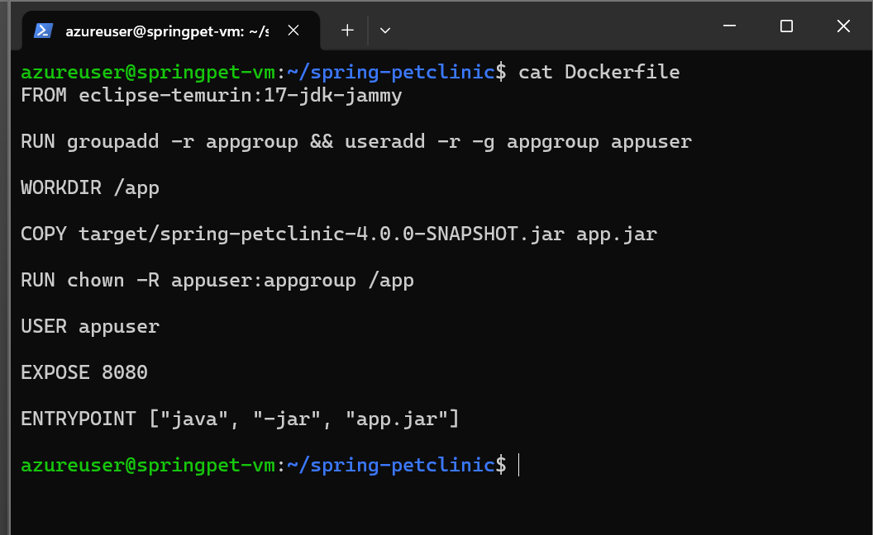
Build Image
docker build -t petclinic .
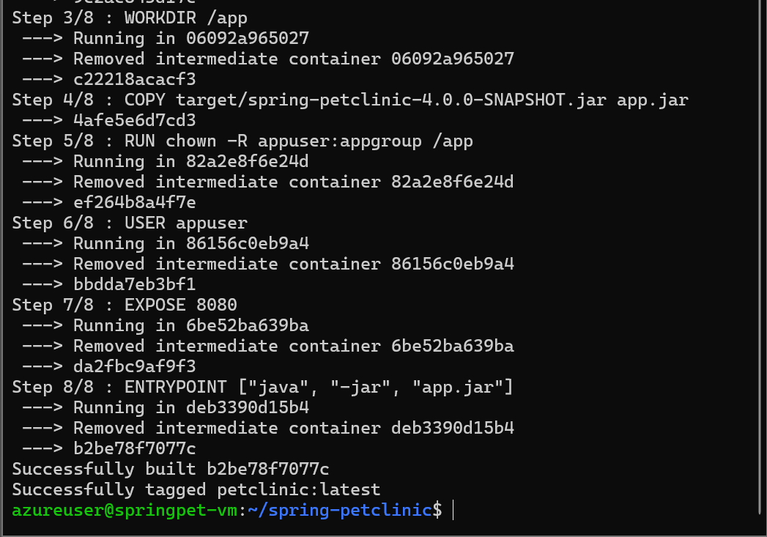
Run Container
docker run -d -p 8080:8080 petclinic
Test:
http://20.220.24.84:8080
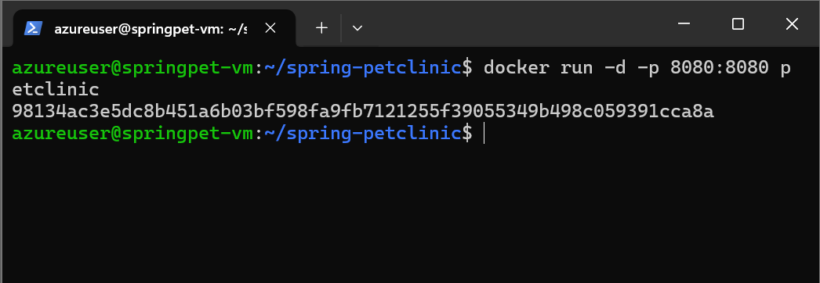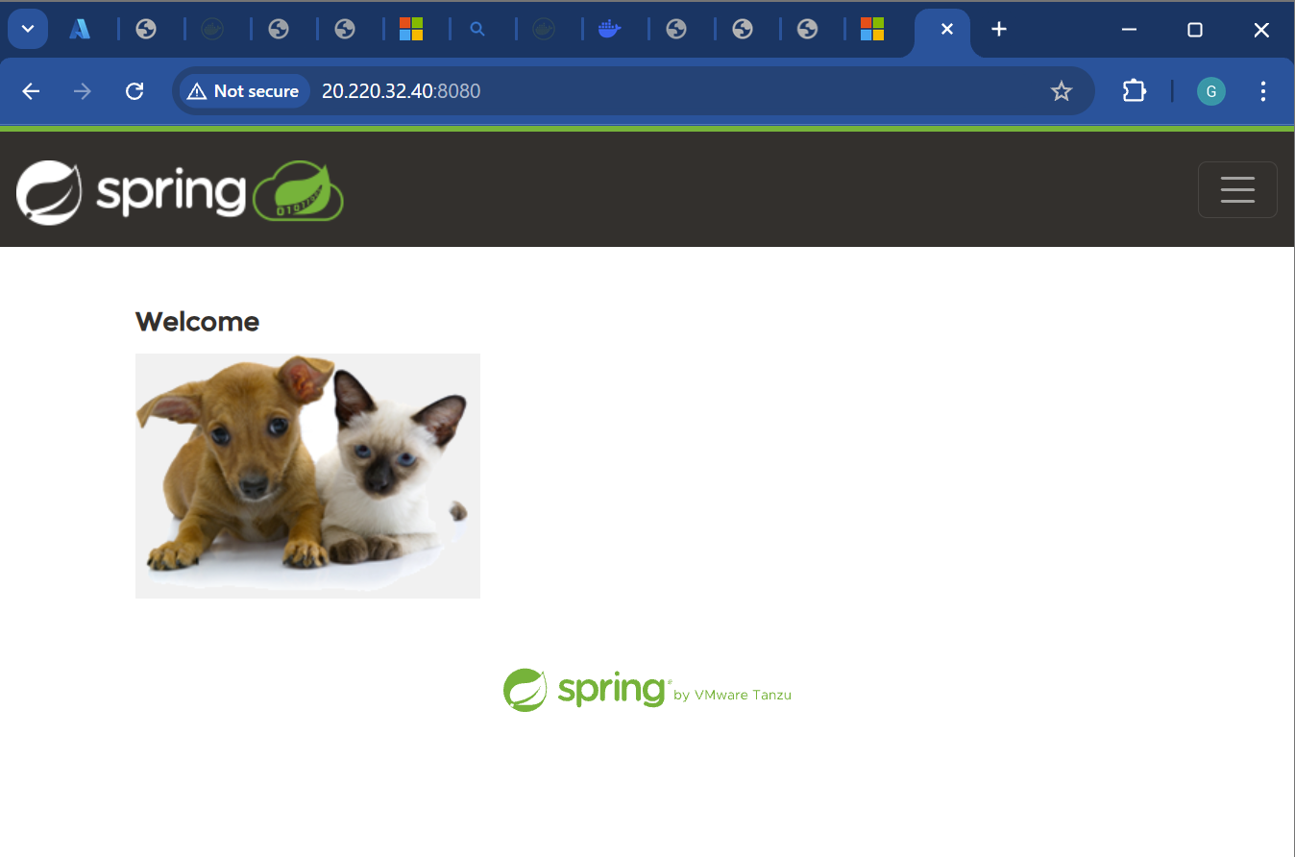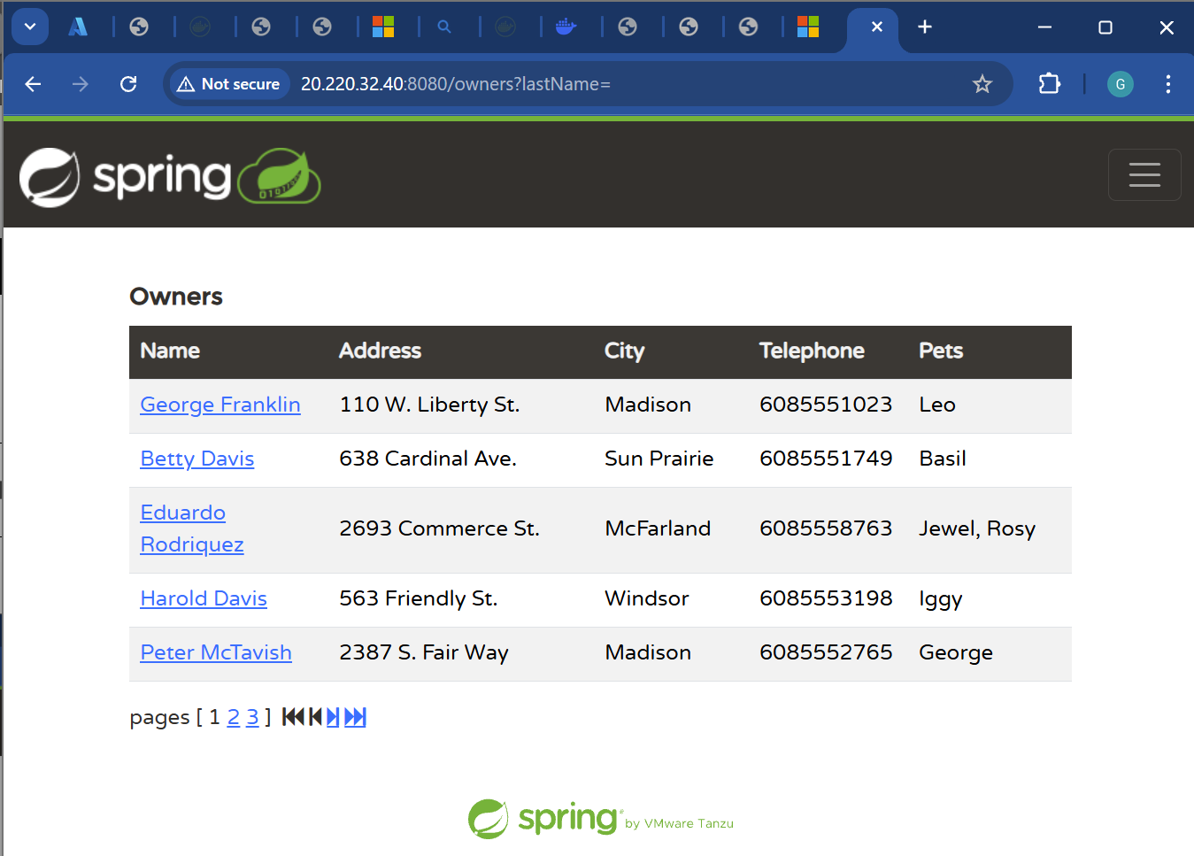

11. Step 8: Push Image to DockerHub
Login
docker login
Tag Image
docker tag petclinic georgedevops97/test:Version1
Push Image
docker push georgedevops97/test:Version1
📸 Output: Image visible in DockerHub repository.
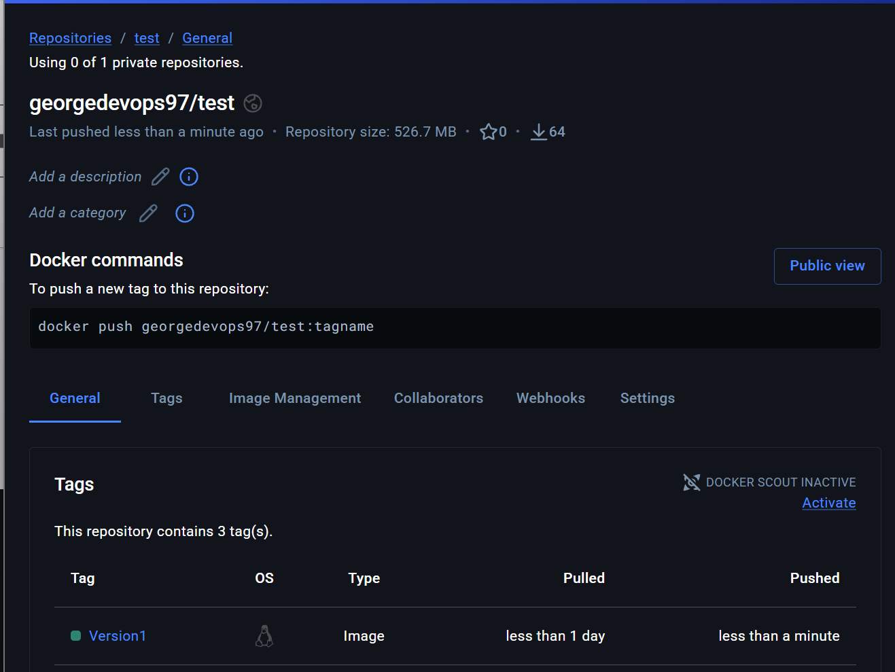

12. Step 9: Push Image to Azure Container Registry
Create ACR
az acr create --resource-group project-res --name mypetacr001--sku Basic
Login to ACR
az acr login --name mypetacr001
Tag Image
docker tag petclinic mypetacr001.azurecr.io/petclinic:latest
Push
docker push mypetacr001.azurecr.io/petclinic:latest
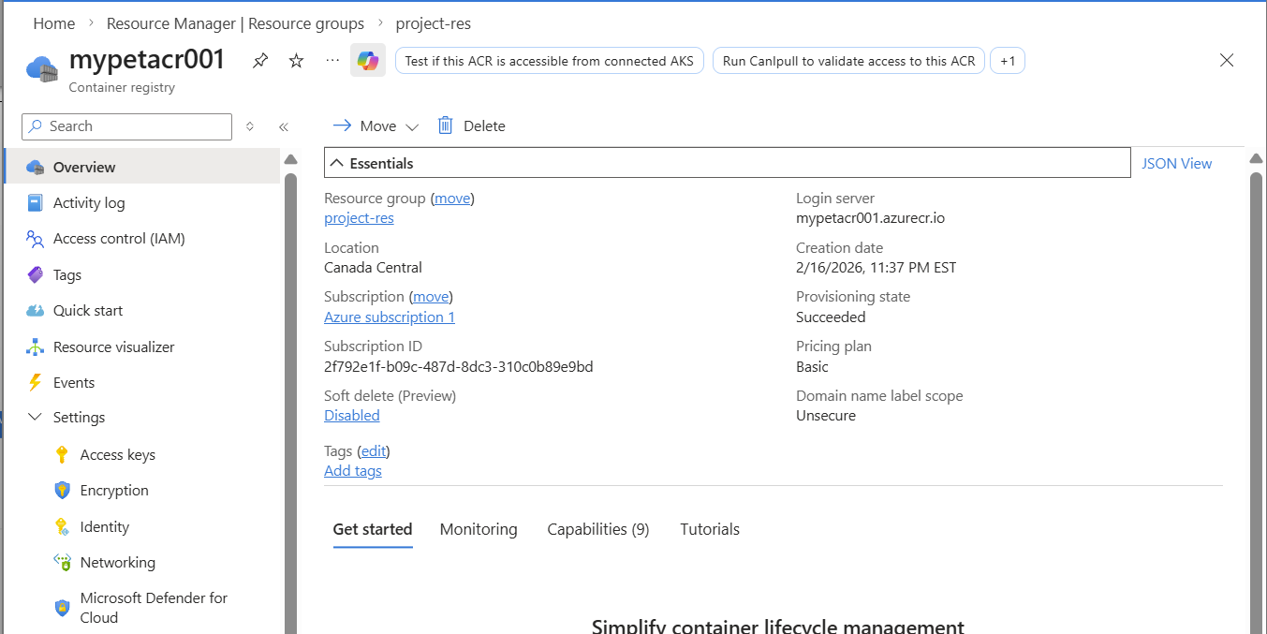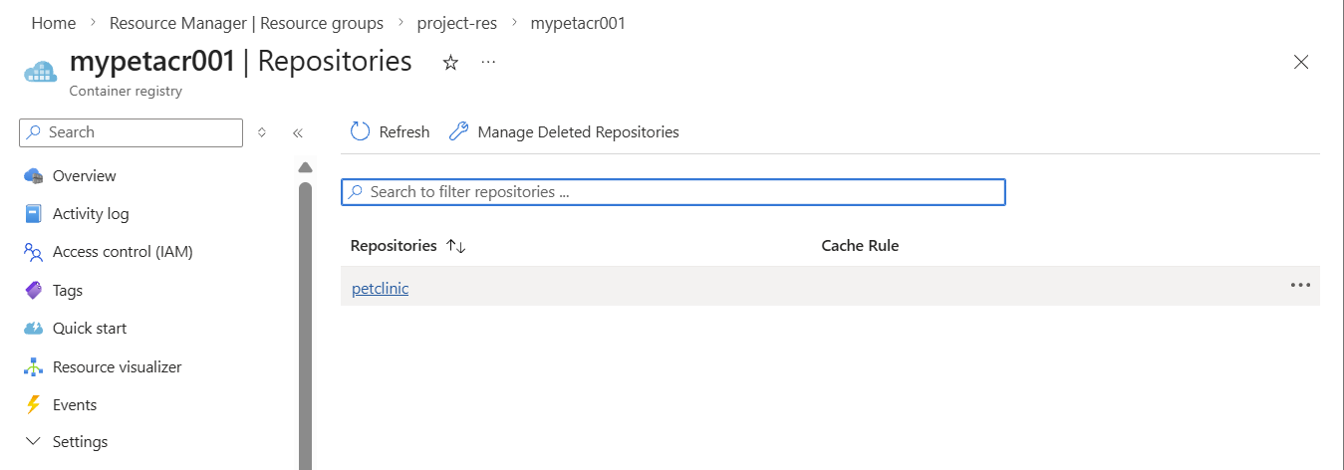

13. Step 10: Deploy to Azure App Service
Create App Service Plan
- OS: Linux
- SKU: Basic B1

Create Web App
Settings:
- Publish: Docker Container
- Image Source: Azure Container Registry
- Select Image & Tag

Access Application
https://<app-name>.azurewebsites.net
📸 Screenshot Required: Running live application.
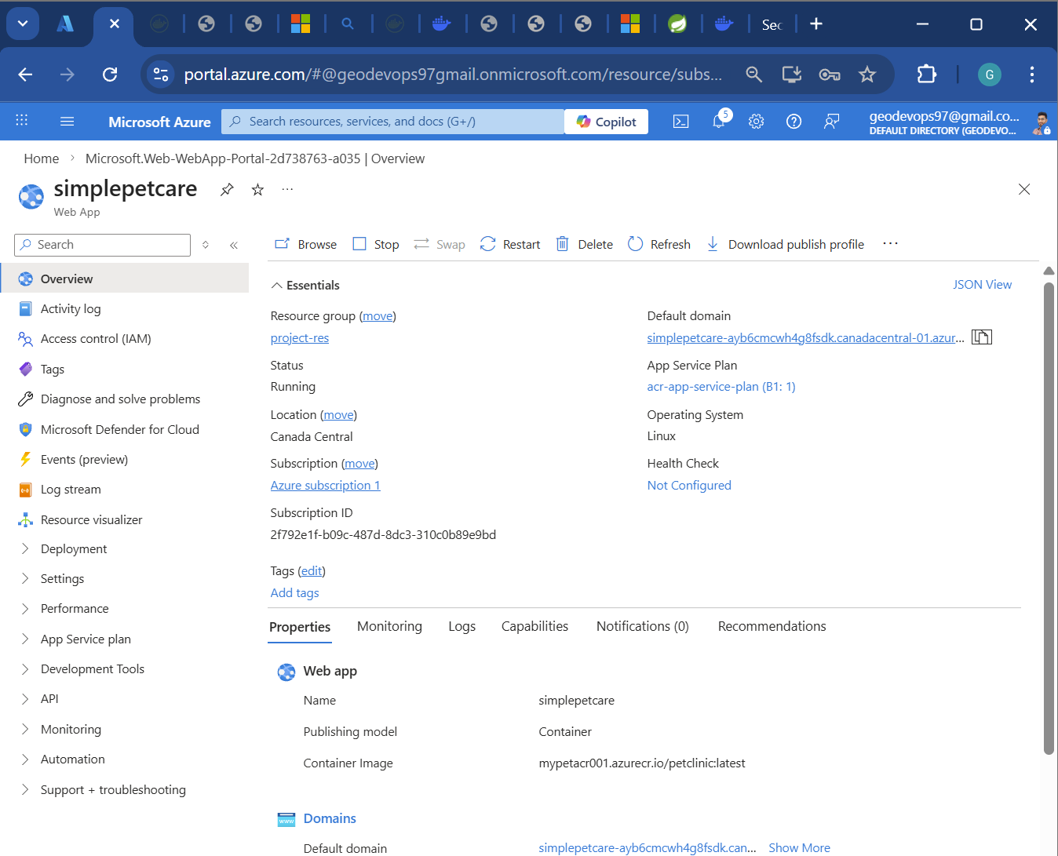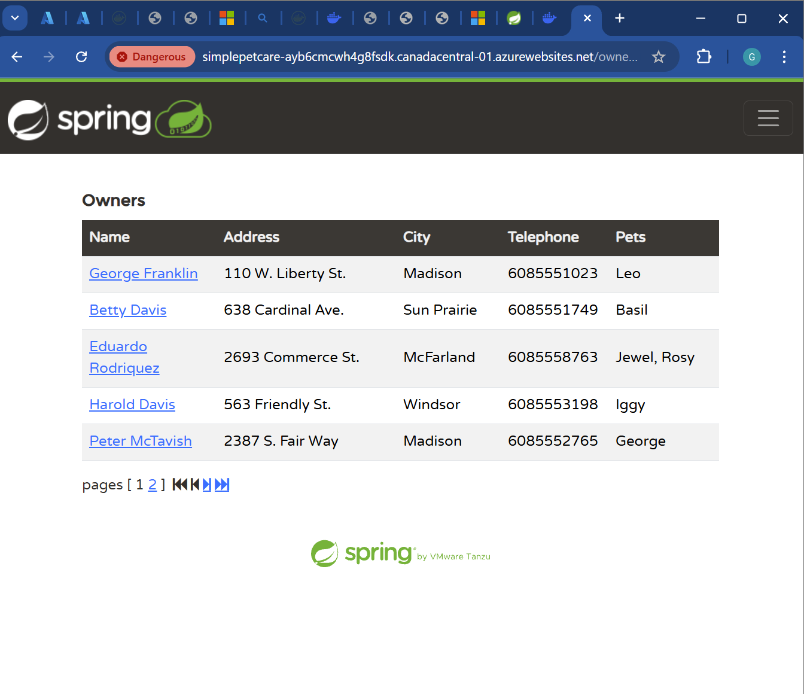

14. Final Output
✔ Java Spring Boot app successfully:
- Built using Maven
- Containerized using Docker
- Stored in DockerHub & Azure ACR
- Deployed on Azure App Service

15. Learning Outcomes
After completing this project, the following skills were gained:
- Azure VM provisioning
- Maven lifecycle understanding
- Docker containerization
- Image registry management
- Cloud deployment automation

16. Conclusion
This project demonstrated a real-world DevOps deployment pipeline using cloud infrastructure and container technology. It showcases how modern applications are built, packaged, and deployed using industry-standard tools.

