التعامل مع قاعدة البيانات:

الملف database.php يحتوى على الفئه database و التى تحتوى على بعض الدوال التى تستخدم للتعامل مع قواعد البيانات عن طريق الواجه Pdo وسوف تستخدم فى هذا المفرر مع مدير إدارة قواعد البيانات MySql. بجوار هذا الملف يوجد الملف الذى يستخدم فى تمرير قيم و توابت الأتصال بالـ MySqlمثل اسم المستخدم و كلمة السر و اسم القاعده و نوع مدير إدارة قواعد البيانات.

يتم اولا انشاء كائن من الفئه database سوف نسميه $db فى نفس الملف database.php و كل ما علينا ىبعد ذلك دمج الملف database.php الى اى صفحه فى موقعنا تتعامل مع قاعدة البيانات.

توجد مجموعة من الدوال المهمه فى الفئة database و منها الداله getRow() والتى تستخدم فى الأستعلام عن سجل واحد:

$db->getRow($sql,array(paramters));

حيث $sql هى جملة الأستعلام بمعاملات موضعيه و المدخل الثانى لتمرير قيم المعاملات. كمثال:

$db->getRow(“select * from asd where id=?”,array($id));

كما توجد الداله getRows() و التى تستخدم فى استرجاع مصفوفه من السجلات:

$db->getRows($sql,array(paramters));

كمثال لإسترجاع كل بيانات الجدول asd :

$db->getRow (“select * from asd”,array());

الداله تستخدم فى اضافة سجل

$db->insertRow ($sql,array(parameters));

كمثال لإضافة سجل الى الجدول asd :

$db->insertRow (“insert into asd (id, name) value(?,?)”,array($id,$name));

كذلك توجد الداله updateRow() لتحديث بيانات سجل و الداله deleteRow() لحذف سجل.

مثال كامل:

Write a web application that can be used to export the reports in Excel format using PHP and MySQL. Therefore, you will create one simple PHP page that will display data from a table in a MySQL database in tabular format when click a button. By clicking this button, one can export the Excel file, which is automatically downloaded to your machine.

Solution:

الخطوه الأولى:

Create a database, quizDB, in MySql server. Make Table in “quizDB” for storing the user information. Give it the name “user”. This table contains UserName, Password etc. For creating a table, run the below script.

**CREATE** **TABLE** IF NOT EXISTS `user` (

`ur_Id` **int**(11) NOT NULL AUTO_INCREMENT,

`ur_username` **varchar**(50) NOT NULL,

`ur_password` **varchar**(50) NOT NULL,

`ur_status` **int**(11) NOT NULL,

**PRIMARY** **KEY** (`ur_Id`)

) ENGINE=InnoDB **DEFAULT** CHARSET=latin1 AUTO_INCREMENT=1;

Now, insert some temporary data to this table. So, for inserting data in the temporary table, I run the below SQL script.

**INSERT** **INTO** `user` (`ur_Id`, `ur_username`, `ur_password`, `ur_status`) **VALUES**

(1, 'asd1@gmail.com', '123', 1),

(2, 'asd2@gmail.com', '567', 1),

(3, 'asd3@gmail.com', '897', 1);

Now, first we make one simple PHP page that will display the above table data in tabular format with one “Export link”.

<html>

<head>

    <title>User Detail Report</title>

</head>

<body>

</body>

</html>

Save the above file with “UserReport.php”.

2. Now, we will add one table for displaying the data. Our table contains 3 columns, “Sr No”, “User Name”,

”Password”.

<table border="1">

    <tr>

        <th>Sr NO.</th>

        <th width="120">User Name</th>

        <th>Password</th>

    </tr>

</table>

Here, we take table border as “1” so user can display, and we create 3 columns for the table header rows.  
Now, we have to fetch the SQL table value for displaying table data rows.

So, first we make MySQL Server database connection. Now, we make MySQL server connection from the PHP file. So, pass server name, user name, password, database name etc.

Change the content of the constants.php file as follows:

<?php

define('DB_TYPE','mysql');

define('DB_HOST','localhost');

define('DB_USER','root');

define('DB_PASS','');

define('DB_DATABASE','quizDB');

?>

انشاء ملف لإنشاء قاعدة البيانات + انشاء الجدول + اضافه البيانات ولنطلق عليه createAll.php وسوف نضع فيه الأكواد التاليه:

<?php

function CreateDB($dbname){

$host="localhost";

$root="root";

$root_password="";

try {

$dbh = new PDO("mysql:host=$host", $root, $root_password);

$dbh->exec("CREATE DATABASE IF NOT EXISTS $dbname;")

or die(print_r($dbh->errorInfo(), true));

} catch (PDOException $e) {

die("DB ERROR: ". $e->getMessage());

}

}

CreateDB("quizDB");

include_once ('database.php');

$r = $db->Execute(file_get_contents('data.sql'));

if($r !== false)

echo "Data are added successfully!<br/>";

else

echo "Error.<br/>";

?>

محتوى الملف كالتالى (انشاء الجدول + اضافة البيانات):

Data.sql:

CREATE TABLE IF NOT EXISTS `user` (

`ur_Id` int(11) NOT NULL AUTO_INCREMENT,

`ur_username` varchar(50) NOT NULL,

`ur_password` varchar(50) NOT NULL,

`ur_status` int(11) NOT NULL,

PRIMARY KEY (`ur_Id`)

) ENGINE=InnoDB DEFAULT CHARSET=latin1 AUTO_INCREMENT=1;

INSERT INTO `user` (`ur_Id`, `ur_username`, `ur_password`, `ur_status`) VALUES

(1, 'asd1@gmail.com', '123', 1),

(2, 'asd2@gmail.com', '567', 1),

(3, 'asd3@gmail.com', '897', 1);

الخطوه الثانيه: عرض البيانات

Now, we make Query, which will select the SrNo, Username and password from the database and pass this with MySQL connection object. As show below:

$rows=$db->getRows("SELECT  * FROM user ",array());

Above, Query fetches the records from the MySQL database and stores it in $rows variable.  
Here, we have record set. Therefore, now we separate it in row-wise data. Repeat the Foreach loop and fetch each row and show in tabular format, as show below:

Foreach($rows as $data){

echo '

<tr>

<td>'.$data['ur_Id'].'</td>

<td>'.$data['ur_username'].'</td>

<td>'.$data['ur_password'].'</td>

</tr>

';

}

Above code will display the data row for the table. So, now complete table with header row and data row is displayed. Now, we put one link; that is, export the data to Excel file.

<a href="UserReport_Export.php"> Export To Excel </a>

Now, complete code for the "UserReport.php" is shown below:

<html>

<head>

<title>User Detail Report</title>

</head>

<body>

<table border="1">

<tr>

<th>Sr NO.</th>

<th width="120">User Name</th>

<th>Password</th>

</tr>

<?php

include_once('database.php');

$rows=$db->getRows("SELECT * FROM user ",array());

Foreach($rows as $data){

echo '

<tr>

<td>'.$data['ur_Id'].'</td>

<td>'.$data['ur_username'].'</td>

<td>'.$data['ur_password'].'</td>

</tr>

';

}

?>

</table> <a href="UserReport_Export.php"> Export To Excel </a> </body>

</html>

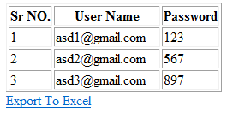

الخطوه الثالثه : التصدير الى Excel

Here, displaying the table data in PHP page is now complete. Now, we have to create file for exporting this table data to excel file in PHP.

Create another PHP file for exporting data to excel and give its name “UserReport_Export.php”. And, write the below code:

1. First, I create the My SQL connection for fetching the data from the database, as shown in above steps.

$rows=$db->getRows("SELECT * FROM user",array());

Here, in variable $setRec, record set is stored. So, we loop the record set and separate the each row of record by writing while loop to fetch each row.

**foreach($rows as $rec)**

**{**

}

1. Now, we have to get the column wise data from the row. So, we write “for each” loop in while loop.

**foreach**($rec **as** $value)

{

}

1. Now, we have to add one tab (“\t”) value between each and every column values and store this full string to any new variable. So, we write some function in between for each loop, as show below,

$rowData = '';

**foreach**($rec **as** $value)

{

   $value = '"' . $value . '"' . "\t";

   $rowData .= $value;

}

1. Now, our columns are ready. We have to separate the rows now. So, we have to add new line character (“\n”) between each new row:

$setData='';

foreach($rows as $rec) {

$rowData = '';

foreach ($rec as $value) {

$value = '"' . $value . '"' . "\t";

$rowData .= $value;

}

$setData .= trim($rowData) . "\n";

}

1. Our table data row and columns are ready now. We have to define a new variable for header row, as shown in below code,

$columnHeader ='';

$columnHeader = "Sr NO"."\t"."User Name"."\t"."Password"."\t";

1. Here, when user clicks on link, we have to download the excel file directly, without showing the data. Just add the below code.

*header("Content-type: application/octet-stream");*

Now, we have to set the filename for downloading excel file.

*header("Content-Disposition: attachment; filename=User_Detail_Reoprt.xls");*

*header("Pragma: no-cache");*

*header("Expires: 0");*

Now, finally we print all the table row data and header data to the excel file.

*echo ucwords($columnHeader)."\n".$setData."\n";*

Complete code for “UserReport_Export.php”,

<?php

//Connect to database

include_once('database.php');

//get Table contents

$rows=$db->getRows("SELECT * FROM user",array());

//save the data as text delimited as excel reuired

//Delimited text files (.xls), in which the TAB (\t)character typically separates each field of text.

//each row is delimted by new line \n

$columnHeader = '';

$columnHeader = "Sr NO" . "\t" . "User Name" . "\t" . "Password" . "\t";

$setData = '';

foreach($rows as $rec) {

$rowData = '';

foreach ($rec as $value) {

$value = '"' . $value . '"' . "\t";

$rowData .= $value;

}

$setData .= trim($rowData) . "\n";

}

header("Content-type: application/octet-stream");

header("Content-Disposition: attachment; filename=User_Detail_Reoprt.xls");

header("Pragma: no-cache");

header("Expires: 0");

echo ucwords($columnHeader) . "\n" . $setData . "\n";

?>

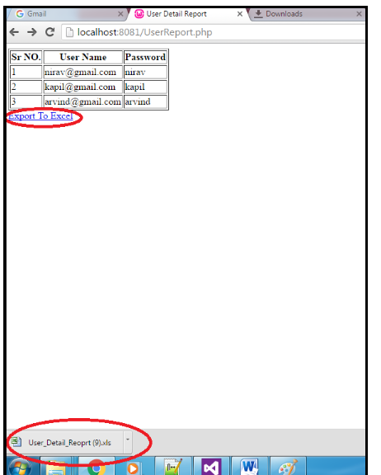

===========================================================================

مثال 2:

**View/edit/delete/add Records:**

Explain with a complete web application, how to insert, edit, update and delete records from the database using PHP. Data from database are fetched and displayed in index.php file. This is our homepage. This file also contains a link to add data. On every row of displayed data, there is also a link to edit and delete data. Below is a sample image of our homepage:

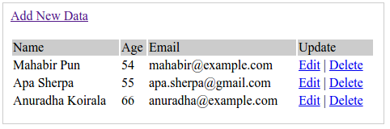

Create a new MySQL database. Let us name the database as "**asd**". Then, create a new table in database ‘**asd**’. Let us name the table as ‘**users**‘.

CREATE TABLE users (  
id int(11) NOT NULL auto_increment,  
name varchar(100) NOT NULL,  
age int(3) NOT NULL,  
email varchar(100) NOT NULL,  
PRIMARY KEY (id)  
);

The following data are inserted in this table:

|  |  |  |
| --- | --- | --- |
| 1 | Asd1 | 20 |
| 2 | Asd2 | 21 |
| 3 | Asd3 | 22 |
| 4 | Asd4 | 23 |
| 5 | Asd5 | 24 |

Solution:

Here we have to create five pages such as database.php (to provide the connection), view.php (to display the records from the database), insert.php (to insert records into the database), edit.php (to edit records), and delete.php (to delete records).

* 1. انشاء قاعدة البيانات و الجدول و اضافة البيانات:

سوف نستخدم قاعدة بيانات المثال السابق: انشاء ملف لإنشاء قاعدة البيانات + انشاء الجدول + اضافه البيانات ولنطلق عليه createAll.php وسوف نضع فيه الأكواد التاليه:

<?php

function CreateDB($dbname){

$host="localhost";

$root="root";

$root_password="";

try {

$dbh = new PDO("mysql:host=$host", $root, $root_password);

$dbh->exec("CREATE DATABASE IF NOT EXISTS $dbname;")

or die(print_r($dbh->errorInfo(), true));

} catch (PDOException $e) {

die("DB ERROR: ". $e->getMessage());

}

}

CreateDB("**quizDB**");

include_once ('database.php');

$r = $db->Execute(file_get_contents('data.sql'));

if($r !== false)

echo "Data are added successfully!<br/>";

else

echo "Error.<br/>";

?>

محتوى الملف كالتالى (انشاء الجدول + اضافة البيانات):

Data.sql:

CREATE TABLE IF NOT EXISTS `user` (

`ur_Id` int(11) NOT NULL AUTO_INCREMENT,

`ur_username` varchar(50) NOT NULL,

`ur_password` varchar(50) NOT NULL,

`ur_status` int(11) NOT NULL,

PRIMARY KEY (`ur_Id`)

) ENGINE=InnoDB DEFAULT CHARSET=latin1 AUTO_INCREMENT=1;

INSERT INTO `user` (`ur_Id`, `ur_username`, `ur_password`, `ur_status`) VALUES

(1, 'asd1@gmail.com', '123', 1),

(2, 'asd2@gmail.com', '567', 1),

(3, 'asd3@gmail.com', '897', 1);

الخطوه الثانيه: انشاء الصفحه الرئيسيه Index.php

**Index.php**

<?php

include_once ("database.php");

$rows=$db->getRows("SELECT * FROM user ORDER BY ur_Id DESC");

?>

<html>

<head>

<title>Homepage</title>

</head>

<body>

<a href="add.html">Add New Data</a><br/><br/>

<table width='80%' border=0>

<tr bgcolor='#CCCCCC'>

<td>Name</td>

<td>password</td>

<td>status</td>

<td>Update</td>

</tr>

<?php

foreach($rows as $res) {

echo "<tr>";

echo "<td>".$res['ur_username']."</td>";

echo "<td>".$res['ur_password']."</td>";

echo "<td>".$res['ur_status']."</td>";

echo "<td><a href=\"edit.php?id=$res[ur_Id]\">Edit</a> | <a href=\"delete.php?id=$res[ur_Id]\"

onClick=\"return confirm('Are you sure you want to delete?')\">Delete</a></td>";

}

?>

</table>

</body>

</html>

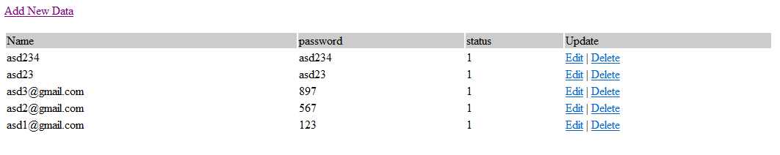

**Add.html:**

<!DOCTYPE html>

<head>

<title>Add Data</title>

</head>

<body>

<a href="index.php">Home</a>

<br/><br/>

<form action="add.php" method="post" name="form1">

<table width="25%" border="0">

<tr>

<td>username</td>

<td><input type="text" name="username" required></td>

</tr>

<tr>

<td>password</td>

<td><input type="text" name="password" required></td>

</tr>

<tr>

<td>status</td>

<td><input type="text" name="status" required></td>

</tr>

<tr>

<td></td>

<td><input type="submit" name="Submit" value="Add"></td>

</tr>

</table>

</form>

</body>

</html>

**Add.php**

<html>

<head>

<title>Add Data</title>

</head>

<body>

<?php

//including the database connection file

include_once("database.php");

if(isset($_POST['Submit'])) {

$name = $_POST['username'];

$password = $_POST['password'];

$status = $_POST['status'];

// if all the fields are filled (not empty)

//insert data to database

$sql= "INSERT INTO user(ur_username,ur_password,ur_status) VALUES(?,?,?)";

$int=$db->insertRow($sql,array($name,$password,$status));

if($int >0){

//display success message

echo "<font color='green'>Data added successfully.";

echo "<br/><a href='index.php'>View Result</a>";

}

else

echo "eroRRRRRRRRRRRRRRRRRRRR";

}

?>

</body>

</html>

**Edit.php**

<?php

// including the database connection file

include_once ("database.php");

if(isset($_POST['update']))

{

$id = $_POST['id'];

$name=$_POST['username'];

$pass=$_POST['password'];

$status=$_POST['status'];

//updating the table

$result = $db->updateRow("UPDATE user SET ur_username=?,ur_password=?,ur_status=?

WHERE ur_Id=?", array($name,$pass,$status,$id));

//redirecting to the display page. In our case, it is index.php

header("Location: index.php");

}

?>

<?php

//getting id from url

$id = $_GET['id'];

//selecting data associated with this particular id

$res = $db->getRow("SELECT * FROM user WHERE ur_Id=?",array($id));

$name = $res['ur_username'];

$pass = $res['ur_password'];

$status = $res['ur_status'];

?>

<html>

<head>

<title>Edit Data</title>

</head>

<body>

<a href="index.php">Home</a>

<br/><br/>

<form name="form1" method="post" action="edit.php">

<table border="0">

<tr>

<td>Name</td>

<td><input type="text" name="username" value="<?php echo $name;?>" required></td>

</tr>

<tr>

<td>Password</td>

<td><input type="text" name="password" value="<?php echo $pass;?>" required></td>

</tr>

<tr>

<td>Status</td>

<td><input type="text" name="status" value="<?php echo $status ;?>"></td>

</tr>

<tr>

<td><input type="hidden" name="id" value=<?php echo $_GET['id'];?>"></td>

<td><input type="submit" name="update" value="Update"></td>

</tr>

</table>

</form>

</body>

</html>

Delete.php

<?php

//including the database connection file

include_once ("database.php");

//getting id of the data from url

$id = $_GET['id'];

//deleting the row from table

$result =$db->deleteRow("DELETE FROM user WHERE ur_Id=?",array($id));

//redirecting to the display page (index.php in our case)

header("Location:index.php");

?>