Testing Document

  - Data Driven Systems – 5CM506
  - Assignment 2

  - Made by 100723791

Anything Mentioned here
is also mentioned in the Demo
located in the submission file.
This File also serves as a User Manual

Overview
Site 3
Register 3
Login 5
Dashboard 5
Create New Record 7
Logout 8
Postman 9

Site

Register
Here we can see the login page in desktop mode. It is ready to accept our credentials and register us onto the system.
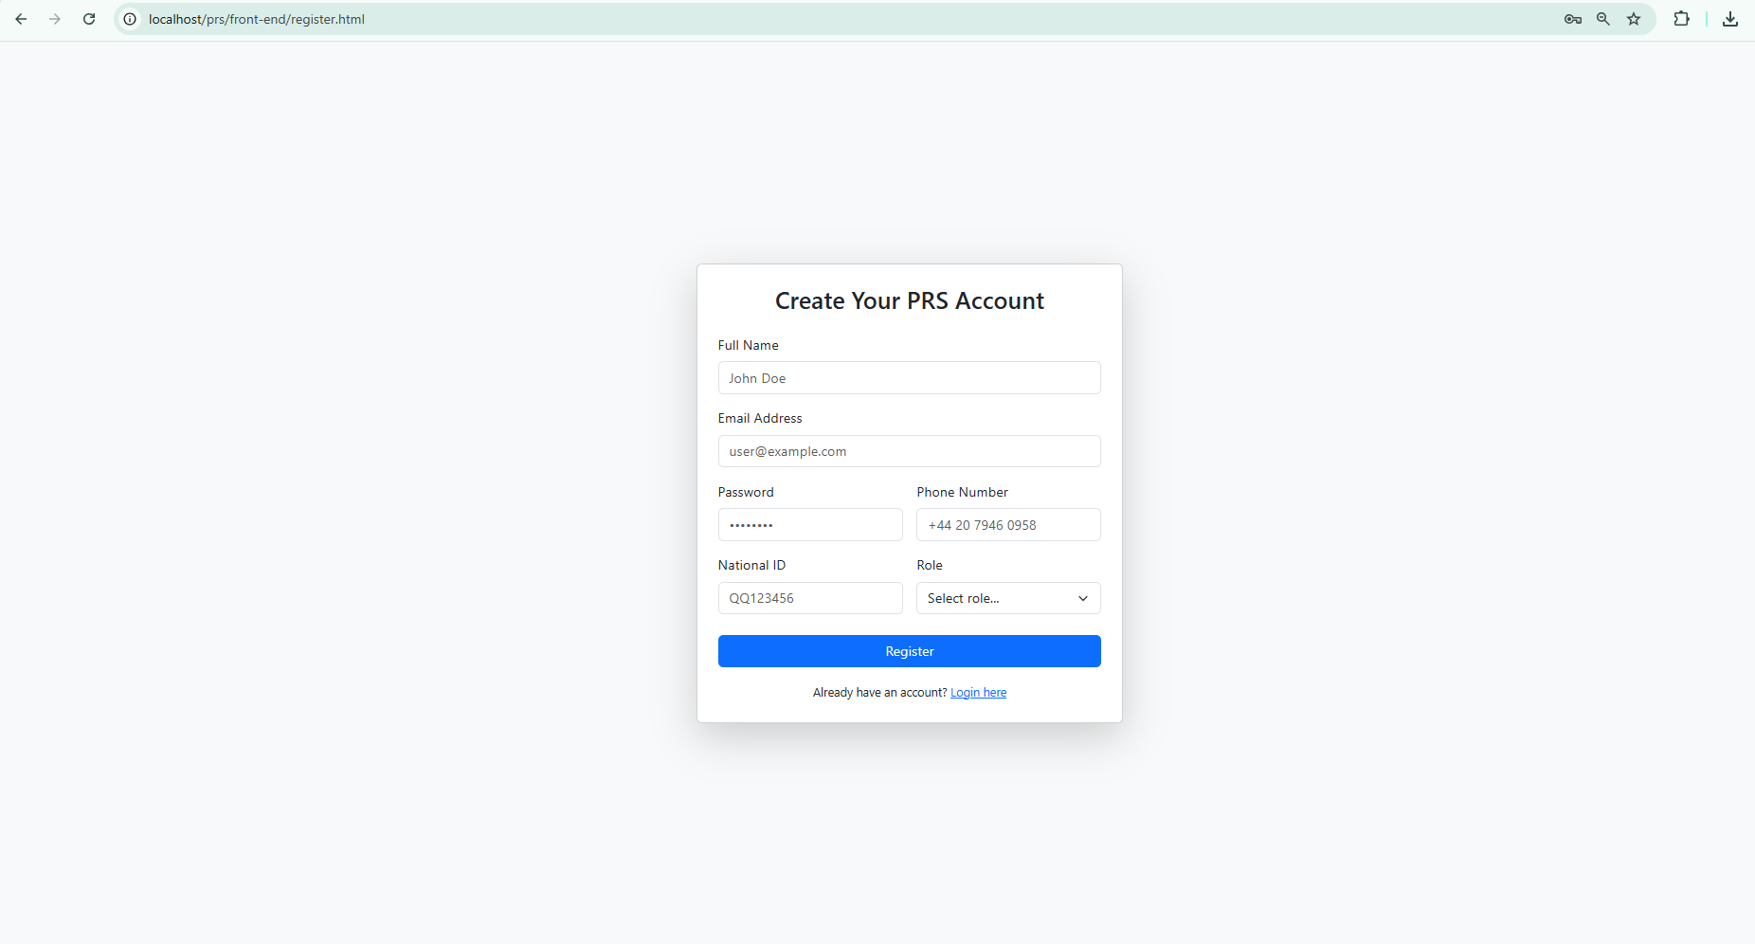
If we enter the same credentials as we did before in another user, it is either going to give us an error or not let us register. Nonetheless we are only allowed to enter a new actual user.

In this next screenshot the login page can be seen fully changing the layout so it can be used in a mobile device or just make the window we use smaller.
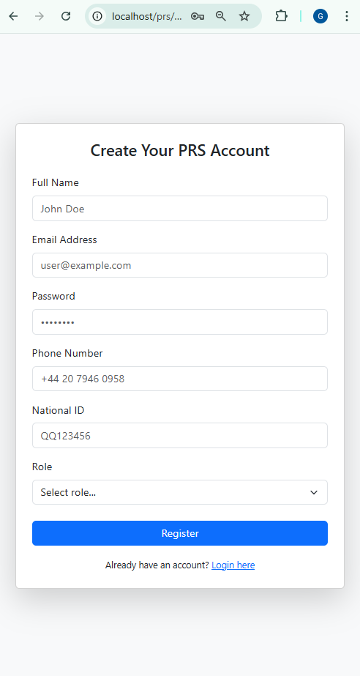

Login
Login is going to accept our information IF we have already registered otherwise, it will not be able to let us in. This is for security measures.
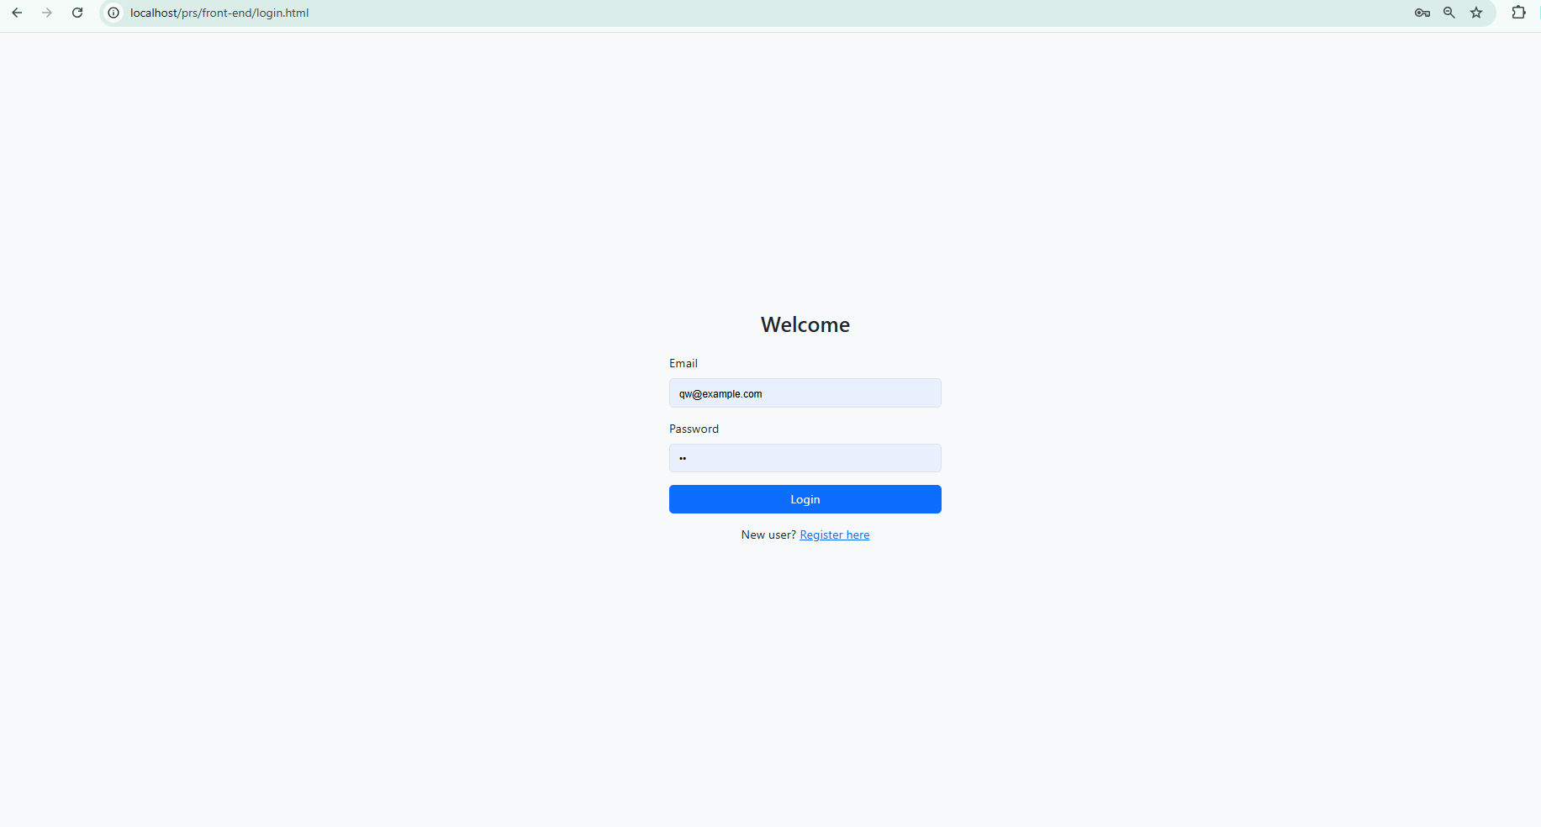
It can also work with a mobile view (like the Register page).

Dashboard
When we Login we are greeted by our Dashboard which shows all of the statistics of the vaccinations.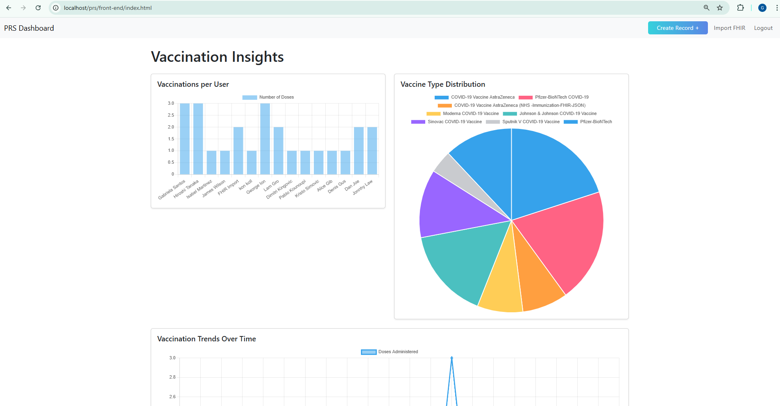
This one is also able to turn into a mobile view. 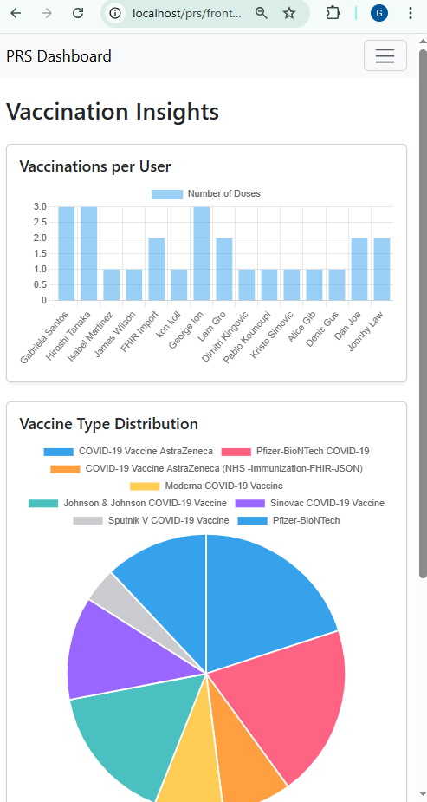

Create New Record
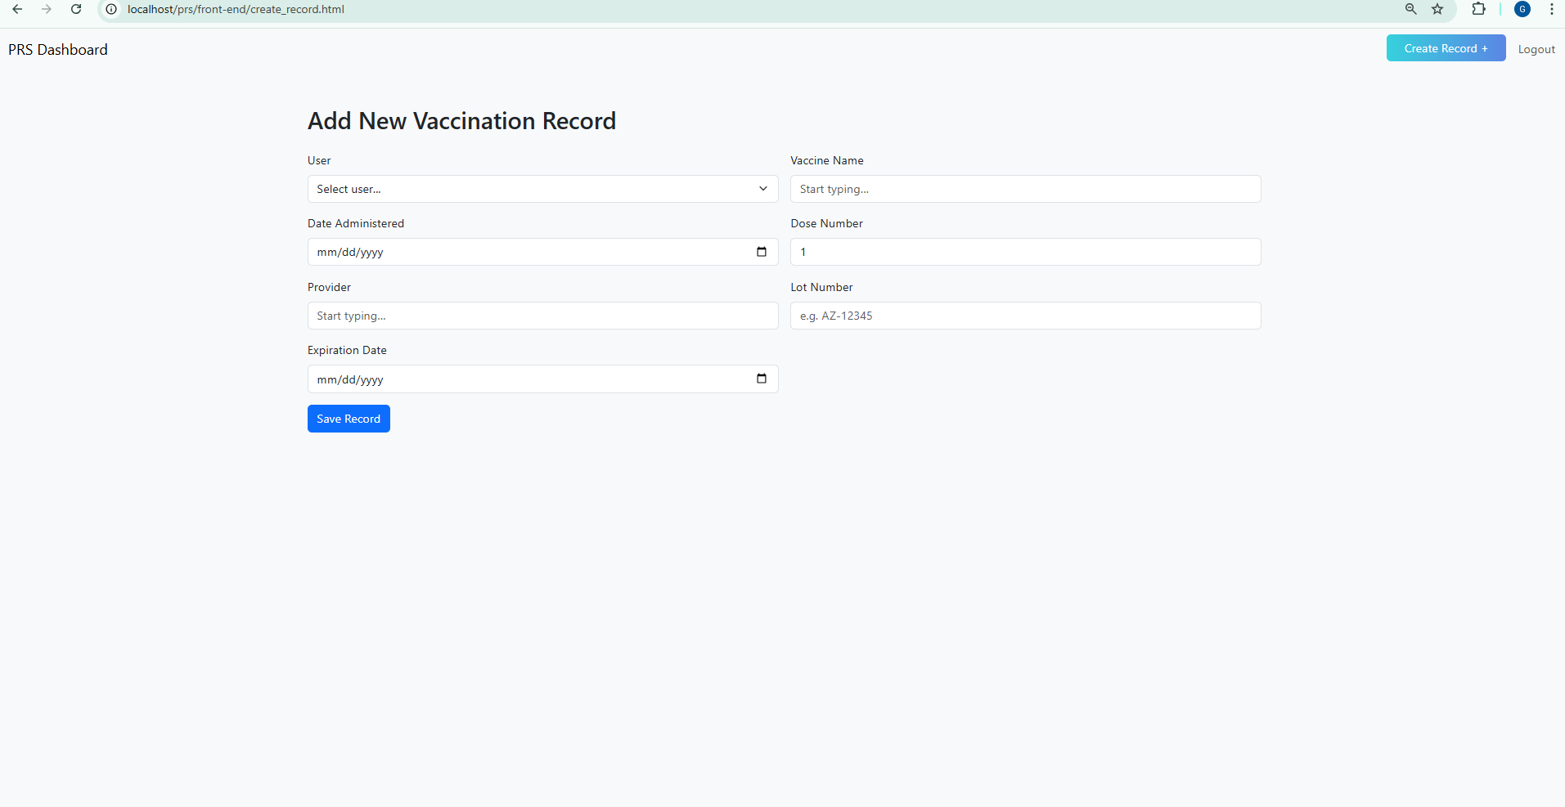
Creating a record is simple and straightforward. When we are done with the writing of all of the information of our vaccination, we Click Seve record and save “record saved” will appear. This one can also interact with the mobile view
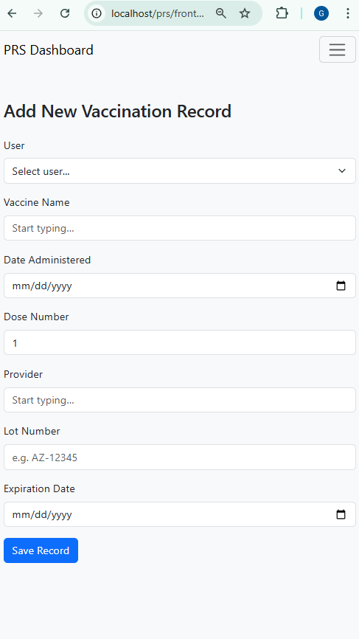

Logout
Login out is very simple and easy we just click on the Logout button located in each page.
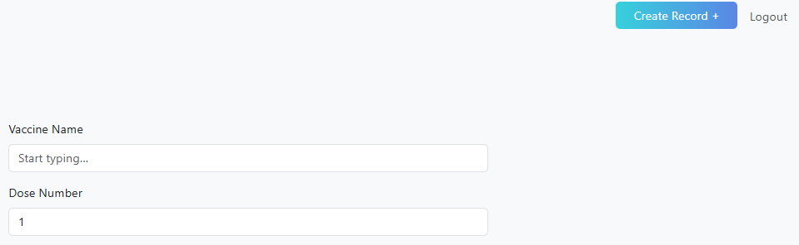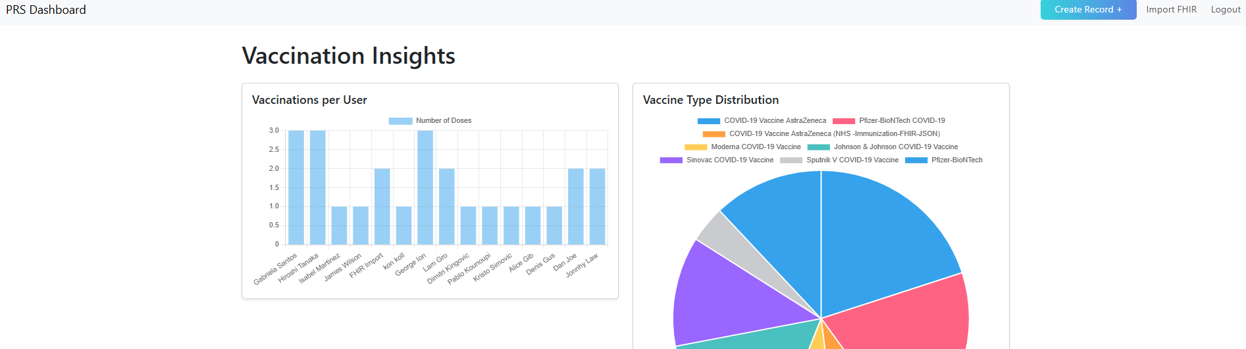
Same with the Dashboard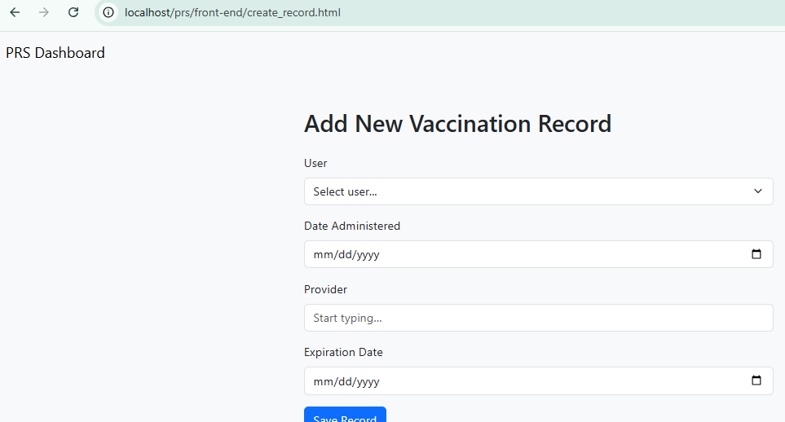

Postman
Here all of the APIs can be seen and are able to run.
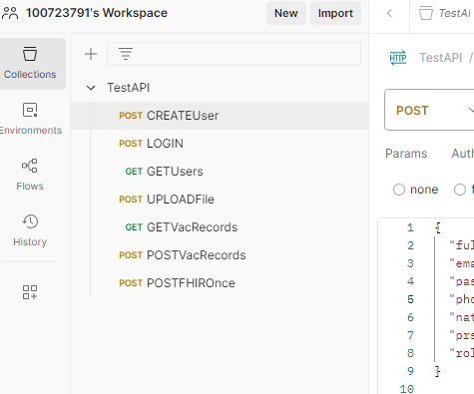
Screenshots from the Demo Testing
