George Gannon

Gmg3f@mtmail.mtsu.edu

Abstract

This program calculates the value of an integral by using the Trapezoidal Rule, Midpoint Rule, and Simpson’s Rule. After this, it calculates the errors of the approximation using numerical analysis.

Approximating Definite Integrals [With Errors] via Python

Calculus 2 Final Project

**Code at a Glance (Python 3, written in IDLE, Sympy/Numpy Required)**

1. **import** sympy as sym
2. **from** sympy **import** Symbol, sin, cos # for trig
3. **from** sympy.solvers **import** solve
4. **from** sympy.utilities.lambdify **import** lambdify # for shortening lines 41-43
5. **import** numpy as np # for arange method
6. x = Symbol('x')
8. **def** f2(x): # Changing this changes function integrated
9. **return** sin(x)**0.5
11. **def** Midpoint(f, step, a, b, n): # calculates by midpoint rule
12. integral_value = 0
13. x_points = np.arange(a,b,step)
14. **for** array_index **in** x_points[:]:
15. integral_value += (f2(0.5*(array_index+array_index+step)))
16. integral_value *=step
18. **print**('Midpoint Sum: The function is approximately equal to',format(integral_value, '.4f'))
20. **def** calculate_derivatives(rule, f2):
21. **if** rule == 'T':
22. derivative = sym.diff(f2(x),x,x)
23. **elif** rule == 'M':
24. derivative = sym.diff(f2(x),x,x) # second derivative for trap or mid
25. **else**:
26. derivative = sym.diff(f2(x),x,x,x,x) # fourth derivative for simps
27. **return** derivative
29. **def** calculate_error(derivative, a ,b, n, x, method):# FInd critical numbers, plug in, get max, plug into error
30. new_derivative = sym.diff(derivative,x)
31. **try**:
32. critical_numbers = [sym.nsolve(new_derivative,a,real = True)]
33. **except** ValueError:
34. critical_numbers = [0]
35. **except** KeyError:
36. critical_numbers = [0]
37. **except** ZeroDivisionError:
38. **print**('The error could not be calculated. I am sorry.''\n') # For when an integral is breaking everything
39. **return**
40. **except**:
41. critical_numbers = [sym.nsolve(new_derivative,a, real=True)]
42. critical_numbers.append(a)
43. critical_numbers.append(b) # Previous two lines put in endpoints into critical numbers list
44. d = lambdify(x,derivative, 'sympy')
45. critical_numbers = [x **for** x **in** critical_numbers **if** **not**(x<a **or** x>b)] #Removes critical numbers not in [a,b]
46. critical_numbers = [abs(d(x)) **for** x **in** critical_numbers] # Absolute values all indices and plugs them into respective derivative for calculating maximum
47. K = max(critical_numbers) # Finds maximum of them
48. **if** method == 'M': # letters determine which error calculation formula to use
49. error = (K*((b-a)**3)) / (24*n**2)
50. **print**('The approximate error is:',error, '\n')
51. **elif** method == 'T':
52. error = (K*((b-a)**3)) / (12*n**2)
53. **print**('The approximate error is:',error, '\n')
54. **elif** method == 'Simpson':
55. error = (K*((b-a)**5)) / (180*n**4)
56. **print**('The approximate error is:',error, '\n')

59. **def** Trapezoidal(f, step, a, b, n): # Calculates by Trapezoidal rule
60. outside = 0.5 * step # (b-a)/n
61. x_points = np.arange(a,b,step)
62. integral_value = f2(a)
63. **for** array_index **in** x_points[1:]:
64. integral_value += (2*f2(array_index))
65. integral_value += f2(b)
66. integral_value *= outside
68. **print**('Trapezoidal sum: The function is approximately equal to', format(integral_value, '.4f'))
70. **def** Simpson(f2, step, a, b, n): #Extremely accurate
71. outside = step/3
72. x_points = np.arange(a,b,step)
73. integral_value = f2(a)
74. ordinate = 1
75. **for** array_index **in** x_points[1: ]:
76. **if** ordinate%2==0:
77. integral_value += (2*f2(array_index))#multiply by 2 if ordinate number is even
78. ordinate +=1
79. **else**:
80. integral_value += (4*f2(array_index))#multiply by 4 if ordinate number is odd
81. ordinate +=1
82. integral_value += f2(b)
83. integral_value *= outside
85. **print**("Simpson's Rule: The function is approximately equal to", format(integral_value, '.4f'))
87. **def** main():
88. beginning_interval = float(input('Enter the beginning of the interval: '))
89. ending_interval = float(input('Enter the end of the interval: '))
90. number_of_subintervals = int(input('Enter the number of subintervals: '))
91. **print**('\n''The function to be integrated is:',str(f2(x)),'\n')
92. # Collecting intervals, n, and step size
93. a = beginning_interval
94. b = ending_interval
95. n = number_of_subintervals
96. step = ((b-a)/ number_of_subintervals)
97. # Reassigning for clarity sake
98. f = f2(step)
99. Midpoint(f2, step, a, b, n)
100. derivative = calculate_derivatives('M', f2)
101. error = calculate_error(derivative, a, b, n, x, 'M')
103. Trapezoidal(f2, step, a, b, n)
104. derivative = calculate_derivatives('T', f2)
105. error = calculate_error(derivative, a, b, n, x, 'T')
107. Simpson(f2, step, a, b, n)
108. derivative = calculate_derivatives('Simpson', f2)
109. error = calculate_error(derivative, a, b, n, x, 'Simpson')
111. main()

## ***Key Locations***

Function for Integration: Line 9

Midpoint Rule: Line 11-18

Simpson’s Rule: Line 70-85

Trapezoidal Rule: Line 59-68

Main Routine: Line 87-109

Derivative Calculation: 20-27

Error Calculation: 29-56

**Goals and Methodology of Project**

Before I began coding, I wanted this, in addition to being an exercise in Riemann sums, I wanted the program to be a practice in using packages I haven’t used before in Python. I had heard of the power of Sympy and Numpy, so I imported those in and got to work. We had been working with lists and arrays in my CSCI 1170 class, so I also wanted to have some practice using those. Therefore, the code itself is most likely *not the optimal solution* to the problem at hand, and it might be very CPU intensive. Also, I have no experience whatsoever coding in an environment besides IDLE, so I did not use say, a Jupyter Notebook.

I first researched all the methods to make sure I had a good grasp on what mathematics had to done. I had knowledge on how Midpoint and Trapezoidal sums worked, but I will admit I had never utilized Simpson’s Rule. Calculating errors would also prove to be a learning experience as I had never done it.

**Coding**

After doing some brief ‘sketching’ and experimenting using a placeholder IDLE file, I concluded that the best approach would be to explode the interval of integration into tiny pieces separated by a ‘step’ size. The step size would be calculated as a variable in the main() and then get passed as an argument into the three main functions (see line 83). After finding the step size, I would put it into the .arange() method with arguments (a,b, step) so that it made an array similar to the following:

For a =1, b=2 ,n=10 and step = (2-1)/10=0.1

[1, 1.1, 1.2, 1.3, 1.4…2.0]

I began coding, and put in a user prompt for specifying a, b, and the number of subintervals. I first coded the midpoint rule (line 12). It proved to be the shortest in terms of code. Next, I coded the Trapezoidal rule and first used a variable called ‘outside’ which is essentially like the outside numbers of the calculation. In Trapezoidal rule’s case, it is delta-x (step)/2. This type of code would appear again in Simpson’s Rule. After researching how Simpson’s Rule worked, I typed a code out that gave me an extremely wrong integral. After some debugging, I found that it was not properly multiplying values and had to code in an ‘ordinate’ system. This solved the bug by ensuring only the odd valued x-sub values would be multiplied by 4, and the even valued ones would be multiplied by 2.

To ensure it was properly calculating the sums, I used a very simple function $X^2$ as I could easily calculate the integral. I found that there was a point where a subinterval around 1000 could severely skew the calculations, but after increasing it or *decreasing it*, it would fix itself. I imagine this was due to the arrange function truncating decimals in an odd fashion. I enhanced the complexity of the functions until it was working for polynomials of the seventh degree.

I took a week-long break, and then came back to code the error calculation. This proved to be a very bad move. I started off by coding a calculate derivative function as both error calculation formulas required them. This was not bad as I got to practice using sympy methods (sym.diff). However, once I began to actually code the error calculations, roadblocks began to happen. Exception after exception occurred, new bugs arose from fixing old ones, certain methods didn’t work because of conflicting whitespace, etc. I had to use many try and exception blocks to get it working. However, after fixing those issues, I can now say that it works with a few limitations. Getting trigonometry to work with the code proved to be a learning experience, but now Sin and Cos work. I imagine that converting a few functions in the program to use SciPy methods would perhaps simplify the code, and maybe even make it even more accurate.

**Limitations/Bugs**

1. Interval must be such that **a<b**
2. Trigonometry only works for two of the three basic functions.
   1. Sin and Cos are verified to be working, but strange errors occur that keep Tan from having precise calculations.
   2. Not been tested with inverse trig, or reciprocals.
3. Strange error occurs with intervals
   1. Can replicate by setting f2 (line 9) to x^2 and then n to 1000.
4. At larger intervals of a and b, the error calculation can be near zero, but still be off by margin, or be near the integral value and show a large error. If I had to make an educated guess with my limited Analysis knowledge, this might be due to non-real answers.

**Sample Outputs**

$$\int_{-5}^{5}{x^{2} dx}$$

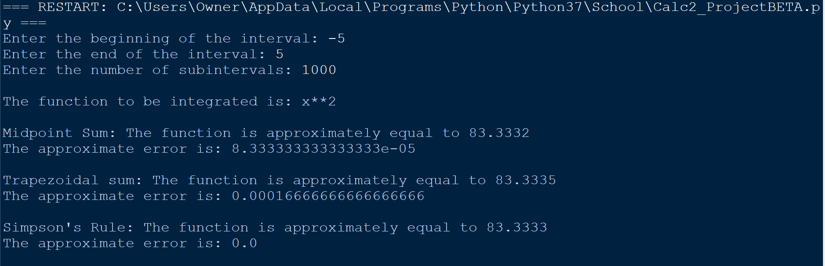

$$\int_{0}^{25}{x^{2}+4x+4 dx}$$

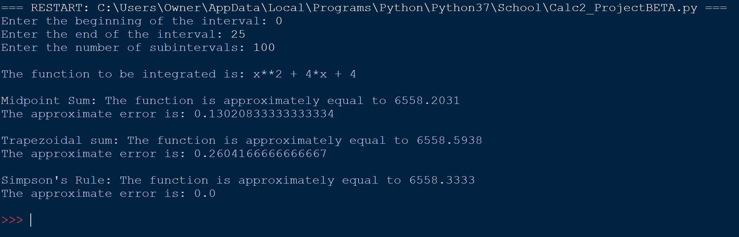

$$\int_{0}^{π}{\sin\left(x\right)dx}$$

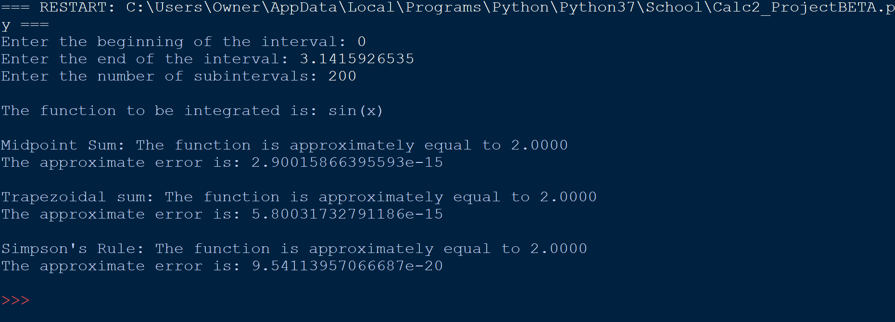

$$\int_{1}^{5}{x^{2}+4x+4+\sin\left(x^{2}\right)*\cos\left(x^{2}\right)dx}$$

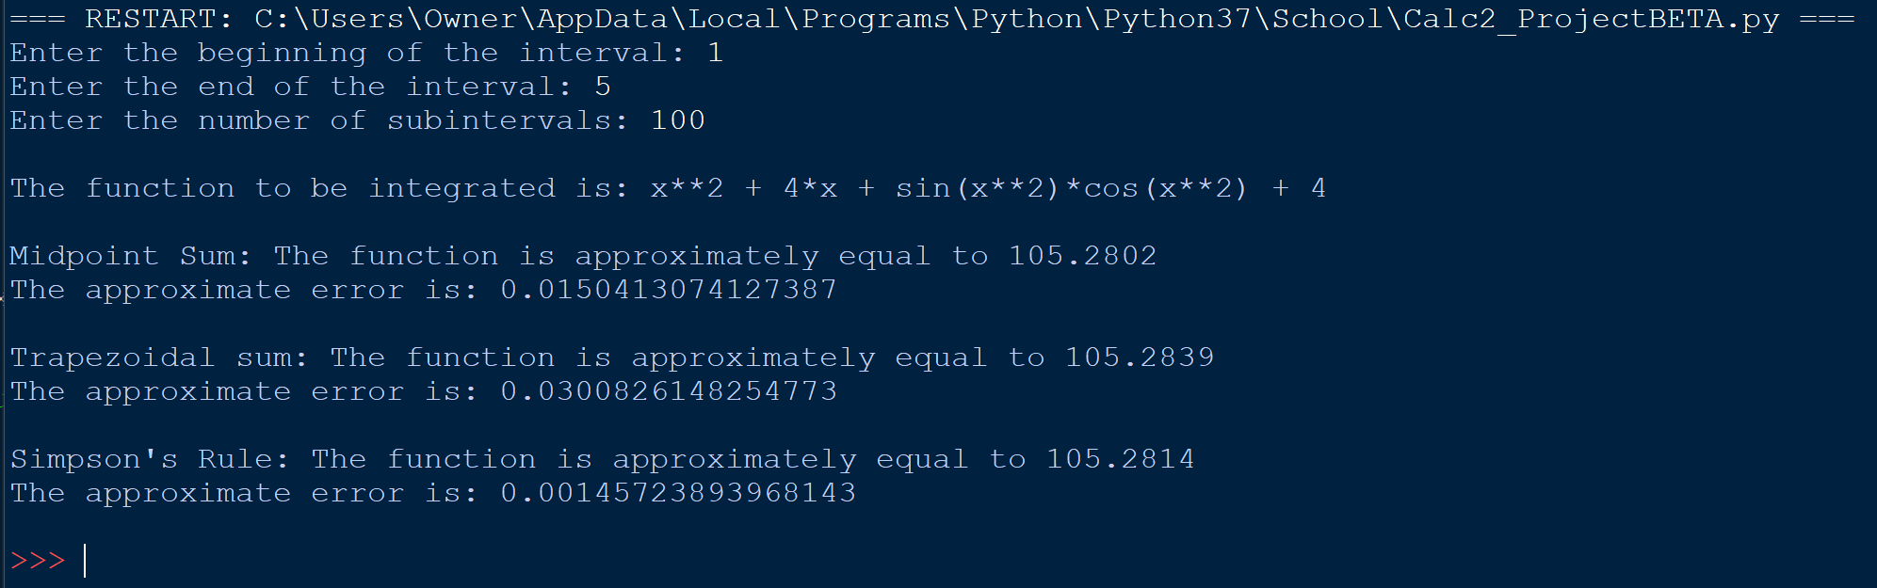

*This output is interesting because the output is the real part of a complex number.

$$\int_{0}^{π}{\sqrt{\sin\left(x\right)}}$$

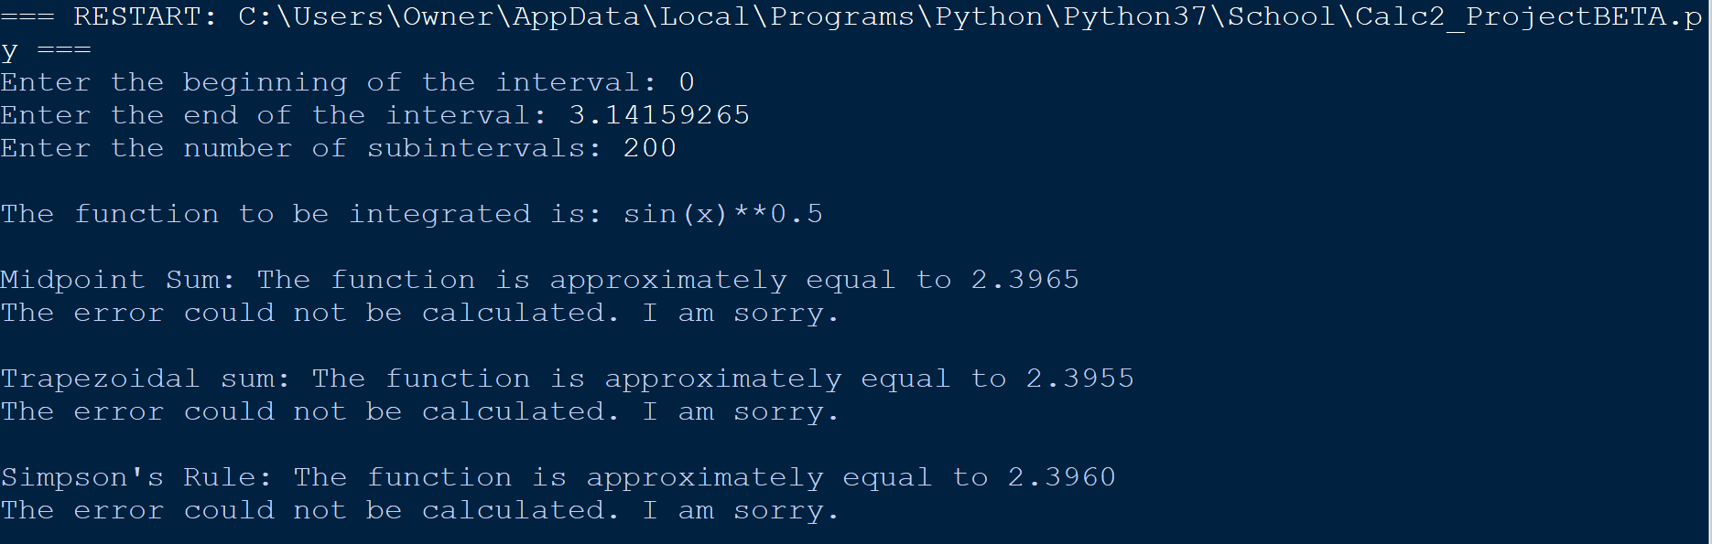

In order to prevent a crash when a zero-division error occurs during error calculation, I coded in an exception block that breaks the error calculation.