An evaluation of the benefits of using a blockchain solution for a food vendor platform such as Just Eat or deliveroo.

Introduction
I will be evaluating the benefits and downfalls of using blockchain technology in the development and implementation of a food vendor platform similar to just eat or deliveroo when compared to development and implementation via a more typical approach using a centralised server. My primary motivation for this is the high fees charged by “middle man” companies that take a fee for connecting and facilitating transactions between two parties, some examples of these industries include food vendors, peer-to-peer ride sharing (Uber), peer-to-peer e-commerce (eBay), freelancer websites (upwork) and many more.
According to the Just eat website [1] their fees for restaurants are a one-off joining fee of £699 and a commission of 14% on every order, some of these fees will be made back in savings on several of the perks offered by Just Eat such as energy bill savings, cashback from specific wholesale stores among other perks. The fee to the customer is a 50p admin charge on every order.
For this, restaurants get advertised on the just eat website, a tablet and printer for receiving and managing orders, personalised data insights, cashback and savings made on services such as wholesale retailers, energy bills, delivery bikes and scooters.
I hope to replicate the core functionality of a food vendor platform on the blockchain, I will then evaluate how fit it is compared to current centralised systems and make a conclusion on if the blockchain based solution can compete with current centralised systems in respect to fees charged, ease of use among other aspects of the system. Though I will be producing a UI to interface with my blockchain back end I won’t be evaluating the UI itself as it not only falls outside the scope of my project but also with the blockchain back-end being public to anyone I would expect several user interfaces to be produced by different developers that interface with a blockchain back-end.

Background and related work

What is a Blockchain (Bitcoin)
in 2008 a person or group of people using the name Satoshi Nakamoto produced the first blockchain protocol, the bitcoin protocol. This protocol was built on top of the ideas of Stuart Haber and W. Scott Stornetta proposed in a paper from 1991 titled “How to Time-stamp a Digital Document” [2] in which they outline a system that would prevent document timestamps from being tampered with.
Satoshi implemented a decentralized and distributed ledger which can record transactions across several computers without the need for a central server. It does this by keeping a record of all transactions held together in groups also known as blocks that are chained together to create a block chain. The transactions on the block chain occur between accounts known as addresses, where each address is a public, private key pair, in the case of bitcoin, elliptic curve cryptography is used to generate this key pair. Each transaction within a block is signed using the senders address’ private key to ensure that only the sender can spend their bitcoin. Each new block generated will approve a previous block by including a hash pointer to that block, chaining the blocks together.

What is a Smart Contract (Ethereum)
In 2013 Vitalik Buterin proposed that bitcoin needed a scripting language for application development, however failing to gain agreement he proposed the development of a new platform with a more general scripting language. Ethereum was then announced in early 2014.
What is Ethereum
Ethereum is a blockchain like the bitcoin protocol however with a few major differences. For one the cryptocurrency used on the Ethereum blockchain is Eth.
Ethereum has the ability to store a smart contract on the blockchain where a smart contract is some code that can be run without any human interaction. One of the main uses for a smart contract which I will be taking advantage of in my project is the notion of an automated escrow, this allows code to store value In the form of cryptocurrency until a set of requirements have been met, at this time the funds can be released to the appropriate parties deemed by the publicly viewable smart contract code.
Technically Bitcoin has the ability to store and run smart contracts also, however it is not considered turning complete due to the halting problem. The issue comes from the fact that any transaction has to be verified by others in the network, if a transaction has an infinite loop the whole network could slow down. Bitcoin resolves this by simply removing the programming controls that would allow a program to run forever, for example loops.
Ethereum however in the yellow paper [3] describes itself as “quasi-Turing-complete” they go on to explain that though the Etherem virtual machine (EVM) would be Turing complete if not for each transaction being “intrinsically bounded through a parameter, gas”. Every operation within the Ethereum Virtual Machine has a specified gas cost to execute. This gas will then be given to the miners of the network as a reward. Upon sending a transaction to the network the gas usage will be estimated, the sender will then specify their own gas price in wei (10^-18 Eth). The Gas sent with the transaction will then be the estimated gas usage * the specified gas price. Setting a lower gas price will save the sender transaction fees however will also cause the transaction to be picked up and processed slower by the network. According to the website “Eth gas station” the current standard gas price is 3 Gwei, or 3*10^-15 Eth.
Contract calls vs contract state changes

The Current State of Ethereum Dapps
A dapp or decentralised application is an application that has its back end code running on a decentralized peer-to-peer network instead of a centralised server.
Currently most active dapps tend to have purposes that remain virtual and don’t extend to the real world, with most of the top dapps being under the category of Games, Wallets, Advertising, Exchanges, Gambling or data storage. [5] I did however find some companies that offered some interesting Business models.
Eva is a Canadian company who are working towards building a decentralised uber like platform on the EOS blockchain. [6] They released the beta version of their application for android and ios in October of 2018 in Canada, and though news on its progress since then has been hard to come by, it seems it is mostly liked with a rating of 3.9/5 of google play.[7]
Swarm.city is an Ethereum based application that is attempting to build a general peer-to-peer marketplace. It says that it could be used to develop many other applications such as a lift sharing application, a peer to peer bnb platform or a freelancing platform. However it appears that the use of the project has diminished largely with the recent fall in the value of cryptocurrency, further development to the system doesn’t seem to be progressing as fast as it once was.
Most of the drive for development of decentralised applications has subsided during the crash of bitcoin over 2018. On the Ethereum blockchain, very few applications that have an impact of the physical world have been developed. The EOS chain has had slightly better success however nothing major.

Design
Development Tools
Choice of blockchain : public vs private
When considering the tools I will use to develop my application, the first and most important decision to make would be the the choice of blockchain protocol to use. Firstly I must consider what is a better fit for my application, a public blockchain or a private blockchain.
Private blockchains like hyperledger and ripple restrict who can access the closed network, they are more centralized as only a few miners validate the blocks so trust is needed in those miners however due to the limited number of miners consensus takes less time meaning the network runs faster and is more scalable.
Public blockchains like bitcoin, ethereum or eos are far more decentralized, anyone with sufficient hardware could setup their own node and contribute towards maintaining the network. Because of this the network is considered trustless, more secure and offers complete transparency which can be a good thing but makes the storing of private/personal data on a public blockchain basically impossible. Also, the larger number of nodes cause consensus to take longer, leading to slower network speeds and scalability concerns among higher energy consumption with proof of work based algorithms.
A private blockchain wouldn’t fit with what I'm trying to achieve, it offers too much of a centralized model that wouldn’t work in the peer-to-peer style of application I’m attempting to make. A public blockchain is completely decentralized so would offer peer-to-peer transactions however the high transaction times and throughput may largely impact the user experience. That being said I feel like most of these concerns can be addressed with the use of the commit and reveal design pattern (more on this later) and some clever asynchronous UI development.

Choice of blockchain : Ethereum vs EOS
For my choice of public blockchain, I’m considering Ethereum and EOS. Both of these protocols are geared around the ability to write smart contracts and develop dapps however there are some key differences such as the consensus algorithm, availability of documentation/online support and the capabilities of the existing frameworks that I should consider before making my decision.
EOS doesn’t charge fees for any computation you request on the network. Instead you are entitled to a proportion of computational power from the network based on the proportion of total EOS tokens you hold. So if you own 1% of all tokens you are entitled to 1% of the networks computational power, this holds true for CPU and GPU usage however, ram is considered far more of a valuable resource and is therefore treated differently. Users of the network can buy ram from a ram pool smart contract. The price of ram is automatically set by the smart contract which uses the Bancor algorithm, this pricing algorithm basically ensures that there is always ram available for purchase because as the amount of available ram approaches 0 the cost of ram approaches infinity. Currently new accounts need 4 to 8 Kb of ram to use the network costing at this time about 0.82 – 1.64 dollars.
EOS uses delegated proof of stake as the consensus protocol. What this entails is a protocol in which participants can cast votes to elect the 21 block producers. If a block producer is honest and earns the trust of the network they accumulate enough votes to remain a block producer. If they act dishonest and abuse their position the networks trust in them will fall and another block producer will be voted in. each staked token corresponds to one vote for the network. Currently, EOS has an annual inflation rate of 5%, 1% of this goes towards rewarding the block producers while 4% goes into a pool that is allocated as payment to developers who wish to improve the network protocol. Because the EOS network only has 21 block producers, consensus takes a lot less time to be achieved. This leads it to have the largest operations per second rate of above 19000000 operations per second [13]

move the delegated proof of stake explenation to background work

Ethereum’s protocol requires a fee (known as gas) to be paid, this fee is proportional to the computational power needed for the transaction. While you could argue that EOS offers a cheaper service to any dapp user due to no fees, the cost has to be paid by the dapp developers which will eventually be passed on to the end user.
Ethereum also differs from EOS in its consensus algorithm. Ethereum is currently using a proof of work algorithm similar to bitcoin, this offers some positives such as better security due to a higher number of block validators, meaning an attacker would need to control more nodes to accomplish a 51% attack. However the higher total block validators causes network consensus to take longer. Meaning transaction time is higher, throughput is lower at about 680000 operations per second [13] and total network energy consumption is higher. That currently being the case, the Ethereum protocol has a lot of updates in development such as sharding, casper and plasma channels that promise to rectify these issues.
Ethereum is far more established the EOS, with Ethereum being released July of 2015 and EOS being released January of 2018, Ethereum has far better support, and developer tools than EOS. Both blockchains have front end libraries that enable interfacing with the blockchains, however again due to the extended time Ethereum has been out for, support, documentation and functionality of these libraries is better than that of EOS.
Though EOS has a higher rate of transactions per second, I feel that the longer track record, better developer support and improved security sway me to chose Ethereum as the platform on top of which I will develop my application.

Language and Framework
Ethereum offers several languages and compilers that are able to compile code into bytecode that can be run by the Ethereum virtual machine, solidity is currently the most popular language, it is a javascript based language and offers the most support. Other languages exist such as serpent, which is based on python however due to serpent being less popular, documentation is harder to come by. For this reason among the fact that I am more comfortable developing in javascript compared to python. I will be using solidity to develop my smart contract based back end.
Initially I used the online ide remix [14] to begin developing my smart contracts, remix offered a very easy entry into the development of smart contracts as you can compile and run tests all in the browser without having to install any other software. I was able to prototype several of the basic systems I would be employing, while just getting a feel for solidity. Eventually my project began to outgrow remix however, the IDE didn’t offer the ability to develop guis and working on several larger contracts was becoming more troublesome.
I then moved over to Truffle, a framework that was developed to assist ethereum developers build and deploy smart contracts, they offerer tools to compile, test and deploy your contracts to either the Ethereum main blockchain, any of the test blockchains or a local running blockchain. Initially I would deploy my contacts to a local running blockchain, this was supplied by a tool released with the truffle framework known as ganache that sets up a local blockchain in memory.

Interfacing with the Blockchain: contract migration
initially when attempting to migrate my contract to the ropsten test network I tried syncing my pc with the ropsten blockchain. This proved to be quite difficult due to the large size of the chain. I opted to use infura instead to resolve this. Infura is a collection of ethereum full nodes that can be used to send transactions to the blockchain without the need for a full node. First a transaction is signed on by the user, then sent to infura who then using their full node broadcast the transaction to the blockchain.

Interfacing with the Blockchain: client application
there is only a few ways someone can send a transaction to the blockchain:
- Running a full node: this means that you have to have a copy of the whole blockchain saved on your device. Constantly updating and verifying transactions, this method is very secure however requires good hardware and a good network connection.
- Running a light client:
- Using a wallet: wallets store your private keys and also allow you to interface with smart contracts via a trusted full node. They are the least secure as no validation is done by you, so any false data received that was sent by the full node or by an attacker who intercepts and changes the contents of a block will be trusted. Though they are easy to use as they require no syncing with the blockchain.

Web3 is a javascript api that provides several libraries for interfacing with a blockchain, metamask will automatically create a web3 connection allowing matamask to facilitate transactions with the blockchain

Design Patterns
When starting to plan my project I thought it best to consider several different design patterns so I could find what I felt best complimented what I was attempting to achieve. As well as refreshing myself on the design patterns I know, I set out researching new unseen design patterns, both those that are generic to all programming and those that are specific to smart contracts [9] [10]. From this I compiled a list of design patterns that would potentially come in useful in the development of my program. This list included:
Factory Contracts: this is similar to the factory design pattern only it applies to smart contracts. a factory smart contract is published that has a method that creates a new contract. This will be useful as I will want to allow new users to call the factory method from the appropriate factory to create their account. Using a factory to handle account creation will also allow for storage of the produced contracts addresses within the factory enabling easier indexing and lookup of these contracts.
Name Registry: using this pattern I would have a contract that is dedicated to storing references to other contracts such as the factories, this way my front end application only has to store the address of the name registry making it easier to ensure that only the latest versions of a contract is being used. all contracts produced would reference this name registry contract so that if they want to access another contract within my system they could do so by first accessing the name registry. For example if a customer wanted access to a specific restaurant the customer could first query the name registry for the restaurant factory address, then they could query the restaurant factory for the specific restaurant they desire.
Commit and Reveal: this pattern is a way to store private data on the blockchain even though all data on the blockchain is publicly visible. It involves first hashing off chain whatever you wish to store, then storing said hash on chain. (the commit) later on a user can submit a guess against the original data, simply hashing their guess and comparing it to the commit on chain to validate if their guess is correct. (the reveal) it should be noted that if the hashing of the users guess and comparison to the committed hash is done on chain it will be revealed to all.
Ownership: this is a way to ensure that only authorised accounts can access the relevant functions of a smart contract. By default anyone can call any smart contract method but by declaring a contract owner, and checking that the sender of a method call has a matching address with the stored owner address, we can restrict the use of each contract to its owner.
Access Restriction: method calls can be modified to add stop clauses or requirements that need to be met to allow execution of the function. Having an abundance of requirements at the start can ensure that a function will fail early reducing the gas cost of a transaction that fails.
Mortal Pattern: contracts should be self destructed by the owner once it is no longer required, an alternative to this may be to disable a contract using access restriction bundled with the state machine pattern to stop the execution of methods in a contract once a specific contract state has been met.
Satellite Pattern: as the blockchain is immutable and contracts can’t be upgraded, only new instances of contracts can be made. To reduce migration gas fees to the network it makes sense to outsource functionality to separate so-called satellite contracts. This way modifying of functionality simply involves migrating a new satellite contract and updating the reference to this contract.
When planning and implementing my program I will ensure to consider these among other design patterns to produce good quality code.

Architecture: System Flow
When beginning to design my systems architecture I thought it best to first try to describe the flow of my system, that being all the primary ideal actions of all the actors. This would help me start to construct my contracts and the interactions between them.
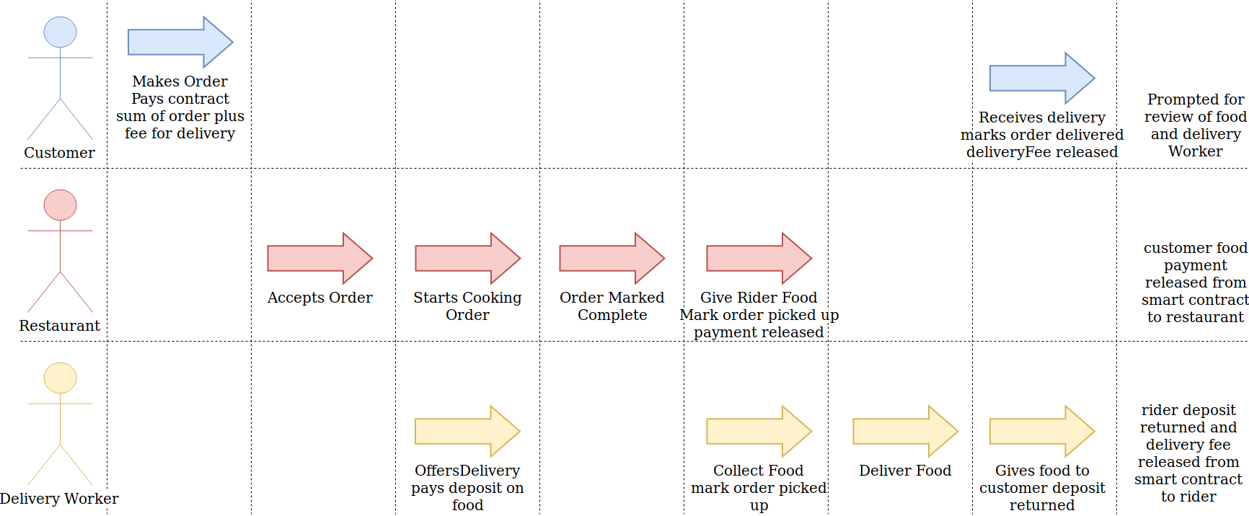
The above diagram shows my system flow. It shows the three agents that will be involved within any one order, the ideal actions taken by them and then the resulting actions issued by my smart contract once all conditions are met.
Considering my system flow has highlighted several design features that I should implement. For one, I realised I needed a way to deter delivery workers against bad practices such as keeping the order for themselves when they should deliver it. I will do this by enforcing a deposit system in which the delivery worker must pay a deposit at least equal to the cost of the order.
Another design feature resolves around the need to create a system for which there are three separate actor types, all of which may have an abundance of new users wishing to create an account of that type. For this reason, I will design my system to make use of the factory contract design pattern. Using this pattern will allow for easy creation of new contract instances via a factory contract while also providing a place to store information on all users of that type.

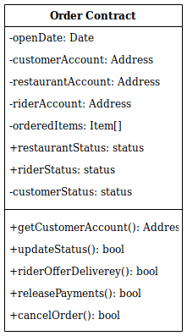
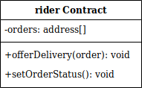
Architecture: plan
after understanding the basic flow of my system I felt it would now be best to draw up a basic system diagram, specifying the contracts, their variables and methods and how they would interact with one another.
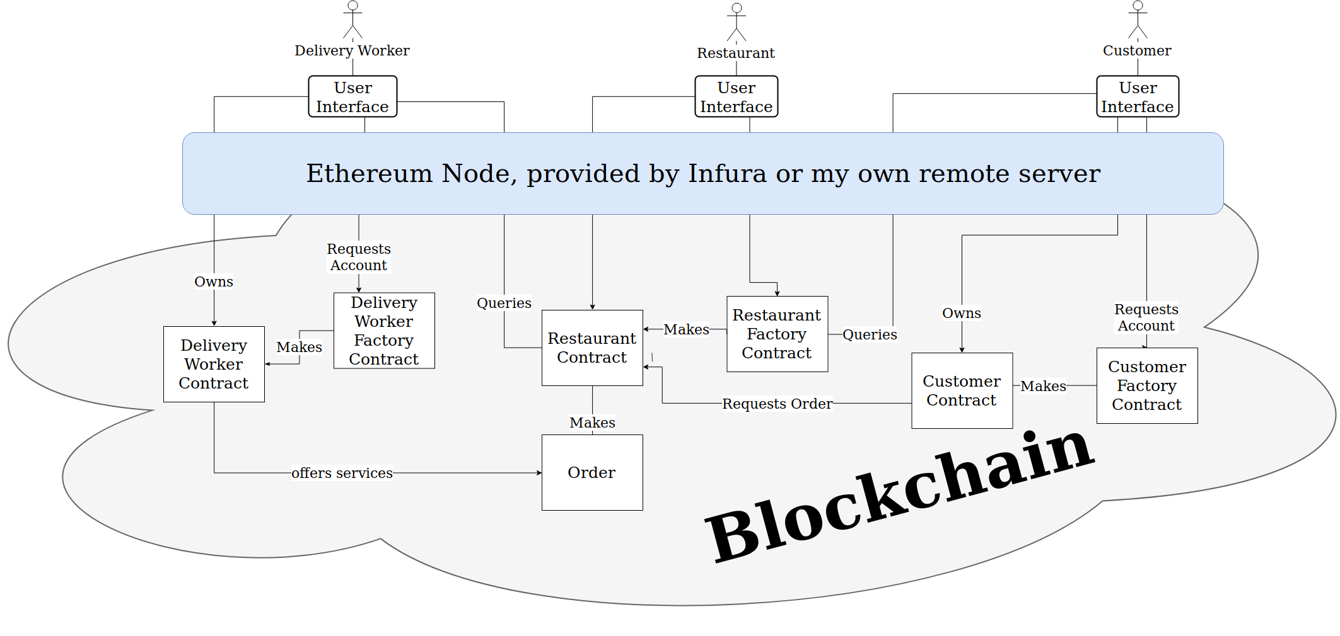
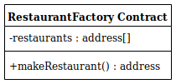
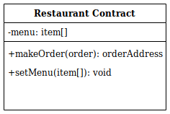
As the management and creation of user accounts would play quite a large role in my program I decided to use the factory contract design pattern, a new customer, delivery worker or restaurant could create an account by calling the respective factory contracts make factory function. Also I can use these factories to store references to active user contracts for querying so for example a user or delivery worker could get all restaurants by checking the list of restaurant addresses within the restaurant factory.
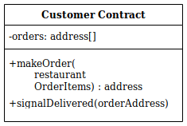
Once a customer has created their account they would query the restaurant factory to find all restaurants, they would then make an order to the restaurant by making a transaction to their own contract, sending payment for the order including the delivery fee and referring to the restaurant address and items they wish to order. The customer contract would then pass on the payment and order information to the restaurant contract at the address specified which would then create an order smart contract and store the customers payment within this contract.
Delivery workers can query in tern first the restaurant factory to obtain all restaurants, then each restaurant to obtain all orders. The delivery worker can then offer to deliver the order by depositing an amount equal to that of the order value into the order contract.
The restaurant will update the status of the food preparation so that the delivery worker knows when to arrive for collection, at this point both delivery worker and restaurant would notify the order contract that the food delivery has been handed over. The delivery worker will then deliver the food to the customers address and then again both parties, delivery worker and customer will signal the food has been handed over. At this point funds will be released into the appropriate accounts.

Planned architecture and system flow: Challenges
though I believe my architecture can provide a system that provides the core functionality of a food delivery service, there are some Challenges that need to be resolved to largely improve the quality of my end produce. The main two being the high transaction times for the ethereum network, as well as the storage of private user data.
All write operations to a blockchain take time to be processed by the network, for ethereum the block time is around 14 seconds [15] however this isn’t consistent and blocks can take longer to process. A user may want to wait several confirmations also to ensure a double spending doesn’t occur increasing the transaction time further. Considering all the transactions that will be made by users of my application not all of them will require an immediate response, for example, creating an account, making an order or updating an order status doesn’t require an immediate response. Though admittedly an immediate response would increase the user friendliness of my system. Some other transactions exist where the delay in transaction time could pose a serious problem. These include the transactions that occur during cargo hand over, such as when the restaurant gives the food to the delivery worker and when the delivery worker gives the food to the customer. Having the restaurant and delivery worker wait for the transaction to process and be confirmed before handing over the food will significantly reduce the appeal of my application against other applications that use more traditional application back ends with no waiting times. Both parties cant risk handing over the food prior to this transactions confirmation due to the risk that the other party simply wont notify the system that they have the order causing no payment to be released. [should I write how to fix this here or later on?] Another transaction that might cause problems due to the high transaction times is the offer made by a delivery worker to deliver an order. If two delivery workers were to offer delivery of an order at a similar time, one of them is going to be the first to get delivery while the other is going to have their deposit locked up until their transaction inevitably fails due to a rider already being assigned, at which time they may lose some funds for the gas paid for any computation that occurred prior to their transaction failing.

Implementation
In this section I will describe my program architecture in greater depth, giving examples of key design choices and explaining the motivations behind them.
Account Creation
new users can create accounts by invoking the make account function from one of the three factory smart contracts, for example if a new customer wishes to make a new account, they will invoke the makeCustomer function from the customer Factory contract. This function first checks to make sure they don’t already have a smart contract linked with their address, if they don’t my factory creates a new customer contract and saves the address of this contract. It then emits an event indicating an account has been made that my frontend can detect to cause the UI to update.
Controller Contract
After some initial testing on my factory contracts and the account contracts they produced I noticed each contract was building an increasing number of addresses referencing other contracts in my system. I decided to implement the name registry design pattern, this meant adding a contract that I named controller, that stores references to the factories within my system. This way contracts could simply query the controller to get the factory addresses.
Account Contracts
As my customer, restaurant and delivery worker contacts share a lot in common I will discus the key parts of their design here and then go into each in more depth. Firstly, each of the account contracts implements the ownership design pattern where they all have a variable specifying the owners address. This is then used across several of the functions within the contract to ensure that only the owner is able to call these functions. The owner address is also the recipient of any payments the contract may receive.
The account contracts also stored references to the order contracts that they are involved with. This allows easy listing of relevant orders for all the users.

Customer Contract
This contract stores information on a customer and provides functionality for that customer to interact with a restaurant contract and an order contract. The

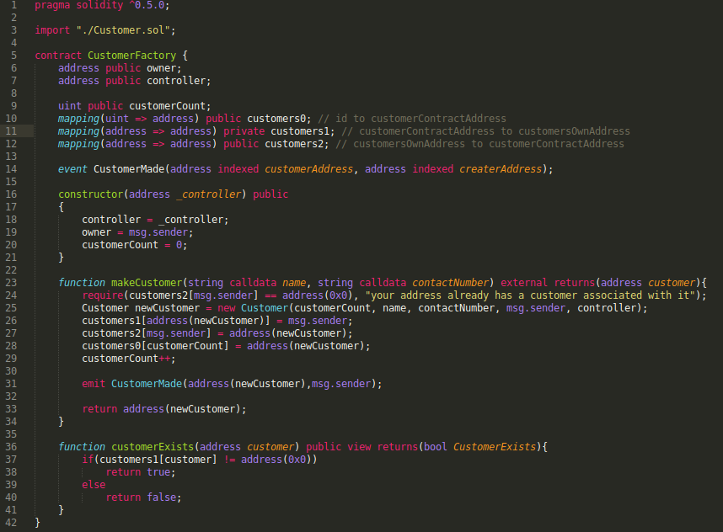

[1] : Just Eat website: https://restaurants.just-eat.co.uk/
[2] : How to timestamp a digital document: https://link-springer-com.abc.cardiff.ac.uk/article/10.1007/BF00196791
[3] : Ethereum yellow paper : https://ethereum.github.io/yellowpaper/paper.pdf
[4] : Eth Gas Station : https://ethgasstation.info/
[5] : state Of the dapps : https://www.stateofthedapps.com/rankings
[6] : Eva about us : https://eva.coop/index.php#about_us
[7] : Eva, Google Play : https://play.google.com/store/apps/details?id=com.evaclient
[8] : swarm city : https://thisis.swarm.city/
[9] : Design Patterns for Smart Contracts in the
Ethereum Ecosystem : https://eprints.cs.univie.ac.at/5665/1/bare_conf.pdf
[10] : Applying Design Patterns in Smart Contracts : https://www.researchgate.net/profile/Qinghua_Lu5/publication/325900304_Applying_Design_Patterns_in_Smart_Contracts/links/5c2ecd8ea6fdccd6b58fa0c4/Applying-Design-Patterns-in-Smart-Contracts.pdf
[11] : state of dapps stats : https://www.stateofthedapps.com/stats
[12] : EOS resource planner : https://www.eosrp.io/#calc
[13] : Block’tivity : https://www.blocktivity.info/
[14] : : https://remix.ethereum.org
[15] : blocktime : https://etherscan.io/chart/blocktime

