**Manchester Metropolitan University**

**Department of Languages, Information and Communications**

**Web Site Development**

# Assessment 1 Sp2 User Journey

You are tasked to create a user journey for each of your personas. Why are they using your guide? What do they hope to achieve?

You should use the following criteria:

* Persona: who is your user
* Tasks. What is the user trying to achieve at this stage?
* Questions. What does the user want to know at this stage?
* Touchpoints. How does the user interact with the organisation at this point?
* Emotions. What is the user feeling at this stage in the process?
* Influences. Who or what is helping to shape the user's decision-making process at this stage? Technology? Environment?
* Opportunities. What opportunities arise at each stage?

Use the accompanying chart to record each of these elements for your personas.

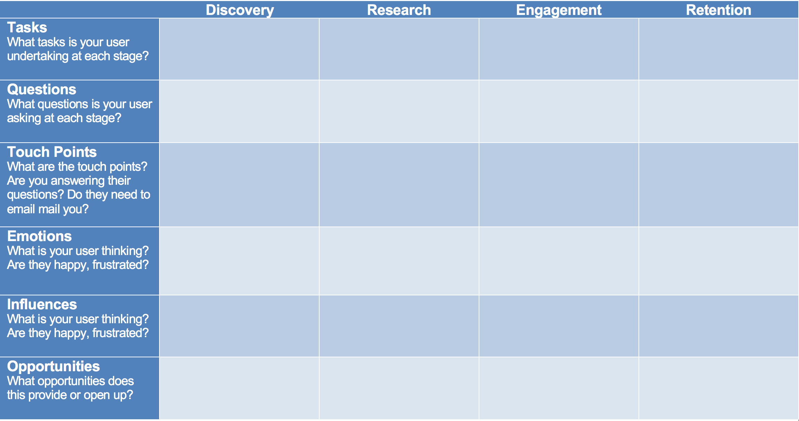

Once the chart is complete you can either submit this on its own or add to it by creating a visual representation of your findings. A creative representation that relays the data will be much more accessible to a team.

See Paul Boag’s article *What Is Customer Journey Mapping and How to Start?* to learn more and see some creative examples. https://boagworld.com/usability/customer-journey-mapping/

Persona One – Name

Scenario – Set the scene, are they accessing the site on the go, sat in front of the TV, quickly at work on their desktop?

Goal – What is key thing your persona is trying to achieve on this visit?

|  |  |  |  |  |
| --- | --- | --- | --- | --- |
|  | Discovery | Research | Engagement | Retention |
| Tasks  What tasks is your user undertaking at each stage? |  |  |  |  |
| Questions  What questions is your user asking at each stage? |  |  |  |  |
| Touch Points  What are the touch points? Are you answering their questions? Do they need to email mail you? |  |  |  |  |
| Emotions  What is your user thinking? Are they happy, frustrated? |  |  |  |  |
| Influences  What is your user thinking? Are they happy, frustrated? |  |  |  |  |
| Opportunities  What opportunities does this provide or open up? |  |  |  |  |

Persona One – Name

Scenario – Set the scene, are they accessing the site on the go, sat in front of the TV, quickly at work on their desktop?

Goal – What is key thing your persona is trying to achieve on this visit?

|  |  |  |  |  |
| --- | --- | --- | --- | --- |
|  | Discovery | Research | Engagement | Retention |
| Tasks  What tasks is your user undertaking at each stage? |  |  |  |  |
| Questions  What questions is your user asking at each stage? |  |  |  |  |
| Touch Points  What are the touch points? Are you answering their questions? Do they need to email mail you? |  |  |  |  |
| Emotions  What is your user thinking? Are they happy, frustrated? |  |  |  |  |
| Influences  What is your user thinking? Are they happy, frustrated? |  |  |  |  |
| Opportunities  What opportunities does this provide or open up? |  |  |  |  |

Persona One – Name

Scenario – Set the scene, are they accessing the site on the go, sat in front of the TV, quickly at work on their desktop?

Goal – What is key thing your persona is trying to achieve on this visit?

|  |  |  |  |  |
| --- | --- | --- | --- | --- |
|  | Discovery | Research | Engagement | Retention |
| Tasks  What tasks is your user undertaking at each stage? |  |  |  |  |
| Questions  What questions is your user asking at each stage? |  |  |  |  |
| Touch Points  What are the touch points? Are you answering their questions? Do they need to email mail you? |  |  |  |  |
| Emotions  What is your user thinking? Are they happy, frustrated? |  |  |  |  |
| Influences  What is your user thinking? Are they happy, frustrated? |  |  |  |  |
| Opportunities  What opportunities does this provide or open up? |  |  |  |  |