

# Contents

Contents 1

Introduction 2

What is ImageGA 2

How does ImageGA work? 2

Running ImageGA for the first time. 2

Downloading and Installing ImageGA 3

Create a Directory folder 3

Run ImageGA demo 3

ImageGA Settings 3

Biological Sex 3

Starting Populations 4

Pool Units 4

Deletion Pool 4

Breeding Pool 4

Number of Generations 4

Mutation Rate 4

Mutation Distribution 4

Mutation Strength 4

Crossover Type 4

Crossover Probability 5

Recombination Completeness 5

Mating System 5

Inversion Mutation Probability 6

Duplication Mutation Probability 6

Scramble Mutation Probability 6

Targeted Duplication Mutation Probability 6

Crowd Operators 6

ImageGA Outputs 7

Individual IDs 7

Parents 7

ImageGA Fitness Calculators 7

Travelling Salesperson 7

Background Match 8

Creating your own Gene Templates 9

Targeted Duplication and Gene Units 9

Creating Your Own Fitness Calculators 10

File and Code Organisation 10

/Fitness Calculators/: 10

/RequisitFunctions/: 10

ImageGA Demo: 11

Recommended Settings for Psychophysics Experiments 11

References 11

# Introduction

Here we describe the features of the genetic algorithm plugin ImageGA in addition to two worked examples of its use i) travelling salesperson problem and ii) camouflage evolution experiment. These examples are designed to showcase the functionality of ImageGA and how it may be used by researchers wishing to conduct their own evolution experiments. The guide as it is published here was designed for ImageGA v1.0, documentations detailing future versions can be found  [GitHub](https://github.com/GeorgeHancock471?tab=repositories&q=&type=public&language=) or our [Website.](https://www.visual-ecology.com/) ImageGA was created for the camouflage evolution simulator CamoEvo. For the documentation explaining how to use CamoEvo refer to the [CamoEvo_Supplement.](https://github.com/GeorgeHancock471/User_Guides/archive/main.zip)

# What is ImageGA

ImageGA is a genetic algorithm (GA) Toolbox for ImageJ designed to aid in survival experiments with evolving ImageJ generated patterns. The plugin is designed to be largely customisable, with built in options for population size, genotype, mutation rates, crossover type and mating system.

ImageGA comes with a built-in template for performing two versions of the Travelling Salesperson problem: a ring-shaped map of 16 cities, and a map of the USA with 48 of the 50 state capitals (excludes Hawaii and Alaska). For each of these problems, Gaussian noise can be added to the data to simulate noise which will naturally occur in other optimisation problems such as the psychophysics experiments ImageGA was designed for.

ImageGA is automatically included with CamoEvo and is required for CamoEvo to run correctly.

# How does ImageGA work?

ImageGA, like most genetic algorithms, relies on classical evolutionary theory in order to produce populations which increase in fitness with each generation (Goldberg and Holland, 1988). Similar to evolution by natural selection, only the surviving (fittest) members of a population get to breed producing offspring that are recombinants of their parents and have their own unique mutations. Over time the fitness of the population is expected to increase as the population fixates on an optimal phenotype.

# Running ImageGA for the first time.

## Downloading and Installing ImageGA

ImageGA can be obtained either by downloading CamoEvo or independently from either on [GitHub](https://github.com/GeorgeHancock471?tab=repositories&q=&type=public&language=) or our [Website.](https://www.visual-ecology.com/) When downloading be sure to use the link specified for each operating system. If you download ImageGA separately you will need to have ImageJ bundled with JAVA from NIH downloaded already. Not FIJI.

## Create a Directory folder

Before you start running ImageGA you will want to create a new empty directory which you will want to save your generation files to. E.g., /ImageGA Test 1/

This will be used as the Working Directory for ImageGA, for storing all of the Generation, Survival and Phenotype Data.

## Run ImageGA demo

Open ImageJ, go to your plugins folder / ImageGA / and run ImageGA demo.

* Select the Working Directory you created.
* Select ‘Salesperson_Ring_16’ as your Template.
* Choose ‘Create Custom’, then set the population size to 24 and the population type to random.
* Keep the Algorithm Settings Part 1 and Part 2 as default.
* Select ‘Salesperson_ Ring_16’ as your fitness calculator.
* ImageGA should then start to produce 10 generations worth of Survival Data for the Travelling Salesperson problem in addition to creating a folder with the fittest route from each generation.
* Within the directory you should find .txt files for each generation, txt files with the fitness value for each generation (total travel distance) and a folder containing maps of the fittest salesperson routes for each generation. In addition, there will be a .csv file named Fitness_Summary containing the fitness values and IDs for all generations.

# ImageGA Settings

All settings for the ImageGA plugin can be altered within the ImageGA interface, this panel will alter the default settings used by the algorithm. In this section you will find descriptions regarding each of the ImageGA operators, how they work and what they do.

## Biological Sex

Within Genetic Algorithms sex/mating type is a commonly used feature for maintaining genetic diversity within large populations (Rejeb and AbuElhaij, 2000). If you choose to enable biological sex the population will be split into two mating types. Males will only be able to mate with females and females will only be able to mate with males. Additionally, when ranking by fitness, males and females are ranked separately.

## Starting Populations

When creating starting populations ImageGA presents you with the option to either create a custom population or use the existing. If you choose to ‘Use Existing’ the gene values and population size of the genotype template will be used. If you instead choose to create custom, you can create a population within intervals of 2. You can then choose whether to use random values, pre-set values, or random mutants from the pre-set values.

## Pool Units

Determines the unit for deleting and breeding individuals within the population can either be integers or percentages. The adjusting the units used makes it easier to tailor the algorithm to populations of specific sizes while percentages are better for handling systems where the algorithm needs to work for populations of multiple sizes.

## Deletion Pool

Determines how many individuals get deleted within the next generation.

## Breeding Pool

Determines the number of individuals that get to breed in the next generation. The number of offspring produced must also equal the number deleted and so the number of times the parents will get to breed will multiply to equal the deletion pool.

## Number of Generations

Determines how many generations the population will evolve for not including generation 0 which is the starting population.

## Mutation Rate

Determines the probability of each gene in the genome undergoing mutation, you can alter the rate of mutation for the offspring and the non-breeding survivors from each generation.

## Mutation Distribution

Determines the distribution of mutations by using existing functions within ImageJ. Using a uniform distribution provides an equal probability of large or small mutations while a normal or Poisson distribution reduce the probability of a large mutation taking place. As the algorithm is based on a decimal gene system, values above 1 or below 0 are clipped.

Uniform = $± X ϵ U[0,1]$

Normal = $± X ϵ N[0,1]$

Poisson = $± exp⁡(X) ϵ ⁡U\left[0,1\right]$

## Mutation Strength

Alters the range of values in which mutations can encompass by dividing the mutation by the number specified.

## Crossover Type

Determines the pattern of recombination of genes between parents.

*Random:* all genes have 50/50 chance of coming from either parent.

*One-Point:* one random section of the genome from each parent are crossed over.

*Two-Point:* two random sections of the genome from each parent are crossed over.

## Crossover Probability

Determines the probability that the offspring of two individuals are produced with crossover. Setting this probability to -1 makes it so that all individuals are produced asexually. If crossover does not occur, then the resulting offspring are copies of each parent + any mutations added.

## Recombination Completeness

Determines whether recombination for each gene is perfect or imperfect. If you choose perfect recombination when a decimal gene is copied it is copied in its entirety. If you choose imperfect recombination then each gene will be a value between that of the two parents but weighted towards one of them following the formula: $g=\frac{\left(p+\left(q*r\right)\right)}{1+r}$, where p = the value from parent 1, q = the value from parent 2, r = $101-(100*\sqrt{x ϵ U[0,1]})$ and g = the resulting gene. Imperfect recombination of genes can aid with phenotypic exploration by creating offspring with values between existing optima, a benefit usually unique to binary encoding systems as opposed to decimal.

## Mating System

Determines the order of mating within the breeding population. Note Poly, Disassortative, Assortative and Adaptive are all experimental mating systems and so aren’t recommended on release.

*Random:* each individual within the breeding pool is randomly paired with an unpaired individual.

*Ranked:* the individuals within the breeding pool mate in the order of fitness with individuals pairing, starting top to bottom, with the individual of adjacent rank.

*Poly:* the number of times the fittest individuals (top 1/6 of the breeding pool) get to mate with gets multiplied by two. Which individuals the fittest are paired with is assigned randomly however the fittest individuals do not get to mate with one another. This reduces the number of mating individuals by two for each poly mating individual.

*Disassortative:* starting with the fittest individual the sum Euclidean distance for each gene is calculated between that individual and the remainder of the breeding pool (n=number of genes, p = the gene from individual 1 and q = the gene from individual 2). That individual is then paired with the individual which had the greatest difference in genotype until all the breeding pool have been paired.

*Assortative:* starting with the fittest individual the sum Euclidean distance for each gene is calculated between that individual and the remainder of the breeding pool (n=number of genes, p = the gene from individual 1 and q = the gene from individual 2). That individual is then paired with the individual which had the lowest difference in genotype until all the breeding pool have been paired.

*Adaptive:* The sum Euclidean difference for each gene is calculated for each parent is measured. If the $\sum_{i=1}^{n}{d(p_{i}}, q_{i})$ (n=number of genes, p = the gene from parent 1 and q = the gene from parent 2) > α that pair votes for an assortative mating system, if $\sum_{i=1}^{n}{d(p_{i}}, q_{i})$ < β the pair votes for disassortative mating and if β < $\sum_{i=1}^{n}{d(p_{i}}, q_{i})$ < α then it votes for random mating (Jung et al., 2016). Whichever mating system receives the most votes is used in the next generation. The Generation 0 always starts with a random mating system.

## Inversion Mutation Probability

Inversions are a more extreme form of mutation where the value of a gene can be flipped. 1-p where p is the original decimal value. Such mutations are often deleterious but can aid in exploration of wider phenotypic spaces. Altering the probability changes the likelihood of each gene in the genome undergoing inversion. This mutation can be applied to offspring or non-breeding survivors.

## Duplication Mutation Probability

Copies a gene replacing a random gene within the genome with its value. Genes which are closer to the copied gene are more likely to be replaced as the gene copying follows a normal distribution: i2 = i1 +- ( $N/2*\sqrt{x ϵ U[0,1])}$, where i2 = the new index, i1 = the old index, N = the number of genes. Duplication is particularly useful when genes of similar function are clustered together within the genome. Altering the probability of duplication changes the likelihood of each gene in the genome undergoing duplication. This mutation can be applied to offspring or non-breeding survivors.

## Scramble Mutation Probability

A random section of the genome of uniformly random length is scrambled, i.e. the sequence of decimal values within the section is randomly reordered. This mutation type is particularly useful concerning problems where the sequence of values for genes is important e.g. travelling salesperson problems. Changing the probability changes the likelihood of scrambling to occur for each individual. This mutation can be applied to offspring or non-breeding survivors.

## Targeted Duplication Mutation Probability

Copies a gene and replaces one of the genes in the genome which has a related output. E.g., the decimal value of a gene that regulates the colour of one part of the image replacing the value of another gene which regulates the colour of a different part of the image. Using this method requires a gene template with genes marked for targeted duplication (*See creating your Own Gene Template).* Changing the probability changes the likelihood of each of the marked genes undergoing duplication. This mutation can be applied to offspring or non-breeding survivors

## Crowd Operators

*This system is experimental and more akin to adaptive mutation than true immigration (immigration being the mixing of individuals from distinct populations) (Derigs et al., 1999, Yang, 2007).*

The sum Euclidean difference for each gene is calculated for each parent. If the $\sum_{i=1}^{n}{d(p_{i}}, q_{i})$ (n=number of genes, p = the gene from parent 1 and q = the gene from parent 2) < δ (δ assigned threshold) then the pair votes for immigration, otherwise they vote against immigration (Derigs et al., 1999). In the event of immigration being the majority vote, new individuals are added to the population following the mechanism chosen, note for each new individual added an individual from the original population is removed starting with the lowest ranking individual (least fit).

*Random:* a new randomly generated individual is added.

*randomMate;* the fittest individuals are mated with a randomly generated individual and the offspring joins the population.

*mutantRegion:* the fittest individual is cloned, and all their genes undergo normally distributed mutation.

*mutantMate:* the top individuals are mated with a mutant copy of themselves (see mutantRegion) following one-point crossover and the offspring are added to the population.

*Dextinction:* The fittest individuals from up to 10 generations ago are re-added to the population.

The likelihood for immigration occurring can be altered by adjusting the δ threshold value. The number of individuals removed can also be adjusted.

# ImageGA Outputs

For each generation ImageGA outputs a .txt file containing the genome of every individual within the population for that generation. Each genome is marked by a unique ID signifying the individual.

## Individual IDs

Each individual generated within a population is given a unique ID by ImageGA e.g., Gen23_Mut1_ID18. ‘Gen’ indicates the generation the individual was created in, ‘mut’ indicates the number of times the individual was in the non-breeding population and ‘ID’ indicates the order in which it was created within the generation it was first made in. Regardless of the ID within the gene template, the ID is automatically replaced with an ID in the correct format.   
  
If you are using crowd operators, individuals created through immigration will possess an X next to their ID number, e.g., Gen12_Mut0_IDX1.

## Parents

For each individual in the population, the parents that produced it are recorded with the denotation Par_[ID]. If the individual was created in the first generation it has no parent, ‘none’. If the individual was created clonally then the parent ID will be the same as the individual’s ID.

If you are using crowd operators, immigrant individuals will have their parents labelled as Par_X, unless you are using the mutantMate or randomMate system, in which case only one of the parents will be labelled ParX to indicate that the individual.

|  |  |  |  |  |
| --- | --- | --- | --- | --- |
| ID | Penzance | StIves | Parent1 | Parent2 |
| Gen1_Mut0_ID15 | 0.900208136 | 0.442986907 | Par_Gen0_Mut0_ID10 | Par_Gen0_Mut0_ID28 |
| Gen2_Mut0_ID3 | 0.926931126 | 0.574447599 | Par_Gen1_Mut0_ID19 | Par_Gen1_Mut0_ID0 |
| Gen0_Mut0_ID8 | 0.246032931 | 0.499525392 | none | none |

# ImageGA Fitness Calculators

Fitness calculators also known as fitness functions are the mechanism with which the genotype template is converted to a phenotype and then measured for its fitness. ImageGA features three built in fitness calculators, each with their own gene template. These can be found in the Fitness Calculator folder located within the ImageGA plugin.

## Travelling Salesperson

The travelling Salesperson Problem or TSP is a commonly used genetic algorithm optimisation tool where a list of cities, towns or coordinates are presented, and the algorithm is tasked with finding the shortest route for visiting all the locations. In both the travelling salesperson examples given each gene corresponds with one of the cities on the map provided. The value of the gene represents the order with which the site is visited, with lower values being visited first. The fitness calculator then measures the distance travelled from one site to the next in the sequence of lowest to highest decimal value. The negative sum distance travelled for each route is then outputted as the fitness value, such that the greater the distance the lower the fitness values. We provide a shorter (16 city) and longer (48) city demo for the purposes of testing algorithm settings.

***Salesperson Ring 16***

In this example a salesperson is attempting to visit 16 cities in a ring site (Figure 1). Each gene in the ‘Salesperson_Ring_16.txt’ corresponds with one of the cities and is labelled with the city’s name. The optimal route is shown on the map in grey. Routes generated by the corresponding fitness calculator are shown in red. For each generation, the optimal route is outputted as a picture. If you use the ‘Salesperson_Ring_16_(Noise)’ calculator, Gaussian noise is applied to the fitness value for each individual in each generation. You can adjust the level of Gaussian noise by editing the value in ‘ImageGA/Fitness Calculators/Salesperson/Noise.txt’, the random Gaussian noise is multiplied by the number within the .txt file.

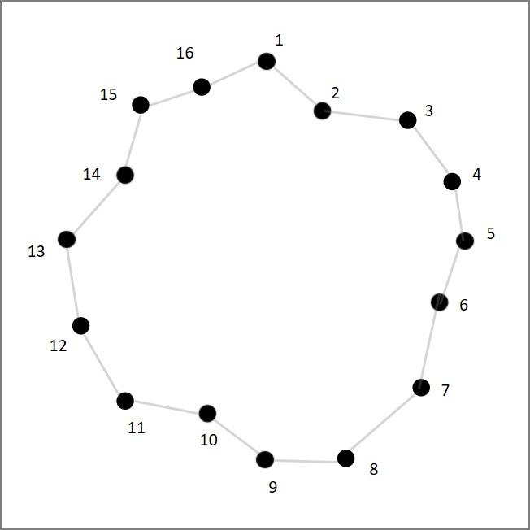

***Figure 1:***  *Ring Map, circular map where the optimal route is a ring shown in grey. Each point represents a location the salesperson needs to visit.*

***Salesperson USA 48***

In this example a salesperson is attempting to visit 48 of the US capitals (Figure 2). Each gene in the ‘Salesperson_USA_48.txt’ corresponds with one of the capital cities and is labelled with the cities name. The optimal route is shown on the map in grey. Routes generated by the corresponding fitness calculator are shown in red. For each generation, the optimal route is shown as a picture. If you use the ‘Salesperson_USA_48_(Noise)’ calculator, Gaussian noise is applied to the fitness value for each individual in each generation. You can adjust the level of Gaussian noise by editing the value in ‘ImageGA/Fitness Calculators/Salesperson/Noise.txt’, the random Gaussian noise is multiplied by the number within the .txt file.

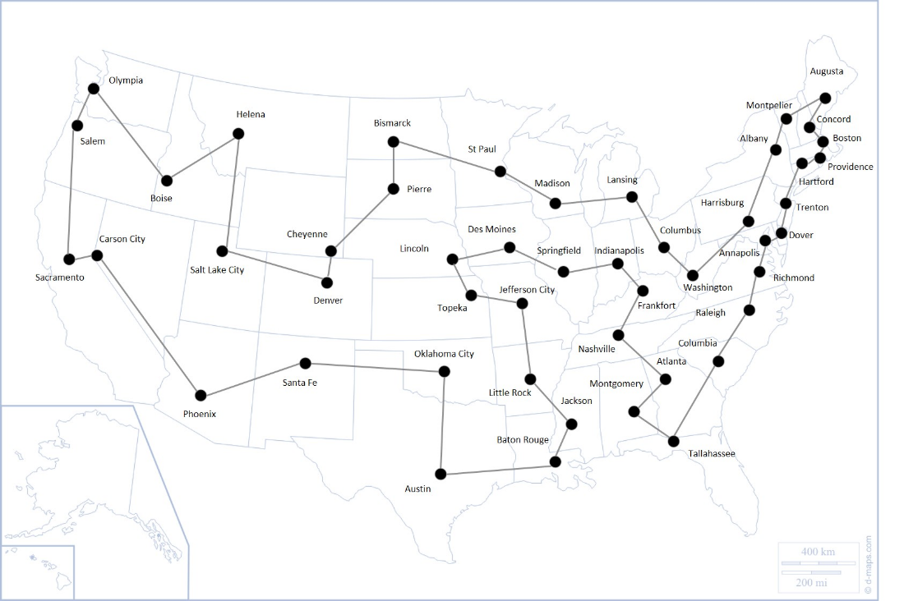

***Figure 2:***  *USA Map of state capitals where the optimal route is a loop shown in grey. Each point represents a capital the salesperson needs to visit.*

# Creating your own Gene Templates

To create a population template, you will need a .csv or .txt file containing a row of ‘headings’. The first heading must always be ‘ID’ this is the number tag which is assigned to each individual within the population (Each individual will be given a Unique ID). Then the following headings are the names given to all of your genes.

|  |  |  |  |  |  |  |  |
| --- | --- | --- | --- | --- | --- | --- | --- |
| ID | Gene1 | Gene2 | Gene3 | Gene4 | Gene5 | Gene6 | Gene7 |

If you so choose the population template can be filled with pre-existing values for all of the individuals within the population. **Providing that the number of individuals is a multiple of 8.** Note that all Genes must be of a decimal value between 0-1.

|  |  |  |  |  |  |  |  |
| --- | --- | --- | --- | --- | --- | --- | --- |
| ID | Gene1 | Gene2 | Gene3 | Gene4 | Gene5 | Gene6 | Gene7 |
| 0 | 0.894957 | 0.87786 | 0.52134 | 0.630631 | 0.347511 | 0.300364 | 0.652148 |
| 1 | 0.154317 | 0.558937 | 0.415092 | 0.74917 | 0.15789 | 0.610404 | 0.363917 |
| 2 | 0.466259 | 0.079911 | 0.373618 | 0.489214 | 0.479554 | 0.769761 | 0.386242 |
| 3 | 0.997533 | 0.641978 | 0.440022 | 0.389718 | 0.085979 | 0.176778 | 0.99077 |
| 4 | 0.000366 | 0.309722 | 0.077846 | 0.873439 | 0.908975 | 0.879219 | 0.899603 |
| 5 | 0.408393 | 0.0137 | 0.880307 | 0.374321 | 0.230493 | 0.129937 | 0.438298 |

## Targeted Duplication and Gene Units

*Note: The following is not necessary for all gene templates, only regions of the genome you wish to undergo targeted duplication (*see ImageGA settings*).*

For certain phenotypes you may find it useful to use targeted duplication of genes. To do this you will need to set up unit genes.

Unit genes act as markers identifying to ImageGA which genes are linked and should be allowed to undergo duplication. They have the following denotation: ‘Unit_X_Y’, where X is a unique letter shared by all the linked units and Y is the order of the units. E.g., Unit_C_0, Unit_C_1 would indicate two linked units with Unit_C_0 being first in the genome. While Unit_A_0 and Unit_B_0 would indicate units that are not linked together. Note gene units must be of equal length and be in the same order.

For example, say you were using a genome which outputs an image with an RGB colour and has stripes with a different RGB colour. You may wish for there to be a chance of the stripes becoming the same colour/more similar in colour to the rest of the image and vice versa.

1. Group the genes in terms of function. I.e., position the genes for the background RGB and the pattern RGB together and in the same order.
2. Add ‘Unit Genes’ between the linked genes. For these linked genes we will mark them with the letter C for colour.
3. Each Unit_C gene must be given a number to indicate order barring the last gene, which is marked with an N, which indicates the end of the unit.

|  |  |  |  |  |  |  |  |  |  |  |
| --- | --- | --- | --- | --- | --- | --- | --- | --- | --- | --- |
| … | **Unit_C_0** | Bg_R | Bg_G | Bg_B | **Unit_C_1** | Pttn_R | Pttn_G | Pttn_B | **Unit_C_N** | … |
| … | 0.89 | 0.88 | 0.52 | 0.63 | 0.35 | 0.30 | 0.89 | 0.88 | 0.52 | … |
| … | 0.15 | 0.56 | 0.42 | 0.75 | 0.16 | 0.61 | 0.15 | 0.56 | 0.42 | … |

1. With the following gene arrangement Bg_R, Bg_G and Bg_B can be copied to the corresponding Pttn gene and vice versa.

# Creating Your Own Fitness Calculators

Creating your own fitness calculator is relatively simple. All it requires is generating a script which can 1) convert the genes you created into the desired output; 2) measure fitness from the output and 3) create a ‘_survival.txt’ file for each generation in the folder where your population is stored. Example code for doing this can be found in the Travelling Salesperson and Background Match demo calculators located in the ImageGA plugin folder.

# File and Code Organisation

For the purposes of making ImageGA easier to edit, the code is organised as follows:

## /Fitness Calculators/:

Contains the .txt file for each fitness calculator.

* Background Match/: *Contains the background photo used by background match.*
* Salesperson/: *Contains the map and Gaussian Noise multiplier for the salesperson problems.*
* Population_Templates/: *Contains the .csv file templates for the genomes of each caclulator.*

## /RequisitFunctions/:

Contains the necessary plugins for running ImageGA.

* AlgorithmSettings.txt*: the previously used settings for ImageGA*
* Fitness_Plotter: *plots the change in fitness over time and concatenates the fitness values for each generation into a .csv file.*
* ImageGA_Algorithm: *The genetic algorithm component for ImageGA, will create a new generation within a destination folder providing that there is an AlgorithmSettings.txt file and a generation file within the assigned folder.*
* ImageGA_Interface: *The interface for adjusting the current ImageGA values and for creating generation_0 for a population.*
* PopulationLocation: *Records where ImageGA_Interface should create its new population and where the Fitness Calculators should save their fitness values to.*

## ImageGA Demo:

Acts as a demonstration for ImageGA combining the core functions together to allow users to run the genetic algorithm using the demo fitness calculators provided.

# Recommended Settings for Psychophysics Experiments

For small populations intended to be used for psychophysics or camouflage evolution experiments the following settings are recommended:

1. A population of 24 or 36 individuals.
2. A deletion pool that does not remove the entire population.
3. A breeding pool that does not include all surviving individuals.
4. A random mating system.
5. A high mutation rate 0.01 – 0.1 for the non-breeding individuals.
6. A low mutation rate 0.001 – 0.005 for offspring.
7. Use two-point crossover.
8. Allow for incomplete recombination.
9. Use a low mutation strength with a normal distribution.
10. Use targeted duplication for repeated genes e.g., colour for different patterns.
11. Use the mutant-mate crowd operator if you intend to run more than 10 generations.

This system ensures that the population isn’t too large for a single player to complete an entire generation; provides a buffer against noise killing off fit individuals by not removing too many; maintains diversity through random mating; ensures that offspring don’t undergo destructive levels of mutation while non-breeders are mutated to boost genetic diversity and provides methods for more rapidly optimising colouration.

# References

DERIGS, U., KABATH, M. & ZILS, M. 1999. Adaptive Genetic Algorithms: A Methodology for Dynamic Autoconfiguration of Genetic Search Algorithms. *In:* VOß, S., MARTELLO, S., OSMAN, I. H. & ROUCAIROL, C. (eds.) *Meta-Heuristics: Advances and Trends in Local Search Paradigms for Optimization.* Boston, MA: Springer US.

GOLDBERG, D. E. & HOLLAND, J. H. 1988. Genetic algorithms and machine learning.

JUNG, C., KIM, Y.-H., YOON, Y. & MOON, B.-R. 2016. A New Adaptive Hungarian Mating Scheme in Genetic Algorithms. *Discrete Dynamics in Nature and Society,* 2016**,** 3512546.

REJEB, J. & ABUELHAIJ, M. New gender genetic algorithm for solving graph partitioning problems. Proceedings of the 43rd IEEE Midwest Symposium on Circuits and Systems (Cat.No.CH37144), 8-11 Aug. 2000 2000. 444-446 vol.1.

YANG, S. Genetic Algorithms with Elitism-Based Immigrants for Changing Optimization Problems. *In:* GIACOBINI, M., ed. Applications of Evolutionary Computing, 2007// 2007 Berlin, Heidelberg. Springer Berlin Heidelberg, 627-636.