George Higginbotham

Module 1.2 assignment – Github Repository Setup

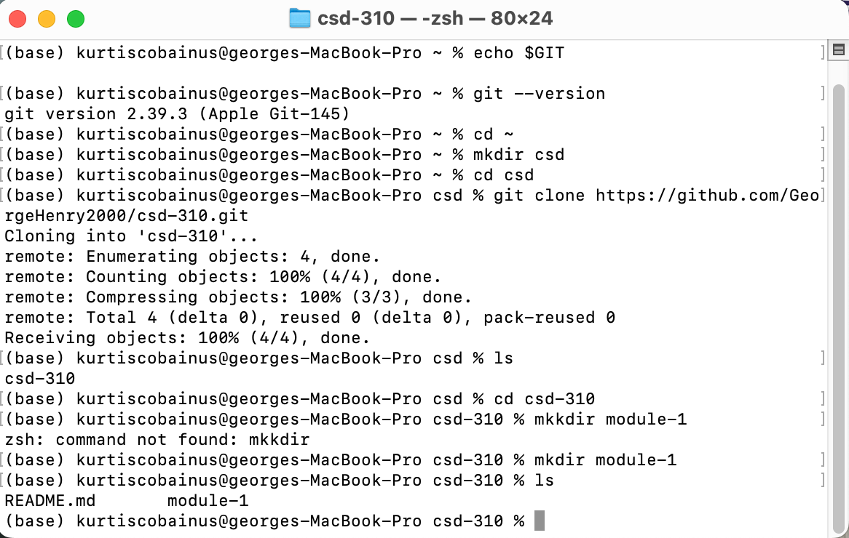

<https://github.com/GeorgeHenry2000/csd-310>