Modern Modular Laboratory V1.0

For Realistic view, as in its in screenshots you need to download Legacy Cinematic Image Effects from Unity Technology.
We are using 4 effects that needs to be placed on Main Camera.
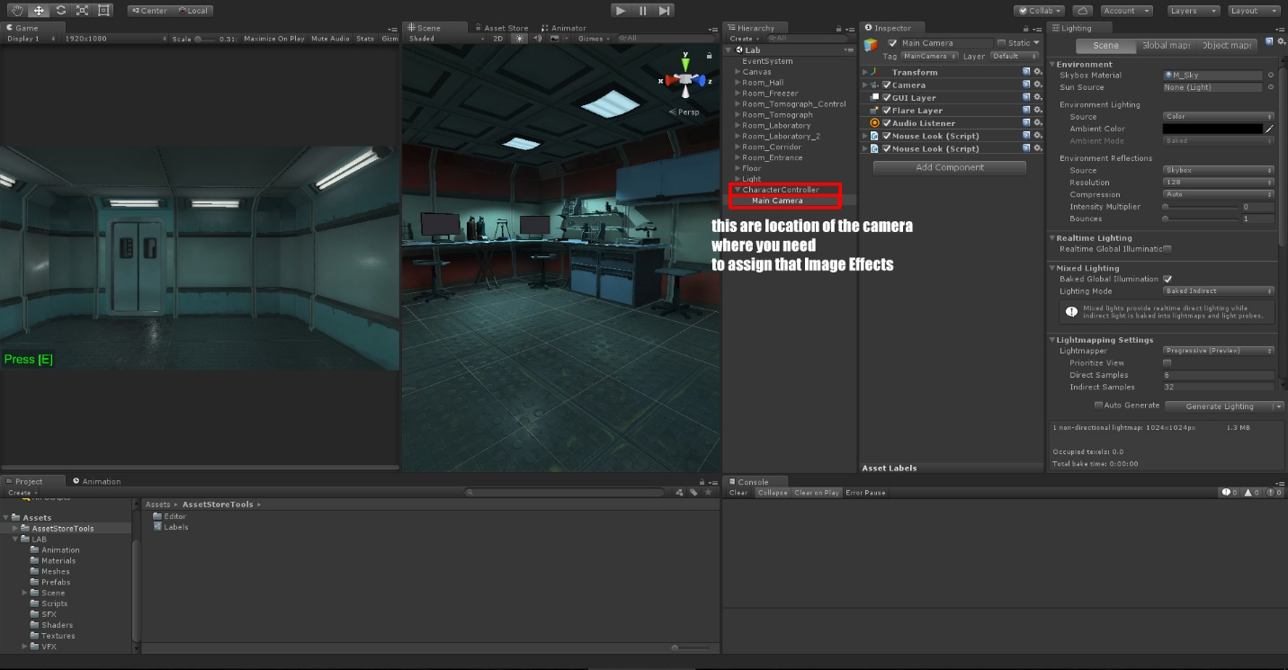
This are: Ambient Occlusion, Bloom, Lens Aberrations and Tone Mapping Color Gradient.
You need to set properties of this effects like in next screens to get the Magic Effect.
