Homework #2

- Create a new class named Vehicle with name, max_speed and mileage parameters declared in the __init__ function. Create a Vehicle object.

- Create a child class Bus that will inherit all of the variables and methods of the Vehicle class. Create a Bus object.

- Write a Python class, which has two methods get_String and print_String. get_String accept a string from the user and print_String print the string in upper case.
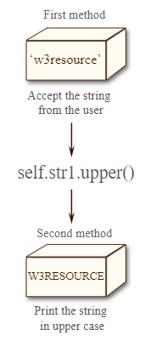

- Write a text file with your identification information. The file will be called my_id.txt

- Write a Python function to count the frequency of words in a file. The function will receive the path for your txt file as its input. The function will return a dictionary where the keys are the words in t he txt file and the values of the keys is the frequency of the word in the txt file.
Example, for the file that we created in question 2 the output of the function will be:
{‘name:’ 1, 'Alex': 1, 'Kuznetsov': 1, ‘age:’ 1, '27': 1, 'phone number:’ 1, '0527389001': 1}

- Write a python program to find the longest word in a text file.

- Build a function that will receive a list with integer values as its input. The function will calculate the sum of the integers in the list and will return the sum result.

- Build a function that will receive a list with integer values as its input. The function will multiply all values in the list and return the result.

- Build a function that will receive a list with integer values as its input. The function will find the minimal value in the list and return this value.

- Build a Python function that accepts a string and calculate the number of upper case letters and lower case letters.

- Create a 1D NumPy array of numbers from 0 to 9. Without any loops.

- Create a 1D NumPy array with number values, float or integer. Extract all odd Numbers from the array, into a new array. Without any loops.

Challenges:

- Create a 2D NumPy eye array 5 X 5. Replace all values that are bigger than 0 to -1. Without any loops.

- Create a recursive function to calculate the value of 'a' to the power 'b'. Example power (3, 2) this means that we are calculating the result of$3^{2}=9$.

- Write a Python program to find validity of a string of parentheses, '(', ')', '{', '}', '[' and ']. These brackets must be close in the correct order, for example "()" and "()[]{}" are valid but "[)", "({[)]" and "{{{" are invalid.

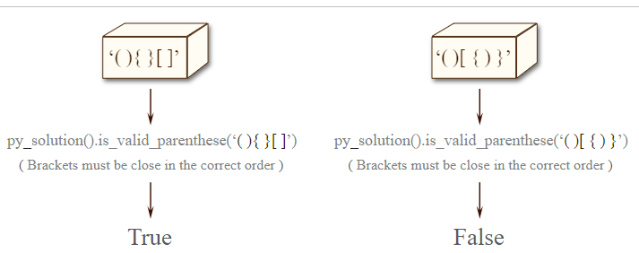

Hint: Create Stack class structure to solve this exercise.

