The Distribution of Snow Depth in the Sierra Nevada and Cascade Mountains of California under the Influence of Different Factors from 1970-2010.

George Jones

GEOG 597

Research Project Spring 2017

May 3 2017

Chair: Dr. Michael Grossman

Committee Members: Dr. Zhou, Dr. Martinez and Dr. Hu

**Introduction**

The April 1 snowpack measurement of snow depth for California snow courses is the most crucial snow measurement for determining the amount of water California will get during the water year from the snowpack (California Department of Water Resources 2016). Snow depth is the most common snowpack measurement taken in the April 1 measurement. It is the distance from the top of the snowpack to the ground of a given snow sample (Viessman and Lewis 2003). The California Department of Water Resources (CDWR) states the snow depth is vitally important to California because it is one of the many states that relies on the snowmelt from the Sierra Nevada and the Cascade Mountains to contribute to its yearly water supply. The snow depth is important for hydrologists to understand the nature and distribution of snow and the properties that are involved in the snowmelt process. The snowmelt typically happens in the spring in California when the demand for water is typically the lowest therefore control schemes such as storage reservoirs have been developed to minimize the problem of runoff loss and save water for the summer months.

The April 1 snowpack measurement is key for a variety of reasons. Hydrologically, it is a measure of the accumulated amount of snow that has fallen on one course over a period. Historically, some snow courses are only measured on April 1 due to the remoteness of the sites so obtaining the most accurate snow depth measurement for those remote snow courses is imperative. The snowpack supplies much of the San Joaquin Delta with its annual water supply to give to the rest of the California. However, Dimick (2015,2) states that snowpack reductions in the northern U.S. Rocky Mountains and other coastal mountain ranges in the western United States in recent years are nearly unprecedented compared to the previous 800 years, mainly due to increased spring warming caused by anthropogenic warming over a course of each decade since 1970.

The San Joaquin Delta (see Figure 1) acts as a central hub for water supply from the melted snowmelt runoff where the rivers that come from the Sierra Nevada Mountains and Cascade Mountain ranges converge and its snowmelt water is distributed to the rest of California for human and agricultural purposes. The Delta is the primary source supplying the whole state of California with over 80% of its drinking water as well as for agriculture and commercial uses (Wheeler 2007). The Delta contains huge agricultural tracts of land worth over $700 million dollars and is reliant on the snowmelt from the Sierra Nevada Mountains in the spring time (Wheeler 2007). The Sierra Nevada snowpack supplies over half of its snowmelt to California’s reservoirs, rivers, and lakes. Findings by the California Department of Water Resources (2016) indicate that the streamflows in the rivers that lead into the San Joaquin Delta have been seeing a decrease in the average annual snowmelt due to the increasing temperatures and lack of heavy snowstorms in northern California over the past 41 years. However, there have been few studies about the water-input climatology of snow and the amount of water one can get out of it. Dingman (2015) comments that the long-term average snow depth is important for hydrologists as it represents the rate at which water is readily available for human use.

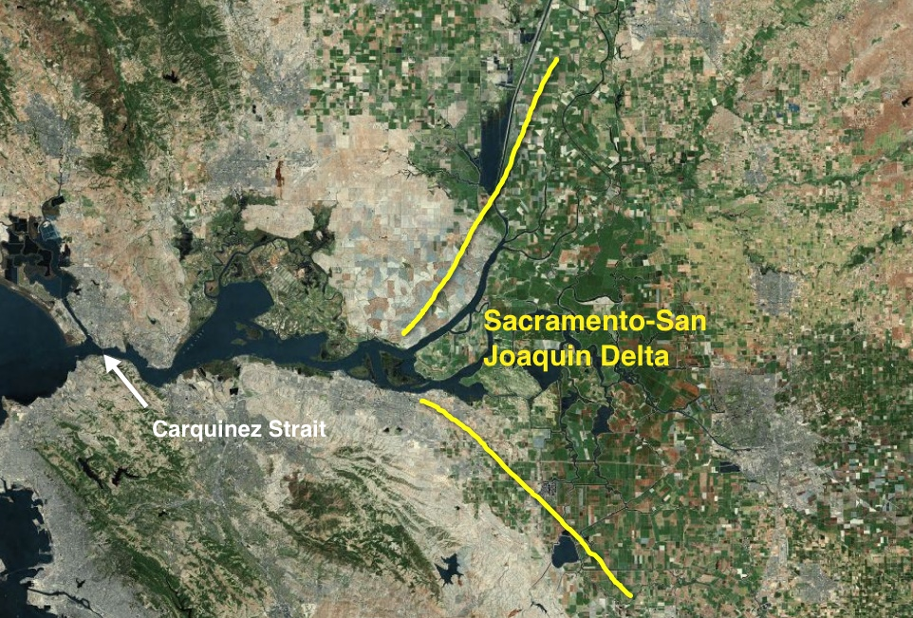

**Figure 1.** The Sacramento-San Joaquin Delta. The Sacramento River, San Joaquin River, Cosumnes River, the Mokelumne River, and other small tributaries enter the San Francisco Bay here (Wheeler 2007).

The earlier spring time runoff indicates longer dry seasons for most of California and reduced water resources in the summer months when the demand for water is at its peak. Glennon (2009, 34) notes that the warmer winter temperatures (October-April in the Sierra Nevada Mountains) across the Sierra Nevada and Cascade Mountains have been threatening the availability of water resources for California for the past 41 years. Glennon (2009, 36) further asserts that, by 2020, the Sierra Nevada Mountain snowpack is projected to diminish by 20 percent on a modest prediction and around 40 percent projection on the more realistic end and will reduce California’s drinking water supply from snowpack. This means that scientists must come up with different ways of collecting and better managing the water they already have or will receive. The snow depth data from the Sierra Nevada snowpack will be of vital importance for water managers and engineers to estimate and distribute water across the state of California for that given year.

Knowledge of where most of the snow depth from the watersheds’ snow courses has been lost or gained will be of vital importance for hydrologists and other engineers and scientists for years to come to access the greatest amount of water available before the snow melts. In addition, this will enable the scientists and water managers to find and distribute the maximum amount water without any waste before the Spring Pulse[1].

Snow researchers and hydrologists realize the importance of studying how the elevation affects the timing, the amount, and the location of where the snow depth is located. It seems to be a prevailing view that higher elevation snow courses have seen the greater increases in snow depth and remain the most important elevation for late summer months (Conway and Benedict 1994; Grundenstein 2006). In addition, the rise in winter temperature has been reported at least ten different weather stations in the Sierra Nevada Mountains from 1960 to 2000 (Howat and Tulzayck 2005). Some researchers tie the rising winter temperature to the declining winter snow (Aguado 1992). However, there have been different views regarding the role of latitudes on winter snow. Dettinger et al. (1998) notes that there has been a north-south see-saw of the distribution winter precipitation, pivoting around 40 degrees’ north latitude. They note that when the northern section of the study area is more wet during winter months, the southern section has seen drier periods of winter precipitation and vice versa. However, Dettinger (2011) later mentions an opposing view that southern latitude snow courses in the Sierra Nevada Mountains have greater variability to the amount of snow depth than those snow courses in the northern Sierra Nevada Mountains. It appears that how the latitude affects winter snow is an empirical matter that needs to be resolved by actual evidence.

The purposes of this research is to investigate the locations where the most snow loss or snow gain has occurred over the 41-year period (1970 to 2010). I chose 1970 as the starting year since this was the year where most of the snow courses in California were put into place. The study area will include five watersheds that feed the San Joaquin Delta. The location of snow courses at different latitudes of the Sierra Nevada Mountains and the continuing rising temperatures over the past four decades will play a major role in where most of the April 1 snow depth will be located. Considering the prevailing views on the role of elevation and temperature, and different roles of latitudes expressed within the research community, this study will address three specific research questions. First, do snow courses at higher degrees of latitudes receive more snow than those snow courses that are in lower degrees of latitudes on a consistent basis? Second, does the latest data support the view that increasingly more winter snow is found at higher elevations? Third, does the latest data support the view that rising winter temperature is associated with declining winter snow?

**Literature review**

***Importance of the April 1 survey***

The California Department of Water Resources (2016) explains that the first snow survey led by Dr. James E. Church began in 1906 on Mt. Rose, a 10,800-foot mountain in Nevada that overlooks Lake Tahoe. Dr. Church set up a technique that measures the depth of snow, which is the vertical distance from the ground surface to the snow’s surface in inches. The difference between the tube filled with the core sample and the empty tube would be known as the snow depth. With Dr. Church’s depth data, a correlation was found between the water content of snow and the spring time water level rise in Lake Tahoe. Using these data, people could come up with a balance between releasing enough water to prevent flooding and not wasting the water if there is an excess amount. Today in California, more than 50 state, national, and private agencies put their efforts in collecting snow data from the Sierra Nevada and Cascade Mountains.

The snow course data is collected by foresters, aerial photographs, and by automatic readings (in more remote locations) which is set up by the Western Climate Center (WCC) that sends the information to a central processing location (California Department of Water Resources 2016). In all, there are about 300 plus snow courses located in the Sierra Nevada mountain range in California and each snow course is visited at least once a year by a snow surveyor (California Department of Water Resources 2016). I will be using approximately 109 snow courses out of the 160 possible snow courses throughout the Cascade and the Sierra Nevada Mountains. The first survey is January 1 and then snow is sampled on the first of each month until May (there may be leftover snow or another snowstorm after April 1). These data are then turned into daily regional snowpack plots which are curves that show how much snow compared to the wettest snow-year on record (1982-1983), the driest year on record (1976-1977), the previous year (2014-2015), and the average snowfall amount for the current year. Each of these values is shown as a percentage of the April 1 snow depth average from the beginning of the water year (October 1) to the end of the water year (September 30) (California Department of Water Resources 2016).

Dimick (2015, 3) comments that the April 1 snow survey measurement is important for engineers and hydrologists for a variety of reasons. He further asserts that the April 1 snowpack measurement is the last measurement before the snow is melted off and becomes runoff as the sun moves further north during the summer months. The April 1 snow measurement is the primary sample for hydrologists to determine how much water they will receive from that location in each year. This is typically the time when the total-accumulated snowfall from the winter months is still on the ground and scientists can estimate how much water California will receive that year (Dimick 2015, 3). From this information, I can solely look at the April 1 measurements in the northern California snow courses because the snowmelt runoff eventually feeds into the California Delta and is transported throughout the state of California through a series of aqueducts and canals.

In addition, Hanak, et al. (2011) hold the position that California’s snowpack usually reaches its peak snow depth each year on April 1. In normal years, the snowpack typically provides 30 percent of the state’s water for the year. The greater the snow depth, the greater the reservoirs total volume and the greater the stream flows will be earlier in the summer when demand for water is high, especially in heavily populated cities such as Los Angeles and San Francisco (Hanak, et al. 2011).

***Increasing temperatures in the Sierra Nevada Mountains***

Dimick (2015, 2) observes that California has seen a steady decline in its snow depth over time which is the by-product of a four-year drought starting back in 2012. The drought has been a manifestation of an on-going trend due to increased winter temperatures in the Sierra Nevada Mountains which have increased 1 to 2 degrees in Fahrenheit since 1915 (Dimick 2015, 3). By 2050, California will expect to see a decrease of 40 percent in its snowpack while temperature is expected to rise by 4 degrees Fahrenheit (Dimick 2015,4).

Dettinger (2001) observed that El Nino conditions are associated with warmer spring temperatures and lower winter precipitation in the norther portion of the western United States where snowmelt was increased. Meanwhile in the southern portion of the study area, Dettinger (2001) found that higher-than-normal precipitation was found in the southern Sierra Nevada mountains, despite the increase in temperature. This lead to a delay in the snowmelt.

Glennon (2009, 44) reports that snowmelt now begins a week earlier than it did before World War II. More of this precipitation falls as rain than it does snow which means that the rain will be more likely to melt the already fallen snow from previous events and cause widespread flooding throughout the state and a diminished amount of available snow. This has serious implications from California’s stand point since 14 percent of California’s power comes from hydroelectric facilities which depends on the snowpack in the Sierra Nevada and Cascade Mountains. The smaller snowpack will reduce power generation by turbines at dams and thus will require more carbon dioxide emissions to be emitted into the atmosphere by use of fossil fuels.

***More precipitation falling as rain than snow***

Van Kirke and Naman (2008) propose that large-scale snowpack models indicate that snowpack levels in the western United States have been declining since the 1960s. Van Kirke and Naman (2008) additionally advocate the view that the results of increased in temperature the Sierra Nevada Mountains have been increases in the percentage of precipitation falling as rain, increased runoff during the winter months, and faster snowpack melt in the early spring.

Howat and Tulaczyk’s study (2005) indicates a change from snow to rain as precipitation has been greatest in the southeastern section of the Sierra Nevada Mountains, where temperature has increased by 3.8 degrees Celsius and total winter precipitation has doubled at multiple stations. In agreement with observed trends in the Pacific Northwest, snowfall has decreased in extreme northwestern California from 1970 to 2000 (NOAA 2008). Howat and Tulaczyk (2005) note that the change in temperature and precipitation has been greatest in southeast region of their study area which saw the amount of snowfall doubled while snowfall has decreased in the northwestern part of the Sierra Nevada Mountains as temperature has increased and more rain fell than snow. The correlation is strongest in the southern Sierra Nevada and in the northwestern coastal mountains. This could mean that southern latitude mountains have experienced the greatest amount of average snow depth from 1970 to 2010 due to the double in average precipitation and as temperature increased in the northwestern mountains that snow depth has decreased.

Dettinger (2011) states that pineapple express storms[2] bring heavy amounts of rain to lower elevations while bringing heavy snow depth to higher elevations. Roughly 90% of California’s precipitation falls between October to April, which are heavily relied upon Pineapple Express storms that bring rain and snow. The amount of rainfall California receives is based on extreme events that are large in variability.

***Influence of latitude on snow depth***

Howat and Tulaczyk (2005) note that linear trends in 1 April snow depth in California, USA, are determined from a dense network of observations over the period 1950–2002. These trends are compared to a concurrent time series of precipitation and temperature and Pacific Ocean climate indices. Howat and Tulaczyk (2005) assert that increased winter temperatures have accompanied both decreasing and increasing snow depth trends, resulting in a weak overall negative trend in snow depth. The spatial distribution of snow depth trend is dependent on both latitude and elevation. Increases in both precipitation and temperature have led to increases in snow depth at lower latitudes in southern Sierra Nevada and decreases at higher latitudes in the northern Sierra Nevada Mountains. A warming of temperature would lead to less snow depth and a cooling of temperature would lead to more snow depth.

Dettinger et al. (1998) notes that there have been a north-south see-saw of precipitation, pivoting around 40 degrees’ north latitude. Dettinger et al. (1998) also notes that the amount of precipitation that falls along California’s west coast and the Sierra Nevada varies from 25 to 55 degrees’ north latitude from interannually to interdecadal timescales. On both those timescales, the amount of precipitation and the type (snow) is more heavily concentrated in locations below 40 degrees of latitude. Suggesting that southern snow courses have received the most snow depth.

***Influence of elevation on the snow depth***

Bethune (2010) notes that snowpack across the northern Sierras has reflected a regional decreasing trend, but the snowpack in the southern Sierras has increased substantially over the past 60 years, likely driven by a moderate increase in precipitation over the past century. Combining with this is the fact that the higher elevations in the southern Sierra snowpack make the southern Sierra Nevada Mountains less sensitive to increases in temperature. In addition, these mountains will have more snowfall because of orographic precipitation[3].

In addition, Conway and Benedict (1994) used the Merced and the Tuolumne Watersheds in California to examine how the snowpack is affected by elevation and topography. They observed and projected changes in temperature in these watersheds, snowfall versus rainfall apportionment, and observed that snowmelt timing varies considerably with the elevation of the location of their study area. They found that there was a direct relationship between snowfall and elevation. Greater snowfall occurred with an increase in elevation. Also, their findings show that 34-36% of snowmelt that accumulated above 3,000 meters was responsible for late-season snowmelt which was the main contributor to the recharge of the groundwater basins and the late-season streamflow of the rivers, streams, and groundwater (Conway and Benedict 1994). Surprisingly elevations that were below 2,100 meters only contributed between 15-20% of the annual streamflow since those elevations are closer to the stream. This goes to show how important snowpack at higher elevations is as it contains most of the snow depth which will be utilized in the industrial, commercial, and agriculture sectors in the summer months after melting.

***Importance of snow depth forecasts***

Forecasting whether California will get a wet or a dry year in terms of how much snow depth they will receive is highly important for public companies and facilities to know how much hydropower they will receive each year. Gleick (2007) explains that good wet years enable companies to use more hydropower, save oil, and reduce greenhouse emissions. However, Gray (2012) observes in dry years, companies must spend more on oil to keep power generating and greenhouse emissions. A good snow forecast is also beneficial to many different sectors across California. The agriculture sector uses the snow depth information for crop patterns and rotations, ground water pumping needs, and irrigation schedules (Gray 2012). Lund et al. (2012) propose that the snow depth forecast is vitally important to the hydropower sector which influences dam operators who determine how much water can be allowed into the storage of a reservoir while reserving space for predicted inflows from the snowmelt. How California can determine how much water they will receive in each year will enable them to distribute the allowed water.

**Discussion of the literature review relevant to research questions**

The literature review above is relevant to my research questions since it accounts for the importance of the April 1 snow depth and how much average snow depth a snow course receives on a decadal basis based on latitude and elevation. The study done by Dettinger (2001) showed that lower latitudes experienced more average snow depth while higher latitudes have seen a decrease amount of average snow depth. In addition, Dimick (2015,2) states that snowpack reductions in the northern U.S. Rocky Mountains and other coastal mountain ranges in the western United States in recent years are nearly unprecedented compared to the previous 800 years, mainly in areas of lower elevation by each decade since 1970. Dettinger (2001) observed how warmer winter temperatures have affected the amount of snow depth a given snow course receives, by either more rain than snow events or spatial movement and variability of the snow. He found that this was most prevalent in lower elevation and latitude snow courses.

**Description of study area**

The study area encompasses five major California watersheds: The North Lahontan, South Lahontan, Sacramento, Tulare, and the San Joaquin (Figure 2 and Table 1). I accessed the latitude and elevation data from the California Department of Water Resources website page by looking at latitude and elevation next to each course. These watersheds in my study eventually drain into the California Delta, located at the conjunction of the Sacramento and the San Joaquin Rivers, where there is key water pumping plants and aqueducts that send the melted snow throughout the state. These watersheds have major bodies of water that contribute to the Delta. These bodies of water include the Sacramento River, the San Joaquin River, the Mokelumne River, Lake Tahoe, Mammoth Lake, and major manmade canals. All either distribute or hold the melted snow water in the Spring. Dettinger (2001) observes that northern California represents a well-defined region for investigation of trends in the snowmelt runoff and timing from the Sierra Nevada Mountains due to its wide variety of altitudes to test the role of snowmelt mechanisms that are associated with the spring time runoff. The Sacramento, San Joaquin, and the Tulare watersheds lie between the windward side of the Sierra Nevada Mountains and the leeward side of the Cascade Mountains in California.

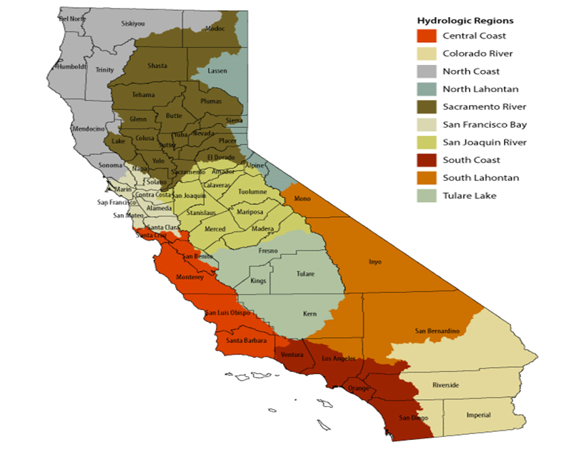

**Figure 2**. Watersheds of California. The Sacramento River, North Lahontan, San Joaquin River, Tulare, and the South Lahontan are the only relevant watersheds that are in my study (California Department of Water Resources 2016).

Dettinger (2001) further asserts that all five of these watersheds are where most the snow depth in the state lies. The North Lahontan and the South Lahontan Watersheds lie on the leeward side of the Sierra Nevada Mountains so they have little impact on the California snow depth. However, for this study I am including the North and South Lahontan Watersheds because I would like to include the results of the snow depth from these watersheds to further the knowledge of scientists and hydrologists. The highest mountains are in the southern extent of the Sierra Nevada Mountains (Figure 3). Much of the western side of the Sierra Nevada Mountains is heavily vegetated due to orographic lifting of moisture coming off the Pacific Ocean that rises, cools and expands, and drops rain, leaving a rain shadow on the eastern side.

**Table 1.** Five watersheds ranked from most northern to southern in California showing average annual snow depth from 1970 to 2010 (NOAA 2015).

|  |  |  |  |  |  |  |  |  |
| --- | --- | --- | --- | --- | --- | --- | --- | --- |
| **Watershed** | **Square Miles** | **Annual Average Snow Depth (inches)**  **(1970-2010)** | **Rain (inches)**  **annual** | **Snowfall**  **(inches)**  **annual** | **Snow Courses**  **(350 in all)** | **Sampled**  **Snow**  **Courses** | **Location by degrees of latitude** | **AvgElevation (ft)** |
| Sacramento | 27,000 | 79 | 27.5 | 46.7 | 110 | 29 | 39.2 -40.2 | 6274 |
| North Lahontan | 790.5 | 80.57 | 24.93 | 65.54 | 105 | 32 | 38.1- 41.9 | 6752 |
| South Lahontan | 790.5 | 83.05 | 18.77 | 80.01 | 60 | 11 | 36.5-38 | 8715 |
| San Joaquin | 15,600 | 78.58 | 12.39 | 15.2 | 45 | 25 | 37.5-38.5 | 8362 |
| Tulare | 17,000 | 69.56 | 13.22 | 16.37 | 30 | 12 | 36.9-37.4 | 9010 |

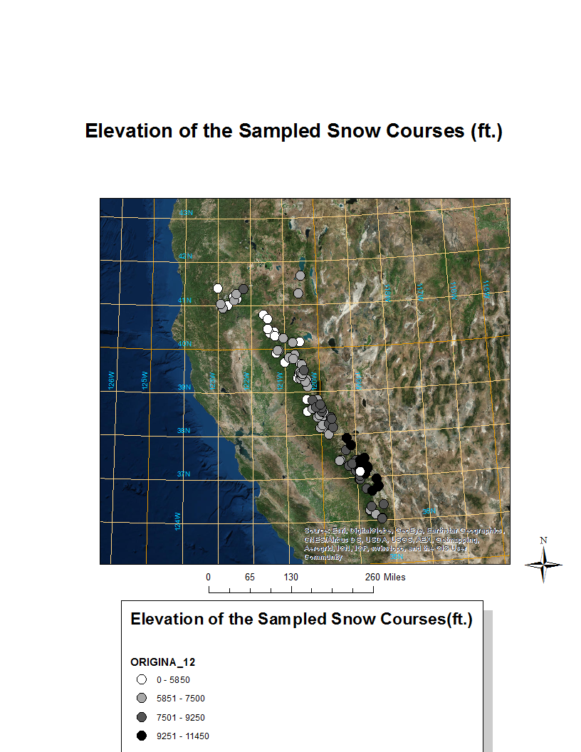

**Figure 3.** Elevation of the snow courses in the Sierra Nevada Mountains. The larger mountains that represented by darker dots, are above 7,100 feet, are in the southern extent of the Sierra Nevada Mountains. (Data: CDWR 2016 and ESRI ArcMap 10.3).

**Data**

The data were downloaded from the California Department of Water Resources website and then entered it into an Excel spreadsheet. All the snow course data (elevation and latitude) came from the California Department of Water Resources, California Data Exchange Center. I obtained the April 1 snow depth data for each snow course for every year from 1970 to 2010. I excluded snow courses that were missing more than two years’ worth of April 1 data. I gathered data for 109 snow courses with at least ten snow courses for each watershed. I started with the 1970 as the leading year in my study since this was the year where most of the snow courses were first implemented and temperature records just began at the snow courses and weather stations (CDWR 2016). Most of the snow courses were not implemented before 1970 (CDWR 2016).

The snow courses in this study were in the Sierra Nevada Mountain Range and the Cascade Mountain Range. The snow courses were selected to give an accurate sample of representation of the area in terms of elevation and aspect of the respective watershed. Elevation undoubtedly plays a role in the snow depth that a snow course receives over a given amount of time. Roos (2012) findings showed that the northern snow courses in the Sierra Nevada Mountains saw the greatest decline in snow depth where elevation were between 4,000-4,500 feet. The southern snow courses that saw a greater increase in snow depth were between 5,500-6,000 feet in elevation. Therefore, one would expect to find more snow in the southern mountains and at higher elevations than in the northern mountains and lower elevations.

***Temperature data***

None of the snow courses have temperature sensors. Historical data was gathered from the National Oceanic and Atmospheric Administration (NOAA) data site. They were used to create the time series graphs in Figures 4 to 8. Most the snow courses lack temperature data from 1970-2010 and the ones that do, only have temperature that go back to 1999 at the earliest date. For the time series temperature graphs, I averaged the winter month (October-April) temperature of the snow courses for each year from 1970 to 2010 based on the average temperature from each watershed using Howat and Tulaczyk’s methodology (Howat and Tulaczyk 2005). Around 80% of California’s precipitation falls between October and April (Howat and Tulaczyk 2005).

As seen with the time-series graphs (Figures 4-8), all four of the major watersheds saw a steady rise in the winter temperature from 1970 to 2010. Powell (2008, 56) comments that temperatures are expected to increase by 2.1 degrees Fahrenheit over the course of the next 30 years in the Sierra Nevada Mountains that will be a possible threat to the snowpack and the water supply for the state.

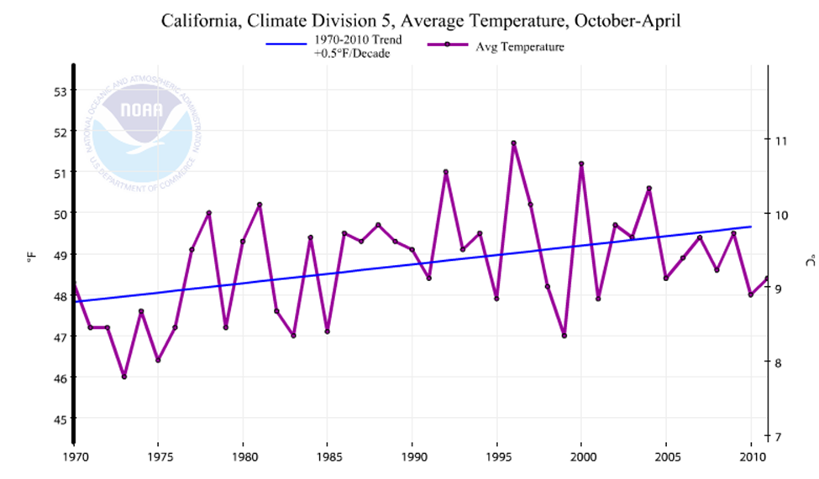

**Figure 4**. The San Joaquin Watershed time-series 1970-2010. The snow season (October to April) temperature has been steadily increased in the San Joaquin Region from 1970 to 2010 (NOAA 2016).

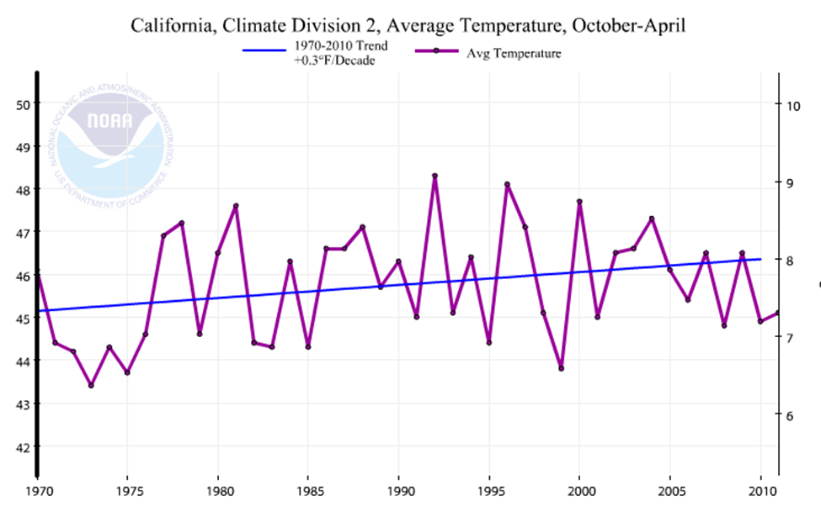

**Figure 5**. The Sacramento Watershed Time-Series. The average winter month temperature has increased from 1970 to 2010 (NOAA 2016).

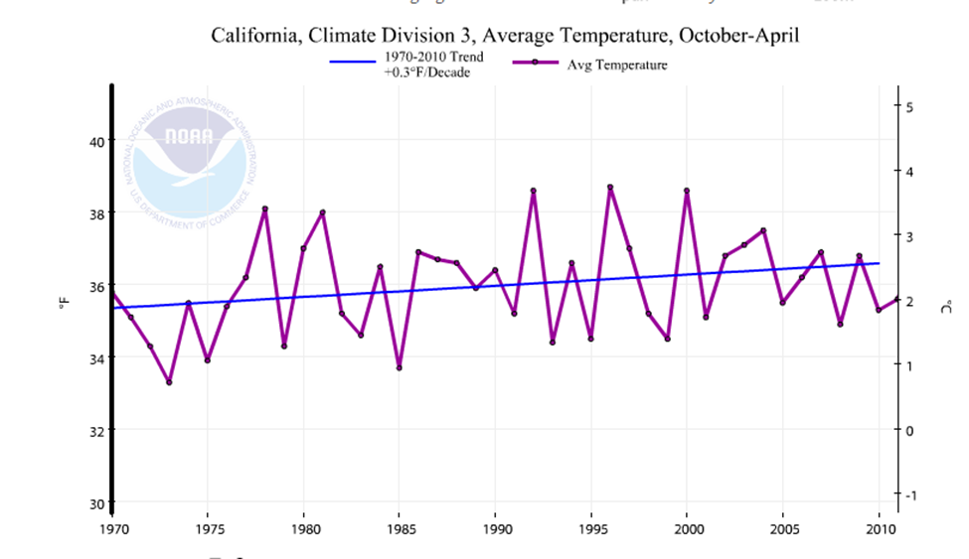

**Figure 6.** North Lahontan Watershed. The average winter month temperature has increased steadily from 1970 to 2010 (NOAA 2016).

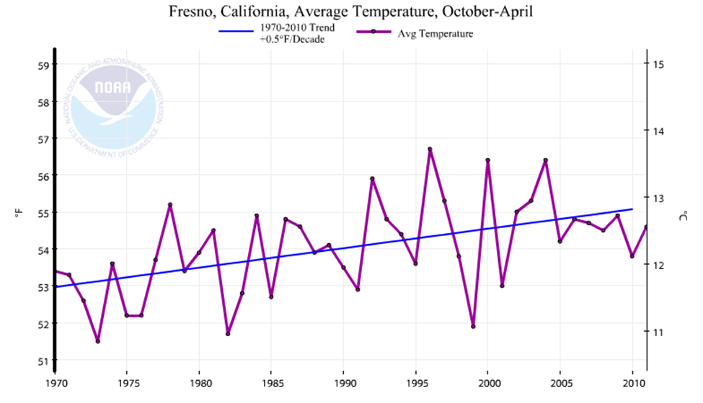

**Figure 7.** The Tulare Watershed time-series that is represented by Fresno which lies in the watershed. The average winter month temperature has increased steadily from 1970 to 2010 (NOAA 2016).

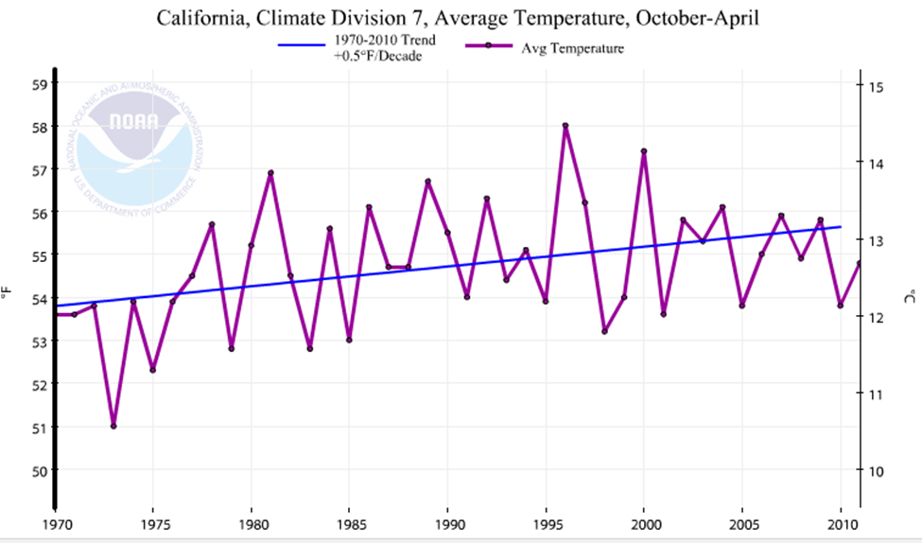

**Figure 8.** The South Lahontan watershed time-series. The average winter temperature has increased steadily from 1970-2010. The temperature rose by one degree Fahrenheit from 52.9 degrees to 53.9 degrees Fahrenheit (NOAA 2016).

**Methods**

For this study, I accept the multiple regression technique to account for snow depth using several independent variables. In the model, the average snow depth is the dependent variable, and latitude, elevation, and the average winter temperature are the independent variables. The latitude was determined by looking at the coordinate point of the snow course from the CDWR. The elevation was determined by feet above sea level of the snow course from the website. The average snow depth is calculated as the average of the annual snow depth during each decade from the 1970s to the 2010s, and the average winter temperature is the average of the October to April temperatures over each decade from the 1970s and the 2010s. The regression equation is:

Avg.SnowDepth = a + b1Latitude + b2Elevation +b3AvgWinterTemp.

where a is the intercept and b1, b2, and b3 are partial regression coefficients for latitude, elevation, and winter temperature respectively.

Originally, there was a concern for spatial autocorrelation in the data. Two possible ways are designed to account for the possible spatial autocorrelation. One is to use watershed dummy variables in multiple regression which may account for correlation that possibly exists among snow courses within a watershed. Another approach to account for spatial autocorrelation is to run spatial regression in which spatial proximity among snow courses is considered when predicting snow depth using the independent variables. In the multiple regression with dummy variables, none of the watershed dummy variables turn out to be statistically significant. In the spatial regression model, the Moran’s I among residuals is also statistically insignificant. This indicates that the data set does not contain adequate spatial autocorrelation. Thus, the standard multiple regression is used.

Four regression models were run, one for each decade (the 1970s, the 1980s, 1990s, and 2010s). The purpose is to see how the regression coefficients will change over time. The temporal changes in the regression coefficients may reveal important dynamics regarding the role of the independent variables in affecting the snow depth.

In addition, multiple regression, scatter plots and two independent sample t test are also used in revealing the snow depth changes over time.

**Results**

I ran multiple regression once for each of the four decades. The R square values are relatively small so that indicates that the model explains only some of the variability of the response data around its mean. The higher R squared the better since a larger share of variations is explained by independent variables. The 1980s’regression had the best the R square value which was close 0.5. The 2000s’ regression had the weakest model with 0.274 as the R square. Although a higher R square is preferred for a regression model if everything else is the same, this is mainly for regression models that are used for prediction. For regression models that are meant to establish statistical significance of independent variables, a relatively low R square should not be a main concern. The F-values are high for each of the decades which mean the regression formulas are valid to explain the average snow depth for each decade for the population regression. All regression models are significant at the 0.01 level.

Most regression coefficients of independent variables came back significant at least at the 0.05 level, except temperature for the 1970s and the 1990s. The intercept values have no practical meaning in the regression since I was looking for the independent variables’ effect alone on the dependent variable. The regression coefficients for the four decades’ models are reported in Tables 3 to 6. The p-values for temperature were close to being significant at the 0.01 level, suggesting more and better temperature data would be needed for further research.

For the 1970s’ regression, the regression coefficient for latitude is 9.503. This means that for every additional degree increase of latitude, the average snow depth is expected to increase by 9.503 inches controlling for the elevation and temperature (Table 2). At the same time, the regression coefficient for elevation is 0.013, meaning that for every foot increase in elevation, the average snow depth is expected to increase by 0.013 inches controlling for latitude and temperature. Temperature was insignificant at the 0.05 level during this decade.

**Table 2.** The 1970s data that showed how independent variables change over time.

|  |  |  |  |  |
| --- | --- | --- | --- | --- |
| **Variable** | **b-value** | **Standard error** | **t-score** | **p-value** |
| Intercept | -371.351 | 102.139 | -3.636 | 0.000 |
| Latitude | 9.503 | 2.260 | 4.205 | 0.000 |
| Elevation | 0.013 | 0.002 | 6.960 | 0.000 |
| AvgTemperature | -0.631 | 0.389 | -1.624 | 0.107 |

For the 1980s’ regression, the regression coefficient for latitude is 8.705. This means that for every additional degree increase of latitude, the average snow depth is expected to increase by 8.705 inches when controlling for elevation and temperature (Table 3). At the same time, the regression coefficient for elevation is 0.017, meaning that for every foot increase in elevation, the average snow depth is expected to increase by 0.017 inches when controlling for latitude and temperature. Temperature was insignificant at the 0.05 level during this decade.

**Table 3.** The 1980s data that showed how independent variables change over time.

|  |  |  |  |  |
| --- | --- | --- | --- | --- |
| **Variable** | **b-value** | **Standard error** | **t-score** | **p-value** |
| Intercept | -356.099 | 106.493 | -3.344 | 0.001 |
| Latitude | 8.705 | 2.356 | 3.695 | 0.000 |
| Elevation | 0.017 | 0.002 | 8.581 | 0.000 |
| Avg.Temperature | -0.812 | 0.402 | -2.022 | 0.046 |

For the 1990s’ regression, the regression coefficient for latitude is 8.070. This means that for every additional degree increase of latitude, the average snow depth is expected to increase by 8.070 inches when controlling for elevation and temperature (Table 4). At the same time, the regression coefficient for elevation is 0.014, meaning that for every foot increase in elevation, the average snow depth is expected to increase by 0.014 inches when controlling for latitude and temperature. Temperature was insignificant at the 0.05 level during this decade.

**Table 4.** The 1990s data that showed how independent variables change over time.

|  |  |  |  |  |
| --- | --- | --- | --- | --- |
| **Variable** | **b-value** | **Standard error** | **t-score** | **p-value** |
| Intercept | -313.106 | 105.088 | -2.979 | 0.004 |
| Latitude | 8.070 | 2.322 | 3.475 | 0.001 |
| Elevation | 0.014 | 0.002 | 6.848 | 0.000 |
| Avg.Temperature | -0.689 | 0.403 | -1.709 | 0.090 |

For the 2000s’ regression, the regression coefficient for latitude is 4.956. This means that for every additional degree increase of latitude, the average snow depth is expected to increase by 4.956 inches controlling for the elevation and temperature (Table 5). At the same time, the regression coefficient for elevation is 0.011, meaning that for every foot increase in elevation, the average snow depth is expected to increase by 0.011 inches controlling for latitude and temperature. Temperature was insignificant at the 0.05 level during this decade

The four decades’ regressions seem to suggest a pattern of geographical shift of the average snow depth. The regression coefficient for latitude become consistently smaller from the 1970s to the 2000s model (9.5, 8.7, 8.1, and 5.0), indicating that each degree of increased latitude was associated with a smaller snow depth increase over time since the 1970s. In addition, there seems to be a pattern of shifting snow depth from the higher to lower elevations between the 1980s and 2000s. The regression coefficients for elevation become consistently smaller from the 1980s to the 2000s model (0.017, 0.014, and 0.011), meaning that for every 1000 feet increase in elevation, the increase in snow depth is 17 inches in the 1980s, 14 inches in the 1990s, and 11 inches in the 2000s. In other words, higher elevations bring progressively less snow depth increase over time since the 1980s.

**Table 5.** The 2000s data that showed how independent variableschange over time.

|  |  |  |  |  |
| --- | --- | --- | --- | --- |
| **Variable** | **b-value** | **Standard error** | **t-value** | **p-value** |
| Intercept | -175.605 | 100.371 | -1.750 | 0.083 |
| Latitude | 4.956 | 2.216 | 2.236 | 0.027 |
| Elevation | 0.011 | 0.002 | 5.951 | 0.000 |
| Avg. Temperature | -0.841 | 0.378 | -2.228 | 0.028 |

***Scatter Plots and the Role of Latitude and Elevation***

To confirm the impact of latitude, the scatter plot in Figure 9 is used to show the relationship between latitude and percent of snow depth changes between the 1970s and 2000s. Between the 1970s and 2000s, the increase in snow depth becomes smaller with rising latitude. Many snow courses in higher latitudes experienced a reduction in the average snow depth. Using a t-test from the scatter plot points (which is used to determine whether there is a significant difference between the values of the two groups) the median latitude 38.630 degrees north, the data points are divided into a higher latitude snow course group with latitudes higher than 38.630 degrees north and a lower latitude snow course group with latitude lower than or at 38.630 degrees north. The average snow depth reduction between the 1970s and 2000s was 4.87 inches for the lower latitude snow course group but 17.74 inches for the higher latitude snow course group.

The sample difference in means for the latitude group is 13(=17.74 – 4.74). My alternative hypothesis is that there is a significant difference in the means of the reductions between the two groups. The two-independent samples t-test shows that the average reduction of

the higher latitude group is significantly higher than the lower latitude group at the 0.01 level (see Table 6 for complete results of test)**.** Based on this the population mean difference between the two groups is significantly larger than 0 at the 0.01 level.

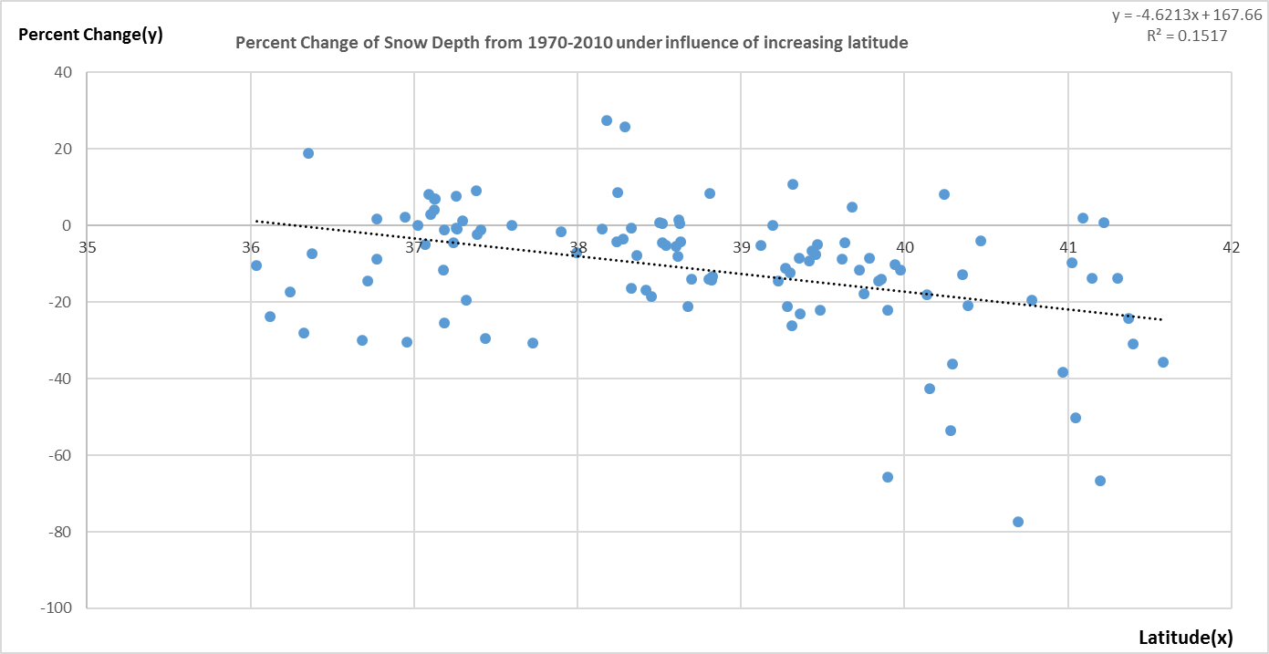

**Figure 9**. The average snow depth of the snow courses has decreased with latitude from 1970-2010. The graph shows a negative trend of percent loss as the snow courses get higher in elevation. More snow courses above 38.630 degrees’ north experienced a greater reduction of snow depth than those courses at or below 38.630 degrees’ north from the 1970s to the 2000s.

**Table 6.** The t-test from snow courses at or below 38.630 degrees north and those above 38.630 degrees north at the 0.01 level. There is a significant difference in the loss of snow depth

|  |  |  |  |  |  |
| --- | --- | --- | --- | --- | --- |
| **Group** | **n** | **Average Inches lost** | **t-test result** | **df** | **P-value** |
| At or Below 38.630 north | 55 | 4.87 | 4.2444 | 96.916 | 0.00002512 |
| Above 38.630 north | 54 | 17.74 | 4.2444 | 96.916 |

Many of the lower latitude snow courses are located on the highest mountains that can gather and hold the snow depth until the April 1 measurement (Stewart 2009). Meanwhile, the higher latitude snow courses are located on the lowest elevation mountains where they are more susceptible to the rise in winter temperature and melt the already fallen snow before April 1.

Similarly, the scatter plot in Figure 10 shows the relationship between elevation and the percent of snow depth changes between the 1980s and 2000s using a t-test from the scatter plot points in Figure 10.

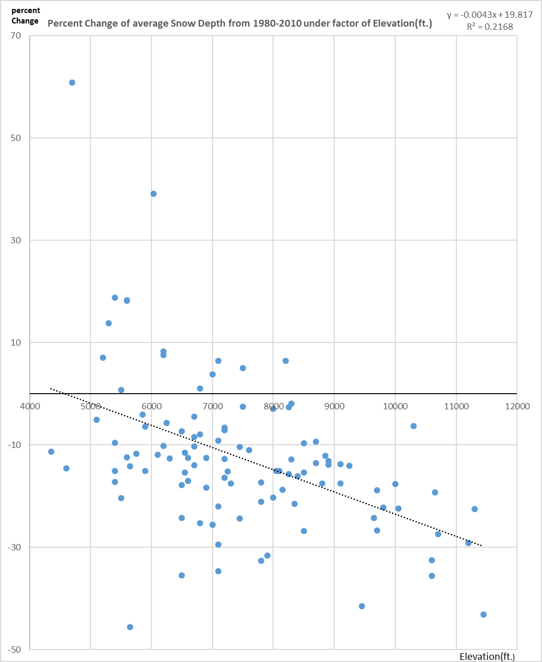

**Figure 10.** Average percentage of snow depth (y-axis) has decreased from 1980s to the 2000s under the influence of increasing elevation (x-axis). The graph shows a negative trend of percent loss as the snow courses get higher in elevation. More snow courses at or above 7100 feet experienced a reduction of snow depth than those courses below 7100 feet from the 1980s to the 2000s.

The increase in snow depth declines with rising elevation. Many snow courses experienced snow depth reduction. However, those snow courses in the higher elevations tend to display more reduction. I found that the elevation median was (7100 feet) and then divided the data into two groups: a higher elevation snow course group with elevations at or above 7100 feet and a lower elevation snow course group with elevation lower than 7100 feet. The results from the reductions indicate: 10.78988 inches for the lower elevation group and 17.18451 inches for the higher elevation group. The sample difference in means for the elevation group is 6.39 (=17.189 – 10.799). My alternative hypothesis is that there is a significant difference between the means of the two groups. The two-independent samples t-test shows that the average reduction of the higher elevation groups is significantly higher than the reduction for the lower elevation group at the 0.05 level (see Table 7 for complete results of the test). Based on this the population mean difference between the two groups is significantly larger than 0 at the .01 level. An explanation for this is that those higher elevated snow courses have seen more precipitation falling as rain than snow or the warmer rain melted the already fallen snow before the April 1 measurement, altering the snow depth data (Van Kirke and Naman 2008).

**Table 7.** The t-test from snow courses below 7100 ft. and those above 7100 ft. at the 0.05 level. There is a significant difference in the loss of snow depth between the snow courses at or above 7100 ft. (17.1845 inches) and the snow courses below 7100 feet (10.7989 inches) from 1980 to 2010.

|  |  |  |  |  |  |
| --- | --- | --- | --- | --- | --- |
| **group** | **n** | **Average inches lost** | **t-test result** | **df** | **p-value** |
| Below 7100 ft. | 50 | 10.7989 | 1.8703 | 69.573 | 0.03283 |
| At or Above 7100 ft. | 59 | 17.1845 | 1.8703 | 69.573 |  |

**Discussion**

In the literature, views regarding the role of latitude on the snow depth vary. Evidence from regression models and the scatter plot results in this study supports the view that the snow depth has seen less decreases in lower latitudes relative to higher latitudes which have seen more decreases in snow depth. Howat and Tulaczyk (2005) note that increases in both precipitation and temperature have led to increases in snow depth at lower latitudes in southern Sierra Nevada and decreases at higher latitudes in the northern Sierra Nevada Mountains. In addition, Howat and Tulaczyk (2005) note that the change in temperature and precipitation has been greatest in the southeast region of their study area which saw the amount of snowfall doubled while snowfall has decreased in the northwestern part of the Sierra Nevada Mountains as temperature has increased and more rain fell than snow. The correlation is strongest in the southern Sierra Nevada and in the northwestern coastal mountains. Dettinger et al. (1998) notes that there has been a north-south see-saw of precipitation, pivoting around 40 degrees’ north latitude. Dettinger et al. (1998) also notes that the amount of precipitation that falls along the West Coast and the Sierra Nevada Mountains varies from 25 to 55 degrees’ north latitude from interannually to interdecadal timescales. On both those timescales, the amount of precipitation and the type (snow) is more heavily concentrated in locations below 40 degrees of latitude but based on either a dry or wet climate regime. Dry regimes in areas below 40 degrees’ latitude indicate a wet regime in areas above 40 degrees’ latitude and vice versa.

Various views are expressed in the literature regarding what caused the relative shift of snow depth toward lower latitudes. Howat and Tulaczyk’s (2005) suggest that positive or drier, Pacific Decadal Oscillation (PDO) events have effected snow courses at the higher latitude snow courses from 1970 to 2010. Positive PDO events typically distribute more rain than snow events due to being warmer (Howat and Tulaczyk 2005). Rain on snow events melt the already fallen snow before the April 1 measurement (Howat and Tulaczyk 2005). This could mean that the northern latitude snow courses have seen more of a percent decline in snow depth from 1970 to 2010 due to the lack of snow and more rain and more rain-on-snow events (Dettinger 2011). Another possible explanation is the cyclical nature of Pineapple Express storms, which are responsible for dumping most of California’s precipitation, for a given year. The number of Pineapple Express storms (see Figure 11) has been cyclical in the Sierra Nevada Mountains since 1960. When more storms arrive, and conditions are wetter. When fewer storms arrive, conditions are drier. The variable nature of the number of Pineapple Express storms could cause the percent reduction experienced by the sampled snow courses by dumping more rain than snow or causing the amount of snow fall to be lower on a given snow course (Dettinger 2011). In addition, these storms typically dump heavy amount of snow fall when they occur. The concern is not the decline in the amount of Pineapple Express storms but whether they drop rain instead of snow and where they dump the snow (Dettinger 2011). It is not guaranteed that the northern snow courses in the northern watersheds will receive their usual amount of snow depth on a yearly basis so relying on the more southern watersheds to supply most of the snow depth into the future will be of vital importance. Although evidence from this study supports the view that snow depth experienced relative shift toward lower latitudes, more study is clearly needed for a convincing conclusion on the matter.

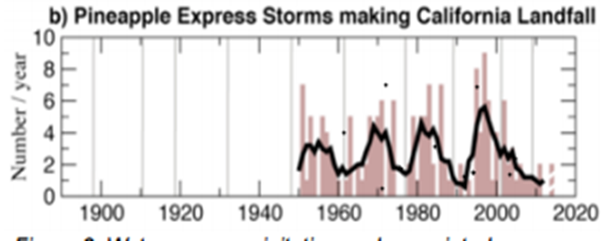

**Figure 11.** The number of Pineapple Express storms that have made landfall from 1950 to 2010 between October and April 1 (Dettinger 2011). Typically, 5-7 storms are expected per year. The rise in winter temperature in California will alter the number of storms and the amount and type of precipitation dropped (Dettinger 2011).

Evidence from the regression models and scatter plot results in this study suggests that the snow depth has seen less decreases in lower elevation relative to higher elevation which have seen more decreases in snow depth. These results contrast the literature that snow courses at lower elevations have seen more reductions over time while snow courses at higher elevations have seen relative more increases over time. The article by Grundenstein (2006) explains that over the past 40 years, satellites have shown a reduction in snow-covered days in North America. Grundenstein (2006) also mentions that increases in both precipitation and temperature have led to increases in snow depth at higher elevations in both the northern and southern Sierra Nevada and decreases of snow depth at lower elevations in both the northern and southern Sierra Nevada Mountains. In addition, Dettinger (2001) results contrasts with my results by asserting that the rise in winter temperature could cause an overall decrease in snow depth at snow courses at lower elevation while snow courses at higher elevation were unaffected by the rise of temperature due to their access of cooler temperatures. As for the cause of relative snow depth shifting toward lower elevations from the 1980s to the 2010s, this could be the result of more rain than snow events during that period or rain-on-snow events between October to April that melt the already fallen snow at higher elevations before the April 1 measurement (Dettinger 2011). Considering evidence from this study which is opposite to the views in the literature, the finding in this study is surprising. This suggests that the role of elevation in affecting snow depth is a topic that requires further investigation.

Some limitations of this study include lack of first hand data. This study largely relies on data from the California Department of Water Resources and NOAA. In addition, the snow depth may also be affected by topography and other obstacles may prevent it from being representative of the surrounding area. I could not include every snow course that has collected snow depth since some of these courses have not measured for years (or decades) because of the statement issued in “Unquenchable” (Glennon 2009).

**Conclusions**

This study finds that between the 1970s and the 2010s, there has been fewer snow depth increases in higher latitudes (above 38.630 degrees north). This suggests that the snow courses that are higher in degrees of latitude will receive less increases of snow depth as one goes up in degrees of latitude. In addition, snow courses at lower latitudes will see a consistent amount of snow depth if the trend continues. A shift of snow depth toward the southern California may be good news to residents in the region where large population and economic centers would benefit from more melting snow. However, it also means that streams and rivers in higher latitudes- such as the Sacramento and Feather Rivers- will possibly see less stream discharge and high flows during the Spring if the trend in snow depth continues to move toward southern latitudes. This may be a threat to fish species that rely on flows from the snow melt. In addition, the lack of snow depth in northern latitudes could cause a reduction of flow for hydroelectric facilities that lie on rivers in the northern Sierra Nevada Mountains, which greatly outnumber those on rivers in the southern Sierra Nevada Mountains (Dettinger 2011).

This study also finds that between the 1980s and 2000s, there had been relatively fewer snow depth increases in higher elevations, or above 7100 feet. This suggests a snow course will receive less snow depth for each additional foot of increase in elevation. This could be trouble for California since higher mountains hold the snow as a time-release reservoir supply for the late summer months where demand for commercial and industrial use is the highest. A recommendation is for dams to release less water during the March-May months instead of saving reservoir space for late melt from higher elevations to prevent overflow. In addition, heightening existing dams will be realistic to hold the most snowmelt possible from the spring surge from lower elevations- since the lower elevation snow courses have experienced the least reduction from my results. The lower elevations are the fastest to melt and to enter the reservoirs (especially from the increase of rain-on-snow events) (Dettinger 2011). Service (2004) notes that California is considering building several new dams as part of a joint state and federal effort to accommodate for the earlier runoff timing from increases in snow depth in lower elevations. But these projects are high in environmental costs and many water experts doubt whether such projects will take place (Service 2004). Other feasible strategies may help such as lining irrigation canals. Canal lining is the process of reducing seepage loss of irrigation water by adding an impermeable layer to the edges of the trench (Service 2004). Seepage can result in losses of 30 to 50 percent of irrigation water from canals, so adding lining can make irrigation systems more efficient (Service 2004). This will save more water for warmer months.

In addition, this study finds that the role of temperature was uncertain from the 1970s to the 2000s. It is significant in some decades and insignificant in other decades. This may indicate a cyclical pattern of temperature in affecting the variation of the snow depth. In addition, this may also mean the role of temperature is not the chief influence on the average snow depth.

Improvements for future studies on snow depth may include the use of LiDAR and remote sensing imagery of the snowpack. The LiDAR unit is on an aircraft or a satellite that zigs zags across the Sierra Neda cordillera. The LiDAR unit shoots 20,000 pulses of light per second to capture the 3D-structure of the snowpack, or the depth (Tuma 2015). In addition, a spectrometer is used to map where the snowpack is. The snowpack can go from zero to 30 feet of snow in only a short distance so LiDAR data provides more accurate assessment of the April 1 snow depth than the snow survey (Tuma 2015). LiDAR will remain vital to analyze and gather the best snow depth data in remote areas than snow surveys. However, LiDAR imagery on the snow can have precision errors in depth estimation so surveying the snow courses manually will still be relevant in achieving optimal data for future measurements (Liu 2016). I assert that the LiDAR data will be the best way to analyze the snowpack data for future studies since the depth determination at more precise levels will be of sought knowledge by snow scientists as the snowpack of the Cascade and Sierra Nevada Mountains continues to be unpredictable on an annual basis.

**References**

Bethune, Mark. “Estimating Deep Percolation in Mountain Snowpack”. *Journal of Climate*. 1466-1467. 2010.

California Department of Water Resources. California Department of Water Resources. [http://www.water.ca.gov/.2016. DOA: January](http://www.water.ca.gov/.2016.%20%20DOA:%20January) 2 2017.

Conway, Herbert, and Richard, Benedict. “Infiltration of Water into Snow”. *Journal of Hydrology.*11-52. 1994.

Dettinger, Michael, Daniel Cayan, Henry Diaz, and David Meko. “North-South Precipitation Patterns in Western North America on interannual-to-Decadal Timescales”. *Journal of Climate.*1998.

Dettinger, Michael. "Variability and trends in Spring Runoff in the Western United States.” *Journal of Water Resources.*63-70. 2001.

Dettinger, Michael. “Climate Change, Atmospheric Rivers, and Floods in California- A Multi-model analysis of storm frequency and magnitude changes”. *Journal of* *American Water Resources Association* 14-23. 2011

Dettinger, Michael. “California Precipitation”. California-Nevada Climate Applicants Program. *Southwest Climate Center*. 2011.

Dimick, Mark. “Lack of Snow Leaves California's Water Tower Running Low”. Washington: *National Geographic*. 2015.

Dingman, S. Lawrence. “Physical Hydrology Third Edition”. Waveland Press. 2015.

Gleick, Peter. "The Impacts of Climatic Changes for the Water Resources of the Colorado and San Joaquin River Basins." Journal of the American Water Resources Association (Jour) 30-43. 2007.

Glennon, Robert. “Unquenchable”. *Washington: Island Press*. 2009.

Gray, Hannah. “California's Water Crisis”. Engineering Article, Los Angeles: *The Illumin*. 20. 2012.

Grundenstein, Adam. “Return Levels of Snow-Water Content in the Sierra Nevada Mountains”. *Journal of Hydrology*, 1-21. 2006.

Hanak, Ellen, Jay Lund, and Ariel Dinar. “Managing California's Water from Conflict to Reconciliation”. San Francisco: *Public Policy Institute of California.* 2011.

Howat, Ian and Slawek Tulaczyk, “Trends in spring snowpack over a half-century of climate warming in California”, USA. *Annals of Glaciology*. 151-155. 2005.

Liu, Xiaojing. “Improvement of long-term snow depth product accuracy from passive microwave satellite observations: A case study with SNODAS data”. *Geoscience and Remote Sensing International.*40-55.2016.

Lund, Jay, Ellen Hanak, and William Fleenor. “Envisioning Futures for the Sacramento-San Joaquin Delta”. Sacramento: *Public Policy Institute of California*. 2007.

Lund, Jay, Ellen Hanak, Brian Gray, and David Houston. “Water and the California Economy”. Sacramento: *Public Policy Institute of California*. 2012.

NOAA National Centers for Environmental information,” Rise in Western U.S. Temperature” http://www.ncdc.noaa.gov/cag/. 2008.

NOAA National Centers for Environmental information, Climate at a Glance: U.S. Time Series, <http://www.ncdc.noaa.gov/cag/>. 2016. DOA: December 31 2016.

Powell, James Lawrence. “Dead Pool”. London: *University of California Press*. 2008.

Service, Robert F. “As the West Goes Dry”. *Science Magazine*. 2004.

Stewart, Iris. “Changes in snowpack and snowmelt runoff for key mountain regions”.

*Journal of Hydrologic Processes,* 78-94. 2009.

Tuma, Drew. “New Tech Helps Measure Sierra Snowpack from Sky”*. ABC7 News. 2015.*

Van Kirk, Robert and Seth Namaan. “Relative Effects of Climate and Water Use on Onbase-Flow Trends in the Lower Klamath Basin”. *Journal of Water Resources*. 2008.

Viessman, Warren, and Gary Lewis. 2003. “Introduction to Hydrology”. Los Angeles: Pearson.

Wheeler, Douglas.” Sacramento Delta San Joaquin Atlas”. Government Report, *Sacramento:* *Department of Water Resources*. 2007.

1. The period from March to May which the snowpack in the Sierra Nevada Mountains is melted off and sends its snowmelt into the rivers and streams in northern California. Defined by peak discharges of the rivers (CDWR 2016).
2. Storms that are a meteorological phenomenon characterized by a strong and persistent flow of atmospheric moisture and associated with heavy precipitation from the waters adjacent to the Hawaiian Islands and extending to any location along the Pacific coast of North America.
3. The process of air or moisture off the ocean striking the side of a mountain or barrier to produce precipitation on the windward side. This leaves a rain shadow, or dry area, on the leeward side of the mountain.