## CS 312 Computer Architecture II Name: Garrett Marshall

**Jason Nickell**

**George Kim**

## Lab 3. More decisions.

Lethargic Larry has more decisions to make now.

**Part A**

He has two friends over this Saturday. They are trying to decide between going to the **beach** or **playing** Texas Hold ‘em. They are willing to **vote**, but they can’t work out an arrangement for counting the ballots. Since Larry has a great tool for making decisions when he is alone they would like a circuit they can use to show the decision.

Provide **three switches** for the friends to vote with; one for each person: Larry (**L**), Sandy (**S**), Fred (**F**). The **on** state will be a vote for the Beach (**B**) and **off** will be a vote for Poker (**P**). The **individuals** will set **their switches**. A **fourth switch** will be set **off** until every person has cast their **vote** (set their switch on or off). Turn the fourth switch **on** to **show** the results of the **vote**.

|  |  |  |  |  |
| --- | --- | --- | --- | --- |
| **L** | **S** | **F** | **B** | **P** |
| **0** | **0** | **0** | **0** | **1** |
| **0** | **0** | **1** | **0** | **1** |
| **0** | **1** | **0** | **0** | **1** |
| **0** | **1** | **1** | **1** | **0** |
| **1** | **0** | **0** | **0** | **1** |
| **1** | **0** | **1** | **1** | **0** |
| **1** | **1** | **0** | **1** | **0** |
| **1** | **1** | **1** | **1** | **0** |

Write the **equations** for each of the outputs as they are defined by the truth table. Use **Karnaugh** maps to **simplify** the equations.

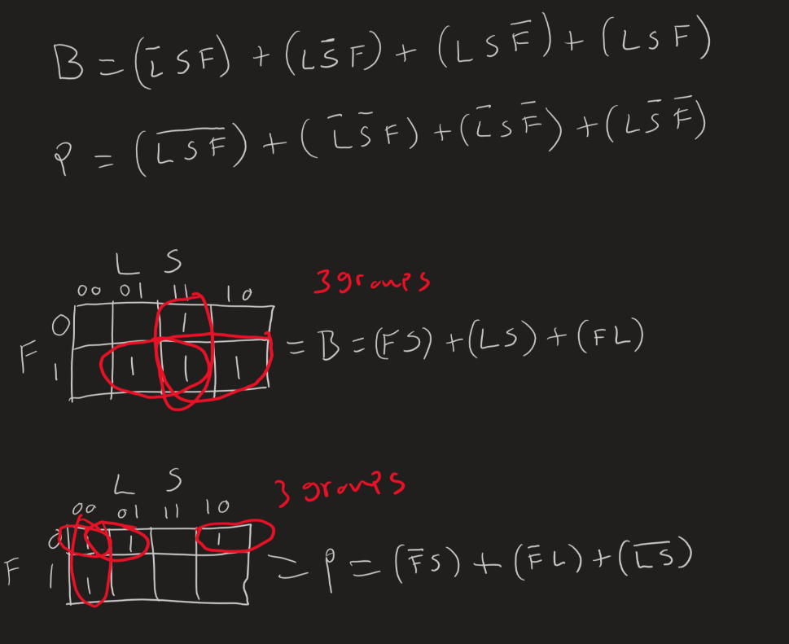

To clarify,

B = FS + LS + FL

P = $\overline{F}S$ + $\overline{F}L$ + $\overline{L}\overline{S}$

Make the circuit that you designed MultimediaLogic and store your MultimediaLogic circuits

Save the circuit diagram as Lab3a. Note, the circuit you design may not be the same as the equations since you are doing one circuit to cover all conditions. Write the equations for the outputs as defined by your circuit design. Put a screenshot of your circuit to the word file.

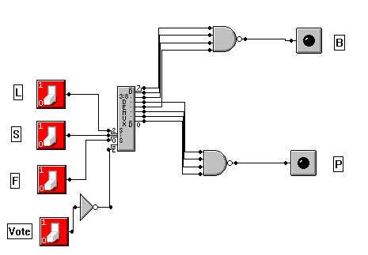

The equations for the outputs in our circuit is derived directly from the truth table using a demultiplexer. Based on the diagram the functions are…

B = $\overline{(\overline{L}SF) * (L\overline{S}F) * (LS\overline{F}) * (LSF)} *vote$

P = $\overline{(\overline{L}\overline{S}\overline{F}) * (\overline{L}\overline{S}F) * (\overline{L}S\overline{F}) * (L\overline{S}\overline{F})} *vote$

**Part B**

**Another** friend, Kim (**K**) has joined the group. This time they have decided to go to the **movies,** but they can’t decide on which movie to attend. They have decided that the decision must be unanimous. They want a circuit that will choose one or the other only when all members have voted the same way. That means that all switches are on and they have chosen the one movie (say A) and when all switches are off and they have chosen the other movie (say B). Like the previous circuit add a switch (Vote) that will be turned on when the votes have been cast. If the switches are not unanimous in one state or the other, neither of the choices will light up. If the no choice is made, the Vote switch is turned off and each person will be allowed to reconsider their vote; they may or may not change it however. Once all have had a chance to reconsider, the Vote switch will be turned on again to see if a choice has been made. If no choice is made after ten attempts they will give up on this pair of movies and come up with another combination to vote on. Add a counter that will count once each time a vote is taken and the 7 segment LED that will show hexadecimal values. When the LED shows ‘A’ then 10 votes have been made.

Place a text box at the top of the set of switches with the label: ‘Movie A’ and a second text box at the bottom of the switches with the label: ‘Movie B’. Add two LED’s with these same names to show which, if either, was selected.

Make the **circuit** that you designed with MultimediaLogic and store your MultimediaLogic circuit. Save the circuit diagram as Lab3b. Note, the circuit you design may not be the same as the equations since you are doing one circuit to cover all conditions. Write the equations for the outputs as defined by your circuit design. Put a screenshot of your circuit to the word file.

The equations for the outputs defined by our circuit design are…

Movie A = $(LSFK) * vote$

Movie B = $\overline{(L + S + F + K)} * vote$