Project 1 (224 words) – Book share website for the Internet Computing Technologies

Course (IAT352 SFU Spring 2017)

The idea of that individual term project was to create a book share library where users can exchange books among each other for free. Due to the amount information of information and project requirements I decide to use the MySQL database. To connect the web interface with the database I used PHP. First step was to create HTML and CSS skeleton of the website to simplify users’ communication with the data base. As basic foundation was finished I start to work with the database itself by defining relations, key and type of organization. There are two main tables were used: books with unique ISBN key identifier and users with unique e-mail key that allows to register/login. The next step was to connect the web interface with the database using proper logic. By creating set of prepared statements and applied proper quires I achieved the following functional for that website: 1) Login/Register; 2) Search by ISBN; search by title, 3) Filter by years; 4) Ability to chose which columns (aka information) would be presented about books. After that, I’ve decided to add AJAX that would parse XML file which contain top 10 of the last month books. Furthermore, to achieve the bonus mark I did the admin page where user with privileges was able to edit database (safely), for example ban users, easily add/remove books.

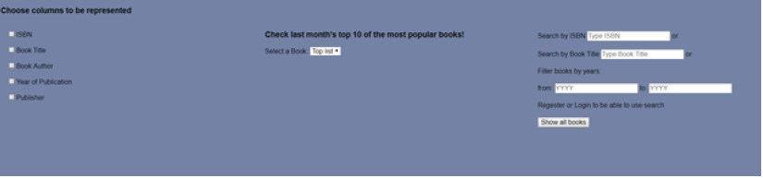

Project 2 (242 words) - Textbook android app for the studying purposes for the Special Topics (science) course (IAT381 SFU Summer 2016)

Team of 3

Role: programing parts that are related to the parsing and SQLite

This was a term project in team of 3 and we decide to create an android application that would achieve following goals: 1) e-reader allows to reduce cost of production and publications; 2) integrate learning elements that would allow to check the material that was red before; 3) track the progress of the studying process. There were certain difficulties with visual presentation of some elements such as tables and diagrams because the interface supposed to be responsive and available for portrait and landscape modes. It was my first experience of developing an android application and work with SQLite and XML parser all in one but my teammate with stronger coding skill was able to navigate me through this process and teach me a lot so I was able to finish my parts without struggling the team. Furthermore, it was interesting communication experience as one of our teammates was concentrated on the design only and did not touch the code and was important for us to implement her ideas precisely with the limit of our skills and time pressure. The result of that collaboration was the fully functional and industry level application (no memory leaking, no data disappearances, no UI dead-ends) that might be used to study the material in a way of the e-book and then test yourself answering on the related questions from the end of the chapter quiz section or at the end of the book exam set of questions.

Personal biography (112 words)

My name is George and I am 4th year student at School of Interactive Arts and Technology at Simon Fraser University. Currently at my last term finishing undergraduate degree (Summer 2018). I am interested in back end development and working with databases and big data. Turned out that I found myself working with SQL databases but my education gave the understanding of the front-end development process and increased my communication skill a lot. Also, I am running small two people company selling used car batteries back to the Japanese factory, for about 3 years. As for my hobbies, I am playing on the guitar for 12 years and cello for 8 years.