GULLIVER TRACKER: HARDWARE COMPONENT & PINOUT SUMMARY

Shopping List:
Temp/Humidity SHT40
12v to 5v converter HOBBYWING 3A UBEC 5V...
Case 158x90x60mm size with PG7 cable glands.
Main Computer LILYGO 7670E or 7670G
Fuse 3a mcb fuse
Barometer BMP280

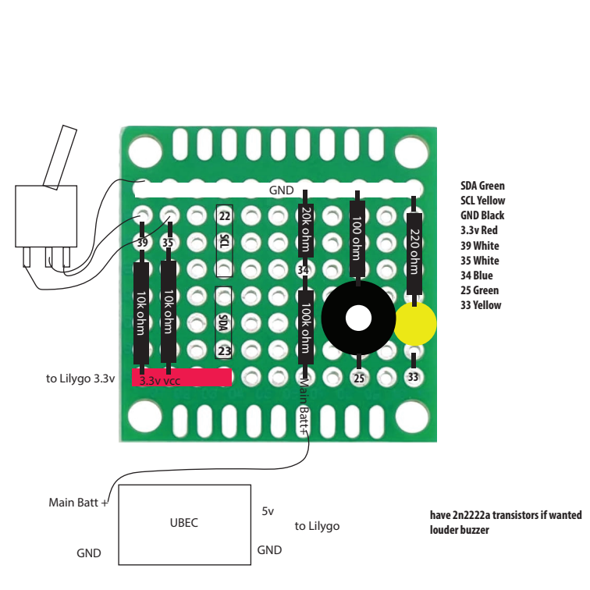

Figure 1. I built a small sub-board to mount the buzzer, LED and voltage divider for sensing the input voltage. There’s also two pull-up resistors (10k ohm) to manage the toggle switch. The UBEC buck converter is used to provide a stable low noise supply of 5v power. I used a small automatic fuse in the box too to protect the battery wiring.

1. Visual & Audio

Indicators
- LED Pin: On the V1 board, this uses GPIO 33. On the V2 board, it utilizes GPIO 48.
- Buzzer Pin: Connects to the physical 5V piezo alert buzzer used to sound the audible alarm if the anchor slips out of bounds. On the V1 board, this maps to GPIO 25. On the V2 board, it maps to GPIO 1.

2. State Toggles & Sensor Peripherals
- Toggle Switch (Moored): Tracks the "Moored" state tied to ground via active-low pull-up logic. This uses GPIO 35 on V1 and GPIO 6 on V2.
- Toggle Switch (Anchored): Tracks the "Anchored" state tied to ground via active-low pull-up logic. This uses GPIO 39 on V1 and GPIO 16 on V2.
- Voltage Sensing (ADC): Handles the battery monitor. It uses GPIO 34 on V1 and GPIO 5 on V2. Your 100kOhm supply-side and 20kOhm ground-side resistor array creates a precise 1:6 step-down ratio. This matches your script's calibrated software multiplier string (pin_voltage * 6.247). The extra 0.247 factor compensates for real-world resistor tolerances and the ESP32's internal input impedance under full 11dB attenuation.

3. Environmental Sensors (I2C Bus)
- SDA (Data) Pin: Assigned to GPIO 23 on V1 and GPIO 40 on V2.
- SCL (Clock) Pin: Assigned to GPIO 22 on V1 and GPIO 42 on V2.
- Supported Sensors: The I2C bus actively queries the SHT40 (Address 0x44) for cabin temperature and relative humidity. It additionally queries the BMP280 (Addresses 0x76 or 0x77) to extract calibrated barometric pressure in hPa.

4. Integrated LilyGo Modem Controls
These pins handle power sequencing and internal communications between the ESP32 microchip and the attached A7670 cellular/satellite module:
- UART Communications: Maps the high-speed data lanes executing your raw AT command handshakes. On V1, TX is GPIO 26 and RX is GPIO 27. On V2, TX is GPIO 11 and RX is GPIO 10.
- Main Board Power Rail: Drives the central hardware transistor gateway, keeping the cellular module's primary voltage rail energized. This is unified on GPIO 12 for both V1 and V2 boards.
- Modem Power Key: Operates the soft-start power key switch, pulse-triggering the modem's boot sequence. This uses GPIO 4 on V1 and GPIO 18 on V2.
- GPS Antenna Power Enable: Both V1 and V2 use GPIO 21 as an isolated hardware power switch to turn the active high-gain GNSS patch antenna on and off. However, the V2 board additionally requires software routing to activate the GPS Antenna LDO via the Modem's internal GPIO 4 using AT commands (AT+CGDRT=4,1 and AT+CGSETV=4,1).

5. MicroSD Card Storage (SPI Bus)
The unified SPI bus connects the SD card reader for the "Store & Forward" offline backlog cache. These pins are standardized across both V1 and V2 boards:
- CS (Chip Select): GPIO 13
- SCK (Clock): GPIO 14
- MISO (Master In Slave Out): GPIO 2
- MOSI (Master Out Slave In): GPIO 15

