CS4303P4 Report
——Mini Thunder: a casual shoot 'em up game
200009419

Introduction
The game design to be a horizontally scrolling flying and shooting game. The player controls a fighter plane to shoot the enemy fighter down as well as parry the incoming crashing and bullet.
The difficulties of the stage will increase as the player gains more score from take down enemies. It reflects on faster moving speed for enemies, faster refreshing, higher hp and so on. The player could upgrade the fighter or restore the hp by collecting supply air drops. A concise and functional user interface is implemented for navigation and status indicating.

Overview & Game Context
The game genre is largely inspired by shoot 'em up games, combined with the techniques of side-scrolling game and absorbed some elements from bullet hell games.
A shoot 'em up game is a game in which the protagonist combats a large number of enemies by shooting at them while dodging their fire (B, Matt). These games are usually viewed from a top-down or side-view perspective, and players must use ranged weapons to take action at a distance. The player's avatar is typically a vehicle or spacecraft under constant attack. Thus, the player's goal is to shoot as quickly as possible at anything that moves or threatens them to reach the end of the level with a boss battle (R, Andrew). Space Invaders is considered the game that set the template for the shoot 'em up genre. It is a fixed shooter in which the player controls a laser cannon by moving it horizontally across the bottom of the screen and firing at descending aliens.
A side-scrolling game or side-scroller is a video game in which the gameplay action is viewed from a side-view camera angle, and as the player's character moves left or right, the screen scrolls with them. These games make use of scrolling computer display technology. The move from single-screen or flip-screen graphics to scrolling graphics, during the golden age of video arcade games and during third-generation consoles, would prove to be a pivotal leap in game design.
The attributes of horizontally scrolling games are largely established by game Defender developed by Eugene Jarvis in 1981. The game set on the surface of an unnamed planet. The player controls a spaceship flying either to the left or right. A joystick controls the ship's elevation, and five buttons control its horizontal direction and weapons. The surface will change dynamically according to the movement of the player.
The design of the game is influenced by game Raiden, a 1990 vertically scrolling shooter arcade video game developed by Seibu Kaihatsu. In each stage, the player manoeuvres the Fighting Thunder craft, engaging various enemies and avoiding their attacks. After completing the eighth and final stage, the player returns to the first stage with the difficulty increased. It provides variety of elements for a shooting game, dazzling bullet, crazy barrage, collectable items, different forms of enemies, and so on. A plenty of game elements in Raiden are applied to the designed game which will be demonstrated in design section.

Design

Title
The title “Mini Thunder” derived from the title of the game Raiden— a Japanese word literally means “Thunder” in English. The title suggests some relations between these two games and “Mini” suggests that the game is designed to be concise.

Genre
The game designed to be a horizontally scrolling flying and shooting game. The main feature including a horizontally scrolling stage, constantly rendered enemies, fast-paced combat, collectible items. The game has a common impression of a "shmup" game: side-view perspective, an overwhelming number of enemies and bullets, ranged weapons, and an avatar of aircraft. Moreover, the game is designed to be a casual game: simple game play that is easy to understand; a concise interface designed to simplify the operation; short game sessions that enables the users to play the game in a short time period.

Characters & Items
There are three characters in the game—Player Fighter, Enemy Fighter, and Enemy Flying Fortress. Player Fighter is controllable by the player. It has three attributions: HP, damage, and maneuverability. HP decides how many damages the player can take or how many mistakes can be made before the game over. Damage determines how many bullets fired could destroy an enemy aircraft: a larger damage number means less bullets to take down an enemy aircraft. Maneuverability determines how quick the aircraft could move to the location of the cursor under easing function (will be discussed in detail in implementation section).
The enemy fighter will be generated in random position on the right of the stage. It cannot fire, but could crash into the player fighter. It has two attribution: speed and HP. Speed controls how fast it moves across the stage while HP determines how many bullets it can sustain. The enemy flying fortress has more HP and slower speed than fighter, and it can fire bullets at the player according to the player location.
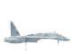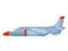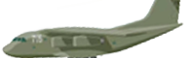
Player Fighter Enemy Fight Enemy Flying Fortress

There are three collectable items in the game: airdrop box for HP recovery (the red one), damage upgrading (the blue one), and maneuverability upgrade (the green one). A random airdrop will be added to the game in certain frames. The player could move the plane to collect the box for upgrading or HP restoration.

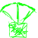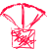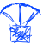
Airdrop-maneuverability Airdrop-HP Airdrop-Damage

Rules & Control
To control the player fighter, the player could simply move the mouse cursor on the screen and the plane will follow the motion of the cursor. To fire bullets, the player could press and hold the mouse left button. A visual game guide is given as figure1.
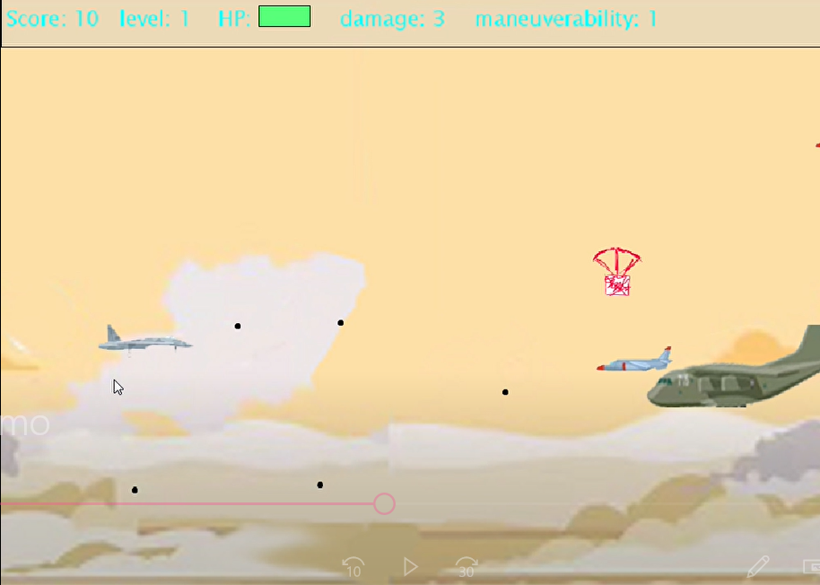
Do not let enemy pass the left edge
Player Fighter
Controlled by
mouse
Enemy flying fortress
Enemy fighter
Airdrop box that can be collected by player
Bullet Fired by enemy flying fortress
Bullet Fired by player
Figure1: Game Screenshot

The rules for the game are straightforward. There is an HP bar on the top panel indicating the current HP left. Once the player fighter crashed into an enemy aircraft, hit by an enemy bullet, or let the enemy aircraft pass the left edge of the stage, the HP will drop and reflected on the HP bar. The initial value of HP is 10, which means the player could sustain above cases ten times before the game ends. The enemy HP will drop equals to the value of the damage each time it hit by a player bullet and the enemy aircraft will be destroyed if the HP is below zero. A crashing will destroy the enemy instantly no matter what value of the HP is. Once the player destroys an enemy aircraft, the game score will be incremented by 1.
The current level is dependent on current score, the difficulties of the game will increase according to the level. The difficulties of the game are reflected on enemy HP, enemy speed and the frequency spawning an enemy. As the level increases, the enemy speed and frequency of spawning will reach a maximum number—to make the game reasonable. However, increments of enemy HP do not have a limitation.
To handle increasing difficulties, the player must collect airdrops to upgrade the damage level and maneuverability level. In every 150 frames, there will be 20% chance to drop a supply box among HP, damage upgrade, and maneuverability upgrade. The player could collect the box by moving the fighter to the position of the box. The red box will restore the player HP to 10. The blue box could increase the damage of player bullets—make it quicker to shoot down enemy aircraft. The green box could increase the swiftness of player fighter—decrease the time delay moving to the position of mouse cursor.

Stage & Goals
The game set on a modern warfare air battle. The player controls a fighter aircraft to destroy incoming enemy air forces. The goal is to gain higher score by destroy more enemy aircraft and to survive from overwhelming waves of enemy and dense barrage. Instead of creating stages and checkpoints, the game designed to be “infinite” that could be played continuously theoretically.
To survive and reach higher score, the player has to swiftly move the fighter to a correct position in order to destroy an enemy or parry enemy bullet or crashing. And the player needs to neutralize the air threaten quickly enough before it reaches left edge.

User Interface

