Non-Invasive Bee Entrance Counting with YOLO in Tropical Beekeeping Environments: A Case Study in Uganda
Agatha Turyagyenda, Mary Nsabagwa, Roseline Akol, Andrew Katumba, Mbazingwa Mkiramweni, Ssali Joshua, George Lukaanya
Abstract—This study presents
Index Terms—Internet of Things (IoT), Precision Apiculture,

INTRODUCTION
Honey bees (Apis mellifera) are essential pollinators, crucial for both global food security and ecosystem biodiversity (Zattara & Aizen, 2021). The health and productivity of a honey bee colony are strongly correlated with its foraging activity. A high exit rate in the mid-morning signals a strong foraging force, while a sudden drop in activity can indicate a stress event(Abou-Shaara, 2014; Bordier & Klein, S, 2018). Monitoring bee activity at the entrance can serve as a vital bioindicator for colony health, nectar flow, and the presence of environmental stressors, such as pesticides, disease, or pests.
Traditional monitoring relies on manual, invasive observation, which is laborious, prone to human error, disruptive to the bees, and lacks temporal constraints and scalability. In Uganda, beekeeping is a significant economic activity for many rural households (Amulen et al., 2019), which employ traditional monitoring for their management. An automated, non-invasive system for monitoring hive activity would give the beekeepers continuous, actionable data.
Recent advances in computer vision coupled with machine learning have been proposed (Benahmed et al., 2022; Mahajan et al., 2023) to address the challenges presented by traditional monitoring. Although they show advances in the identification and tracking of bees, they are often only experimental-based studies and are not integrated into practical systems (Kaplan Berkaya et al., 2021; Rodriguez et al., 2018). Additionally, the models trained on datasets from Europe or North America may not generalise well to the different bee subspecies (e.g., Apis mellifera scutellata), varying hive structures, and unique environmental conditions found in Uganda.

This study addresses these challenges by:
- Developing an automated system for bee counting using a YOLO-based object detection.
- Collect and annotate a dataset from hives in Uganda.
- Evaluate and compare the performance of the model against established architectures.
- Demonstrate the feasibility of real-time monitoring under real-world field conditions.

RELATED WORK
Monitoring honeybee entrance traffic has transitioned from early mechanical counters to modern deep learning approaches. The two dominant categories are sensor-based monitoring and computer-vision-based systems.

A. Conventional and Sensor-Based Monitoring
Early automated systems involved dedicated detection hardware positioned at hive entrances. Mechanical photoelectric counters, such as (Struye et al., 1994) used infrared beams to detect in–out activity. Although cost-effective, these systems require periodic cleaning and are susceptible to beam obstruction caused by contamination, propolis deposition, or multiple bees passing simultaneously. Capacitive sensing solutions such as BeeCheck (Bermig et al., 2020) improved resilience to dirt; however, entrance-tunnel designs still alter natural flight behaviour and induce bottlenecks during high-traffic periods. RFID-based monitoring (Penaloza-Aponte et al., 2024) offers detailed tracking of tagged individuals but remains invasive, expensive, and only covers a small fraction of the colony. Infrared (IR) beam systems (Shaw et al., 2011) employed multi-channel IR gates to register bee crossings based on beam interruption. Although effective in controlled environments, these systems exhibit high false-trigger rates due to debris, overlapping insects, thermal noise, and require optical alignment. Photoresistor-based systems (Andrijević et al., 2022) detect bee passage via photodiodes or LDRs. While low-cost and simple to install, their accuracy degrades due to entrance congestion and sensors failing from dust or pollen. Overall, sensor-based systems lack reliability under heavy occlusion and have physical constraints that may disrupt normal hive activity.
B. Traditional Computer Vision Techniques for Bee Counting
Computer vision (CV) emerged as a viable, non-invasive alternative. Classical CV-based studies relied on traditional, conventional detection pipelines that involve manually tuning individual stages, such as image filtering and image segmentation, before applying a machine learning algorithm for classification. Techniques included using background subtraction and ellipse approximations for detection, or implementing image velocimetry algorithms. (Kulyukin & Reka, 2016) explored omnidirectional bee counting from images. (Babic et al., 2016)(Wario et al., 2015) utilised optical flow and background subtraction for bee detection, but the performance of their systems degraded with changes in lighting or background. Conventional CV approaches generally have lower computational complexity and are suitable for environments where the surroundings can be controlled. However, accurately counting bees, especially when many bees are clustered (occlusion), remains a challenge in computer vision systems, leading to missed detections. Some conventional approaches fail to distinguish individual bees entering the hive in a cluster or row, thus highly underestimating the count.
C. Deep Learning for Bee Detection and Counting
With the advancement of deep learning, object detector-based models have increasingly replaced conventional methods for complex tasks like bee traffic monitoring due to their improved robustness and accuracy, particularly in complex, real-world scenes with high density. Convolutional Neural Networks (CNNs) have been applied to bee traffic, often coupled with motion detection algorithms. (Kulyukin & Mukherjee, 2019) developed a two-tier method combining motion detection for object segmentation with CNN-based classifiers to recognise and count individual bees at the hive entrance. This approach aims to estimate omnidirectional bee traffic levels through bee motion counts. CNN classifiers are frequently used for bee classification in general and Varroa monitoring. Object detection architectures like You Only Look Once (YOLO) and Single Shot MultiBox Detector (SSD) are now the most popular approaches for bee counting. The majority of object detection studies focus on bee traffic monitoring. (Ryu et al., 2021) developed a system using YOLOv4 combined with the DeepSORT model for tracking, which achieved a high detection accuracy of 99.5%. Other studies have utilised YOLOv5 for video analysis of bee traffic in front of the hive. Newer variants like YOLOv8 have also been explored for bee activity monitoring, focusing on object localisation and tracking, yielding high detection scores such as 0.97 mAP. Different YOLOv8 variants have demonstrated inconsistent performance across different datasets regarding outgoing and incoming accuracy (Mahajan et al., 2023; Sledevič & Abromavičius, 2023).
D. The Contextual Gap and Motivation
The goal of automated counting systems is to quantify traffic. To perform precise counting and traffic measurement, many systems employ special hardware setups to restrict movement, such as modified beehive entrances with parallel tunnels that ensure bees move only in one direction (Bermig et al., 2020). For automated measurement of in-and-out activity using imaging systems, total counts have been reported with accuracies ranging from 92.4% to 96.0% across several video samples (Bozek et al., 2017; Liang, 2024; Picek et al., 2022). However, forcing movement through special passages can alter natural bee behaviour. There remains a challenge of applying these advanced models to complex, unmodified, real-world field environments, especially those in diverse geographical locations.
Precision Beekeeping is in its infancy in developing countries. (Wakjira et al., 2021) developed a bee monitoring system in Ethiopia and Indonesia, but did not include visual data from the apairies. However, the deployment and performance benchmarks of advanced machine learning models for bee monitoring in the context of a Ugandan apiary, where factors like local honeybee subspecies behaviour and environmental variables could influence detection, have not been extensively reported in the published works.
This paper addresses this gap by implementing an advanced YOLO model to perform precise bee counting at the hive entrance in an African context. By focusing on optimising the object detection model of the YOLO architecture and performing benchmarks with state-of-the-art, our work contributes a localised dataset and an adapted YOLO model optimised for small-object detection under a natural environment.

Materials and methods
A smart IoT-enabled system has been developed to monitor bee populations, specifically for Uganda. The system developed consists of multiple sensors, including: videos, temperature, humdity, sound, carbon dioxide, audio and vibration. This study, however, focuses on the videos that were collected at the entrance of a Kenya Top bar hive, common amongst small and medium-scale farmers. The system comprises the Raspberry Pi Zero 2W processor and the Raspberry Pi Camera Version 3 to capture the videos. The study aims to quantify the bee population at the entrance of our beehive at different times of the day and during varying seasons. This was achieved in four phases: (1) Data Collection and Annotation, (2) Model Architecture Selection, (3) Training Configuration, and (4) Evaluation

Data Collection
Initially, the selected model was trained on the videos captured autonomously by the developed system from the entrance, but provided a low accuracy of mAP@50: 0.5354 and mAP@50:95: 0.1903. The study, therefore, collected additional data to further improve the accuracy of the model. The data set consisted of 18,390 images collected from active bee colonies under varying environmental and colony conditions from different geographical areas of Uganda, namely: Nwoya (Northern Uganda), Mukono (Suburban Central Uganda), Kumi (Eastern Uganda), Mubende (Rural Central Uganda) and Mbarara (Western Uganda). Video data was recorded using smartphone cameras capable of high-resolution capture, either mounted or handheld, at the hive entrance to record the movement of bees entering and exiting. The hives were also opened to monitor internal conditions, particularly to observe the queen bee, drones, worker bees, and any beetle presence. Each video captured approximately two minutes of hive activity, ensuring adequate coverage of different behavioural states. The collected data represented a range of colony conditions, including normal and strong colonies, hives with missing queens, swarming colonies, colonies exhibiting beetle infestation, and weak colonies. Data collection required careful observation of hive behaviour, often in collaboration with beekeepers to minimise colony disturbance.

  - Data cleaning
The recorded videos, captured at 30 frames per second, were converted into an image dataset by extracting three frames from every thirty frames to ensure temporal variation while reducing redundancy. The resulting dataset contained a considerable amount of noise, such as blurred images, empty backgrounds, and frames with non-bee objects. These unwanted samples were manually identified and removed by the team to improve the overall quality of the dataset. This manual cleaning process was essential to ensure that the images used for model training contained only meaningful visual information relevant to bee activity. After cleaning, the refined dataset was uploaded to the Roboflow platform to facilitate team-based annotation and preprocessing for model training.
  - Data annotation and preprocessing
The annotation and preprocessing stages were performed on the Roboflow platform. Each image was carefully reviewed to ensure that bees were properly annotated by drawing bounding boxes around them. Duplicate and blurry images were removed, and background noise was minimised to ensure that only high-quality examples were retained. All images were resized to a uniform resolution of 640 by 640 pixels, which provided a balance between detection accuracy and computational efficiency during both training and inference. This standardisation ensured that the dataset was consistent and compatible with the input requirements of the chosen model. Following annotation and preprocessing, the dataset was split into training, validation, and testing subsets in proportions of 80%, 15%, and 5%, respectively, using a stratified random split (random seed = 42) to maintain class balance across all splits. To investigate the effect of image quality on model robustness, JPEG compression was applied at varying quality levels per split: training images were compressed at quality 10 to maximise augmentation diversity, validation images at quality 30, and test images were retained at full quality (100) to reflect real-world inference conditions. All images were saved in JPEG format regardless of their original encoding. A YAML configuration file (data.yaml) was generated to specify the dataset paths, number of classes (nc: 1), and the single class label (‘bee’) required by the Ultralytics training pipeline.

Model Architecture Selection
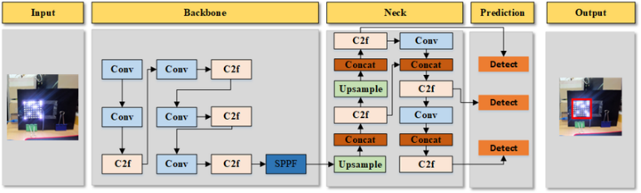
The model architecture selected for this study was the You Only Look Once (YOLO) framework, specifically the YOLOv8 variant developed by Ultralytics. YOLOv8 is a single-stage convolutional neural network (CNN) that performs real-time object detection by predicting bounding boxes and class probabilities directly from input images in a single forward pass. This efficiency makes it ideal for time-sensitive tasks such as tracking bee movements at hive entrances. The architecture is composed of a backbone network based on CSPDarknet for feature extraction, a neck module that enhances multi-scale feature fusion, and a detection head that predicts bounding boxes and class probabilities at multiple scales. This multi-scale capability is particularly useful for detecting small and fast-moving objects like bees. YOLOv8 was chosen over other models such as Faster R-CNN and SSD due to its balance between accuracy, inference speed, and computational efficiency, which makes it well-suited for deployment on resource-constrained environments such as Raspberry Pi or NVIDIA Jetson boards.
Figure 1: YOLO V8 Architecture

Training Configuration
Model training was conducted on a NVIDIA GeForce RTX 5090 GPU on JupyterLab notebook using the PyTorch deep learning framework and the Ultralytics YOLOv8x implementation. The model was initialized with pre-trained COCO weights (yolov8x.pt) and configured for single-class detection (single_cls=True). Since the COCO dataset does not specialise in small flying insects, the model was fine-tuned on the local bee dataset to adapt it to the specific visual features of bee imagery. The training process consisted of 150 epochs with a batch size of 16 and an image input size of 640 by 640 pixels. The optimiser was set to auto-selection, which resolved to AdamW with an initial learning rate of 0.01, a final learning rate ratio of 0.01, momentum of 0.937, and weight decay of 0.0005. Loss function gains were set as: bounding-box loss (box) = 7.5, classification loss (cls) = 0.5, and distribution focal loss (dfl) = 1.5. A linear learning rate warm-up was applied for the first 3 epochs with a warmup momentum of 0.8. To improve model robustness and generalization, a comprehensive set of augmentation techniques was applied: HSV-Hue jitter (0.015), HSV-Saturation (0.7), HSV-Value (0.4), random rotation up to 10 degrees, translation (0.1), scale (0.5), shear (2 degrees), perspective distortion (0.001), vertical and horizontal flips (both at probability 0.5), mosaic augmentation (1.0), mixup (0.1), copy-paste (0.1), random erasing (0.4), and random crop fraction (0.9). These augmentations were chosen to simulate the range of conditions encountered in real-world Ugandan apiary environments, including partial occlusions, varying illumination, and perspective changes. Early stopping was implemented with 20 epochs to prevent overfitting once the validation loss plateaued. Following training, the best-performing model weights (best.pt) were evaluated on both the validation and test splits, and the model was exported to ONNX format for cross-platform deployment on resource-constrained devices such as Raspberry Pi or NVIDIA Jetson boards.

Evaluation Metrics
The performance of the trained model was evaluated using standard object detection metrics, including Precision (P), Recall (R), F1-score (F₁), mean Average Precision (mAP), and Frame Processing Rate (FPS). These metrics were chosen to comprehensively assess the accuracy, sensitivity, and real-time performance of the proposed bee detection system.
Precision measures the proportion of correctly predicted bee detections among all detections made by the model. It is given by:
Precision (P) = TP / (TP + FP)
where TP represents true positives (correct detections) and FP represents false positives (incorrect detections). A high precision value indicates that the model generates few false detections during inference.
Recall measures the model’s ability to detect all relevant bees in an image or video frame. It is expressed as:
Recall (R) = TP / (TP + FN)
where FN represents false negatives (missed detections). A high recall value indicates that the model successfully detects most of the bees present in the scene.
The F1-score was used as a balanced measure that considers both. It is calculated as the harmonic mean of precision and recall:
F₁ = 2 × (P × R) / (P + R)
The main performance metric used for object detection tasks was the mean Average Precision (mAP), which represents the area under the precision–recall curve. It evaluates the accuracy of both object classification and localisation. In this study, two variants were reported: mAP@0.5, which uses an Intersection over Union (IoU) threshold of 0.5, and mAP@0.5:0.95, which averages mAP values across multiple IoU thresholds from 0.5 to 0.95 in steps of 0.05. The general formula for mAP is given by:
mAP = (1 / n) × Σ(APᵢ)
where APᵢ represents the average precision for class i, and n is the total number of classes. In this study, n = 1 since only a single class (“bee”) was considered.
To evaluate the model’s suitability for real-time monitoring, the Frame Processing Rate (FPS) was also measured. FPS quantifies how many frames the model can process per second during inference and is defined as:
FPS = N₍frames₎ / t₍processing₎
where N₍frames₎ is the number of frames processed, and t₍processing₎ is the total processing time in seconds. A higher FPS value indicates better real-time performance, which is essential for continuous hive monitoring in field conditions.

Results and Discussion
The YOLOv8x model was trained for the full 150 epochs on an NVIDIA GeForce RTX 5090 GPU. Training completed in approximately 10.85 hours, processing 14,727 training images across 921 batches per epoch at a throughput of approximately 3.9 iterations per second. The model contains 68,153,571 parameters across 210 layers (113 layers in the fused inference configuration) and requires 258.1 GFLOPs per forward pass. The learning rate schedule followed the configured warm-up phase for the first three epochs, after which MuSGD with momentum 0.9 was applied. Mosaic augmentation was automatically disabled after epoch 140 to allow the model to fine-tune on unaugmented cropped images in the final ten epochs, resulting in a sharp drop in training losses (box loss fell from approximately 0.933 at epoch 140 to 0.649 at epoch 150) while validation metrics continued to improve.
A. Training Convergence
Training metrics improved steadily across all 150 epochs. The box loss declined from 2.263 at epoch 1 to 0.649 at epoch 150, while the classification loss fell from 1.796 to 0.306 and the distribution focal loss reduced from 1.383 to 0.838. Validation mAP@50 increased monotonically from 0.657 at epoch 1 to 0.936 at epoch 150, with no plateau or degradation observed, indicating that the model did not overfit and that the early stopping criterion (patience of 20 epochs) was not triggered. The mAP@50:95, a stricter measure that requires tighter bounding box localisation, rose from 0.268 to 0.584 over the same period. Validation precision reached 0.902 and validation recall reached 0.894 by the final epoch.
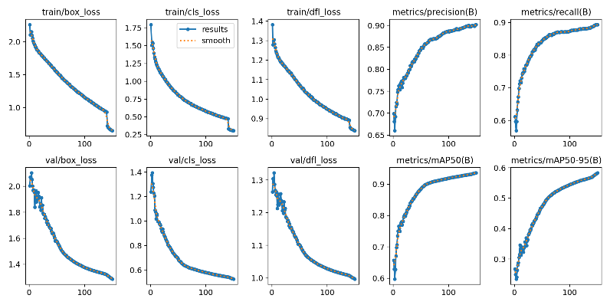
Figure 2: Training and validation metrics over 150 epochs. Top row (left to right): training box loss, cls loss, and dfl loss, all showing consistent monotonic decline. Bottom row: corresponding validation losses alongside validation Precision, Recall, mAP@50, and mAP@50:95. The sharp drop in all losses at epoch 140 corresponds to the scheduled disabling of mosaic augmentation (close_mosaic=10). No plateau or divergence is observed, confirming that early stopping (patience=20) was not triggered.

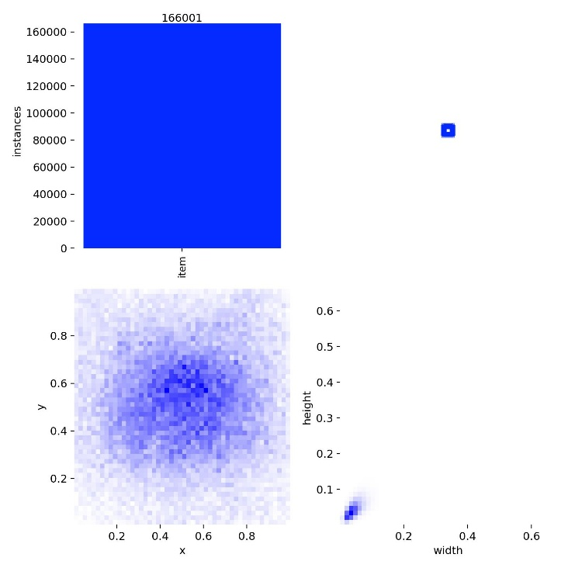
Figure 3: Training dataset label statistics for the single bee class across 166,001 annotated instances. Top-left: instance count bar chart confirming a single-class dataset labelled as 'item' (consistent with single_cls=True training). Bottom-left: spatial heatmap of normalised bounding box centre coordinates, showing a diffuse distribution concentrated in the central image region typical of hive entrance footage. Right: bounding box width-height scatter plot, tightly clustered around width ≈ 0.05 and height ≈ 0.07 of the image dimension, reflecting the small, compact appearance of individual bees at 640×640 resolution.
Figure 5: Training batch 1 — additional ground-truth annotations under mosaic augmentation. This batch illustrates the diversity of hive entrance scenes captured: partially obscured entrances, varying background foliage, different hive box colours, and frames with high annotation density (many bees at the entrance) alongside sparse frames with only one or two visible bees. The 'Supported by NatureUganda' branding visible on several hives confirms the Ugandan field context of the dataset.

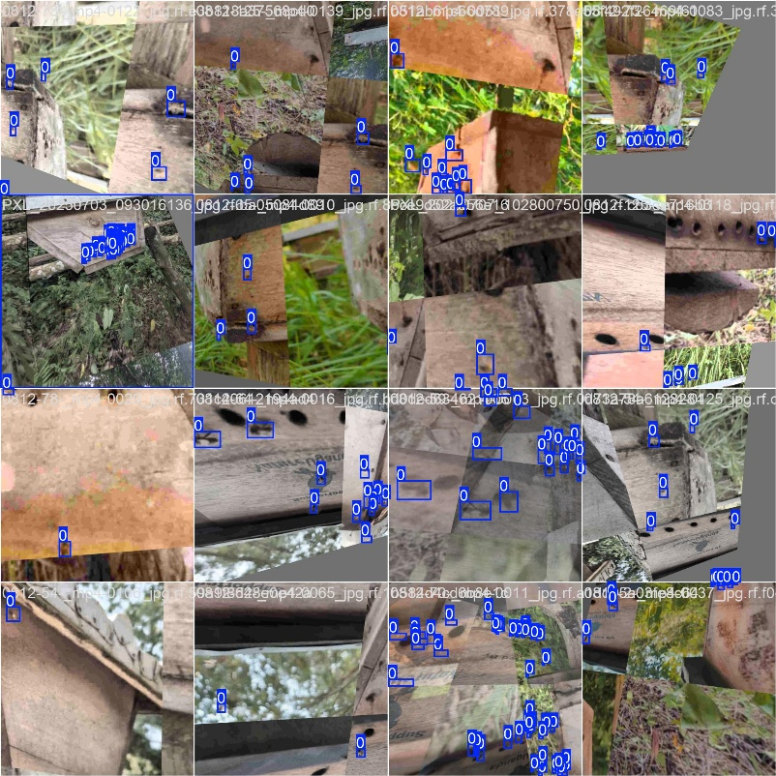

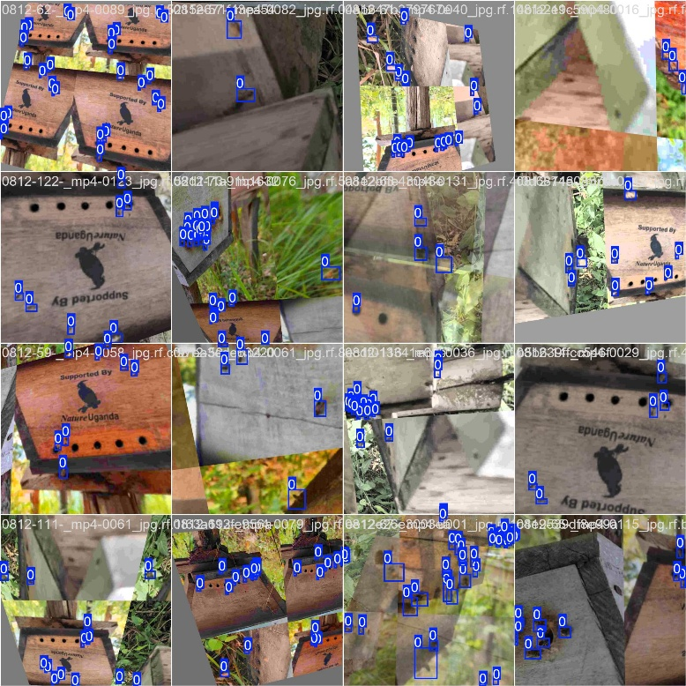
Figure 4: Training batch 0 — ground-truth bounding box annotations on mosaic-augmented images. Each tile combines four training frames from different video sources (filenames prefixed 0812- indicate the hive video source) using the mosaic augmentation strategy (mosaic=1.0). Bounding boxes are shown in blue. The augmentation applies random rotation (±10°), scaling (±50%), perspective distortion, and HSV colour jitter to every composite tile, producing the varied orientations and lighting conditions visible across the batch.

B. Quantitative Performance
The best model weights (best.pt, 136.7 MB) were evaluated separately on the validation and test sets. On the validation set (2,743 images, 31,308 bee instances), the model achieved a Precision of 0.9022, a recall of 0.8942, an mAP@50 of 0.9366, an mAP@50:95 of 0.5850, and an F1-Score of 0.8982. Inference speed on the validation set was 0.9 ms preprocessing, 4.8 ms inference, and 1.1 ms postprocessing per image, corresponding to an effective throughput suitable for real-time deployment. On the held-out test set (920 images, 10,406 instances), the model achieved a Precision of 0.8577, Recall of 0.7966, mAP@50 of 0.8586, mAP@50:95 of 0.3676, and an F1-Score of 0.8260. The test set performance, while lower than validation, reflects the deliberate use of full-quality (JPEG quality 100) images in the test split against the heavily compressed training images, making the test split a realistic proxy for field deployment conditions. The inference speed on the test set was 0.9 ms preprocessing, 4.7 ms inference, and 1.3 ms postprocessing per image on the GPU.
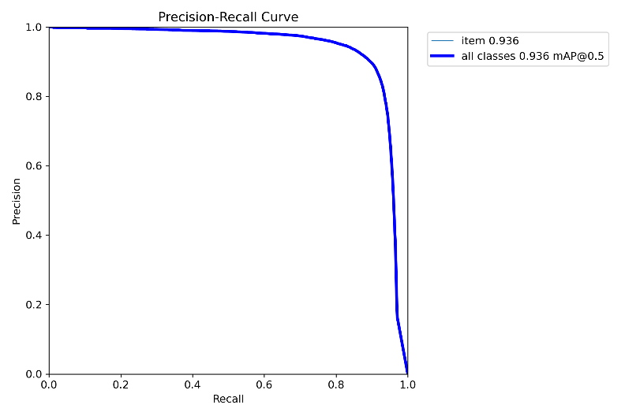
Figure 6: Precision-Recall (PR) curve for the bee class evaluated on the validation set (2,743 images, 31,308 instances) using best.pt. The curve maintains near-perfect Precision (≈1.0) up to Recall ≈ 0.85 before declining sharply, yielding an area under the curve (mAP@0.5) of 0.936. The steep drop beyond Recall = 0.90 reflects the difficulty of retrieving the hardest-to-detect bees — those that are heavily occluded, motion-blurred, or at the extreme periphery of the frame

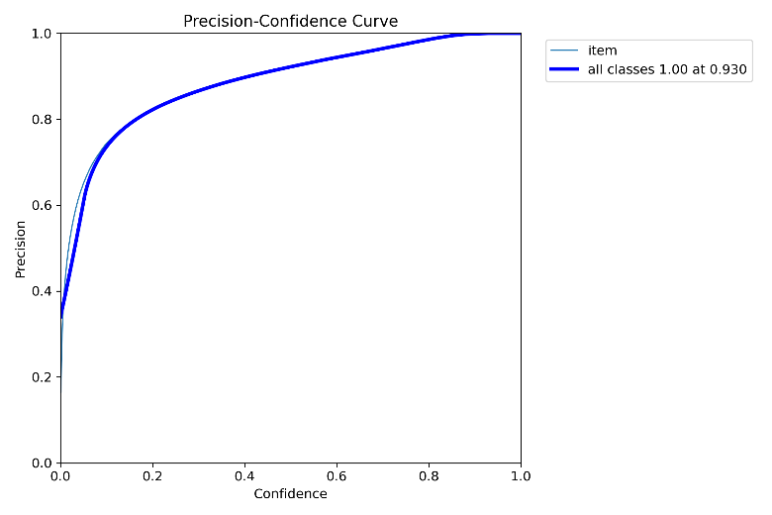
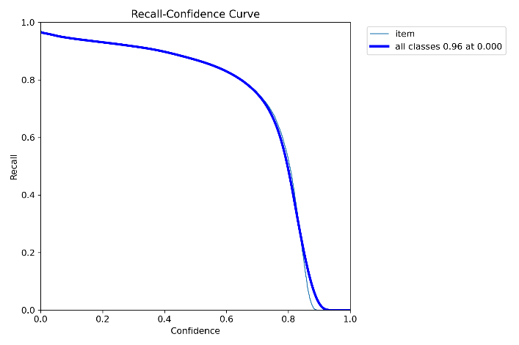
Figure 7: Precision-Confidence curve on the validation set. Precision increases monotonically from ≈0.35 at confidence 0.0 to 1.00 at confidence 0.930, demonstrating that the model produces very few false positives when a sufficiently high threshold is applied. The curve confirms that the model's detections, when made with high confidence, are reliable — important for deployment scenarios where false alarms (boxes on hive wood, shadows, or propolis) are costly.

Figure 10: Confusion matrix on the validation set (2,743 images, 31,308 bee instances). The model produced 29,239 true positive detections (bees correctly identified), 2,069 false negatives (bees missed, predicted as background), and 4,892 false positive detections (background regions incorrectly classified as bees). No inter-class confusion exists by design, as the dataset contains a single class (single_cls=True). The 4,892 false positives likely arise from high-texture regions of the wooden hive surface, propolis deposits, and motion-blurred frames that resemble bee silhouettes at JPEG quality 30.

Figure 8: Recall-Confidence curve on the validation set. Peak Recall of 0.96 is attained at the lowest confidence threshold, declining steadily to near zero above confidence 0.90. The curve shows that at the optimal operating confidence of 0.417 (as identified by the F1 curve), the model retains Recall ≈ 0.89, recovering the vast majority of bee instances while rejecting low-confidence spurious detections.

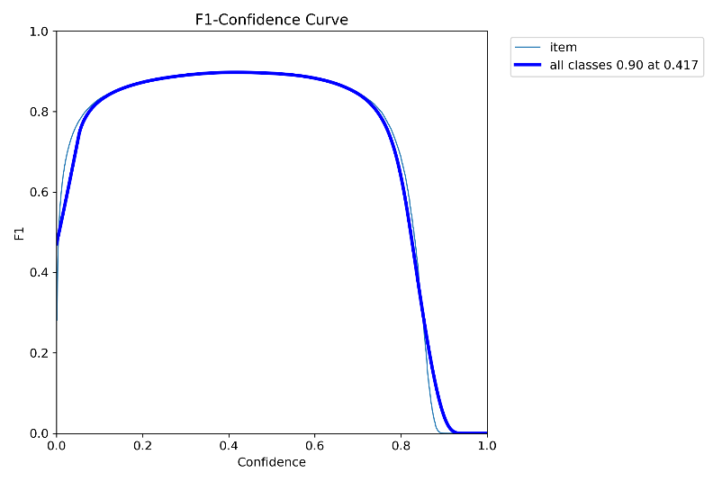
Figure 9: F1-Confidence curve on the validation set. The F1-score peaks at 0.90 at a confidence threshold of 0.417, defining the optimal operating point that balances Precision and Recall for real-time deployment. The broad, flat plateau between confidence 0.1 and 0.75 (F1 ≥ 0.85) indicates robustness to threshold choice — the model performs well across a wide range of confidence settings, which is advantageous for field deployment where lighting conditions may vary.

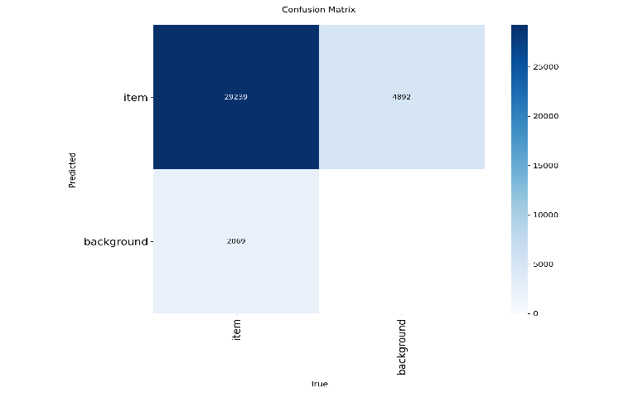
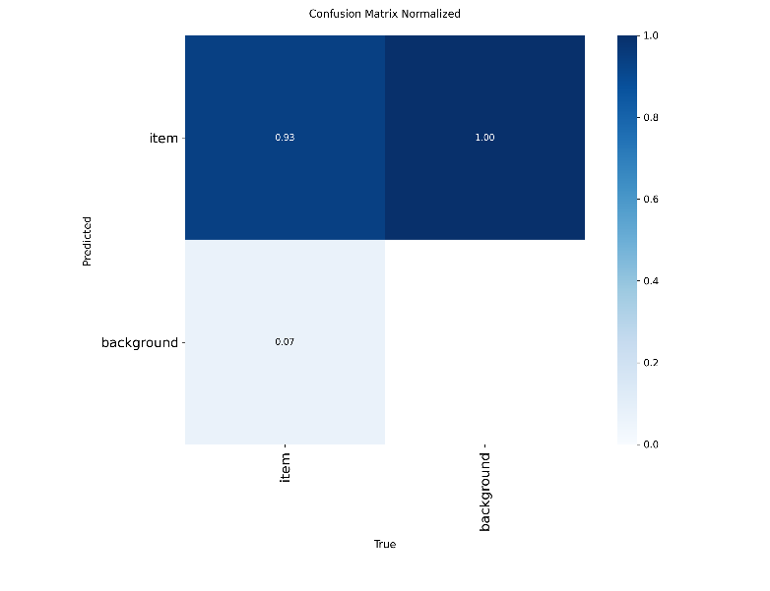
Figure 11: Normalised confusion matrix on the validation set. Of all ground-truth bee instances, 93% are correctly detected (true positive rate) and 7% are missed as background (false negative rate). All background regions predicted as bees (false positives) are shown as 1.00 in the background column, reflecting that all false positives are predicted as the 'item' class — a known characteristic of single-class detectors operating with a low confidence threshold near the optimal 0.417.

C. Real-Time Video Inference
The trained model was applied to a raw video recorded at a Ugandan hive entrance (1_2024-09-09_180010.mp4). Each frame was resized to 384×640 pixels before inference and processed at a confidence threshold of 0.4. Per-frame inference
times ranged from approximately 6.8 ms to 48.2 ms, with a typical inference time of around 14–17 ms per frame on the GPU, corresponding to approximately 60–70 frames per second under normal conditions. Bees were successfully detected across a variety of entry and exit scenarios, including frames with single, double, and triple bee detections. Frames with no detections corresponded to brief periods of low hive activity or clear-background frames at the beginning of video clips. Bounding boxes and confidence scores were drawn on each frame and written to an output video file, demonstrating the feasibility of real-time monitoring under actual Ugandan apiary field conditions.
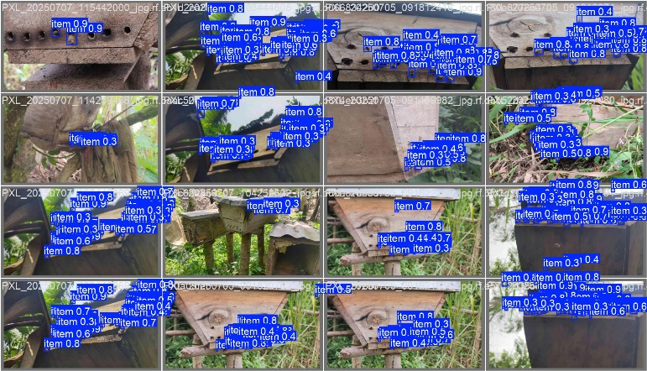

Figure 12: Validation batch 0 — model predictions with bounding boxes and confidence scores from best.pt. Detections are shown across a diverse sample of validation images sourced from the PXL (Pixel phone camera) series recorded at Ugandan apiaries in July 2025. Confidence scores range from 0.3 to 0.9 across the batch, with higher scores on bees captured in clear foreground positions and lower scores on partially occluded or distant bees. Frames with dense activity show multiple overlapping detections correctly resolved by NMS (IoU threshold 0.7).

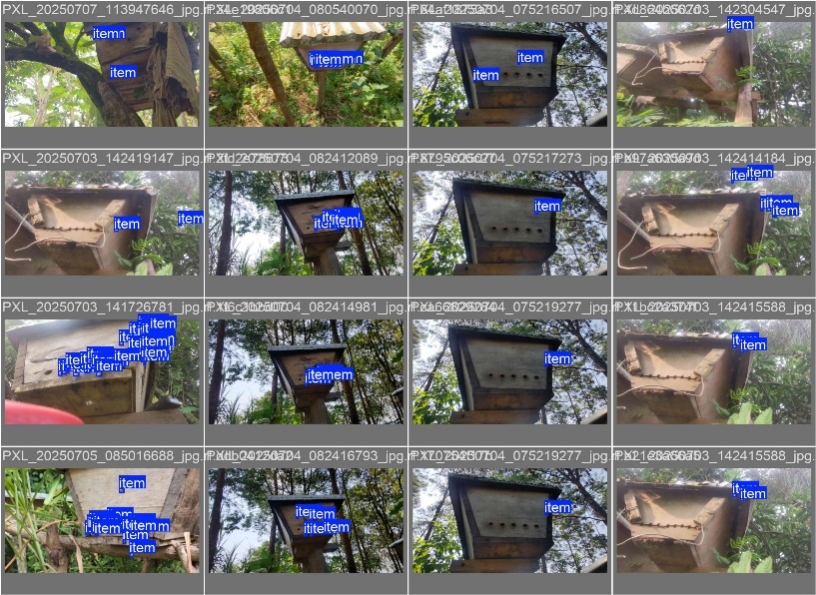
Figure 13: Validation batch 1 — ground-truth bounding box annotations on validation images from the PXL camera series (July 2025 field recordings). These labels serve as the reference for computing validation metrics. Comparing this figure with Fig. 11 illustrates cases where the model successfully localises bees at the hive entrance holes and landing board, as well as cases where small or partially visible bees near the frame edges represent the primary source of false negatives (Recall = 0.894).

D. Dataset Characteristics and Quality Observations
The final dataset contained 18,390 valid annotated image-label pairs after filtering out 5 empty label files encountered across several video sources. The training split comprised 14,727 images, and the validation split 2,743 images, with 920 images reserved for testing. During training, the Ultralytics loader flagged a small number of duplicate bounding box annotations (10 images with 1 duplicate each) that were automatically removed; these arose from a small set of near-identical video frames retained after the frame-extraction and cleaning pipeline. Additionally, a mixed detect-segment dataset warning was raised during label scanning due to the presence of a small number of segmentation masks (84 out of 166,001 training boxes; 56 out of 31,308 validation boxes), which were automatically discarded, with only bounding box annotations used for training.

E. Model Export and Deployment Artefacts
Following evaluation, the best model weights were exported to ONNX format (best.onnx, 260.1 MB) using ONNX opset 20 with onnxslim post-processing to reduce model size. The ONNX model supports cross-platform inference and is compatible with runtime environments including ONNX Runtime, OpenCV DNN, and hardware-accelerated backends such as TensorRT on NVIDIA Jetson. Both the PyTorch checkpoint (best.pt, 130.4 MB after optimizer stripping) and the ONNX model were saved to the model artefact directory alongside a metrics.json file recording the final validation scores. These artefacts provide the foundation for integration into a low-cost embedded monitoring system suitable for Ugandan beekeeping contexts.

Conclusion
This study demonstrated the feasibility of a YOLOv8x-based automated bee detection system trained and evaluated on data collected from active beehives in Ugandan apiaries. The study addressed the lack of representative data for the Apis mellifera scutellata subspecies and the unique environmental conditions of East Africa. A dataset of 18,390 annotated images, sourced from videos recorded with smartphone cameras under real-world field conditions, was collected and used to fine-tune the YOLOv8x architecture pre-trained on COCO. Training for 150 epochs on an NVIDIA GeForce RTX 5090 GPU yielded a model that achieved a Precision of 0.9022, Recall of 0.8942, mAP@50 of 0.9366, and F1-score of 0.8982 on the validation set, and a Precision of 0.8577, Recall of 0.7966, mAP@50 of 0.8586, and F1-score of 0.8260 on the held-out test set. The model ran at approximately 14–17 ms per frame during real-time video inference on a GPU, confirming its suitability for continuous hive entrance monitoring.
The gap between validation performance (mAP@50 = 0.937) and test performance (mAP@50 = 0.859) is because of the difference in image quality between splits: training images were compressed at JPEG quality 10 to increase augmentation diversity, while the test set used full-quality images to mimic real deployment conditions. This design choice means the trained model must generalise from highly compressed training data to high-fidelity inference frames, which is representative of practical field deployment. Future work should investigate whether training with a broader distribution of quality levels can reduce this gap further.
The system was validated on footage captured from a single hive under the specific environmental conditions of central Uganda, including the local subspecies Apis mellifera scutellata, variable natural lighting, and unmodified wooden hive entrances. These conditions differ substantially from the controlled setups and European bee subspecies on which most prior published systems have been evaluated, underscoring the importance of localised data collection and model adaptation. The results establish a baseline for precision apiculture in Sub-Saharan Africa and contribute a localised dataset and fine-tuned model to this underserved domain. The trained model was exported to ONNX format to enable deployment on resource-constrained devices such as Raspberry Pi or NVIDIA Jetson boards, supporting the development of low-cost autonomous monitoring stations for rural Ugandan beekeepers.
References
Abou-Shaara, H. F. (2014). The foraging behaviour of honey bees, Apis mellifera: a review. Https://Vetmed.Agriculturejournals.Cz/Doi/10.17221/7240-VETMED.Html, 59(1), 1–10. https://doi.org/10.17221/7240-VETMED
Amulen, D. R., D’Haese, M., D’Haene, E., Acai, J. O., Agea, J. G., Smagghe, G., & Cross, P. (2019). Estimating the potential of beekeeping to alleviate household poverty in rural Uganda. PLOS ONE, 14(3), e0214113. https://doi.org/10.1371/JOURNAL.PONE.0214113
Andrijević, N., Urošević, V., Arsić, B., Herceg, D., & Savić, B. (2022). IoT Monitoring and Prediction Modeling of Honeybee Activity with Alarm. Electronics 2022, Vol. 11, Page 783, 11(5), 783. https://doi.org/10.3390/ELECTRONICS11050783
Benahmed, H. K., Bensaad, M. L., & Chaib, N. (2022). Detection and tracking of honeybees using YOLO and StrongSORT. Proceedings - 2022 2nd International Conference on Electronic and Electrical Engineering and Intelligent System, ICE3IS 2022, 18–23. https://doi.org/10.1109/ICE3IS56585.2022.10010142
Bermig, S., Odemer, R., Gombert, A. J., Frommberger, M., Rosenquist, R., & Pistorius, J. (2020). Experimental validation of an electronic counting device to determine flight activity of honey bees (<em>Apis mellifera</em> L.). Journal Für Kulturpflanzen, 72(5), 132–140. https://doi.org/10.5073/JFK.2020.05.03
Bordier, C., & Klein, S, Y. L. C. (2018). Stress decreases pollen foraging performance in honeybees. Journal of Experimental Biology. https://journals.biologists.com/jeb/article/206/22/3991/bit.ly/3KfeGZo
Bozek, K., Hebert, L., Mikheyev, A. S., & Stephens, G. J. (2017). Towards dense object tracking in a 2D honeybee hive. Proceedings of the IEEE Computer Society Conference on Computer Vision and Pattern Recognition, 4185–4193. https://doi.org/10.1109/CVPR.2018.00440
Kaplan Berkaya, S., Sora Gunal, E., & Gunal, S. (2021a). Deep learning-based classification models for beehive monitoring. Ecological Informatics, 64, 101353. https://doi.org/10.1016/j.ecoinf.2021.101353
Kaplan Berkaya, S., Sora Gunal, E., & Gunal, S. (2021b). Deep learning-based classification models for beehive monitoring. Ecological Informatics, 64, 101353. https://doi.org/10.1016/J.ECOINF.2021.101353
Kulyukin, V., & Mukherjee, S. (2019). On Video Analysis of Omnidirectional Bee Traffic: Counting Bee Motions with Motion Detection and Image Classification. Applied Sciences 2019, Vol. 9, Page 3743, 9(18), 3743. https://doi.org/10.3390/APP9183743
Kulyukin, V., & Reka, S. K. (2016). Toward Sustainable Electronic Beehive Monitoring : Algorithms for Omnidirectional Bee Counting from Images and Harmonic Analysis of Buzzing Signals. Engineering Letters, 24, 3.
Liang, A. (2024). Developing an AI-based Integrated System for Bee Health Evaluation. https://arxiv.org/abs/2401.09988v1
Mahajan, Y., Mehta, D., Miranda, J., Pinto, R., & Patil, V. (2023). NeuralBee - A Beehive Health Monitoring System. 2023 4th International Conference on Communication Systems, Computing and IT Applications, CSCITA 2023 - Proceedings, 84–89. https://doi.org/10.1109/CSCITA55725.2023.10104935
Penaloza-Aponte, D., Brandt, S., Dent, E., Underwood, R. M., DeMoras, B., Bruckner, S., López-Uribe, M. M., & Urbina, J. V. (2024). Automated entrance monitoring to investigate honey bee foraging trips using open-source wireless platform and fiducial tags. HardwareX, 20, e00609. https://doi.org/10.1016/J.OHX.2024.E00609
Picek, L., Novozamsky, A., Frydrychova, R. C., Zitova, B., & Mach, P. (2022). MONITORING OF VARROA INFESTATION RATE IN BEEHIVES: A SIMPLE AI APPROACH. Proceedings - International Conference on Image Processing, ICIP, 3341–3345. https://doi.org/10.1109/ICIP46576.2022.9897809
Rodriguez, I. F., Megret, R., Acuna, E., Agosto-Rivera, J. L., & Giray, T. (2018). Recognition of Pollen-Bearing Bees from Video Using Convolutional Neural Network. Proceedings - 2018 IEEE Winter Conference on Applications of Computer Vision, WACV 2018, 2018-January, 314–322. https://doi.org/10.1109/WACV.2018.00041
Ryu, J.-S., Jung, J.-W., Jeong, C.-H., Choi, B.-J., Lee, M., & Kwon, H. W. (2021). Honeybee In-Out Monitoring System by Object Recognition and Tracking from Real-Time Webcams. Journal of Apiculture, 36(4), 273–280. https://doi.org/10.17519/APICULTURE.2021.11.36.4.273
Shaw, J. A., Nugent, P. W., Johnson, J., Bromenshenk, J. J., Henderson, C. B., Debnam, S., Bromenshenk, J. J., Henderson, C. B., Seccomb, R. A., Rice, S. D., Etter, R. T., A Bender, S. F., Rodacy, P. J., Shaw, J. A., Seldomridge, N. L., Spangler, L. H., Wilson, J. J., Dunkle, D. D., Nugent, P. W., … Mizutani, K. (2011). Long-wave infrared imaging for non-invasive beehive population assessment. Optics Express, Vol. 19, Issue 1, Pp. 399-408, 19(1), 399–408. https://doi.org/10.1364/OE.19.000399
Sledevič, T., & Abromavičius, V. (2023). Toward Bee Motion Pattern Identification on Hive Landing Board. 2023 IEEE Open Conference of Electrical, Electronic and Information Sciences, EStream 2023 - Proceedings. https://doi.org/10.1109/ESTREAM59056.2023.10134852
Struye, M. H., Mortier, H. J., Arnold, G., Miniggio, C., & Borneck, R. (1994). Microprocessor-controlled monitoring of honeybee flight activity at the hive entrance. Apidologie, 25(4), 384–395. https://doi.org/10.1051/APIDO:19940405
Vitor Alexandre Campos Figueiredo, S. M., & J. (2022). Detection and tracking of honeybees using YOLO and StrongSORT. 2nd International Conference on Electronic and Electrical Engineering and Intelligent System (ICE3IS). https://doi.org/10.5753/sbcup.2020.11226
Wakjira, K., Negera, T., Zacepins, A., Kviesis, A., Komasilovs, V., Fiedler, S., Kirchner, S., Hensel, O., Purnomo, D., Nawawi, M., Paramita, A., Rachman, O. F., Pratama, A., Faizah, N. Al, Lemma, M., Schaedlich, S., Zur, A., Sper, M., Proschek, K., … Brodschneider, R. (2021). Smart apiculture management services for developing countries: the case of the SAMS project in Ethiopia and Indonesia. PeerJ. Computer Science, 7. https://doi.org/10.7717/PEERJ-CS.484
Wario, F., Wild, B., Couvillon, M. J., Rojas, R., & Landgraf, T. (2015). Automatic methods for long-term tracking and the detection and decoding of communication dances in honeybees. Frontiers in Ecology and Evolution, 3(SEP), 150114. https://doi.org/10.3389/FEVO.2015.00103/BIBTEX
Zattara, E. E., & Aizen, M. A. (2021). Worldwide occurrence records suggest a global decline in bee species richness. One Earth, 4(1), 114–123. https://doi.org/10.1016/J.ONEEAR.2020.12.005



AGATHA TURYAGYENDA received her Bachelor’s degree in Computer Engineering from Makerere University, Kampala. She holds a Master’s degree in Electronics, Communication, and Computer Engineering from Nottingham University, UK. She is currently an Assistant Lecturer at the Department of Electrical and Computer Engineering, Makerere University. She has experience in designing and developing automated devices in agriculture and health care. Her current interests are in the Internet of Things and Machine learning

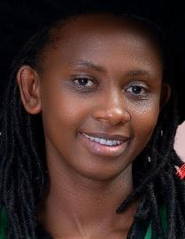

MARY NSABAGWA received a Bachelor of Science in Computer Science from Makerere University, Uganda, received a Master of Engineering in Computer Science and Technology from Hunan University, People’s Republic of China, and a PhD in Computer Science from Makerere University. She is a computer science Lecturer and researcher at Makerere University. Her research interests are in embedded systems and wireless sensor networks.

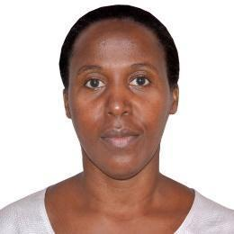
ROSELINE AKOL received a Bachelor of Science in Engineering (Electrical) from Makerere University in 1997, a Master of Science and Doctor of Philosophy in Electronic Engineering from the University of KwaZulu-Natal, South Africa, in 2002 and 2008, respectively. She has been lecturing in the Department of Electrical and Computer Engineering at the College of Engineering, Design, Art and Technology (CEDAT) of Makerere University since September 2010. Her research interests are in Coding and information theory, digital signal processing, mobile communication systems, and technologies.

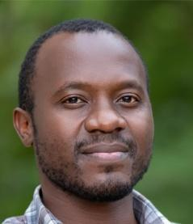
ANDREW KATUMBA received a Bachelor of Science in Engineering (Electrical) from Makerere University, an M.Sc. degree in optics and photonics from the Karlsrule Institute of Technology, Karlsrule, Germany, in 2013, and a Ph.D. degree in photonics engineering from Photonics Research Group, Ghent University-imec, Ghent, Belgium, in 2019. He is a lecturer in the Department of Electrical and Computer Engineering at Makerere University, where he also serves as the Lead for the Marconi Research and Innovation Lab (Marconi Lab). His research interests include Learning, AI4 Social Good, AI in Health, Photonics, and Neuromorphic Computing

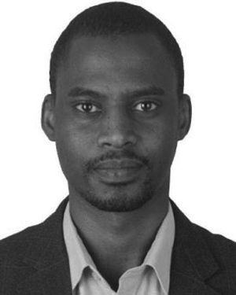
MBAZINGWA ELIREHEMA MKIRAMWENI received the Bachelor’s degree in Electronic Information Engineering and the master’s degree in Information and Telecommunication Engineering from the University of Science and Technology Beijing, Beijing, China, in 2011 and 2014, respectively. He received a Doctoral degree in Information and Technology from Xidian University. He is a lecturer with the Dar es Salaam Institute of Technology, Tanzania. His research interests include resource and interference management and network optimization for 5G networks, UAV-assisted cellular networks, and game theory for wireless communications


SSALI JOSHUA is currently pursuing his Bachelor's degree in Computer Science from Makerere University in hopes of graduating
in 2026. From 2024 to the time of publishing, he was a Research Assistant with the Admenea project under the IoT-Ra laboratory at Makerere University. He loves to be challenged, which has led him to discover new things. This precious character of his is the reason he effortlessly tackles challenges in the fields he desires, which include Embedded Systems, Robotics, and Machine Learning.

LUKAANYA GEORGE is currently pursuing a Bachelor’s degree in Software Engineering at Makerere University, with an expected graduation year of 2027. Since 2024, he has been serving as a Research Assistant on the Admenea Project under the IoT-Ra Laboratory at Makerere University.
He has a strong passion for learning and the acquisition of new knowledge across both specialized and general domains. His curiosity and enthusiasm enable him to approach complex challenges with confidence and persistence. His research and professional interests include Machine Learning, Software Development, and Embedded Systems.

We acknowledge the financial support of NORAD through the NORHED2 program under grant agreement QZA21/0159 as part of the AdEMNEA project. Agatha Turyagyenda is currently an Assistant Lecturer at the Department of Electrical and Computer Engineering, Makerere University (P.O.Box 7062, Kampala, Uganda). Andrew Katumba is a lecturer in the Department of Electrical and Computer Engineering, at Makerere University (P.O.Box 7062, Kampala, Uganda). Roseline Akol is a lecturer in the Department of Electrical and Computer Engineering at the College of Engineering, Design, Art and Technology (CEDAT) of Makerere University (P.O.Box 7062, Kampala, Uganda). Mbazingwa Elirehema Mkiramweni is a lecturer with the Dar es Salaam Institute of Technology, Tanzania (P.O.Box 7062, Kampala, Uganda). Mary Nsabagwa is a computer science Lecturer and researcher at Makerere University (P.O.Box 7062, Kampala, Uganda).

