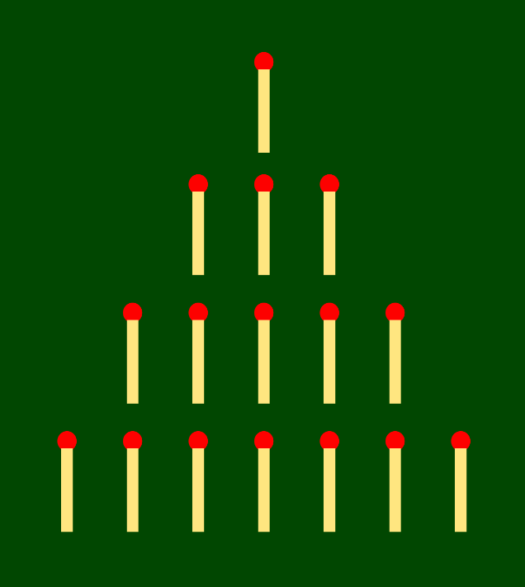

Nim Game

George Mathew Paul, Roll Number 9

Jayanth Edara, Roll Number 11

Our Own High School

# **Acknowledgements**

During completion of the project, I am highly indebted to the following people for their valuable support and suggestion, which enabled me to complete and present the project in its final form:

* I am thankful to my project partner Jayanth for his support and crucial contribution towards the project.
* I am highly indebted to my Computer Teacher, Mr. Agnelo Paul, for his extremely helpful and valuable suggestions for the improvements.
* Last, but not the least, I am extremely grateful to my parents for their support and encouragement.

Table of Contents

Acknowledgements 2

Certificate 4

Nim Game 5

History of Nim 5

How to play NIM Game: 5

Winning Strategy: Logic we used for PC Move 5

Flow Chart 6

User Manual 8

Import Libraries 8

Classes in the program: 8

Screen Shots 10

Source Code 18

NIMGAMEdisplay.PY 18

NIMGAMEsqlcon.py 22

NIMGAMEpcbrain.py 24

References 27

# **Certificate**

Roll No 9

Certified that Master Jayanth Edara

of grade 12. Section A has carried

out project work in Computer Science prescribed by the Central Board

of Secondary Education, New Delhi during the academic year 2020-2021.

.................................................

         Teacher-in-charge

Date: .........................................

.....................................                  .......................................

External Examiner                                          Internal Examiner

# **Nim Game**

The project is the design and realization of a special-purpose computer to play the game of Nim, an ancient game involving the removal of pieces from stacks. Two players alternate turns, and each turn consists of removing any number of pieces from any one stack. The person taking the last piece is the winner.

# **History of Nim**

Origins of the game are uncertain. Charles Bouton, 1901 Coined the name “Nim” for the game. Developed a complete theory of the game, including a winning strategy.

# **How to play NIM Game:**

1. NIM starts with 5 rows consisting of a maximum of 5 matchsticks.
2. Players take turns removing any number of matchsticks from one of the rows.
3. Player can choose only from one row at a time.
4. Whoever takes the last of the matchsticks wins!
5. Click MOVEOVER for PC to start

# **Winning Strategy: Logic we used for PC Move**

1. Convert the number of match stick in each row into its binary notation
2. Add the columns up independently modulo 2.
3. The resulting value is called the Nim sum
4. A winning position occurs when the Nim sum equal zero
5. A losing position occurs when the Nim sum is greater than zero
6. A player can always make a move from a losing position to a winning one.
7. Once in a winning position, the next move will always result in a losing position
8. Therefore, the optimal strategy is to always be converting losing positions to winning positions on each move.

# **Flow Chart**

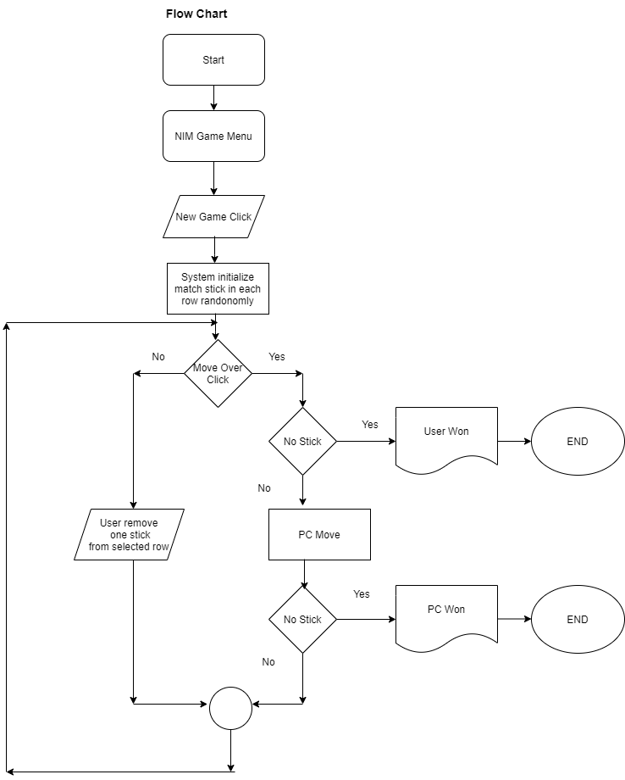

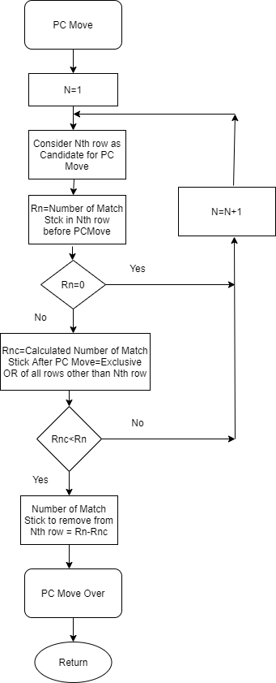

# **User Manual**

1. Download all the following documents: NIMGAMEdisplay.py, NIMGAMEpcbrain, NIMGAMEsqlcon.py, matchstickbutton.jpg, MatchStick.ico, buttonclicksound.wav.
2. Install all the following python libraires:

* MySQL connector - pip install mysql-connector-python
* PIL - pip install Pillow

# Import Libraries

|  |  |  |
| --- | --- | --- |
| SNo | Libraries | Uses |
| 1. | PIL- ImageTk, Image | Python Imaging Library adds image processing capabilities. Used to load the matchstick image. |
| 2. | Tkinter- messagebox, simpledialog, ttk | It is the standard Python interface to the Tk GUI toolkit. Tkinter used to create main game window. All tk widgets – buttons, combo box, entry, simple dialog are used for game play. |
| 5. | winsound | Adds game button clicks and victory sounds |
| 6. | mysql.connector | Connection to sql nim user table |

# Classes in the program:

1. Main ()
2. Nim ()
3. User ()

Functions in Main:

|  |  |  |
| --- | --- | --- |
| SNo | Function | Uses |
|  | Redisplay () | Constantly updates the nim window |
|  | btn_remove () | Removes the matchsticks selected by the user |
|  | newuser_click () | Inputs user’s new name |
|  | pcmove_click () | PC Moves |
|  | newgame_click () | Resets the matchsticks in the rows |
|  | stats_click () | Provides the stats of the selected user |
|  | CallbackFunc () | Shows all the existing names in combo box from the SQL table. |

Methods in Nim class:

|  |  |  |
| --- | --- | --- |
| SNo | Function | Uses |
|  | initialize() | Initialize the matchstick matrix |
|  | pcmove() | The ‘brain’ of PC in method ‘pcmove’. The pc decides the number of matchsticks to be removed in game using the bitwise XOR operation. |

Methods in User class:

|  |  |  |
| --- | --- | --- |
| SNo | Function | Uses |
|  | get_users() | Retrieves usernames to populate combobox |
|  | get_stats() | Display the stats of current user |
|  | add_user() | Adds new username to sql user table |
|  | update_game_status() | Updates stats of all users. |

|  |  |
| --- | --- |
| **fetchall()** | The fetchall method retrieves all (remaining) rows of a query result, returning them as a sequence of sequences.The **fetchall** function gets all records. |
| **append()** | The append() method in python adds a single item to the existing list. |
| **commit()** | This method sends a COMMIT statement to the MySQL server, committing the current program. |
| **close()** | Closes the opened file |
| **cursor()** | Allows Python code to execute SQL command in a database session |
| **connect()** | The connect() constructor creates a connection to the MySQL server and returns a MySQLConnection object |

SQL Functions used:

# 

# **Screen Shots**

Initial Screen

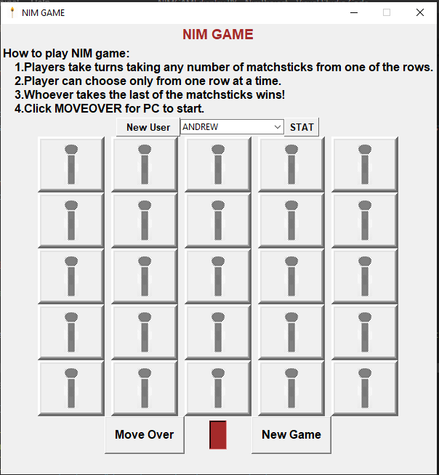

Adding new user

Click on New User Button to add new user.

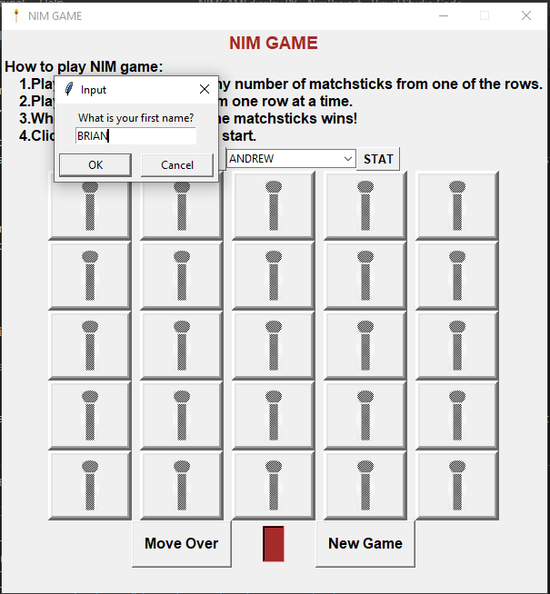

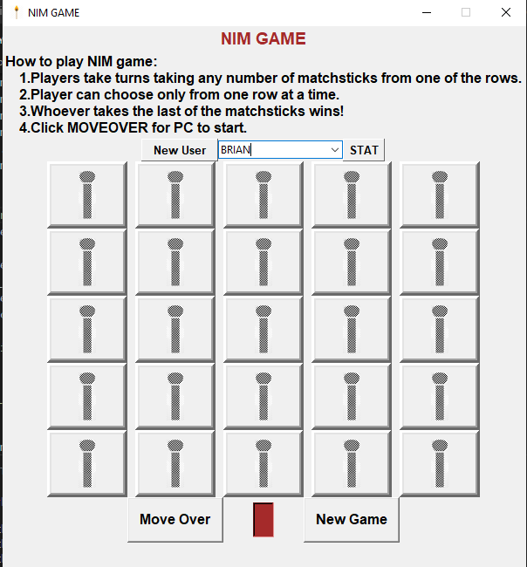

Click on New Game to start Game

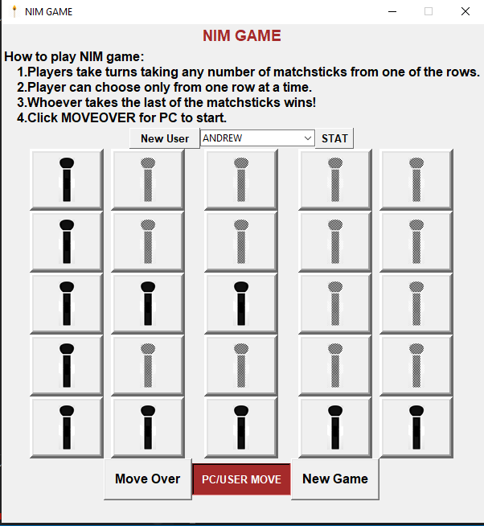

After user Move

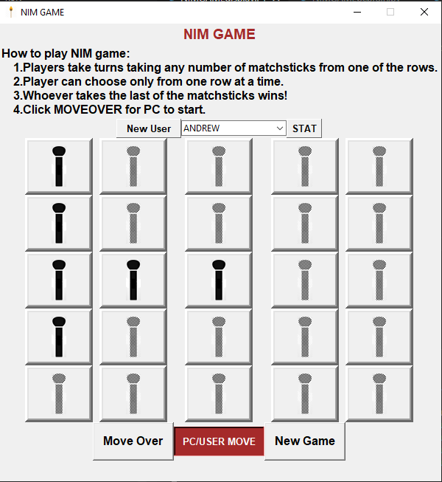

After PC Move

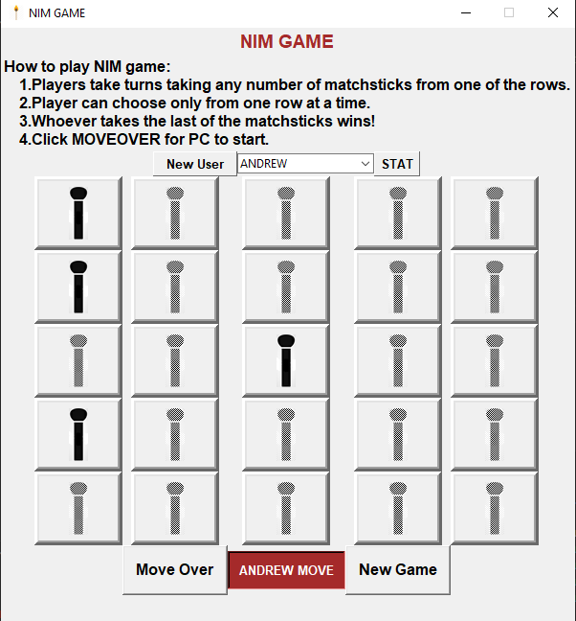

PC Won

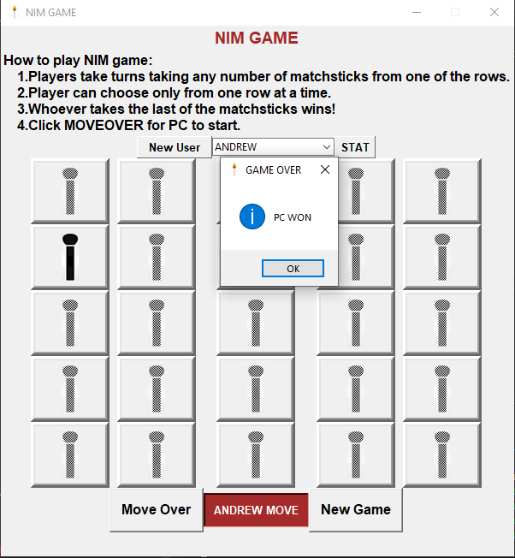

Select the user and click on Stat button to get game statistics of the selected user.

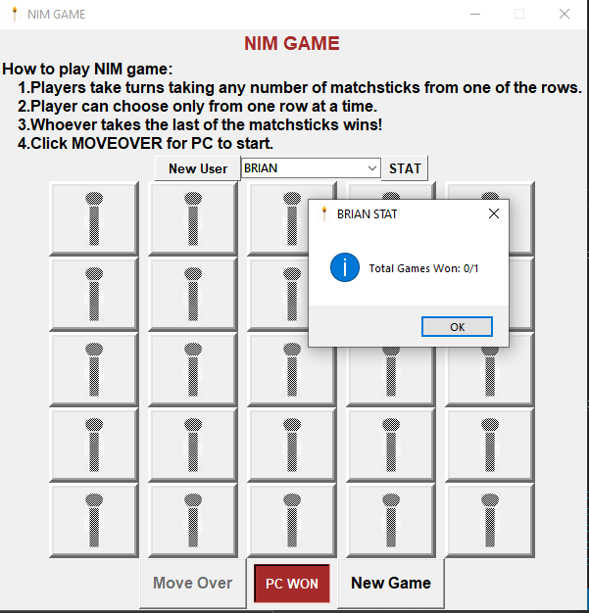

# **Source Code**

# **NIMGAMEdisplay.PY**

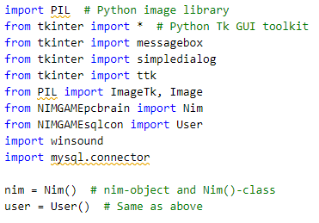

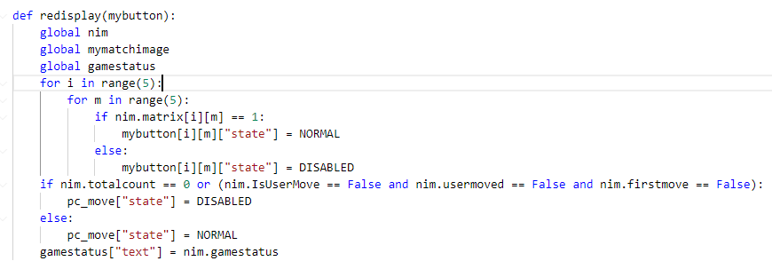

//Module used to remove stick

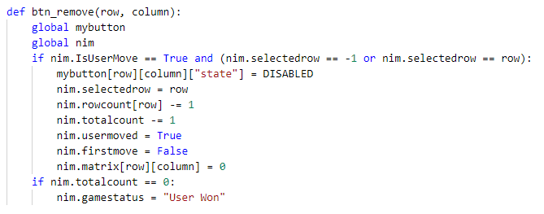

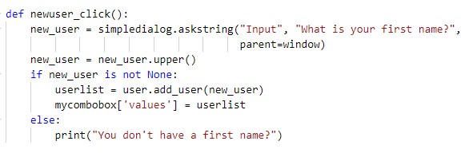

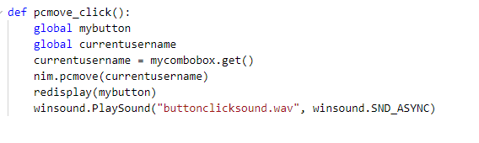

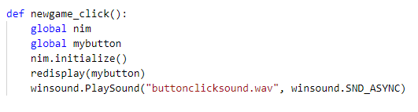

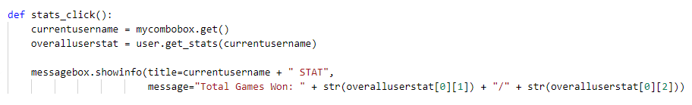

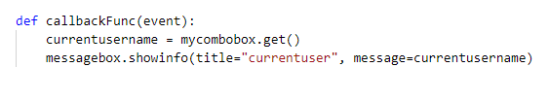

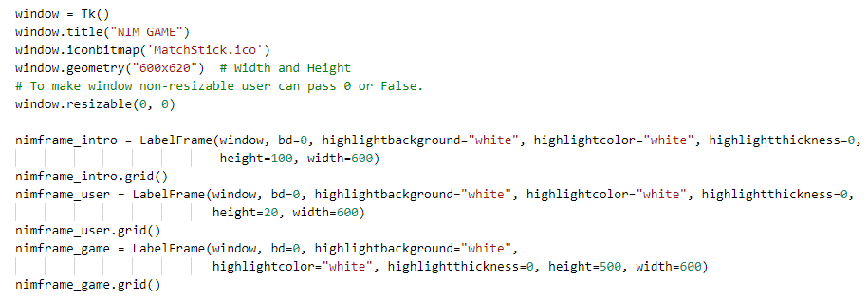

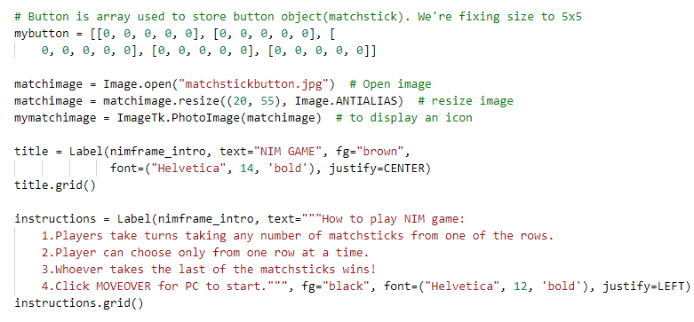

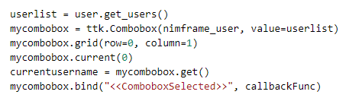

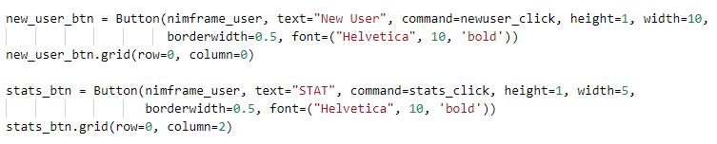

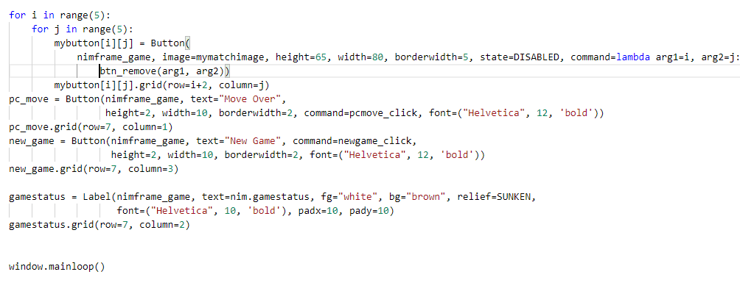

# **NIMGAMEsqlcon.py**



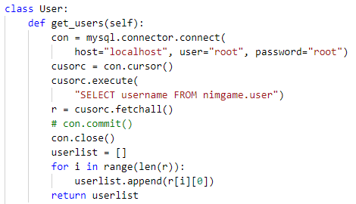

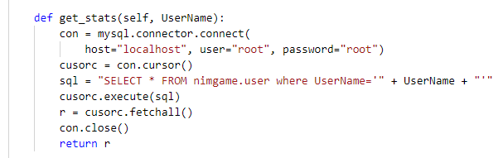

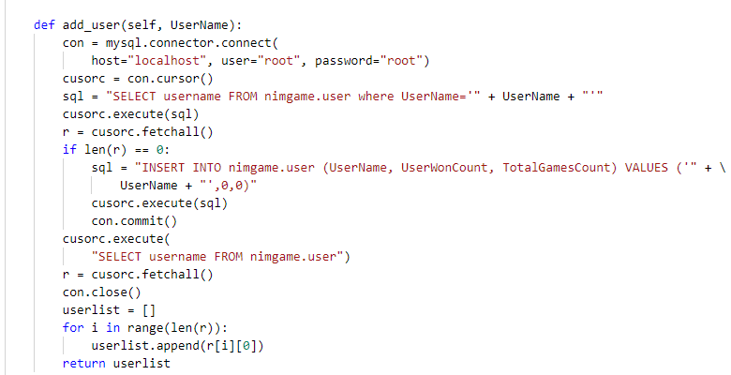

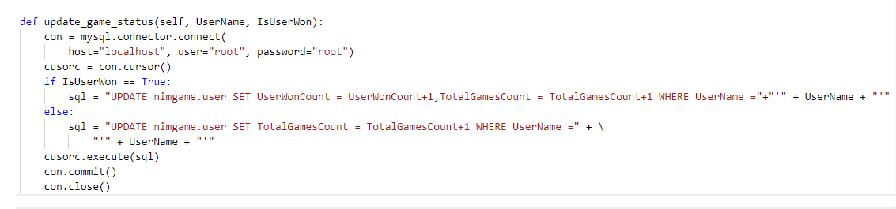

# **NIMGAMEpcbrain.py**

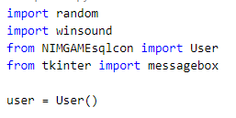

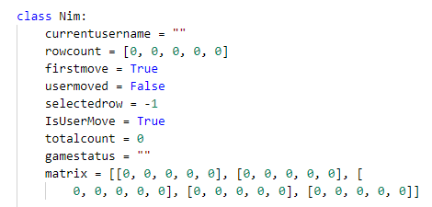

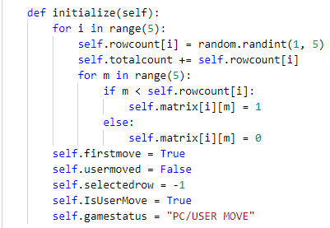

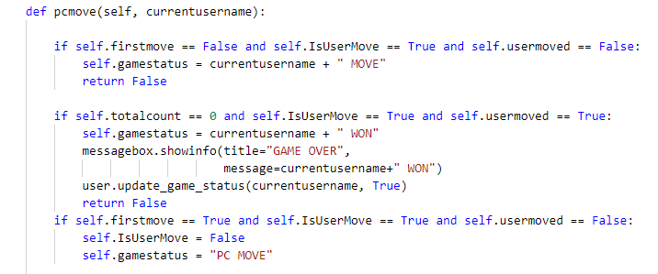

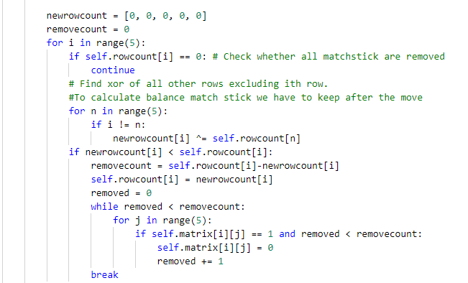

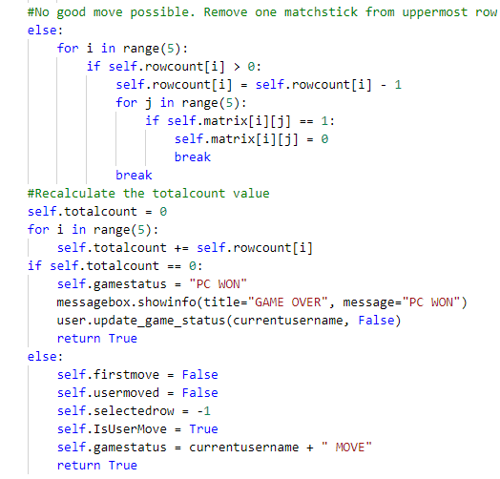

# **References**

Nim. (2020, December 08). Retrieved January 04, 2021, from <https://en.wikipedia.org/wiki/Nim>

*TkDocs Tutorial*, tkdocs.com/tutorial/index.html.

*Welcome to*. (2020, December 28). Python.Org. https://www.python.org/