Computer

System

Design

And

Build

Computer Systems

Gheorghe Mitrea

Tower Hamlets College

TH1118495

Contents

Task 1 2

1. Understand the function of computer systems 3

1.1 Explain the impact of computer systems in social and work, evaluating the role of computer system in different environment? 3

1.2 Using the diagrams I discuss about: 4

1.2.1 Computer components 4

1.2.2 Purpose of some system utilities (Defragmenter, HDD clean-up etc.) 10

1.3 Compare different types of computer systems and the suitability of usage in different environment 11

Task 2 13

2. Be able to design computer systems 13

2.1 Discuss various stages that you would follow in arriving at final specifications of recommended system including: 13

2.1.1 Software specifications: 14

2.1.2 Hardware specifications 16

2.2 Justify and evaluate your selection of Hardware/ Software to meet the requirement of the company? 19

Task 3 21

3. Be able to build and configure computer systems 21

3.1 With the aid of diagram produce the following task: 22

3.1.1 Health and safety procedures 22

3.1.2 Assemble (in step by step process) a typical computer system? (include lab work evidence) 22

3.1.3 Install (in step by step process) the operating system (including lab work evidence) 33

3.2 Produce a test report showing the process you would take to verify the installation. 37

Task 4 43

4. Routine regarding maintenance on a computer system 43

4.1 Preventive Maintenance 43

4.1.1 Company’s strategy regarding different types of backup 44

4.1.2 Automatically schedule for defragmentation process 53

4.2 What are the steps before making an improvement software or hardware to an operating system? 56

4.2.1 Security Programs 56

4.2.2 Applications that are strInformation Technologyly necessary to be installed immediately after installing the operating system 59

4.2.3 Optional software installation 59

# **Task 1**

# Understand the function of computer systems

## 1.1 Explain the impact of computer systems in social and work, evaluating the role of computer system in different environment?

#### Introduction

The most important role in influencing of contemporary life it holds today undisputed by technology, computers are the future whether we like it or not. Power of technological environment has become so obvious that all people felt the pressure of the daily existence of an integrator system. Using the technology of computer generates effects in vary domains: education, agriculture, culture, industry, commerce and global trade, low, in private sector (family life), on the environment, governance, free access to information, transportation etc.

Human society has sought ways and means that would ensure a better adaptation to major technological changes. As there are new needs, new problems and have identified new technical means of settlement, to meet the needs of life, they have created new institutions that have sought to absorb the impact of new technologies and discourage abuses that could lead the uncontrollable effects. However, application of new technologies, even when resolving current issues of production, increase welfare, improve health, gave birth sometimes unwanted side effects whose solution required and require new efforts.

On children, recent studies trying to establish worst between two equally intense fascinations: the TV screen and computer monitor. When time spent at the computer decreases the time spent watching television, the child appears to be the winner. But when it replaces computer friends, play outdoor sports, physical and mental development of the child, it may suffer. In general, computers are more efficient than humans, in areas which require a lot of calculations, because of the rapidity with performing these calculations and the precision with which it conducts. Computers are used in many sectors: governmental level, in business, medicine, education, etc.

Expanding the use of computer technology in almost all areas of life as well as in international networks connecting computers made the offense committed by means or via computer to be more diverse, more dangerous and more present internationally. An analysis of the factors generating criminal actions showed that communication networks and computer modern present specific features which are very useful for criminals and involves great difficulties for potential Information Technologies and law enforcement (complex issues of security systems, multiplicity of systems hardware and software lack of experience of many users, anonymous communication, encryption and international mobility). Groups active in organized crime, economic espionage professionals and intelligence services around the world already exploit these new features of cyber-criminal activities. Many governments, business people, many home users do not realize the danger they are exposed to these new conditions to commit crime nor the protection against cybercrime has great significance, nor are potential pathways technical and legal requirements to counter threats offenders.

###### Advantages of using the computer

Used sparingly, the computer can be our best friend. Some advantages of using computers especially by children

* learn to seek and use information using multiple sources - enrich their knowledge with information from various fields
* The computer develops concentration and attention, increase responsiveness as well as coordination.
* A shy child gives the opportunity to interact with someone without having to be afraid of rejection.
* While using the computer find a variety of educational programs presented more attractive and understandable to the baby.
* most games develop reaction speed, logical thinking, competitive spirit,
* is beneficial for every child to become familiar with the computer, which is indispensable in the future, but parents are required to supervise, allowing access within a specified timetable and explained.
* Can learn through play colours, numbers, letters, figures and geometric shapes, etc.,
* Learn to use a tool that you will use in the coming years, perhaps the future job.
* Efficiently, computer games they can develop thinking and mathematical logic.

###### DISADVANTAGES OF COMPUTER USE

The irrational use of computers has disadvantages:

* Lack of exercise leads to obesity
* Position in front of the computer can result in deformities of the spine;
* Contact with strangers, dangerous;
* Tend to accept typos; "Inventing" new rules of writing, which may confuse the spelling;
* Watching violent scenes or prohibited materials with minors;
* Building habits get everything "ready-made" (reports, papers);
* It seems that some children become less sociable;
* Computer addiction.

Researchers have shown that time spent in front of the computer by children, should not exceed one hour per day. Prolonged use of the computer may cause central nervous system disorders - insomnia, nightmares at night, restless sleep, addiction. Computer games evade him the child in an imaginary world, open only to replace the age-specific social activities successfully. If a child withdrawn deteriorates, the need for communication gradually disappearing.

“The main reason people use the internet is to communicate with other people and the principal reason why people send email messages to others is to maintain interpersonal relationships” (Hampton, 2001)

The impact of computers at work these days we are witnessing a revolution in the work place substantially by the introduction of technology, the consequence of which is that the nature of work is changing. At the human level while some workers may find that the technology makes the jobs more complex and satisfying, others may find themselves confused and suddenly incompetent.

Social impact: “Computers have changed the way people relate one to another and their living environment, as well as how humans organize their work, their communities and their time” (McIver Jr, 2003). The needs and desire of society has developed a lots of computers la supercomputers, mobile telephones, games, digital and video devices mobile computing devices, graphic processors.

**Internet**

Risks

- The emergence of deficiencies

- Affecting health

- The organization of the situation of the time

- The add Information Technologies

- Violent games they farm aggressiveness

- Accumulation of fatigue

- The adoption of an aggressive language

- The possibility of obtaining erroneous information

- Use results in excessive a sedentary lifestyle

- Dependent on the internet leads to sedentary sleep insufficient, unhealthy food at the involvement in extracurricular activities

- Removes the young people of reality

- They young people form a scale of values upside down

- There are sites for adults to which they have access

Benefits

- E-mail addresses specifically created for students in the framework of local institutions for school activities

- Encourages access to information in the activities of the school

- The existence of a library online

- The accumulation of new contacts

- Is the most modern, fast, easy and pleasant form of communication

- The source of the communication with the people you care about remote

- The existence of some sites with educational purpose of online shops

- Can be established contacts with persons with concerns similar

- Games stimulate the development of strategies to find new solutions, thinking complex, speed of reaction, power of concentration, memory and motivation of the suction device to success.

In conclusion, the computer and the Internet are a kind of "bad" cannot live without. In an information society, we need them both adults and children, which we cannot block access to internet and computer, but we can monitor and limit.

## 1.2 Using the diagrams I discuss about:

### 1.2.1 Computer components

An operating system, OS abbreviated (English operating system, in abbreviated form OS), is a product of the type of software that is part of a system, equipment or appliance computerized system and which is involved in the management and coordination of the activities of the latter. The computerized system can be a computer, a workstation (workstation), a server, a PC, a notebook, a netbook, a smartphone, a road navigation, an e-book reader or some domestic appliances, as well as the players and multimedia. The operating system plays the role of the host for applications that are running on the equipment (hardware) respectively (Silberschatz, 1998). Examples of operating systems:

* DOS
* WINDOWS
* LINUX
* UNIX
* MAC OS
* SOLARIS

The main computer hardware components:

**Motherboard**

This is the most important component located in the carcase; is also referred to as the main board (motherboard) (BARBOS, 2014). On it is applied to the following components: processor (CPU), memory, other plates necessary for the operation of the equipment inserted into special bays, called slots. Among the other plates exist: video card, sound card, modem, Network Interface Card, etc. In addition, serial and parallel ports are for connecting to peripheral devices, such as: mouse, printer, modem.

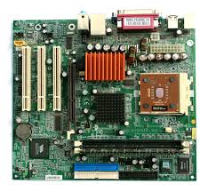

Figure Motherboard

The base plate stays in touch and with the other components of the computer which are not directly on her, buses (such as CD-ROM, HDD, floppy disk).

**Processor (CPU) -** A set of microscopic circuits which represents the CPU with the main information in a computer. The main features of the power of a CPU are:

- the amount of memory that can be read at a time

- the speed of execution of operations

- the number of different instructions can be executed

Figure 2 CPU

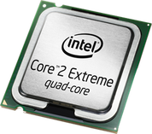

The processor or CPU (Central Processing Unit) is the brain of the computer, is the most important component in the computer (Wolf, 2012). He is processing all data. Frequency (speed) processor is measured in MHz (megahertz) or GHz (gigahertz). The higher frequency, the better, since the both the "pulsing" data are more quickly. A processor from present has up to 4 GHz (4000 MHz).

The processor architecture (form of the interior's) is 32-bit or 64-bit, (or older, 16-bit, 8 bits.) (see explanation of these bit to page). The two large companies which are manufacturing processors are Intel and AMD. Their processors are very diversified, for example, Intel has many models of processors, among which Celeron, Pentium, Core 2, Core i3, Core i7, etc. The Fastest current CPU is Core i8.

The Processor receives bit (0 and 1-s) that appear in it without respect on your hard drive or from the memory (RAM) and send it back to you on the screen or on any storage medium after it has arranged in a form the ordinate we understand. The data are taken from the hard drive or other storage media and are sent in RAM where processes them. Then sends the result on the screen through the video card, or the sound through the audio board. The processor thinks everything from the RAM, because it is approximately 10000 times faster than the hard drive in the case in which we can get hard drive into account as space of processing. Anyway, computers are not built to be able to operate without RAM.

The Processor receives instructions from the programs in memory and processes them in a quantity of million per second.

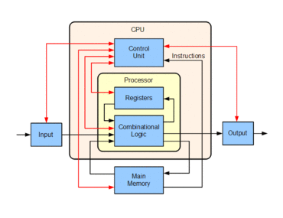

Figure Scheme of data processing

Inside of the processor are very many sectors, which each has a role. A sector for the arithmetic mean, one for decoding of instructions, one who controls the speed, one that contains the registry (the smallest possible memory from the computer), one that deals with the graphics and more recently the Northbridge.

The processors can be described by two main parameters: width and speed. The speed of the processor is measured in megahertz (MHz), so in millions of cycles per second, so as it is higher, the processor is more quickly. The width of a CPU is indicated by the three main characteristics:

* bus input and output data,
* internal registers
* address bus.

**Video card**

Is responsible for the display images on the monitor screen. It is the second component, after the processor that determines the ability of a computer.

**Sound card**

A sound card contains:

* a processor the digital signal (DSP)
* a digital converter-analogue (ADC) for audio enters the computer
* read-only memory (ROM) or Flash Memory for data storage
* interface for musical instruments digital (midi file) for the connection of external music (for most of the plates, the game port is used for connecting a MIDI adapter external)
* Jack sockets for connecting the speakers and the microphone in the same way and other inputs and outputs a game port for connecting a joystick or gamepad

**Memory**

The maximum amount of time the answer refers to the time interval that it is necessary the internal memory to read or write data. Can be found at the same time two major types of memories: ROM and RAM. The main factors which influence the performance of the internal memory of a computer is characterised by the two parameters:

* size,
* the maximum amount of time of response;

The size of this memory is in close connection with the microprocessor used (in this case with the limitations imposed by the it). A value often encountered for this size is 1 Mbyte. As it is more than the performance of the computer are better.

The maximum amount of time the answer refers to the length of time that it is necessary the internal memory to read or write data. More exactly, the time interval that flows from the moment in which receives from the microprocessor command to read and the moment at which the deposited on the data bus value read (similar is and for writing). The average value of this parameter is 70 ns.

**The ROM memory**

Memory that can only be read - is a type of non-volatile memory (the information contained in this type of memory is not lost when stopping the computer). The programs in ROM are shipped with your computer and make the so-called firmware. ROM (Read Only Memory - Memory computer only) is a memory that contains information (usually programs) irreversible repairs have previously been made on the duration of the use made of the computer. The ROM memory is written only once, usually in the manufacture of the computer. This type of memory cannot be rewritten or deleted. The main advantage which this memory brings it is the insensibility front of the electric current.

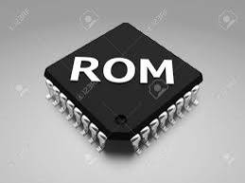

Figure ROM memory

Contents shall be kept and even when it is not supplied with power. The ROM memory is generally used to store the BIOS (Basic Input Output System) a PC. In practice, a date with the evolution of pcs this time of memory has undergone a series of changes that have as a result the rewriting/burning "Flash" by the user of the BIOS.

**RAM (Random Access Memory)**

RAM is a volatile memory (DAINTITH, 2004), which makes the information contained here may be lost when disengaging the computer from the power supply. This is memory that can be read or written at random in this way he might face access a single cell of the memory without that involve the use of other cells.

In practice it is the working memory of the PC, this is useful for temporary processing data, after which it is required that they be stocked (saved) on a support that does not directly depends on the energy supply to maintain information. In RAM is loading the operating system and programs of application.

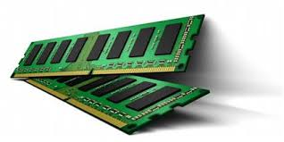

Figure RAM memory

It is a memory access speed very high current (8-10 ns). If a few years ago it was characterised after the access time (60-70 ns), now is characterized by the speed of the bus to which work with the processor (currently memory washer operating on the bus 66, 100,133 Mhz). RAM shall be classified in the SRAM (Static) and DRAM (Dynamic).

**HARD DISK (HDD)**

**Hard Disk** serves as a non-volatile memory (AM Caulfield, 2010), storage medium for documents, the files or applications of the user. It is a fixed establishment of data storage.

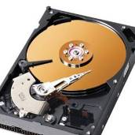

Figure Hard Disk

Depending on the connection interface hard drives are classified in:

- Hard disk drives the small computer systems interface (SCSI) - hard disk drives with great features from being connected to an SCSI interface, interface that is controlled by the intelligent systems (controllers) them with meant to coordinate the flow of information between the hard disk drive and the system. This type of storage drives are used mainly fitted on the servers or on those computers where it is desirable to a high performance concerning the transfer of data.

- Hard Disk Drives (EIDE Enhanced Integrated Drive Electronics) - general term applied to all establishments that have a controller included in the unit. Along the time the storage units of this kind have known a series of deployments among which remember the protocol Ultra ATA.

The main features of the HDD refer to:

* The capacity for the storage of information and capacity to data manipulation by the PC (PC Handling Date);
* Search Time (seek time) - is a measure expressed in milliseconds of the speed with which the hard disk can move the read-write from one location to another. The Delay produced by the rotation time is the time required for the sector you want to reach the head read/write once the head was positioned on the gang in question.
* transfer rate of the host system - is represented by the amount of data that can be transfer through the data buses of the system;
* the transfer rate of the hard disk (average rate) - is the speed at which the data are transferred to and from the dish. The usual unit of measure of this feature is the number of bits per second. The parameter that influences the rate of transfer in addition to the speed of rotation is given and the density of the data on the dish expressed either by the number of tracks / inch or by quantity of bit / inch.
* The number of revolutions per minute (RPM) -means the speed of rotation of the disc. The special feature of this parameter is that this speed is constant. As the speed is below the delays due to the positioning of the physical mechanisms are higher having a direct impact on immeasurable generated by the rotating movement and implicitly on the rate of transfer of the disc itself;
* The amount of memory cache - directly influences the performance of the hard disk, reducing the queue times.

**Optical Drives (CD/DVD-R/RW)**

The storage units of data on optical media are CD (Compact Disc) or DVD (Digital Versatile disk). They can only read (Read) data stored or they can read, write and re-write to the optical (Read Write, Re-write).

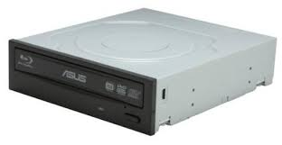

Figure CD-ROM

### 1.2.2 Purpose of some system utilities (Defragmenter, HDD clean-up etc.)

The operating system needs to be always installed on clean, i.e. on a partition that has been formatted in advance (Wilson, 2014). Performance of your operating system tends to fall in time for several reasons and because of this must be at regular intervals would fix the reparation or to re-install the system operation.

#### Defragmentation

The fragmentation of the hard disk in particular, are due to the deletion of the files and the inclusion of other new files, which normally may not occupy the space of the old files, each with memories greater or smaller. The files will become very dispersed fragmented or on the entire disc. When a program must upload a file, the charging time lasts longer because of the time of additional assembly of parts components located in different parts of the hard disc capacity. Long times for access to a file is a first sign that the file could be fragmented in that this may occur when an infestation with some viruses of the computer.

The program Disk Defragmenter has the role to reassemble the fragmented files in this way increases the loading speed of files.

The operating system involves the following:

- scanning the hard disk

- defragmentation of the hard disk

- installing and uninstalling upgrades

- setup menu Start

- delete unnecessary files

- installation of the latest versions of drivers

#### Clean-up tools

A registry cleaner is a type of program designed for cleaning the Windows registry. The Windows registry can become fragmented and cluttered over time, which can lead to performance problems. Disk Clean-up is a computer maintenance utility that is included in the Microsoft Windows operating system and it is designed to free up space on the hard drive. The clean-up process involves searching and analysing the hard drive for files that are no longer needed. Then it proceeds to remove them and thus freeing up disk space on the hard drive. We can clean various types of data like downloaded program files, temporary Internet files, offline webpages, Recycle Bin, compress old files.

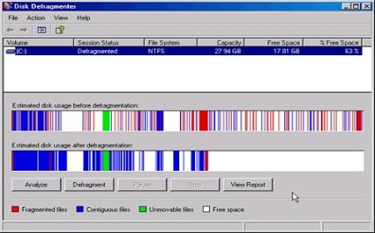

Figure Defragmentation

Other utility tools are archiving, unarchiving, scandisk, antiviruses etc..

## 1.3 Compare different types of computer systems and the suitability of usage in different environment

Criteria for classification:

- type CPU

- the quantity of internal memory on which the microprocessor can use;

- the storage capacity of the auxiliary memory;

- the peripheral speed of exit;

- The speed of processing - expressed in MIPS (Millions of Instructions Per Second);

- the number of users who may have access to the computer at the same time;

- the cost of the system.

#### Supercomputers

Typically include resources hardware or software, in the order of hundreds or thousands of processors that work in parallel. The result is a more impressive computing power (can execute over 1.8 billion operations per second), and due to the fact that he uses the technologies which are at the limit of the current possibilities, under the circumstances in which the price is not the main factor in their construction. The main applications are in the field of military, of scientific research, the airline industry and spatial. The price of a mainframe but it is so far, being expressed in general in millions of dollars. An approach most recent focuses on the use of the distributed systems (based on the network of computers) in order to obtain comparable performance, but at a price of one order of magnitude lower.

#### Mainframe

Is a type of computer also high power, but not at the same level as the supercomputers. Are used most often for the management of data bases very large-scale and other related applications which require a storage capacity of very large and a strong interaction with a large number of computer users, who organized a big volume of data communications.

#### Servers

Are computers that have the role to make available to the other systems of the various computing resources (storage capacity, computing power, information of a particular type), usually by means of a network of computers. Being intended to serve usually a large number of requests in parallel, the server must have a lot of calculation power.

#### Microcomputers (workstations, personal computers / desktop systems, laptop)

Represents the type of computer that uses a microprocessor as the central unit for processing (CPU) and which may only be used by one person at a time.

- that the stations (workstations) are designed for work individually, but are designed to run your business applications, complexity, such as: 3D graphics, processing audio and video, type applications the DAC or GIS, processing of numerical data, etc.

- desktop systems fall into the category of personal computers, which may be used for the office applications (edit the texts, spreadsheet, database size etc.) or for games. Are in principle the cheapest computers and for this reason the most accessible to the general public.

- laptop, notebook, netbook are terms which designate personal computers portable. They are based on the same principles and technologies as systems and the desktop. The difference is in equipment and emphasis on mobility. A computer is the mobile size and lightweight and can operate for a while (several hours) using batteries, without power from the mains. The main target of this category of the system are mainly the business environment, but also other zones for which the mobility is essential.

Task 2

# Be able to design computer systems

## 2.1 Discuss various stages that you would follow in arriving at final specifications of recommended system including:

* Recommended hardware specification
* Software specification
* Sample activity documentation

#### Introduction

In March 2016, the college global-art.co.uk in which I am working, has open a new small branch in the city, this project is desired to train professionals in the field of the development of a photo-video editing applications for the numerous requests coming from our customers. So I was appointed as Project Manager for this project of the college.

#### The interview

Together with the other managerial departments of the college, we discuss an annual budget as regards the department which we rule and the agreement regarding the budget for the project was to identify very good programs and very good computer with high-performance. The budget provides for the purchase of new 15 computers, which are compatible with the type of software used. We decided also a list which to identify the steps of the project:

* What type of software we use for our photo and video editing?
* Which possible computers

#### Questioners

The next step was to identify the type of software which we will use for our video editing. The school will run courses in numerous territory of representation outline, so I decided to have discussions with all 15 employees which is the most suitable software for our desire and we decided of these software specifications in video and photo editing on the market.

Photo editing

* Adobe Photoshop CC 2014
* Paint Shop Pro X7 Ultimate

Video Editing

* Adobe Premiere Pro CC (2014)
* Movie Studio 13 Platinum

### 2.1.1 Software specifications:

For photo and video editing we need a computer that meets both the hardware specifics of the application used and complexity of the program itself used. The physical components necessary for photo and video editing are the processor, RAM, HDD, graphics card.

Below are the main specifications of the software which will use for our projects:

|  |  |  |  |  |
| --- | --- | --- | --- | --- |
| **Parts** | **Adobe**  **Photoshop CC 2014** | **Paint Shop Pro X7 Ultimate** | **Movie Studio 13 Platinum** | **Adobe Premiere Pro CC (2014)** |
| **OS** | **Microsoft Windows 7 with Service Pack 1, Windows 8 or Windows 8.1** | **Windows XP (SP3)/Vista/7/8** | **Windows 7, Windows 8, Windows 8.1, or Windows 10, Windows 8 or later with a touchscreen required for touchscreen editing)** | **Microsoft Windows 7 with Service Pack 1 (64-bit) or Windows 8 (64-bit)** |
| **CPU** | **Intel Pentium 4 or AMD Athlon 64 (2GHz or faster)** | **1.5GHz with SSE2** | **2 GHz processor (multicore or multiprocessor CPU recommended for HD or stereoscopic 3D)** | **Intel Core2 Duo or AMD Phenom II processor with 64-bit support** |
| **RAM** | **2 GB of RAM ( 8 GB recommended)** | **1 GB (2 GB recommended)** | **2 GB RAM (4 GB of RAM recommended)** | **4 GB of RAM**  **(8 GB recommended)** |
| **HDD** | **2 GB of hard- disk space of installation, additional space required during installation** | **1GB (2GB recommended)** | **500 MB space for installation** | **4 GB of available hard-disk space for installation; additional free space required during installation (cannot install on removable flash storage devices).**  **Additional disk space required for preview files and other working files (10 GB recommended)**  **7200 RPM or faster hard drive (multiple fast disk drives configured for RAID 0 recommended)** |
| **Graphics card** | **OpenGL 2.0 capable system** |  | * **512 MB GPU memory** * **Supported NVIDIA (requires a CUDA-enabled GPU and driver 270.xx or later, NVIDIA recommends NVIDIA Quadro for professional applications and recommends use of the latest boards based on the Fermi architecture),** * **AMD requires an OpenCL-enabled GPU and Catalyst driver 11.7 or later with a Radeon HD 57xx or higher GPU. If using a FirePro GPU, FirePro unified driver 8.85 or later is required Intel GPU** * **Intel requires an OpenCL-enabled GPU such as HD Graphics 4000** | **NVIDIA GForce Gt 650 M or above**  **and for AMD series at least AMD FirePro M2000 or above** |
| **Optical Drive** |  |  | * **DVD-ROM drive (for installation from a DVD only)** * **Supported CD-recordable drive (for CD burning only)** * **Supported DVD-R/-RW/+R/+RW (for DVD burning only)** * **Supported BD-R/-RE drive (for Blu-ray Disc™ burning only)** |  |
| **Display** | **1024x768 (1280x800 recommended) with 16 bit colour and 512 MB of VRAM ( 1GB recommended )** |  | **1280x1080 display** | **1280 x 800 display** |
| **Other requirements** | **Internet connection and registration are necessary for required software activation, validation of subscription and access to online services** |  | * **Microsoft .NET Framework 4.0 SP1 (included on application disc)** * **Apple® QuickTime® 7.1.6 or later for reading and writing QuickTime files** * **Internet Connection (for Gracenote MusicID Service)** * **IEEE-1394DV card (for DV capture and print-to-tape)** * **USB 2.0 connection (for importing from AVCHD, XDCAM EX, NXCAM, or DVD camcorders)** * **You must provide your registration information to Sony Creative Software Inc., a US company, in order to activate the software. Product requires online registration.** | **Sound card compatible with ASIO protocol or Microsoft Windows Driver Model**  **QuickTime 7.6.6 software required for QuickTime features**  **Optional: Adobe-certified GPU card with at least 1 GB of VRAM for GPU-accelerated performance**  **Internet connection and registration are necessary for required software activation, validation of subscriptions, and access to online services.** |

### 2.1.2 Hardware specifications

Once we recognized the software we need, the next stage of the decision-making process is searching for information and identification of alternatives of a computer system to match the application requirements we chose.

A consumer which was triggered the interest, will be tempted to search for additional information. Thus, the effort of documentation depends on the consumer, but and the degree of accessibility to additional information, so the element of maximum importance is the sources of information to which will focus the consumer and the influence that will have each of them on the decision to purchase. The sources of information are:

- personal sources (family, friends, neighbours, knowledge);

- commercial sources (advertising, personal selling, distributors, packaging, exhibitions);

- public sources (mass-media, consumer organizations);

- the sources of direct experimental (exam, the use of the product).

The number and the power of influence of these sources of information varies depending on type of the products and the personal traits of the buyer. In general, the customer receives the greater part of the information relating to a product from commercial sources. The most effective information comes from personal sources. Commercial ones are intended to inform the personal perform the functions of identification and assessment. By collecting the information, the consumer becomes aware of competing brands side toward their characteristics. In the case of the product presented, the most important factors of decision product functionality and the price and also the variety of products available on the market.

The basic needs of video can join and trim our shots, include add effects and motions, and import sound and video. What's more, preferably we need this to be done with no slack or obstruction from the PC.

So I will compare some similar computers in accordance with the following criteria:

- CPU

- RAM

- HDD

- Video card

|  |  |  |  |
| --- | --- | --- | --- |
| **Parts** | **Chillblast Fusion Drone** | **Lenovo ThinkStation D30 Workstation** | **Scan 3XS Z170 Performance GTK6** |
| **Operating system** | **Windows 10 Home 64 bits** | * **Windows 8 Pro** * **Windows 7 Professional 32/64** * **Windows 7 Ultimate 64** | **Windows 10** |
| **CPU** | **Quad-core 3.7GHz AMD Athlon X4 860K** | **Intel Xeon E5** | **Quad-core 3.5GHz up to 4GHz, Intel Core i5-6600K (Overclocked)** |
| **RAM** | **8GB RAM** | **16GB RAM (2GB x 8 1333MHz DDR3 DIMM)** | **8GB RAM** |
| **HDD** | **1TB hybrid hard disk** | * **7200 rpm HDD** * **SSD HDD / up to 1280GB** * **Hybrid SATA / up to 12TB** | **256GB SSD, 1TB hard disk** |
| **Video card** | **2GB AMD Radeon R7 370** | **NVIDIA 5000 Graphics Card**  **Up to two NVIDIA Quadro 6000 adapters** | **4GB Nvidia GeForce GTX 970** |
| **Lowest Price** | **500 £** | **1.384 £** | **1.000 £** |

##### Chillblast Fusion Drone

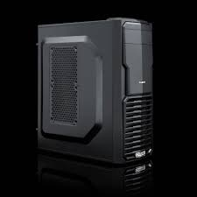

**Pros:**

* Low price.
* Corsair liquid cooling.
* Quad core CPU.
* 1TB of SSHD storage.
* Quiet operation.
* Micro-ATX chassis.

**Cons:**

* AMD Athlon X4 has limited power.
* Severely restrInformation Technologyed upgrade path

##### **Lenovo ThinkStation D30**

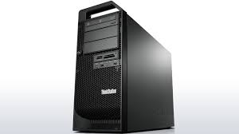

**Pros:**

* It's an intense, expandable, proficient level workstation that users will use to make advanced media like vivified motion pInformation Technologyures, investigate for gas and oil, or make outlines for substantial things such as scaffolds and air ship
* Lots of expansion space and internal connectors
* Dual eight-core Xeon processors with Hyper-Threading. Nvidia Quadro graphics
* 1,120-Watt power supply.

##### **Scan 3XS Z170 Performance GTK6**

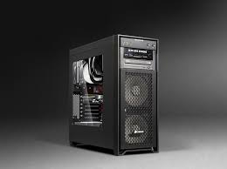

Pros:

* Has a powerful processor
* High-quality HDD
* Multiple connectors

Cons:

* Compared to Lenovo ThinkStation D30 the video card is lower performance
* Cooling performance not so good

After examining some types of computers from different firms producing, we have identified three models that were in my attention. These models were after a careful study and lengthy of the characteristics of each computer model by comparing them on both positive and negative, we decided that the Lenovo ThinkStation D30 Workstationmeets the needs of being impressed in principle by the speed with which process the information, fidelity graphics and the storage capacity of the information.

## 2.2 Justify and evaluate your selection of Hardware/ Software to meet the requirement of the company?

#### 2.2.1 Justify: Intel or AMD platform?

Intel dominates the market in the segment of the processors for computers, but this domination is all the more obvious in the case of components for video editing.

PC processers, working frameworks, and equipment are turning out to be more equipped for managing the requirements for video editors, and now and again even surpass the execution of Macs.

So what it truly comes down to is close to home inclination. On the off chance that you are more agreeable and sure utilizing a Mac, then stay with it. However, don't make a special effort spending additional cash on a Mac on the off chance that you are pretty much as substance utilizing a PC. There is no right choice on picking one stage over the other, however in the event that you ask certain individuals which is better, they might don't think so.

#### 2.2.2 Evaluate the specifications of the hardware of a computer in photo and video editing

CPU– This is the most essential part of the PC with regards to speed and execution. It has advanced in the previous decade from a single processor Intel Pentium to the current multi-processor Intel i3, i5 and i7 models. For video altering purposes, we will need to purchase an i5 or i7 processor (quad-processor) as we will see the distinction on the off chance that we get anything lower. Particularly when you are in the rendering phase of altering, having a quick processor will make your life a ton less demanding.

Memory RAM –this permits the PC to run various assignments in the meantime. The more memory of our framework has, the more altering we can manage without backing the PC off. For individuals just surfing the web and watch recordings, 2GB or 4GB of RAM will generally be enough, however video altering requires more than that. We will require no less than at least 4GB, however 8GB is suggested or even 16GB would be incredible if our financial plan can permit it.

Hard Drive – If we are purchasing a pre-fabricated PC, the standard hard drive size is for the most part around 500GB. We will need to update it or purchase a different hard drive since Hi-Def recordings take up a huge measure of space. One hour of HDV video will take up no less than 13GB of our hard drive, and more up to date superior quality will require considerably more. We ought to have no less than a 2TB inside hard drive. What's more, to the extent speed is concerned, we try to search for a 7200RPM drive. It may not be a tremendous distinction contrasted with 5400 RPM, but rather it will make certain errands quicker and these days there isn't an enormous value distinction between the two velocities.

Video Card – Although it's not the most essential segment in our video altering framework, it can make things smoother, particularly in the event that you are doing 3D moves and other embellishments. It will take a percentage of the heap off the RAM and it will be an update from the standard motherboard video chip. A decent video card can likewise make our review process run speedier. We don't have to spend a great deal of cash on a decent video card however, as those are more for gamers. I would suggest getting a NVIDIA and ATI video card with no less than 512MB of memory.

While processor, memory, and GPU all quicken nearby video preparing, working proficiently with various documents and higher resolutions additionally requires effectively moving the video outlines from and to records on plate. Particularly on the off chance that you tend to composite numerous layers in your courses of events, your hard drive not just needs the ability to store the majority of your unique, altered, and transitional clasps, additionally requires the data transfer capacity to at the same time convey the edges from every one of the documents for continuous playback. Furthermore, again video resolutions will assist push the hard drive necessities

Task 3

# **Be able to build and configure computer systems**

#### Introduction

The centrepiece of most computers is the motherboard. It is the cornerstone of the physical and logical of the entire system. The circuitry on the motherboard defines the computer, its capabilities, their limitations and the personality of the latter. Almost all personal computers compatible builds on a common thing, namely that are integrated on a single circuit board that the Foundation. This big plate has printed on it the most important components that define the system: the microprocessor, Circuit support and memory. We add to this the different components of the system input/output through the various elements of the connection unit. Most of the producers, for example, Apple, Commodore or Tandy, they found out that is more economical construction products with a single large base plate, which the producers to add different types of sockets (slots) for which they can link the additional circuits to add the computer's performance. This idea has been used for the first time by IBM, which building the first personal computer (PC), was used the same media ensuring that will be the basis of almost all of the computers by the Office. The role of the motherboard in a system of calculation the base plate represents the centre of communications by which all other components which make up the broadcast information between them. Each part from the CPU, is connected to the motherboard in one way or another. Another primary function of the base plate is to supply the power electrical components that go in close connection with the system, namely the processor, the graphics card, the RAM, etc.; may meet the case where a code to receive electric power and from the motherboard and directly from the main source of the computer. This having regard the explanation that although the motherboard may normally ensure the energy requirement of all the components attached to them, there may be cases in which a component may be built as not to go to standard parameters only with the energy provided by the motherboard. This is encountered in particular to the cooling systems fans(s) because the computer must not operate these components, they can be connected directly from the source to avoid over loading the motherboard.

The integrated circuit is an electronic device consisting of the interconnection of several components passive and active on a plate of semiconductor material (e.g. silicon carbide), which is in most cases is introduced into a sealed from the environment and packed with elements of the connection (terminals). The first integrated circuit occurred in 1959. The framework of integrated circuits shall enter certain components that make a precise and clearly defined with other structures consisting of a system of encoding (binary system), which is mentioned or structured by different electrical pulses and apparently their intensity. Order of magnitude of these individual notes of calculation must be limited to the structures of particularly small, that occur or are to be carried out by the time intervals are analogous (of the order of nanosecond). It is noted so, in the framework of a system of when driving on a device (computer, any other kind of structure, the mechanism of the driving) appear microstructures flying at a given moment in the interdependence to form a coherent whole, a finished product.

## With the aid of diagram produce the following task:

* Health and safety procedures
* Assemble (in step by step process) a typical computer system? (include lab work evidence)
* Install (in step by step process) the operating system? (include lab work evidence)

### 3.1.1 Health and safety procedures

Before start assembling a PC, we must have a view of certain aspects of health and safety. Electrostatic discharge can cause numerous problems within a system. To protect us and our PC from electrostatic discharge, we need to take additional precautionary measures like:

* + If the equipment is supplied via a power cable, we remove the plug from the wall socket before the opening of the unit.
  + We use an antistatic mat together with an antistatic wrist strap.
  + Pay attention to sharp parts of the PC and take as much time as is needed.
  + Store PC components in antistatic containers.
  + Take care to do not force parts into spaces where it doesn't fit since that implies it shouldn't go there.
  + Handle our PC segments by their edges as it were
  + Abstain from assembling our PC in zones of high static, for example, covered territories. On the off chance that you can, attempt to abstain from wearing garments, for instance, those made of synthetics as they might make static.
  + Some tools that we need for assembly are: flat nose screwdriver, Phillips screwdriver, tubular screwdriver, brush, tweezers, Pliers wire, stripping pliers, crimping pliers
  + Check if the software is from a trusted company.
  + Hold the CD\DVD by edges, don't get them filthy or get fingerprints on them which could obstruct the execution or even stop them from working.
  + Not to have any fluids/food in or around the PC
  + Ensure there is data Backups of our PC records and information

### 3.1.2 Assemble (in step by step process) a typical computer system? (include lab work evidence)

#### Preparation of the computer case and the motherboard

Preparing the computer case and allows static electricity discharge accumulated in our body. This can affect components that you can manipulate and disrupt or spoil. Static electricity can be discharged if his hands reach some of the computer case that is not painted, for example, the metallic structure supporting computer components. One way used by professionals is the use of anti-static bracelets. This is a bracelet that we bear in hand when we walk in the computer, and they connect a wire to the casing.

The computer case is formed of a metal support structure (on which the fixed components of the computer) that is coated with two side panels, a top panel and a front panel ("front" of the computer). All panels are removable, usually being fixed with metal screws or plastic elements. The side panels and higher are usually metal and plastic front panel. Certain enclosures side panels and top panel forming a whole, so it handles together.

     We begin by disassembling the side panels. These are attached with several bolts to the rear of the metal support structure. After unscrewing draw on all panels and they slide backwards until the moment they leave the track and so that is can be removed. No need to remove the top and front panels, but we can do if we consider it necessary.

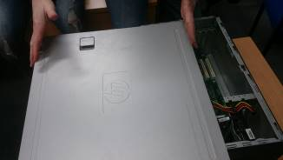

Figure Disassembling the side panels during the lab

**The motherboard** connects all system components. It decides how much memory you can install and how many additional boards and hard drives can be mounted.

Is enough for most tasks to have a PCI express slot for a video card, but hard-core gamers or those who use multiple monitors need two, three or even four slots for video cards. DDR3 memory type is supported for all new boards and a memory frequency of 1333 MHz for is a starting point. More means better but more expensive. It is recommended to target motherboards have several USB 3.0 ports and SATA3 (6Gb / s), as the latest generation connectivity with peripherals or hard drives.

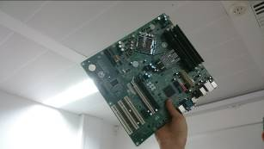

Figure dispatched the motherboard during the laboratory

#### Components of the motherboard

In the diagram below we have an example of how is built a motherboard and how are structured all the elements of the motherboard:

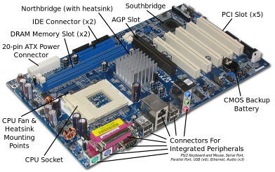

Figure The structure of a motherboard

* The slot to processor - is the slot place where it is introduced the processor
* slots for RAM - are the slots where they are entered the pads of RAM
* PCI slots (Peripheral Component Interconnect) - are the slots where they are introduced peripheral cards on the platform PCI (e.g.: the audio board, Network Interface Card, etc.)
* the Slot AGP (Accelerated Graphics Port) - was the old slot is dedicated to the video card(s). Is No Longer the factory motherboards with AGP slot.
* PCI Express Slots - Slots where they have entered the peripherals on the platform PCI Express, such as the video card(s).
* SATA connectors (Serial AT Attachment) - Are the connectors for devices with the SATA cable (e.g.: hard disk, DVD-ROM, etc.)
* Connectors IDE (or stain) (Integrated Drive Electronics / Parallel AT Attachment)- Are the connectors for devices with the IDE cable (e.g. hard disk, CD/DVD-ROM, floppy, etc.)
* USB ports (Universal Serial Bus) - are the slots for USB devices at the
* Ports of PS/2 - are the sockets for keyboard and mouse
* Parallel port - is the port for connecting devices to the socket for parallel. (e.g.: printer)
* Connector to the power supply unit - Is the connector where it is introduced into the power source
* The power connector 12v processor - is a special plug the power for the processor
* BIOS Chip - is the chip that contains the BIOS
* Battery for the CMOS jumper (better said the battery for a specific section of the Southbridge chip and is CMOS technology, of course) - Is the battery that supplies power to the CMOS that can keep the settings when the computer is turned off.
* The chip and the video port integrated - Integrated video (not all motherboards have integrated video boards)
* Chip sockets and the audio board integrated - The integrated audio
* Chip and the Ethernet port integrated network - the integrated network card the
* Northbridge part
* Southbridge part

#### Fitting the processor

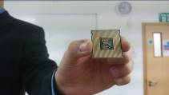

Figure The processor

The motherboard is the main printed circuit board and contains the buses (Bus), or electrical pathways, found in a system of calculation. These buses allow the circulation of data between the various components that comprise a computer. The motherboard is also known as the system board, the backplane, motherboard, or the main board.

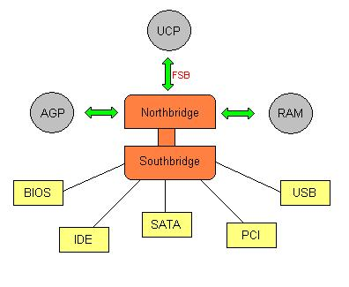

Figure : Architecture and the communication of the chipset computer

The processor is presented as a plate on top is body processor, and at the bottom are metal contacts (called pins - "needles") who will contact after mounting the motherboard. The processor should be secured in a place called "socket". Processor socket has on one side a metal arm. Its role is to enable fixing CPU socket pins and then catch it.

We take processor in hand and pressed it gently into the socket so that specially marked corner (is blunt or is marked with a small arrow) of plate processor to be positioned exactly right arm hinge metal. The processor cannot be fixed in the socket than the correct position, if we incorrectly positioned its pins will not enter fully into the holes. The processor socket is fully stabilized after the cap metal arm descend to the horizontal and fix it to its original position.

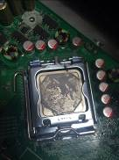

Figure The processor after mounted in his socket

#### Cooler mounting (radiator+ fan)

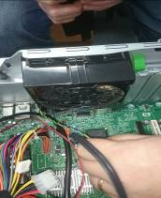

Figure : mounting the ventilator and the fan during the lab

New computing systems are designed so that an overheated close automatically to prevent damage to components. Some processors have built-in mechanisms to reduce speed or even stopping an overheated. Cooling the entire computer system is achieved by using fans (Fan). They pull cool air into the chassis and remove warm air from it, the more efficient airflow to cool internal components.

Cooling components can also be achieved by attaching radiator (heat sink) to them. We heatsink over the processor. They absorb heat from the components that are attached and eliminates having a large area. The radiator works on thermal energy transfer and is made of metal (copper or aluminium) quickly removes heat. The thermal conductive material, a larger surface means better cooling.

The fan is secured using the screws on the top of the radiator. To make the fan work it shall be supplied with electric current and this shall be done using a small bead finished with plastic. This must be secured in a wall socket with three-track connector located on the base plate in the vicinity of the processor socket.

#### Fitting the motherboard in the case

After we installed the processor and heat sink we can secure the motherboard to the frame with screws.

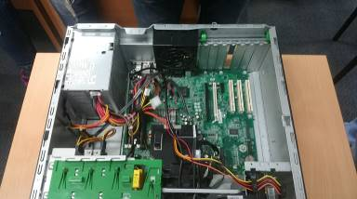

Figure : fixing the motherboard in the computer case

Through motherboard power supply is achieved plates installed PCI and AGP slots. The electricity supply to the motherboard is performed using a cable that comes from the power supply. At the end of this cable is a connector that should fix it by pressing (after I correctly oriented) ATX socket on the motherboard. This is usually white and has two rows of holes in parallel. Source out of many cables, and each has at its end a connector that matches the one kind of outlet. ATX socket on the motherboard connector is unique and, therefore, entering into it is easy to spot.

#### Connect to the motherboard of the buttons on the front panel

On the housing front panel buttons are starting and resetting the computer, along with status LED that indicates activity separate. These devices (among others) connects to the motherboard through some thin threads at the end of which lies some black plastic connectors that have two or more holes. The motherboard has one or two connectors with pins (needles) that must enter into holes’ connectors at the ends of the wires.

     These devices (sockets) on the motherboard stands out easily because there are some lines long and thin plastic exiting some needle. Each device contains several plug sockets placed side by side lengthwise and against each function of motherboard is written on them. For example, outlet besides that reads HD-LED diode is to show us a separate state activity. Besides outlet that writes PW-ON is to be fixed wire connector that comes with the button on / off the computer. Besides that, says SPK socket is to be secured in wire connector coming from the speaker housing, at which we detect any problems with the startup. Besides outlet to write RST is to be fastened in wire connector that comes from the computer reset button.

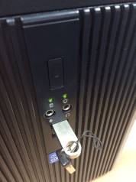

Figure : front panel and buttons, USB

#### Mounting memory cards

It is suitable for mounting cards memory after we installed the motherboard into the case. If we get used to proceeding in this way, then it will be very easy to install new RAM cards (when we decided to increase the amount of system memory) without disassembling the carcass.

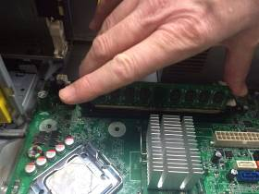

Figure : mounting the memory cards

DDR or SDRAM memory modules show like thin flakes. The slots in which fits the memory modules are characterized by the fact that at the side sections have two devices from the plastics ("clamps'), which allow the highly reliable memory modules in the slots. These clips can be pressed up and down.

#### Fitting hard disk (HDD), floppy disk and optical devices

Behind the front panel of the casing are separate places of restraint, floppy drive and CD-ROM. These places are stacked vertically and are of two types: some wider (CD-ROM) named places ("bays") of 5.25 inches and more narrow (for hard disk and floppy disk) called recesses 3, 5 inches. Usually, slots have guides that help us properly introduce computer components, and that also support these components because they do not fall until we change them with screws.

#### Floppy disk

First storage medium magnetic, which evolved the spectacular time from sizes of 8 inch at the current 3.5 inch. It is a technology outdated but is no longer in use by certain areas of IT where the use of calculation and older operating systems.

#### Mounting the hard disk

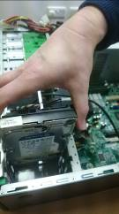

Figure : Mount the hard disk

HDD connects to the motherboard via an IDE cable. It has three connectors, one each at each end and one in the middle of the cable. Certain cable connector that secures the motherboard has a special locking mechanism so as not to dislodge cable accidentally. IDE connectors must be oriented correctly or will not enter the IDE sockets for component or the motherboard.

#### Mounting the CD-ROM

It is recommended to place the CD-ROM as above (but not in the last place) so as to have good ventilation in its upper part, which typically heats most. The CD-ROM must be inserted into the bay from outside to inside the housing.

When you install the CD-ROM, we have two possibilities. The CD-ROM can operate in slave mode ("Slave") of the ATA separate but can also operate under the Master, Secondary ("Secondary Master").

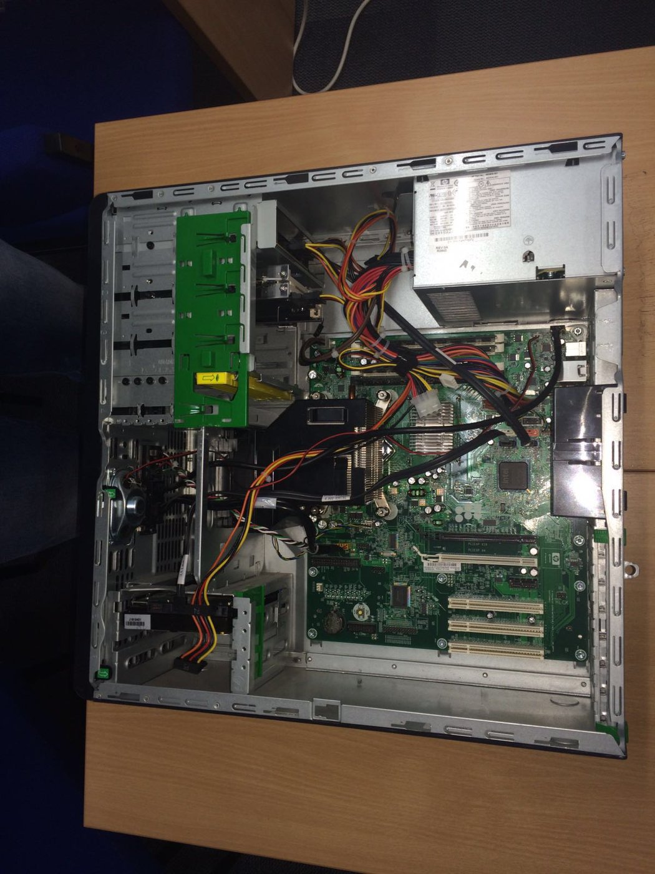

Figure : mounting the CD-ROM

The CD-ROM DRIVE more must be connected to the motherboard and with an audio cable supplied with the unit. It shall be composed of two wires and engage to the mains called "Analog Audio" on the CD-ROM drive and CD 1 on the motherboard.

#### Fitting the Video Card

The video card is installed in the PCI Express or AGP slot. Keep video card with both hands, with gold-plated connectors edge down and the metal edge to the rear of the casing.

Some very powerful graphics cards need to be able to operate at maximum performance, with an additional power electricity outside that provided by the motherboard. It will be necessary to connect one of the cables coming out of the power supply to the appropriate socket existing video card.

#### Mounting the network card

To be able to connect to a network, a computer needs a network card Network Interface Card (NIC). The network card shall be mounted in a PCI slot. A good position is the last PCI slot.

Network Interface Cards can be integrated on the motherboard or can be attached to it by expansion ports, or can be connected to the computer via the USB ports respectively with PC cards (in the case of laptops).

#### Mounting the soundcard

In order to produce sounds, the computing system needs a component which to produce, this being the sound card. These are often integrated on the motherboard or can be connected to it by expansion ports, offering outputs and audio inputs. Regardless of the type plate, all convert the digital signal to analogue, transforming the sound in a format heard of man. The quality of the sound of this depends on the audio board and the installed program controlling it.

The number of inputs and outputs are different, but there are three connectors on which we can find at each of the board shall be: line out, the line in and microphone.

From simple and up to the professional (5.1 or 7.1), all the plates have audio displayed symbols to identify the different ports, which are coded colours.

In the case where the motherboard does not have built a sound card, but neither can we connect one to the base plate so that it does not have the proper ports, we can attach an audio board via the USB port.

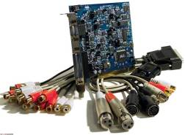

Figure : mounting the soundcard

#### Closing the computer case

We lay the two side panels of the housing and fix them with screws. We cannot fix the screw in the left pane (if we look at the front of the case) to be able to open it more easily if problems occur at start up.

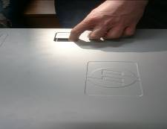

Figure : closing the computer house

Connect the power cord to the plug on the casing housing that is near the power supply fan. The cable must then be connected to the socket on the wall. It is recommended that you plug this cable directly between the wall and not through a triple plug. It is also recommended not to connect the power cord from the wall outlet only after I finished connecting peripheral devices and monitor.

#### Connecting the monitor and peripherals

The monitor has two cables at the rear. One is the connecting cable from the video card. It has at its pin connector that must enter into the appropriate socket on PV. The connector must be oriented correctly; otherwise it will not enter the outlet. Gently push the connector until we see the pins went completely plug holes. Then fix PV connector using its two screws. Second cable monitor power cable is electrically, and he usually enter directly into the AC outlet (220 V) on the wall, thus having at its end a conventional plug. There are situations where this second cable is not connected to the wall outlet, but from an outlet on the back of the computer case in this situation at its cable having a special connector.

#### Connecting the Keyboard and Mouse

Keyboard and mouse connect usually some type plugs PS / 2 located on the motherboard. These outlets must be visible through two holes in the housing. If they are not yet visible means that the holes are covered with sheet metal. We take a screwdriver and push aside the question sheet, which must be detached easily. Although the two connectors (keyboard and mouse) are identical, each should be pushed into the special jack on motherboard. Usually the chassis beside the two holes PS/2 are two small printed drawings showing where to insert the connector where the mouse and keyboard. If you have a mouse or a USB keyboard to be connected to these USB plugs (whatever) on the motherboard. Outlets PS/2 are round, and USB plugs are rectangular. Connector PS/2 has some pins to be correctly oriented thin or they will not enter the outlet PS/2 on motherboard.

#### Checking the operation of a computer system

The instruction book provided by the manufacturer of components but also the website of the manufacturer should be consulted before assembly of the computer system. Visual inspection will be achieved based on these sources.

Assembling a computer system must be done with great attention to detail. Because the components are manufactured by numerous manufacturers, despite standardization incompatibilities may exist, but there is also the possibility that different generations of components to be inconsistent although they are from the same manufacturer.

Because of this visual check of correct connection is very important. Strange position of a component can mean incorrect connection will cause problems. Also check both internal and external components. Incorrect connections and fixations can cause vibration (power supply, fans, drives), excessive heat (processor, graphics card) or data transfer errors (processor, memory, drives). Improperly connected cables can damage the whole system component and therefore will check both the current and the data. Remedy mistakes, errors in this stage may prevent further damage and costs.

Having all the components connected properly we can turn on the computer system.

Computer motherboard contains a special chip called CMOS containing a special program called BIOS (Basic Input / Output System). At start up (boot) your computer, it launches a test of components called POST (Power On Self-Test). If parts are damaged or not connected properly, they are detected at this stage, and the computing system will indicate this by issuing audible signals (beeps) and possibly visual. The signals vary depending on the manufacturer to identify their correct motherboard see the documentation. If POST does not detect errors of calculation means that the system works.

BIOS can be accessed during POST pressing a key or combination of keys, depending on the manufacturer. Once obtained the program can check data relating to the operation of the computer system, can change some settings and can set access rights to system BIOS respectively.

### 3.1.3 Install (in step by step process) the operating system (including lab work evidence)

First, to boot from external media (CD, DVD, USB memory or Hard Disk) we will need to connect the storage device to the computer, and if we use a CD or a DVD, we insert the disc into the CD / DVD-ROM. Next turn off the computer, turn it on and before they appear on screen logo existing operating system repeatedly press the F12 key. Stop only when the screen displays a list of all devices that can perform computer booting.

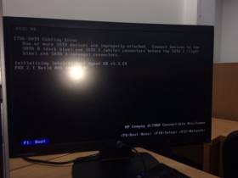

Figure : perform computer booting

#### Installation environment

If instead the list will start the operating system or motherboard of the PC does not have the option of selecting the boot device without accessing the BIOS or this possibility has been disabled in the BIOS. Finally, if the list does not appear, and the operating system starts to load, completes booting and shut down the computer.

#### Installing the operating system

The operating system is the only software that can be considered essential because he "inspires" the computer and makes it capable of operating in accordance with user needs. The role of the operating system in a computer is to ensure a stable and efficient operation of all components, whether hardware or software. The operating system manages computer resources and acts as an interface between the hardware (processor, video card, etc.) and software (word, internet explorer, games, etc.) to them help to work optimally.

After turning on the computer to the installation media, we might see on the screen a text that invites us to press any key to use it. We do this; then we expect to display the first dialog of the wizard to install Operating system

In the first dialog window, you will need to indicate the assistant installation of the language in which you want to install the operating system, the country in which we are as well as the arrangement of the keyboard used:

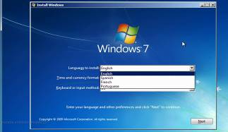

Figure : Choose the language, the country and the keyboard style

To the next step, click the **Install now** in order to be able to continue with installation. Before we continue, the assistant will bring us to the knowledge of the license terms the Windows 7 operating system, terms which we will have to accept to be able to perform the installation to:

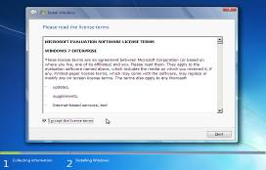

Figure : the license terms of Operating system

After accepting the license terms, to the type of installation, we choose Custom (advanced):

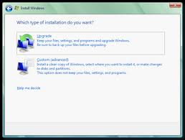

Figure : Type of installation of Windows

#### Installing Operating system: creating partitions

If we install Operating system on a new hard drive in the window "Where do you Want to install Windows", we should see something like the example below:

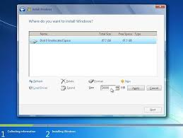

Figure : Creating partitions

In the case where we want to install Windows 7 on the whole the Hard Drive in a single partition, we click the Next button. Otherwise, i.e. in the situation in which we want to create the partitions manually, we choose Drive Options (Advanced), to create a new table of partitions.

#### Continuing the installation of Operating system

Henceforth, until we see the window where you will be asked to enter our username and password to unlock the computer, watching without intervening. During installation, the computer will stop and restart automatically.

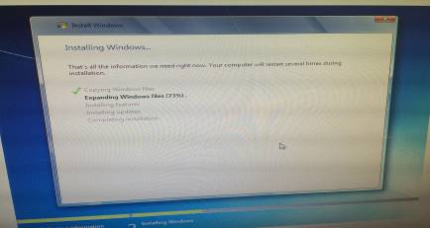

Figure : Copying, expanding and installing the system operating

After this we will be invited to create our user account and password:

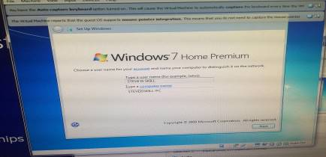

Figure : create user account and password

The next step is to insert the Windows product key:

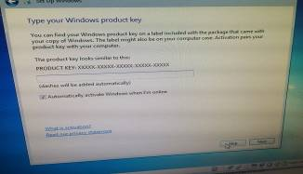

Figure : Validate the product

Then set up the time:

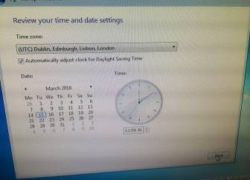

Figure : Set up the time

After this we specify the network location:

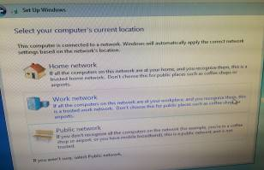

Figure : specify the network location

Next step is to complete the installation of the Windows:

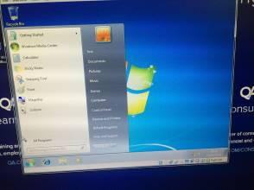

Figure : Finalizing the installation of Windows

## Produce a test report showing the process you would take to verify the installation.

For checking installation of the operating system, I will use ***Computer Management*** tool to check if all the drivers are correctly installed. To see the performance of computer I will use ***Resource Monitor***.

I will look for ***Computer Management*** and then open the utility:

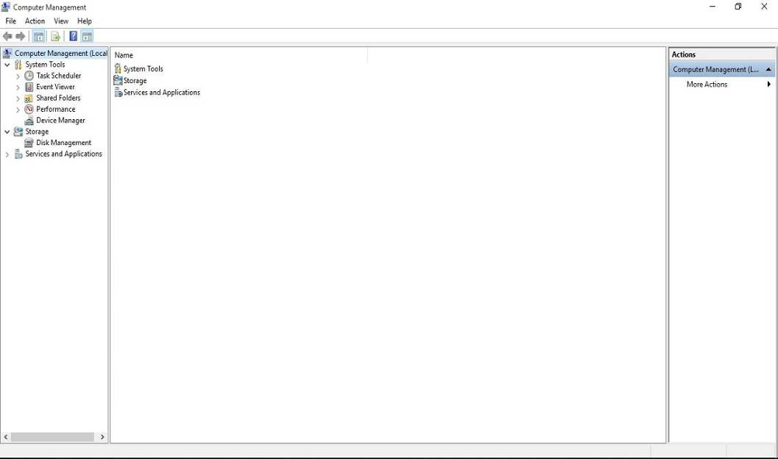

Figure Open the Computer Management

Empowers clients access to framework devices and into more particular administration of their PC. As can be found in the above photo, the fundamental Computer Management has entry to zones inside of Windows. Zones incorporate Event Viewer, Shared Folders, Local Users and Groups, Performance Logs and Alerts, Device Manager, Removable Storage, Disk Management, Indexing Service, and different ranges.

To check if the installation of the Windows, regarding the drivers, I will look in the Device Manager to see if is any error for my computer hardware and software drivers.

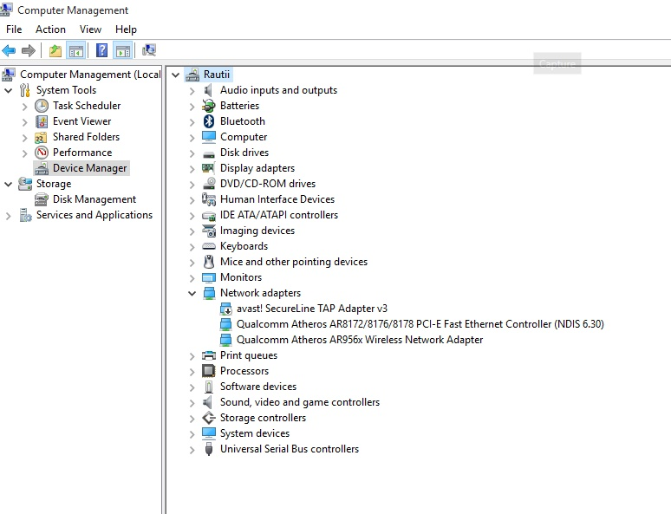

Figure 35 Open Device Manager to see any error of my operating system's system installation

If is not any error regarding the installation of the drivers, then I can go forward with the view of the performance. For this I will use Resource Monitor.

Resource Monitor is a tool that lets our monitor, our computer activity and help us to control the programs, services and processes that are ongoing. View and details about the work of the network, our computer performance and the number of users who are connected at a given moment.

To open the Windows Resource Monitor is to click left on the left menu in the Computer Management and then click on the Resource Monitor:

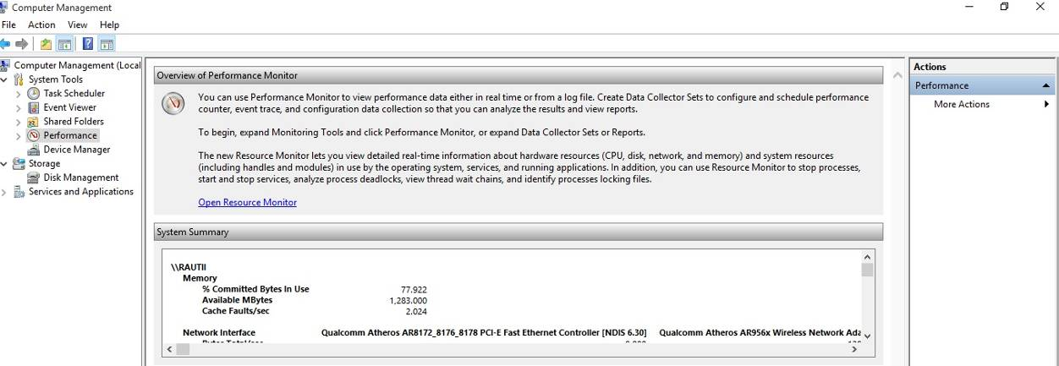

Figure Open Resource Monitor to see the performance of the computer

Next steps are to view all the aspects of the computer performance. The first task is the ***Overview task*** to see all the processes of my computer at that time, here I can manage what applications I want to close and also it shows me the percentages of usage for CPU, Memory, Disk and Network:

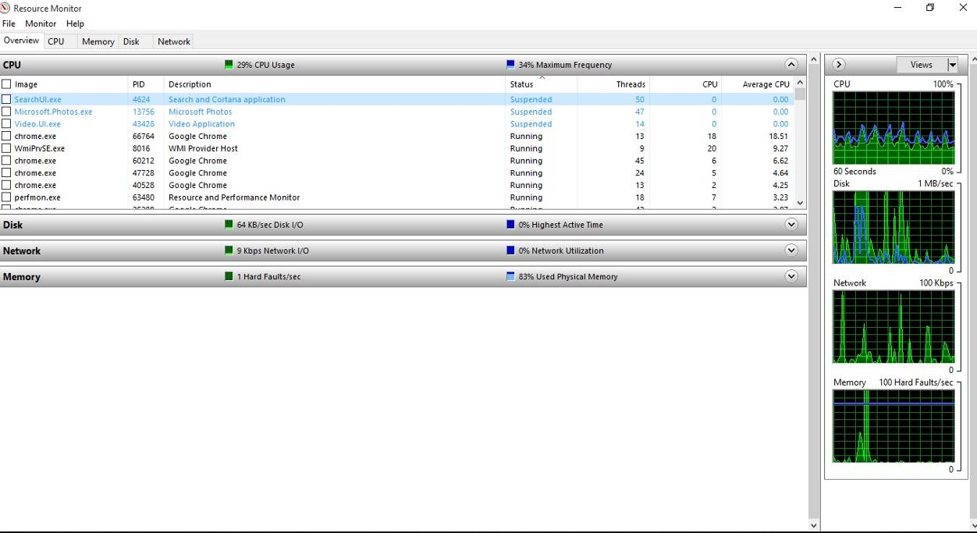

Figure Look at the overview of the performance of the computer

In the above image I can see easily that the Hard Disk is running slow, otherwise the other performances’ computer is looking good.

I will continue with the performance of the CPU and I see the computer has four processors, a good speed of the CPU of 0.78 GHz with more than 219 processes. This result shows me that is a good performance of CPU:

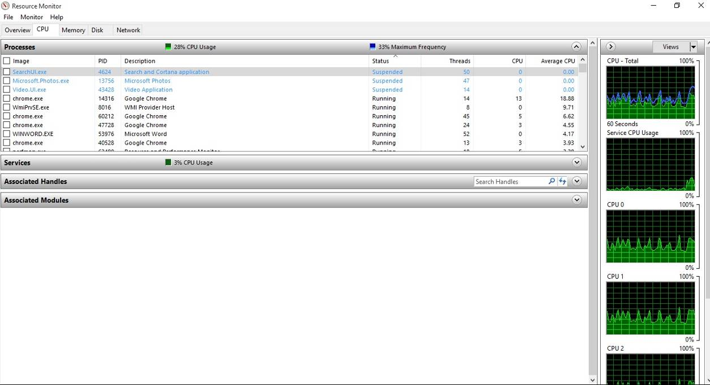

After this task I will pass to the next one which is the **performance of Memory**:

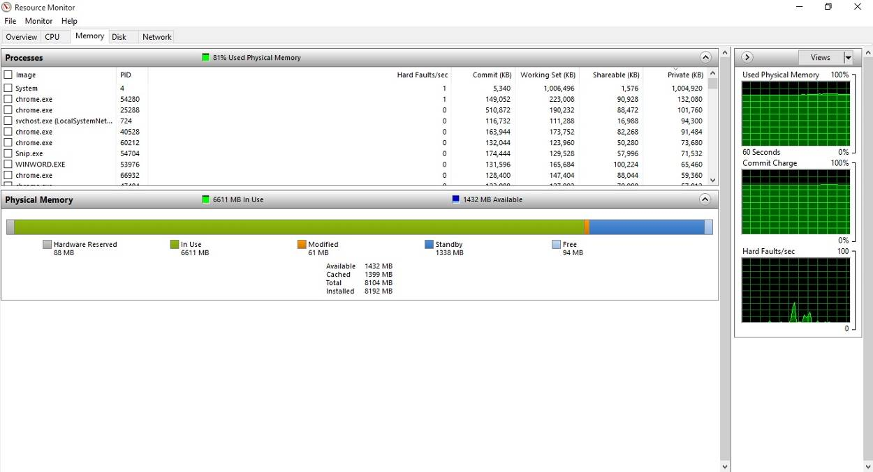

Figure Performance of my RAM

From the pInformation Technologyure above I see a huge usage of RAM, with 6.7 GB out of 8 GB RAM but for a lots of applications which are using enough memory. I can say that is a good memory for my computer.

The next step is to check the **performance of the Hard Disk** and for this I will go to **Disk Task** of the Resource Monitorto see how is working the hard disk:

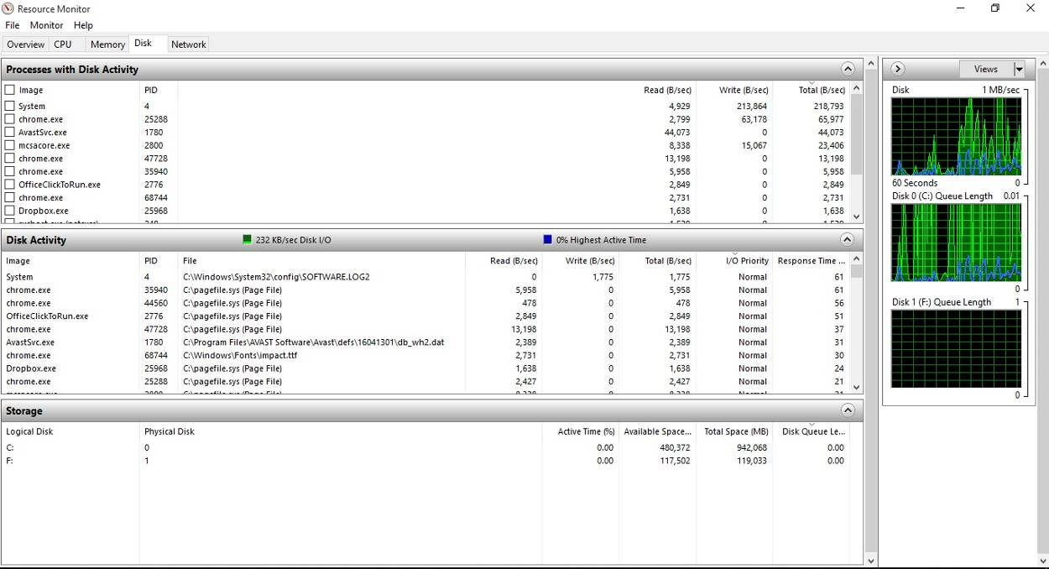

Figure Performance of the Hard Disk

As I can see from the previous image the Hard Dis is the problem of my computer’s performance. This image explain well that I need to add a SDD Hard Disk for a good performance of the computer, with a faster reading and writing of Hard Disk.

The last test of performance tasks is to go to the **Network** tab of the Resource Monitor to see how is working the Ethernet Network Card, the Local Area Connection and the Wi-Fi also. In the Network tab I can see also what background applications are using the Internet.

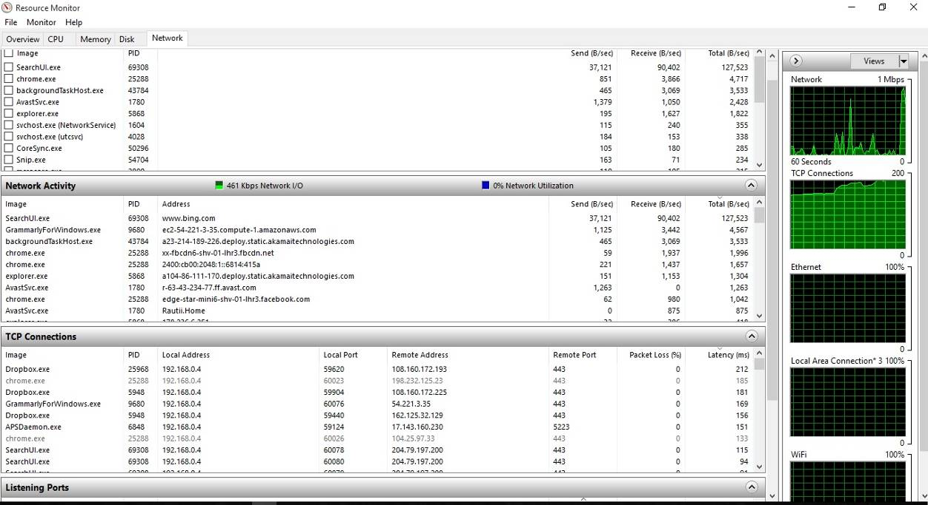

Figure Network activity

Task 4

# Routine regarding maintenance on a computer system

## 4.1 Preventive Maintenance

Preventive Maintenance is the key to obtaining a correct, for the duration of the computer; a preventive maintenance program administered correctly reduces problems, data loss, failures of components and ensure the system for an extended period of life (Chen, 2003).

There are two types of maintenance procedures preventative: Active and passive safety.

***Active maintenance*** involves in the particular regular cleaning of the system and its components, the anointing main components, relocate the components of the motherboard and put the connectors in their sockets, reformatting the hard disk and performing regular backups.

***Passive maintenance*** involves the system protection for the environment (for example, by use of the devices with protection), providing an environment clean and covered with a controlled temperatures and to avoid excessive vibration.

Example of a list of the *weekly maintenance* of the disc:

* Back-up data and important files
* Delete all temporary files, such as: files with the extension .tmp, files with the Extension .chk, the history of the Web browser and a temporary Internet files
* Empty the Recycle Bin
* At the end, run the defragmentation utility.

Example of monthly maintenance procedures:

* Create a restore point at the launching of the operating system;
* Search and install updated drivers for video controllers, sound cards, modems and other equipment;
* Search and install updated versions of the operating system;
* Search and install updated versions of the antivirus software;
* Clean the system, including the monitor screen, keyboard, CD/DVD drives, units of flexible disc, the mouse.
* Verify if all the fans in the system working correctly, including pc fans the processor heat sink, on the power supply and any fan on the chassis.

### 4.1.1 Company’s strategy regarding different types of backup

Backup is the most important function in the maintenance of a system. Refers to the carrying out of the backup of data in the event of malfunctions. The Backup is a tool least used for that the achievement of the backup is an operation burning off time and during the archival data in the backup, the system cannot be used.

It is recommended that this Backup to be kept on an external storage device (floppy disk, CD, magnetic tape), or on a different networked computer, respectively on the server to the network. When we do not have enough space available, may be called upon to store on the internet important data using the Clouds services or using the space provided free of charge by the services hosting websites (webmaster, 2012).

After launching the application Recovery (Backup creates the backup, restore refers to the system restore by reading the backup.

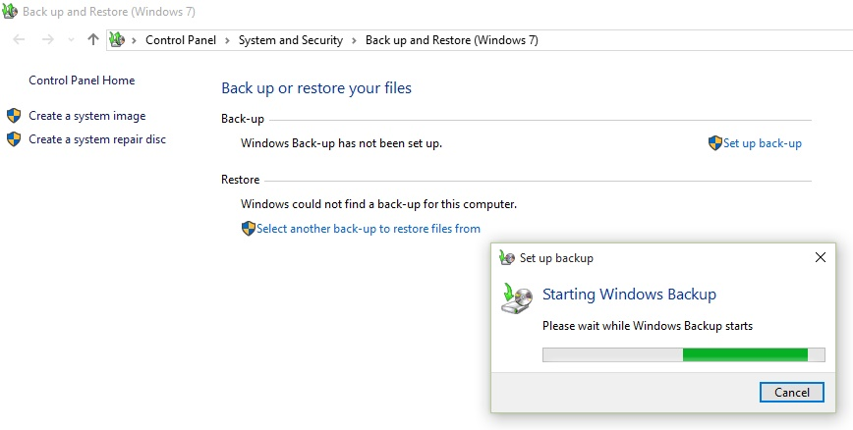

Figure Create a Backup

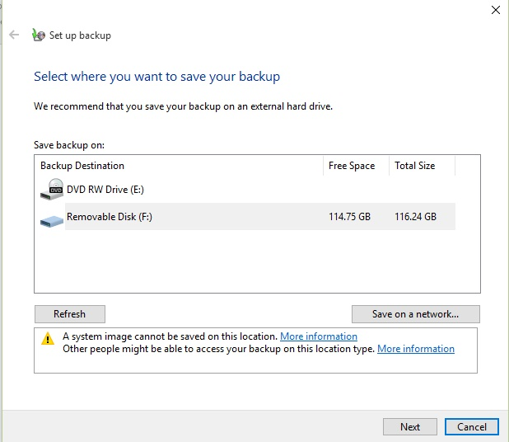

Figure Chose the location where to save the our Backup

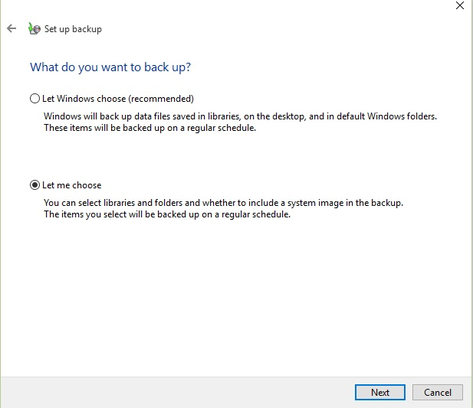

Figure What do I want to backup

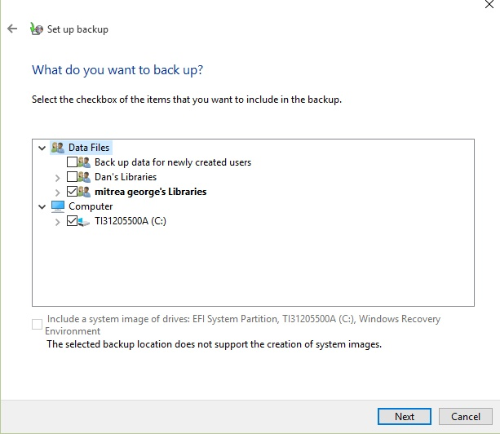

Figure choose the applications, documents or folders I want to backup

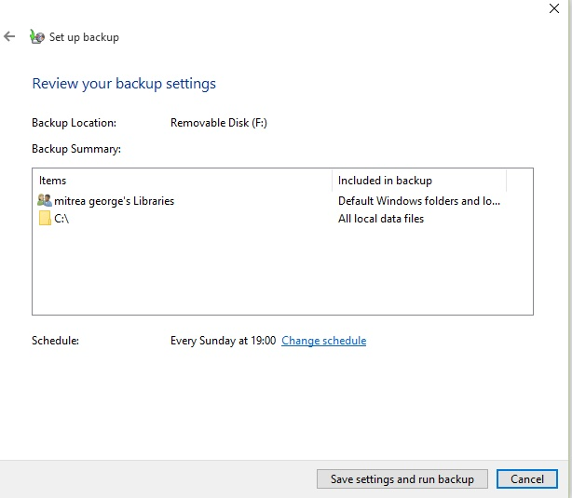

Figure Confirm the settings of the Backup and run it

The user will be asked to specify:

* The type of activity: backup or restore
* What type of data to save (documents, settings, pInformation Technologyures and movies, contacts, folders)
* What to save themselves from the existing files (tick the relevant boxes)
* The environment where will be the backup (floppy disk, magnetic tape or file on the hard disk for subsequent copying on another environment, e.g. CD, location in the network). Will be mentioned the name of the file and in the extension will be .bkf

After completing settings, last screen wizard will contain the summary of options made by the user, for the purpose of verification and the ability to define advanced backup types (by clicking the "Advanced"). Running the backup is done by pressing the button "Finish". The backup operation is completed, and the system returns an information window (the date, the time the copy was created, during its creation, size).

To make a Restore Point on the file backup I will select the location where are backups and extract the data structure saved. The system returns an information window (a driver that was launched restore operation, the total size of data transferred during operation)

:

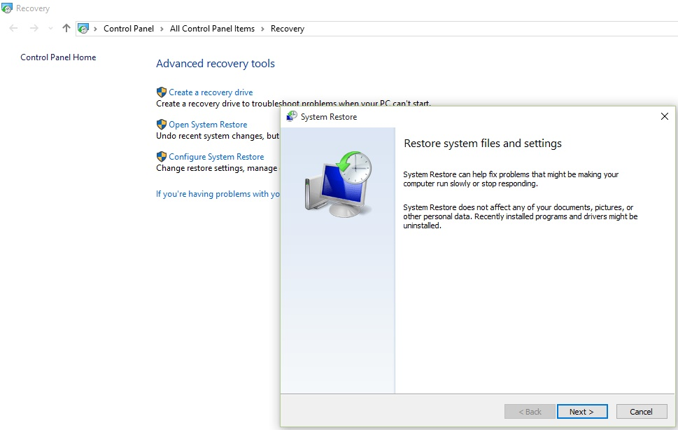

Figure Open System Restore for a Restore Point

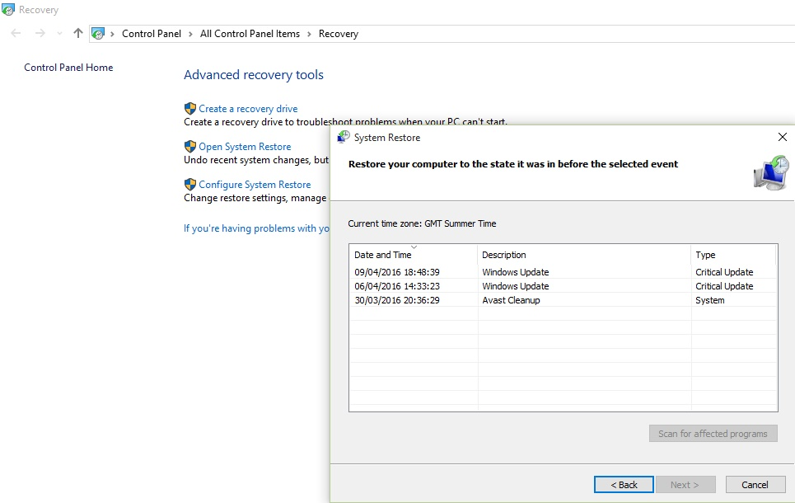

Figure Chose the Restore Point wanted

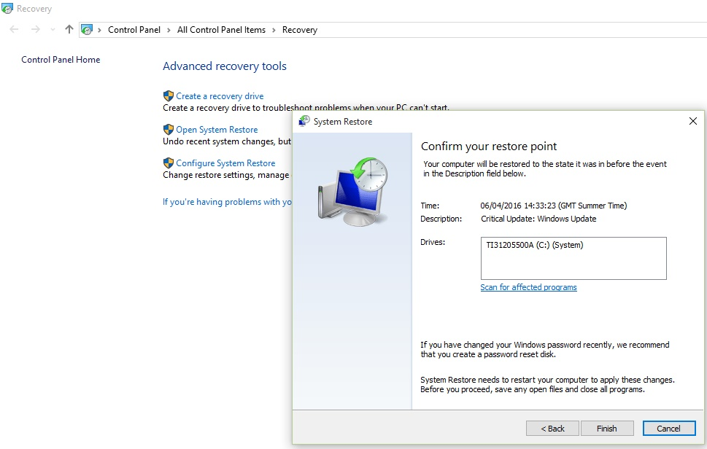

Figure Confirm the Restore Point choose

I can create restore points, which reflects the image data on the computer at a time. If the data is lost, it can restore the system from one of automatic or user-created without losing documents that have been modified and saved in the meantime. It just loses unsaved data until that time. Backups and restore points should always be done before major changes in the system, such as updates, upgrades, installing and uninstalling software that interacts with the operating system.

There are more types of Backup which can help our company to secure our data from our computers systems:

#### Complete Backup

The Complete Backup is starting point for all other types of backup and contains all the files and folders that have all been selected to be saved. Since retaining complete backup all files and directories, with the complete data backups, data recovery time will be much shorter. When I choose another type of copy, I remember that the restoration time may be longer.

It would be ideal always to run full backups of our company data because they are the most complete. Because of the time required for execution, often avoid using full copy type. Complete Backups are often limited to a weekly or automatic monthly performance, although media storage capabilities and speeds are increasing, making it a tempting idea executions complete copy every evening.

Complete backup offered the best solution for data protection and given that you can schedule automatic backup execution; it requires only small interventions compared to the benefits you have. A single backup can restore all the saved data.

However, we must be aware of security risks: each complete copy of all the data. If the data storage media will be hacked, stolen or lost, the backup can reach the hands of unauthorized persons. For this reason, when we decide to use a backup program to complete, make sure that it supports data encryption to protect them.

Benefits:

* Restoring the fastest
* All data are saved in one file (optimal management of files)

Disadvantages:

* Copy time is longer compared to other types of copy.
* The space required in the target is higher (compared to incremental copy type or copy differential). Given the low price for storage devices, this is one minor drawback.

#### Incremental Backup

Incremental Backup or additional Backup copies all files changed since the last full backup, differential or incremental. The advantage is that the incremental copy runs fastest. The downside is the time to restore because each version is processed, it leads to a longer process of restoring.

Incremental backup provides a method for copying data faster than performing repeated full backups. One copy only modified files are included Incremental Backup after the latest. Hence the name: each backup is a copy of a previous increment.

The time required for backup execution can be much shorter than the time required to complete the copy execution. The advantage of the short copy is, however, a downside: longer time to restore files. Restore Incremental copy; we need the latest copy of full and incremental copies of all executed after complete copy.

For example, suppose we put a full copy Friday, and Monday, Tuesday, and Wednesday have run Incremental Backup. If we need to restore backed up Thursday morning, we'll need all four backups: Friday full backup and backup of Monday, Tuesday, and Wednesday. By comparison, if we had made a copy Differential Monday, Tuesday, and Wednesday, Thursday morning to restore files we need only Complete Backup and Differential Backup, Wednesday.

Advantages Incremental Backup:

* It is the fastest way to copy only the files modified since choose
* Save storage space compared to other types
* Each incremental backup can keep a different version of a file/ directory

The disadvantages of this kind of backup:

* Full recovery takes longer compatible with other types of backup (we need firstly complete the backup for all versions and incremental copy after it)
* To restore the latest version of a file, you must first copy the version found it contains.

#### Image Backup

The Image Backup is identical to the Complete Backup, except that the files are not compressed zip archive and cannot be protected with a password. A copy of the image is most commonly used to create an exact version of the data. Has the advantage of backup files can be opened using various tools such as Windows Explorer.

A backup image is an exact copy of selected files and folders at a time. The Image Backup is the fastest since the destination copy files and folders without compression. The speed ​​of execution has drawbacks: require an ample storage space and cannot be protected by a password.

While other types of pack copy all files and directories into a single source compressed file, an image copy all files stored in a separate destination. Thus, the destination becomes an "image" of the source.

Benefits:

* Fastest backup type, especially if used together with "Fast Image."
* Destination creates an image of the selected files and folders, which we can browse and retrieve it later

Disadvantages:

* It requires more storage space than any backup
* We cannot protect our files with a password
* Doesn’t keep previous versions of files

#### Differential Backup

Differential Backup copies all data changed since the last Complete Backup. Copy differential advantage is the short time compared to restoring a full or incremental copy. If you run too often, Differential Backup can increase the overall size to be larger than the Complete Backup.

Although there is a significant difference, sometimes confuses the backup and the incremental differential. An Incremental Backup includes all files changed since the last Complete Backup, Differential or Incremental but Differential Backup provides a middle ground solution that includes all files changed since the last full copy. Hence the name: Copies all the differences since the last full copy.

Restoring Differential Backup is a faster process than the Incremental Backup is needed because only two executions of copies: the last Full Backup and Differential Backup.

Benefits:

* Restoration is faster than restoring from incremental backup
* Backup execution is faster than the full copy
* Of storage space required is less than the full copy

Disadvantages:

* Restoration is slower than the full copy
* Backup execution is slower than incremental backup
* The storage space required is greater than the incremental backup.

#### *As a recommendation for our company, even if The Complete Backup offers the best protection it is good to have a strategy for saving data, where Complete Backup is performed weekly, and faster types of copying (such as Incremental Backup) are executed daily.*

### Automatically schedule for defragmentation process

*What does defragmentation?*

The process by which the operating system optimizes the layout of files on your hard drive so they can be accessed more quickly by operating system.

*Windows will work better if we defragment your hard drive?*

Definitely yes but we should not expect spectacular performance. However, the difference will be noticeable when working on PC. The files will open quicker, apps as copying files will be faster.

*How often we should defragment our hard drive?*

It is helpful to defragment at least two times per month. If we download as many files, make moves/ copying/ deleting files frequently than we have to do the defragmentation process each week.

To schedule an automatic defragmentation of the hard disk or other external drivers we use the Defragment and Optimise Drives which is located in Windows Administrative Tools:

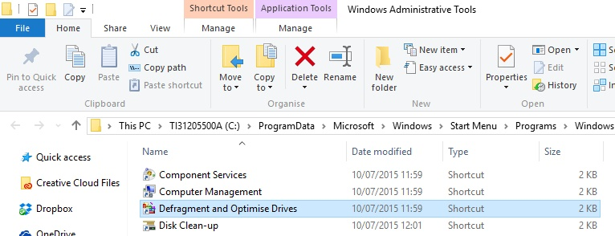

Figure Open Defragmentation Tool from Windows Administrative Tool

After this I will open the application for an Automatic Schedule purpose by changing the Settings:

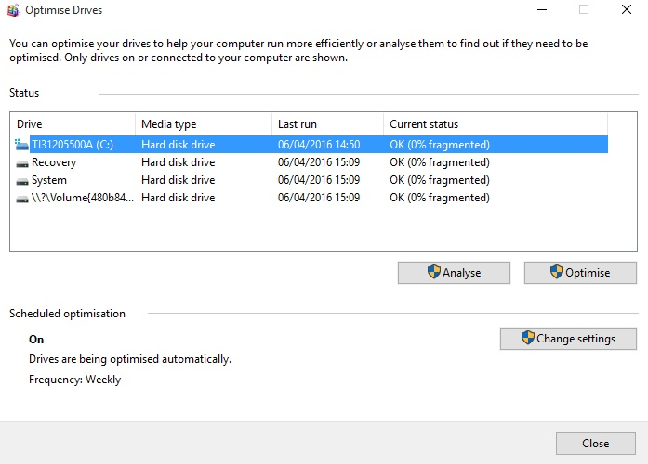

Figure Change the Settings of an Automatic Defragmentation

The next step is to click on Change Settings from Optimise Driver application and check the box Run on a schedule, to be sure that the Automatic Schedule is ON, then I will choose the Frequency of this schedule and after this I will make a selection of partitions or drivers I want to be optimised by defragmentation:

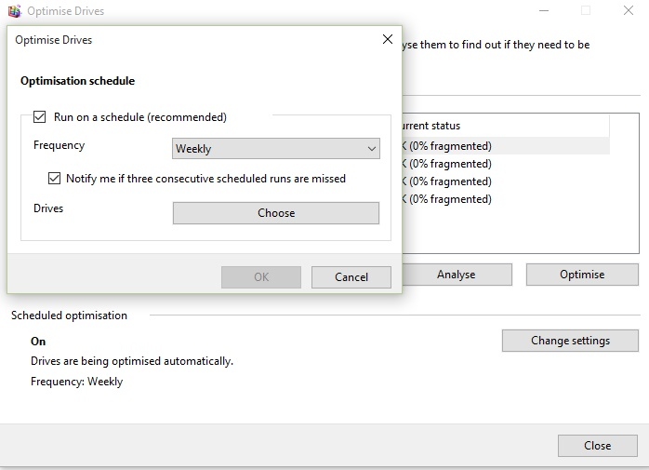

Figure Optimisation schedule of defragmentation

Once I have chosen the partitions and drivers that we will defragment by an automatic program when we just have to finish setting by pressing the OK button.

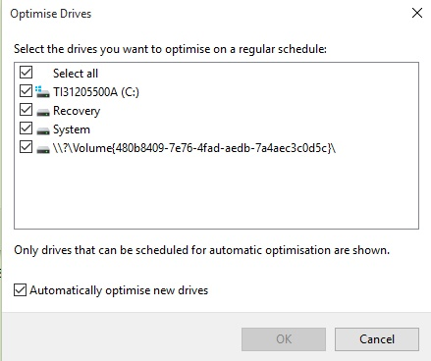

Figure Choose the partitions or the external drivers to be defragmented

## What are the steps before making an improvement software or hardware to an operating system?

The next stage after installing the drivers of a computer system, I will look to the structure of the computer system which contains both hardware components and software parts and these two essential components need to work in concordance.

Makers of equipment offer an extensive variety of models, each with its particular determination. This unit audits the numerous computer parts of a PC framework and how they associate. Choosing which specific type is proper for a given circumstance relies on upon an assortment of variables.

Working structures programming is expected to run the PC. This unit takes a gander at the Microsoft working structures which as of now rule the business sector, however, we will likewise take a gander at other working structures and investigate no less than one other in a few the point of interest. The working structure, together with major utilities, gives the programs expected to deal with a PC structure.

This unit takes a gander at the choices accessible for critical utilities, for example, hostile to infection programming, which is frequently preinstalled in any case, may be bought from an outsider.

##### **Before upgrading the hardware components**

When I choose to do a hardware upgrade must first watch a few mandatory requirements that component installation, I will track the component if that is compatible with my computer. I'll check if hardware components like motherboard, power supply, RAM memory and other essential computer hardware system are compatible with the new device I want to install.

Also, another important factor is to check if the acquisition price is cost-effective hardware components that may deserve more to invest in buying a new computer than to spend money, example only buying hardware components just that. But if to look at improving the processing speed of the computer when it is better to invest in acquiring that hardware component, which is cheaper than buying an entire computer system.

Then I will track the help that component will assist the newly installed operating ratio and better functioning of the operating system.

##### **Before upgrading the software**

Before upgrading any software, we have to look at some factors such as compatibility and cost.

The first part, *the* ***compatibility***, refers to the relationship of compatibility between the new or enhanced desired application with the specifications of the computer, an example being when we want to make an upgrade to the operating system I should think about the fact that the programs which use them will go with the new update of the operating system.

I will also look at if the new upgrade or installation will be compatible with the specifications of hardware on my computer.

***The cost***, why we consider this simple aspect is that for some shortcomings such as bugs, we can invest a lot of money for nothing, getting up to change with this new upgrade program.

### 4.2.1 Security Programs

Once I installed the operating system and drivers we needed it appears some warnings that tell me that I need an ***antivirus program*** or ***firewall***, and that the PC is not protected until I install one of these.

#### **Antivirus**

Antivirus is a program that we install on our computer or any other device to protect it from infection by malware. The notion of malware is a generic term that refers to any type of malicious software program, the proper functioning computer, such as viruses, worms, Trojan horses or spyware monitoring programs (Bailey, 2007). In fact, the term "malware" comes from the combination of the words malicious (malicious) and software (program, computer). If our computer is infected with malicious attacker can capture all your keystrokes and steal our documents.

We can take an antivirus programme even to download it free such of Avast Free Antivirus, Bitdefender Antivirus Free Edition, AVG Antivirus Free, Avira Free Antivirus, Microsoft Security Essentials or even buy antivirus software or as standalone solutions often included in a suite of security programs from Avira, Norton Antivirus, Kaspersky, Bitdefender, BullGuard. We take an antivirus program only from reliable suppliers known. It is a common trick used by criminals distributing fake antivirus programs that are actually malware. The same rule applies when installing other programs mandatory or optional.

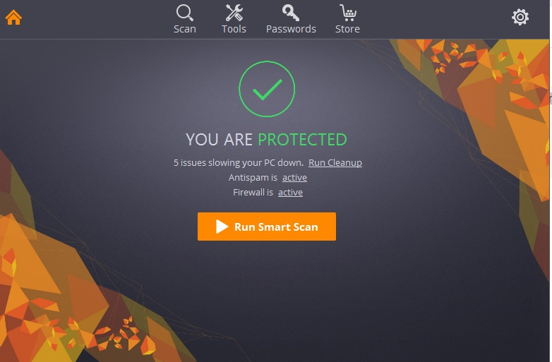

Figure Protected by an antivirus

#### Firewall

If our computer has confidential information, there is no guarantee that information will not be disclosed. However, such guarantees are needed, especially those who work with critical information. Data Protection provides a firewall.

The firewall should provide a barrier between the network and the computer. In other words, it is a filter. The firewall keeps track computer connection, analyses the connection and decide whether to allow the connection or not (Al-Shaer, 2004).

Configuring the firewall:

The main recommendations for configuring audio connections allowed the applications that really need the connection. Also, it should be configured in such a way that the application has access to only those ports that work, not more. Sounds complicated? It has modern firewall configuration wizard that will simplify configuration.

Types of Firewall:

Looking forward, the firewall is, I should mention that there are two types of walls. Personal and corporate wall is the wall. Firstly, personal wall is an application on a user's computer. Corporate wall is an application that is installed on the gateway between LAN and Internet.

personal firewall

If an application installed on our computer does not have appropriate firewall rules, it will see a notification by which the user will be her decision to approve or deny the connection. Today there are plenty of firewalls. Regardless of the type, the characteristics practically do not differ from each other. The main differences are how to use, user interface and also paid or free. Do not forget that many antivirus applications have built-in firewall.

Corporate Firewall is an application that is installed as a gateway between LAN and Internet. Configure firewalls such a system administrator, thus protecting the entire network of computers.

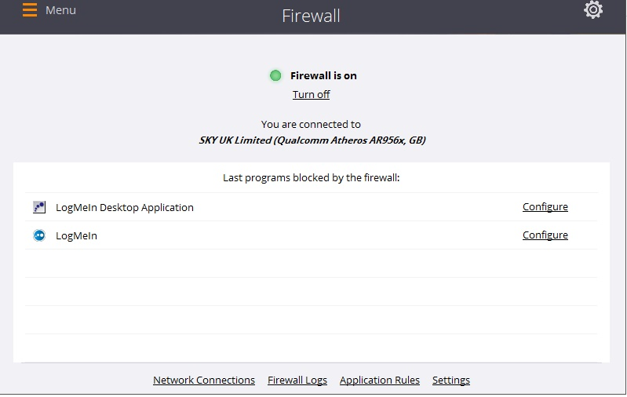

Figure Running the Firewall on a computer

### 4.2.2 Applications that are strInformation Technologyly necessary to be installed immediately after installing the operating system

Java Runtime Environment

* is a package that allows running 'applets', i.e. scripts / programs that are written in the Java environment. Many websites have content Java.

DirectX

* is a group of technologies that help parse and display a graphically rich content, like 3D animations, video, is required by almost all 3D games and applications.

.NET Framework

* is a package that contains everything you need to run applications written in.NET. For example, drivers from ATI, Paint.NET, FH Update Checker, are applications that can not run without.NET Framework.

Shockwave Player

* allows you to run multimedia content, interactive demonstrations. It is also a browser plugin from Adobe.

#### WinRAR

* Certainly we will need to open an archive a new game for example or files downloaded from the net. WinRAR is the most widely used program and is also good.

#### Adobe Reader

* Certainly you will need to open a .pdf file (in .pdf book or an article).

#### Adobe Flash Player

* One of the most popular uses of the Internet's view movies and online videos and online games. All this requires Adobe Flash Player

### 4.2.3 Optional software installation

* **A new browser**

Internet Explorer already have a server, but I guess you want to have an experience more enjoyable when using Internet. Use Firefox, Opera, Chrome.

* **Multimedia programs**

What computer is that we can not use it to watch movies and listen to music?!

* **Programs of Instant Messaging (chat)**

Skype, Yahoo Messenger.

# References

Al-Shaer, E. a. H. H., 2004. *Modeling and management of firewall policies,* s.l.: Network and Service Management.

AM Caulfield, A. D. J. C. T. M., 2010. *A high-performance storage array architecture for next-generation, non-volatile memories,* s.l.: IEEE Computer Society.

Bailey, M. O. J. A. J. M. Z. J. F. a. N. J., 2007. *Automated classification and analysis of internet malware,* Beerlin: Springer.

BARBOS, A., 2014. *Motherboard Parts and Functions: Getting to Know Your Hardware,* s.l.: Udemy blog.

Chen, C. C. Y. a. Y. J., 2003. *On a dynamic preventive maintenance policy for a system under inspection,* s.l.: Elsevier.

DAINTITH, J., 2004. *A DInformation Technologyionary of Computing,* s.l.: Encyclopedia.com.

Hampton, K. a. W. B., 2001. Long Distance Community in the Network Society Contact and Support Beyond Netville. pp. 476-495.

Hampton, K. a. W. B. 2. L. D. C. i. t. N. S. C. a. S. B. N. A. B. S. 4. p.-4., 2001. Long Distance Community in the Network Society Contact and Support Beyond Netville. In: *Long Distance Community in the Network Society Contact and Support Beyond Netville.* s.l.:American Behavioral Scientist, pp. 476-495.

McIver Jr, W., 2003. *A community informatics for the information society,* s.l.: Communicating in the information society.

Silberschatz, A. G. P. G. G. a. S. A., 1998. *Operating system concepts (Vol. 4),* s.l.: Reading: Addison-Wesley.

webmaster, 2012. *Types of Backup,* s.l.: http://typesofbackup.com/.

Wilson, K., 2014. *Computer Maintenance,* s.l.: Springer.

Wolf, M., 2012. *Computers as components: principles of embedded computing system design,* s.l.: Elsevier.