Gheorghe Mitrea

Tower Hamlets College 2017

Formulate a project

Contents

1. Task 1 Formulate Three Outline Project Specifications 4

1.1 Option 1 Implementation of a New Computerised System in Melchester College 4

1.1.1 Requirements for Hardware, Software and other Equipment for Option 1 5

1.1.2 How Long Time will Take the New Implementation 7

1.1.3 Incremental Stages 7

1.1.4 Impact on the day-to-day operations 8

1.1.5 Laws and Ethical Aspects 8

1.2 Option 2 Upgrading and Carrying Out the Existing Inventory System 9

1.2.1 Requirements of Hardware, Software and other Equipment for Option 2 9

1.2.2 How Long Time will Take the Upgrade 11

1.2.3 Incremental Stages 11

1.2.4 Impact on the day-to-day operations 11

1.2.5 Laws and Ethical Aspects 12

1.3 Option 3 Outsourcing of the Whole Function and Computerised Inventory System to the Outsourcing Company 12

1.3.1 Requirements for Hardware, Software and other Equipment for Option 2 12

1.3.2 How Long Time will Take the Upgrade 13

1.3.3 Incremental Stages 14

1.3.4 Impact on the day-to-day operations 14

1.3.5 Laws and Ethical Aspects 14

1.4 Selection of The Outline Project Specifications 15

2. Task 2 Selected outline project specification 16

2.1 Research and review over the project area 16

2.2 Evaluation of the feasibility of the project 17

2.3 Analysis of the outline specifications critically 17

2.4 Estimation of cost and implications of resource 17

2.5 Objectives of the outline project specification 18

2.6 Limitations 18

2.7 Roles and responsibilities 19

2.8 Budget of the project 19

3. Task 3 Specification Report 20

3.1 Cost of the project 20

3.1.1 Scale of operations 21

3.1.2 Timescales 21

3.2 How Long Time will Take the Upgrade 22

3.3 Incremental stages 22

3.4 Impact on the day-to-day operations 22

3.5 Standards and legislations 23

3.5.1 Ethics and sustainability 23

3.5.2 Resource implications 23

3.5.3 Quality and suitability of the outline project specifications 23

4. Task 4 Project Plan 24

4.1 Timescales 24

4.2 Deliverables 25

4.3 Milestones 26

4.4 Quality assurance systems 26

4.5 Plans 26

4.6 Monitoring features 27

Bibliography 28

##### Introduction

In this program, the discussion will be on the implementation of a new computerised system in the Melchester College. The new system will help in easy and quick access to the details of the hardware and suppliers, maintaining history, record keeping, storing details of the inventory and maintain a list of hardware for the purpose of improving health and safety records. For the implementation of this new computerised system in the Melchester College different aspects related to the system will be discussed such as the cost of the hardware and software, timescale and the scale of operations, the time taken for the up-gradation and the impact of this new computerised system inventory over the operations of ICT department of the college.

Melchester College is using around 450 personal computers, printers and scanners for the purpose of storing and maintaining the data related to the hardware, supplier, maintenance and records on the computer of manager of ICT department.

# Task 1 Formulate Three Outline Project Specifications

Melchester College is planning to implement a new computerised system for ICT department, a purpose of dealing with the different issues related to the recording of the data and maintaining the data of hardware across the college. For the purpose of solving these problems, the Manager of ICT department is analysing three outline project specifications. These three outline project specifications are the implementation of the new computerised system in which the college will have all the computers, hardware and software. The first option is to have a new database application to entry all data details about the devices, suppliers, histrory and location of the devices. The last outline project specification is outsourcing of the process, which will reduce the burden of management of the computerised system and the record keeping function of the inventory (Fakkirappa Kattimani, 2013). These three outline project specifications are discussed below:

## *Option 1* Implementation of a New Computerised System in Melchester College

In this outline project specification a complete new computerised system will be implemented by Melchester College for the execution of the operations of:

* record keeping, retrieval, quick and easy access to the details of the hardware
* maintaining the detailed records of the history at a single place, offering the details of the inventory,
* dealing with the government allocated personal computers and issuing the list of hardware for the purpose of facilitating and improving the health and safety record keeping.

In this outline project specifications, all the existing data details about hardware components, will be replaced with the new systems which will result in an enhancement of the effectiveness of the operations of ICT department.

### Requirements for Hardware, Software and other Equipment for Option 1

Melchester College can replace the old inventory system with a new database (Al-Daihani, 2011). This will enhance the performance as well as provides a better environment for the storage of information or data.

#### Cost of the hardware and software

* The cost will not be so high, because is not involving buying expensive software and hardware to release this database interface and provides effective results or the expected outcomes to the college.
* The ICT manager of the Melchester College wishes to store or record the details related to the hardware, suppliers, location of the devices, history maintenance on its computer for the easy and quick access or retrieval.

#### Scale of operations

The operations or the installation of the new computerised system is done for the purpose of enhancing the process of record keeping. The installation of the new computerised system is on the medium level as the college is installing this system for storing or keeping the files in a better manner. The installation of the new computerised system in Melchester College to record data details of laptops, scanners, printers, monitors and base units (workstations) will be used for the better execution of the record keeping process (Handayati, 2014).

#### Timescale

* Planning process is taking about five days, the design about twenty-two days, the installation about eighteen days, then the testing phase will take around 9 days, after this will come the training phase with seven days’ period and the operation phase or handover phase will be placed in about five days:

Table 1 Timescale of the option 1

|  |  |  |
| --- | --- | --- |
| **Activity** | **Duration** | **Description** |
| Analysis Phase 1 | 5 days | Planning is done for the purpose of installation of the new computerised system in the Melchester College |
| Database Design Phase2 | 22 days | The new computerised system is designed for ICT department, for the purpose of better recording keeping and execution of operations. |
| Implementation Phase 3 | 18 days | The new computerised system is installed for ICT department. |
| Testing Phase 4 | 9 days | The installation process is reviewed for the analysis of the lack of effectiveness of the new system. |
| Training Phase 5 | 5 days | Training is provided for the users to become more familiar with the new digital database interface. |
| Operation (Handover) Phase 6 | 5 days | Steps are taken for the handover the new computerised system. |

### How Long Time will Take the New Implementation

It will take 68 days as the installation will consume more time and training needs to be provided for the use of the new computerised system. The implementation of this outline project specification will be done in different stages.

### Incremental Stages

The installation of this system will enhance the performance of the college and provide effectiveness to the record keeping system of the Melchester College.

The implementation of this outline project specification will be done in the next stages:

* Analysis Phase 1
* Database Design Phase2
* Implementation Phase 3
* Testing Phase 4
* Training Phase 5
* Operation (Handover) Phase 6

### Impact on the day-to-day operations

The daily activities and the effectiveness of the routine functions of the organisation will increase due to which the operations can be performed in a better manner. The storing process of the records is a core function and need to be done in a proper manner so as to avoid the loss of the record due to not recording the information (Mtebe, 2011).

### Laws and Ethical Aspects

There are various laws and ethical aspects which Melchester College need to consider for providing safety and security to the information or data of confidential nature. There are few ethical considerations and laws which need to be focused by Melchester College, and these ethical considerations and legislation include transparency of data and safety and security of data from unauthorised access (Al-Daihani, 2011).

* Standards: Correct use of data resources of the organisation, procedures and policies, management reporting levels required, security. The operations of the college are conducted in an ethical manner by following the legislative guidelines and storing the records or data in a proper manner for easy and quick access or retrieval of the record (Hu, 2012).
* Legislation: data protection act, software licence, contract, copyright;
* Ethical issues: disposal of confidential documents and personal data, improper using information technology, irresponsible or harmful to society (e.g., aggressive e-mails, cookies, etc.). Correct use of data resources of the organisation (e.g., respecting the confidentiality of information); establishing liability for those who do not follow the above items; using the software without paying the copyright.

## *Option 2* Upgrading and Carrying Out the Existing Inventory System

In this outline project specifications, Melchester College can update the old inventory system, so as to enhance the effectiveness and to consider the cost or the burden of the college.

### Requirements of Hardware, Software and other Equipment for Option 2

Melchester College can update the old computerised system inventory made in Excel. This will enhance the performance as well as provides a better environment for the storage of information or data.

#### Cost of the hardware and software

* This outline project specification can affect the storage and recording of the data as the hardware equipment not work to be recorded in an effective condition. The record of them is quite hard without an automatic update of the maintenance history or entry of new data details for the devices or suppliers. The cost of upgrading will be zero financial investment, because the database in Excel will be redesigned for a better manner and functionality.

#### Scale of operations

The operations or the installation of the new computerised system is done for the purpose of enhancing the main functions of the database. The installation of the updated computerised system is on a basic level as the college is updating this system for storing or keeping the records in a better manner. For the installation of the new computerised system in Melchester College laptops, scanner and printers and the rest of devices of inventory will be used for a basic execution of the record keeping process.

#### Timescale

* Planning process about six days, the installation about seven days, then the monitoring the new update in three days and handover four days:

Table Timescale of the option 2

|  |  |  |
| --- | --- | --- |
| **Activity** | **Duration** | **Description** |
| Planning process for the installation | 6 days | Planning is done for the purpose of installation of the new computerised system in the Melchester College |
| Installation | 7 days | The new computerised system is installed in the Melchester College for the purpose of better recording keeping and execution of operations. |
| Monitoring or evaluating | 3 days | The installation process is reviewed for the analysis of the lack of effectiveness of the new system. |
| Handover | 4 days | Steps are taken for the handover the new computerised system. |

### How Long Time will Take the Upgrade

It will take one month time as the installation will consume more time and training needs to be provided for the use of the new computerised system.

### Incremental Stages

The installation of this system will enhance the performance of the college and provide an acceptable level to the record keeping system of the Melchester College.

The implementation of this outline project specification will be done in the next stages:

* Planning process
* Installation
* Monitoring
* Handover

### Impact on the day-to-day operations

The day-to-day operations and the effectiveness of the routine functions of the organisation will increase due to which the operations can be performed in an acceptable manner. The storing process of the records is a basic function and need to be done in an acceptable manner so as to avoid the loss of the record due to not recording the information (Mtebe, 2011).

### Laws and Ethical Aspects

Ethical aspects, laws, rules and regulations need to be considered for the purpose of ensuring that no harm is created to the confidential information of others and of the college (Fakkirappa Kattimani, 2013):

* Standards: Correct use of data resources of the organisation, procedures and policies, management reporting levels required, security;
* Legislation: data protection act, software licence, contract, copyright;
* Ethical issues: disposal of confidential documents and personal data, improper using information technology, irresponsible or harmful to society (e.g., aggressive e-mails, cookies, etc.). Correct use of data resources of the organisation (e.g., respecting the confidentiality of information); establishing liability for those who do not follow the above items; using the software without paying the copyright.

## *Option 3* Outsourcing of the Whole Function and Computerised Inventory System to the Outsourcing Company

### Requirements for Hardware, Software and other Equipment for Option 2

In this outline project specifications, entire process or the function will be outsourced to the third party which will be responsible for the storage and recording of the information or data of Melchester College in a safe and secure manner by complying the ethical aspects, laws, rules and regulations.

#### Cost of the hardware and software

* The outsourcing company will be managing the information and data on their computers which will save the cost of Melchester College, also which would have incurred in the purchase and installation of the computers, software and other hardware required for the ICT department of the college.
* The outsourcing company will perform all the operations of ICT department, and for these services provided by the outsourcing company to the Melchester College, fees will be charged by the outsourcing company, and these fees are around 1000 £/month, which is a very high price for the college.

#### Scale of operations

* The operations or the installation of the new computerised system is done for the purpose of enhancing the process of record keeping.
* The outsourcing company will be responsible for the installation of the new computerised system, which should be on a professional level as the college is installing this system for storing or keeping the records in a better manner.

#### Timescale

* The outsourcing company will be responsible for the planning process.

### How Long Time will Take the Upgrade

* The outsourcing company should do the inventory process until the finish of the contract between Melchester College and outsourcing company.

### Incremental Stages

The installation of this system will enhance the performance of the college and provide a professional level to the record keeping system of the Melchester College.

The implementation of this outline project specification will be done in the next stages:

* Planning process
* Installation
* Monitoring
* Handover

### Impact on the day-to-day operations

* No impact on day-to-day operation as the outsourcing company will develop the new computerised system.

### Laws and Ethical Aspects

The outsourcing company will make sure that it is not creating any harm to the confidentiality and keeping the data of Melchester College in the safe and secure manner by proper management of the records and ensuring the easy and quick access to the data stored on the system by the Melchester College (Al-Daihani, 2011):

* Standards: Correct use of data resources of the organisation, procedures and policies, management reporting levels required, security;
* Legislation: data protection act, software licence, contract, copyright;
* Ethical issues: disposal of confidential documents and personal data, improper using information technology, irresponsible or harmful to society (e.g., aggressive e-mails, cookies, etc.). Correct use of data resources of the organisation (e.g., respecting the confidentiality of information); establishing liability for those who do not follow the above items.

## Selection of The Outline Project Specifications

By the requirement of Melchester College, it is planning to implement a new database application for hardware inventory system and will implement a new computerised system at the place of the old computerised system so as to enhance the performance of the ICT department of Melchester College. Melchester College is planning to implement this new computerised system in which the existing inventory system, will be replaced for enhancing the effectiveness of the operations and management of the data in a better manner.

# Task 2 Selected outline project specification

A new computerised system has been chosen which will help to deal with the issues faced by Melchester College due to the lack of proper, efficient and latest computer systems for the management of the data of the college. The manager of the ICT department wanted to implement a project or a new system which will result in the easy and retrieval of the information or details related to hardware and software. Installation of a new computerised system will lead to an enhancement of the performance of the college.

The new computerised system will help the manager of the ICT department of Melchester College in the storage of the records related to the hardware, supplier and maintenance on the computer of the manager. The expected outcomes from the installation of the new computerised system include:

* maintaining the history, the details of the college and the individual items of the hardware in an effective manner,
* dealing with the returns of the government on the number of the computers allocated to the college,
* offering the details of the hardware in every room of the school, providing the details of the hardware assigned to every room of the college and quick and easy access to the details of the hardware and the supplier of the hardware (Castellano, 2014).

## Research and review over the project area

The project area covers the installation of the new computerised system in which the new database application will be on ICT manager’s computer, so as to execute the activities of the hardware inventory in a better manner. All the personal computers were situated in the dedicated ICT room due to which all the systems were located at a centralised location, but from the installation of the new system college will be able to locate the personal computers at the different rooms for the better storage and recording of the details.

The college is planning to spread the network of the computers, hardware and software across the campus so as to make sure that the operations are carried out in an efficient manner without any adverse impact on the operations of the college (Best, 1999).

## Evaluation of the feasibility of the project

The project which Melchester College is planning to implement at the college campus for the purpose of spreading the area of the network so as to cover the functions of the college in an effective and efficient manner. Melchester College is conducting regular check-ups of the computers, hardware and software so as to ensure the health and safety of the computers, equipment and software. The new computerised system is efficient and is capable of fulfilling the requirements of the Melchester College.

## Analysis of the outline specifications critically

The outline project specification which has been selected by Melchester College is effective and efficient and capable of fulfilling the expectations and the requirements of the college. The network of the area needs to be expanded which helps in equipping the computers, hardware and software in every room of the school. The installation of the system will assist in the fulfilment of the expectations of the college (Helo, 2016).

## Estimation of cost and implications of resource

The cost will be at a low level for this new computerised system of inventor, as the investment in purchasing the software and the hardware for this project doesn’t need expensive investments. For the installation of the system, various resources need to be applied or allocated in the installation process. The resources which will be required for the installation of the new computerised system include the human resource, finance and knowledge of the technology. These resources need to be utilised in a proper manner for the attainment or accomplishment of the objectives framed by the college in relation to the installation of the new computerised system at the college campus (Babravicius, 2012).

## Objectives of the outline project specification

The objectives or the expected outcomes of the outline project specifications include:

* Offering the quick and easy access to the details of the hardware and the supplier.
* Issuing the list of the hardware for the purpose of facilitating and improving the records about the health and safety.
* Providing the history of the maintenance of the individual item of the hardware.
* Dealing with the returns of the government on the number of the personal computers allocated to the admin.
* Providing the records related to the hardware allocated to the different subject areas.
* Offering the details of the inventory of the hardware in every room.

## Limitations

There are few limitations which can create impact over the installation or implementation of the new computerised system include the shortage of time and the lack of proper knowledge for the installation of the computers, hardware and software in the college campus for locating the equipment in different classrooms in a decentralised manner (Dhanavandan, 2011).

## Roles and responsibilities

A project manager will be named for this project. The functions and responsibilities of the implementation phase of the new computerised system need to be divided among the staff of the ITC department and college in such a manner that they can handle the operations of the hardware inventory in a proper manner. The role of providing training and management of the new hardware inventory database need to be allocated to the different staffs so as to provide proper training to the staff for the execution of the operations of the college in an appropriate and effective manner. Regular check needs to be done so as to analyse that the roles and responsibilities assigned to it are performed in a proper manner.

## Budget of the project

The budget for this project is sustained by a loan took it from the government, which will be paid back in five years of loan term. All the project cost will be £30.000, which will cover the cost for resources, such as the project manager, a data analyst, a database developer, a tester of the database. The cost of the resources such as materials (software and hardware needed to develop this kind of software interface will be zero because they will use an open source software such as Xampp server, PhpMyAdmin database interface or MySQL Workbench UI.

|  |  |
| --- | --- |
| From government sources | £ 30.000 |
| From the private sources of trustees | £ 764 |
| Total funding for the project | £ 30.764 |

# Task 3 Specification Report

Melchester College is using around 450 hardware devices, which must be stored, recorded and maintained, all this data is related to the equipment, suppliers, maintenance and records on the computer of manager of ICT. For this purpose, Melchester College is planning to implement a new computerised system which will result in enhancement in the performance of the different equipment.

The reasons behind the decision of installation of the new computerised system include quick and easy access to the details of the hardware or supplier, to provide the history of maintenance on every individual item, providing maintenance history, providing the records of the different hardware allocated to the subject areas, offering the details of the inventory of hardware, dealing with the returns of government and issuing the list of hardware for the purpose of facilitating and improving the health and safety records. Before the installation of the new computerised system, there is a need to analyse different aspects related to the system (Ayoku & Okafor, 2015).

For the replacement of the old computerised system, a new computerised system will be installed which will help in enhancing the performance of the college and also provide support to the process of dealing and managing the data or the records in a better manner. The hardware equipment required for the installation of the new computerised system includes laptops, printer, monitor, base units and scanners. All this equipment will replace the existing hardware equipment used in the college for the storage of the information or for the purpose of record keeping (Handayati & Ritme, 2014).

## Cost of the project

The cost of the new computerised system is low in comparison to the other such investments as is needed only to pay the project team members for developing this new system, in rest the cost for materials is zero pounds spending, because the team project decided to use good and open sources software to develop this database.

The average salary as project manager for such project in UK is £25/hour, the cost of a data analyst is around £30/hour, also the cost as a database tester is around £30/hour and finally the cost for developer is £30/hour.

The period for entire project is about 68 days for 704 hours, this means that the entire project will cost £19,880.00 financial investment.

This cost can be covered by the effective utilisation of the new computerised system and keeping the records in an effective manner.

### Scale of operations

The operations or the installation of the new computerised system is done for the purpose of enhancing the process of record keeping. The installation of the new computerised system is on medium level as the college is installing this system for storing or keeping the records in a better manner. For the installation of the new computerised system in Melchester College laptops, scanner and printers will be used for the better execution of the record keeping process. (Handayati & Ritme, 2014).

### Timescales

|  |  |  |
| --- | --- | --- |
| **Activity** | **Duration** | **Description** |
| Analysis Phase 1 | 5 days | Planning is done for the purpose of installation of the new computerised system in the Melchester College |
| Database Design Phase2 | 22 days | The new computerised system is designed for ICT department, for the purpose of better recording keeping and execution of operations. |
| Implementation Phase 3 | 18 days | The new computerised system is installed for ICT department. |
| Testing Phase 4 | 9 days | The installation process is reviewed for the analysis of the lack of effectiveness of the new system. |
| Training Phase 5 | 5 days | Training is provided for the users to become more familiar with the new digital database interface. |
| Operation (Handover) Phase 6 | 5 days | Steps are taken for the handover the new computerised system. |

## How Long Time will Take the Upgrade

The total period of this option will take 68 working days, all these stages of implementation will be made during the period 13/02/2017 – 17/05/2017. The non-working days will Saturday and Sunday, also the next days such as St Patrick’s Day, Easter Monday and Early May Bank Holiday will be days-off.

## Incremental stages

The installation of this system will enhance the performance of the college and provide effectiveness to the record keeping system of the Melchester College. The operations of the college are conducted in ethical manner by following the legislative guidelines and storing the records or data in a proper manner for easy and quick access or retrieval of the record (Hu & McGrath, 2012;2011).

## Impact on the day-to-day operations

The day-to-day operations and the effectiveness of the routine functions of the organisation will increase due to which the operations can be performed in a better manner. The storing process of the records is a basic function and need to be done in a proper manner so as to avoid the loss of the record due to not recording the information (Mtebe, et. al., 2011).

## Standards and legislations

Quality standards have been decided and according to these standards the focus should be over the safety and security of the data and management of the data in an easy manner so as to use the data or record stored on the computers in an easy and quick manner. There are various legislations formed by the government and the different authorities, which helps in the storage of the records in proper manner and these legislations include computer misuse act that is focused over the use of the computers in ethical manner, data protection act, official secrets act, health and safety act, communications Defamation act that ensures that the facts are accurate and true and Obscenity

### Ethics and sustainability

Ethics is the process of bifurcating the right and wrong. In this changing world, ethical issues need to be considered. Adoption of new computerised system results in creation of the sustainability problems which affects the effectiveness of the new computerised system. Melchester College may face an ethical issue which is sustainability as the data stored on the computers is increasing which creates an issue and can create huge impact over the system. The manner in which information or data is used need to be analysed for the purpose of maintaining sustainability and conduct of activities or operations of the college in ethical manner (Dhanavandan, et. al., 2011).

### Resource implications

The implementation of the new computerised system will result in increase the cost involved in the developing this new hardware inventory and the software needed to help developing this database application is a free source of using. Regarding the cost of hardware needed to develop the database this one will be a new workstation from Melchester College, given to the team project until the end of project. This new computerised system will result in increase in the effectiveness of the college in managing, storing and recording the information or data.

### Quality and suitability of the outline project specifications

The outline project specification which has been selected is effective and efficient that will enhance the performance of the ICT department of Melchester College.

# Task 4 Project Plan

For the implementation of the new computerised system at Melchester College a project plan need to be prepared so as to execute the implementation in a proper and effective manner which helps in the attainment of the objectives set by the college. The project plan will include the process or the stages which will be focused over the implementation of the new computerised system at Melchester College in proper way.

## Timescales

|  |  |
| --- | --- |
| **Activity** | **Description** |
| Analysis Phase 1 | In this phase of the project plan the planning will be done according to which the new computerised system will be implemented at the campus of the Melchester College. |
| Database Design Phase2 | The new computerised system is designed for ICT department, for the purpose of better recording keeping and execution of operations. |
| Implementation Phase 3 | In this phase, the implementation of the new computerised system will be done so as to make sure that the requirements or the expected outcomes of the Melchester College are achieved (Sampath Kumar & Biradar, 2010). |
| Testing Phase 4 | The installation process is reviewed for the analysis of the lack of effectiveness of the new system. |
| Training Phase 5 | In this phase, the focus will be over providing training and guide to the staff for the use of the newly installed computerised system at the campus of the college (van Deursen & van Dijk, 2014).  Also, |
| Operation (Handover) Phase 6 | In this phase, the implementation process will be evaluated and monitored so as to ensure that the new computerised system is used by the Melchester College in an effective manner.  Also, in this phase of the project plan the gaps will be identified so as to remove or eliminate the issues or the gaps for achieving the desired outcomes of the Melchester College. |

Figure Timescale for the project

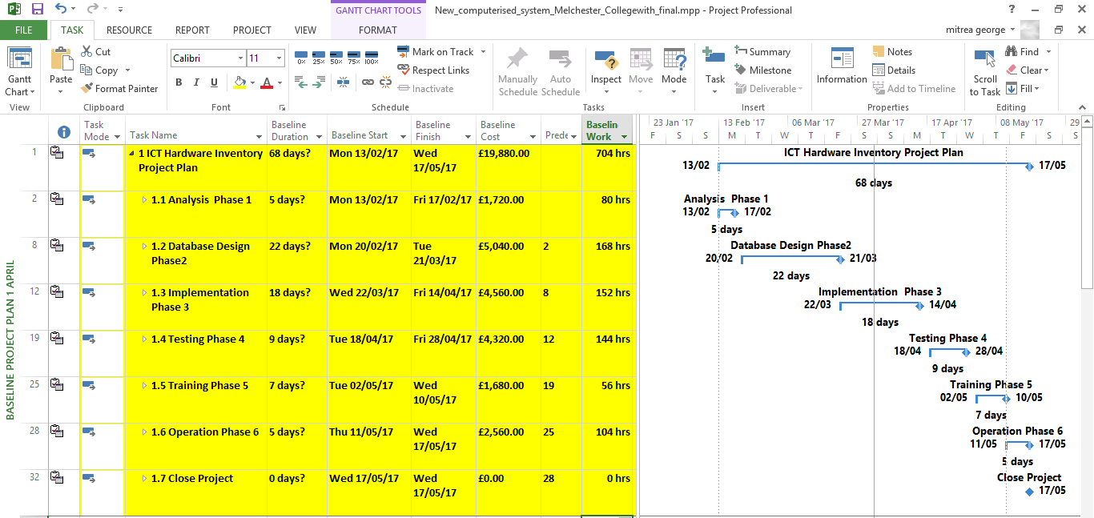

## Deliverables

The objectives or the deliverables of the new computerised system include decentralisation of the computers, hardware and software at the campus of the Melchester College so as to make sure that the area of the campus is covered properly and all the rooms are equipped with the required equipment for the execution of the operations. The deliverables of the new computerised system are quick, easy and efficient access to the details of the hardware and supplier of the Melchester College, issuing the list of the hardware for the purpose of facilitating and improving record keeping system of the college for maintaining the health and safety, offering the details of the inventory of the hardware in every room of the college and providing and maintaining the history of the hardware allocated to the subject areas (Attuquayefio & Addo, 2014).

## Milestones

The different phases of the timescale will be operated and a close check will be done of these phases so as to ensure that all the phases are applied in an effective manner and ensuring that these phases are executed as per the plans formulated in the project plan. After the completion of every phase the objectives of the phase will be evaluated so as to make sure that the phases are focused over the objectives decided by the college for installation of the new computerised system (Oye, et. al., 2014).

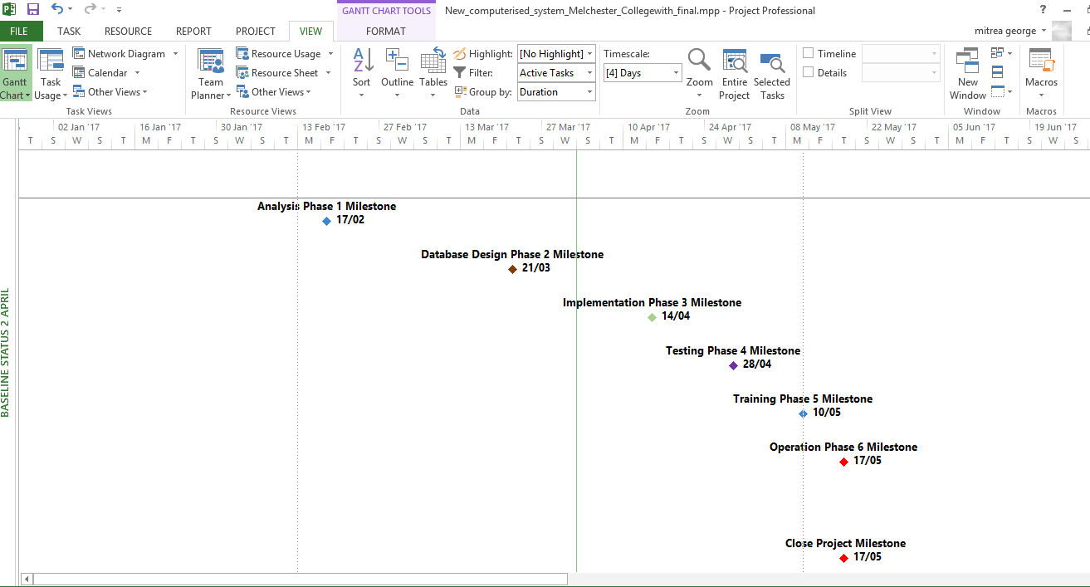

Figure Baseline Milestone for each task

## Quality assurance systems

The main motive behind adoption of the quality assurance system is to prevent the mistakes and errors which can create adverse impact over the installation or implementation of the new computerised system. The focus will be over the surety that the quality of the new computerised system will be maintained. The major focus will be over the risks or the issues in the process of implementation of the new computerised system which can affect the implementation process and the effectiveness of the system. A group or team will be formed which will keep a check over the quality of the system and attainment of the objectives of the project or the new computerised system (Verhoeven, et. al., 2016).

## Plans

For the implementation of the new computerised system, the whole implementation process is divided into different phases so as to make sure that all the aspects are covered in a proper manner without skipping out any activity of the phase. The plan will include the different aspects related to the new computerised system such as limitations, implications, resources required for the project, deciding the timescale or timeframe for the execution of the plan prepared by the college.

## Monitoring features

For the purpose of monitoring the implementation process of the new computerised system a team will be formed who will be responsible for the checking of the implementation of the new system. For the effective implementation, the team will assign different tasks or activities to the different members of the team so as to make sure that effective implementation is done. A list will be made so as to analyse the aspects which need to be monitored in a proper manner and covering all the aspects of the implementation process.

# Bibliography

Al-Daihani, S., 2011. *ICT education in library and information science programs: An analysis of the perceptions of undergraduate students,* s.l.: Library review.

Babravicius, K. a. V. E., 2012. *Knowledge of ICT of Secondary School Graduates,* s.l.: Informatics in Education-An International Journal.

Best, A., 1999. *Secondary data bases and their use in outcomes research: a review of the area resource file and the Healthcare Cost and Utilization Project,* s.l.: Journal of medical systems.

Castellano, J. A.-P. D. a. B. P., 2014. *Evaluation of research using computerised tracking systems (Amisco® and Prozone®) to analyse physical performance in elite soccer,* s.l.: A systematic review. Sports medicine, 44(5), pp.701-712..

Dhanavandan, S. E. M. a. N. M., 2011. *Information Communication Technology (ICT) Infrastructure Facilities in Self-Financing Engineering College Libraries in Tamil Nadu,* s.l.: Library Philosophy and Practice, (1), p.69..

Fakkirappa Kattimani, S. a. R. N. R., 2013. *Evaluation of librarianship and ICT skills of library and information professionals working in the engineering college libraries in Karnataka, India: a survey,* s.l.: Program, 47(4), pp.345-369..

Handayati, P. a. R. A., 2014. *THE DEVELOPMENT OF ICT-BASED ASSESSMENT DATABASE WITH REINFORCEMENT ON ACCOUNTING SUBJECT AT SENIOR HIGH SCHOOL,* s.l.: European Scientific Journal.

Helo, P. G. A. a. R. A., 2016. *Designing and Managing Industrial Product-Service Systems,* s.l.: Springer.

Hu, Z. a. M. I., 2012. *Integrating ICT into College English: An implementation study of a national reform,* s.l.: Education and Information Technologies, 17(2), pp.147-165..

Mtebe, J. D. H. a. R. C., 2011. *Integrating ICT into teaching and learning at the University of Dar es Salaam,* s.l.: Distance education.