Information Systems in Organisations

Gheorghe Mitrea 1118495

TOWER HAMLETS COLLEGE  2017

Understand, Analyses and Evaluate an information systems for a Business

**Table of** Contents

INTRODUCTION 3

1. TASK 1 Understand Information Needs within Different Functional Areas of Organisations 4

1.1 Evaluate the Information Needs of each of the Functional Areas 4

Production 4

Retail services 4

Professional services 5

1.2 Evaluate the Suitability of Information Systems for Each of These Functional Areas 4

2 TASK 2 Compare Information Systems 6

2.1 Current Trends in Using Information Systems Applications to Solve Business Problems 6

2.2 Use an Information System to Generate Valid, Accurate and Useful Information 7

Testing and validating the functionality of a new system requirements 7

2.3 Alternative Methods to Solve the Problem 11

First Alternative Method for Solving the Problem is to Create a Spreadsheet in Excel 11

Second Alternative Method for Solving the Problem is to Create a File Text in Notepad 12

3 Task 3 Describe Three Appropriate Information Systems Stating the Function which each Performs 13

3.1 Management Information System (MIS) 14

3.2 Transaction Processing System (TPS) 15

3.3 Decision Support System (DSS) 17

CONCLUSION 19

Proposals for the improvement of the structure, functioning and monitoring of the information system of the firm 19

Choice precede an evaluation of the design of the information system in this field of activity 20

Implementation of the new information system for House of Fraser 20

Bibliography 21

***Table of figures***

Figure 1 Information system in business 4

Figure 2 Testing and validation of hardware and supplier details 8

Figure 3 Testing and validating the maintenance history of hardware 8

Figure 4 Testing and validating the number of hardware items for each department area 8

Figure 5 Testing the records of hardware location across the college 9

Figure 6 Testing the update data 10

Figure 7 Testing of insert new data in the database 10

Figure 8 2 Functions of MIS 14

Figure 9 MIS in business of HoF 15

Figure 10 Functions of TPS (Source: Internet TPS, 2016) 16

# *INTRODUCTION*

House of Fraser (HoF) is the British department store that operates the business in different parts of the world and has stores across the United Kingdom and Ireland. Organisation was established in 1849 that named as Fraser & Sons with more than 4500 employees.

The current study indicates the information needs of the all the functional areas and identifies the suitability of information system for all the functional areas. The report identifies the current trends in using information systems application to solve business problems in two functional areas and reflect the use of the information system to obtain valid, correct and useful information for a given problem. It will evaluate the alternative methods for solving the problem and describe the three appropriate information systems stating the function that performs.

The company's objective is to encourage professional development, to generate long-term profitability, combining economic success with the best energy solutions for the present and for the future, creating an environment of mutual benefit through social and economic partners.

Information Strategy of the company is that the information House of Fraser as the most important thing in the organisation, ensuring the integrity and well-being company. Information system to suit the organisational structure of the nodal points of branching or the concentrated information centres according to the requirements expressed by the decision of the organisation. Therefore, the functional parameters are closely related to the organisational structure. Like any other organisation, information travels and is sought by those base means, i.e., internet, phone, e-mail, the mail arrived and sent in a short morning meeting of the head, the morning agenda checking deadlines.

# 1. TASK 1 Understand Information Needs within Different Functional Areas of Organisations

## Evaluate the Information Needs of each of the Functional Areas

House of Fraser organisation has services in the United Kingdom and Ireland with about 60 stores. The large and professional services of the organisation include the production, retail and professional services to customers. Organisations need to acquire and manage the information to accomplish the objective effectively. The major functional areas in House of Fraser are:

### Production

The organisation has production work in custom gift articles and delivery of products for businesses. Some target customers require the information, the upcoming market changes and possibilities to introduce the product. Information about the availability of employees and raw material along with scopes helps to retain the best position in business. This kind of information helps the organisation to prepare the products and features according to market demand to achieve the market attention and benefits (Burke, 2013). The organisation has an own website to collect the orders and deliver the product. The team of an organisation is also dedicated to the production of new services and features in online presence. The information is also required for the efficiency of users and their activities on the website to present the business in an efficient manner. However, the data collection for product department depends upon other services of organisation and most of the time not so accurate to make a right decision on production.

### Retail services

The retail services of the organisation are based on the demand of customer and market changes. HoF needs the information about the client intentions, market trends, pricing policies, the legal

framework to follow and availability of products. The retailing services need to manage the customer information, transactions, suggestion and demand for products. Information is also required to manage the sales and retail services effectively to target customers. Organisation has benefits with the availability of accurate information and in time delivery of gifts to customers (Creswell, 2014). However, the retail information was difficult to manage because of customers’ custom behaviour. For instance, they may order the product but may not want to buy now. They also may want to return the product as part of the refund.

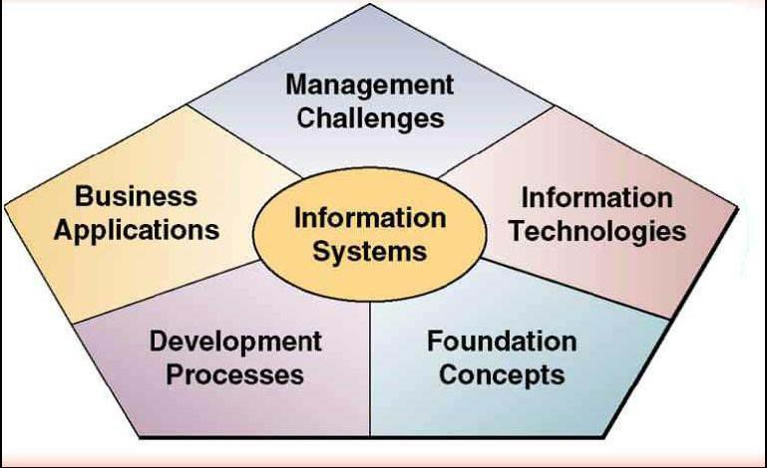

Figure Information system in business

(Sources: Internet, Information system in business, 2016)

### Professional services

The organisation has a major part of services to deliver the products in gift form. The professionalism is required to present the things in attractive and innovative manner. The information is required for the selection of product, delivery time and target customers. Organisation uses delivery vehicles and services, high-quality packing of gift articles, secure order processing and in time delivery to clients and businesses. The organisation has effective use of information about the processing of orders and delivery of gift items. Information is managed to reduce the interaction and to simply the business operations. The internal services and processes

of the organisation also require the information about the revenue, production and productivity in the workplace. The professionalism in the organisation comes from the management of information about transactions and outcomes in an effective manner to meet market sustainability and scopes (Sravanthi, 2012).

## Evaluate the Suitability of Information Systems for Each of These Functional Areas

To manage the information in the organisation for raw material, production, sales and services, the information system is helpful. The organisation may use various kinds of information systems to meet the efficiency, effectiveness and benefits. Content management system (CMS) and Enterprise resource planning (ERP) system may help the organisation to manage the information.

The functional area of HoF like production needs the information system to manage the availability, source and utilisation of raw materials in the workplace. The system also needs to be capable of handling the information about the products and their cost. The system must be capable of generating to analytical results about the products and their consumption in the market along with organisational effort and assets to prepare them. Proper collection and use of information through information system can help the production unit to use the information in the decision- making process. HoF can use the information system to record the production work and to align the work to overall progress and strategies. With better management, the organisation can make the benefits with global customers and market opportunities. However, it requires a complete set of software and hardware to run the production work effectively.

Delivery to customers and businesses for the products and gifts requires the management of information about the address, delivery status, and payment options. Information systems are effective tools to manage the information for right time use and to enhance the accessibility in organisation. The delivery function of the organisations needs a lot customer, operational and functional information to accomplish the objective. Information systems can reduce the effort to manage and update the information in real time and increase the productivity of the organisation. Information systems can help to generate the invoices, track the payment and product and to know back from the customers about the services. The mass communication to customers also can be simplified with the use of information systems. However, the information system must be robust and safe to operate on a large number of records and communications. The sustainability also

depends on the personalisation of a system according to demands in HoF organisation (Galbreth, 2013).

HoF has professional services to deliver the gift articles and to spread the love and smile. The activities of the organisation to accomplish the professional work require faster and secure system. The organisation can use distributed information system to simplify the work and to monitor the performance and position of the employees. The information system helps the organisation to communicate with customers in live time. However, the information system may not be capable of linking all the branches and their records before the central management office. The information system also may not be capable of integrating the remote employees in organisational business. The system may be limited to standalone use or number of staff.

# TASK 2 Compare Information Systems

## Current Trends in Using Information Systems Applications to Solve Business Problems

HoF is using the information system to simplify the effort and management in product and retail services. The organisation is moving away from the traditional operations and using the information system to manage the information. The use of information system in the organisation has helped to solve the following problems in two functional areas.

Problems in Production Services

To produce the clothes and gift articles according to customer demands, it is necessary to manage the client feedbacks and suggestions. HoF was also facing the problems to handle the information about the market trends and scores to produce the innovative products. With tradition systems, it was difficult to generate the logical and efficient information for production departments. HoF has used the information system like decision supporting system not only to manage the information but also to produce the valid data for decisions making process (Heagney, 2012).

Current trends like automation of data collection and information analysis automation are helping the organization collect the data from online and business operations along with better graphical presentation to use in strategies. Also, the cross functional integration is helping to reuse the data generated from one application into another application. CRM, market intelligence portal, ERP and social media can be used in integrated manner to share and reuse the information in business operations.

Problems in Retail Services

The organisation was facing the problems in retail services as the manage orders, generate an invoice, take payment and deliver the product on time. The organisation was using the system to handle the customer information and a separate process was used to update the inventory and revenue model. The decentralised processing was not effective the deliver the accurate information and most of the time, HoF needs to update the content manually. The trends in information system like integrated e-commerce, payment and inventory helps the organisation to reduce the effort in an information system. For instance, the orders through emails, mobile and e-commerce are under the same information system (Offenberg, 2015). Once the order is accomplished the related updates are made effectively with the help of information system like transaction processing system. The information system has solved the problem of payment collection issues. The organisation has achieved high performance and accuracy in work due to automatic update operations through information systems.

## Use an Information System to Generate Valid, Accurate and Useful Information

In Unit 4 Project Design Implementation and Evaluation it was built and handled a database for ICT department of Melchester College, which is using now the information system to simplify the effort and management of hardware inventory system. The college is moving away from the traditional operations in manage the inventory of all the devices across the college and now is using a new computerised inventory system to manage the information of all the hardware, from all the departments. In the next section is explained the requirements asked by the organisation and how the database was managed to cover all the specifications.

### Testing and validating the functionality of a new system requirements

1. The first test is related to offer a quick access to the hardware and the supplier details. This was made by came with the output of ***hardware_and_supplier__details*** view where I can be see the details of the device, type of the device, registration of the devices and details of the suppliers of the devices:

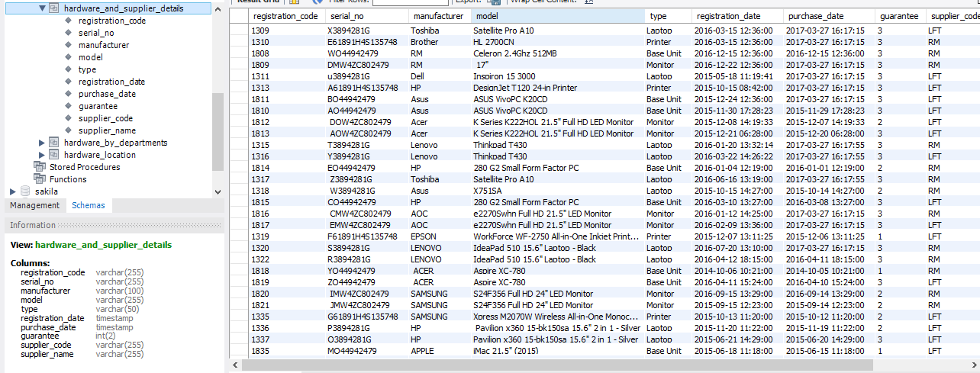

Figure Testing and validation of hardware and supplier details

1. The next step is to test and validate the maintenance history on individual items of a hardware. For this verification were introduced the details of job description, registration device, details of device, details of the device job type. This was made by came with the output of ***device_maintenance_history***:

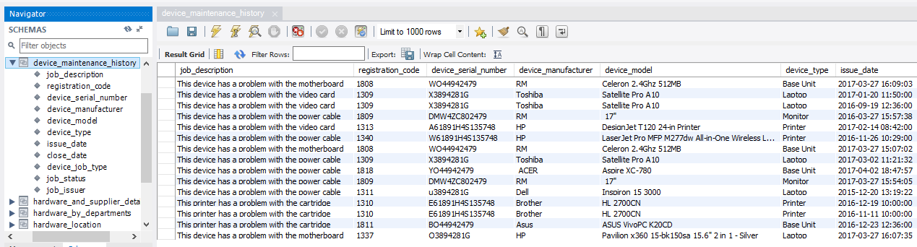

Figure Testing and validating the maintenance history of hardware

1. The next test is related to test and validate the records of hardware allocated to subject areas. To realise this test were introduced the details of device inventory, department location and details of each department. This was made by came with the output of ***device_maintenance_history***:

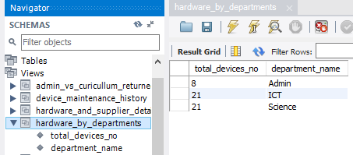

Figure Testing and validating the number of hardware items for each department area

1. The following test is regarding the testing and validating the records related to the location for each device across the college. For this were necessary the details of device inventory, device registration, device details, device type, department location and details of campus college’s buildings location. This was made showing the output of ***device_maintenance_history***:

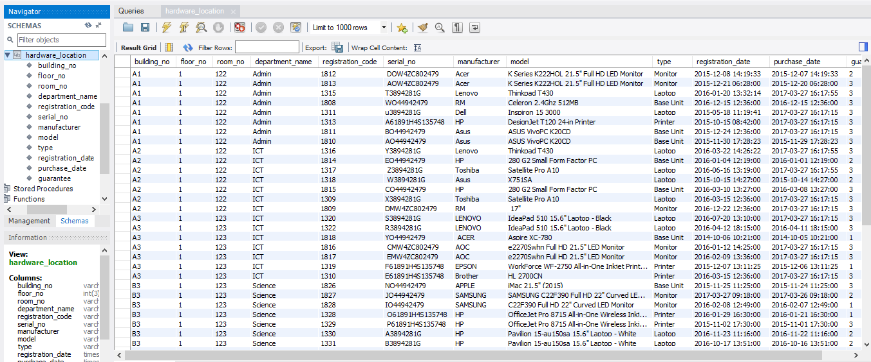

Figure Testing the records of hardware location across the college

1. The next test will come with the test and validation of the government returns on the number of Base Units allocated to Admin vs Curriculum. For this were necessary the details of total number of PCs for Administration Department vs Curriculum departments (ICT department and Science Department). For this query were necessary the details of each department involved:

* device job
* device job type
* device inventory
* device registration
* device
* device type
* department location
* department

This was made by showing the output of ***admin_vs_curicullum_returned***:

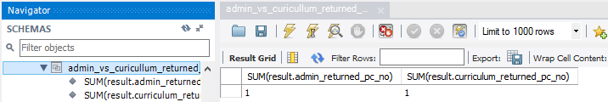

Figure 6 Testing the number of PCs returned of Admin vs Curriculum departments

1. Test of Update Data in ict_hardware_inventory Database

The data can be updated for a particular id. The next case will show if the data of a device can be updated by selecting the model data (Satellite Pro A10) of device id 1 from device table and inserting new data for the same id device with another value (Satellite Pro A11):

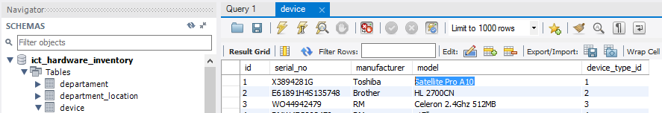

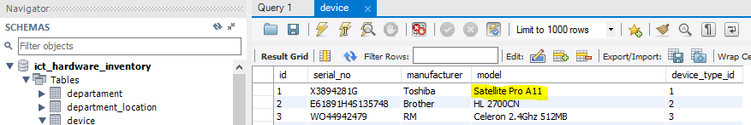

Figure Testing the update data

1. Test of insert new data for the system inventory

The next test is related to insert new data for a new job of a device by selecting device_job table and add new data after the last job of a hardware and apply the changes:

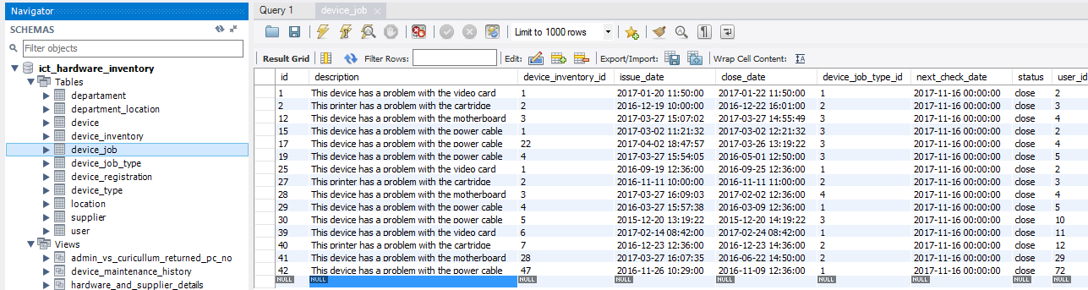

Figure Testing of insert new data in the database

## Alternative Methods to Solve the Problem

ICT Department of Melchester College may use the alternative methods to address the problems in keeping records of all the devices across the college. To record and keep details evidence of devices, suppliers, departments, maintenance history and details of maintenance could be made by creating and using Excel spreadsheets or text format documents like.txt created in Notepad or plain text with different text applications. The next alternative methods will show how they could help ICT Department of Melchester College to manage the inventory of hardware across the college, what are the main functions of these methods and the advantages and disadvantages of using them for the new inventory system:

### First Alternative Method for Solving the Problem is to Create a Spreadsheet in Excel

The Excel application is a spreadsheet processor and is part of the Microsoft Office suite.

The spreadsheet processor has the role of processing data presented as a table, so it is very used in the economic field (balance sheets, trade balances, stock merchandise), but also in other areas where the data organised in a tabular form.

Excel-managed files are located on the disk with the extension XSL (the file names being * .xls). Excel organises the information as a book or workbook containing multiple sheets, so the default filename is Book n, where n is the number of the book. The name can be changed by the user through the Save As option on the File menu. Multiple spreadsheets can be opened simultaneously.

Advantages of Personal Surveys

* Costs of data collection significantly smaller
* Fairly high response rate
* Links can be made between older Windows programs that do not allow other pathways
* Changes can be made to the source files, and changes occur automatically in the documents to which they were linked
* Linked files need less memory than embedded files
* Since the document and data are included in the same file, it no longer depends on links, access paths, and source files
* Source data should not be retained
* The changes do not have to be entered in the source application

Disadvantages

* Do not allow query operations
* Request a lot of work because the graphical interface
* Documents containing inserted objects are bulkier
* After the edits, the resolution of images is poorer in comparison with the source document

### Second Alternative Method for Solving the Problem is to Create a File Text in Notepad

Text files contain the information stored in the form of a string (possibly on several lines, but it is known that the end of the line is also a character). The most used application for text files is Notepad.

***Advantages***

* Storing text has as its main advantage of the human readable format of the information. This means that at any time it can open the file in a publisher and it can interpret what it writes directly to it, without the need for another application. (Example: C sources). Costs of data collection significantly smaller
* Links can be made between older Windows programs that do not allow other pathways
* Since the document and data are included in the same file, it no longer depends on links, access paths, and source files
* Source data should not be retained
* The changes do not have to be entered in the source application

***Disadvantages***

* text information occupies more than binary formats and is hard to be processed by programs
* Do not allow query operations
* Request a lot of work because the graphical interface

# Task 3 Describe Three Appropriate Information Systems Stating the Function which each Performs

An information system is a set of interrelated and interconnected data which provides information to the management as and when required. In specific term, it is a study of the network that helps House of Fraser organisation to collect, interpret process, create and distribute the data (Demeulemeester, 2013).

Useful Information System depends on the different business capacities of House of Fraser company, for example, management, transaction, decision support, production, marketing, finance and personnel and so forth. These divisions or capacities are known as useful functional areas for HoF. Each functional area obliges applications to play out all data handling identified with the capacity of company. The prevalent functional areas of House of Fraser are:

1. Management Information System (MIS)
2. Transaction Processing System (TPS)
3. Decision Support System (DSS)
4. Financial Information System
5. Marketing Information System
6. Production/Marketing Information System
7. Human Resource Information System

It will be described the first three functional areas that the organisation uses:

## Management Information System (MIS)

It is the study of people, technology and organisation which helps in decision making. In this context, MIS plays a major role in providing information to anyone involved in the management of HoF (House of Fraser).

In the same way as Decision-Support System (DSS) is an activity decisional which relate to decisions on short term which are executed by top managers of the company and by the heads of sectors which approved the plan for the activity on a short-term basis. However, the information should serve the purpose for which it is required. With the knowledge of MIS, the employees of the company can create their system for researching and storing the data and also gains knowledge about databases, networks, computer security. MIS performs three functions:

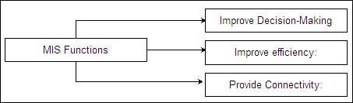

Figure 2 Functions of MIS

* + - MIS improves decision making by providing information on the various issues that enhances the quality of decision making in HoF. The management also gets supported by MIS as it provides the instant information in urgency. With its sufficient quality, it is adding to the bottom line of the organisation.
    - MIS improves efficiency which helps in enhancing the productivity of the managers and employees inside the company of HoF. MIS contributes to secure the employee rights about the information and make the system robust to handle the information according to trends and risk in the market.

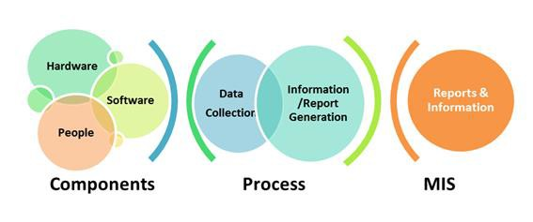

Figure MIS in business of HoF

(Source: internet MIS, 2016)

* + - MIS connects the organisation with managers and employees. Better communication helps HoF to enhance the productivity and performance of the employees.
    - MIS helps the organisation to centralise the information so that it can be secure and store effectively. The management staff of HoF can be controlled effectively for their task and objectives regards to organisation.

## Transaction Processing System (TPS)

It is part of operational management of House of Fraser, which is characteristic of the structured decisions, the information provided are:

* + - Set points, their content covering the need for information society determined by the decisions taken routine at this level
    - Detailed because the manager must know in detail the scrolling mode of activity within his area of responsibility
    - Internal Affairs
    - Presents the historical character
    - Is obtained with a certain frequency, when providing the information being the default.

TPS refers to the processing of information system for a business transaction that includes collecting, modifying and recovery of all the necessary data. House of Fraser can use this system in transacting various operations that stores and collects various data and then transfer into meaning outcomes. The famous examples of TPS are a credit card, making a cash withdrawal at ATM’s. TPS performs the same function as information systems perform i.e. input the transaction, processing the transaction and generating the output of the transaction.

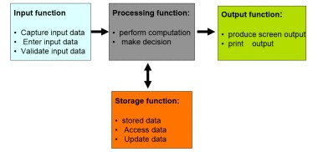

Figure Functions of TPS (Source: Internet TPS, 2016)

TPS performs the basic function in sequence:

* + - It captures the root data, enter the data in the system and correct the data errors that are known as data validation (Kantardzic, 2011).
    - It stores the data in files and database that can be accessible and ensure sequencing and update the data with that it manipulate the data that includes calculations and decision making.
    - At last, it generates the output in the form of reports such as a summary report, exception report.

## Decision Support System (DSS)

Decisional activity expressed the job of the information system to provide the necessary information to take decisions. This is fulfilled by the managers of the leading and the heads which approved the plan for the activity in the near term (plan of selling and purchasing, of raw material, of machinery), as well as the approval or amendment of the balance sheet.

It is computer application program that interprets and analyse the business data and information and presents it to the management for making effective decisions. It is different from an operational application which collects the day to day information or data for HoF. It is an informational application that collects the information from all over the segments and provides assistant for making the decision. The decision support system in HoF is used to generate the graphical data by previous activities and record in business. The organisation uses the decision support system to predict the number of products, estimation for investment, the requirement of resources and supply chain strengths. It performs three functions:

* + 1. Information Management

DSS perform this function in an efficient manner. It involves storing the data, retrieving the data and reporting the information in a structured manner. HoF uses the structured information to make it easily understandable and usable in decision system. The strength of the organisation is driven by the management of information.

* + 1. Data Quantification

DSS brief or concise a large amount of data, manipulate it and extracts the core data from the information. Data quantification in HoF helps to attain the efficiencies in business operations and forecasting. The organisation can identify the information about the users and their interest in business activities. It also helps to predict the requirements of products for the specific set of users in the market.

* + 1. Model Manipulation

DSS helps in creating and resolving the scenarios to answer the “what if” questions. It includes model forming, alternatives solutions through the use of various research or management approaches. The DSS helps HoF to find the alternative solutions and attempts to make the decision of procedures.

From the three systems, an organisation can accomplish the tactical, strategic and operational requirements in business. The information system at each level helps the organisation to run the business effectively with less effort and high performance. HoF can use the information system to make the decision in retail services and production unit. Information system helps the organisation to manage the performance at each level (Heagney, 2012). The customer can be managed effectively with the use of information system. In the case of HoF, all systems are good, but TPS is most usable to handle most of the business operations and objectives. HoF can use TPS to simplify the delivery of products to target customers and to make the payment options efficient.

*The role played by the information system within the company*

Operational activities are tactical and administrative, which relate to the various aspects of specific: testing the candidates in employment, orientation and accommodate new candidates, proper preparation of them (training them), solving the problems of security and protection of labour staff, rewarding and the wages of the staff.

Strategic activities are those relating to the planning of human resources in the long-term or the environment to meet the objectives of the organisation.

# CONCLUSION

The report has been evaluated the information requires in various functional areas of the organisation along with sustainability of information system to generate the beneficial returns in business operations. The report has been discussed how the information system can be used to solve the problems in business and how the information is trustworthy to use in the organisation. The report has also been evaluated the use of alternative methods to get the best solution for the problem. The report has been evaluated three information system to support the operational, strategic and tactic plans of the organisation.

***As regards the personal of HoF*** - organization payroll needs the equipping with high-performance computers for storing electronic information system which is reduced and the speed of work. Also, equipping with specific programs in which general manager to put the electronic signature, and the transfer of the compartments will be facilitated.

### Proposals for the improvement of the structure, functioning and monitoring of the information system of the firm

Recommendations on the improvement of the information system for House of Fraser company are:

* + - The execution of a project developed of the information system
    - Organisation and the implementation of the control system inside of HoF
    - Information for the introduction of the most modern techniques of communication of the informatics field and training of persons for their use
    - Correspondence between the information given and received and the reality of the existence to be accurate
    - Fluidity and rapidity of in compliance with the terms for the transmission of information

### Choice precede an evaluation of the design of the information system in this field of activity

In the design phase of the information system will be resolved the following problems:

* + - The granting of the plan of the information system with the strategy and the objectives of the organisation.
    - Designing the architecture of the information system in such a way as to be able to make the integration of the different databases.
    - Employment of a specialist for the notification of the problems and achieve their bookings.

### Implementation of the new information system for House of Fraser

The establishment of the stages of deployment:

The efficiency of informational systems requires a joint effort. Among the designers must be included users, the production team and personal assistance.

* Preparation of the information system
* Application of the solutions in stages and evolution of tracking them
* Correction of the disturbances in the case where they exist.

# Bibliography

Burke, W., 2013. *Organization change: Theory and practice,* s.l.: Sage Publications. Creswell, J., 2014. *A concise introduction to mixed methods research,* s.l.: Sage Publications.

Demeulemeester, E. K. R. a. S. A., 2013. *Project management and scheduling.,* s.l.: Flexible Services and Manufacturing Journal, pp.1-5.

Galbreth, M. a. G. B., 2013. *Competition and sustainability: The impact of consumer awareness,*

s.l.: Decision Sciences, 44(1), pp.127-159.

Heagney, J., 2012. *Fundamentals of project management.,* s.l.: AMACOM Div American Mgmt Assn.

Jain, P. S. S. a. Y. S., 2014. *Financial management practices.,* s.l.: Springer,

Käkölä, T. a. F. P., 2015. *Validating the Design Theory for Managing Project Scope during Software Sourcing and Delivery,* s.l.: s.n.

Kantardzic, M., 2011. *Data mining: concepts, models, methods, and algorithms.,* s.l.: John Wiley

& Sons.

Kerzner, H., 2013. *Project management: a systems approach to planning, scheduling, and controlling.,* s.l.: John Wiley & Sons.

Offenberg, D. a. P. C., 2015. *How do acquirers choose between mergers and tender offers?* s.l.: Journal of Financial Economics, 116(2), pp.331-348.

Sravanthi, G. D. M. R. S. a. R. M., 2012. *A spatial domain image steganography technique based on plane bit substitution method.,* s.l.: Global Journal of Computer Science and Technology Graphics & Vision, 12 (15).