**Pillars of Wisdom**

**Foundation Class**

**2/6/2019**

**Bet-El ‘The House of God’**

The patterns of God as seen throughout scripture paints a picture of the construction of a house from the digging of its foundations to laying the finishing touches. As we continue with our foundational exposition, we need to look at the salvation journey as a building project where God is the architect and builder. Every believer is a house unto God **1st Cor 16:19** that he desires to live in and commune with his beloved **Jn 14:23.** Salvation is not a ticket to ‘heaven’, but the start of a construction project.

Paul in his discussion with the Athenians in **Acts 17:24** made it clear that God does not live in physical buildings made by human hands. The religious attachment to physical buildings was a key reason why Jesus ensured that the temple of Jerusalem was utterly destroyed. However, due to ignorance and poor teaching the worship of physical houses of worship; church programs, events, reverence of ‘holy days’, is still present in our current religious dispensation. God is uncovering true worship by taking us back to the foundations of his working in us to build his house **Jer 6:16**. The ancient ways of God hold the blueprints and patterns for our salvation journey. What could be more ancient that the framework of the ‘Holy Trinity’ which is the divine expression of God’s relationship with himself and with his creation. The Father is the source and designer of God’s will, which is revealed and expressed through his Son, and the Holy Spirit effects this Will. God created us to function and not as spectators in a celestial wonder, but to engage and be fruitful in every sphere of life. The popular Christian notion that we were saved to go to heaven and worship God for eternity is a clear deception that has led many believers to live a fruitless, sad and depressed life. God has redeemed us to venture into the limitless, infinite, eternal Kingdom were we function with our gifts and calling in an ever expanding and revealed journey of ‘doing what I see my father do’ **Jn 5:19.**

The hallmark of salvation is based on us calling upon the name of the Lord **Rom 10:13**. Calling on this name is not just a matter of speech but a reality of life where we understand how to live based on the pattern of design and functionality God has set in our hearts **Ecc 3:11**. Simply put, the design of life is encoded in the name of the Lord. This name form a Hebraic perspective is **‘YAHWEH’** but its proper lettering contains the Hebrew letters **‘Yud’**, **‘Hei’**, **‘Vav’**, **‘Hei’**.

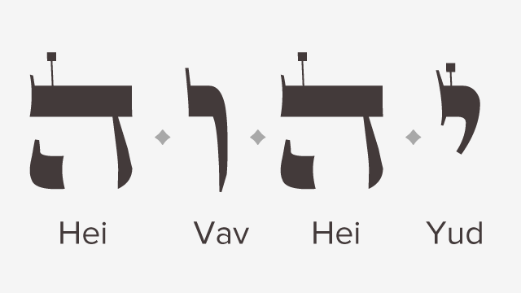

**Yud/Infinite/Heavenly/Authority/Kingship**

The Yud represents the infinite nature of God who fills all in all with his divine glory and love. This represents the heavenly realm which is the source of the blueprint of life. The divine design for every creature sits in the heavenly realm **Psa 119:89**. It is from heaven we get ideas and concepts that enable us to function. The ultimate desire of God is to build you into a house that has direct access to this realm and is functioning solely from it **Prv 16:9**. Heaven is a governmental realm which hold the power and authority of God. Believers must understand that it is not physical death that access death, but it is God who opens up this realm as we desire to know more of him and seek to apply his word in our lives. The fallen world is a hopeless plane of existence where mortals and animals pursue each day so that they can make it to the next. Kingdom life is not speculative but is concrete and sure because its design and origin was planned way before the foundations of the world. My fellow brethren in Christ, let us live in this hope that the plan and design of your life is seated in Heaven and God is building us into a house that will access this blueprint and make it functional on the earth for all eternity.

**Hey/Spiritual/Channel/Pathway/Prophetic**

The Hey represents the breath of life that God breathed into Adam **Gen 2:7** which enables us to participate in the design of life as created by God. This is the Spiritual realm which translates the blueprints of heaven into a form through which it can be executed in creation. The Spirit of God who was brooding over the waters is the same who searches the deep things of God so that he can pull from the infinite counsel of God and give us access to his divine nature. For years Christians have perfected the art of maneuvering the spiritual realm by prayer, fasting, the word and prophecy, howbeit this should be done with reference to the authentic blueprint of Heaven and directed towards functionality on earth through the Soul.

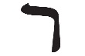**Vaw/ Soulish/Process/Human**

The Vaw represents a hook which draws the divine elements that are designed in Heaven, accessed through the Spiritual realm to the natural realm where functional manifestation takes place. In Gen 2:7 God formed Man by taking his Spirit and placing into in the human body to form the Soul. This Soul is the element chosen to transmit the heavenly and spiritual dimensions into the natural world. God’s word has the capacity to convert a fallen soul into one which is connected to heaven and is spiritually downloading his will, and bringing forth his glory onto the earth. The Soul of man is the engine and power plant that God uses to fulfill his will on the earth. The purpose of spending years studying the word is to cleanse the soul by replacing the concepts and mentalities of the world and planting the precepts of Godly wisdom, counsel, knowledge and understanding. The Soul is the essence of who you and it is a functional entity which means that true repentance and conversion involves work and fruit bearing. Since birth we have been exposed to the fallen world and functioned according to its template **Eph 2:1-2** and became masters at it **Luke 16:8**, in this respect we were simple being natural and doing what we thought was normal and alright. In our ignorance and darkness, Christ saved us and brought us into his Kingdom **Col 1:13** so that he can teach us his ways and that we function and be masters at them too. The spirit of religion denies the Soul its functional ability and keeps us in an endless cycle of poverty both spiritually and naturally. The word of God equips the soul to function and thereby bringing its full redemption **1st Thess 5:23.**

**Hey/ Earthly/Natural/Stewardship**

The second Hey represents the earthly and natural manifestation of God’s word that was designed in Heaven, accessed by the Spirit, processed by the Soul and is now being displayed on the earth. The life of a believer is like a grain of wheat that was stored in the granaries of Heaven, has been sent by the Spirit in prayer and prophecy, whose Soul has been shaped and processed so that his life in the Body is a display of God’s will. When God’s word leaves his abode, the journey taken until its display is in essence the functional capacity and structure of his house which is the manifestation of sonship **Isa 55:11**. It is the delight of heaven when a word is fully manifested on earth which is the cornerstone of eternal life.

Let us recap the key discourse of this foundational teaching. The journey of salvation is likened unto a construction project where God is actively molding and shaping us as his dwelling place. God’s divine plan is for us to function within his mandate which he prepared for each one of us before the foundation of the world. In the name of God **‘ YHVH’** is the blueprint of kingdom life which is designed and sourced in the Heavenly realm, accessed through the Spiritual realm, received and processed by the Soul and ultimately manifested by the Body in the natural realm. This pattern is eternal and death does not alter it, neither did the fall of man change God’s plan; it is as it was before the foundations of the world. This should help us evaluate our lives based on God’s eternal plan where we are being transformed and converted by his word to enable us function in our mandated sphere of life where we will eternally grow by revelation and understanding. Let us move away from the simple religious foolishness of awaiting for a speculative ‘rapture’ or awaiting to ‘go to heaven’ after we die, and venture into the depths of God’s word and engage in this beautiful, revelatory, infinite masterpiece called eternal life.

**Shallom**

**Robert Waihenya.**