Robotic vision assignment 2

Pie Detection

George Norman

21015858

Contents

Introduction 3

Design 3

State diagram 3

Lab View Code 3

What was used 6

Test table 7

# Introduction

The task is to create a pie detector using a MYRIO and a camera. Detecting the right pie and knocking bad pies away with a servo motor. This task also requires use of a light senser to trigger an LED if the light is too low and a physical button to override the system a button on the MYRIO can also be used.

The project also calls for the use of TCP and UDP.

TCP will be used for remote access of the rejection of pies the feed in which this pie detector/ rejector will get a live feed through UDP.

# Design

## State diagram

## Lab View Code

The project started by setting up the camera: screenshot bellow:

In this part of the program the camera is put through the IMAQ prosses. Also above shows the image put through cast image, this casts the image in a grey scale. The camera also gets put through a get colour pixel value which outputs the colour value.

The top IMAQ seen in this screenshot is the destination image which gets cast into grey.

At the bottom of this screenshot the detect circles block is being fed by the cast image and has an output saying number of circles detected.

Above the Circle detection is the colour match. This takes a colour sample of one of the pies. This colour is then put through a learn colour which is then put through a colour match VI which is also fed the output from the original image coming through the camera.

The colour match is then output into an index array that is then put into a case structure.

Which when true a LED on the MYRIO will light up.

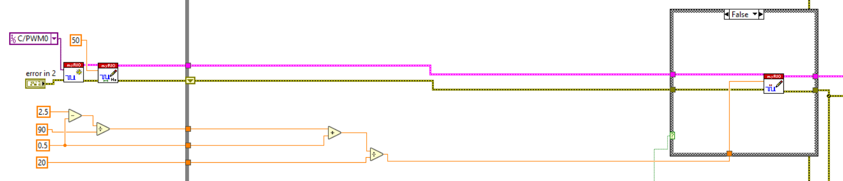

When the case structure is false meaning a colour match has not happened the servo motor will go off rejecting the false pie.

The above code shows a case structure that is connected to a physical button once pressed an LED will turn on and the servo motor will function and reject the pie this can be used for manual override.

Above is the code for the light detection which states if the light detector senses it is too dark an LED will turn on to help the camera see the pies.

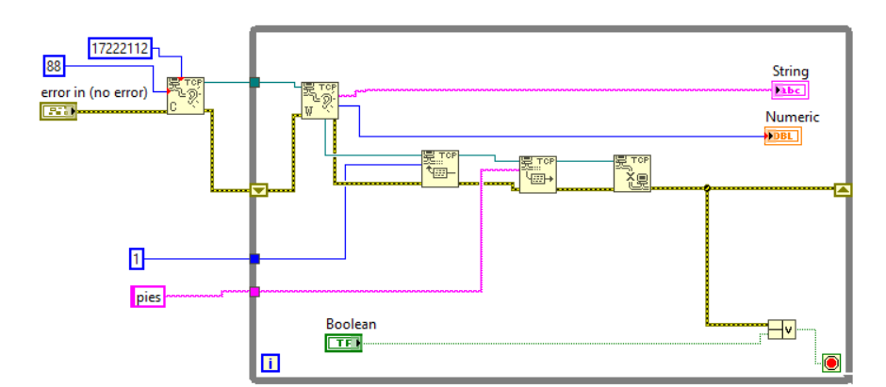

Above is the TCP it has the IP address of the RIO and output a string and numeric value.

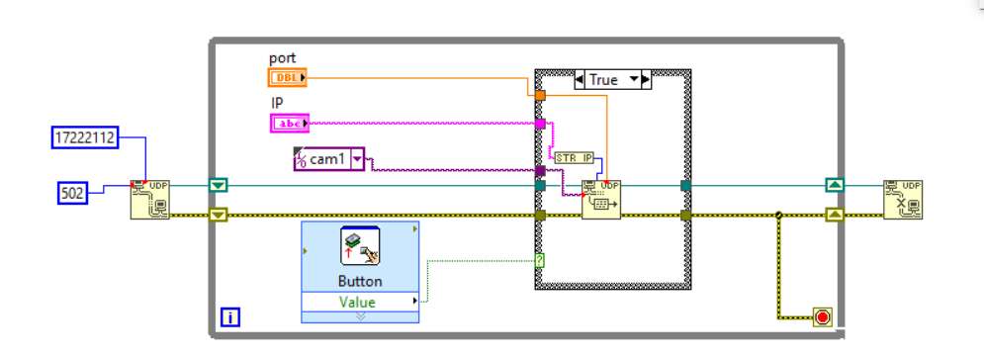

This is the UDP it takes the client IP address and sends image data for remote access so an external person can monitor the pies.

# What was used

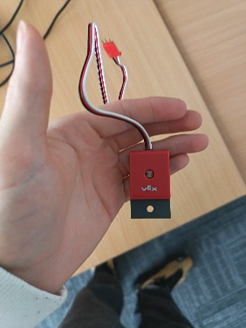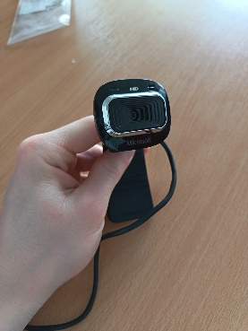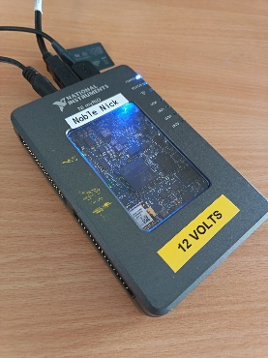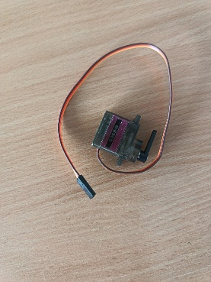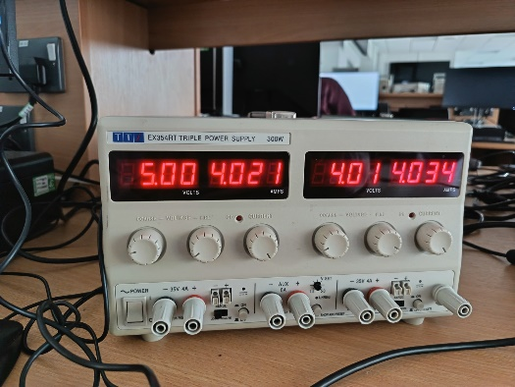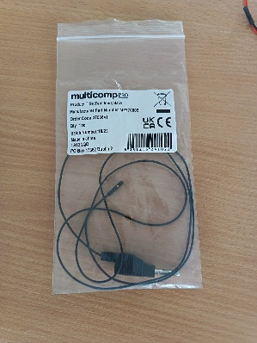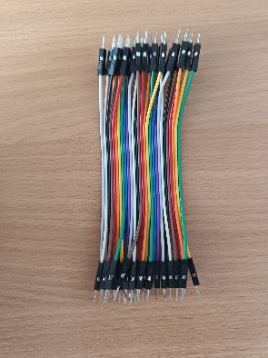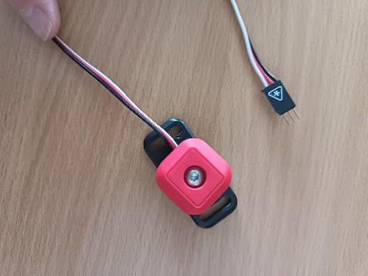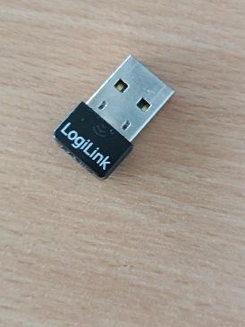

# Test table

|  |  |  |
| --- | --- | --- |
| Test | Pass | Fail |
| Camera | iiiiiiiiiiiiiiii |  |
| Servo motor | iiiiiiiiiiiiiiii |  |
| Light senser | iiiiiiiiiiiiiiii |  |
| External Button | iiiiiiiiiiiiiiii |  |
| MYRIO Button | iiiiiiiiiiiiiiii |  |
| MYRIO LED | iiiiiiiiiiiiiiii |  |
| UDP | iiiiiiiiiiiiiiii |  |
| TCP |  | iiiiiiiiiiiiiiii |