Business Intelligence Using Text Mining

Abhay Kulkarni

11/18/2019

Table of Contents

# Introduction

## What is Shark Tank?

Shark Tank is an American business reality television series on ABC that premiered on August 9, 2009.[1] The show is the American franchise of the international format Dragons’ Den, which originated in Japan as Tigers of Money in 2001. It shows entrepreneurs making business presentations to a panel of five investors or “sharks,” who decide whether to invest in their company.

# Project Objective

## Step 1

* A dataset of Shark Tank episodes is made available. It contains 495 entrepreneurs making their pitch to the VC sharks. You will ONLY use the “Description” column for the initial Text Mining exercise.
* Extract the text into text corpus and perform the following operations:
* Create Document Text Matrix
* Use “Deal” as a Dependent Variable
* Use the CART model and arrive at your CART diagram
* Build a Logistic Regression Model and find out your accuracy of the model
* Build the RandomForest model and arrive at your varImpPlot

## Step 2

* Now, add a variable to your analysis called “ratio”. This variable is “askedfor/valuation”. (This variable is to be added as a column to your dataframe in Step 1)
* Rebuild “New” models- CART, RandomForest and Logistic Regression

## Step 3

* CART Tree (Before and After)
* RandomForest plot (Before and After)
* Confusion Matrix of Logistic Regression (Before and After)

# Libraries/ Packages

library(tm)  
library(SnowballC)  
library(randomForest)  
library(RColorBrewer)  
library(wordcloud)  
library(caret)  
library(rpart)  
library(rpart.plot)  
library(caTools)  
library(latexpdf)

# Speeding Processor Cores

library(parallel)  
library(doParallel)

## Warning: package 'doParallel' was built under R version 4.0.2

## Loading required package: foreach

## Warning: package 'foreach' was built under R version 4.0.2

## Loading required package: iterators

## Warning: package 'iterators' was built under R version 4.0.2

clusterforspeed <- makeCluster(detectCores() - 1) ## convention to leave 1 core for OS  
registerDoParallel(clusterforspeed)

setwd("C:\\Users\\user\\Documents\\SharkTank_Text-Mining")  
getwd()

## [1] "C:/Users/user/Documents/SharkTank_Text-Mining"

# Import Dataset and Representation along with data cleaning

## Import Dataset

SharkTankData = read.csv("Dataset.csv", stringsAsFactors=FALSE)

## Data Cleaning

1. Transform to lower
2. Remove Numbers
3. Remove Punctuation
4. Remove Stopwords
5. Stem Document
6. Strip Whitespace

corpus = Corpus(VectorSource(SharkTankData$description))  
corpus = tm_map(corpus, content_transformer(tolower))  
corpus = tm_map(corpus, removeNumbers)  
corpus = tm_map(corpus, removePunctuation)  
corpus = tm_map(corpus, removeWords, c("the", "and", "is" , "in", "for", "where", "when","make","made","like","use","can","compani","company", stopwords("english")))  
corpus = tm_map(corpus, stemDocument)  
corpus = tm_map(corpus, stripWhitespace)

## Word Cloud

palette = brewer.pal(8, "Dark2")  
wordcloud(corpus,colors=palette, min.freq = 1, max.words = Inf,rot.per=0.35, random.order = FALSE)

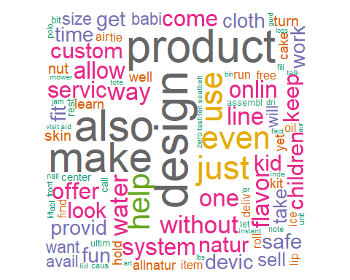

## Build a Document-Term Matrix (DTM)

DTM <- DocumentTermMatrix(corpus)  
DTM

## <<DocumentTermMatrix (documents: 495, terms: 3462)>>  
## Non-/sparse entries: 9210/1704480  
## Sparsity : 99%  
## Maximal term length: 21  
## Weighting : term frequency (tf)

## To reduce the dimensions in DTM, removeSparseTerms and sparsity less than 0.995

sparse = removeSparseTerms(DTM, 0.995)

sparse

## <<DocumentTermMatrix (documents: 495, terms: 895)>>  
## Non-/sparse entries: 6129/436896  
## Sparsity : 99%  
## Maximal term length: 21  
## Weighting : term frequency (tf)

## Let’s visualize DocumentTermMatrix

TDMplot <- as.matrix(sparse)  
TDFrequency <- colSums(TDMplot)  
TFrequencyPlot<- sort(TDFrequency,decreasing = TRUE)  
barplotTDM <- barplot(TFrequencyPlot[1:15],col='tan',las=2)

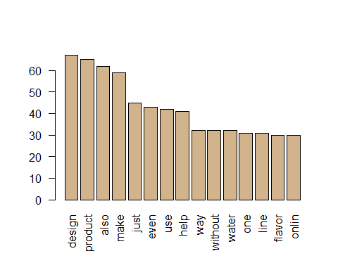

**Findings**

* The above Barplot shows us the top 15 most frequent word in the Corpus.
* Design, product, water, flavour gives us an idea of the pitch made by companies to Sharks.

## Convert to data.frame

descSparse = as.data.frame(as.matrix(sparse))

## Add dependent variable to the dataframe. “Deal” is the dependent variable

descSparse$deal <- SharkTankData$deal

## Check how many TRUE vs FALSE are there in dependent variable

table(descSparse$deal)

##   
## FALSE TRUE   
## 244 251

**Findings**

* This is a Balanced Dataset. TRUE and FALSE are almost 50% each.

## Create Backup of the dataset

backupSharkTank <- descSparse

## Encoding the target feature as factor

class(descSparse$deal)

## [1] "logical"

## Converting Deal from Logical to Factor

descSparse$deal<-as.factor(descSparse$deal)

## Checking if it converted to factor correctly

class(descSparse$deal)

## [1] "factor"

## Creating Backup of dataset

backup2shartank<- descSparse

str(descSparse$deal)

## Factor w/ 2 levels "FALSE","TRUE": 1 2 2 1 1 2 1 1 1 2 ...

# Predictive modelling.

Using ‘Deal’ as the dependent variable. Build CART, Logistic Regression and Random Forest to predict if Investors will invest in the business or not.

## Split data into Train and Test

set.seed(123)  
split = sample.split(descSparse$deal, SplitRatio = 0.8)  
training_set = subset(descSparse, split == TRUE)  
test_set = subset(descSparse, split == FALSE)

## Check Split

table(training_set$deal)

##   
## FALSE TRUE   
## 195 201

table(test_set$deal)

##   
## FALSE TRUE   
## 49 50

# CART

CARTSharkTank = rpart(deal ~ ., data=training_set, method="class")

## Plot CART Diagram

rpart.plot(CARTSharkTank)

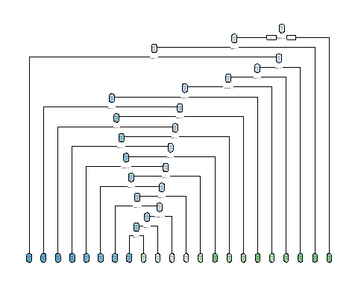

prp(CARTSharkTank, extra="auto")

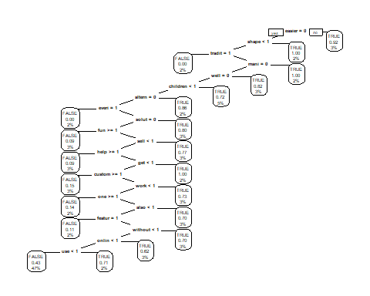

## Predicting CART Test

predictCARTest = predict(CARTSharkTank, test_set[-896], type="class")

## Evaluating CART Test Set

confusionMatrix(data = predictCARTest,reference = test_set$deal, mode = "everything",positive = "TRUE")

## Confusion Matrix and Statistics  
##   
## Reference  
## Prediction FALSE TRUE  
## FALSE 39 32  
## TRUE 10 18  
##   
## Accuracy : 0.5758   
## 95% CI : (0.4723, 0.6745)  
## No Information Rate : 0.5051   
## P-Value [Acc > NIR] : 0.095500   
##   
## Kappa : 0.1552   
##   
## Mcnemar's Test P-Value : 0.001194   
##   
## Sensitivity : 0.3600   
## Specificity : 0.7959   
## Pos Pred Value : 0.6429   
## Neg Pred Value : 0.5493   
## Precision : 0.6429   
## Recall : 0.3600   
## F1 : 0.4615   
## Prevalence : 0.5051   
## Detection Rate : 0.1818   
## Detection Prevalence : 0.2828   
## Balanced Accuracy : 0.5780   
##   
## 'Positive' Class : TRUE   
##

# Random Forest Model

## Random forest model

classifierRF = randomForest(x = training_set[-896],  
 y = training_set$deal,  
 ntree = 30)

## Predicting the Test set results

y_pred = predict(classifierRF, test_set, type="class")

## Evaluating Test Set with Random Forest

confusionMatrix(data = y_pred,reference = test_set$deal, mode = "everything",positive = "TRUE")

## Confusion Matrix and Statistics  
##   
## Reference  
## Prediction FALSE TRUE  
## FALSE 34 31  
## TRUE 15 19  
##   
## Accuracy : 0.5354   
## 95% CI : (0.4323, 0.6362)  
## No Information Rate : 0.5051   
## P-Value [Acc > NIR] : 0.30785   
##   
## Kappa : 0.0736   
##   
## Mcnemar's Test P-Value : 0.02699   
##   
## Sensitivity : 0.3800   
## Specificity : 0.6939   
## Pos Pred Value : 0.5588   
## Neg Pred Value : 0.5231   
## Precision : 0.5588   
## Recall : 0.3800   
## F1 : 0.4524   
## Prevalence : 0.5051   
## Detection Rate : 0.1919   
## Detection Prevalence : 0.3434   
## Balanced Accuracy : 0.5369   
##   
## 'Positive' Class : TRUE   
##

## variable importance as measured by a Random Forest

varImpPlot(classifierRF,main='Variable Importance Plot: Shark Tank')

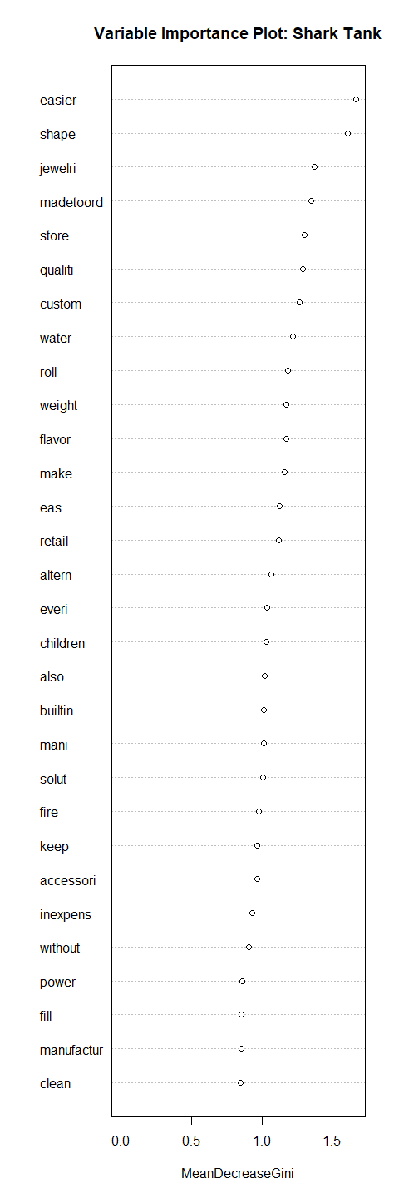

# Logistic Regression Model

## Building Logistic Regression Model

Sharktanklogistic = glm(deal~., data = training_set,family="binomial")

## Warning: glm.fit: fitted probabilities numerically 0 or 1 occurred

## Make predictions

predictLogistic = predict(Sharktanklogistic, newdata =test_set[-896],type = "response")

## Warning in predict.lm(object, newdata, se.fit, scale = 1, type = if (type == :  
## prediction from a rank-deficient fit may be misleading

predictLogistic

## 4 7 8 10 11 14   
## 1.000000e+00 1.000000e+00 1.000000e+00 1.000000e+00 2.220446e-16 2.220446e-16   
## 18 26 32 35 38 39   
## 2.220446e-16 2.220446e-16 1.000000e+00 2.220446e-16 1.000000e+00 2.220446e-16   
## 41 42 45 54 55 58   
## 2.220446e-16 2.220446e-16 1.000000e+00 1.000000e+00 1.000000e+00 1.000000e+00   
## 61 75 91 94 108 109   
## 2.220446e-16 1.000000e+00 2.220446e-16 2.220446e-16 1.000000e+00 1.000000e+00   
## 115 116 120 121 125 127   
## 2.220446e-16 2.220446e-16 1.000000e+00 1.000000e+00 2.220446e-16 1.000000e+00   
## 131 156 158 161 162 164   
## 1.000000e+00 1.000000e+00 2.220446e-16 1.000000e+00 2.220446e-16 1.000000e+00   
## 165 167 177 183 191 196   
## 1.000000e+00 1.000000e+00 1.000000e+00 1.000000e+00 1.000000e+00 1.000000e+00   
## 199 200 204 210 215 218   
## 2.220446e-16 2.220446e-16 2.220446e-16 2.220446e-16 1.000000e+00 1.000000e+00   
## 223 233 234 238 244 249   
## 2.220446e-16 2.220446e-16 1.000000e+00 1.000000e+00 1.000000e+00 1.000000e+00   
## 253 264 267 270 274 280   
## 2.220446e-16 1.000000e+00 1.000000e+00 2.220446e-16 1.000000e+00 2.220446e-16   
## 282 290 294 303 311 322   
## 1.000000e+00 2.220446e-16 2.220446e-16 1.000000e+00 1.000000e+00 1.000000e+00   
## 324 329 333 345 351 353   
## 1.000000e+00 1.000000e+00 1.000000e+00 1.000000e+00 1.000000e+00 2.220446e-16   
## 358 367 372 375 376 377   
## 1.000000e+00 2.220446e-16 1.000000e+00 1.000000e+00 2.220446e-16 2.220446e-16   
## 382 383 387 399 405 407   
## 2.220446e-16 2.220446e-16 2.220446e-16 2.220446e-16 1.000000e+00 2.220446e-16   
## 423 424 430 440 441 446   
## 1.000000e+00 1.000000e+00 1.000000e+00 2.220446e-16 1.000000e+00 1.000000e+00   
## 448 453 463 472 476 479   
## 2.220446e-16 1.000000e+00 2.220446e-16 2.220446e-16 2.220446e-16 2.220446e-16   
## 483 488 490   
## 1.000000e+00 1.000000e+00 1.000000e+00

## Evaluate the performance of the Random Forest

ypredlog <- as.factor(ifelse(predictLogistic > 0.5,"TRUE","FALSE"))

confusionMatrix(data = ypredlog,reference = test_set$deal, mode = "everything",positive = "TRUE")

## Confusion Matrix and Statistics  
##   
## Reference  
## Prediction FALSE TRUE  
## FALSE 24 18  
## TRUE 25 32  
##   
## Accuracy : 0.5657   
## 95% CI : (0.4623, 0.665)  
## No Information Rate : 0.5051   
## P-Value [Acc > NIR] : 0.1344   
##   
## Kappa : 0.13   
##   
## Mcnemar's Test P-Value : 0.3602   
##   
## Sensitivity : 0.6400   
## Specificity : 0.4898   
## Pos Pred Value : 0.5614   
## Neg Pred Value : 0.5714   
## Precision : 0.5614   
## Recall : 0.6400   
## F1 : 0.5981   
## Prevalence : 0.5051   
## Detection Rate : 0.3232   
## Detection Prevalence : 0.5758   
## Balanced Accuracy : 0.5649   
##   
## 'Positive' Class : TRUE   
##

Performance of the Models(BEFORE)

|  |  |  |  |
| --- | --- | --- | --- |
|  | CART | Random Forest | Logistic Regression |
| Accuracy | 0.5758 | 0.5859 | 0.5657 |
| Sensitivity | 0.3600 | 0.5200 | 0.6400 |
| Specificity | 0.7959 | 0.6531 | 0.4898 |

# additional variable called as Ratio which will be derived using column askfor/valuation

# New CART Model with additional Ratio variable

SharktankwithRATIO <- descSparse

SharktankwithRATIO$ratio = SharkTankData$askedFor/SharkTankData$valuation

## Split data into Train and Test

set.seed(123)  
splitnew = sample.split(SharktankwithRATIO$deal, SplitRatio = 0.8)  
Newtraining_set = subset(SharktankwithRATIO, splitnew == TRUE)  
Newtest_set = subset(SharktankwithRATIO, splitnew == FALSE)

NEWCARTSharkTank = rpart(deal ~ ., data=Newtraining_set, method="class")

## Plot CART Diagram

rpart.plot(NEWCARTSharkTank)

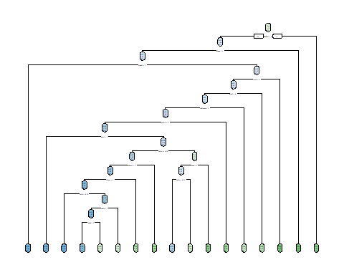

prp(NEWCARTSharkTank, extra="auto")

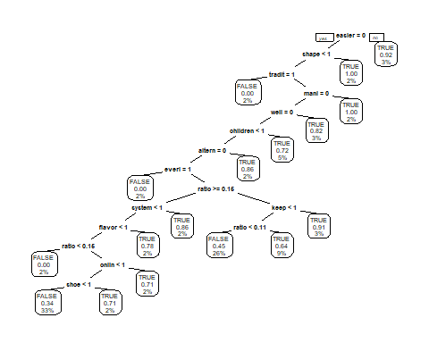

## Predicting NEW CART TestData

NewpredictCARTest = predict(NEWCARTSharkTank, Newtest_set[-896], type="class")

## Evaluating Test Set

confusionMatrix(data = NewpredictCARTest,reference = Newtest_set$deal, mode = "everything",positive = "TRUE")

## Confusion Matrix and Statistics  
##   
## Reference  
## Prediction FALSE TRUE  
## FALSE 37 37  
## TRUE 12 13  
##   
## Accuracy : 0.5051   
## 95% CI : (0.4027, 0.6071)  
## No Information Rate : 0.5051   
## P-Value [Acc > NIR] : 0.5401297   
##   
## Kappa : 0.015   
##   
## Mcnemar's Test P-Value : 0.0006068   
##   
## Sensitivity : 0.2600   
## Specificity : 0.7551   
## Pos Pred Value : 0.5200   
## Neg Pred Value : 0.5000   
## Precision : 0.5200   
## Recall : 0.2600   
## F1 : 0.3467   
## Prevalence : 0.5051   
## Detection Rate : 0.1313   
## Detection Prevalence : 0.2525   
## Balanced Accuracy : 0.5076   
##   
## 'Positive' Class : TRUE   
##

# New Random Forest Model

## New Random forest model

NewclassifierRF = randomForest(x = Newtraining_set[-896],  
 y = Newtraining_set$deal,  
 ntree = 30)

## Predicting the Test set results

Newy_pred = predict(NewclassifierRF, Newtest_set, type="class")

## Evaluating Test Set with Random Forest

confusionMatrix(data = Newy_pred,reference = Newtest_set$deal, mode = "everything",positive = "TRUE")

## Confusion Matrix and Statistics  
##   
## Reference  
## Prediction FALSE TRUE  
## FALSE 33 29  
## TRUE 16 21  
##   
## Accuracy : 0.5455   
## 95% CI : (0.4423, 0.6459)  
## No Information Rate : 0.5051   
## P-Value [Acc > NIR] : 0.24100   
##   
## Kappa : 0.0932   
##   
## Mcnemar's Test P-Value : 0.07364   
##   
## Sensitivity : 0.4200   
## Specificity : 0.6735   
## Pos Pred Value : 0.5676   
## Neg Pred Value : 0.5323   
## Precision : 0.5676   
## Recall : 0.4200   
## F1 : 0.4828   
## Prevalence : 0.5051   
## Detection Rate : 0.2121   
## Detection Prevalence : 0.3737   
## Balanced Accuracy : 0.5467   
##   
## 'Positive' Class : TRUE   
##

## variable importance as measured by a Random Forest

varImpPlot(NewclassifierRF,main='Variable Importance Plot: Shark Tank')

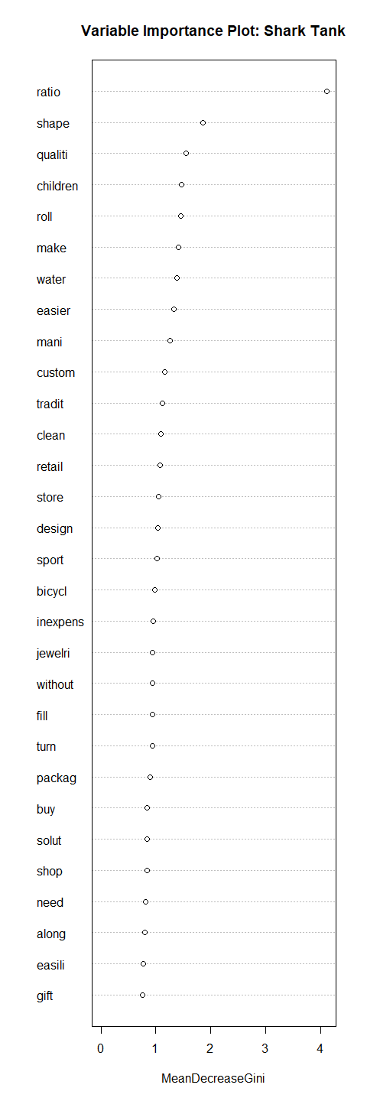

# New Logistic Regression Model

## Building New Logistic Regression Model

NewSharktanklogistic = glm(deal~., data = Newtraining_set,family="binomial")

## Warning: glm.fit: algorithm did not converge

## Warning: glm.fit: fitted probabilities numerically 0 or 1 occurred

## Make predictions

NewpredictLogistic = predict(NewSharktanklogistic, newdata =Newtest_set[-896],type = "response")

## Warning in predict.lm(object, newdata, se.fit, scale = 1, type = if (type == :  
## prediction from a rank-deficient fit may be misleading

## Evaluate the performance of the Random Forest

Newypredlog <- as.factor(ifelse(NewpredictLogistic > 0.5,"TRUE","FALSE"))

confusionMatrix(data = Newypredlog,reference = Newtest_set$deal, mode = "everything",positive = "TRUE")

## Confusion Matrix and Statistics  
##   
## Reference  
## Prediction FALSE TRUE  
## FALSE 22 18  
## TRUE 27 32  
##   
## Accuracy : 0.5455   
## 95% CI : (0.4423, 0.6459)  
## No Information Rate : 0.5051   
## P-Value [Acc > NIR] : 0.241   
##   
## Kappa : 0.0891   
##   
## Mcnemar's Test P-Value : 0.233   
##   
## Sensitivity : 0.6400   
## Specificity : 0.4490   
## Pos Pred Value : 0.5424   
## Neg Pred Value : 0.5500   
## Precision : 0.5424   
## Recall : 0.6400   
## F1 : 0.5872   
## Prevalence : 0.5051   
## Detection Rate : 0.3232   
## Detection Prevalence : 0.5960   
## Balanced Accuracy : 0.5445   
##   
## 'Positive' Class : TRUE   
##

# Conclusion

Let’s compare the accuracy of each model before ratio feature added and after ratio feature added.

## Before and After Model Comparission

|  |  |  |  |  |  |  |
| --- | --- | --- | --- | --- | --- | --- |
|  | CART(1) | CART(2) | RF(1) | RF(2) | LReg(1) | LReg(2) |
| Accuracy | 0.5758 | 0.5051 | 0.5859 | 0.5152 | 0.5657 | 0.5455 |
| Sensitivity | 0.3600 | 0.2600 | 0.5200 | 0.4200 | 0.6400 | 0.6400 |
| Specificity | 0.7959 | 0.7551 | 0.6531 | 0.6122 | 0.4898 | 0.4490 |

* CART 1 (Before) is performing better 57.58 than CART 2(After) 50.51
* RF 1 (Before ) 58.59 performing better than RF 2(After) 51.52
* Logistic Regression(1) 56.57 is better than Logistic Regression(2) 54.55
* COLUMN RATIO IS REDUCING PERFORMANCE OF ALL THE MODELS.