GAUTENG CITY COLLEGE
Knowledge · Integrity · Achievement
ADVANCED PROGRAMMING II
DATA VALIDATION SYSTEM (JAVA SWING)
Project: Aracnid Validation System

Field | Detail
Student Name | George Sewata Motseatsea
Student Number | 0507025672084
College | Gauteng City College
Course | Advanced Programming II
Lecturer | Mr Owami
Date | 20 September 2026

Table of Contents

1. Introduction
The Aracnid Validation System is a desktop application built in Java using Swing (JFrame/JPanel) as part of the Advanced Programming II module. The purpose of the system is to capture a set of personal details through a graphical user interface and validate every field in real time, giving the user immediate feedback on whether their input is acceptable before the data can be saved.
The system captures a Name and Surname, ID/Student number, Date of Birth, Gender, Contact Number and Email Address. Each field is validated using an appropriate combination of presence, type, length, format and range checks, and the result of each check is shown to the user next to the relevant field as it is typed, rather than only after clicking a button.

2. System Design
Before coding began, the interface was planned around a simple, single-panel layout so that every field, its status message, and the action buttons (Validate, Clear, Exit) would be visible at once without scrolling or switching tabs.

2.1 Layout
- A single form panel with each label directly above its input field, and a small status label directly beneath each field to carry live feedback.
- Consistent spacing between label groups so the form reads top-to-bottom in a natural order (Name → ID → Date of Birth → Gender → Contact Number → Email Address).
- The Validate, Clear and Exit buttons are grouped together at the bottom of the form so the primary actions are always in the same place.

2.2 Colour Scheme and Typography
- A dark header bar ("ARACNID VALIDATION SYSTEM") in a bold, heavy font (Arial Black) contrasts against a light grey form background, avoiding the plain default grey Swing look.
- Status text uses colour to carry meaning: green for a passed check ("Validated!") and red for a failed check, so the user can tell the state of a field at a glance without reading closely.
- A hand-drawn spider and web graphic reinforces the "Aracnid" theme and gives the form a distinct visual identity rather than a generic business form.

2.3 Usability
- Validation runs live as the user types (via a DocumentListener on each text field) instead of only when the Validate button is pressed, so mistakes are caught immediately.
- Every error message is written in plain, non-technical language (e.g. "Only 10 digits!", "Use YYYY-MM-DD") rather than exposing exception text or technical jargon.
- The Clear button resets every field and every status label back to its neutral instruction text (e.g. "Enter your ID"), so the form can be reused without restarting the application.
Figure 1 below shows the interface as implemented, matching the plan above.
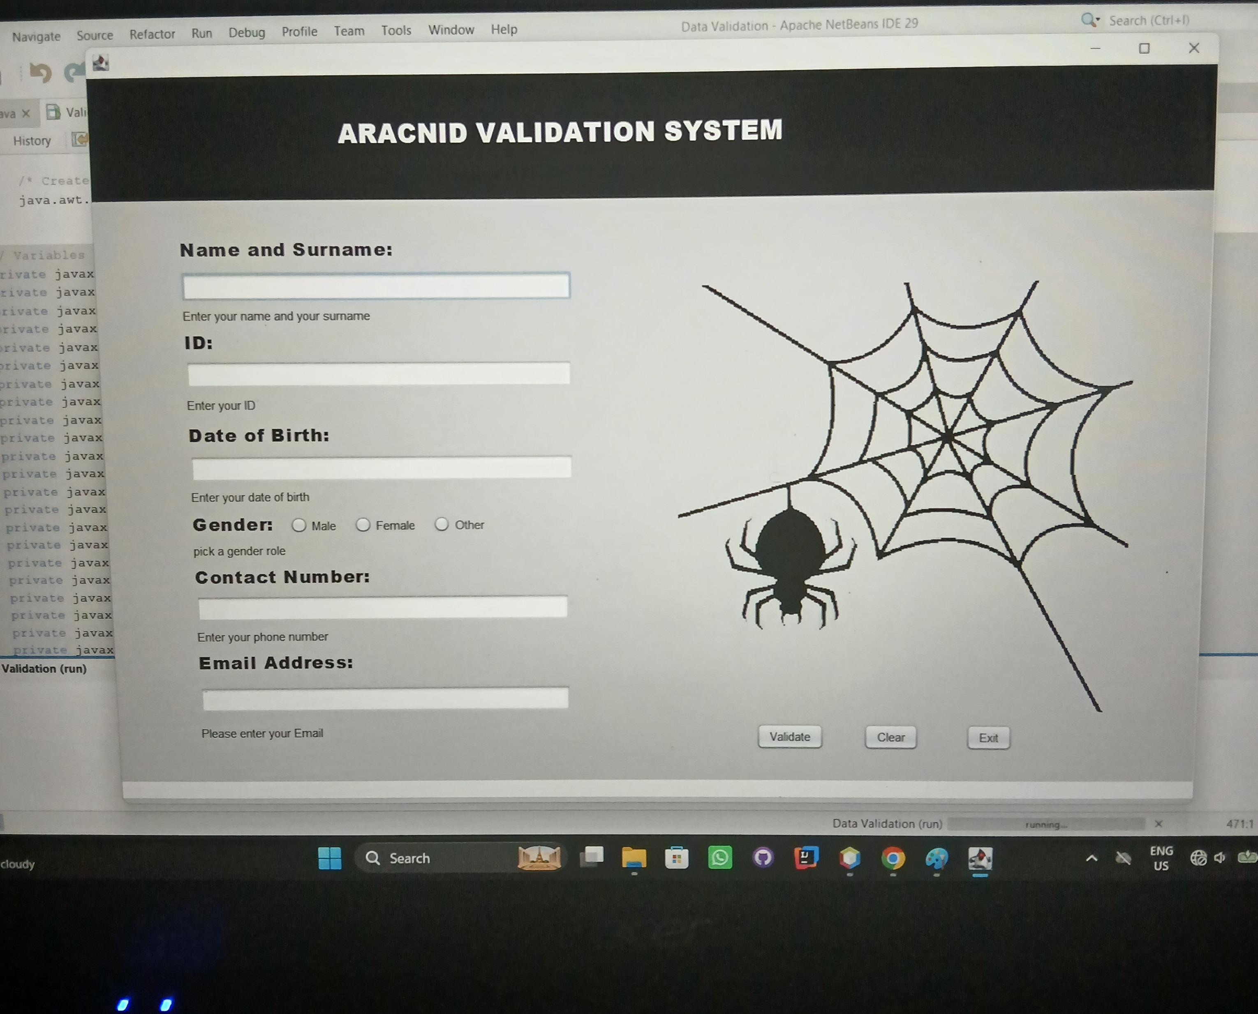
Figure 1: The Aracnid Validation System interface, showing the empty form with its neutral instruction text before any data is entered.

3. Fields
The table below lists every field captured by the form and what it is intended to capture.
Field | Purpose
Name and Surname | Captures the user's full name as free text.
ID / Student Number | Captures a numeric ID or student number used to identify the person.
Date of Birth | Captures the user's date of birth, used to confirm the person is within a realistic age range.
Gender | Captures the user's gender via a set of radio buttons (Male, Female, Other).
Contact Number | Captures a local 10-digit phone number for contacting the user.
Email Address | Captures an email address in a standard, contactable format.

4. Validation Checks
Every field is checked using one or more of the five checks required by the brief: presence, type, length, format and range. The table below explains which checks were applied to each field and why they are appropriate.
Field | Checks Applied | Why It Is Appropriate
Name and Surname | Presence; Length (minimum 2 characters) | A name cannot be blank, and a single character is not a realistic name, so a short minimum length filters out accidental input.
ID / Student Number | Presence; Type (digits only); Length (6-13 characters) | IDs and student numbers are always numeric, and most real-world ID formats fall within this length range, so this catches both letters and unrealistic lengths.
Date of Birth | Presence; Format (YYYY-MM-DD or DD/MM/YYYY, parsed as a real calendar date); Range (year between 1920 and 2010) | The format check ensures the text can actually be interpreted as a date (rejecting things like 2024-13-45), and the range check filters out unrealistic birth years.
Gender | Presence (one of Male/Female/Other must be selected) | A radio-button field only needs a presence check, since the options themselves already constrain the value to a valid type.
Contact Number | Presence; Type (digits only); Format (exactly 10 digits) | South African local numbers are a fixed 10-digit format, so an exact-length numeric check is the correct format check for this field.
Email Address | Presence; Format (regex pattern requiring text@text.text) | An email address needs to match a recognisable pattern (local part, @, domain, extension) before it can be considered contactable.

5. Testing
This section provides evidence that each validation check works as intended. Every field was tested twice: once with invalid data to confirm the correct error message appears, and once with valid data to confirm the field is accepted.

5.1 Before Testing (Invalid Data)
Figure 2 shows the form after each field was touched with no valid input entered: every field's live check has already fired and is showing its presence/format error at once, in the same run.
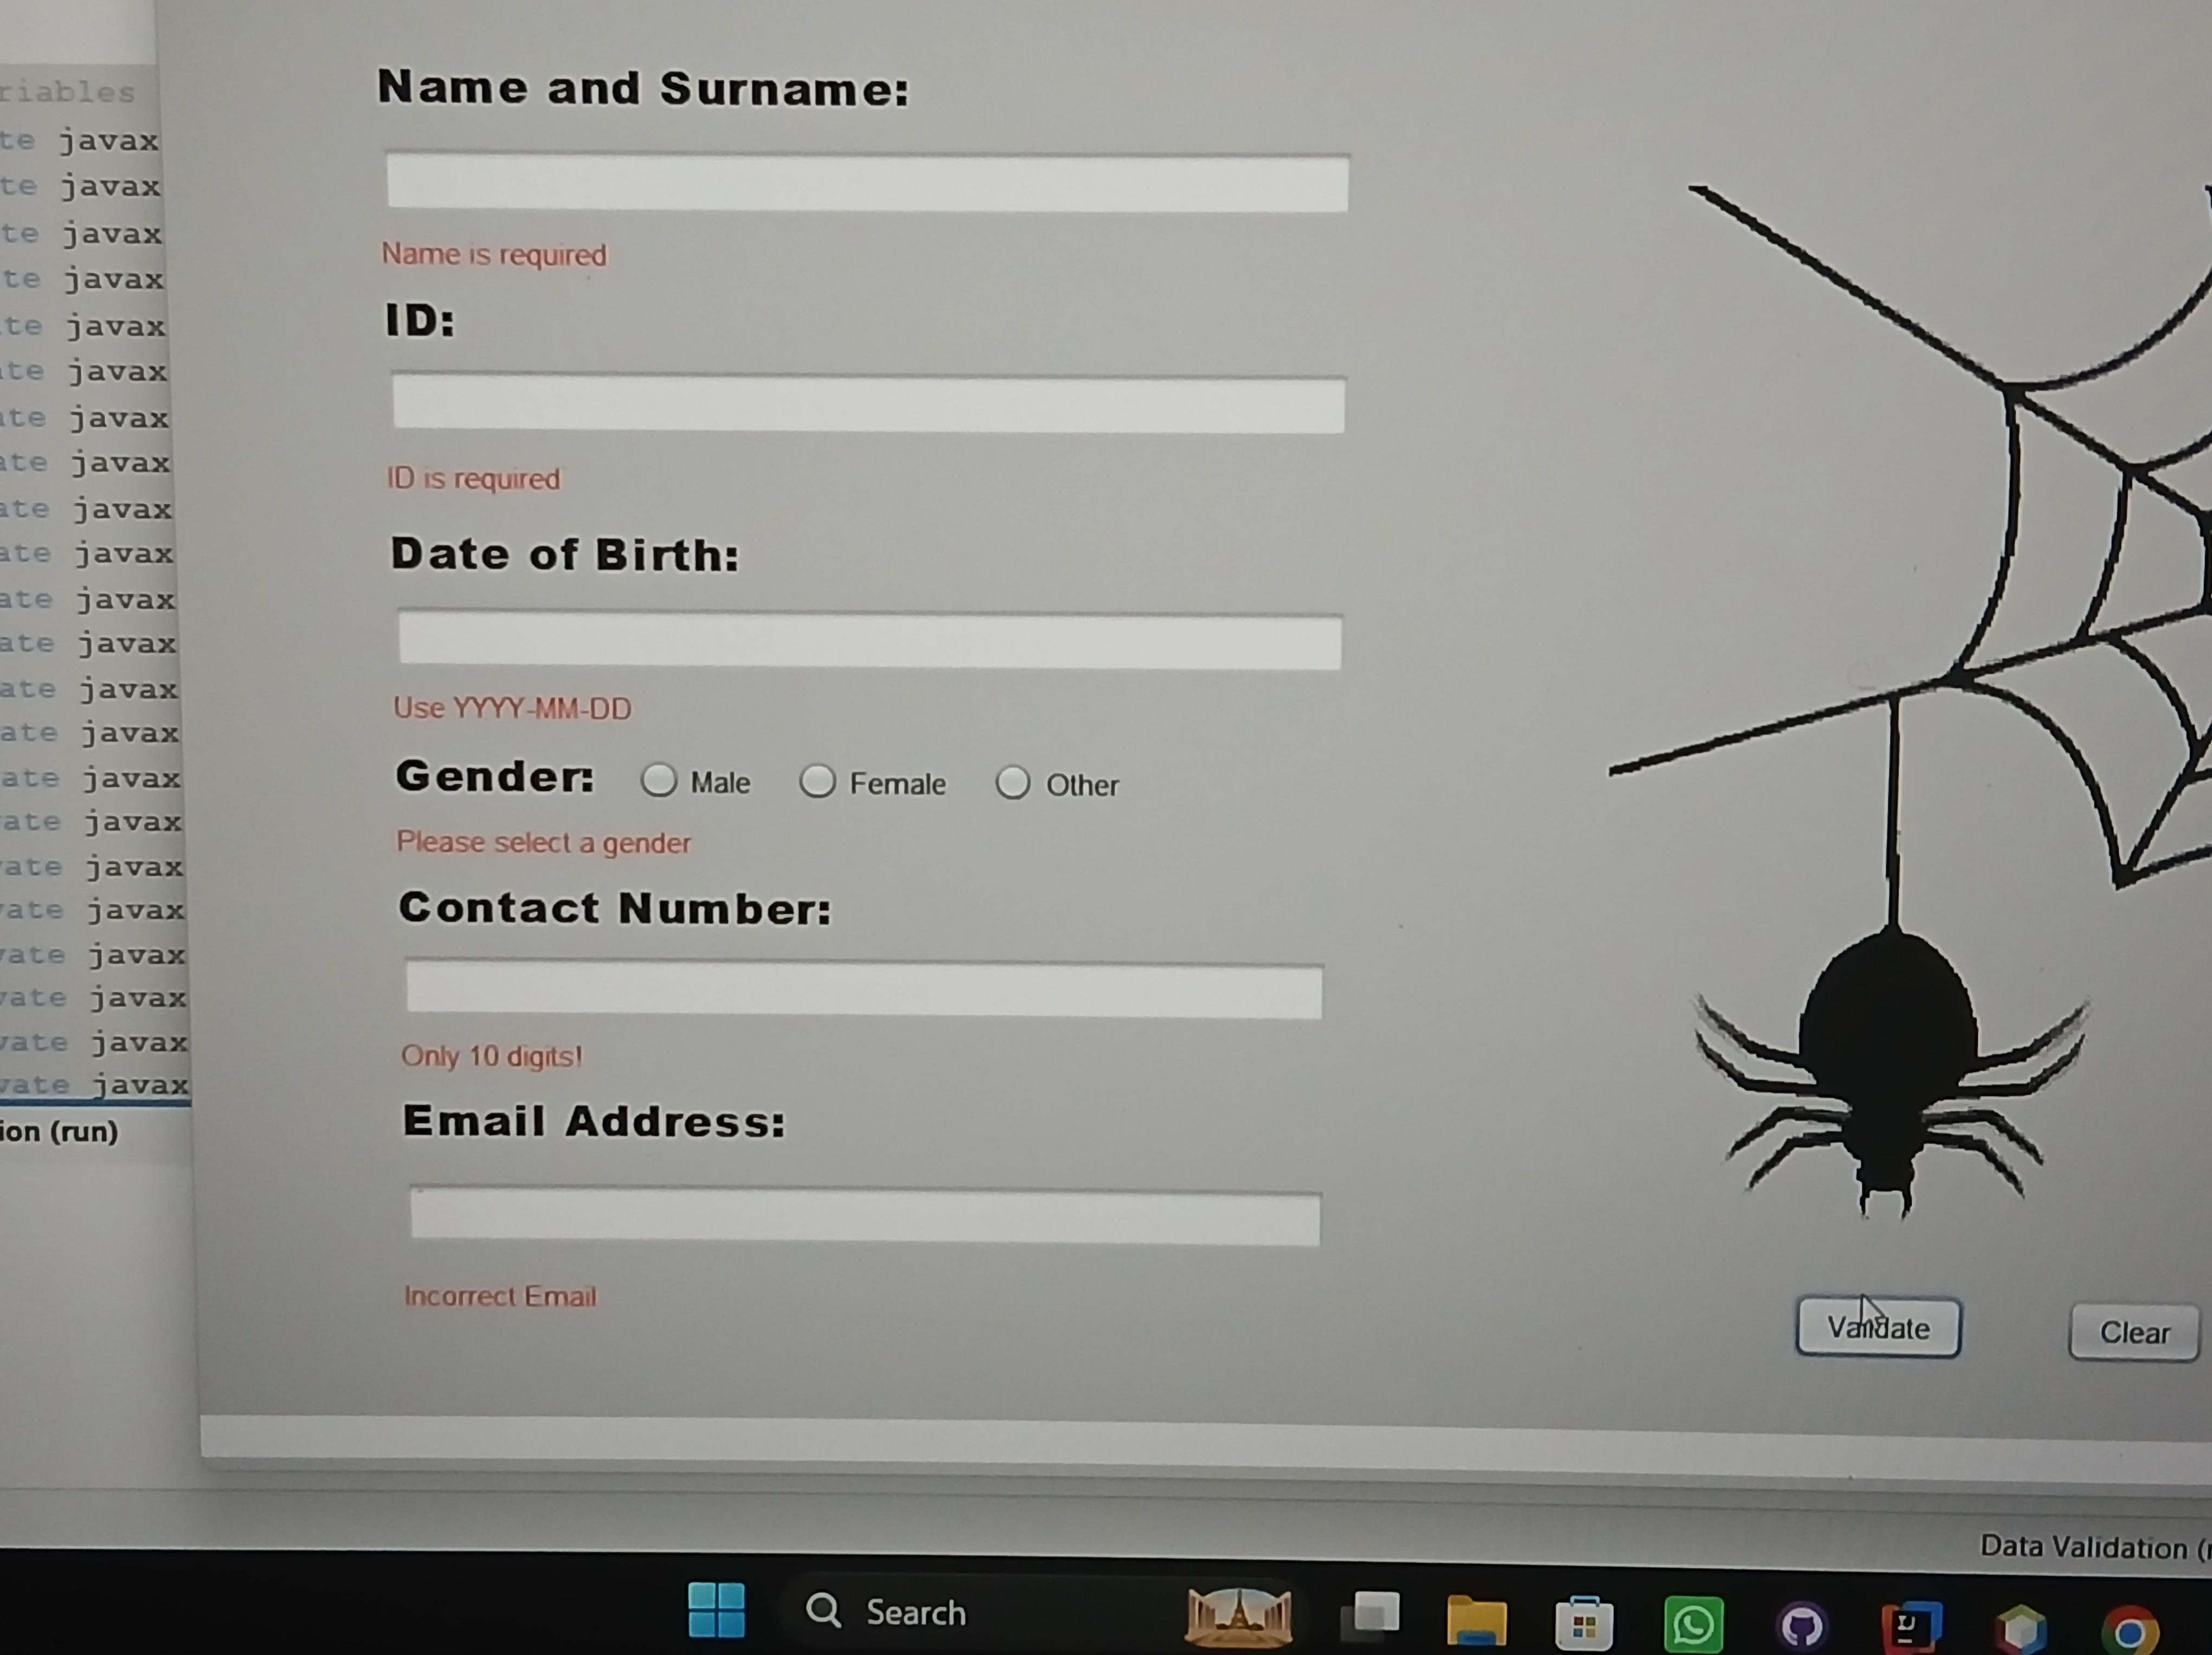
Figure 2: All fields showing their invalid-input error at once — "Name is required", "ID is required", "Use YYYY-MM-DD", "Please select a gender", "Only 10 digits!" and "Incorrect Email".
Figure 3 shows the Name field specifically after a single character ("d") was typed, demonstrating that the length check (not just the presence check) is enforced: the message changes from "Name is required" to "At least 2 characters".
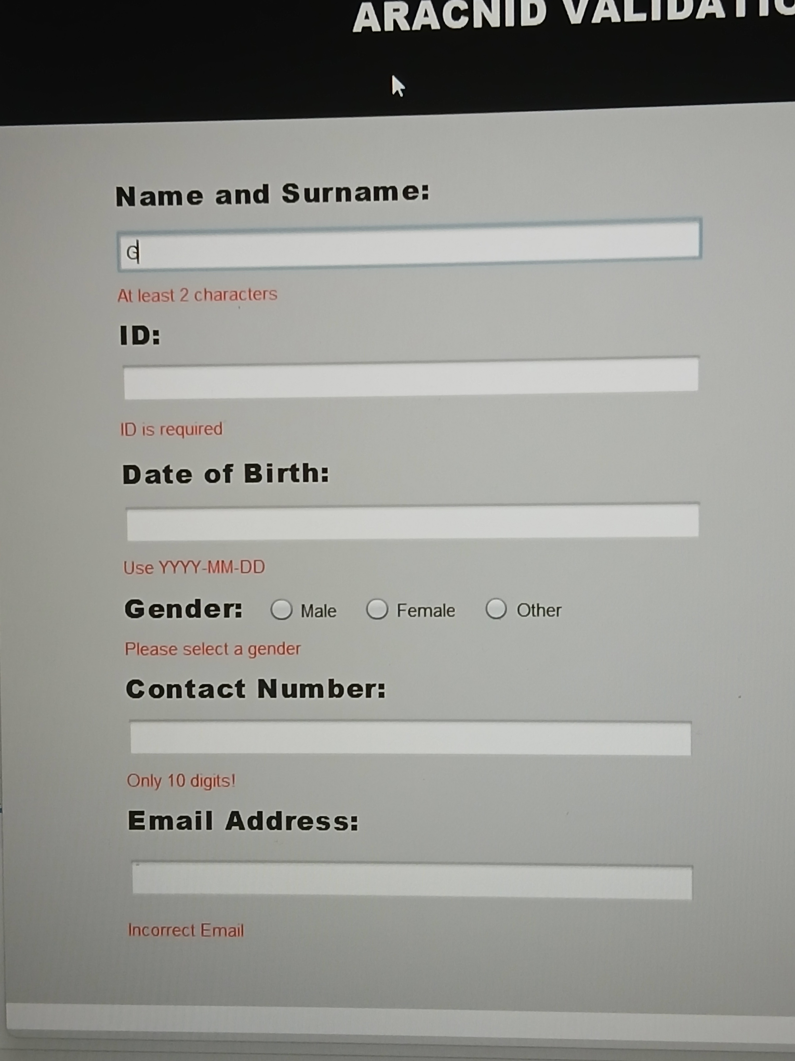
Figure 3: Name field with a single character entered, showing the length-check message "At least 2 characters" while the remaining fields still show their own errors.

5.2 After Testing (Valid Data)
The screenshots below were taken in one continuous run, correcting one field at a time, to show that each field's status is independent of the others: fixing one field turns only that field's label green while the rest keep showing their own current state.
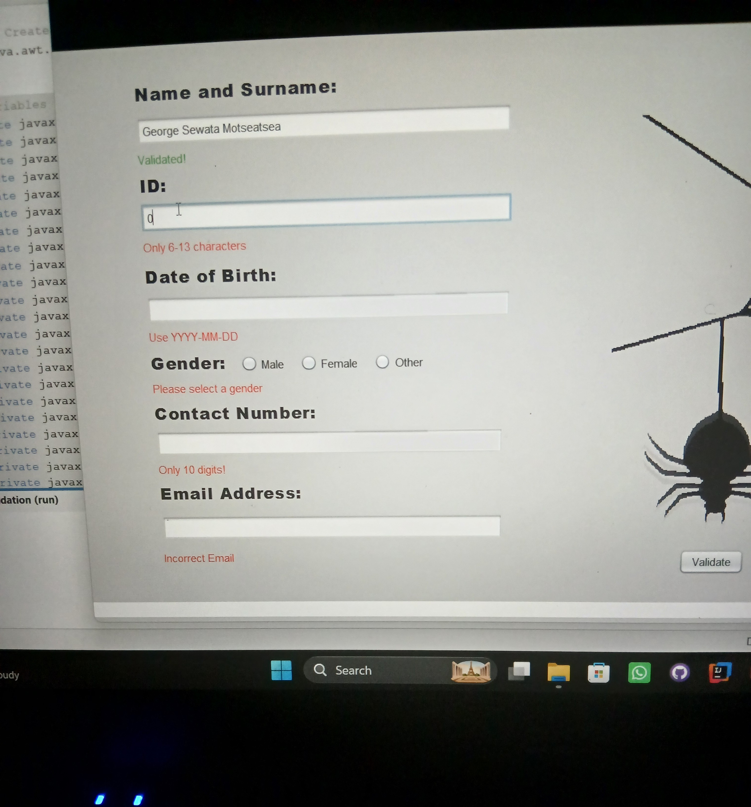
Figure 4: Name field accepted ("Validated!") after entering "George Sewata Motseatsea"; ID, Date of Birth, Gender, Contact Number and Email Address are still pending/invalid.
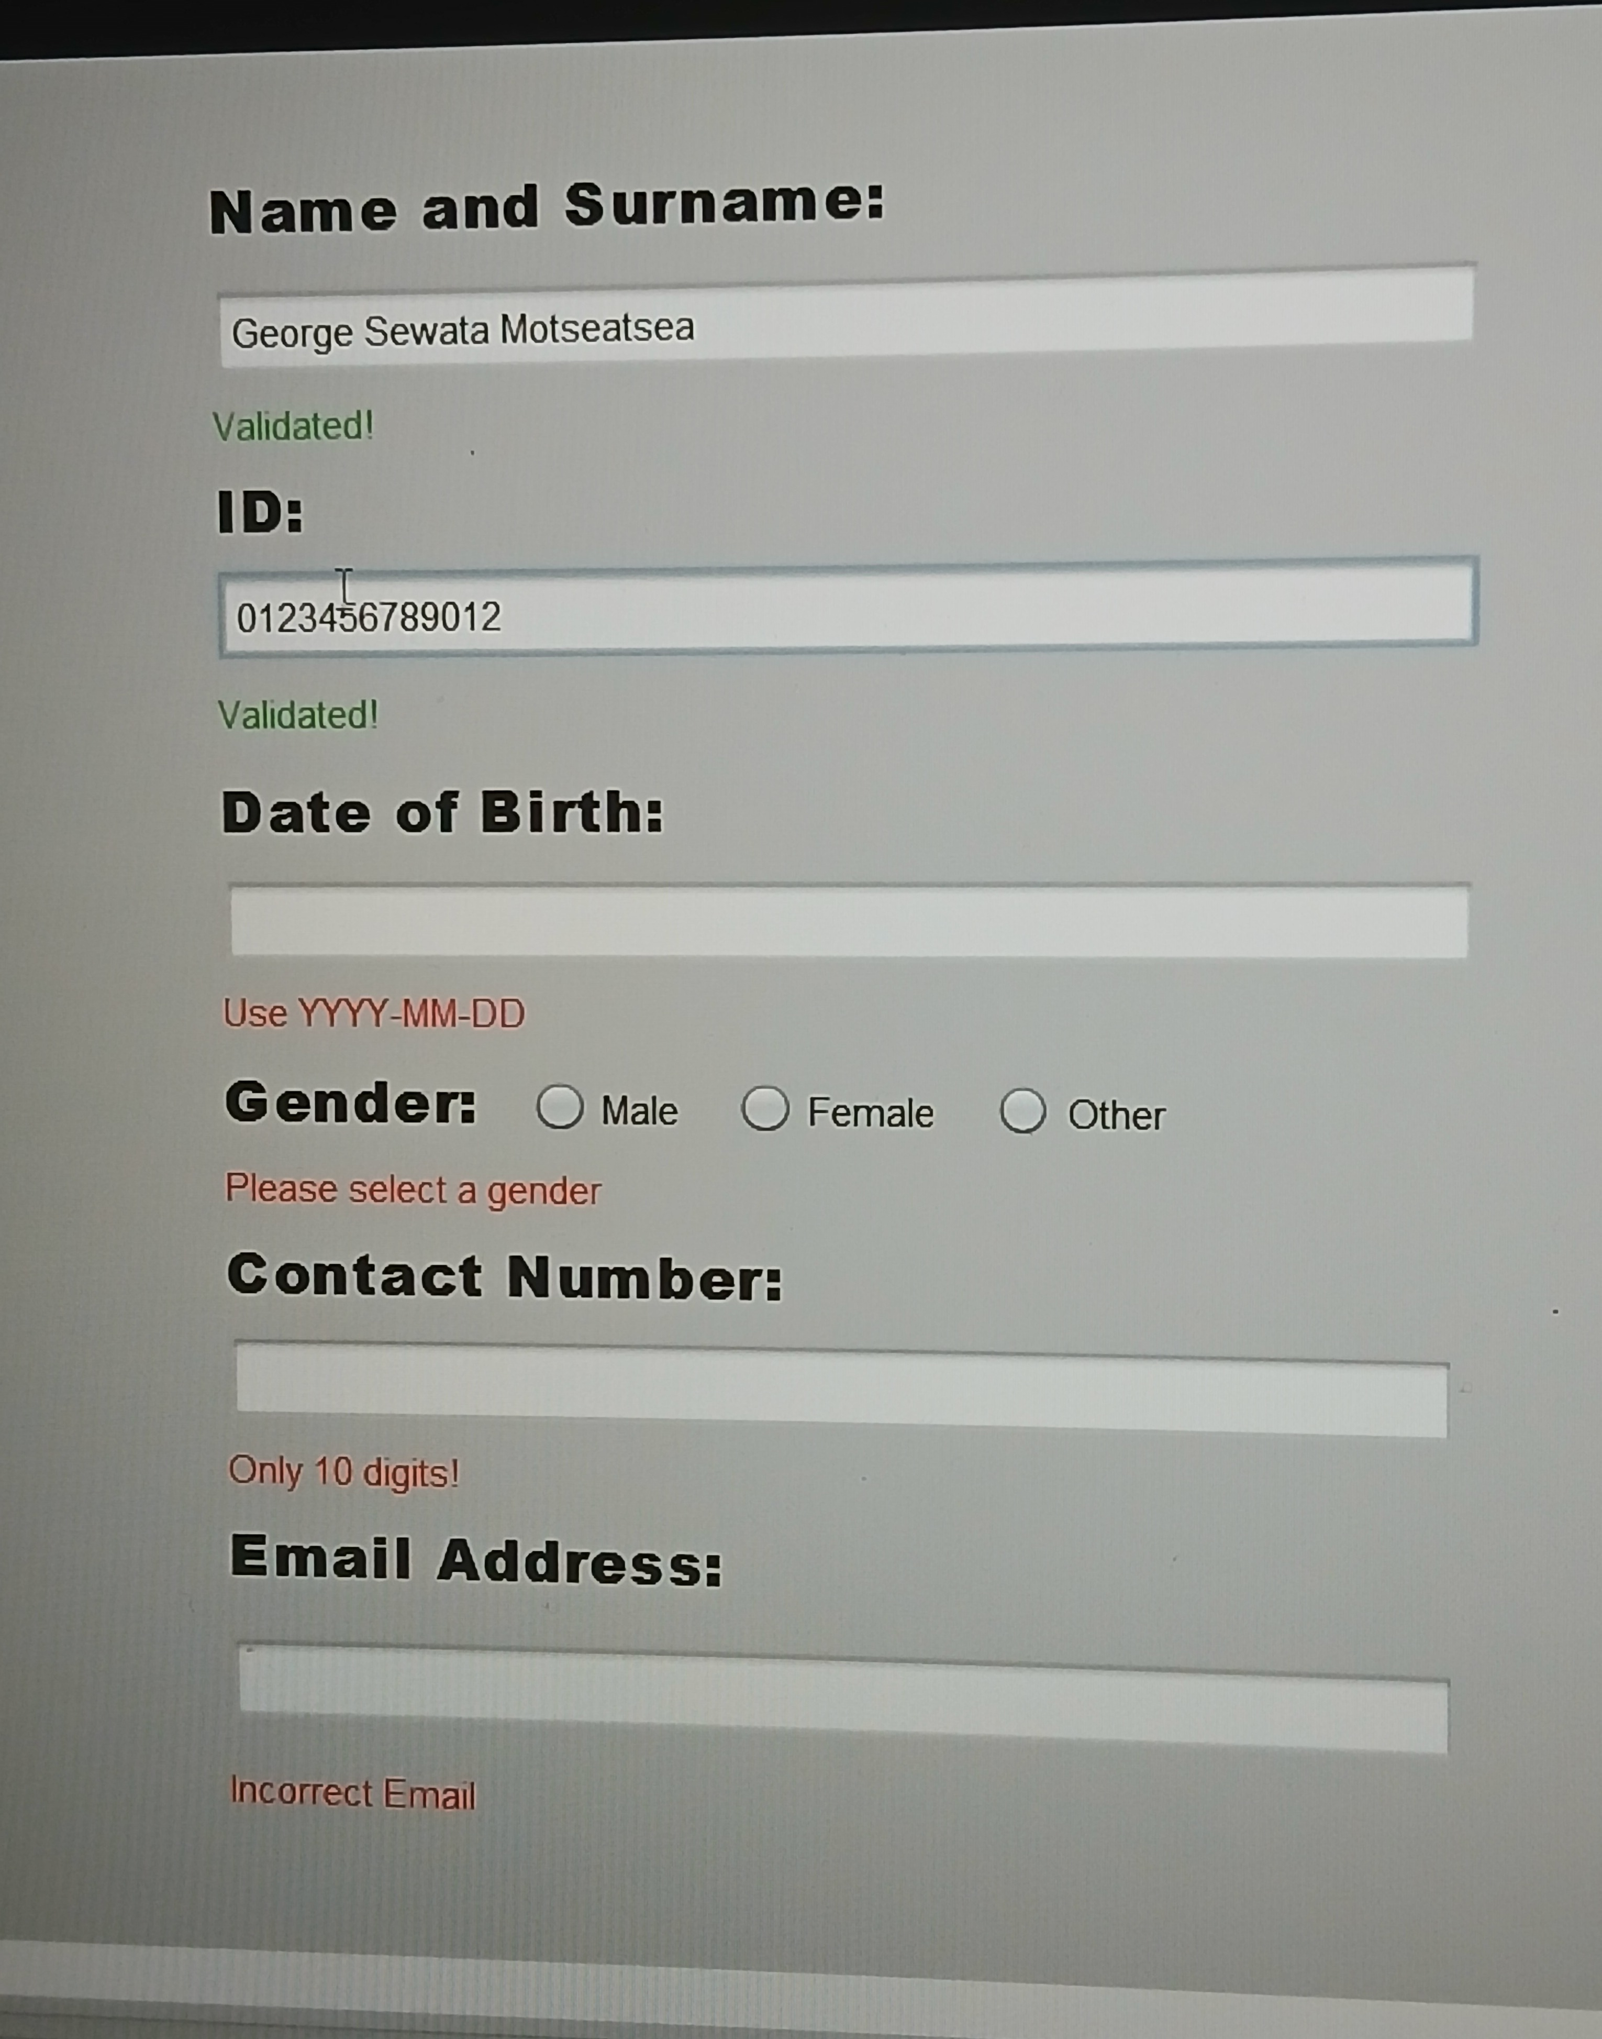
Figure 5: ID field also accepted after entering the 13-digit numeric value "0123456789012".
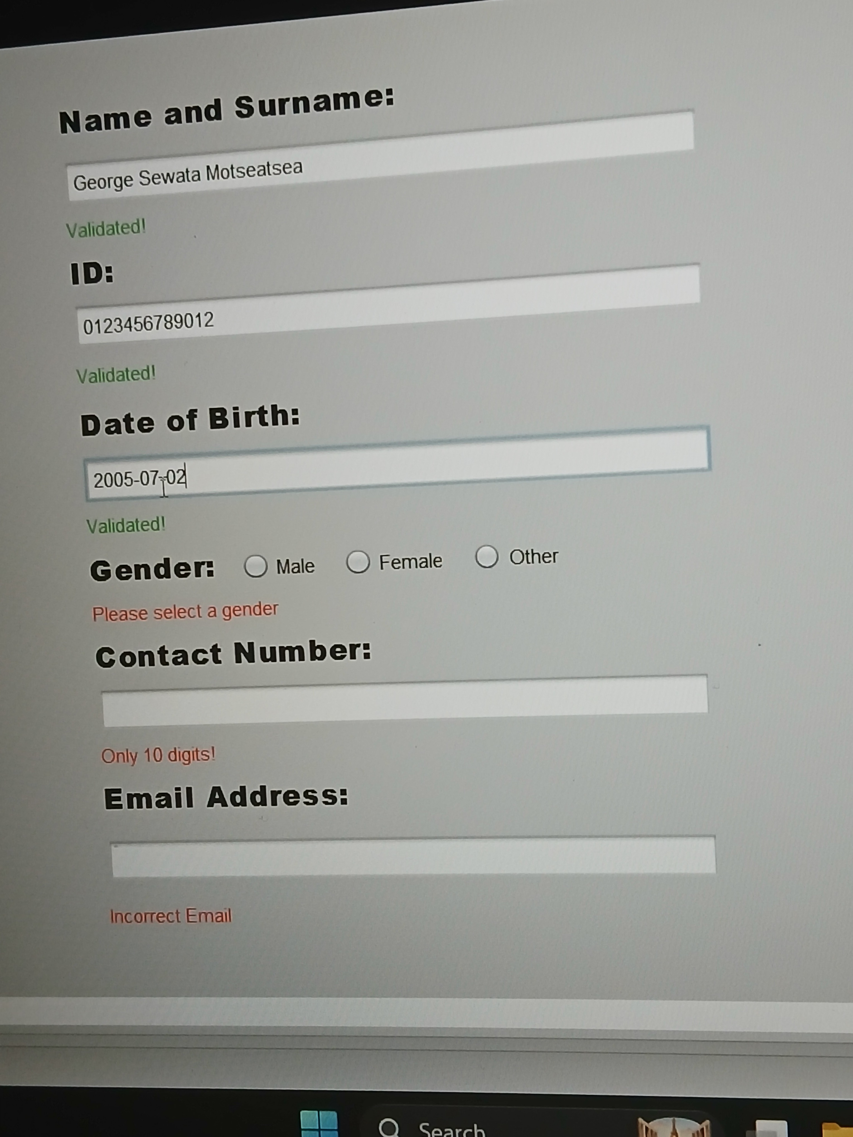
Figure 6: Date of Birth field also accepted after entering "2005-07-02", which passes both the format check and the 1920-2010 range check.
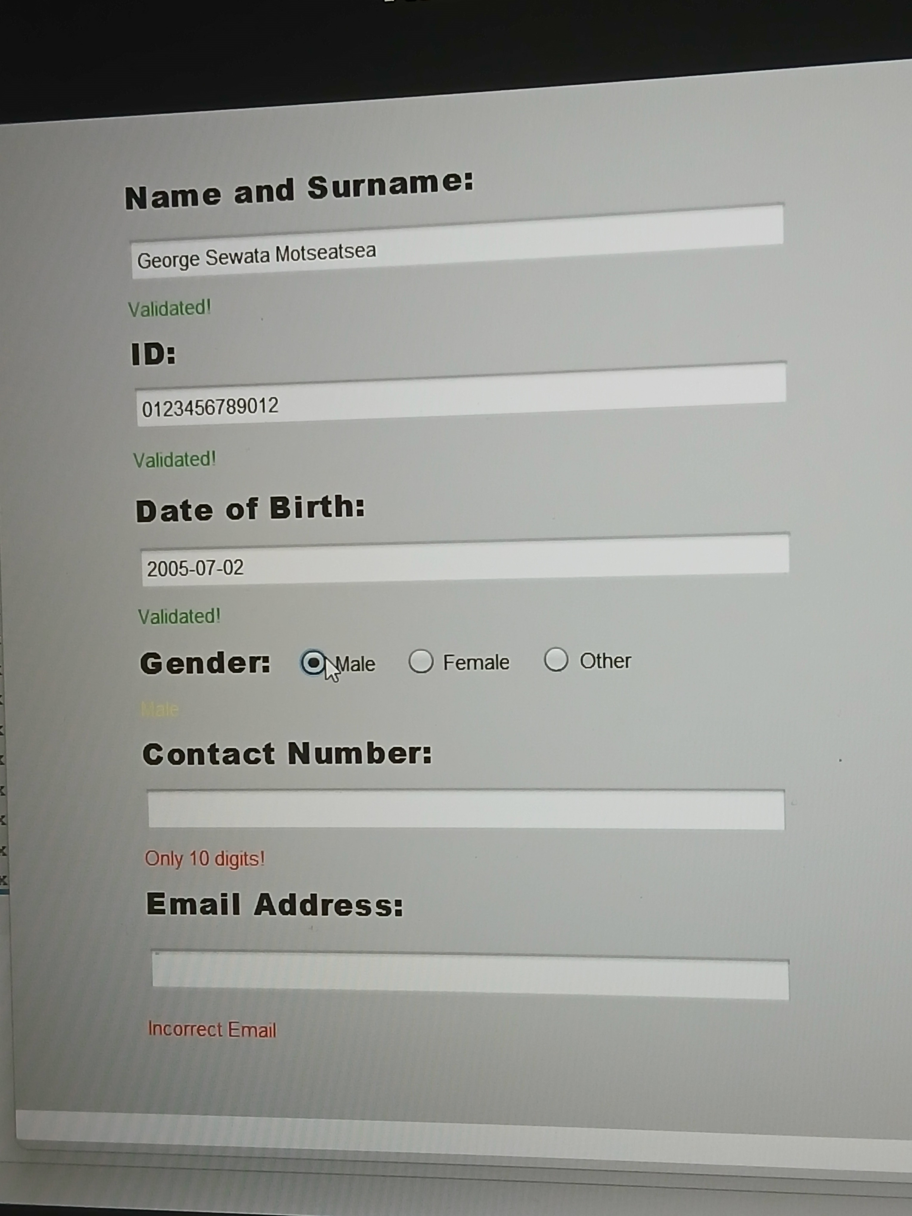
Figure 7: Gender also accepted after selecting "Male"; the status label echoes the selected value.
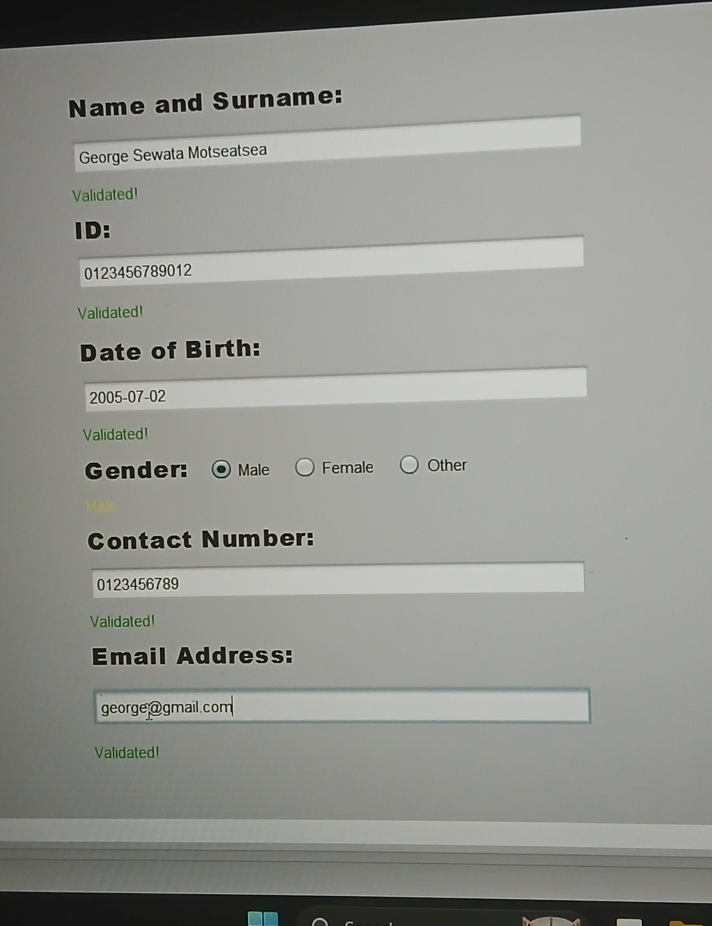
Figure 8: Contact Number ("0123456789") and Email Address ("george@gmail.com") also accepted — every field now reads "Validated!".

5.3 All Input Valid
Figure 9 shows the completed form once every field has passed validation and the Validate button has been pressed, triggering the success dialog.
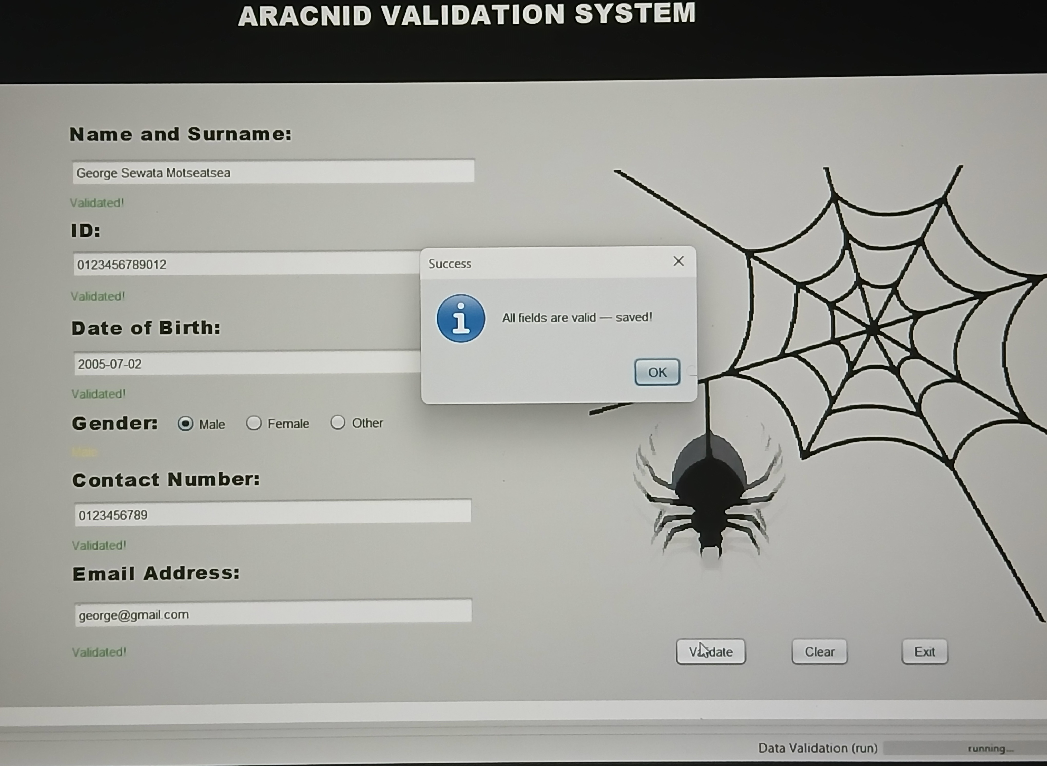
Figure 9: Completed form with all fields validated and the "All fields are valid — saved!" success dialog shown.

6. Code
This section walks through the key parts of the source code. The full source is available in the GitHub repository linked in Section 7; the sections below are the parts most relevant to how validation works.

6.1 Wiring up live validation
In the constructor, setupLiveValidation() is called straight after initComponents() so that every listener is attached as soon as the form is built.
public Validation() {
initComponents();
setupLiveValidation();
}
setupLiveValidation() attaches a live check to every text field and a click listener to each gender radio button. addLiveCheck() is a small helper that wraps a JTextField's Document in a DocumentListener, so any insert, removal or change of text in that field immediately re-runs its validation method.
private void setupLiveValidation() {
addLiveCheck(txt1, this::validateName);
addLiveCheck(id, this::validateId);
addLiveCheck(dob, this::validateDob);
addLiveCheck(contact, this::validateContact);
addLiveCheck(email, this::validateEmail);

male.addActionListener(e -> validateGender());
female.addActionListener(e -> validateGender());
other.addActionListener(e -> validateGender());
}

private void addLiveCheck(javax.swing.JTextField field, Runnable check) {
field.getDocument().addDocumentListener(new javax.swing.event.DocumentListener() {
public void insertUpdate(javax.swing.event.DocumentEvent e) { check.run(); }
public void removeUpdate(javax.swing.event.DocumentEvent e) { check.run(); }
public void changedUpdate(javax.swing.event.DocumentEvent e) { check.run(); }
});
}

6.2 Showing feedback
Every validation method reports its result through one shared helper, setStatus(), which sets the status label's text and colours it green for a pass or red for a fail. Keeping this in one place means every field gives feedback in exactly the same visual style.
private void setStatus(javax.swing.JLabel label, boolean ok, String message) {
label.setText(message);
label.setForeground(ok ? new java.awt.Color(0, 170, 0) : java.awt.Color.RED);
}

6.3 An example field check: Date of Birth
The Date of Birth check is the most involved, since it needs a format check and a range check together. It accepts two different date formats, parses the text into a real java.time.LocalDate (which rejects impossible dates such as 2024-13-45 on its own), and then checks that the resulting year is realistic.
private boolean validateDob() {
String v = dob.getText().trim();
try {
java.time.LocalDate parsed;
if (v.matches("^\\d{4}-\\d{2}-\\d{2}$")) {
parsed = java.time.LocalDate.parse(v,
java.time.format.DateTimeFormatter.ofPattern("yyyy-MM-dd"));
} else if (v.matches("^\\d{2}/\\d{2}/\\d{4}$")) {
parsed = java.time.LocalDate.parse(v,
java.time.format.DateTimeFormatter.ofPattern("dd/MM/yyyy"));
} else {
throw new java.time.format.DateTimeParseException("Bad format", v, 0);
}
int year = parsed.getYear();
if (year < 1920 || year > 2010) {
setStatus(dobStatus, false, "Year must be 1920-2010"); return false;
}
setStatus(dobStatus, true, "Validated!");
return true;
} catch (Exception e) {
setStatus(dobStatus, false, "Use YYYY-MM-DD");
return false;
}
}
The remaining fields (Name, ID, Contact Number, Email Address and Gender) follow the same pattern: read the field's text, run the checks that are appropriate for that field's type, call setStatus() with the result, and return a boolean so the Validate button can know whether the whole form passed.

6.4 Gating the Save/Validate action
The Validate button re-runs every field's check using the & operator (rather than &&) so that all six checks run and update their status labels, even if an earlier one has already failed. The dialog only appears once every single check has returned true.
private void ValidateBtnActionPerformed(java.awt.event.ActionEvent evt) {
boolean allValid = validateName() & validateId() & validateDob()
& validateContact() & validateEmail() & validateGender();
if (allValid) {
javax.swing.JOptionPane.showMessageDialog(this,
"All fields are valid — saved!", "Success",
javax.swing.JOptionPane.INFORMATION_MESSAGE);
}
}

7. GitHub Repository
The full source code for this project is hosted at:
https://github.com/GeorgeSew/Input-Validation-System
To clone and run the project:
- Clone the repository: git clone https://github.com/GeorgeSew/Input-Validation-System.git
- Open the project folder in Apache NetBeans (File → Open Project).
- Locate Validation.java and run it (right-click → Run File), or run the project's main class.
- The repository includes a README.md describing the project and these run instructions in more detail.

8. Conclusion
Building the Aracnid Validation System meant moving from a single "click Validate and see a popup" approach to live, per-field feedback using DocumentListener — restructuring one long validation method into separate reusable methods per field.

The Date of Birth field caused two bugs along the way. First, a logic error: splitting the date string on '-' or '/' to get the birth year quietly broke depending on the format typed in. Switching to java.time.LocalDate.parse() fixed it properly, since it validates the whole date at once. Second, a missing closing brace while restructuring that method caused a cascade of confusing compiler errors elsewhere in the code — a good reminder that scattered NetBeans errors often trace back to one missing brace near the first one.

Overall, the project gave me hands-on experience with Swing event handling (DocumentListener, ActionListener), regex validation, and the java.time API — plus a better sense of how small touches, like per-field status labels, improve a form's usability.

9. References
- Oracle. (n.d.). Java Platform, Standard Edition Documentation. Retrieved from https://docs.oracle.com/en/java/javase/
- Oracle. (n.d.). How to Write a Document Listener. The Java Tutorials. Retrieved from https://docs.oracle.com/javase/tutorial/uiswing/events/documentlistener.html
- Oracle. (n.d.). Class LocalDate. Java SE Documentation. Retrieved from https://docs.oracle.com/en/java/javase/17/docs/api/java.base/java/time/LocalDate.html
- Apache NetBeans. (n.d.). Apache NetBeans IDE Documentation. Retrieved from https://netbeans.apache.org/kb/docs/index.html
- [Add any additional tutorials or sources you personally consulted.]

