
dgs266 NAAL rEPORT
XOR Gate project

March 25, 2026
cHIH-Hsiang tsao
Bindu Kansara

Introduction (project details)
This project is to design and build a digital logic circuit using XOR gates. The circuit uses four push buttons as inputs (A, B, C, and D) and one LED as the output.
The main function of the circuit is to perform a 4-input XOR operation. The output LED turns ON when there is an odd number of HIGH inputs, and turns OFF when there is an even number of HIGH inputs.
In this project, the circuit was first tested on a breadboard to verify its functionality. Then, the schematic and PCB layout were designed using Fusion 360. Finally, all components were soldered onto the PCB to complete the final circuit.
This project provides a fundamental understanding of digital logic design, XOR gate operation, and basic PCB design and soldering techniques.

Logic Diagram and Truth Table (of the circuit)
A | B | C | D | Y
0 | 0 | 0 | 0 | 0
0 | 0 | 0 | 1 | 1
0 | 0 | 1 | 0 | 1
0 | 0 | 1 | 1 | 0
0 | 1 | 0 | 0 | 1
0 | 1 | 0 | 1 | 0
0 | 1 | 1 | 0 | 0
0 | 1 | 1 | 1 | 1
1 | 0 | 0 | 0 | 1
1 | 0 | 0 | 1 | 0
1 | 0 | 1 | 0 | 0
1 | 0 | 1 | 1 | 1
1 | 1 | 0 | 0 | 0
1 | 1 | 0 | 1 | 1
1 | 1 | 1 | 0 | 1
1 | 1 | 1 | 1 | 0
Table 1: Truth table of the 4-input XOR circuit.

Bread Board Picture/Screenshot (plus 2-3 working conditions from truth table)
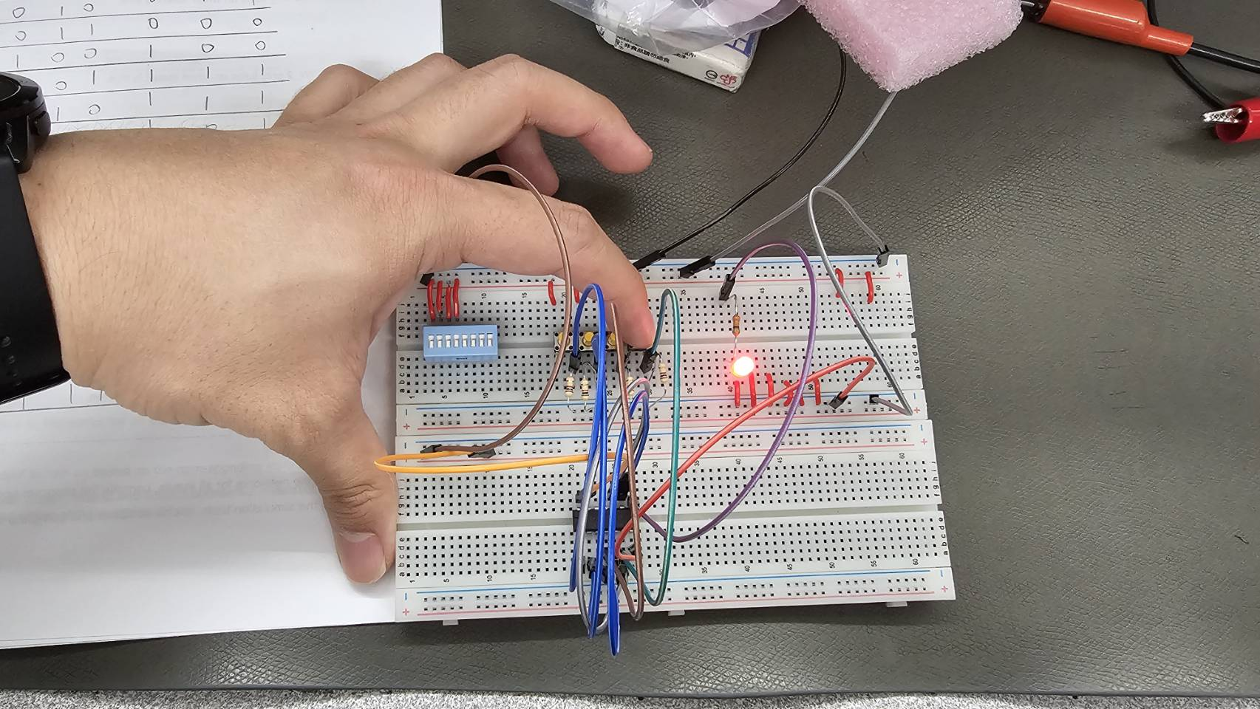
Figure 1: Breadboard implementation. A=0 B=0 C=0 D=1 → Output=1 (LED ON)
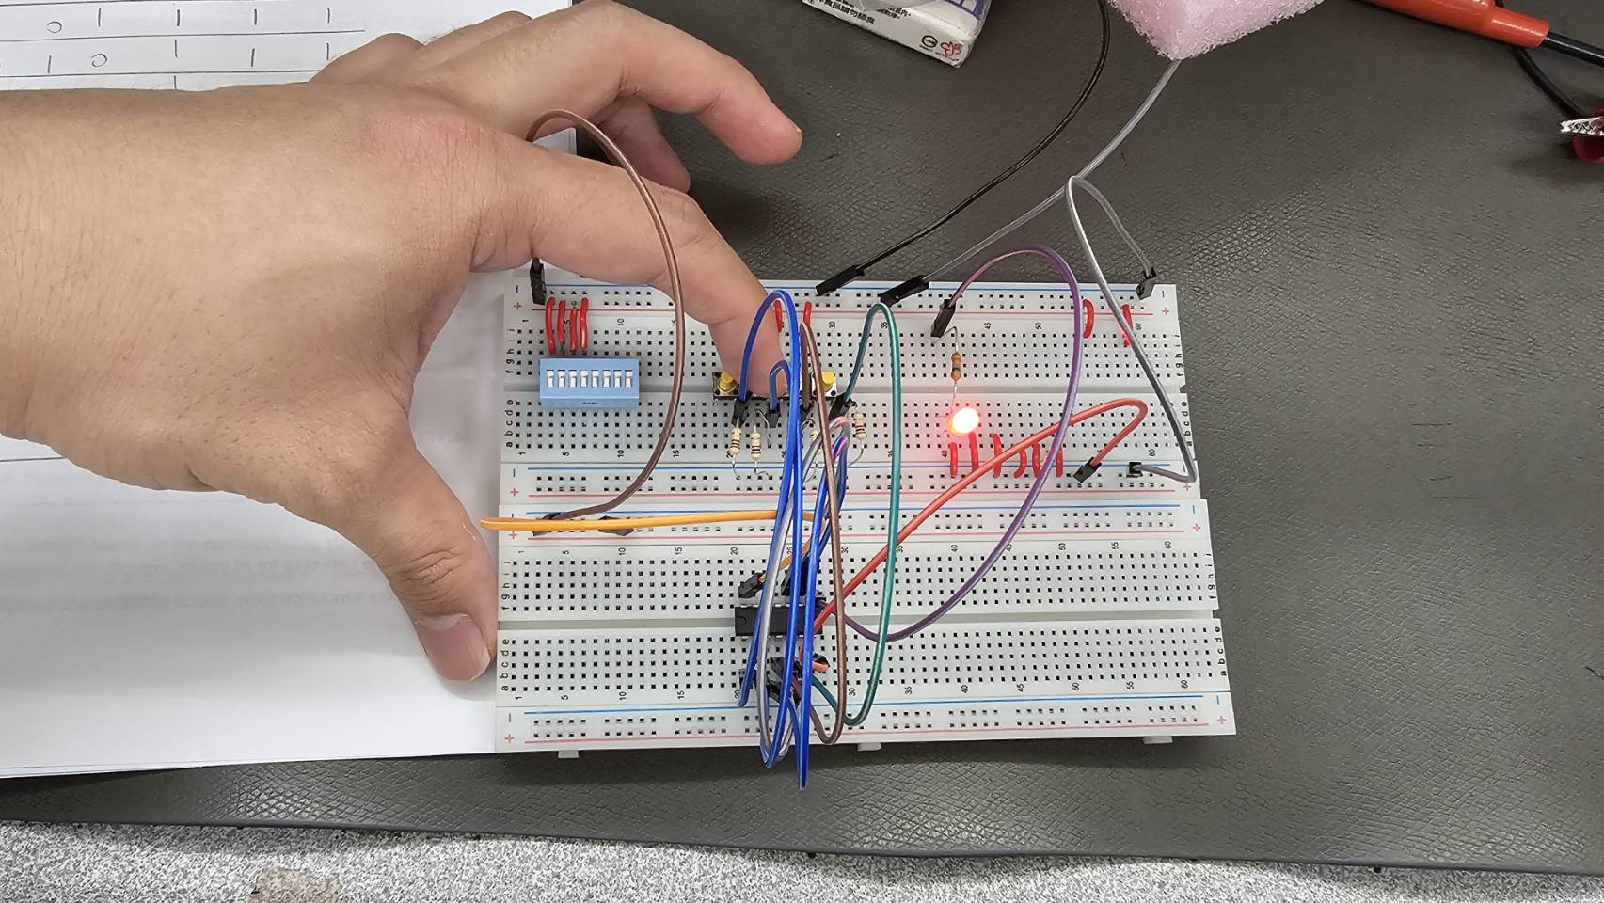
Figure 2: Breadboard implementation. A=0 B=1 C=0 D=0 → Output=1 (LED ON)
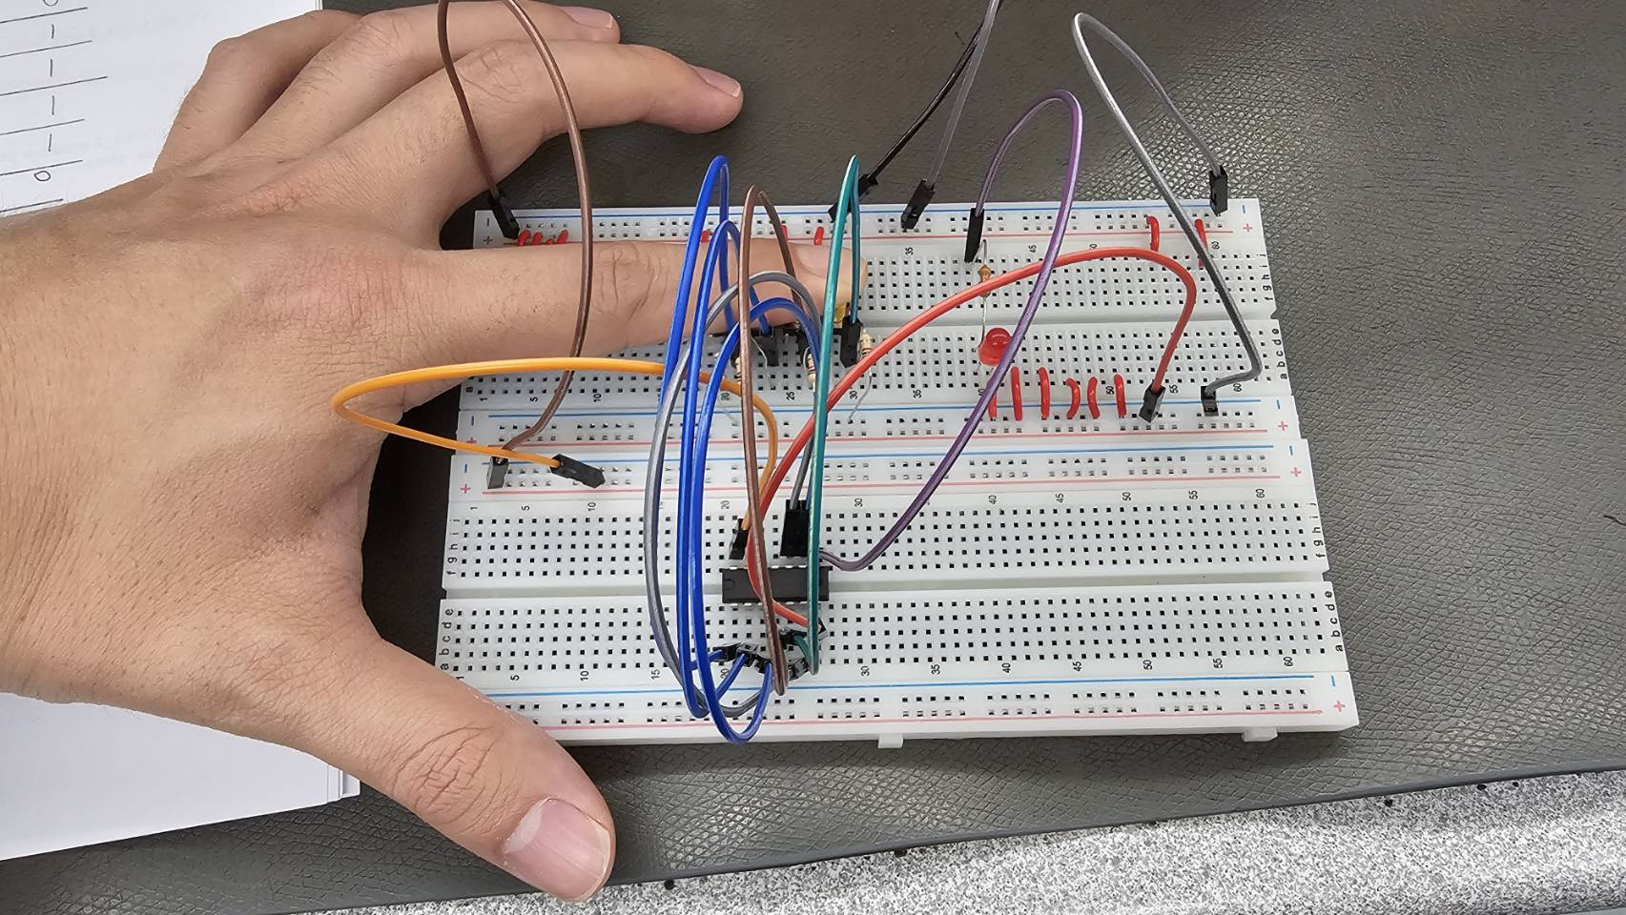
Figure 3: Breadboard implementation. A=1 B=1 C=1 D=1 → Output= 0 (LED OFF)

Schematic Picture/Screenshot (Fusion 360)
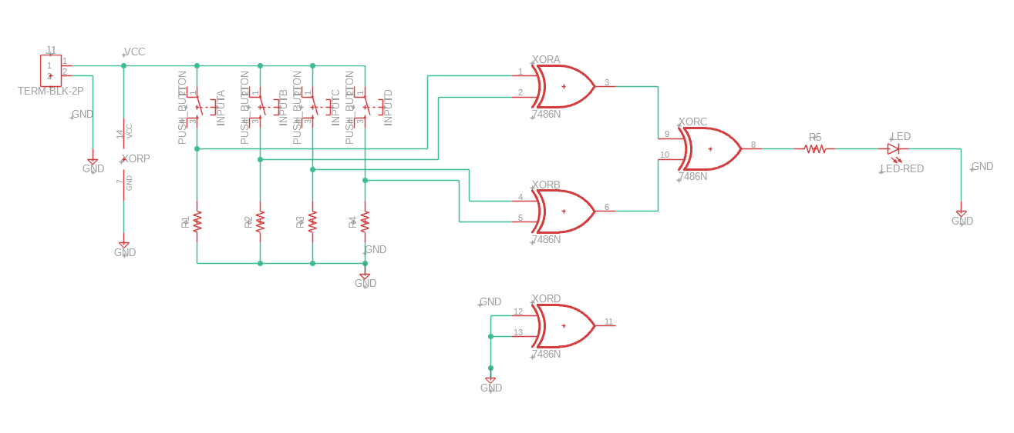
Figure 4: Schematic design in Fusion 360.

PCB Picture/Screenshot (Fusion 360)
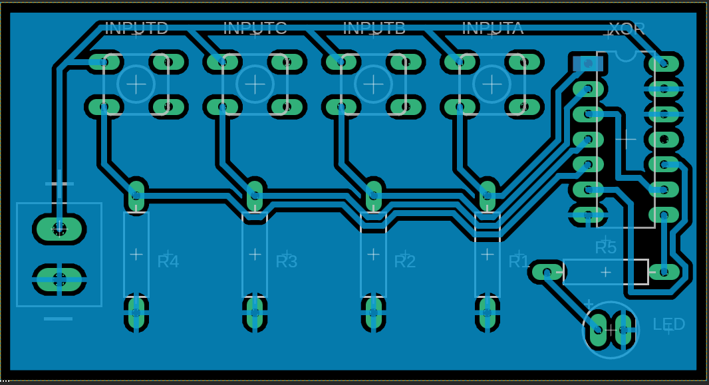
Figure 5: PCB layout in Fusion 360.
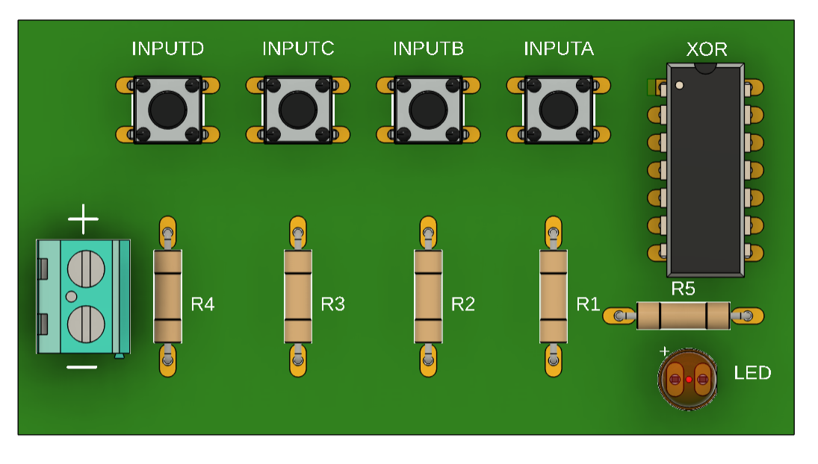
Figure 6: 3D view of the PCB design.

Picture of the final soldered PCB
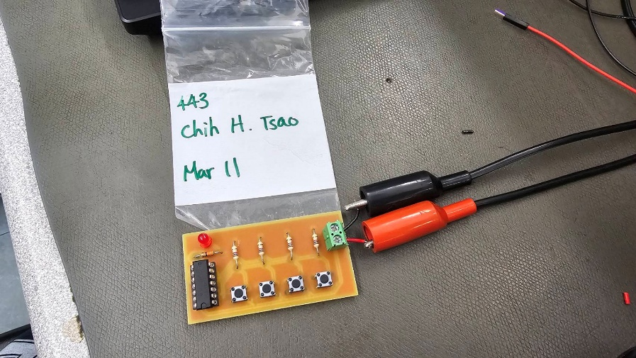
Figure 7: Final soldered PCB. A=0 B=1 C=0 D=0 → Output=1 (LED ON)
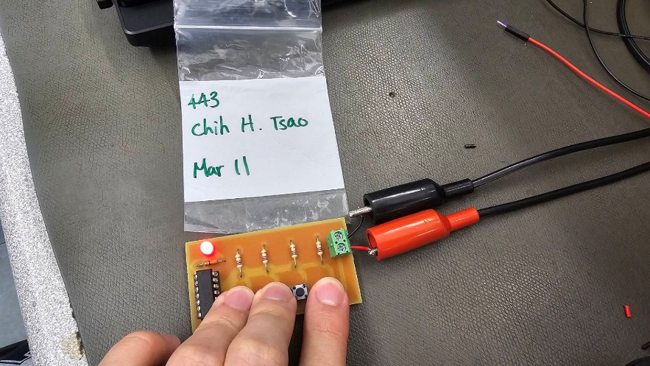
Figure 8: Test final soldered PCB. A=1 B=1 C=0 D=1 → Output=1 (LED ON)
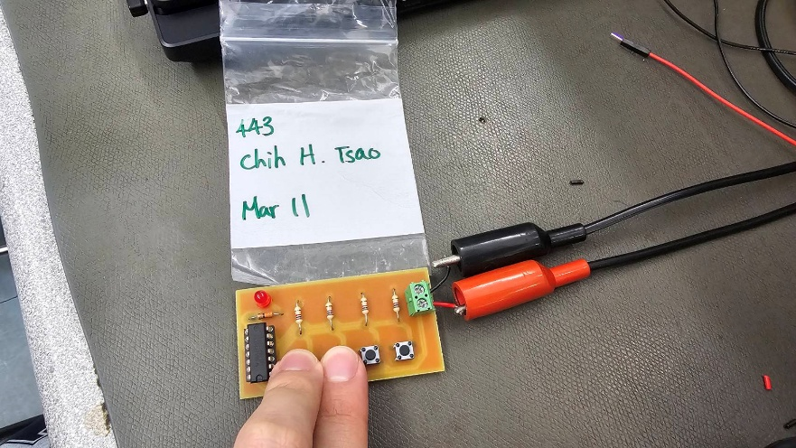
Figure 9: Test final soldered PCB. A=1 B=1 C=0 D=0 → Output=0 (LED OFF)

Bills of materials with all parts used in the project
Reference Designator | Description | Digikey P/N
R1 R2 R3 R4 | RES 1K OHM 5% 1/4W AXIAL | CF14JT1K00CT-ND
R5 | RES 330 OHM 5% 1/4W AXIAL | CF14JT330RCT-ND
IC1 | IC GATE XOR 4CH 2-INP 14DIP | 296-4777-5-ND
U1, U2, U3, U4 | SWITCH PUSH SPST-NO 10MA 12V | 563-1932-5-ND
LED1 | LED RED DIFFUSED T-1 3/4 T/H | 754-1264-ND
X1 | Connector - 2pos Screw Term Block SIDE ENT 5.08MM | 277-1667-ND
Table 2: Bill of materials

Project challenges and lessons learned
During this project, several challenges were encountered that provided valuable learning experiences. One of the main difficulties occurred during the soldering process. It was observed that using larger clearances and wider traces can help reduce the risk of solder bridging, as excess solder may easily spread and cause short circuits between adjacent pads.
Another issue was related to the use of polygon (ground fill). When solder spreads beyond the pad area, it can unintentionally connect to the ground plane, resulting in a short circuit. This can be particularly frustrating, as the circuit may not function correctly even after completing the soldering process, such as the LED not turning on or off as expected.
In addition, PCB size optimization was identified as an important consideration. It was found that the circuit does not require the full board size, and the layout can be made more compact to reduce material usage and cost. However, reducing the board size introduced new challenges in arranging components efficiently while maintaining a clear and logical signal flow.
Furthermore, this project highlighted the importance of proper component labeling and placement during the PCB design stage in Fusion 360. Since the PCB provided by the school does not include silkscreen, it is necessary to rely on the design documentation to identify component positions and polarity. Without clear labeling, assembly and troubleshooting become more time-consuming and prone to errors.

Overall, these challenges improved understanding of PCB design, soldering techniques, and the importance of careful planning in achieving a reliable and efficient circuit design.

Conclusion
In conclusion, this project successfully demonstrated the design and implementation of a 4-input XOR logic circuit using both breadboard and PCB methods. The circuit operated as expected, with the output LED correctly indicating the result based on the truth table.
Throughout the process, important skills were developed, including circuit analysis, PCB design using Fusion 360, and soldering techniques. Challenges such as solder bridging and layout considerations provided valuable learning opportunities and improved practical understanding.
Overall, this project enhanced both theoretical knowledge of digital logic circuits and hands-on engineering skills, preparing for more advanced electronic design tasks in the future.

