GROUP 5
CHIH-HSIANG TSAO
XUANYU LI
Instructor: Pari Qarehdaghi
Date: Apr 1, 2026
LM324-Based Voltage Level Meter
CAD266 NAA Group Project Report

Contents
1. Introduction (project details) 2
2. Theory of Operation 2
3. Calculations Threshold 3
4. Bread Board Picture 4
5. Schematic Picture/Screenshot 5
6. PCB Picture/Screenshot (Fusion 360) 5
7. Picture of the Gerber viewer 7
8. Picture of the final soldered PCB 7
9. Bills of materials with all parts used in the project 8
10. Analysis and Discussion 9
11. Project challenges and lessons learned 9
12. Conclusion 10
13. References 11

Table of Figures
Figure 1: Simulation results using nominal resistor values. 3
Figure 2: Simulation results after adjusting resistor values. 4
Figure 3: Breadboard implementation of the circuit. 4
Figure 4: Schematic diagram of the circuit. 5
Figure 5: PCB layout designed in Fusion 360. 5
Figure 6: 3D view of the PCB (front side). 6
Figure 7: 3D view of the PCB (rear side). 6
Figure 8: Gerber file visualization of the PCB design. 7
Figure 9: Final soldered PCB (front side). 7
Figure 10: Final soldered PCB (rear side). 7

List of Tables
Table 1: Bill of Materials (BOM) 8
Table 2: Component Part Numbers Used in Fusion 360 8

Introduction (project details)
This project is to design and build an analog voltage indicator circuit using the LM324 operational amplifier. The circuit uses a voltage divider network to generate multiple reference voltages and compares them with an input voltage (Vin).
The output is displayed using four LEDs, where each LED turns ON when the input voltage exceeds a specific threshold level. This allows the circuit to visually represent different voltage levels.
The circuit was first tested on a breadboard, followed by schematic and PCB design using Fusion 360. Finally, the circuit was soldered onto a PCB for final testing.
This project provides a practical understanding of comparator operation, voltage division, PCB design, and soldering techniques.
This project also demonstrates the practical limitations of real-world components compared to theoretical design.

Theory of Operation
The LM324 operational amplifier is used as a comparator in this circuit. A comparator compares two input voltages:
If V+ > V−, the output is HIGH.
If V+ < V−, the output is LOW.
A resistor voltage divider is used to generate multiple reference voltages. These reference voltages are connected to the inverting input (V−) of each comparator, while the input voltage (Vin) is connected to the non-inverting input (V+).
Each LED is connected to the output of a comparator. When Vin exceeds the corresponding reference voltage, the comparator output goes HIGH, turning on the LED.

Due to the limitations of the LM324, the input voltage range is approximately from 0V to (VCC − 2V), which affects the maximum usable threshold voltage.

Calculations Threshold
V1 = 8.2 V, V2 = 4.7 V, V3 = 2.8 V, V4 = 1 V
I = 9V / 20kΩ​ = 0.45mA
R1 = (9V – 8.2V) / 0.45mA = 1.78kΩ
R2 = (8.2V – 4.7V) / 0.45mA = 7.78kΩ
R3 = (4.7V – 2.8V) / 0.45mA = 4.22kΩ
R4 = (2.8V – 1V) / 0.45mA = 4.00kΩ
R5 = (1V – 0V) / 0.45mA = 2.22kΩ
nominal
R1 = 1.77kΩ
R2 = 7.78kΩ
R3 = 4.22kΩ
R4 = 4.00kΩ
R5 = 2.22kΩ
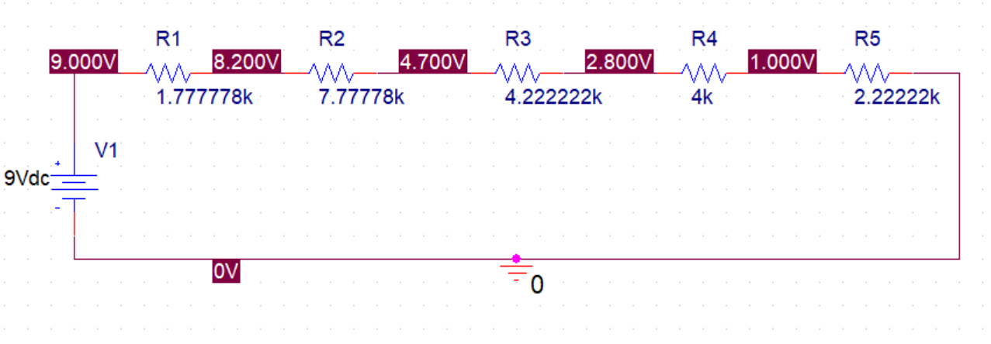
Figure 1: Simulation results using nominal resistor values.

Due to the LM324 limitation, R1 was adjusted to 3.3kΩ to lower the highest threshold voltage.

Final selected values (E24 standard):
R1 = 3.3kΩ
R2 = 7.5kΩ
R3 = 4.3kΩ
R4 = 3.9kΩ
R5 = 2.2kΩ 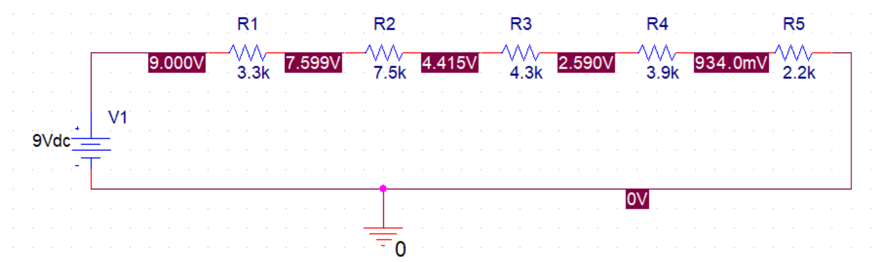
Figure 2: Simulation results after adjusting resistor values.

Bread Board Picture
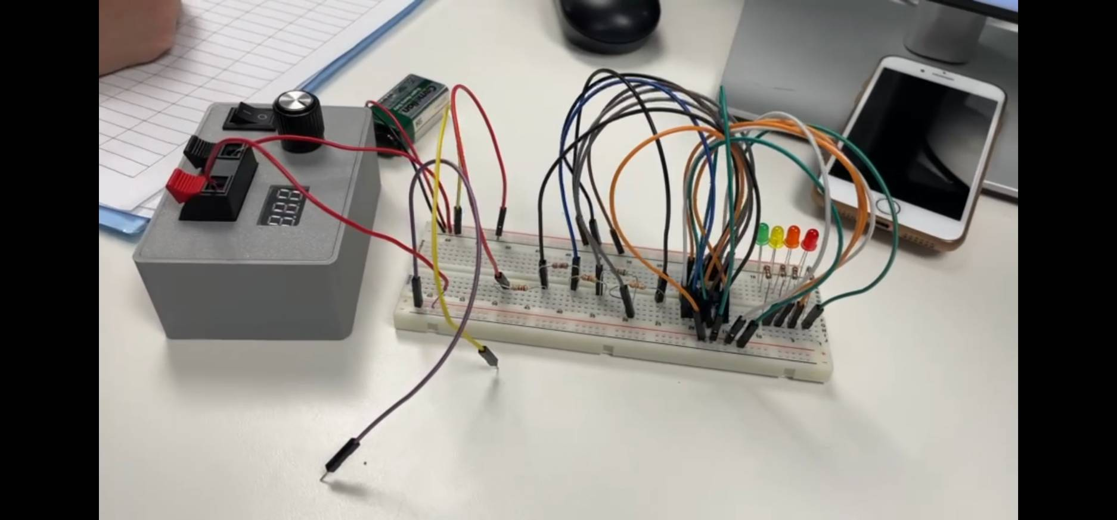
Figure 3: Breadboard implementation of the circuit.

Schematic Picture/Screenshot
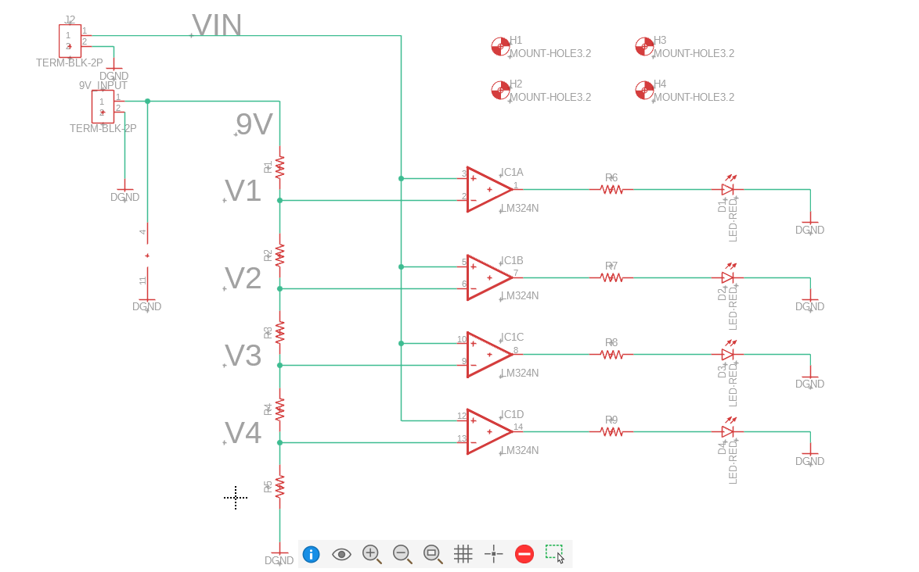
Figure 4: Schematic diagram of the circuit.

PCB Picture/Screenshot (Fusion 360)
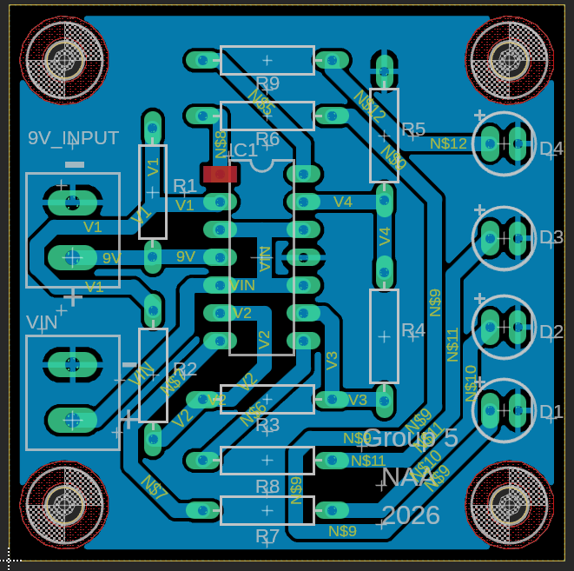
Figure 5: PCB layout designed in Fusion 360.
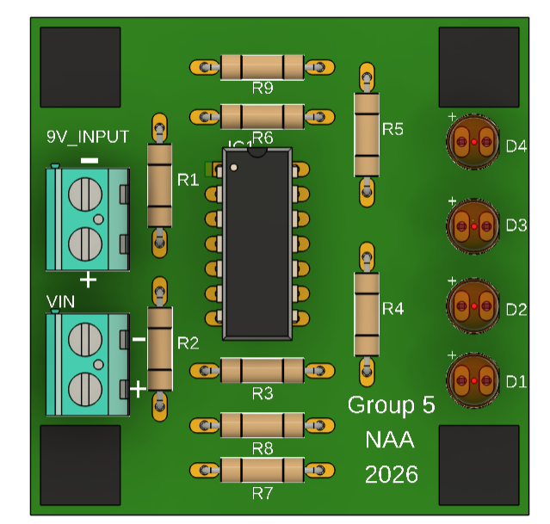
Figure 6: 3D view of the PCB (front side).
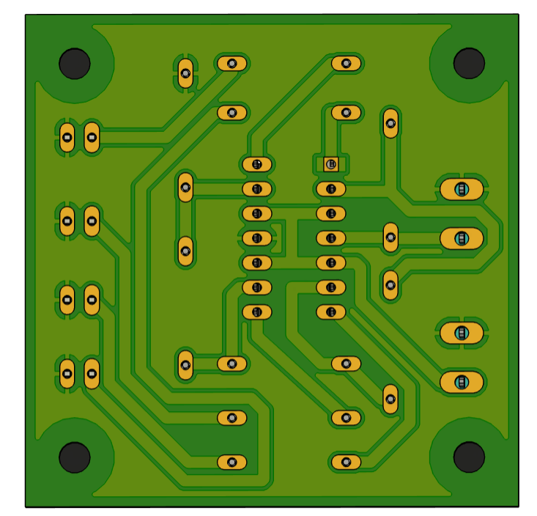
Figure 7: 3D view of the PCB (rear side).

Picture of the Gerber viewer
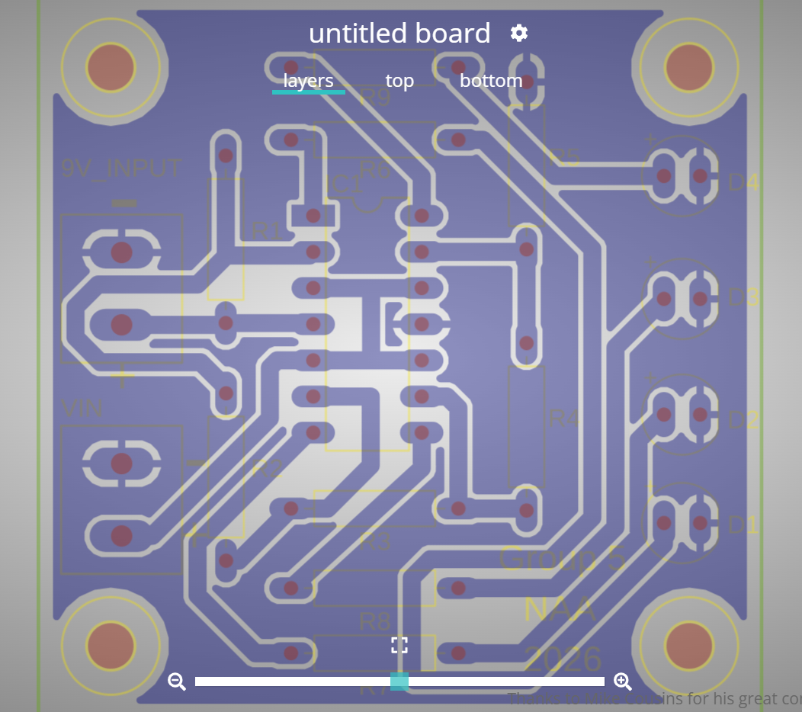
Figure 8: Gerber file visualization of the PCB design.

Picture of the final soldered PCB
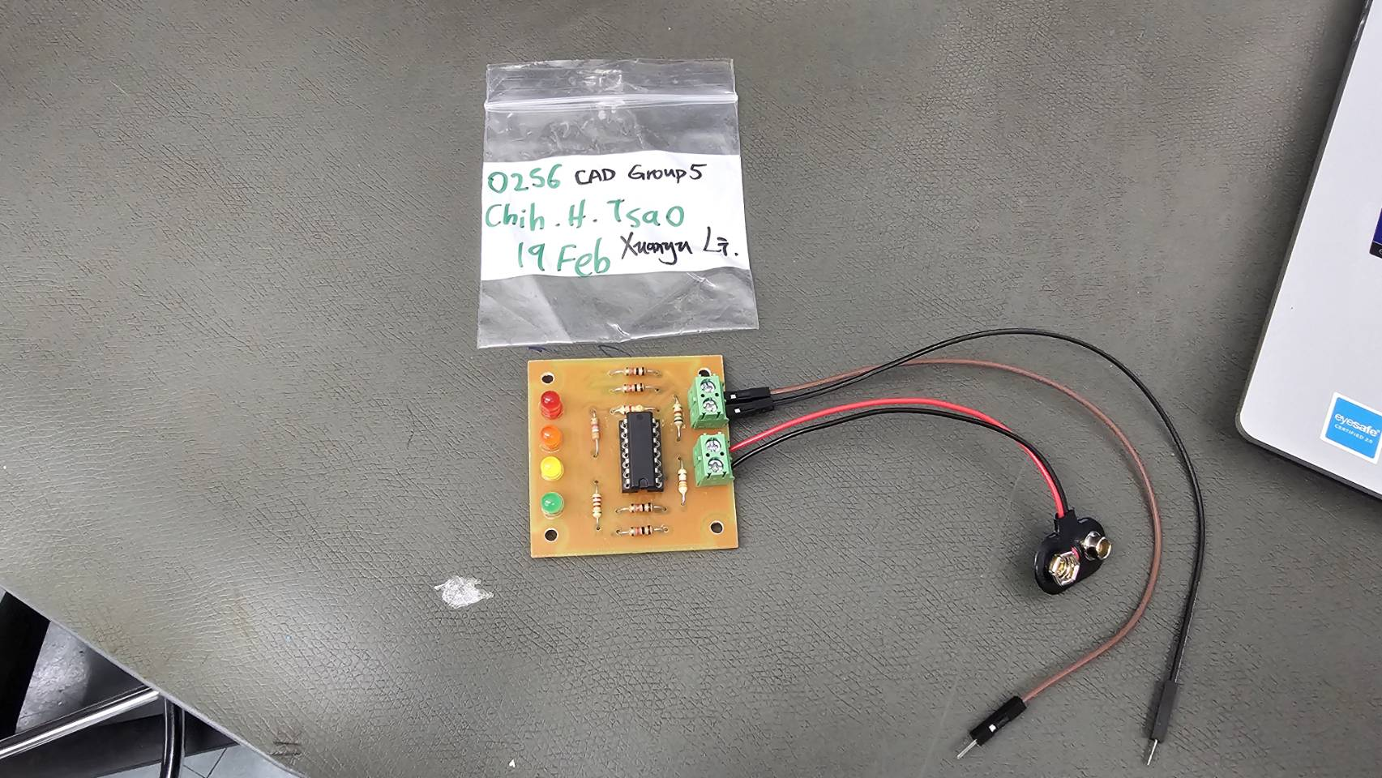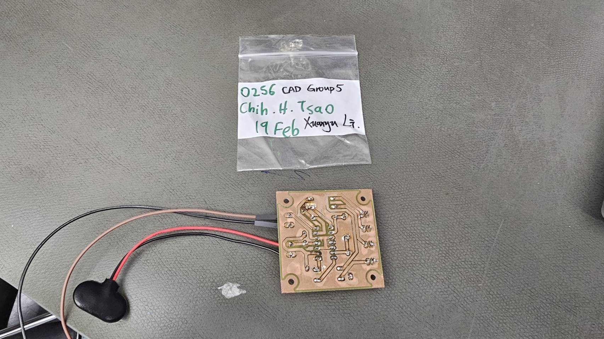
Figure 9: Final soldered PCB (front side).
Figure 10: Final soldered PCB (rear side).

Bills of materials with all parts used in the project

Table 1: Bill of Materials (BOM)
Reference Designator | Description | Digikey P/N
R1 | RES 3.3K OHM 5% 1/4W AXIAL | CF14JT3K30CT-ND
R2 | 7.5 kOhms ±5% 0.25W, 1/4W Through Hole Resistor Axial Carbon Film (6.00mm) | CF14JT7K50CT-ND
R3 | 4.3 kOhms ±5% 0.25W, 1/4W Through Hole Resistor Axial Carbon Film (6.00mm) | CF14JT4K30CT-ND
R4 | 3.9 kOhms ±5% 0.25W, 1/4W Through Hole Resistor Axial Carbon Film (6.00mm) | CF14JT3K90CT-ND
R5 | 2.2 kOhms ±5% 0.25W, 1/4W Through Hole Resistor Axial Carbon Film (6.00mm) | CF14JT2K20CT-ND
R6, R7, R8, R9 | 1 kOhms ±5% 0.25W, 1/4W Through Hole Resistor Axial Carbon Film (6.00mm) | CF14JT1K00CT-ND
LED1, LED2, LED3, LED4 | LED RED DIFFUSED T-1 3/4 T/H | 754-1264-ND
IC1 | IC OPAMP GP 4 CIRCUIT 14DIP | 296-9542-5-ND
X1, X2 | Connector - 2pos Screw Term Block SIDE ENT 5.08MM | 277-1667-ND

Table 2: Component Part Numbers Used in Fusion 360
Reference Designator | Fusion part number
R1-R9 | RESISTOR_AXIAL-11.7MM-PITCH
LED1, LED2, LED3, LED4 | LED_5MMRED
IC1 | LM324N
X1, X2 | TERMBLK_ 25 .08MM
H1, H2, H3, H4 | MOUNT-HOLE3.2

Analysis and Discussion
During the initial testing phase on the breadboard, the circuit did not operate as expected. This led us to suspect several possible issues, including faulty breadboard connections, poor wire contact, or even a defective IC that might have been internally shorted.
We systematically checked each possibility by re-seating components, verifying connections, and testing continuity. However, after eliminating these potential causes one by one, we confirmed that the issue was not due to assembly or hardware faults.
Instead, the root cause was identified as a limitation of the LM324 operational amplifier. The input voltage range of the LM324 does not extend close to the supply voltage, which meant that the highest reference voltage could not be properly processed by the comparator. This explained why the circuit failed to operate correctly under the original nominal design.
This process demonstrated that not all issues originate from physical faults; some are inherent limitations of the components used.

Project challenges and lessons learned
During this project, several challenges were encountered that provided valuable learning experiences.
One of the main challenges was related to the use of ground polygon. During soldering, excess solder could easily spread and unintentionally connect to nearby copper areas, increasing the risk of short circuits. This made it difficult to ensure reliable circuit operation, and as a result, the use of polygon was minimized in later design stages.
Another challenge was component placement. In order to achieve a clean and visually balanced layout, additional effort was required to carefully arrange components. For example, the spacing of the four LEDs was calculated to ensure equal distances, which increased the complexity of the design process.
The most difficult part of the project was trace routing. A structured and logical layout was desired, but this limited routing flexibility. As a result, routing often required multiple iterations and adjustments of component positions to achieve a workable solution. Initially, wider traces were used based on previous experience. While this made routing more difficult due to increased space requirements, it provided better reliability during soldering by reducing the likelihood of solder bridging between adjacent conductors.
From these challenges, several important lessons were learned. This project emphasized the importance of understanding component limitations, particularly when working with the LM324 operational amplifier. It became clear that relying solely on theoretical calculations is not sufficient, and that datasheets must be carefully reviewed to ensure proper operation.
In addition, the digital multimeter (DMM) proved to be an essential troubleshooting tool. The DMM was frequently used in continuity mode to detect short circuits. In this mode, the multimeter emits an audible beep when a low-resistance path is detected, allowing quick identification of unintended connections such as shorts between power and ground. This significantly improved the debugging process and also helped assist other groups in identifying similar issues.
Overall, this project highlighted the importance of systematic troubleshooting, careful planning, and balancing between design aesthetics and practical implementation.

Conclusion
In conclusion, this project successfully demonstrated the design and implementation of a voltage level indicator circuit using the LM324 operational amplifier. The circuit was able to compare an input voltage with multiple reference voltages generated by a resistor divider network, and display the result using LEDs.
Through testing and refinement, the final circuit was able to operate as expected, with each LED turning on at its corresponding threshold level. Adjustments to the original design were necessary to account for the practical limitations of the LM324, ensuring reliable operation within its valid input range.
This project provided valuable hands-on experience in circuit design, PCB layout using Fusion 360, and soldering techniques. It also emphasized the importance of understanding component specifications and verifying designs through testing and troubleshooting.
Overall, this project strengthened both theoretical knowledge and practical engineering skills, and highlighted the importance of careful planning and attention to detail in electronic design.

References
Texas Instruments. (2023). LM324 Low-Power Quad Operational Amplifier Datasheet. https://www.ti.com/lit/ds/symlink/lm324.pdf
Seneca Polytechnic. (2024). CAD266 Final Project – Level Meter (Rev.1.3).
Microcontrollers Lab. (n.d.). LM324 Op-Amp: Pinout, Datasheet, Features & Applications. https://microcontrollerslab.com/lm324-op-amp-pinout-datasheet-applications-features-datasheet/

