**General about ecosystem**

Ecosystems are communities of organisms and non-living matter that interact together. Each part of the ecosystem is important because ecosystems are interdependent. Every factor in an ecosystem depends on every other factor, either directly or indirectly. Damaged or imbalanced ecosystems can cause many problems. With climate change a real and present danger and natural resources increasingly overexploited, human well being is ever more dependent on the remaining pockets of resilience and ecosystem health. Human activities are important in almost all ecosystems.

<https://www.youtube.com/watch?v=GK_vRtHJZu4&t=128s>

*According to pandemic(Covid 19) (θα μπορούσε να μπει στα news στην αρχική σελίδα)*

[*https://www.instagram.com/tv/CM7vWcaFMrW/*](https://www.instagram.com/tv/CM7vWcaFMrW/)

**Threats**

Human activity is a major threat to the planet's **biodiversity**. This is because human population growth thus far has been exponential, meaning that its growth rate stays the same regardless of population size.

*(Αναφορά στην επίδραση του ανθρώπου στο περιβάλλον και πώς το απειλεί)*

* **Pollution**: Pollution can occur from the runoff or disposal of chemical substances, or from energy sources (noise and light pollution). ([*https://www.nrdc.org/stories/air-pollution-everything-you-need-know*](https://www.nrdc.org/stories/air-pollution-everything-you-need-know)*)*
* **Introduced species**: Humans may unintentionally, or intentionally, introduce a non-native species into an ecosystem. This can negatively effect an ecosystem because the introduced species may outcompete native organisms and displace them.( <https://www.earth.com/earthpedia-articles/invasive-species-plants-animals/>)
* **Genetic Modification:** The use of genetic modified organisms, or GMOs, has played an important role in increasing crop yields so we can feed our populations. In addition to providing better crop yields, modified plants are better able to resist disease and parasites, tolerate more extreme temperatures, or thrive with less water. (<https://www.newfoodmagazine.com/topic/genetic-modification/>)

## **Climate change** :Earth is facing is caused by the increase in global temperatures. Human activity is changing Earth's atmosphere faster than it has ever changed during its history. Extensive overuse of **nonrenewable resources**, like fossil fuels, can cause great harm to the environment. (<https://phys.org/news/2019-04-decade-critical-climate.html>)

## **Deforestation:** For every corn field you see, chances are good there was once a forest in its place. As our population continues to increase, humans create more and larger farms, which means removing the dwindling number of forests. Forests are also cleared for the lumber that we use to build our houses and to make room for new houses.( <https://whatmaster.com/what-is-the-exploitation-of-natural-resources/>)

*(Τι συμβαίνει στα ζώα, άγρια φύση και τα φυτά, εκείνα πως απειλούνται)*

***Animals***

Animals are under threat from many different kinds of human activities, from directly destroying habitat to spreading invasive species and disease. Most ecosystems are facing multiple threats. Each new threat puts additional stress on already weakened ecosystems and their wildlife.

## **Javan rhinoceros**

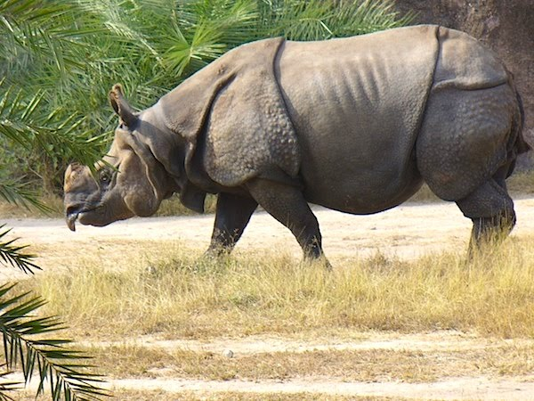Hunted especially for the properties of **its horn** used in traditional Chinese medicine and as decoration. There were **only about 29** of these animals in the island of Java, Indonesia, in 2012. Apart from poaching, habitat destruction and loss for agriculture and development are further threats to the rhino populations.

**Cheetah**

Today there are just 7,100 cheetahs left in the wild. Cheetahs are facing a double whammy: They are getting killed directly, and then also their prey species are getting killed in these savannah areas, so the cheetahs having nothing to subsist on. Like other large carnivores, cheetahs face habitat loss driven by conversion of wilderness areas into managed land dedicated to agriculture or livestock. People will then sometimes kill cheetahs if they perceive the animals as a threat to their livestock, even though cheetahs rarely take domesticated animals.

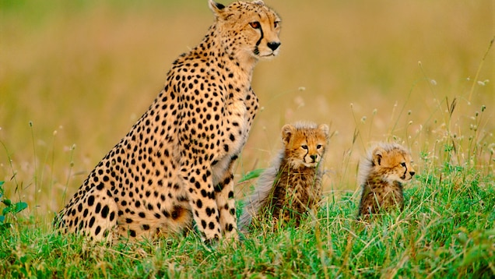

## **Tiger**

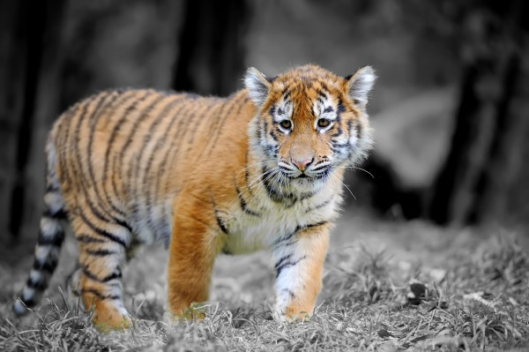Its population **has diminished by more than 60%** due to human invasion of its habitat and, again, poaching (also thought to have powers by oriental medicine).The**largest feline on the planet**, it roamed freely from Turkey to Russia. Currently, subspecies have disappeared from the Caspian Sea, Java, south of China (only alive in zoos) and Bali. People hunt tigers for their pelts, teeth, claws, and bones. These items are collected and sold as novelty items; some still use them as a symbol of status. In distant parts of the world, some people use tiger body parts in undeveloped medical practices. Most of these treatment ideas have been tested and discredited by many esteemed scientists.

## **Red tuna**

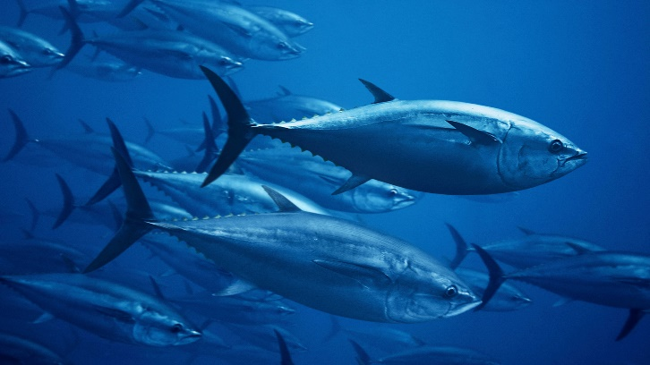In **serious danger of extinction**, measures are being taken to limit fishing it, **since the sushi boom** has targeted this fish. Overfishing has reduced its population by 85% in recent years, endangering this species that was so plentiful in the 60's.

## **Asian elephant**

Threats to wild Asian elephant populations include habitat loss from deforestation and agricultural development, as well as [conflict with humans as elephants seek space](https://www.nationalgeographic.com/animals/article/rohingya-refugee-crisis-elephants-bangladesh) and raid crops grown close to their forest habitats.Most illegal ivory today comes from African elephants, with some 30,000 poached each year. Asian elephants, nonetheless, do still face the threat of poaching for the ivory trade. Only males have tusks, and females have been largely spared. However, a growing [trade in elephant skin](https://news.nationalgeographic.com/2017/11/wildlife-watch-asian-elephant-skin-poaching-myanmar/), used for jewelry, threatens both males and females alike. Young wild elephants are also [trafficked from Myanmar into Thailand](https://www.traffic.org/site/assets/files/3278/elephant-ivory-trade-thailand.pdf) for the tourism trade. In 2012 the Thai government began cracking down on smuggling.

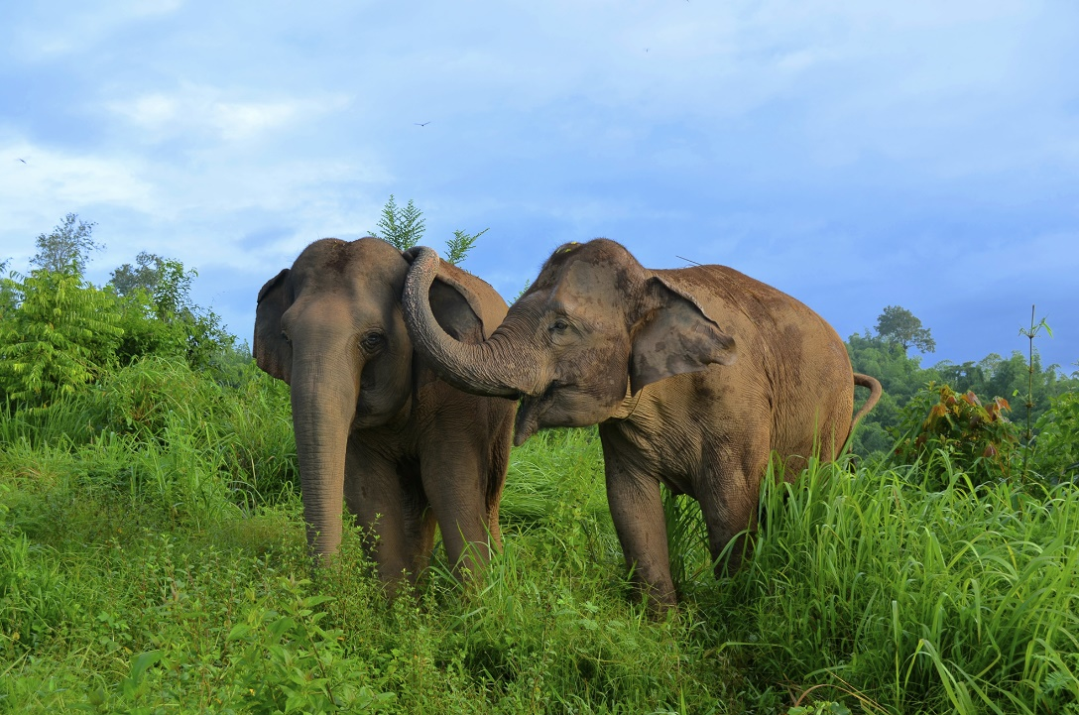

## **Vaquita porpoise**

The single most significant threat to the vaquita's survival is accidental entanglement. The small animal frequently gets caught in fixed fishing nets (gill-nets), as by-catch. Unable to surface for air, the entangled animals drown within minutes. This threat is accelerated by illegal fishing for another endangered species that lives in the vaquita habitat.

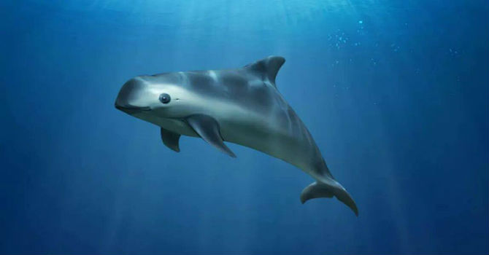

## **Mountain gorilla**

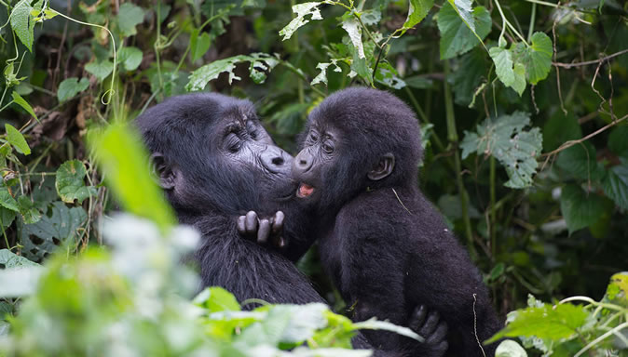The plains gorilla appears to be safe. But its mountain cousin **could disappear completely by 2025**. A critical situation that affects a few populations around the Congo river: Rwanda, Uganda and Congo. The causes? The disappearance of its habitat, traditional, medicine, hunting, oil &gas exploration, wildlife trade.

**Amazon**The world’s largest forest is also the site of the biggest projected losses. More than one-quarter of the region will be without forests if trends continue. Cattle ranching and agriculture are the dominant causes of deforestation in most of the region.

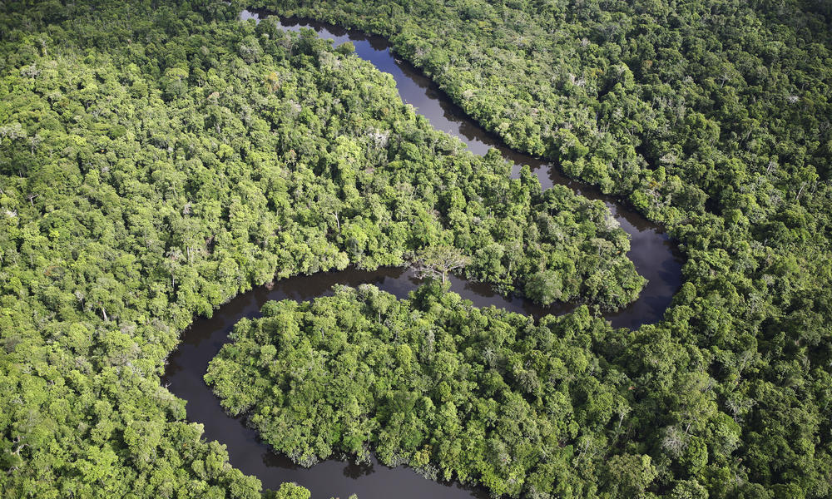

*(Παραδείγματα από επιδράσεις ανθρώπου)*

**Effects**

Pollution, including land pollution, water pollution and air pollution, poses a serious threat to ecosystems. Pollution can threaten or kill organisms that are central to ecosystems, causing the ecosystem to become imbalanced.

When we convert land for agricultural, urban, and industrial land uses, we remove some portion of a functioning **ecosystem**. When we use land and water too intensively, we may change the way ecosystems function and affect its health, integrity, and capacity for resilience. Nowadays, a lot of well-known ecosystem are threatened to disappear from the face of the Earth.

**Caribbean coral reefs**

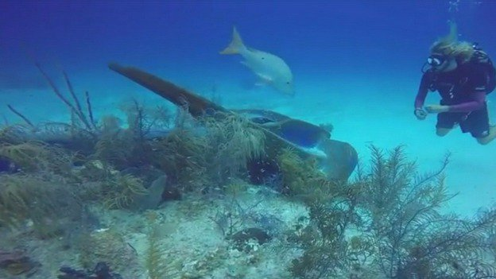An estimated one-third of Caribbean coral reefs are threatened by coastal development. This includes sewage discharge, urban runoff, construction, and tourist development. Sediment and pollution from inland sources threaten about one-third of Caribbean coral reefs. **Overfishing threatens over 60 percent of Caribbean coral reefs.** Fishing above sustainable levels affects coral reefs by altering the ecological balance of the reef.

**Alaska kelp forest**

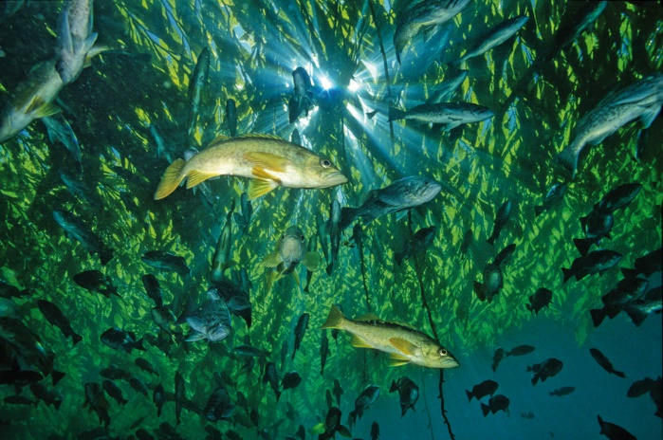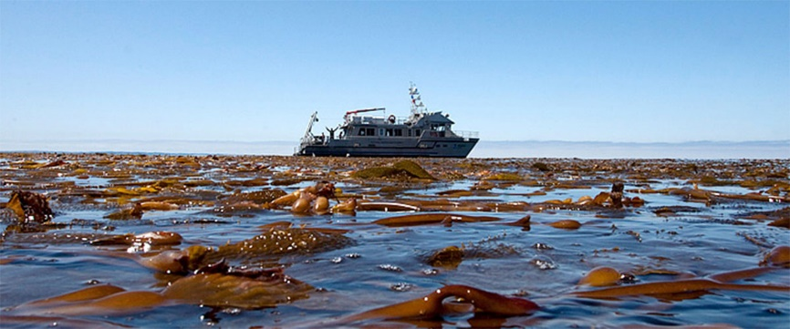The coast of Alaska is protected by an ecosystem of algae that are the perfect environment for the emergence of many species, including commercial exploitation fish stocks. However, they are under serious strain as a combination of pollution and overfishing, which threaten the delicate balance of the system. Lack of fish has lead to a decline in otter numbers, which would normally keep urchin populations under control.Sadly, with the loss of their natural predators, the sea urchins are left to their own devices to munch their way, unimpeded, through the algal kelp forests.

*Before-After*

**The Murray-Darling basin wetlands**

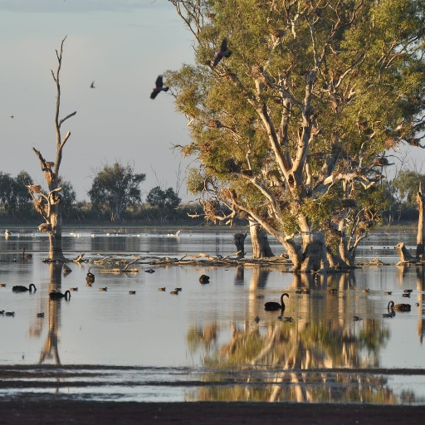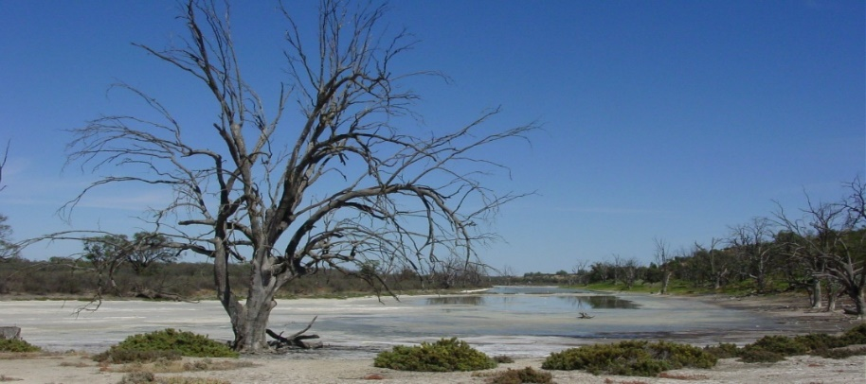The Murray and Darling rivers basin in Australia, with a length of over 3,500 kilometers, not only supply water to the most populated area of the country (Adelaide, Melbourne and Sydney), but also **give life to wildlife and flora** of a lot of swamps, forests and lakes.The biggest enemy of these wetlands is the farm holding, which has led to the **disappearance of the vegetation of the area** and drought in some parts of the Murray River (which is estimated at 18% capacity), causing salinity level rise.

*Before-After*

## **South karst springs**

Of the fifty species of crabs that inhabit the Piccaninnie Ponds Park, on the southern coast of Australia, **34 of them they are endangered** and critically endangered. This sad reality is caused by the disappearance of the water table - accumulation of underground water - that rises to the surface. The reason for this is a drastic drop in the water table. Large swathes of the area are currently protected, but this may not be enough to save them.

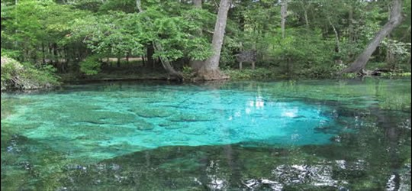

## **Mountain 'fynbos' on Cape Town**

## One of the most threatened ecosystems in the world is located in Cape Town, South Africa. With extensions that accommodate 8,500 vascular plant species -70% of them endemic-, thickets of fynbos are in **grave danger of disappearing** because of the fires, urban expansion and urban expansion. Moreover, the introduction of **invasive plant and animal species** puts in serious danger the natural composition of the area. The international organization points out that nearly 20% of all native plant species in Africa are typical of this ecosystem.

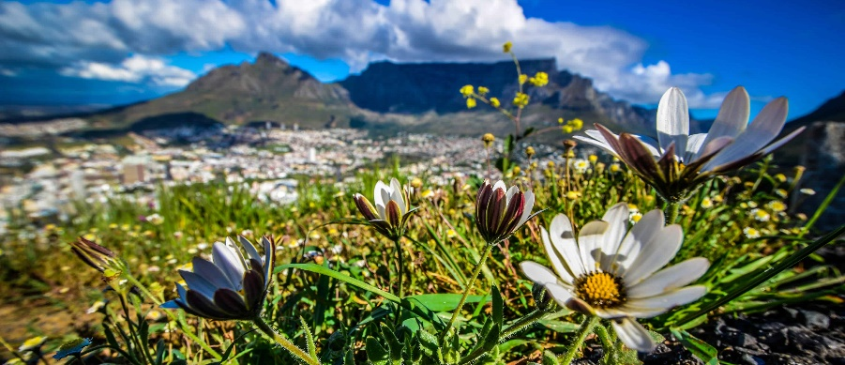

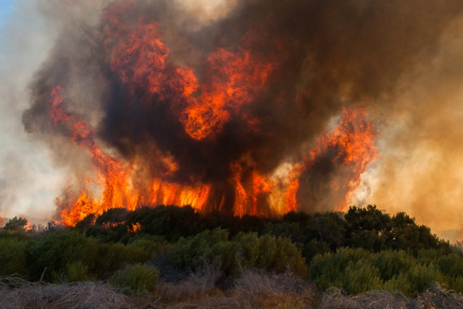

*Before-After*

**Aral Sea**

## The case of the Aral Sea, probably dry after 600 years, is the symbol of destruction.**IUCN has listed this ecosystem as unrecoverable**, as it used to be in the fourth largest lake in the world and now it's not even be in the top twenty. It has lost 28 of its native species because of desertification, and pesticides and salinity make it impossible to continue growing cotton and grain, **an economic engine for the area**. The Aral Sea was fed by the rivers Amu Darya and Syr Darya, two of the largest rivers of Central Asia.

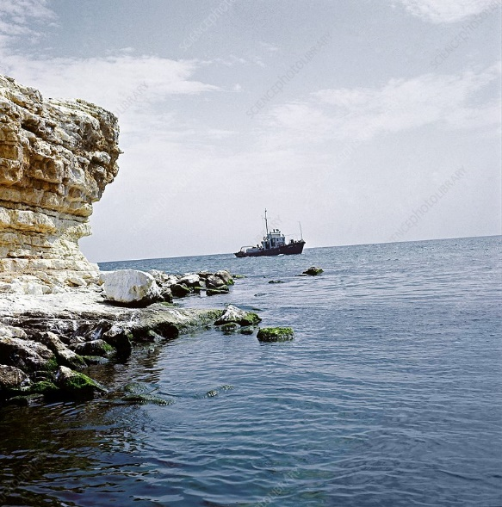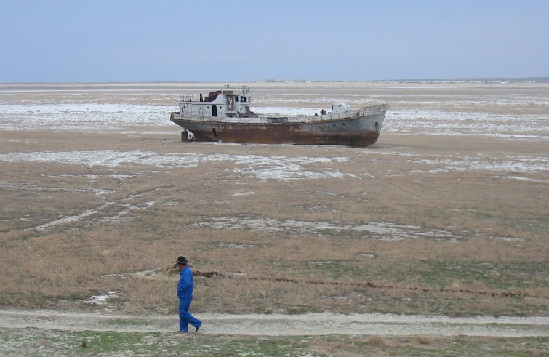

*Before-After*

**What we can do?**

1)Donate/Volunteer🡪 to make shelters for animals and save places to grow up-live and not be in danger from human activities. (και κάτι παρόμοιο για τα δάση αλλά δεν σκέφτηκα κάτι)



2)Reduce our waste, there are several reasons to reduce. For example, people can use reusable bottles, not plastic bags so we can and don’t throw away them in oceans, forest. & Recycle

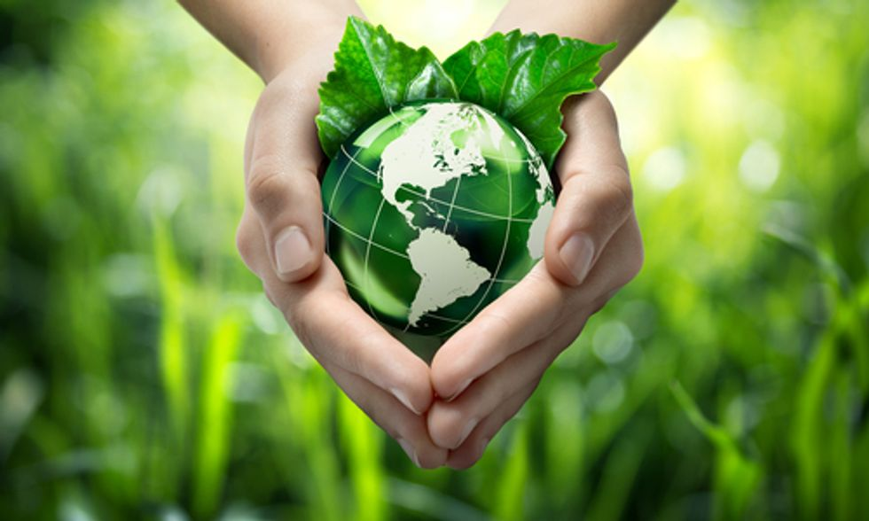

3)Produce more food on less land. Produce food where it's most likely to thrive, which will use less water and less land. Farmers can use sustainable practices can help save the life on land.

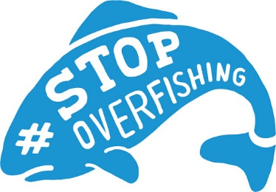4)Eliminate overfishing. We can refine our fishing methods to save the oceans🡪 responsible farming. When done correctly, farming fish can lead to a [sustainable way of providing food](https://www.conserve-energy-future.com/easy-and-simple-steps-you-need-to-know-today-to-live-sustainable-life.php) and resources to the [global population](https://www.conserve-energy-future.com/causes-effects-solutions-of-overpopulation.php). So far, this practice has seen success with species of fish that are prone to overfishing, such as arctic char and bass.

5)Walk, Ride Bike, take public transmit to reduce pollution.

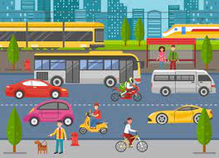

6)Create organizations which can inform(educate) people about the problems which ecosystem faces. People can plant trees, find ways to protect endangered species, forest from deforestation(cut only the trees which are older or can grow up easily and the environment can be protected. They can “use their voice” to express their purpose and save protect life on land.

