In Damali Ayo’s “Rent-a-Negro”, she attacks a very controversial topic – the objectification of African-Americans and the treatment of African-Americans as commodities. In what I would call a bit of a bold project, Ayo pushes the idea that the services of African-Americans are still treated as a commodity and puts it right in your face. Everything about the project is straight forward and to the point. I chose this piece because I think it’s still extremely relevant today.

Obviously in today’s world the issue is not as open as something like slave trading or “renting a negro” is, but it’s still there. A few examples that jumped out to me when I was reading about Ayo’s project / website, were an ESPN piece that was run a few weeks ago that literally auctioned players in the NFL (a predominantly black sport), an NBA owner’s multiple incidents with inflammatory comments on black people (Donald Sterling), and when Paula Deen described the depiction of blacks as waiters serving in a restaurant.

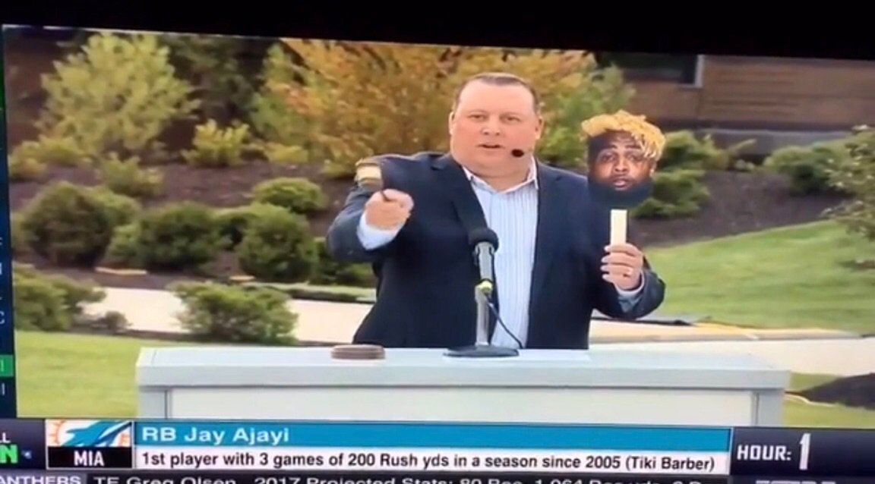

The first example that came to mind was the most recent one in which ESPN ran a piece where players in a predominantly black league were being auctioned. I thought it was ludicrous that a television network station as large as ESPN could have possibly thought it was okay to run a segment like that. Not only that, but a network that is known for being on the forefront of issues like this due to the nature of their content. ESPN calls itself the “world wide leader in sports”, which means they cover a wide range of athletes who come from diverse backgrounds from all around the world. The segment was in poor taste but it really makes you question how certain people might view athletes.

Almost all owners across the four major American sports leagues (NFL, MLB, NBA, and NHL) are white and in 3 of the 4 leagues (excluding hockey), a majority of the athletes and players have colored skin. In multiple instances, a former NBA team owner, Donald Sterling, made racially charged comments that have no place in the world. In 1983, Sterling used the N-word to describe players in an interview, and in 2006, Sterling was being sued for allegedly refusing to rent to African-Americans at his residential complexes in LA. It wasn’t until 2014 that Sterling was banned from the NBA for being a racist, after 33 years of owning an NBA basketball team.

In Paula Deen’s incident, she thought of having an entirely black staff of waiters and waitresses as a beautiful experience because it resembled the role of slavery in the manner of which they served. She also described her interest in hiring such a staff dressed to look like “slaves” at a wedding.

These three isolated incidents might not portray all perceptions that people might have of African-American servitude in the modern day, but it shows that there are people that still judge blacks in America a certain way or have a preconceived notion of how African-Americans are a commodity. The project by Ayo drew quite a range of responses from violent threats to “very real rental requests”. It was meant as a satirical project to show how African-Americans are viewed in a certain light when their services are being offered in certain situations.