Mod-10 Counter state table

* The first line tells us that only a positive clock edge will result in an increment. Any other condition results in the next state of Q (denoted Q+) being unchanged (equal to Q).
* The second line defines the behavior when the reset is active low (to agree with the active-low reset on the Nexys Video board).
* The third row tells us that the counter will hold when the 2-bit control is equal to 00.
* The fourth row tells us that the counter will count up when the 2-bit control is equal to 01. The "mod 10" means that the counter is supposed to count from 0 to 9 and then, on the next count, roll back to 0.
* The fifth row tells us that the counter will load in the value 'D' when the 2-bit control is equal to 10.
* The sixth row tells us that the counter will synchronously reset when the 2-bit control is equal to 11.

|  |  |  |  |  |
| --- | --- | --- | --- | --- |
| clk | reset | ctrl | D | Q+ |
| 0,1,falling | x | xx | x | Q |
| rising | 0 | xx | x | 0 |
| rising | 1 | 00 | x | Q |
| rising | 1 | 01 | x | Q+1 mod 10 |
| rising | 1 | 10 | D | D |
| rising | 1 | 11 | x | 0 |

Complete the Q trace in the following timing diagram based on the state table for the mod-10 counter.

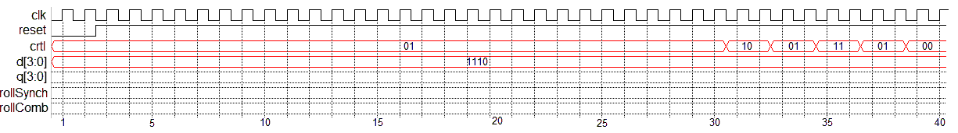

Using only comparators, a 4-bit register, and an adder construct the logic for the mod-10 counter.

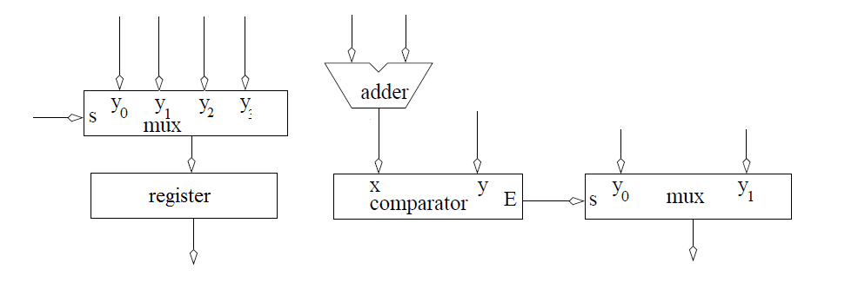

--------------------------------------------------------------------

-- Name: Chris Coulston

-- Date: Jan 13, 2015

-- File: lec04.vhdl

-- HW: Lecture 4

-- Crs: ECE 383

-- Purp: Demo the use of processes for a mod 10 counter

-- Documentation: I pulled some information from chapter 8.

-- Academic Integrity Statement: I certify that, while others may have

-- assisted me in brain storming, debugging and validating this program,

-- the program itself is my own work. I understand that submitting code

-- which is the work of other individuals is a violation of the honor

-- code. I also understand that if I knowingly give my original work to

-- another individual is also a violation of the honor code.

-------------------------------------------------------------------------

library IEEE;

use IEEE.std_logic_1164.all;

use IEEE.NUMERIC_STD.ALL;

entity lec4 is

Port( clk: in STD_LOGIC;

reset : in STD_LOGIC;

ctrl: in std_logic_vector(1 downto 0);

D: in unsigned (3 downto 0);

Q: out unsigned (3 downto 0));

end lec4;

architecture behavior of lec4 is

signal rollSynch, rollCombo: STD_LOGIC;

signal processQ: unsigned (3 downto 0);

begin

-------------------------------------

-- ctrl behavior

-- 00 hold

-- 01 count up mod 10

-- 10 load D

-- 11 synch reset

-------------------------------------

process(clk)

begin

if (rising_edge(clk)) then

if (reset = '0') then

processQ <= (others => '0');

rollSynch <= '0';

elsif ((processQ < 9) and (ctrl = "01")) then

processQ <= processQ + 1;

rollSynch <= '0';

elsif ((processQ = 9) and (ctrl = "01")) then

processQ <= (others => '0');

rollSynch <= '1';

elsif (ctrl = "10") then

processQ <= unsigned(D);

elsif (ctrl = "11") then

processQ <= (others => '0');

end if;

end if;

end process;

rollCombo <= '1' when (processQ = 9) else '0';

Q <= processQ;

end behavior;