-------------------------------------------------------------------------

-- File: lec18.vhdl

-- Ctrl: 00=Hold 01=Increment 10=Load 11=reset

-------------------------------------------------------------------------

entity lec10 is

generic( N : integer := 4);

port( clk : in STD_LOGIC;

reset : in STD_LOGIC;

ctrl : in std_logic_vector(1 downto 0);

D : in unsigned (N-1 downto 0);

Q : out unsigned (N-1 downto 0));

end lec10;

architecture behavior of lec10 is

signal processQ: __________________________________ ;

begin

process(clk)

begin

if (rising_edge(clk)) then

if (reset = '0') then

processQ <= ___________________ ;

elsif (ctrl = "01") then

processQ <= ___________________ ;

elsif (ctrl = "10") then

processQ <= ___________________ ;

elsif (ctrl = "11") then

processQ <= ___________________ ;

end if;

end if;

end process;

Q <= processQ;

end behavior;

------------------------------------------------------------------------------

-- File: user_logic.vhd

------------------------------------------------------------------------------

use work.lec18Parts.all;

entity user_logic is

generic (

C_NUM_REG : integer := 4;

C_SLV_DWIDTH : integer := 32);

port ( LED : out std_logic_vector(7 downto 0);

Bus2IP_Clk : in std_logic;

Bus2IP_Resetn : in std_logic;

Bus2IP_Data : in std_logic_vector(C_SLV_DWIDTH-1 downto 0);

… lots of other stuff …);

architecture IMP of user_logic is

signal ___ : unsigned (7 downto 0);

begin

counter: ________

generic map (____)

port map( ___________________________,

___________________________,

slv_reg1(1 downto 0),

unsigned(slv_reg0(7 downto 0)),

______________________________);

LED <= std_logic_vector(Q);

SLAVE_REG_READ_PROC : process(slv_reg_read_sel, slv_reg0, slv_reg1) is

begin

case slv_reg_read_sel is

when "1000" => slv_ip2bus_data <= X"000000" & std_logic_vector(Q);

when "0100" => slv_ip2bus_data <= slv_reg1;

when others => slv_ip2bus_data <= (others => '0');

end case;

end process SLAVE_REG_READ_PROC;

end IMP;

------------------------------------------------------------------------------

-- counter.vhd Do you need to add: use work.lec18Parts.all;

------------------------------------------------------------------------------

entity counter is

port ( LED : _____________________________________________;

S_AXI_ACLK : in std_logic;

S_AXI_ARESETN : in std_logic;

S_AXI_WDATA : in std_logic_vector(C_S_AXI_DATA_WIDTH-1 downto 0);

… lots of other stuff …);

architecture IMP of counter is

AXI_LITE_IPIF_I : entity axi_lite_ipif_v1_01_a.axi_lite_ipif

port map( S_AXI_ACLK => S_AXI_ACLK,

S_AXI_ARESETN => S_AXI_ARESETN,

S_AXI_WDATA => S_AXI_WDATA,

Bus2IP_Clk => ipif_Bus2IP_Clk,

Bus2IP_Resetn => ipif_Bus2IP_Resetn,

Bus2IP_Data => ipif_Bus2IP_Data,

… lots of other stuff …);

USER_LOGIC_I : entity counter_v1_00_a.user_logic

port map (

LED => _______________,

Bus2IP_Clk => ipif_Bus2IP_Clk,

Bus2IP_Resetn => ipif_Bus2IP_Resetn,

Bus2IP_Data => ipif_Bus2IP_Data,

… lots of other stuff …);

end IMP;

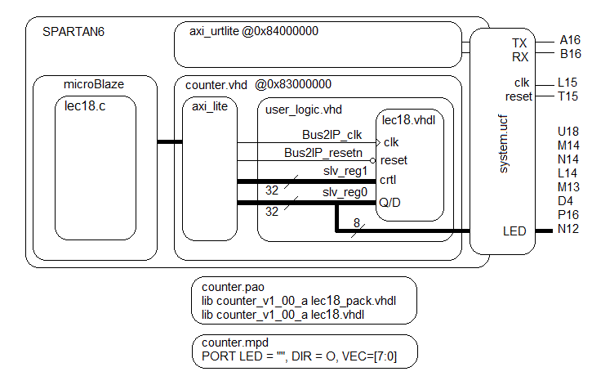

//--------------------------------------------------------------------

//-- Name: Chris Coulston

//-- Date: Feb 25, 2015

//-- File: lec18.c

//-------------------------------------------------------------------------

#include <xuartlite_l.h> // Contains XUartLite_RecvByte

#include <xparameters.h>

#include <xil_io.h> // Contains Xil_Out8 and its variations

#include <stdio.h> // Contains xil_printf

#define uartReadReg 0x84000000 // read <= RX, write=>TX

#define countQReg 0x83000000 // 8 LSBs of slv_reg0 read=Q, write=D

#define countCtrlReg 0x83000004 // 2 LSBs of slv_reg2 are control

#define count_HOLD 0x00 // The control bits are defined in the VHDL

#define count_COUNT 0x01 // code contained in lec18.vhdl. They are

#define count_LOAD 0x02 // added here to centralize the bit values in

#define count_RESET 0x03 // a single place.

int main(void) {

u8 c;

while(1) {

c=XUartLite_RecvByte(uartReadReg);

switch(c) {

case '?':

xil_printf("--------------------------\r\n");

xil_printf(" count Q = %x\r\n",Xil_In16(countQReg));

xil_printf("--------------------------\r\n");

xil_printf("?: help menu\r\n");

xil_printf("c: COUNTER count up LEDs (by 9)\r\n");

xil_printf("l: COUNTER load counter\r\n");

xil_printf("r: COUNTER reset counter\r\n");

break;

//------- Tell the counter to count up – does not quite work as intended

case 'c':

Xil_Out8(______________,______________);

Xil_Out8(______________,______________);

break;

//------- Tell the counter to load a value

case 'l':

xil_printf("Enter a 0-9 value to store in the counter: ");

c=XUartLite_RecvByte(uartReadReg) - 0x30;

Xil_Out8(countQReg,_____________); // put value into slv_reg1

Xil_Out8(countCtrlReg,count_LOAD); // load command

xil_printf("%c\r\n",c+0x30);

break;

//---------- Reset the counter

case 'r':

Xil_Out8(countCtrlReg,________________); // reset command

break;

//------------- unknown character

default:

xil_printf("unrecognized character: %c\r\n",c);

break;

} // end case

} // end while 1

return 0;

} // end main