Installation instructions for ECE 383

There is no need to copy the ISE 14.7 folder to your machine, it can be run from the Shared Software Drive. Do NOT plug in your Digilent Atlys board until instructed to do so below.

1. Xilinx ISE 14.X System Edition.
   1. Its available on the Software Drive (Xilinx ISE 14.7 folder) and here \\AFAEDUFILESHARE\Applications\Campus\DFEC\xilinx_ise\ECE383_Install
   2. Launch xsetup.exe (log in as administrator)
   3. Welcome: -> Next
   4. Accept License Agreements: accept both terms -> Next
   5. Select Products to Install: select ISE Design Suite System Edition -> Next
   6. Select Installation Options: check all boxes -> Next
   7. Select Installation Directory: check all boxes -> Next
   8. Installation: -> Next
   9. The Installer will take about 15 minutes to complete.
   10. If you get a pop-up for WinPCap, just skip the install as its already on your machine.
   11. In the “Select a MATLAB installation for System Generator IDS 14.7” pop-up click Ok.
   12. In the Xilinx License Configuration Manager pop-up
       1. select “Locate Existing License”
       2. Next
       3. Click Load License….
       4. Navigate to D:\Xilinx ISE 14.7, select Xilinx.lic, and Open
       5. In the Xilinx License Configuration Manager pop-up select Yes to overwrite the old license.
       6. Select Close to close the license manager
       7. Select Finish to close the ISE 14.7 Installer.
   13. Testing:
       1. iMPACT
          1. Start -> Xilinx Design Tools -> ISE Design Suite 14.7 -> ISE Design Tools -> 64-bit Tools -> iMPACT
          2. Make sure your ATLYS board is powered and the microUSB cable plugged into the “PROG” USB connection.
          3. In the Automatically create and save a project click yes and check box.
          4. In the Welcome to iMPACT pop-up check “Configure device…” radio button and make sure “Automatically connect…” is selected from the pull-down. Click OK
          5. Your board should be recognized and you should get the Auto Assign Configuration File pop-up. Click check box and Yes
          6. Navigate the majority.bit file on the Software Drive, click OK
          7. In the Attach SPI or BPI PROM, select No
          8. In the Device Programming Properties pop-up click OK
          9. Right mouse click on the Green Xilinx chip and select program
          10. You should see the Configure Operation Status pop-up and then a blue Program Succeeded at the bottom of the page.
          11. Switches (SW0, SW1, and SW2) should now control LED LD0 with a majority vote.
          12. This configuration file is store in RAM and will be forgotten when power is removed.
       2. ISE Project Navigator
          1. Launch Start -> Xilinx Design Tools -> ISE Design Suite 14.7 -> ISE Design Tools -> 64-bit Project Navigator
          2. Click New Project
          3. In the New Project Wiard pop-up enter lec1 as the Name and select a location. Keep Top-level source type as HDL. Click Next
          4. Use the following values in the next pop-up. Click Next.

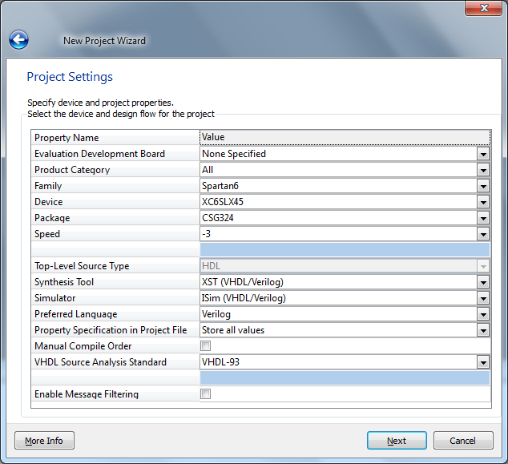

1. Click Finish
2. Copy the lec1.ucf, lec1.vhdl, lec1_tb.vhd files into the project folder which contains the lec1.xise file.
3. In ISE, add these three files by Project -> Add Source. Select all three and Open
4. In the Adding Source Files… pop-up, leave the faculty and click OK
5. Select the Simulation radio button, select lec1_tb, and then double click on Simulate Behavioral Model

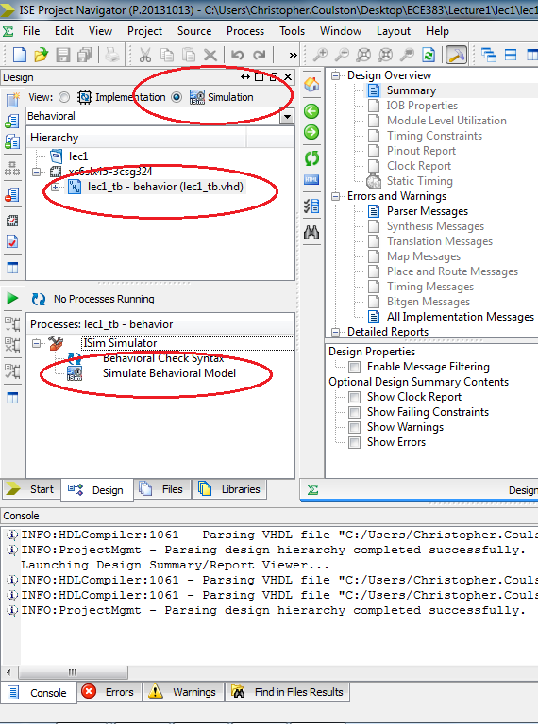

1. This will launch ISIM.
   * + - 1. You can zoom all to see all the timing traces
         2. Select and remove test data waveforms
         3. Click on the green timing diagram lines to see values at that moment in time
         4. Successful simulation is indicated in the Console area.

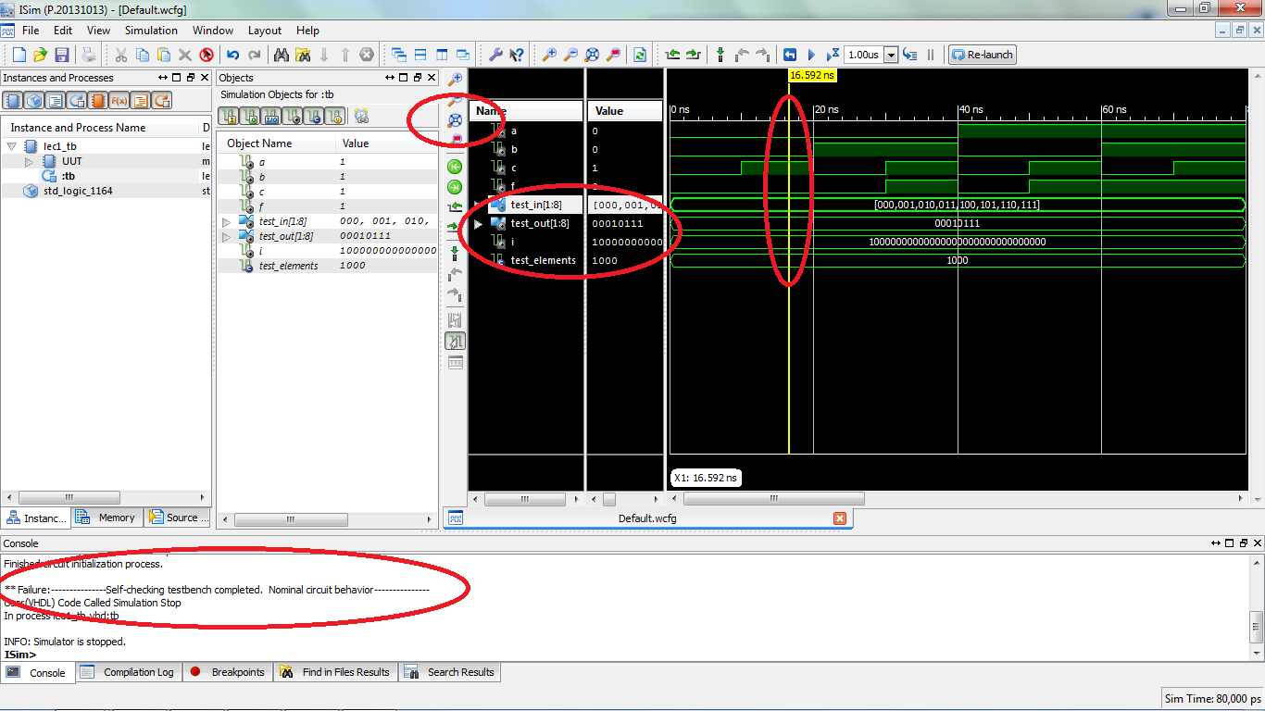

1. Select the Implementation radio button, select majority - structure, and then double click on Generate Target Device
2. This will “compile” your design and launch iMPACT. Use the previous instructions to test that you can download the majority.bit file to the ATLYS board.

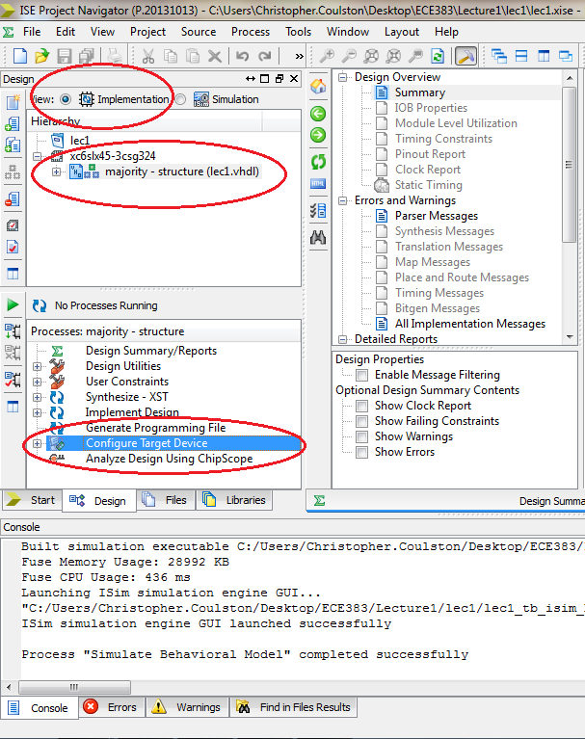

1. Board Support Package
   1. Check that its already installed to: C:\Xilinx\Atlys_BSB_Support_v_3_7\
      1. It available on the Software Drive and from the [Digilent website](http://www.digilentinc.com/atlys/).
      2. Extract this folder to a permanent location on your computer.
      3. Move it to: C:\Xilinx\Atlys_BSB_Support_v_3_7\
   2. Run **inst_uninst.bat** in C:\Xilinx\Atlys_BSB_Support_v_3_7\Atlys_BSB_Support_v_3_7\Digilent_AXI_IPCore_Support_v_1_35
      1. Enter 14.7 as the version
      2. Type “I” for install
2. Digilent Adept Xilinx
   1. Its available on the Software Drive or from the [Digilent website](http://www.digilentinc.com/Products/Detail.cfm?Prod=ADEPT2), download and install the Adept 2.16.1 System, 32/64-bit Windows.
   2. Enter in your administrator user ID and password
   3. Agree with all the defaults and Next your way through the install.
3. Digilent Plugin for Xilinx
   1. Its available on the Software Drive (D:\libCseDigilent_2.5.2-x86-x64-Windows) or from the [Digilent website](http://www.digilentinc.com/atlys/), download and install the "[Digilent Plugin for Xilinx Tools](http://www.digilentinc.com/Products/Detail.cfm?NavPath=2,66,768&Prod=DIGILENT-PLUGIN)."
   2. They are located in the subdirectory \libCseDigilent_2.5.2-x86-x64-Windows\ISE14x
   3. The installation instructions are included as a PDF in the downloaded zip file.
   4. The Digilent Plug-in needs to be copied into a specific ISE directory.
      1. From: D:\libCseDigilent_2.5.2-x86-x64-Windows\libCseDigilent_2.5.2-x86-x64-Windows\ISE14x\plugin\nt64\plugins\Digilent folder .
      2. To: C:\Xilinx\14.7\ISE_DS\ISE\lib\nt64\plugins\Digilent\libCseDigilent
4. Tera Term
   1. Download teraterm-4-85.exe from <http://en.sourceforge.jp/projects/ttssh2/releases/>
   2. Configure the speed to Tera Term by using the "Setup" => "Serial Port" menu option
   3. The baud rate should be 9600 for this lab
5. Serial port drivers
   1. Its available on the Software Drive (D:\exar) or from the [Exar website](http://www.exar.com/common/content/default.aspx?id=10296), download and install USB – XR21V1410 (click on the 2.2.0.0 driver dated Nov 2014)
   2. Connect the power supply to the ATLYS board – turn on power.
   3. Plug a microUSB cable into the “UART” port of the Atyls board and connect to computer.
   4. You should get “Your device is Ready to Use” pop-up on the system try. If not, install the drivers you just downloaded.
   5. Launch the device manager
   6. Click on Ports (COM & LPT)
      1. Look for XR211V140 USB UART (COMx)
      2. Note the COM number – x above.
   7. Launch Tera Term
      1. Setup -> Terminal: Set New-line Receive to Auto
      2. Setup -> Serial Port: Set Port, Baud 9600, Data=8-bit, Parity=none, Stop=1 bit, Flow control=none
   8. Flip switches on the ATLYS board (SW0-SW7)
   9. Press and release push buttons (BTNL, BTNR, BTNC, BTND BTNU)
   10. Output should appear in Tera Term