# Name: Section:

# Homework Assignment: submit via gradescope

1. Draw a detailed diagram of the oscilloscope grid required for Lab1 [Do not try to reuse and edit the picture below]. A detailed diagram must be drawn on green engineering paper (or draw using a computer program) and include

* (x,y) corners of the monitor.
* (x,y) each of the four major corners (already given).
* y-coordinates for all the major horizontal grid lines.
* (x,y) coordinates for one set of three horizontal of hatch marks. Indicate with an arrow which set of three.
* x-coordinates for al the major vertical grid lines.
* (x,y) coordinates for one set of four vertical of hatch marks. Indicate with an arrow which set of four.

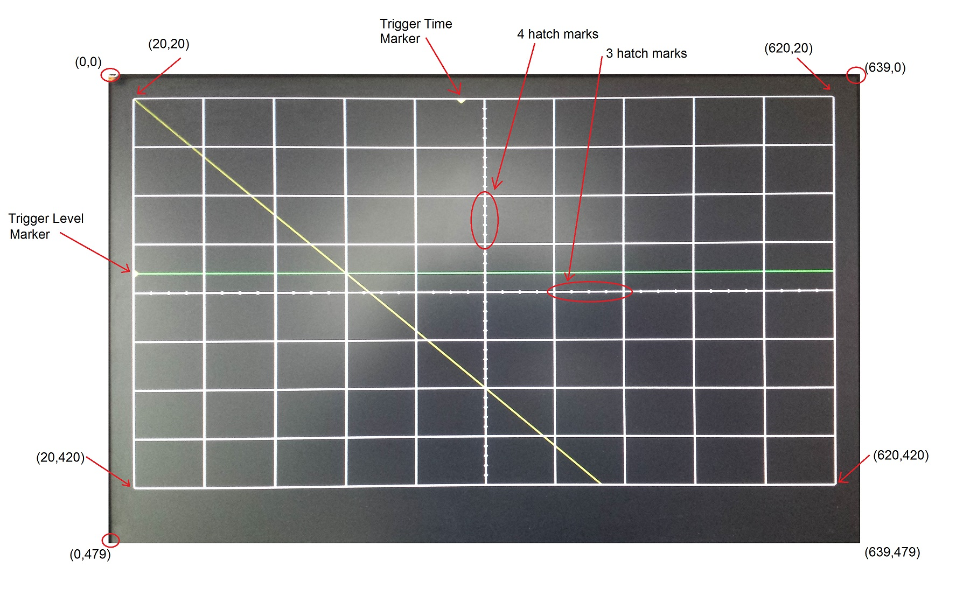

1. Given that the pixel clock is running at 25Mhz, add the **durations and counts** of the h_synch and v_synch signals show in Lab1. Set time=0 on the blue dashed line on the left side of the region labeled "Active Video". **You should add durations and counts for all blue lines.**   
   