# Name: Section:

# Homework Assignment: submit via gradescope

1. Complete the timing diagram below assuming that the register is positive edge trigger and has an asynchronous active low reset.

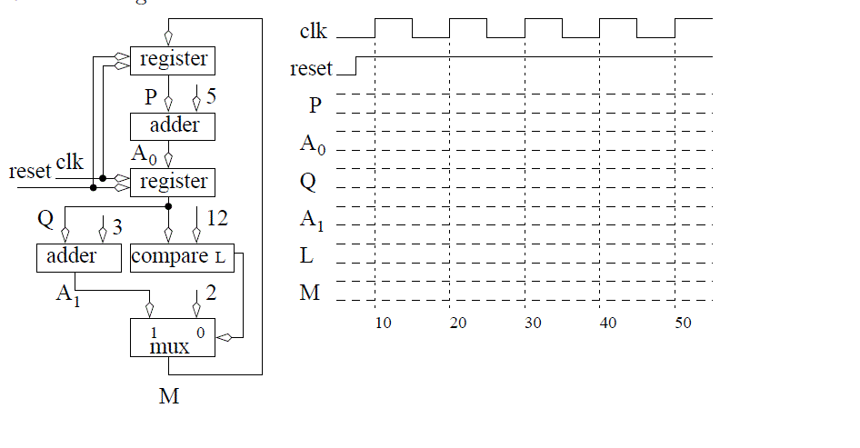

1. In an ideal world when the button on the FPGA board is pressed, the output go solidly from 0 Volts to 5 volts and back to 0 volts when released. Unfortunately, push-buttons are mechanical devices with contacts that literally bounce when contact is made and broken. This bouncing will cause the voltage to oscillate several times in quick succession.

Switch bouncing is a major problem in digital circuits because the circuit sees the signal change several times and may take actions appropriate for each of these bounce values when the user only intended a single actions to take place. Your task in this problem is to develop a statemachine based debouncer (with a timing delay), in which every time a button is pressed and release, the output will increment a counter only one time using the “action” signal. It will follow this mini-C algorithm:

action = 0;

while (button == 0); // wait for button press

for (i=0; i < 20_msec_count; i++); // delay 20 msec for bouncing to stop

while (button == 1); // wait for button release

for (i=0; i < 20_msec_count; i++); // delay 20 msec for bouncing to stop

action = 1; // do the action for the button event

action = 0; // undo the action for the button event

Note1: 20 milli-seconds is usually a sufficient delay for most switch bouncing to end. The world record for the fastest button presses by a human was 16 presses in one second, which corresponds to 62.5 msec, so delaying 20 msec will not miss a button press.

Design a FSM component called **button_debounce** based on the above mini-C code using the methods taught in lesson 10 and the state machine code style taught in lesson 9. Use the lesson 10 test bench HW07_tb.vhdl and lec10.vhdl (the counter to be incremented by your **button_debounce** component.

The entity for your FSM is:

entity **button_debounce** is

Port( clk: in STD_LOGIC;

reset : in STD_LOGIC;

button: in STD_LOGIC;

action: out STD_LOGIC);

end **button_debounce**;

The given test bench simulates two button push and releases, with oscillations after each push and release. Therefore, if your code works properly, the count should be 2 at the end.

Note2: In the testbench, I slowed the clock from your FPGA’s 100 MHz clock down to a 100 KHz clock to greatly speed up the simulation time. However, this obviously impacts the “count” required to reach 20 msec. For your simulation, you can use either a 100 MHz clock (needed for debouncing your future labs) or the 100 KHz clock (to run a faster simulation).

**Turn in:**

* 1. The state diagram for your FSM and its datapath, and the FSM output table (neatly hand drawn or computer drawn is fine).
  2. Upload the vhdl code to bitbucket, with an appropriate header and comments
  3. Use the testbench to test your component and include the simulation plot(s). The plots should include a zoomed out plot of the overall simulation, and possibly zoomed in plots of key points (I should be able to see the time that the “action” occurred; each time the test-bench-level counter is counted up; and the timing of the 20 msec delays [can usually see this as a time from a certain state transition to the time the action occurs]). Show the following signals - remove all other signals from the plot(s).
     + clk
     + reset
     + FSM state
     + button
     + Count value