1 Introduction 2

2 Description of Objects in hierarchy 3

2.1 Main Camera 3

2.2 GCSpeechRecognition 4

2.3 Analysis_Scripts_Here 4

2.4 Bluetooth_Comm 5

3 How to change 6

1. Introduction

Current version: 0.0.2

Change history:

Rewrite response information exchange working flow by event

Remove unusable script after update

Add TCPIP response message which contain hand error and current gesture type

This project is aiming to use Bluetooth and TCP/IP connection to control Robot.

1. Description of Objects in hierarchy

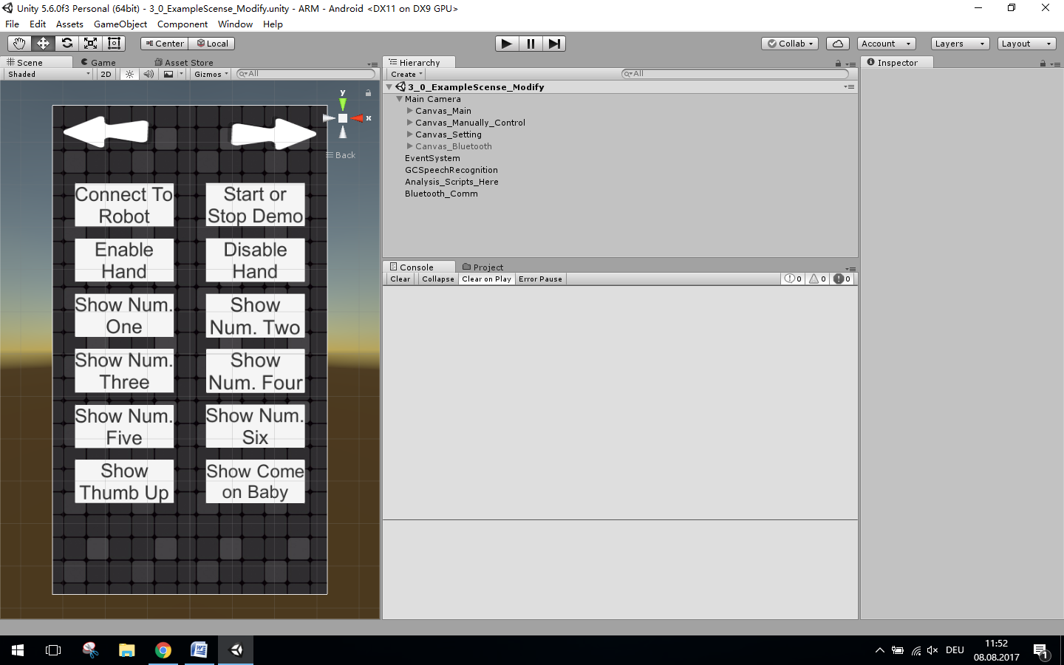

In hierarchy there are all the objects and scripts which need to be use in app.

* 1. Main Camera

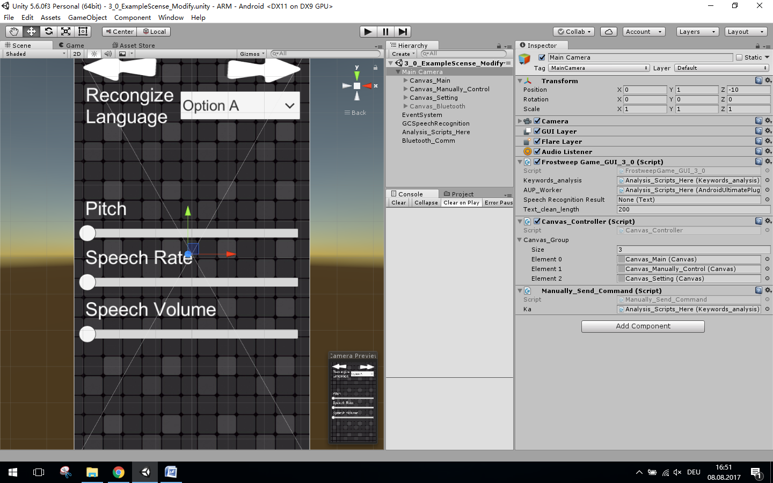

In Main camera you will found three scripts has been attached, “Frostweep_Game_GUI_3_0”, “Canvas_Controller” and “Manually_Send_Command”.

1. Frostweep_Game_GUI_3_0 is the script managing button objects. Those buttons are assigned in Canvas_Main below Main Camera. This script must assign in same object tree with button in order for script to find buttons it needs. This script manage follow functions:

* Receive message from script “keywords_analysis” and print on first page.
* Print recongnized raw message.
* Management button and tell speech recognize module to start or stop record sound.
* Stop or restart TTS module to talk wile operator is trying to speak.
* Manage language drop down list in setting manual.

1. Canvas_controller is managing all canvas, which allow user to change menu page in APP.
2. Manually_Send_Command script is managing button objects assigned in Canvas_Manually_Control. Those buttons will call function in script and send key words to keywords_analysis to send control command manually on app display. It sent command to script “keywords_analysis”.
   1. GCSpeechRecognition

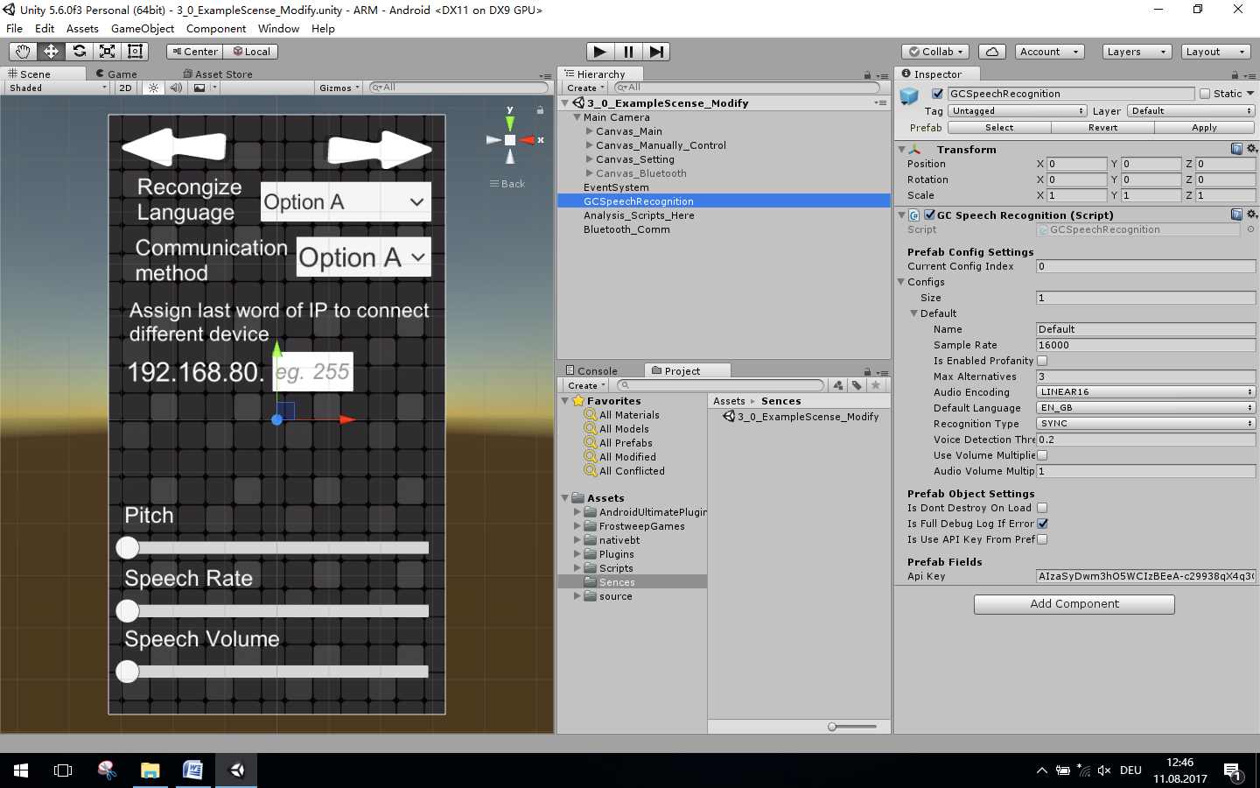

In this object there is only one script has been assigned. That is “GC_Speech_Recognition”. This script controls some basic setting of speech recognition module.

* 1. Analysis_Scripts_Here

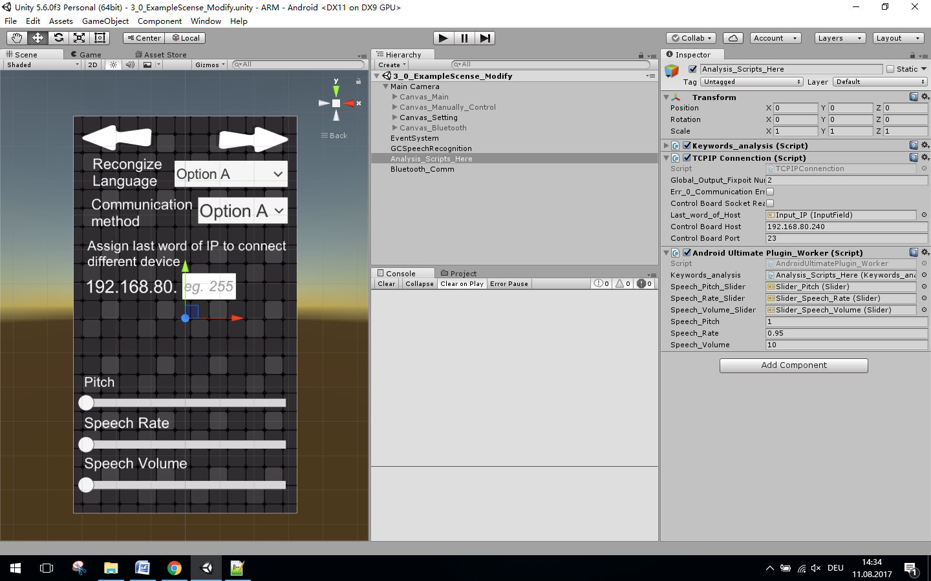

This object contains three scripts, which are, “Android_Ultimate_Plugin_Worker”, “Keywords_analysis”, “TCPIP_Connection”.

1. Android_Ultimate_Plugin_Worker receive text data and speak it out by using TTS engine. It use three slider in setting manual to change speak rate, pitch and volume.
2. Keywords_analysis start working after received text data. It extracts key words and compare to key words list to decide send what command to Robot. Keywords to identify different language need to be adding in this script.
3. TCPIP_Connection is use to establish socket connection to Robot.
   1. Bluetooth_Comm

Contain script “BT_Chat_Testting”. This script establish Bluetooth connection to bluetooth device.

1. How to change
   1. Change to another Google cloud service account

Google cloud need API key to identify who is using their service. There for, just change API key in the script GC_Speech_Recognition to change a different cloud service account.



* 1. Change or add recognition key words
     1. Add new language recognition keywords

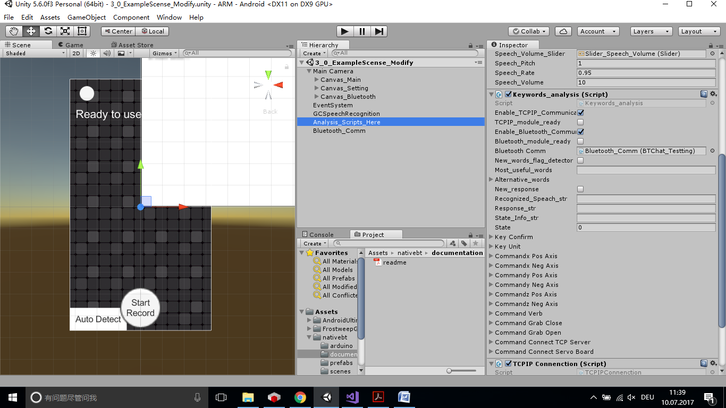

Add your key works in “Keywords_analysis”.

The key word identify rule from a sentence is shown below:

|  |  |  |  |
| --- | --- | --- | --- |
| Single command |  |  |  |
| Direction | Verb(option) | number | unit |

Key confirm is a single command keyword contains the words to confirm speech recognition is correct, and command will sent to robot after user said this keyword.

Key unit contains the unit of the number. The Keywords_analysis extract number before this key word from sentence.

Command x Pos Axis use to identify robot to move along x axis in positive direction.

Command x Neg Axis use to identify robot to move along x axis in negative direction.

Command y Pos Axis use to identify robot to move along y axis in positive direction.

Command y Neg Axis use to identify robot to move along y axis in negative direction.

Command z Pos Axis use to identify robot to move along z axis in positive direction.

Command z Neg Axis use to identify robot to move along z axis in negative direction.

Command verb is to ensure “Keywords_analysis” is going to extract correct number from sentience.

Command Grab Open is a single command keyword to command robot to open grab.

Command Grab Close is a single command keyword to command robot to close grab.

Command Connect TCP server is a single command keyword to start connect robot with socket connection.

Command Connect Server Board is a single command keyword to start connect server board with Bluetooth connection.