

SOFTWARE MANUAL

6-AXIS SERVODRIVE

**Abstract**

This document is the software manual for the 6axis board and details how to operate with the servodrive, configure the board and commission the application.

**Table of contents:**

1 General information 1

1.1 Introduction 1

1.2 Safety warnings 1

1.3 Storage and Installation Environment  1

1.4 Transport, installation and wiring   1

1.5 Operation and adjustments   2

1.6 Maintenance and inspection   2

2 Software introduction 4

2.1 PC Interface 4

2.2 Setup of interface 4

2.3 PC Connection 4

3 Interface startup 5

3.1 6-axis user level 6

3.2 Parameter management 8

3.3 Workspaces basics 9

3.4 Adding new watches 11

3.5 Working with traces 11

3.6 Description of trace interface 13

3.7 Event and alarm list (List) 14

3.8 Update in 6-axis software 15

4 Configuration 17

4.1 Parameterization reset 17

4.2 Loading motor parameters 17

4.3 Motor auto-configuration 19

4.4 Motor customization 20

4.5 Extra current 20

4.6 Manual JOG 21

4.7 Mechanical brake 21

4.8 Aligment / phasing modes 21

4.9 Digital i/o and analogic inputs 22

4.9.1 Inputs 23

4.9.2 Outputs 23

4.9.3 Analog inputs 24

5 CANOpen configuration 25

5.1 Pulses phasing and index calibration 25

5.2 Homing checks 25

6 Commissioning 26

6.1 Encoder checks 26

6.2 Motor cable checks 26

6.3 Inertia auto-tune 27

6.4 Standalone tuning 27

6.4.1 Speed test 27

6.4.2 Position test 28

6.5 Firmware variable list 29

7 Troubleshooting 31

7.1 Device alarms 31

7.2 How alarms are reported from 6-axis device 31

7.3 How alarms are reported in Tex controller 31

7.4 How Tex controller reacts to 6-axis alarms 31

7.5 List of alarms 32

1. General information
   1. Introduction

Thank you for choosing this product. This document is an integral part of the product, as it contains the procedures and parameters necessary for the assembly, installation, wiring, commissioning and support of the product.

The purchaser and/or qualified person with knowledge of electrical and/or electronic systems who will be using the product must be in possession of the use and maintenance manual and must keep it available for reference at any moment.

* 1. Safety warnings

Follow the precautions given (with warning symbols) closely, as they are crucial for safety:

 General danger symbol

 Hazardous electrical voltage symbol

* 1. Storage and Installation Environment 

Do not store or use the product in the following environments:

* + - * Exposed to direct sunlight
      * Exposed to temperature, condensation and relative humidity levels higher than those indicated in the specifications table
      * Exposed to dust, salinity, water, oil, chemicals, corrosive or inflammable gases or fuels
      * In environments with pollution degree higher than 2
      * When subject to impact or vibrations
  1. Transport, installation and wiring  

Do not drop the product

* Grasp the product by the motor, always checking first to ensure it is not hot – burn hazard!
* Do not install the product if there are signs of damage to the packaging or the product itself
* Wiring must be performed by qualified personnel, with the power supply disconnected
* Ensure that there is sufficient ventilation to dissipate the heat produced by the product.
* During the installation and wiring operations, protect any product openings with appropriate guards so that no conductive metallic objects of any kind are able to get in
* Ensure the connectors are firmly tightened
* Install appropriate safety components (fused disconnect switch) up line of the power supply
* Use shielded cables in locations subject to static electricity, strong magnetic fields or in the presence of electrical lineUse suitable and appropriately sized cables for connection of the power supply, motor and control signals connections; 
* For control signal connections longer than 1m, it is recommended to use shielded cables with the shielding connected to an available earth signal; 
* Make sure that the power supply voltage complies with the one on the rating plate; 
  1. Operation and adjustments  
     + - At first power on or after a period of more than two months of unused use, it’s recommended to keep the logical part fed for at least 24 hours;
       - Operate the product only subject to checks on the compatibility of the load and the machine in which it will be installed;
       - Do not approach the machine when the product is configured with the reset on error function, as the machine could restart suddenly after a stop caused by an error;
       - Do not place body parts near the rotating parts;
       - Use appropriate personal protective equipment during machining close to the axis ends (presence of sharp edges in the tongue seat);
       - Before performing the machine test, provide adequate protections around the rotating parts (joints, etc.);
       - Never operate the device or its switches with wet hands 
  2. Maintenance and inspection  
     + - Ensure that all safety precautions have been taken before performing maintenance or inspection operations
       - Do not touch the heatsink and the motor as these components heat up when the product is operational and remain hot even after it is switched off
       - Do not uninstall the product when it is powered, switch it off then wait at least two minutes before doing so
       - Do not change the wiring, the supply voltages, etc. while the product is powered
       - Do not repair or modify the product
       - The product does not require any particular preventive maintenance. However, we recommend performing the following checks regularly:
* Check the condition and tightening of the connections
* Check that the heatsink is clean and ventilated
* Do not treat the product as normal domestic waste: it must be taken to an appropriate collection point for electrical and electronic waste. Failure to observe this requirement can lead to civil and/or criminal penalties, and could have damaging consequences for the environment and human health. 

1. Software introduction

This section explains how to setup 6-axis parameters from application needs. It also shows the basics of PC interface program used to parameterize the Servodrive.

* 1. PC Interface

PC-interface BSI is the software that allows 6-axis parameterization, tuning and trouble-shooting; BSI is tested on the following PC configuration:

* Windows XP / Vista / 7/ 8 /10 for both 32 bit and 64 bit
  1. Setup of interface

The PC-interface BSI needs the following libraries to be installed in the PC to properly work:

* + - * .NET framework 2.0: In the Libraries folder, user will find both 32bit and 64bit version (NetFx20SP2_x86.exe or NetFx20SP2_x64.exe)
      * Visual C++ 2005 SP1 redistributable: user needs to launch “vcredist_x86.exe”
      * IXXAT VCI drivers: user needs to launch “vci_3_4_1_3080.exe”

**Note:** On newer PC configuration (Windows Vista/7/8/10), .NET framework 2.0 will already be installed.

* 1. PC Connection

To connect the 6-axis device to PC, user needs a null modem serial cable with DB9 female connectors. The following figure shows how to build the cable:

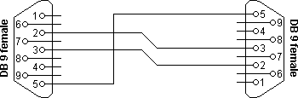

**Table 1**

|  |  |  |
| --- | --- | --- |
| CN 1 | CN 2 | Function |
| 2 | 3 | Rx <- Tx |
| 3 | 2 | Tx ->Rx |
| 5 | 5 | GND |

**Note:** On newer computers, user will need a USB-Serial adapter for 6-axis connection. Communication is tested and will work correctly with an USB-serial adapter.

1. Interface startup

On startup, BSI asks user for the communication channel. 6-axis can communicate to interface via serial port or CAN-bus adapter. Communication with interface via CAN-bus will be explained further in this document.

Using serial port, user needs to select the “Com port” from the dialog. BSI shows the list of detected ports and update list if user connects and disconnects ports during this selection.

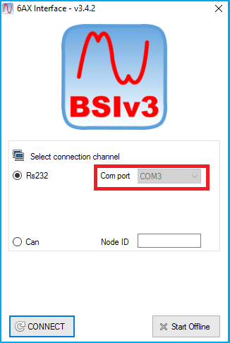

**Figure 2**

After pressing ”OK” button, BSI will read the target parameter and be ready for use. The following figure shows the main windows of BSI.

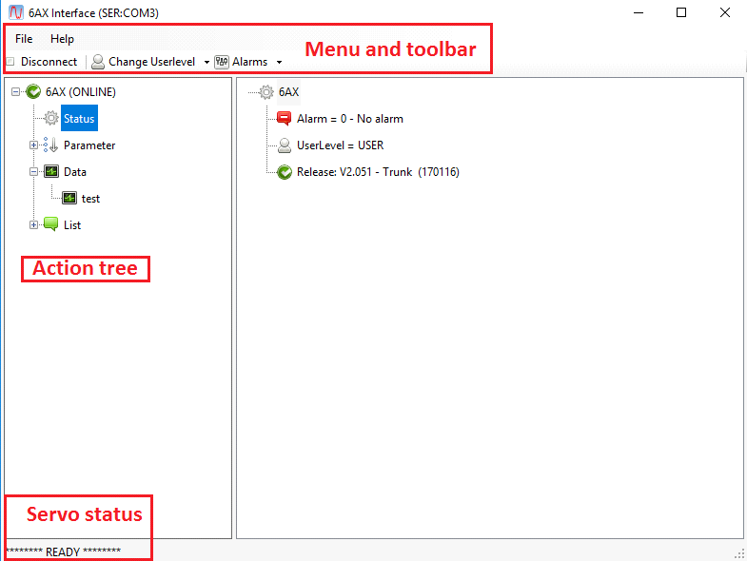

**Figure 3**

Main element of the interface:

* + - * Action tree: user can select a node on the tree. After the selection, the right part of the interface will be updated with a proper viewer.
      * Data: show BSI outputs that are provided for debug purposes
      * List: show the list of alarms/events
      * Parameter: show the parameter tree of the 6-axis device
      * Status: show the “service” panel for 6-axis device
      * Menu & toolbar: menu bar contains parameter top-level functions (loading and saving parameters). By using toolbar, user can reconnect the device after losing connection (for example after power cycling 6-axis) and open existing workspaces or open a new one (see following sections for workspace details).
      * Servo status: user can see a brief description of 6-axis status. The following table gives a summary of 6-axis device status.

| **Status indication** | **Meaning** |
| --- | --- |
| Target communication lost | BSI can't communicate with 6-axis board. User need to check logic supply and serial cable connection |
| Waiting power | Logic supply is ON. Power supply is OFF |
| Powered, ready to go | Logic and power supplies are ON. Product is waiting for enable |
| Phasing in progress | 6-axis is doing the phasing procedure for incremental encoder motors |
| Servo running | 6-axis has at least one axe enabled and running |
| Servo on alarm | 6-axis has detected an alarm and all axes have been stopped |
| Calibration in progress | 6-axis has started a calibration procedure on one axe |
| CANOpen = INIT | CANOpen is in the NMT INIT stage (no BOOT message sent) |
| CANOpen = PREOP | CANOpen is in the NMT PREOP stage (SDO configuration stage) |
| CANOpen = OP | CANOpen is in the NMT OP stage (runtime) |
| CANOpen = STOPPED | CANOpen is in the NMT STOPPED stage (guard expired) |
| (sampling) | Data is being sampled on 6-axis device |
| (sample DONE) | Data sampling has been finished and download is in progess |

**Table 2**

* 1. 6-axis user level

BSI interface interacts with 6-axis board using an access user-level, this helps to prevent the change of unsafe and potentially dangerous parameter to casual users. 6-axis has the following user levels:

* + - * USER: only basic parameter can be changed, password is not required for this level.
      * APPLICATION: application configuration can be changed, password not required.
      * SYSTEM: dangerous parameter can be changed, password is required.
      * ROOT: manufacture parameter can be changed, a second password is required. 6-axis applicator does not need this password.

**Note:** “System” user level’s password is “1836”. That ROOT parameter contains hardware configuration and calibrations, these parameter are written from manufactory during burn-in and should not be changed by users. *ROOT parameter modification will void 6-axis warranty.*

User can change the user-level by selecting the “Status”node and choosing the new user-level from the multiple choice selection on the toolbar.

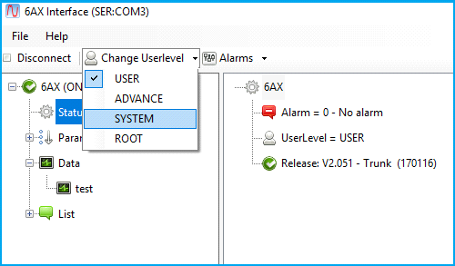

**Figure 4**

* 1. Parameter management

BSI allows read / write a single parameter using the parameter tree. This is useful for configuration of particular functions or to tune one axe.

BSI also allows save parameter file (from menu, File > Save parameter), write on PC the full configuration of the Servodrive. With the “load parameter” function, user can load a Parameter file to a new 6-axis device or to restore a previous configuration on the 6-axis device.

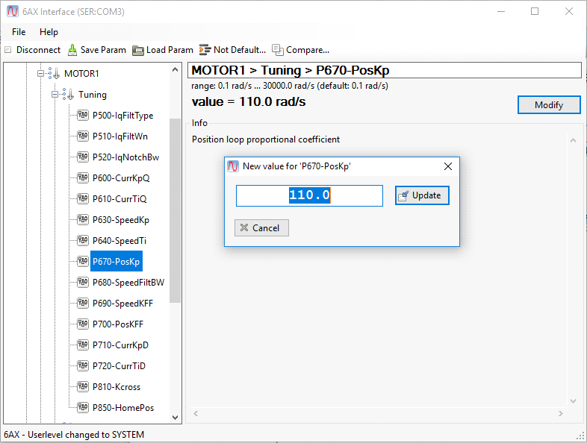**Figure 5**

Single parameter modifying: after selecting the parameter, user can press “Modify” button on the right to modify parameter value and press “Update” to confirm the new value.

If inserted value is not allowed, BSI will issue a warning to the user and will not change the value. Value can be rejected for the following reason:

* Value is out of range (esp. CAN-bus node id out of 1-127 range)
* Value is invalid (esp. User trying to set 900kbaud in the CAN-bus baud rate)
* Value can't be changed when at least one axis is running (esp. User is trying to change mode of operation when axis is already running).

Parameter file saving: User can save all the 6-axis parameters using the “Save parameter” option on the toolbar. BSI will ask to the user where to save the file and the file name to prompt.

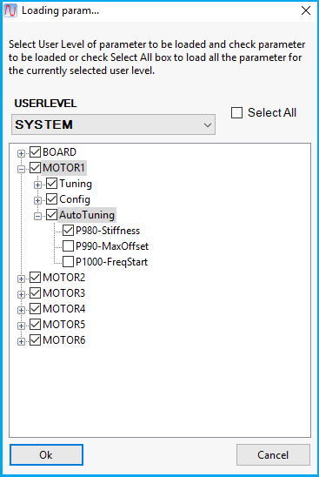**Figure 6**

Parameter file loading: with the ”Load parameter” option on the toolbar, user can load a parameter file from Desktop. After confirmation of file to be loaded, BSI will issue a dialog for selection of actual list of parameter to be loaded:

If user check the”Select All” flag, all parameter of the file will be uploaded to 6- axis device. otherwise, user can select the actual list (esp. only Motor1 parameters).

User can also choose the maximum user level for parameter to be uploaded. (Esp. if “Application” is checked, only user Application parameter would be selectable on the tree on the right.)

If user selects “System” user level parameter and 6-axis board user level is lower, BSI will issue the password input dialog for level elevation.

* 1. Workspaces basics

BSI allows user to monitor internal values of 6-axis devices using workspaces.

A workspace is an additional window that shows target internal information using workspace's boxes like watches, traces or plot-table.

BSI comes with a number of pre-configured workspaces for the application. Furthermore, user can configure his own workspaces to achieve particular task, for example analyzing some unwanted behavior on real machine.

The following figure shows a workspace:

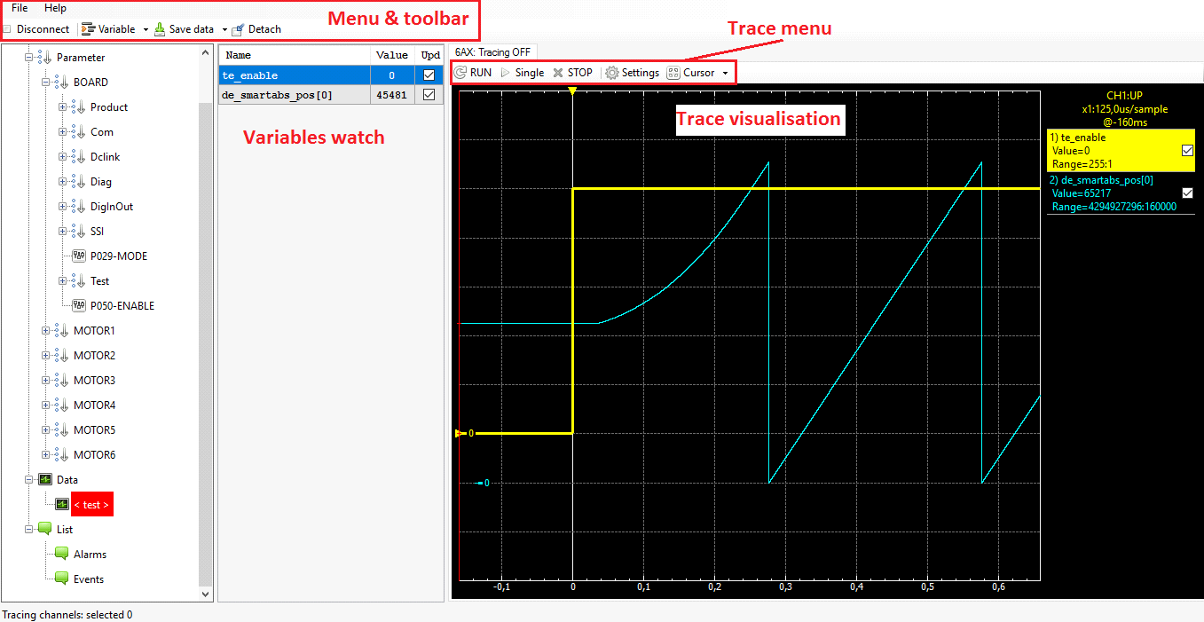

**Figure 7**

A workspace is composed by the following fields:

* Watch: a watch allows user to read periodically a value from target (esp. motor

position, motor speed, dc-link voltage, board temperature etc). Watch box shows the name of the signal and its actual value. Watches are refreshed only when “Upd” button is checked (update).

* Traces: a trace allows user to show signal trend using the same sample ratio of the target board (or a multiple of the maximum sample ratio). Every trace can sample max 8 channels.

Menu items:

* “File\Open”: discard current configuration and load another workspace
* “Save data\Save wks”: save workspace configuration on current file
* “Save data\Save wks as...”: save workspace configuration on a new file
* “Save data\Start logging”: save data on a new file
* “Save data\Stop logging”: stop the data log
* “Save data\Save options”: the user can select the type of file to be saved (.png, .csv or .m)
* “Variable\Add new var”: add a new variable to the watch list.
* “Variable\Write value”: change the value of a modifiable variable.
* “Detach”: switch the trace visualisation on a new window.

* 1. Adding new watches

To create a new watch:

Click on ””Variable\Add new var” on the menu, a new window will appear.

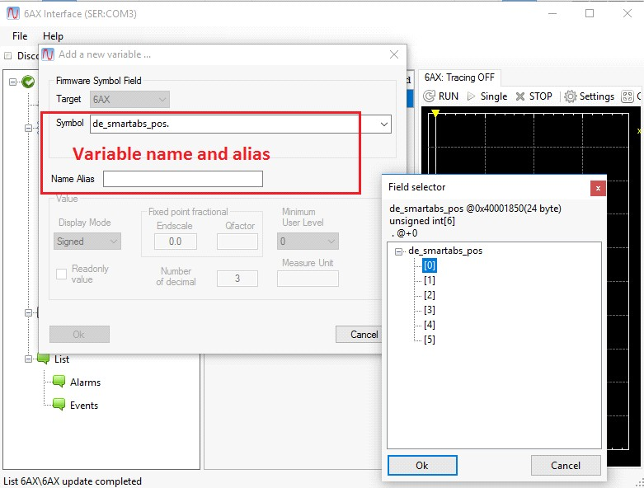

**Figure 8**

* type the start of the symbol name on keyboard (filter field will be automatically updated)
* cycle between matching symbols with TAB key
* when symbol field is right, press ENTER key
* if the symbol is structured, will be displayed the field selection box. Select the right field opening tree nodes and press OK.

See section “Firmware variable list” for an extensive list of information for 6-axis board (motor position, speed, current etc.).

* 1. Working with traces

Traces show the trend of up to 8 signals. Buffering of data happens on the target ensuring precision on data sampling.

User can specify signals to be sampled and sampling parameter in a way similar to an oscilloscope. It can be chosen a trigger signal, trigger level and condition (up/down). Tracing is useful also when user needs to know what is the behavior of some signals before some events happened, since tracing can show signal trend before trigger.

The following picture shows a trace:

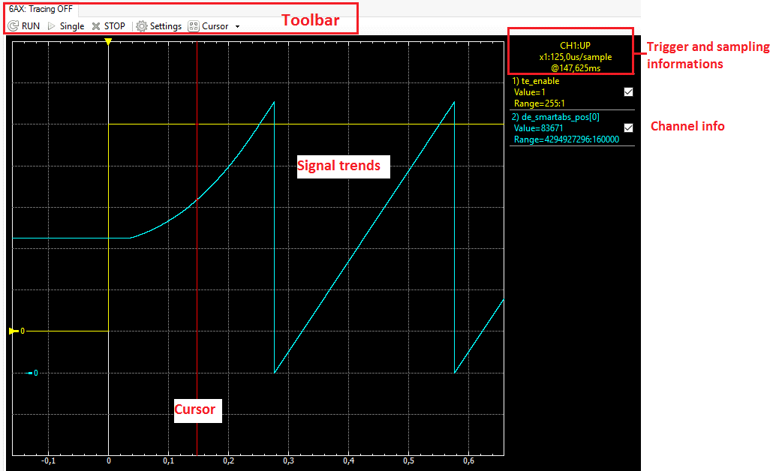

**Figure 9**

By clicking on “Settings” from the Toolbar, the user can select all the already mentioned options. In “Sampling” the sampling rate and the trace duration can be selected.

As can be seen in Figure 10, in “Trigger”, the user can select the trigger mode and the threshold value. In the “Variable” list, the user can add the variables to be plotted (they must be already added in the watch field), as well as show their range and decide which signal should be used as “Trigger” signal.

The previous picture shows also a white vertical line with a yellow arrow. User can use this cursor by dragging it on the trace window, in order to set the trigger instant inside the trace duration.

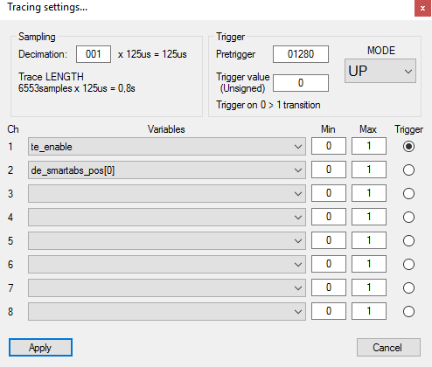

**Figure 10**

When configuration is ok, user can issue a trace command using the ”single” or checking ”run”. After command is issued, tracing start on the device searching for the trigger event. if “AUTO” is specified, no trigger event will be waited and tracing will end as soon as the buffer is completed.

Furthermore, data can be inspected using a cursor function (showed in red in the previous picture). Either clicking on a trend or moving by cursor keys, user can select a particular sample.

Trace canvas also support fast moving by pressing “CTRL” key with cursor keys. User can also zoom nearby cursor by pressing CTRL with up/down arrows.

* 1. Description of trace interface

The toolbar of a trace contains the following items:

* “RUN” check: enable/disable the continues tracing. if enabled, after one trace completed, a new one will be issued immediately.
* “SINGLE” button: issue a trace start when click discard; if tracing is in progress a new command will be issued riding previous sampled data
* 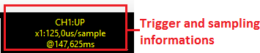“Settings” button: open the trace settings dialog

Trigger and sampling box information:

**Figure 11**

First line contains the channel used as trigger signal and the trigger mode. In this example, the first channel is used (CH1) with the UP trigger mode. Second line shows the sampling ratio. One sample every 125 us. Third line contains cursor position. It shows the time associated with the cursor position. Please note that if cursor is before trigger event, then both time and sample number will be negative.

**Figure 12**

Trace information:

On the first line is shown the channel number and the signal name (or the alias defined in the settings dialog). Second line shows the sample of the trend currently selected by the cursor. Third line shows the range of the trend for the signal.

Cursor handling:

* Cursor can be moved by clicking on the trace or by pressing LEFT/RIGHT cursor keys
* Cursor can be moved quickly by pressing CTRL + LEFT/RIGHT keys
* Canvas can be zoomed nearby the cursor by pressing CTRL+UP/DOWN keys.
  1. Event and alarm list (List)

Selecting List node on the main tree-node in the left of BSI, user can access the event and alarm list of the target board. The following pictures show an event list and a fault list screen:

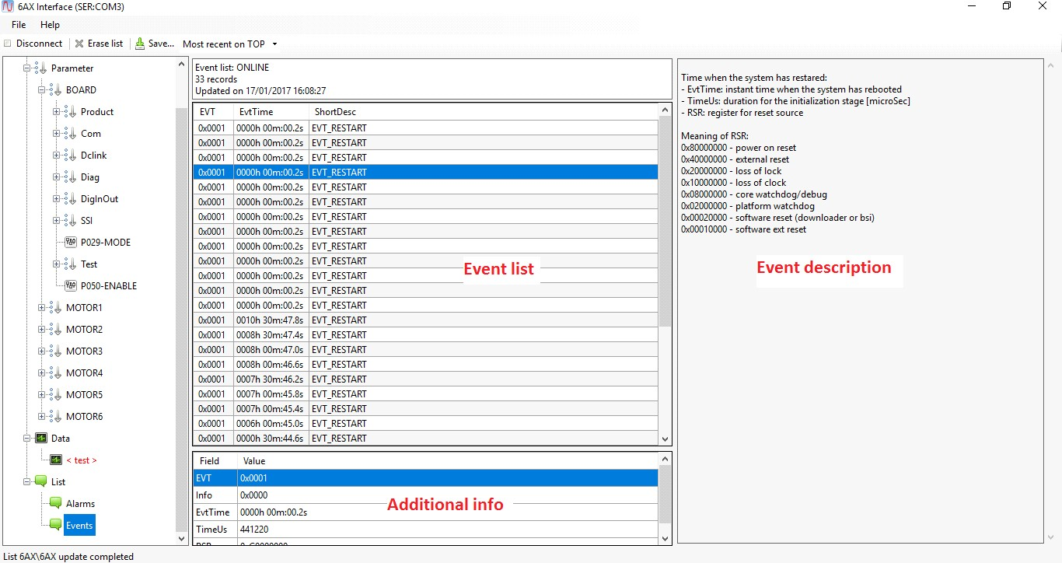**Figure 13**

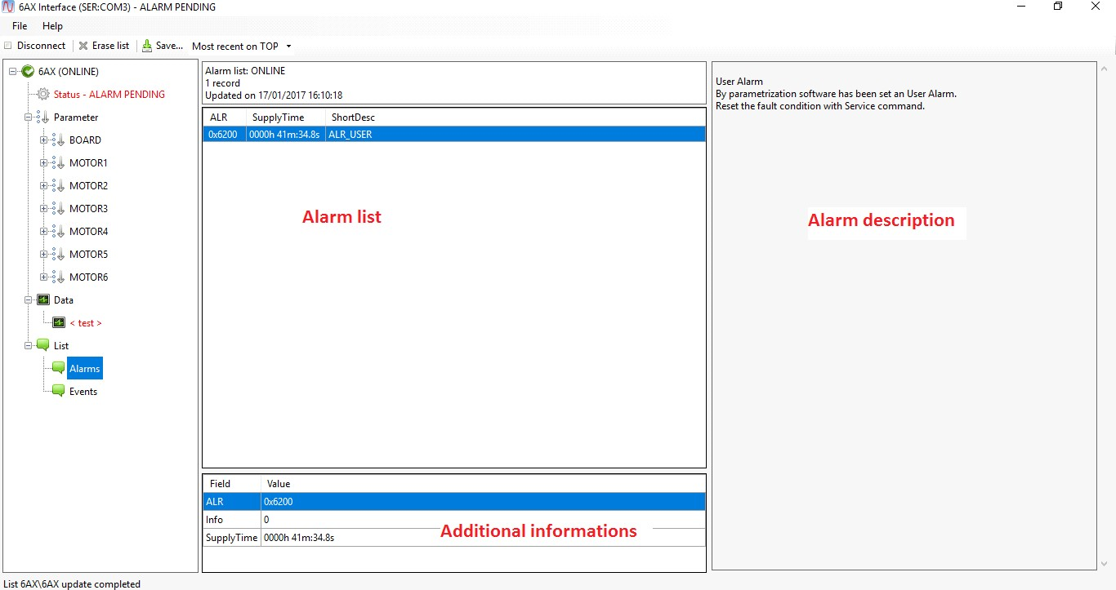

**Figure 14**

On the top of the list is shown the supply time. This time is the board life counter and every log in the list refers to that time.

The main list contains the actual event / alarm records.

**NOTE:** the message of a fault starts with the hexadecimal code. this code is sent on CANOpen via EMCY service on fault detection.

Every event/fault can have additional info attached. This info is shown on the box under the main list. for example on a phasing fault, in the additional info, user can find the axis number and the error detail code.

Last, on the right side, there is a detailed description of the event/fault and some guidelines for alarm diagnosis and recovery.

On the top, there are two utility buttons for the list:

* Erase list: allows user to clear the lists
* Save: allows user to save the event/fault list and the additional information to file.

See the section “List of 6-axis alarms” for details on board faults.

* 1. Update in 6-axis software

This section explains how to use the PC utility to update 6-axis firmware. For software update, user needs:

* + - * install of support libraries (see section “Setup of interface”)
      * null-modem db9 pc cable (see section “PC connection”)
      * Update software distribution containing “bsi.exe” and “main.mo2” files.

Please note that after software update, 6-axis parameters will NOT be modified. If new parameters are added on new software release, they will be set to default value.

**WARNING:** Do not switch off power during update. Interrupting the update procedure could prevent user to do subsequent updating Procedure:

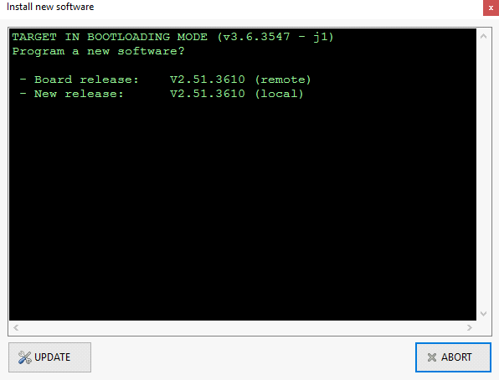

**Figure 15**

* + - * Connect cable and power on 6axis
      * Connect to BSI

If the software is out-of-date, the following window will appear:

* + - * Click on “Update” button and confirm the dialog.

Update sequence will start erasing device and programming the new version. On update end, downloader will show “UPDATED TO [version number]”.

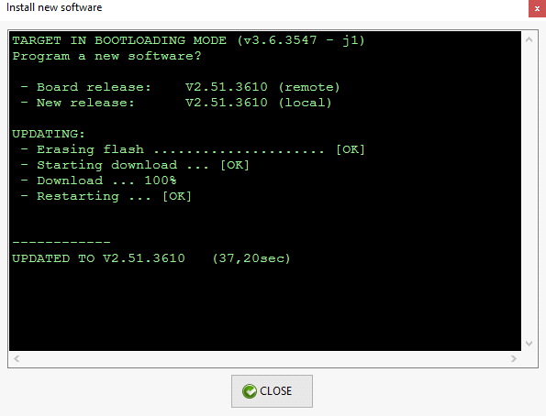

**Figure 16**

1. Configuration

6-Axis servo driver comes from factory with a empty default parameter configuration. This means that user needs to load parameter for the motor according to application machine.

After loading motor parameterizations, user will also need to change other application specific parameters, such as function for digital input or outputs etc. Then, drive will be ready for switching on power and tuning motors.

* 1. Parameterization reset

Parameter library contains a special parameter file named “Empty.sdp”. User can load this parameter file to reset parameter to factory default.

* 1. Loading motor parameters

PC interface comes packaged with a library of qualified motors. For each motor, user will find a parameter file containing basic parameter. Each parameter file contains configuration for all 6 motors and user can choose to load all motor or only some of them.

If user motors are not contained in the default library, user can enter manually motor parameters or use the auto configuration procedure (see next paragraph). Esp. Application has the following motor configuration:

* Axe 1 and 2: Siboni S0802B375-INC4096
* Axe 3: Siboni S0801B373-INC4096
* Axe 4: Siboni S0601B302-INC2048

Configuration procedure:

* + - * Start BSI
      * File > Open parameter
      * Choose file: Siboni\S0802B375-INC4096 and press “Open”
      * From the parameter selection check MOTOR1 and MOTOR2
      * Press OK
      * If prompted insert SYSTEM password “1836”
      * BSI will load parameter for MOTOR1 and MOTOR2 to 4axis
      * Repeat step 2,3,4,5 for MOTOR3 “S0801B373-INC4096”
      * Repeat step 2,3,4,5 for MOTOR4 “S0601B302-INC2048”
  1. Motor auto-configuration

4-Axis Servodrive is able to auto-configure itself for a motor not present in the predefined library. Data necessary for starting the procedure are contained on the motor nameplate:

|  |  |
| --- | --- |
| **Parameter** | **Description** |
| **INom** | Rated motor current as Ampere, RMS multiplied by 1.41  Esp. 3.0Arms »INom=4.23A |
| **WNom** | Rated speed for motor as RPM |

Procedure for motor auto configuration:

* Ensure motor has no load connected to shaft and shaft key is removed
* Connect with BSI, in Service node, select SYSTEM user level, and set password to 1836
* set BOARD\Mode=16
* set BOARD\Test\EnableAxis as bit-field for axis to be configured:
  + - axe1 » EnableAxis = 0x1
    - axe2 » EnableAxis = 0x2
    - axe3 » EnableAxis = 0x3
    - axe4 » EnableAxis = 0x4 etc.
* set INom/WNom parameter for axes to be auto-configured (Esp. MOTOR1\Config\INom, MOTOR1\Config\WNom)
  + INom: insert rated Ampere RMS value multiplied by 1.41 W
  + Nom: insert rated speed as RPM
* connect high-voltage power
* Press I1; BSI will show “PHASING in progress”
* Motor will move according to configuration procedure

On end, BSI will show “POWERED, ready to go”. If procedure finds alarms, BSI will show “Servo on ALARM”.

Troubleshooting for auto-configuration alarms:

|  |  |
| --- | --- |
| **Alarm Code** | **Description** |
| 0x7390 - ERR_PHASE_W | Motor phase terminal W disconnected; check motor cabling |
| 0x7391 - ERR_PHASE_V | Motor phase terminal V disconnected; check motor cabling |
| 0x7392 - ERR_PHASE_U | Motor phase terminal U disconnected; check motor cabling |
| 0x7393 - ERR_NOINDEX | Encoder index pulses not sensed during motion; check encoder cabling |
| 0x7394 -ERR_PHASE_ENC | Encoder A/B pulses not sensed during motion; check encoder cabling |
| 0x7396 - ERR_PARAM | Error while writing parameters during auto-config procedure; contact producer |
| 0x7397 -ERR_CONN_POW | Power supply low when auto-config procedure has started, check power supply |
| 0x7398 - ERR_KE | Error during KE estimation: procedure is not able to reach 80% of nominal speed WNom; either reduce WNom, check power supply or replace motor |
| 0x739C - ERR_J | Error during J estimation: procedure is not able to start motor or to reach nominal speed; check shaft friction, power supply and motor cabling |

* 1. Motor customization

Once loaded basic parameter, user can configure some feature of the motor according to the application needs.

* 1. Extra current

Each motor has an extra-current/torque capability for a limited time. Motor can require a current/torque greater than rated one. When limit is exceeded, current will be limited to nominal one until required current/torque will become lower than rated for TExtra time.

Please note that depending on application, performance may be degraded if extra- torque limitation is enabled (esp. quick acceleration until reaching the limitation, tracking may be good while after reaching limitation. Tracking error can increase).

Parameters:

* MOTORx\Config\INom: rated current (as rated current RMS multiplied by 1.41)
* MOTORx\Config\IExtra: extra current (as extra current RMS multiplied by 1.41)
* MOTORx\Config\TExtra: extra current erogation time (as ms.); if TExtra=0, motor will always be allowed to output IExtra current/torque

Guidelines:

* For normal application, user can choose TExtra=0, and IExtra=2xINom
* For heavy duty application, increase IExtra. ensure IExtra ≤ 3xINom until otherwise stated from motor manufactory
* use TExtra>0 for ensure proper motor cooling on heavy duty application
  1. Manual JOG

4-axis device allows user to move motors in a JOG function using integrated keys (see related description of procedure). With the following parameter, user can customize Jog behavior:

* MOTORx\Config\VelJog: reference speed for jog function
* MOTORx\Config\IMaxJog: maximum current for speed control in jog function (IMaxJog = INom will allow jog function to deliver rated torque)

Please note that jog profiles have a constant acceleration: jog profile will reach VelJog speed in 1 sec.

* 1. Mechanical brake

Each axis can drive a digital output for axis electro-mechanical brake. Digital input/output configuration parameter define mapping from function to output pin. The parameters for defining brake activation are:

* MOTORx\Config\TLock: time from brake lock (digital output switch off) to actual motor torque switch off
* MOTORx\Config\TUnLock: time from actual motor torque switch on to brake unlock (digital output switch on)
  1. Aligment / phasing modes

6-axis handles only incremental encoder position sensor. Each encoder input has A/B/Index phases. Therefore, when switching on axes after power on, drive needs to perform a special procedure to find proper phasing of motor rotor. After this procedure has been completed, motor can be driven by torque, speed or position control functionalities.

6-axis drive allows two type of electrical phasing (also called alignment procedure):

* + - * Standard: during procedure little movement are performed in the rotor axis, Movement can be as great as one third of electrical sector (electrical sectors are equals to pole pairs). For example with 4 pole pairs, standard alignment will move motor rotor for maximum 360o/4/3=30°.
      * Align-pulses: the procedure detects electrical rotor position via fast current spikes, allowing rotor phasing without movement. Before use this procedure user needs to perform index calibration (see ), otherwise an alarm will be triggered by 6-axis. Alignment/phasing parameters:
* MOTORx\Config\AlignType: 0=standard, 2=pulses
* MOTORx\Config\AlignDelta: delta position for encoder validation during alignment procedure
* MOTORx\Config\IAlign: alignment/phasing current

**NOTE:** Standard alignment procedure contains some connection checks useful for initial commissioning. If application requires pulse alignment due to restrictions to rotor movement, we still suggest using standard alignment during commissioning. After commissioning, user can perform index calibration and enable pulse alignment.

* 1. Digital i/o and analogic inputs

6-axis comes with the following input / output capability:

* n.9 digital input (DIN0 ~ DIN8) + n.4 digital output (DOP1 ~ DOP4)
* n.1 analogical input -10 ~ 10V (AIN0)
* n.1 analogical input 0 ~ 3.3V (AIN1)

Software allows using digital input/outputs and analogical inputs through fieldbus. Digital input/outputs can also be assigned to special functions via configuration parameters in category “Board\DigInOut”. Each input (DIN0 ~ DIN9) and each output (DOUT0/DOUT1 and DOP1 ~ DOP4) has a parameter to choose the related function.

User can also set polarity inversion for both digital inputs and outputs by using parameter “Board\DigInOut\PolarityInv”.

* + 1. Inputs

These parameters allow configuration for digital inputs DIN0 ~ DIN9 with the following association:

|  |  |  |
| --- | --- | --- |
| **Value** | **Code** | **Description** |
| 0 | GPIO | Only GPIO: input is mirrored in CanOPEN object 4C00 without additional functions |
| 1 | HOME1 | Input is configured as zero switch for axis 1 |
| 2 | HOME2 | Input is configured as zero switch for axis 2 |
| 3 | HOME3 | Input is configured as zero switch for axis 3 |
| 4 | HOME4 | Input is configured as zero switch for axis 4 |
| 5 | THERM_ALARM | Input is configured to trigger a thermal alarm |
| 6 | EXT_ALARM | Input is configured to trigger an external alarm |
| 11 | I1 | Input is configured to emulate onboard push-button I1 |
| 12 | I2 | Input is configured to emulate onboard push-button I2 |
| 13 | I3 | Input is configured to emulate onboard push-button I3 |
| 21 | OT_NEG_1 | Input is configured as negative overtravel for axis 1 |
| 22 | OT_POS_1 | Input is configured as positive overtravel for axis 1 |
| 23 | OT_NEG_2 | Input is configured as negative overtravel for axis 2 |
| 24 | OT_POS_2 | Input is configured as positive overtravel for axis 2 |

**Note:** when assigning key I1/I2/I3 on digital input, onboard keys will still operate as usual.

When configured, overtravel function will cut axis torque for speed and position control modes (negative overtravel for negative movements, positive overtravel for positive direction movements).

* + 1. Outputs

This parameter allows configuration of functions on DOP1/2/3/4 and DOUT0/1 with the following association:

|  |  |  |
| --- | --- | --- |
| **Value** | **Code** | **Description** |
| 0 | GPIO | Output is driven by CANOpen register 4C01 |
| 1 | BRAKE1 | Output drives electrical brake for axis 1 |
| 2 | BRAKE2 | Output drives electrical brake for axis 2 |
| 3 | BRAKE3 | Output drives electrical brake for axis 3 |
| 4 | BRAKE4 | Output drives electrical brake for axis 4 |

|  |  |  |
| --- | --- | --- |
| 10 | ALARM | Output is set when an alarm is detected |
| 11 | LED_RED | Output is configured to mirror RED onboard led |
| 12 | LED_GREEN | Output is configured to mirror GREEN onboard led |

**Please note:**

* without polarity inversion, digital output will be switched ON when brake is locked (axIe switched off)
* with polarity inversion, digital output will be switched ON when brake is released (axIe switched on) - DEFAULT

Refer to parameters MOTORx\Config\Brake for activation and deactivaton time for brake output.

* + 1. Analog inputs

Analog inputs don't have special function. Value can be read as CANOpen manufactory specific register (please refer to CANOpen interface documentation).

1. CANOpen configuration

Parameters in group BOARD\CANOpen allows configuration of CANOpen settings (baudrate and node-id).

After setting configuration, user need to switch operating mode to CANOpen to enable communication by setting parameter BOARD\Mode=0 to switch on CANOpen slave management.

* 1. Pulses phasing and index calibration

To enable pulses phasing is necessary to perform index calibration procedure.

Index calibration:

* switch on 24V supply on 6axis and connect with BSI
* set “BOARD\TEST\EnableAxis” based on axis to calibrate (esp. 0b0100 third motor)
* set BOARD\Mode=15 (index calibration)
* switch on power supply
* press button I1

Procedure may take some minutes (status bar will display “Calibration in progress”). On completion, 4-axis will return ready. If status bar displays “Servo on ALARM”, please check on the log the alarm refer to “device alarms” for details. Upon procedure completion, Servodrive will return ready. Parameter “MOTORx\Config\IndexCalibration” will now contain the calibrated value

Enable pulses phasing:

* set MOTORx\Config\AlignType=2
  1. Homing checks

When using homing procedure with index and homing switch, user must check proper phasing between index pulse and switch to ensure reliable homing operation. Procedure:

* + - * switch on 24V supply on 4axis and connect it with BSI
      * open workspace “IndexSwitchDelta” and enable watch update
      * enable homing procedure on involved axe from controller
      * verify “Index-Switch Delta” in the workspace. Value has to be in the range 5000-60000. If value is less than 5000 or great than 60000, user need to move switch and retry the procedure

1. Commissioning

This section explains how to verify motor tuning and how to make it work properly with the Tex controller.

* 1. Encoder checks

Before switching on power, user need to check proper cabling of encoder:

* switch on 24V supply on 4axis and connect with BSI
* select “monitor”
* enable “Pos1” variable refresh
* move motor 1 rotor and verify correct pulse count. If displayed value oscillates around zero, check if phase A and phase B of encoder 1 are properly connected
* enable “IdxCount1” variable refresh
* move motor 1 rotor and verify the increment on every turn. If count is stuck to zero, check cabling of Z pulse
* repeat step 3-6 for other motors.
  1. Motor cable checks

Follow this procedure:

* switch on 24V supply on 6axis and connect it with BSI
* set BOARD\Mode=40 (speed test)
* set BOARD\Test\EnableAxis: enable used motors (For example, if motor 1 and 2 used, set parameter to 0b0011).
* set BOARD\Test\WStar1=0, BOARD\Test\WStar2=0,
* set MOTORx\Config\AlignType=0 (standard alignment)
* switch on power supply
* push button “I1”

Selected motors should align and start speed control at zero speed. The status bar should display “Servo RUNNING". If status bar displays “Servo on ALARM”, select LOG on the main tree to check the alarm reason refer to “device alarms” section for details, then to stop test press button “I2”; to reset alarms press button “I3”.

* 1. Inertia auto-tune

6-axis allows application inertia auto-tune. Before procedure enable, user need to setup some parameter that define auto-tune behavior.

Auto-tune steps:

* switch on 24V supply on 6axis and connect with BSI
* set target perceptual stiffness MOTORx\Autotuning\Stiffness; as first try, set it to 25%
* set target offset MOTORx\Autotuning\MaxOffset to the maximum displacement allowed during the procedure (For example: 2 Turns)
* set initial frequency MOTORx\Autotuning\FreqStart (For example 1 Hertz)
* set BOARD\Test\EnableAxis to the number of motor (Esp. motor 2 > 0b0010)
* set BOARD\Mode=22 (Auto-configure with limited movement)
* switch on power supply
* ensure that motor travel range is compatible with “MaxOffset” parameter
* push button I1
* Procedure may take some minutes (Statusbar will display “Calibration in progress”). On completion, 6axis will return ready. If statusbar displays “Servo on ALARM” check on the log the alarm refer to “device alarms” for details.
  1. Standalone tuning

This procedure allows user to check speed and position control performance and do basic tuning using BSI PC software.

**WARNING:** since procedure is done with numeric control disconnected, user **MUST** ensure that test movement parameters are compatible with travel range of motor.

* + 1. Speed test

In speed test (Mode=32), 6-axis generates a reference speed profile defined by parameters:

* BOARD\TEST\WStar1: first profile speed
* BOARD\TEST\WStar2: second profile speed
* BOARD\TEST\TRamp: defines the time to switch from first and second speed (define acceleration of speed switch)
* BOARD\TEST\TCycle: defines the period of the speed profile

Procedure:

* switch on 24V supply on 4axis and connect with BSI
* define a profile setting WStar1/WStar2/TRamp/TCycle. On first trials, use low acceleration and low target speed
* set BOARD\Mode=40 (speed test)
* open workspace “SPEED_Ctrl_X”, where X is the motor
* switch on power supply
* start test with button I1 and stop it with button I2
* acquire tracing by clicking on “SINGLE” button
* adjust Kp (MOTORx\Tuning\SpeedMovKp) and Ti (MOTORx\Tuning\SpeedMovTi) to tune performance. By increasing Kp and reducingTi for a quicker response, reducing Kp and increasing Ti for better disturbance rejection
* verify that Iff (feedforward current) is 70/80% of IqRef (current demand); if Iff is less, increasing Jload parameter (MOTOR\Tuning\Jload)
  + 1. Position test

In position test, 6-axis generates a reference position profile defined by parameters:

* BOARD\TEST\ThStar1: first profile position
* BOARD\TEST\ThStar2: second profile position
* BOARD\TEST\TRamp: defines the time to switch from first and second position (define speed of speed switch)
* BOARD\TEST\TCycle: defines the period of the position profile Procedure:
* switch on 24V supply on 6 axis and connect it with BSI
* define a profile setting ThStar1/ThStar2/TRamp/TCycle. On first trials, use low acceleration and low target speed
* set BOARD\Mode=45 (position test)
* open workspace “POS_Ctrl_X” where X is the motor
* switch on power supply
* start test with button I1 and stop it with button I2
* acquire tracing by clicking on “SINGLE” button
  + if speed tracking is good (Speed and SpeedRef overlapped), increase PosKp (MOTORx\Tuning\PosKp) to reduce PosError
  + if speed tracking is bad, reduce PosKp (user need to improve speed tracking performance to get better position tracking performance)
  + if necessary, try to adjust also speed loop parameters General advice for parameter tuning:
* on high frequency ringing, decrease the SpeedMovKp
* on low frequency oscillation, increase SpeedMovKp and SpeedMovTi
* for increasing performance for the position control increase PosKp: when high frequency noise appears or PosError behaviour shows, the bandwidth of position loop is too near to speed loop

Furthermore, ensure that feedforward actions act as required:

* speed feedforward should have the same form of the first derivative of the position reference. This signal should not contain edges or discontinuities, otherwise master is not interpolating correctly or the fieldbus have some timings problem (missing frames or wrong interpolation time)
* current feedforward should follow closely the form of the Iq real current. If the feedforward action is significantly smaller than the actual current, increase Jload parameter
  1. Firmware variable list

The following table summarizes the principal variables that can be used in watch or traces in the BSI workspaces.

**Note:** “[ax]” notation means the array index and follows this association:

* [0]: first axis
* [1]: second axis
* [2]: third axis
* [3]: fourth axis

|  |  |  |
| --- | --- | --- |
| **Variable name** | **Description** | **U.m.** |
| encoders[ax].Position | Actual position (CANOpen notation) | CANOpen notation   * 16msb=round counter * 16lsb=round fraction |
| encoders[ax].IdxSeenCount | Index count from power-on | Index count |
|  | | |
| controls[ax].Regs.PosError | Position error during position loop execution (CANOpen notation) | CANOpen notation |
| controls[ax].Regs.PidW.Ref | Speed reference in the speed control loop | Rad/s |
| controls[ax].Regs.PidW.Fdb | Speed measuring the speed control loop | Rad/s |
| controls[ax].Regs.PidW.Err | Error (reference - measure) for speed control loop | Rad/s |
| controls[ax].Regs.PidW.Out | Output of the speed loop (current reference for IQ loop) | Ampere peak |
|  | | |
| controls[ax].Regs.PidIq.Ref | Reference of Iq current loop | Ampere peak |
| controls[ax].Regs.PidIq.Fdb | Measure of Iq current loop | Ampere peak |
| controls[ax].Regs.PidIq.Err | Error (reference - measure) for Iq current control loop | Ampere peak |
| controls[ax].Regs.PidIq.Out | Output of Iq current loop | Phase volt peak |
|  | | |
| controls[ax].Regs.WffCalc | Feedforward speed computed by position reference | Rad/s |
| controls[ax].Regs.IffCalc | Feedforward current computed from acceleration of the reference and  the Jlod+Irot parameters | Ampere peak |
| controls[ax].Regs.VffCalc | Feedforward tension computed by motor speed and BEMF coefficient | Volt peak |
|  | | |
| controls[ax].ThStar | Position reference from CANOpen or testing (valid only for position control modes) | CANOpen notation |
| controls[ax].WStar | Speed reference from CANOpen or testing (valid only for speed control  modes) | CANOpen notation |
| controls[ax].IStar | Iq current reference from CANOpen or testing (valid only for Iq current  control modes) | CANOpen notation |
| controls[ax].Type | Control type: 0=control off 10=torque d/q  12=speed (with internal feedforward filter) 13=position (with internal feedforward filter)  14=speed (with external feedforward generation) 15=position (with external feedforward generation) |  |
| controls[ax].Mon.Irms | Load RMS current | Ampere RMS |
|  | | |
| te_enable | Variable for command testing modes from BSI: 0=testing is switched off (equals to pushing I2)  1=enable testing (equals to pushing I1) 3=force an alarm reset (equals to pushing I2) |  |
|  | | |
| co_ax_contexts[ax].Device.Cont rolWord | CANOpen control word for axis | see DSP402 |
| co_ax_contexts[ax].Device.Statu  sWord | CANOpen status word for axis | see DSP402 |
| co_nmt_state | CANOpen DS301 network state 1=INIT  2=PRE-OPERATIONAL  8=OPERATIONAL  16=STOPPED |  |
| co_sync_cycle_time | Sync cycle time for interpolation modes | micro-seconds |

1. Troubleshooting
   1. Device alarms

When an alarm is detected inside the 6-axis drive, execution for the related axis is stopped and an alarm is recorded on the alarm list. Stopping execution means that DSP402 state machine will transit to FAULT or FAULT_REACTION state.

Depending on the kind of error, slow down of the axis can be possible or not. If possible, DSP402 state machine will transit to FAULT_REACTION and optionally slow down ramp will be performed. If fault does not allow a reaction (error in the encoder of the motor), then DSP402 state machine will transit in FAULT state and power stage is just switched off.

Furthermore, some alarms are axis specific (esp. following error on an axis), while other alarms are board specific (esp. overtemperature). For single axis errors, other axis will not be affected and execution can proceed. For multi-axis errors, all the DSP402 state machine will switch to a fault state meaning that controller needs to handshake fault using “FaultReset” for each axis.

* 1. How alarms are reported from 6-axis device

Alarms for 6-axis device can be read using the LOG viewer in BSI. Upon LOG node selection, BSI will download alarm list and will show to user the list of alarm and additional information.

If CANOpen is enabled, upon alarm trigger, 6-axis will also emit and emergency message to the fieldbus master, as required by DS301 specification.

* 1. How alarms are reported in Tex controller

User can analyze alarms also on Tex Controller CANOpen information window:

* press Test until CANOpen information windows appears
* select 6axis device
* in EMCY window will compare the list of emergency from controller power-up Is possible to show EMCY description inside the CANOpen informational dialog. Please refer to Tex Computer documentation for procedure and file format.
  1. How Tex controller reacts to 6-axis alarms

When an alarm is detected on 6-axis device, the CANOpen state machine transit to FAULT status, Tex Controller detects fault, log it and try to restart drive.

* 1. List of alarms

The following table gives a summary of 6-axis alarms.

Meaning of alarm characteristics:

* Code: hexadecimal alarm code emitted by CANOpen. EMCY code and recorded in the log. the list can be read by BSI interface
* Alarm: short description of the alarm
* Description: more extensive description of the alarm
* Can recover: indicates if the alarm can be reset by the master (via DSP402 fault reset mechanism) or by BSI. If “remarks” is specified, some restriction may apply for the recovery of the alarm.

|  |  |  |  |
| --- | --- | --- | --- |
| **Code** | **Alarm** | **Description** | **Can**  **recover** |
| 2185 | Overcurrent I2T DCLINK | Has been detected a overload on DC-link for a time over the threshold Integral Time.  Last current value sampled was Sampled, whereas the limit, in this operating condition, is Limit.  Is possible reset this fault if spend the time Integral Time. | YES  Remarks |
| 2186 | Short Circuit DCLINK | Has been detected an peak overload on dc-link.  Possible causes:  -There is a Short circuit in output  -there is a peak of load on more axes contemporaneously  -strong electromagnetic disturbance | YES  Remarks |
| 2187 | Short Circuit DCLINK | System has detected a short circuit on the DC-link; please check motor cabling.  Since resetting too frequently can lead to damage, the system will inhibit more than 5 reset in 300sec | YES  Remarks |
| 2283 | Short circuit SPM | System has detected a short circuit on motor; please check motor cabling. | YES |
| 2284 | Error current sensing | System has detected a problem on current reading.  Please contact manufactory. | NO |
| 2311 | Overcurrent SPM | System has detected a overload on power module; please check motor  loads and accelerations. | YES |
| 3210 | Overvoltage DCLINK | System has detected an overvoltage on dc-link. For high inertia loads, please install an external resistor.  Fault can be resetted only if the actual voltage is less than the hardware  predefined max voltage (see hardware manual for actual voltage limits of the power stage) | YES  Remarks |
| 3220 | Undervoltage DCLINK | System has detected a low power voltage while drive is enabled; under normal conditions, controller switch off 4-axis device BEFORE power supply is cut from emergency circuitry  After the system detects this condition, the axis will stop as a result of a CanOPEN DSP402 transition from OPERATIONAL to READY_TO_SWITCH_ON state; to re-enable the operation the state  machine should be driven by the control word accordingly. | N/A |
| 4110 | Environment Over temperature | Environment temperature has exceeded nominal values.  Reset is possible only if the actual environment temperature is less than  parametrized maximum value reduced by 10°C | YES  Remarks |
| 4210 | Motor Over temperature | Motorovertemperature has been detected from an external temperature  proble connected using a configured DIN input | YES |
| 4310 | Heatsink Over temperature | Power heatsink temperature has exceeded nominal values.  Reset is possible only if the actual heatsink temperature is less than  parametrized maximum value reduced by 10°C | YES  Remarks |
| 5117 | Undervoltage SPM | System has detected a low voltage supply on power stage typically this is related to an hardware problem in the power stage.  Recover is only possible if the power stage logic supply is restored. | YES  Remarks |
| 5530 | Hardware error to the parameters memory | System has detected a faulty data memory.  Please contact manufactor | NO |
| 6200 | User alarm | System has detected a “User Alarm”; use alarms are triggered by BSI to check system behaviour upon alarm trigger. | YES |
| 6310 | Parameter loading error | During startup, access to parameter memory has failed; verify parameter values.  Please not that recover of this error is possible, however the parameter value is not guaranteed to be valid. | YES  Remarks |
| 6311 | Parameter update error | On parameter update, write to memory has failed; verify parameter values.  Please not that recover of this error is possible, however the parameter value is not guaranteed to be valid. | YES  Remarks |
| 6312 | Parameter memory fail | During startup, access to parameter memory has failed; verify parameter values.  Please not that recover of this error is possible, however the parameter value is not guaranteed to be valid. | YES  Remarks |
| 7180 | Excessive braking | System has detected an excessive activation of regeneration braking  resistor;for high inertia loads, please install an external resistor. | YES |
| 7381 | Zero mark error | System detected an error on index pulse.  Please check encoder cabling. | YES |
| 7382 | Encoder Error | System detected an error on encoder phases.  Please check encoder cabling. | YES |
| 7383 | Motor Error, phase U | During motor phasing, system detected a disconnected U motor phase;  please check cablingand motor insulation | YES |
| 7384 | Motor Error, phase V | During motor phasing, system detected a disconnected V motor phase;  please check cablingand motor insulation | YES |
| 7385 | Motor Error, phase W | During motor phasing, system detected a disconnected W motor phase;  please check cablingand motor insulation | YES |

|  |  |  |  |
| --- | --- | --- | --- |
| 7386 | Error DC-Link Low during  motor phasing | Phasing has been enabled without power supply; please check controller behavior. | YES |
| 7387 | Encoder calibration error | Error during index calibration procedure. Please check encoder cabling. | YES |
| 7388 | Error realignment Idx | System has detected an incorrect offset between A/B phases and index pulse; please check encoder cabling and ensure encoder is firmly linked to  motor | YES |
| 7389 | Insufficient movement on  phasing | During phasing, no movement has been detected. Please check encoder  cabling and ensure phasing current is enough | YES |
| 738A | Short circuit error, during  phasing | During phasing system has detected a short circuit.  Please check cabling. | NO |
| 738B | No Encoder calibration (IdxCal = -1) | Pulses phasing has been enabled without perform index calibration. Please perform index calibration. | YES |
| 738C | Phasing mode not  allowed | Choose another phasing mode | YES |
| 738D | Software Overcurrent  during phasing | During phasing system detected an overcurret. Please check motor cabling | YES |
| 738E | Alarm during phasing | During phasing a generic alarm has been detected.  Please contact manufactory. | YES |
| 7390 | Auto-tuning error: Phase W disconnected | check phase W connections for the motor AxisNumber.  - AutotuningState ->State in which the error has detected.  After the fix, retry the auto-tuning procedure. | YES |
| 7391 | Auto-tuning error: Phase V disconnected | check phase W connections for the motor AxisNumber.  - AutotuningState ->State in which the error has detected.  After the fix, retry the auto-tuning procedure. | YES |
| 7392 | Auto-tuning error: Phase U disconnected | check phase W connections for the motor AxisNumber.  - AutotuningState ->State in which the error has detected.  After the fix, retry the auto-tuning procedure. | YES |
| 7393 | Auto-tuning error: Error of zero mark not found | Check the encoder connections and assemblage for the motor AxisNumber.  - AutotuningState ->State in which the error has detected.  After the fix, retry the auto-tuning procedure. | YES |
| 7394 | Auto-tuning error: Encoder phase error | Check the encoder connections, pinout and assemblage for the motor AxisNumber.  - AutotuningState ->State in which the error has detected.  After the fix, retry the auto-tuning procedure. | YES |
| 7395 | Auto-tuning error: Error motor not detected | check power connections for the motor AxisNumber.  - AutotuningState ->State in which the error has detected.  After the fix, retry the auto-tuning procedure. | NO |
| 7396 | Auto-tuning error: Parameter store error | - ParError:  ParError=1 ->parameter non-existent ParError=2 ->parameter not used ParError=3 ->Access level error ParError=4 ->Parameter mapping error ParError=5 ->Out of range value  ParError=6 ->access denied, Servodrive in RUN After the fix, retry the auto-tuning procedure. | NO |
| 7397 | Auto-tuning error: Error, DC-Link voltage too low | Check the connection and the voltage of the power supply  - AutotuningState ->State in which the error has detected.  After the fix, retry the auto-tuning procedure. | YES |
| 7398 | Auto-tuning error: Error Ke assessment | Is impossible reached the rated speed, check the parameter WNom and retry:  - AutotuningState ->State in which the error has detected.  After the fix, retry the auto-tuning procedure. | YES |
| 7399 | Timeout during phasing  stabilization | Phasing procedure has exceeded the assigned time.  Please check encoder cabling. | YES |
| 739A | Error assessment of Load Moment of inertia | Inertia auto-tune has failed.  Please check cabling and auto-tune parameters. | YES |
| 739B | Load Moment of inertia  parameter storing error | Inertia auto-tune has failed.  Please check cabling and auto-tune parameters. | YES |
| 739C | Auto-tuning error: Error  assessment of Load inertia | Inertia auto-tune has failed.  Please check cabling and auto-tune parameters. | YES |
| 739D | Auto-tuning error: Wrong encoder direction | During speed test, direction is wrong; check Power and Encoder connection and retry  - AutotuningState ->State in which the error has detected.  After the fix, retry the auto-tuning procedure. | YES |
| 739E | Homing error: error on  value setting | System has detected an error during the homing value setting.  Please contact manufactory. | NO |

|  |  |  |  |
| --- | --- | --- | --- |
| 739F | Brake fault | Check if the brake cabling and voltage alimentation. | YES  Remarks |
| 8611 | Following error | Following error has been detected and axis is configure to stop on following error | YES |
| 8780 | Wrong interpolation time | Detected sync time on CANOpen bus is different from pre-defined cycle  time. Please check controller configuration. | YES |
| 9080 | External alarm | An external alarm has tripped; external alarm is detected from a digital input  DIN properly configured | YES |
| FF10 | Testing error | Check the testing parameters | YES  Remarks |