

**Кафедра управления морским транспортом**

**Дисциплина:** **«Технология и организация перевозок» (ТиОП)**

“The Technology and Organization of Cargo Carriage”

КУРСОВАЯ РАБОТА

Тема: ВЫБОР ОПТИМАЛЬНОГО ТИПА СУДНА ДЛЯ ЗАДАННОГО

НАПРАВЛЕНИЯ

NOMINATION OF THE BEST TYPE OF VESSEL FOR SETPOINT

DIRECTION

Вариант № 61

|  |  |
| --- | --- |
|  | Выполнил студент группы: 207.21  М. А. Калугин  . .2023г.  Проверил преподаватель  С. В. Пестерев  . .2023г. |

Владивосток

2023

**ЗАДАНИЕ**

на курсовую работу по дисциплине

**«ТЕХНОЛОГИЯ И ОРГАНИЗАЦИЯ ПЕРЕВОЗОК»**

студент: Калугин Матвей Александрович

группа: 207.21

Тема задания: Выбор оптимального типа судна для заданного направления

NOMINATION THE BEST TYPE OF VESSEL FOR SETPOINT DIRECTION

Исходные данные:

Вариант: 61

|  |  |  |  |  |
| --- | --- | --- | --- | --- |
| Направление (Direction) | Род груза  (Cargo) | Объем перевозки (Volume) (тыс.т) | Тип судна  (Type of vessel) | Тэкс  ( суток) |
| Ванино – Корсаков (Vanino – Korsakov) | Минеральные удобрения (mineral fertilizer) | 65 | Сухогруз  (Dry cargo vessel) | 330 |
| Корсаков - Иокогама (Korsakov – Yokohama) | Металлолом  (Scrap metal) | 190 |
| Иокогама – Ванино (Yokohama – Vanino) | Бытовое электрическое оборудование (household electrical equipment) | 80 |

Графическая часть: 1. Графики зависимостей

2. Схема судна

Дата выдачи: «14» февраля 2023 г.

Срок сдачи «____»____________ 2023 г.

Преподаватель: _______________ /Пестерев С.В./

Студент: Калугин М. А.

**CONTENTS**

Introduction . . . . . . . . . . . . . . . . . . . . . . . . . . . . . . . . . . . . . . . . . . . . . . . . . . .

1. General guidelines. . . . . . . . . . . . . . . . . . . . . . . . . . . . . . . . . . . . . . . . . . . . .
   1. Explanatory note and graphic material preparation. . . . . . . . . . . . . . . . .
   2. Explanatory note filling. . . . . . . . . . . . . . . . . . . . . . . . . . . . . . . . . . . . . .
   3. Graphic part of the coursework. . . . . . . . . . . . . . . . . . . . . . . . . . . . . . . .
   4. Prototype vessel calculations . . . . . . . . . . . . . . . . . . . . . . . . . . . . . . . . .
2. Coursework stages guidelines . . . . . . . . . . . . . . . . . . . . . . . . . . . . . . . . . . .
   1. Type of vessel requirements justification. . . . . . . . . . . . . . . . . . . . . . . .
      1. Operation of ships at a given direction external conditions analysis. .
      2. Cargo transport characteristics. . . . . . . . . . . . . . . . . . . . . . . . . . . . . .
      3. Line parameters calculation . . . . . . . . . . . . . . . . . . . . . . . . . . . . . . . .
      4. Selected vessel type basic requirements . . . . . . . . . . . . . . . . . . . . . . .
   2. Variant series variation and definition boundaries justification . . . . . .

2.2.1. The choice of boundaries and intervals of variation by net load capacity

* + 1. Choice of boundaries and intervals of variation in speed. . . . . . . . . . .
    2. Choice of boundaries and intervals of variation by type of SPP. . . . . .
  1. Vessel weight calculation . . . . . . . . . . . . . . . . . . . . . . . . . . . . . . . . . . . . .
  2. Vessel carrying capacity and number of vessels calculation. . . . . . . . . .
  3. Vessel construction cost calculation. . . . . . . . . . . . . . . . . . . . . . . . . . . .
  4. Estimated vessel operating costs calculation . . . . . . . . . . . . . . . . . . . . .
     1. Expenses calculation using national currency. . . . . . . . . . . . . . . . . . .
     2. Expenses calculation using foreign currency. . . . . . . . . . . . . . . . . . .
  5. Determining monetary and financial indicators of the ship's operation
  6. Nominating the best variant . . . . . . . . . . . . . . . . . . . . . . . . . . . . . . . . . .
  7. Calculation of the main dimensions of the selected vessel type. . . . . . .
  8. Results of designing the optimal type of ship for a given line. . . . . . . .

Application . . . . . . . . . . . . . . . . . . . . . . . . . . . . . . . . . . . . . . . . . . . . . . . . . . . Bibliography . . . . . . . . . . . . . . . . . . . . . . . . . . . . . . . . . . . . . . . . . . . . . . . . . . .

**INTRODUCTION**

«Nomination of the best type of vessel for setpoint direction» coursework is to be done by 3rd year students (including foreign students) studying «Technology of transport processes» (Transportation and Management in water transport). It is based on the course project "Designing the optimal type of vessel for a given line" and edited by L.I. Yudenkova on the recommendation of the Department of MTM of MSU named after admiral G.I. Nevelskoy, reflecting changes in the transport market. The introduction of anti-Russian sanctions and the movement of cargo flows from the Western to the Far Eastern basin of the Russian Federation. The purpose of this course project is to consolidate theoretical knowledge and acquire practical skills related to the development of the best service for opening a new international shipping line.

Calculation and publication of an attractive schedule for customers, tariffs (with surcharges and discounts), as well as substantiation of the main operational and technical characteristics of new types of ships is the most important task when planning the development of international maritime transport, since the competitiveness and further development or bankruptcy of the shipping industry depend on the correct determination of these parameters. companies in the global freight market.

The specificity of the maritime transportation market lies in its openness to the participation of shipping companies from almost all developed countries of the world. So from ports of China and from the ports of South Korea there previously only were two lines, which are Fesco China Direct Line (FCDL) and Korea-Soviet Direct Line (KSDL) respectively.

Since then, 10 different new companies shipped their cargo between these ports, including: MAERSK (Holland), American President Line (Singapore), MSC (Switzerland), CMA-CGM (France), SINOKOR (S. Korea) and others, which leads to the conclusion that such a factor as import-substituting Russian transport service is exceptionally important - to provide the best intermodal transportation service in marine container business.

The main goal (task) of this coursework is to make students, on the basis of improving their previously acquired knowledge, able to correctly substantiate the parameters for opening a new shipping line with the development of a competitive vessel and service project, including:

- making schedules

- calculating basic tariffs (with discounts and rebates)

- nominating the best type of vessel - stevedore contract with a container terminal (carriage contract).

The second task is to preparate students for theoretical work in foreign and joint shipping companies, including NVOCC, as well as in their representative offices abroad, therefore, the maximum volume of the course project is recommended to be written in English

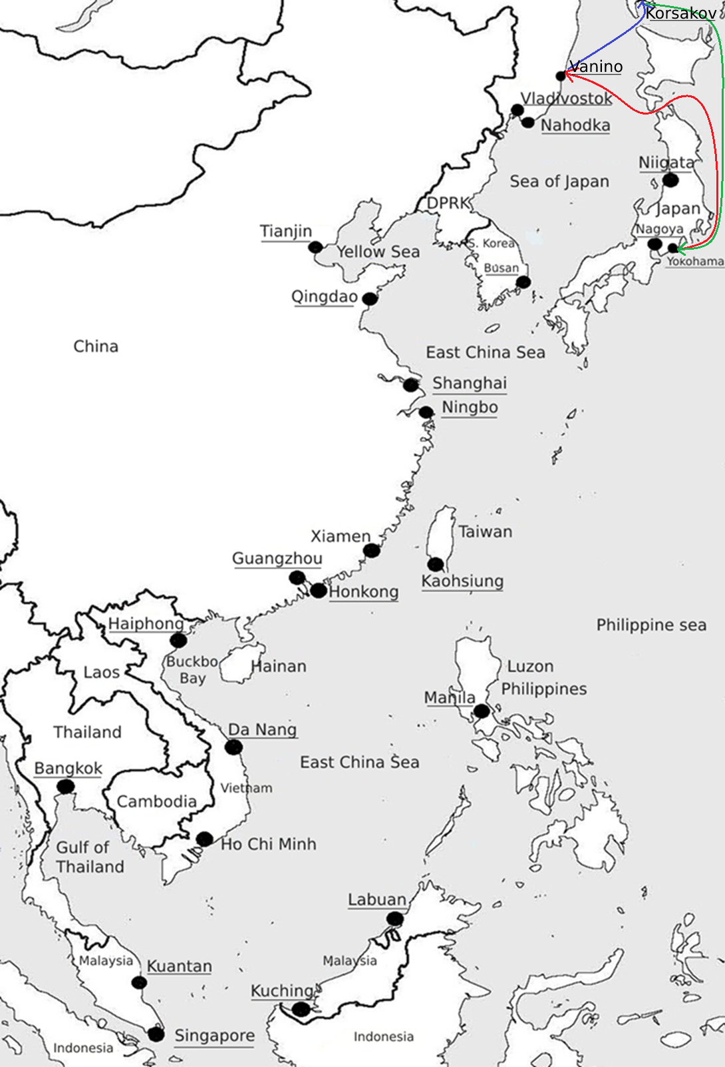

**2.1. Requirements justification for the vessel type**

The correct choice of ship type can only be made after a deep analysis of the factors that affect the final performance of the ship. The study of these factors can be performed in the following sequence:

- the volume, structure and dynamics of cargo flows in given directions are studied;

- studying the external conditions of operation of ships;

- the transport characteristics of the given cargoes are studied;

- analyzes the experience of the fleet (prototypes) in this direction for a number of years;

- generalized and formed requirements for the designed type of vessel and the organization of vessel traffic in a given direction.

**2.1.1. External conditions analysis for ship operation**

The Sea of Japan occupies the southernmost position compared to the rest of the Far Eastern seas. This sea is located between Eurasia and Korea. Sakhalin and the Japanese Islands are the frontiers delimiting the waters of the Sea of Japan from the Pacific basin.

The area of the water surface is 1062 thousand square kilometers with a volume of water of about 1630 thousand km3. The depth of the Sea of Japan is 1535 m on average, while maximum depth is 3699 m. This sea belongs to the marginal oceanic seas.

There are no large islands in the waters of the Sea of Japan. Among the small islands, the most famous are: Moner, Rebun, Oshima, Sado, Askold, Russian, Putyatin. All these islands are located near the coast. The predominant part of the islands is located in the east of the sea.

The salinity of the water of the Sea of Japan is 33.7-34.3%, which is slightly lower than the average salinity of the waters of the World Ocean.

The climate of the Sea of Japan is temperate, monsoonal. The northern and western parts of the sea are much colder than the southern and eastern parts. In the coldest months (from January to February), the average air temperature in the northern part of the sea is about -20 °С, while in the south it’s about +5 °С. The summer monsoon brings some warm and humid air. The low temperatures off the west coast are largely caused by the cold current passing there.

According to ice forming conditions, the Sea of Japan can be divided into three regions:

Tatar Strait, the area along the coast of Primorye from Cape Povorotny to Cape Belkin and Peter the Great Bay. In winter, ice is only constantly observed in the Tatar Strait and Peter the Great Bay. In the rest of the water area, with the exception of closed bays and gulfs in the northwestern part of the sea, it is not always formed.

The Sea of Okhotsk is a [marginal sea](https://en.wikipedia.org/wiki/Marginal_sea) of the western [Pacific Ocean](https://en.wikipedia.org/wiki/Pacific_Ocean). It is located between [Russia](https://en.wikipedia.org/wiki/Russia)'s [Kamchatka Peninsula](https://en.wikipedia.org/wiki/Kamchatka_Peninsula) on the east, the [Kuril Islands](https://en.wikipedia.org/wiki/Kuril_Islands) on the southeast, [Japan](https://en.wikipedia.org/wiki/Japan)'s island of [Hokkaido](https://en.wikipedia.org/wiki/Hokkaido) on the south, the island of [Sakhalin](https://en.wikipedia.org/wiki/Sakhalin) along the west, and a stretch of eastern [Siberian](https://en.wikipedia.org/wiki/Siberia) coast along the west and north

It is connected to the [Sea of Japan](https://en.wikipedia.org/wiki/Sea_of_Japan) on either side of Sakhalin: on the west through the [Sakhalin Gulf](https://en.wikipedia.org/wiki/Sakhalin_Gulf) and the [Gulf of Tartary](https://en.wikipedia.org/wiki/Gulf_of_Tartary); on the south through the [La Pérouse Strait](https://en.wikipedia.org/wiki/La_P%C3%A9rouse_Strait).

In winter, navigation on the Sea of Okhotsk is impeded by [ice floes](https://en.wikipedia.org/wiki/Ice_floes). Ice floes form due to the large amount of freshwater from the [Amur River](https://en.wikipedia.org/wiki/Amur_River), lowering the [salinity](https://en.wikipedia.org/wiki/Salinity) of upper levels, often raising the [freezing point](https://en.wikipedia.org/wiki/Freezing_point) of the sea surface. The distribution and thickness of ice floes depends on many factors: the location, the time of year, water currents, and the sea temperatures.

Cold air from Siberia forms sea ice in the northwestern Sea of Okhotsk. As the ice forms, it expels salt into the deeper layers. This heavy water flows east toward the Pacific, carrying oxygen and nutrients, supporting abundant sea life. The Sea of Okhotsk has warmed in some places by as much as 3°C (5.4°F) since preindustrial times, three times faster than the global mean. Warming inhibits the formation of sea ice and also drives fish populations north.

With the exception of [Hokkaido](https://en.wikipedia.org/wiki/Hokkaido), one of the Japanese [home islands](https://en.wikipedia.org/wiki/Japanese_Archipelago), the sea is surrounded on all sides by territory administered by the Russian Federation. South [Sakhalin](https://en.wikipedia.org/wiki/Sakhalin) and the [Kuril Islands](https://en.wikipedia.org/wiki/Kuril_islands) were administered by Japan until 1945. Japan claims the southern Kuril Islands and refers to them as [Northern Territories](https://en.wikipedia.org/wiki/Kuril_islands_dispute).