<Income Tax calculator>
OVerall Report
Version <1.0>

<Bantouvakis Georgios 4119>

Table of Contents
Introduction 4
Refactored Design 4
Use Cases 4
Architecture 8
Detailed Design 8
Classes Responcibilities and Collaborations (CRC CARDS) 11

Introduction

The purpose of this project was to refactor the Income Tax Calculator Application that have been given to us. I have implemented all the refactor tasks, some improvement on the GUI and unit test that cover all the use cases of the project.
The improvements on the gui include the ability to select a taxpayer who is loaded by double-click on his AFM and the ability to delete a taxpayer who is loaded by click on his AFM and press the Delete button from the keyboard.
Also, I have created same dummy files with AFM 111111111.txt and 111111111.xml to be used for the unit tests.

Refactored Design

Use Cases

Use case ID | LoadTaxPayer
Actors | User
Pre conditions | A file with format AFM_INFO.txt or AFM_INFO.xml should exist.
Main flow of events | - The use case starts when the user chooses to load the file of the taxpayer  - The program loads the file and read the data of the payer.
Alternative flow 1 | In case that the file does not exist, or the format is not correct, the program should throw an exception with the right error message.
Post conditions | The data are loaded.

Use case ID | TaxPayerInfoDisplay
Actors | User
Pre conditions | Taxpayer data are
Main flow of events | 1. The use case starts when the user selects the taxpayer that wants from the list of all taxpayers.  2. All tax info of taxpayer are displayed to the user.
Alternative flow 1 | If the taxpayer is not loaded the program should throw an exception with the right error message.
Post conditions | Info of taxpayer are displayed.

Use case ID | Add Receipt
Actors | User
Pre conditions | Taxpayer info are loaded and displayed
Main flow of events | 1. The use case starts when the user selects to add receipt to taxpayer.  2. A pop up window ask for information with correct format so as the receipt added to the payer  3. After the receipt is added, the txt file that contains all user’s info should be updated
Alternative flow 1 | If the format of user’s input is not correct the program should throw an exception with the right error message.
Post conditions | The receipt is added, and the file is update

Use case ID | DeleteReceipt
Actors | User
Pre conditions | Taxpayer info are loaded and displayed
Main flow of events | 1. The use case starts when the user selects to delete a specific receipt of taxpayer.  2. After the receipt is deleted the txt file that contains all user’s info should be updated
Alternative flow 1 | If the receipt does not exist, the program should throw an exception with the right error message.
Post conditions | The receipt is deleted, and the file is updated.

Use case ID | DisplayReport
Actors | User
Pre conditions | Taxpayer info are loaded and displayed
Main flow of events | 1. The use case starts when the user selects to see the report of the taxpayer.  2. A pop up window shown up with 2 graphs:  2.1. A bar chart with the tax that payer should pay and detailed tax report (basic tax and the impact of the receipts)  2.2 A pie chart with analysis about the different types of receipts.
Post conditions | The 2 types of charts are displayed.

Use case ID | SaveTaxPayerInfo
Actors | User
Pre conditions | Taxpayers’ info is loaded and displayed
Main flow of events | 1. The use case starts when the user selects to save taxpayer’s info.  2. The user should select in what form the data will be save , in a txt file or an xml file  3. A file with format AFM_LOG.txt or AFM_LOG.xml is created with users’ info
Post conditions | The file is created.

Use case ID | Delete Taxpayer
Actors | User
Pre conditions | Taxpayers are loaded and displayed in a list
Main flow of events | 1. The use case starts when the user selects to delete a Taxpayer from the list of taxpayers  2. A pop up window show up that asks from user to give payer’s AFM.
Alternative flow 1 | If the payer does not exist, the program should throw an exception with the right error message.
Post conditions | The payer is deleted and removed from the list of payers.

Architecture
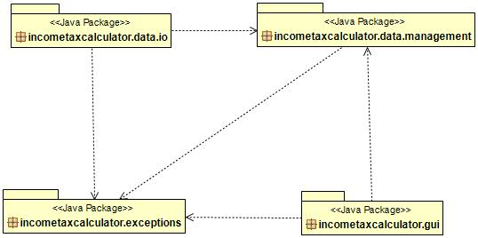

Detailed Design
Package: incometaxcalculator.gui
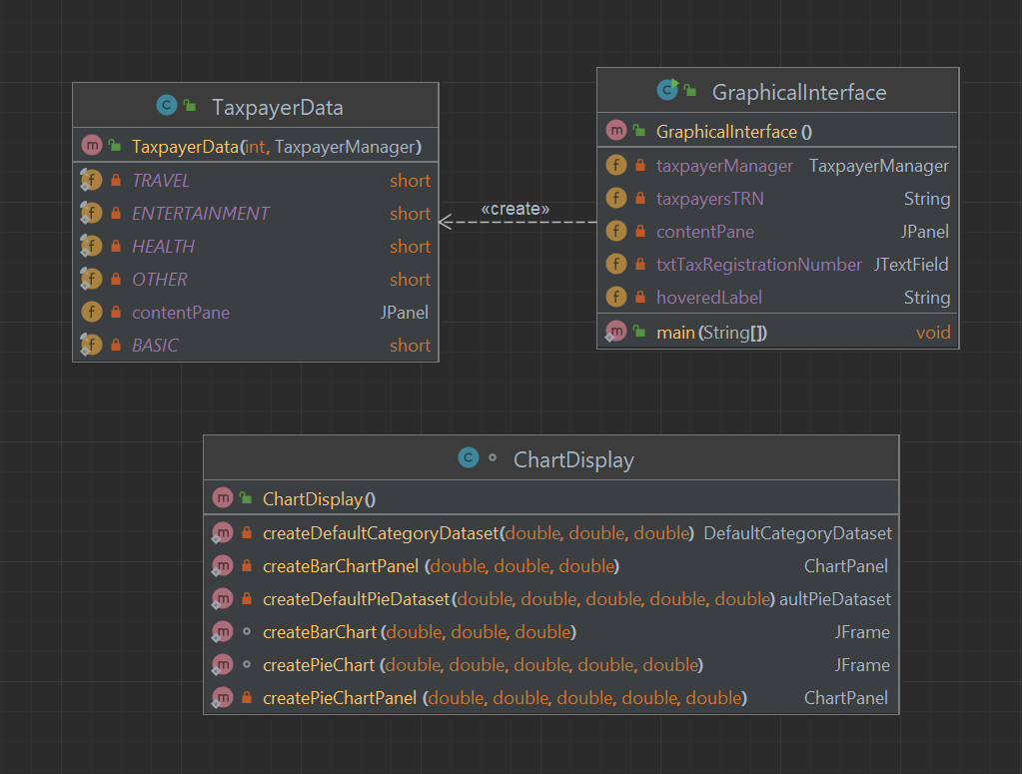
Package: incometaxcalculator.exceptions
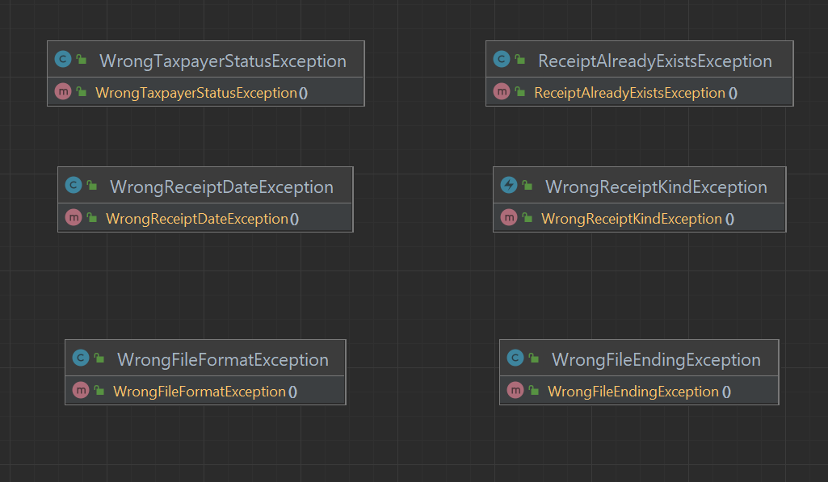

Package: incometaxcalculator.data.management
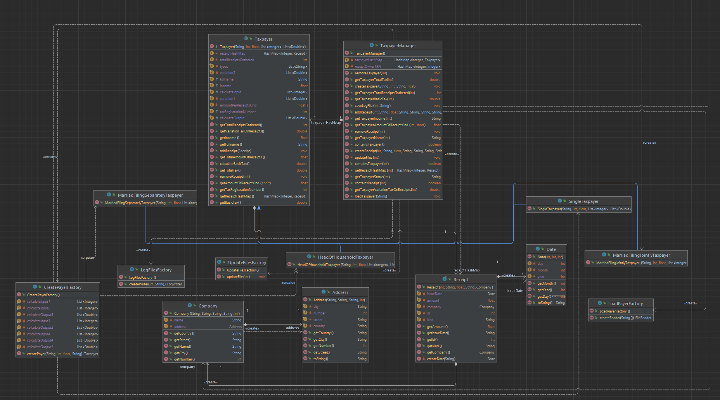

Package: incometaxcalculator.data.io
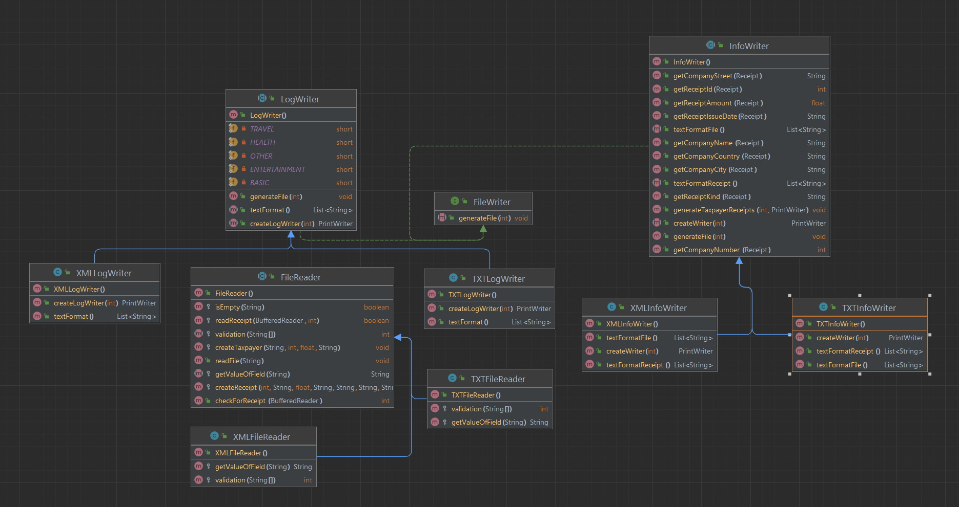

- The main problems of the old project were:
  - Dead Code: This problem was handled by just delete the methods that were not used
  - Duplicate Code: This problem was solved by creating abstract methods to the top layers and create specific classes that implement only the methods that were necessary
  - Complex logic: For example, complex if – else logic was solved by replacing the code with for loops to be easier to read and extend
  - Not small and compact methods: For example, TaxpayerManager class was responsible for too many actions. I removed where it was possible object creation to different files to clean TaxpayerManager and make the project more extendable

Classes Responsibilities and Collaborations (CRC CARDS)

Class Name: FileReader
Responsibilities | Collaborations
- This class is an abstract class who is responsible to implement methods that are used to read the files that contains taxpayers’ info | - This class has 2 abstract methods that are implemented from TXTFileReader and XMLFilerReader.

Interface Name: FileWriter
Responsibilities | Collaborations
- This interface is responsible is implemented from other classes to update taxpayer file when needed | - This interface is implemented from InfoWriter, LogWriter, TXTInfoWriter, XMLInfoWriter, TXTLogWriter, XMLLogWriter

Class Name: InfoWriter
Responsibilities | Collaborations
- This class extends FileWriter interface and is responsible to write the updates that happen to each user to his files. | - This class has 2 inheritors TXTInfoWriter and XMLInfoWriter

Class Name: LogWriter
Responsibilities | Collaborations
- This class extends FileWriter interface and is responsible to write the log files when user wants to save taxpayer info. | - This class has 2 inheritors TXTLogWriter, XMLLogWriter

Class Name: TXTFileReader
Responsibilities | Collaborations
- This class extends FileReader class with the appropriate methods when the file that is loaded has txt format | - Extends FileReader

Class Name: TXTInfoWriter
Responsibilities | Collaborations
- This class extends InfoWriter class with the appropriate methods when the updates that happens to a taxpayers should write to a .txt file | - Extends InfoWriter

Class Name: TXTLogWriter
Responsibilities | Collaborations
- This class extends LogWriter class with the appropriate methods when the user wants to save the log in a .txt format | - Extends LogWriter

Class Name: XMLFileReader
Responsibilities | Collaborations
- This class extends FileReader class with the appropriate methods when the file that is loaded has xml format | - Extends FileReader

Class Name: XMLInfoWriter
Responsibilities | Collaborations
- This class extends InfoWriter class with the appropriate methods when the updates that happens to a taxpayers should write to a .xml file | - Extends InfoWriter

Class Name: XMLLogWriter
Responsibilities | Collaborations
- This class extends LogWriter class with the appropriate methods when the user wants to save the log in a .xml format | - Extends LogWriter

Class Name: Address
Responsibilities | Collaborations
- This class is responsible to create Address type objects | - Company class uses Address objects

Class Name: Company
Responsibilities | Collaborations
- This class is responsible to create Company type objects

Class Name: Company
Responsibilities | Collaborations
- This class is responsible to create Company type objects

Class Name: CreatePayerFactory
Responsibilities | Collaborations
- This class is responsible to create taxpayer objects. | - TaxpayerManager class uses this class

Class Name: Date
Responsibilities | Collaborations
- This class is responsible to create Date type objects

Class Name: HeadOfHouseholdTaxpayer
Responsibilities | Collaborations
- This class is responsible to taxpayer of HeadOfHouseholdTaxpayer type | - Extends Taxpayer class

Class Name: LoadPayerFactory
Responsibilities | Collaborations
- This class is responsible to create FilerReader objects. | - TaxpayerManager class uses this class

Class Name: LogFilesFactory
Responsibilities | Collaborations
- This class is responsible to create LogWriter objects. | - TaxpayerManager class uses this class

Class Name: MarriedFilingJointlyTaxpayer
Responsibilities | Collaborations
- This class is responsible to taxpayer of MarriedFilingJointlyTaxpayer type | - Extends Taxpayer class

Class Name: MarriedFilingSeparatelyTaxpayer
Responsibilities | Collaborations
- This class is responsible to taxpayer of MarriedFilingSeparatelyTaxpayer type | - Extends Taxpayer class

Class Name: Receipt
Responsibilities | Collaborations
- This class is responsible to create Receipt type objects

Class Name: SingleTaxpayer
Responsibilities | Collaborations
- This class is responsible to taxpayer of SingleTaxpayer type | - Extends Taxpayer class

Class Name: Taxpayer
Responsibilities | Collaborations
- This class is responsible to implement all methods to manipulate taxpayer’s objects

Class Name: TaxpayerManager
Responsibilities | Collaborations
- This class is responsible to implement all methods that connect taxpayer with receipts and taxes

Class Name: UpdateFilesFactory
Responsibilities | Collaborations
- This class is responsible to create infoWriter objects. | - TaxpayerManager class uses this class

Class Name: ReceiptAlreadyException
Responsibilities | Collaborations
- This class is responsible to throw an error with message: Receipt already exists | - TaxpayerManager class uses this class

Class Name: WrongFileEndingException
Responsibilities | Collaborations
- This class is responsible to throw an error with message: Please check your file ending and try again | - TaxpayerManager class uses this class

Class Name: WrongFileFOrmatException
Responsibilities | Collaborations
- This class is responsible to throw an error with message: Please check your file format and try again | - TaxpayerManager class uses this class

Class Name: WrongReceiptDataException
Responsibilities | Collaborations
- This class is responsible to throw an error with message: Please make sure your date is DD/MM/YYYY and try again. | - TaxpayerManager class uses this class

Class Name: WrongReceiptKindException
Responsibilities | Collaborations
- This class is responsible to throw an error with message: Please check receipts kind and try again | - TaxpayerManager class uses this class

Class Name: WrongTaxpayerStatusException
Responsibilities | Collaborations
- This class is responsible to throw an error with message: Please check taxpayer’s status and try again! | - TaxpayerManager class uses this class

Class Name: ChartDisplay
Responsibilities | Collaborations
- This class is responsible to create the gui for the 2 types of charts that the app needs | - TaxpayerData class uses this class

Class Name: GraphicalInterface
Responsibilities | Collaborations
- This class is responsible to create the main gui of the app

Class Name: TaxpayerData
Responsibilities | Collaborations
- This class is responsible to create the gui about taxpayers’ info

