**Q1:** (**FP-growth**) FP-growth algorithm to find all frequent pattern with minimum support = 3. To verify your work, there are 14 of them. Show your steps.

**Scan DB once, find frequent 1-itemset and sort it:**

|  |  |
| --- | --- |
| Item | frequency head |
| f | 7 |
| c | 6 |
| a | 5 |
| d | 5 |
| e | 5 |
| b | 3 |

F-list = f-c-a-d-e-b

|  |  |  |
| --- | --- | --- |
| TID | Items | ordered |
| 1 | a,b,c | c,a,b |
| 2 | a,c,d | c,a,d |
| 3 | d,e,f | f,d,e |
| 4 | e, f | f,e |
| 5 | a,c,e,f | f,c,a,e |
| 6 | a,b,c,f | f,c,a,b |
| 7 | b,c,d,e | c,d,e,b |
| 8 | e,f | f,e |
| 9 | a,c,d,f | f,c,a,b |
| 10 | d,f | f,d |

**Scan DB again, construct FP-tree:**

**Find frequent itemsets:**

|  |  |  |
| --- | --- | --- |
| Patterns containing | Conditional pattern base | Frequent |
| f | null | {f} |
| c | f:3 | {c, fc} |
| a | c:2, fc:3 | {a, ca, fa, fca} |
| d | c:1, ca:1, f:2, fca:1, | {d, cd, fd} |
| e | cd:1, fd:1, f:2 | {e, fe} |
| b | cde:1, ca:1, fca:1, | {b, cb} |

There are 14 frequent patterns with minimum support = 3:

{f, c, a, d, e, b, fc, ca, fa, cd, fd, fe, cb, fca}.

**Q2:** (**Apriori**) Find all frequent 3-itemsets **candidates** using Apriori algorithm with alternate 𝐹𝑘−1×𝐹𝑘−1Fk−1×Fk−1 Method mentioned page 45 of the chap 4 slides. To save your work, assume we have found all 2-itemsets already (you are allowed to reuse the result found in Q1). Then, perform candidate pruning over your result.

According to Q1:

F2 = {fc, ca, fa, cd, fd, fe, cb} is the set of frequent 2-itemsets.

Merge each of them from F2 to generate the set of candidates 3-itemset:

L3 = {fca, fcd, fda, fec, fcb, cad, cab, fae, cdb, fde}

**Candidate pruning:**

Prune {fda} because (da) is infrequent.

Prune {fec}because {ec} is infrequent.

Prune {fcb} because {fb} is infrequent.

Prune {cad} because {ad} is infrequent.

Prune {cab} because {ab} is infrequent

Prune {fae} because {ae} is infrequent.

Prune {cdb} because {cd} is infrequent.

Prune {fde} because {de} is infrequent.

Therefore, after candidates pruning: **candidate 3-itemsets**: L3 = {fca, fcd}

**Support counting:**

Count the support by scanning the DB: {fca:3}, {fcd:1}

**Candidate elimination**

Eliminate candidates {fcd}

Therefore, frequent 3-itemsets is{fca}

**Q3:** (**Min-Hash**) Given the set of shingles {A,B,C,D,E,F,G,H} and the following three documents 𝐷1,𝐷2,𝐷3, compute the MinHash for them against each of the permutation 𝑝1,𝑝2,𝑝3 Calculate the Jaccard similarity between these documents and the similarity of MinHash of these documents.

As for p1, BDEFHGAC,

|  |  |  |  |
| --- | --- | --- | --- |
| p1 | D1 | D2 | D3 |
| B (1) | 1 | 1 | 0 |
| D (2) | 1 | 0 | 0 |
| E (3) | 0 | 0 | 1 |
| F (4) | 1 | 0 | 1 |
| H (5) | 1 | 1 | 0 |
| G (6) | 0 | 0 | 0 |
| A (7) | 0 | 1 | 0 |
| C (8) | 0 | 0 | 0 |

As for p2, CDEFABHG,

|  |  |  |  |
| --- | --- | --- | --- |
| p2 | D1 | D2 | D3 |
| C (1) | 0 | 0 | 0 |
| D (2) | 1 | 0 | 0 |
| E (3) | 0 | 0 | 1 |
| F (4) | 1 | 0 | 1 |
| A (5) | 0 | 1 | 0 |
| B (6) | 1 | 1 | 0 |
| H (7) | 1 | 1 | 0 |
| G (8) | 0 | 0 | 0 |

As for p3, ACBDGFEH,

|  |  |  |  |
| --- | --- | --- | --- |
| p3 | D1 | D2 | D3 |
| A (1) | 0 | 1 | 0 |
| C (2) | 0 | 0 | 0 |
| B (3) | 1 | 1 | 0 |
| D (4) | 1 | 0 | 0 |
| G (5) | 0 | 0 | 0 |
| F (6) | 1 | 0 | 1 |
| E (7) | 0 | 0 | 1 |
| H (8) | 1 | 1 | 0 |

Signature matrix:

|  |  |  |  |
| --- | --- | --- | --- |
|  | D1 | D2 | D3 |
| p1 | 1 | 1 | 3 |
| p2 | 2 | 5 | 3 |
| p3 | 3 | 1 | 6 |

Calculate the similarities:

|  |  |  |  |
| --- | --- | --- | --- |
|  | D1-D2 | D1-D3 | D2-D3 |
| Jaccard similarity | 0.4 | 0.2 | 0 |
| MinHash similarity | 0.33 | 0 | 0 |

**Q4:** (**MST**) Create 3 clusters using minimum spanning tree (MST) with the following coordinates. Please reproduce the diagram in your

**Calculate the distance between each point:**

|  |  |  |  |  |  |  |  |  |  |  |  |
| --- | --- | --- | --- | --- | --- | --- | --- | --- | --- | --- | --- |
| **(1,3)** | 0 |  | | | | | | | | | |
| **(1,4)** | 1 | 0 |  | | | | | | | | |
| **(0,2)** | √2 | √5 | 0 |  | | | | | | | |
| **(2,6)** | √10 | √5 | 2√5 | 0 |  | | | | | | |
| **(3,0)** | √13 | 2√5 | √13 | √37 | 0 |  | | | | | |
| **(4,2)** | √10 | √13 | 4 | 2√5 | √5 | 0 |  | | | | |
| **(5,2)** | √17 | 2√5 | 5 | 5 | 2√2 | 1 | 0 |  | | | |
| **(5,5)** | 2√5 | √17 | √34 | √10 | √29 | √10 | 3 | 0 |  | | |
| **(6,0)** | √34 | √41 | 2√10 | 2√13 | 3 | 2√2 | √5 | √26 | 0 |  | |
| **(5,6)** | 5 | 2√5 | √41 | √9 | 2√10 | √17 | 4 | 1 | √37 | 0 |  |
| **(7,0)** | 3√5 | 2√13 | √53 | √61 | 4 | √11 | 2√2 | √29 | 1 | 2√10 | 0 |
| **distance** | **(1,3)** | **(1,4)** | **(0,2)** | **(2,6)** | **(3,0)** | **(4,2)** | **(5,2)** | **(5,5)** | **(6,0)** | **(5,6)** | **(7,0)** |

**Generate the minimum spanning tree (MST):**

Erase two longest lines √10 (point (1,3) and point (4.2)) and 3(point (5,2) and point (5,5)) and generate 3 clusters:

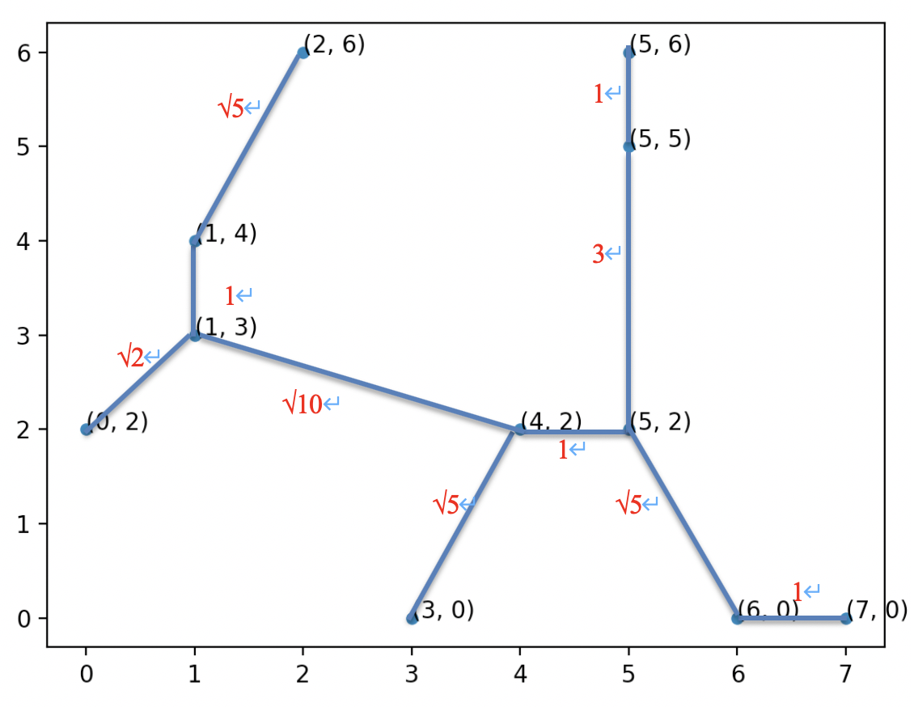

1

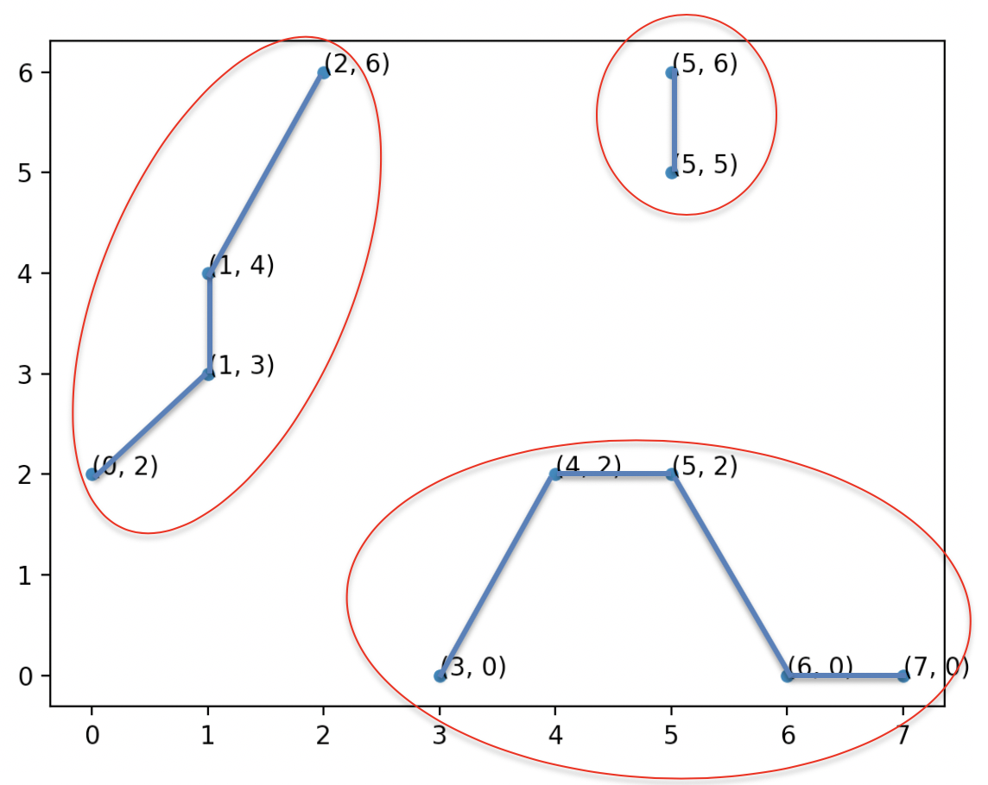

Cluster1: (0,2), (1,3), (1,4), (2,6),

Cluster2: (5,5), (5,6),

Cluster3: (3,0), (4,2), (5,2), (6,0), (7,0),