**2*CREATE A TABLE EMPG WITH ATTRIBUTES EID PRIMARY KEY ,ENAME, AGE, SALARY:**

**SQL> CREATE TABLE EMPG(EID NUMBER (20) PRIMARY KEY,ENAME VARCHAR(20),AGE NUMBER(20),SALARY NUMBER(20));**

**TABLE CREATED**

**SQL> INSERT INTO EMPG VALUES(&EID,'&ENAME',&AGE,&SALARY);**

**Enter value for eid: 1**

**Enter value for ename: GAYTAHRI**

**Enter value for age: 20**

**Enter value for salary: 50000**

**old 1: INSERT INTO EMPG VALUES(&EID,'&ENAME',&AGE,&SALARY)**

**new 1: INSERT INTO EMPG VALUES(1,'GAYTAHRI',20,50000)**

**1 row created.**

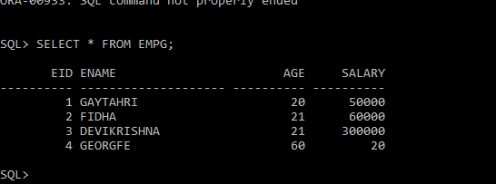

**\*COUNT OF EMPLOYEES**

**SQL> SELECT COUNT (EID) FROM EMPG;**

**COUNT (EID)**

**----------**

**4**

**\*FIND MAXIMUM AGE**

**SQL> SELECT MAX (AGE) FROM EMPG;**

**MAX (AGE)**

**----------**

**60**

**FIND MINIMUM AGE**

**SQL> SELECT MIN (AGE) FROM EMPG;**

**MIN (AGE)**

**----------**

**20**

**SQL>**

**\*SUM OF SALARY**

SQL> SELECT SUM (SALARY) FROM EMPG;

SUM (SALARY)

-----------

410020

SQL>

*FIND AVG SALARY

SQL> SELECT AVG (SALARY) FROM EMPG;

AVG (SALARY)

-----------

102505

* FIND AVG AGE

SQL> SELECT AVG(AGE) FROM EMPG;

AVG(AGE)

----------

30.5

SQL>

*CREATE VIEW FOR NAME AND AGE

SQL> CREATE OR REPLACE VIEW AGEVIEW AS SELECT ENAME,AGE FROM EMPG WHERE AGE >30;

View created.

SQL>

DISPLAY THE NAME OF EMPLOYEE IN THE DECENDING ORDER OF SALARY

SQL> SELECT ENAME SALARY FROM EMPG ORDER BY SALARY DESC;

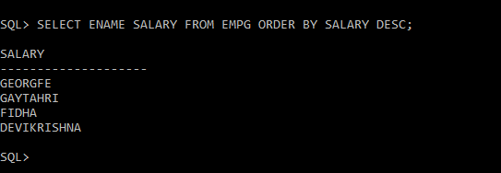

DISPLAY AGE ASENDING ORDER

SQL> SELECT ENAME AGE FROM EMPG ORDER BY AGE;

AGE

--------------------

DEVIKRISHNA

FIDHA

GAYTAHRI

GEORGE